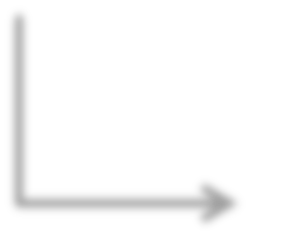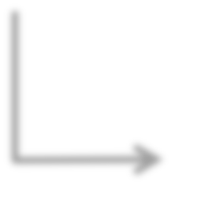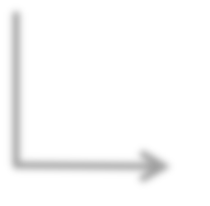

**Class EBPlugin**

**Field seeWarning: boolean**

**Constructor**

**EBPlugin()**

**Method**

**handleMessage()**

**Parameter**

**message : EBMessage**

**Method Invocation**

**EditBus.removeFromBus()**

**If Statement 2**

**Block 2**

**Expression**

**seeWarning**

**Then Part**

**Return statement**

**Statement**

**seeWarning=true;**

**Expression**

**Log Method Invocation 2**



**Method actionPerformed()**

**Block 1**

**Expression action=null**

**Field**

**context: ActionContext**

**Field**

**actionName: String**

**Constructor**

**Wrapper()**

**Statement**

**this.context=context;**

**Statement**

**this.actionName=actionName;**

**Then Part-­‐ Expression**

**Log Method Invocation 1**

**Else Part: Method Invocation**

**Context.removeAction();**

**Class Wrapper**

**Parameter context:ActionContext**

**Parameter actionName: String**

**Block**

**Parameter Evt : ActionEvent**

**If Statement 1**



Class Wrapper

Class EBPlugin

0.34

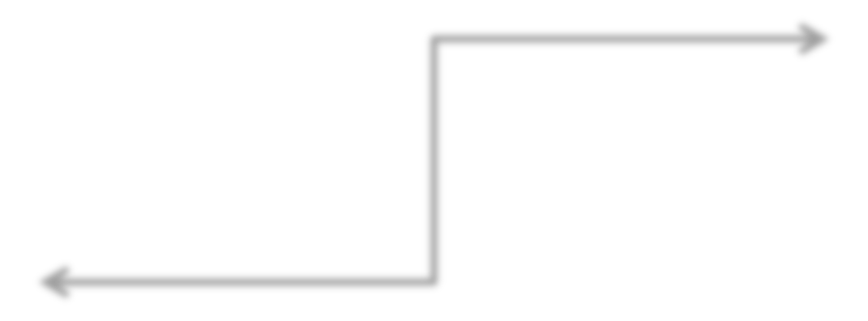

Method handleMessage()

Method actionPerformed()

Constructor Wrapper()

0.56

0.26



Block 1

Block 2

0.55



Method actionPerformed()

Method handleMessage()

0.56

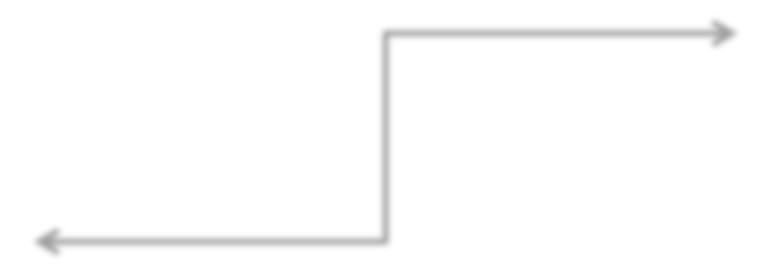

Else Part: Method Invocation Context.removeAction();

Method Invocation EditBus.removeFromBus();

Log method Invocation 1

0.44

0.33



If Statement 1

If Statement 2

0.33



Log method Invocation 1

Log Method Invocation 2

0.75



Field context: ActionContext

Field seeWarning: boolean

Field actionName: String

0.35

0.34