**Effects of Shelter on Canopy Microclimate in Arid and Semi-Arid regions: A Tool for Conservation.**

Nargol Ghazian1*, Mario Zuliani1, Michael Westphal2, and Christopher J. Lortie1, 3.

1Department of Biological Science, York University, 4700 Keele St, Toronto, ON M3J 1P3, Canada

2US Bureau of Land Management, Central Coast Field Office, 940 2nd Ave, Marina, CA 93933, United States

3National Centre for Ecological Analysis and Synthesis (NCEAS), 735 State St #300, Santa Barbara, CA 93101, United States

*Corresponding Author: Department of Biological Science, York University, 4700 Keele St, Toronto, ON, M3J 1P3, Canada. Email: [nargolg1@my.yorku.ca](mailto:nargolg1@my.yorku.ca)

**Introduction**

As the rate of anthropogenic climate change increases, many arid and semi-arid regions in western United States face extensive ecological shifts as a consequence1. At the current rate, approximately 8% of all species worldwide are expected to become extinct2. Factors such as land-use alongside urbanization can further decrease biodiversity by reducing the available terrestrial habitant in which species can live3–5. In deserts, animals will not only experience large scale changes such as draught, but also small scale changes such fluctuations in temperature and light, since for these organisms deserts are extremely heterogeneous at fine scales6,7.

The type of vegetation that covers a terrestrial habitat is an important characteristic that can influence: foraging site selection8, reproduction9, predator-prey interaction10, and thermoregulation11. Many of the above can be classified as a positive interaction between the vegetation and beneficiary species.

The state of California is home to many diverse landscapes, many of which are dominated by a magnificent variety of shrubs12. Species such as *Ephedra californica* (Mormon Tea) are known to be foundational plants, able to provide a variety of benefits to protégé species through various mechanistic pathways that include, but are not limited to, seed trapping, abiotic stress amelioration, and soil modification13. In many arid and semi-arid regions, dominant shrubs are able to positively facilitate other taxa through the shelter effects provided by their canopy14. Canopy microclimates are generally cooler, more humid, and have lower solar radiation compared to open sites14,15. Shrubs fulfil a critical functional role; hence, more species are associated with shrubs than open spaces16. This is evident in many lizards species such as *G. sila* that are found in shrubs in high afternoon temperatures17.

In recent years however, land-use (agriculture, oil fields, urbanization) and the spread of invasive grasses have altered the ecosystem dynamicsof many scrublands18,19. This is unfortunate since post-disturbance recovery of native vegetation can be slow20. Given the current rates and predictor models, it is now more crucial than ever to find ways to mitigate the impacts of climate change. Because shrub canopy may be crucial to the survival of other taxa, it’s therefore important to find alternate modes of conservation whilst landscape recovery is made and new shrubs are grown.

Artificial canopies, such as rainout shelters and Open-Top-Chambers (OTC), have been used to study the change in a variety of abiotic parameters such as CO2, temperature, soil temperature, solar radiation, and humidity 21,22. Although these shelters are effective, they’re relatively expensive to build and may be difficult to assemble in a short period of time. The landscape alongside the climate of southern California provides us with the opportunity to explore the effects man-made shelters that are inexpensive and can easily be assembled in the field. A cheaper alternative that pioneered in this study is UV Permeable Shade Cloth Shelters (UPSS) made with PVC pipes and shade cloth.

This study aims to A) describe the methodology of constructing UPSS, B) explore its effects on canopy microclimate, specifically temperature and light intensity, and C) examine how various light blockage intensities and shelter shape influence the above parameters. Given that man-made structures, as well as natural vegetation have the ability to alter their canopy’s microclimate, it was predicted that the highest blockage intensity would result in the greatest cooling effect and would be the most effective at lowering solar radiation. Furthermore, rectangular shelters would be better at cooling compared to those that are triangular as triangle blocks wind more effectively, leading to air stagnation and an increase in temperature (temperature stagnation)23. These predictions were tested by deploying temperature and light loggers inside and outside of shelters.

**Materials & Methods**

***Study site***

This study was conducted in Panoche Hills Management Area located on the western edge of the San Joaquin Valley, California (Bureau of Land Management; 36◦41.78′ N, 120◦47.89′ W). The region’s climate can be characterized as arid/semi-arid. The average annual precipitation is 25.5 cm with an annual low and high temperature of 10.4 ºC and 76.3 ºC, respectively. Winter and fall are considered to be the wettest seasons. The mean temperature observed in May is 20.4 ºC and 23.7 ºC in June (Los Baños Weather Station, <http://www.usclimatedata.com/>).

The region is heavily dominated by invasive grasses such as: *Bromus madritensis ssp. Rubens, Bromus hordeaceus, Erodium cicutarium* and *Schismus barbatus*. Shrubs are generally evenly distributed on this sea of invasive grasses, with *E. californica* being the most abundant shrub at >80% cover14. The presence of the native community is low and includes: *Phacelia tanacetifolia, Amsinckia grandiflora,* and *Monolopia congdonii.*

***Shelter Construction***

Shelters were constructed using PVC piping and UV permeable shade cloths at three light blockage intensities: 15%, 50%, and 90%. The open (no structure) at 0% light blockage served as control. The cloths were attached to the PVC using zip ties. Table 1 describes the number of pieces at specific dimensions and diameter needed to build each triangle or square shelter. There were six replicates of each shape-two pertaining to each blockage percentage-for a total of 12 replicates. Pipes were slid onto metal stakes, which were hammered into ground for stability (Fig. 1-2 Supplementary Appendix). Latitude and longitude coordinates of each shelter and open was also recorded (Supplementary Appendix). Rectangular (square) shelters consisted of two sides with two 61 cm ½ inch pipes facing the ground connected to a 61 cm ¾ inch pipe using a 90º elbow. Triangular shelters were built using a 75 cm ¾ inch top pipe connected to a ½ inch to ¾ inch adapter. The adapter was then attached to a ½ inch 3-way 90º elbow fitted with two 61 cm ½ pipes. Cloths were used to cover two side of the triangular shelters and three sides of the rectangular shelters. Because the terrain was uneven, dimensions very slightly differed between shelters; thus, cloths were not pre-cut and instead cut into the desired shape and size after PVC skeletal structure assembly was done. The directionality of shelters was at random. Shelters were visited on a weekly basis to ensure they stay intact.

**Table 1.** A list of PVC pieces used for shelter skeleton construction is provided alongside the quantity needed to build one of each shelter-type.

|  |  |  |
| --- | --- | --- |
| Piece | Quantity for Triangular Shelter | Quantity for Rectangular Shelter |
| 61 cm (½ inch diameter) pipe | 4 | 4 |
| 61 cm (¾ inch diameter) pipe | NA | 2 |
| 75 ¾ cm pipe | 1 | NA |
| ½ inch to ¾ inch adapter | 2 | NA |
| ½ inch to ¾ inch 2-way 90º elbow | NA | 4 |
| ½ inch 3-way 90º elbow | 2 | NA |

***Abiotic Measurements***

To measure the difference in light and temperature within shelters and between shelters and open microsites, Onset HOBO Temperature/Light Pendant (8K) loggers were placed inside and directly outside the shelters. A total of 24 pendants were used, where each pendant was tied to a plastic stake using a zip tie. Stakes were hammered into the ground until stable with ~10 cm remaining above ground. This was to done to ensure that logger data were not influence by ground cover and true ambient conditions both inside and outside were recorded. Air temperature (ºF) and light intensity (lum/ft2) were recorded hourly. Loggers were placed out mid-May (20th) and collected in mid-June (12th), 2019 to represent spring-summer seasonal variation. Data collected were then categorized into time-blocks: morning (6 AM-11:59 PM), afternoon (12 PM-11:59 PM), evening (12:00AM-5:59AM).

***Statistical Analyses***

All statistics were performed using R version 3.6.124. Workflows can be found on: <https://nargolg1.github.io/Animal-Behaviour-and-Climate-project/CH3/shelter-comparison.html>. Temperature and light data distribution were looked at (*ggqqplot* function, *ggplot2*25 library) where temperature followed a positively-skewed, normal distribution and intensity appeared to have an exponential distribution. All zeros for the intensity parameter were omitted as they corresponded to afternoon/evening when there was naturally total darkness, in order not to interfere with true shelter light blockage analyses. The relationship between temperature and light intensity was examined using Kendall’s rank correlation (non-parametric, continuous data), as well as scatterplots with *Generalized Linear Model (GLM)* fitted regression lines for the different time-blocks and light blockage intensities using the function ggplot from the package *ggplot2*. GLMs were used to compare between temperatures, shape, and cover type with timeclock serving as a co-variate. This model was fitted with a Gaussian distribution. A similar model was used for intensity with a Poisson fit. GLM dispersion parameters and AIC scores were used to compare and select the appropriate fit. An ANOVA with a Chi-square test was performed where all the variables in the both models were shown to be significant. Subsequently, a post-hoc comparison of the GLMs was performed (function *emmeans*, *emmeans* library)26 to test for specific interactions.

**Results**

The above methods resulted in the construction of the shelters in figures 1. Shelter assembly was uncomplicated and lasted around 15 minutes per shelter when working in pairs. Shelters remained intact during the duration of the entire study period. Zip ties proved to be effective at keeping the shade cloths attached to shelter skeletal structure.

In general, an increase in temperature was associated with an increase in light intensity (Kendall’s tau= 0.487, p <2.2e-16). This was true irrespective of shape, time block, or blockage intensity/cover type (Fig. 3-6 Supplementary Appendix). Shelters significantly altered canopy microclimate during the study period at all times of the day. There were significant differences between the different blockage intensities when predicting temperature (ANOVA F= 5.763, p= 0.016) and light intensity (ANOVA F= 213.68, p<2.2e-16). Differences between rectangle and triangle were particularly important during the evening (p<0.0001), Furthermore, the various structures also affected temperature (ANOV F= 90.484, p<2.2e-16) and light (ANOVA F=37.154, p<2.2e-16) in a significantly different ways. Light blockage intensity (cover type), shape, and time block were used as predictors for temperature and light intensity GLM. In the post-hoc analyses, differences between rectangle and triangle showed to be important. The 90% blockage was the only cover type that showed to be significant for temperature comparisons. Rectangle was shown to be better at cooling during all times of the day at 90% blockage (p<0.0001; Table 2). Rectangle was better at blocking light at all time blocks (Table 2; p<0.0001). 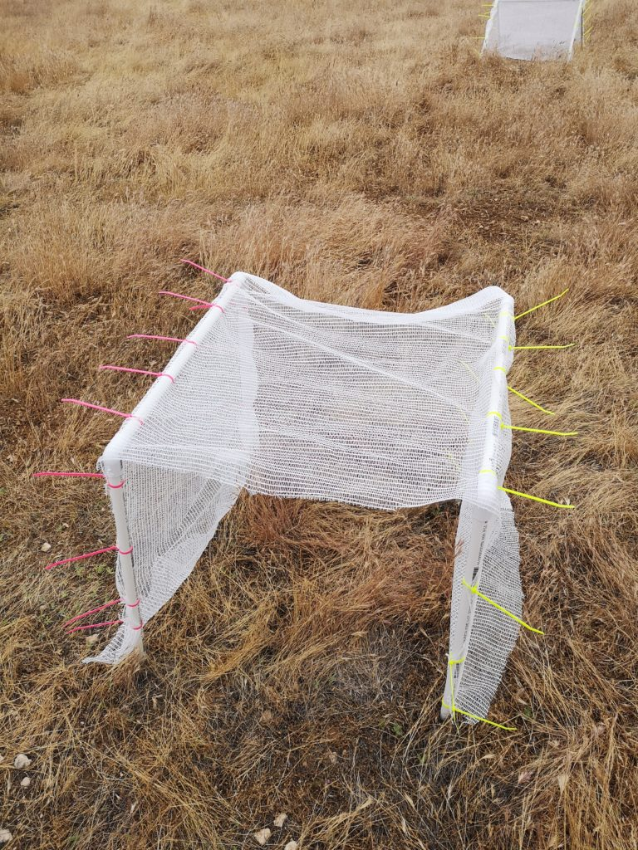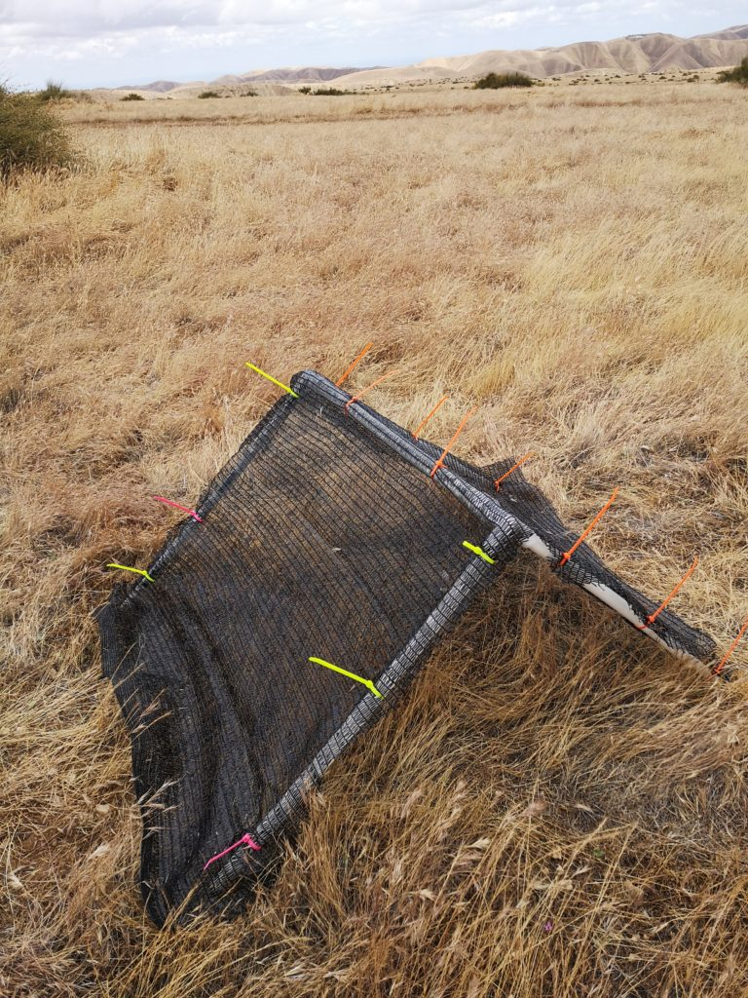

**Figure 1.** Left-Triangular shelter with 90% shade cloth attached to PVC skeleton using zip ties. Right-Rectangular shelter with 15% shade cloth attached to two PVC skeletal frames.

**Table 2.** Emmeans values and standard error for square and triangle shelters are given for the different time blocks of the day at Panoche Hills, CA. Values are for *emmeans* comparison with temperature as the response variable. Values were compared using a pairwise method. Significance is measure at α < 0.05 and bolded if significant. Only significant comparisons were included in the table.

|  |  |  |  |  |  |
| --- | --- | --- | --- | --- | --- |
| Time Block | Blockage Intensity (%) | Rectangle | Triangle | Effect Size (z) | p-Value |
| Afternoon | 90 | 89.9±1.115 | 83.5±1.108 | 5.431 | **p<0.0001** |
| Evening | 90 | 84±0.878 | 77.6±0.870 | 5.431 | **p<0.0001** |
| Morning | 90 | 80.08±0.862 | 74.4±0.855 | 5.431 | **p<0.0001** |

**Table 3.** Emmeans values and standard error for square and triangle shelters are given for the different time blocks of the day at Panoche Hills, CA. Values are for GLM with light intensity as the response variable. Values were compared using a pairwise method. Significance is measure at α < 0.05 and bolded if significant. Only significant comparisons were included in the table.

|  |  |  |  |  |  |  |
| --- | --- | --- | --- | --- | --- | --- |
| Time Block | Blockage Intensity (%) | Square | Triangle | No Structure | Effect Size (z) | p-Value |
| Afternoon | 0 | 82.3±0.0742 | 82.0±0.0724 |  | -24.357 | **p<0.0001** |
| Afternoon | 15 | 91.4±0.0861 | 91.0±0.0845 |  | -739.449 | **p<0.0001** |
| Afternoon | 50 | 85.5±0.0760 | 85.1±0.0740 |  | 193.211 | **p<0.0001** |
| Afternoon | 90 |  |  |  | 430.142 | **p<0.0001** |
| Evening | 0 |  |  |  | -24.357 | **p<0.0001** |
| Evening | 15 |  |  |  | -739.449 | **p<0.0001** |
| Evening | 50 |  |  |  | 193.211 | **p<0.0001** |
| Evening | 90 |  |  |  | 430.142 | **p<0.0001** |
| Morning | 0 |  |  |  | -24.357 | **p<0.0001** |
| Morning | 15 |  |  |  | -739.449 | **p<0.0001** |
| Morning | 50 |  |  |  | 193.211 | **p<0.0001** |
| Morning | 90 |  |  |  | 430.142 | **p<0.0001** |

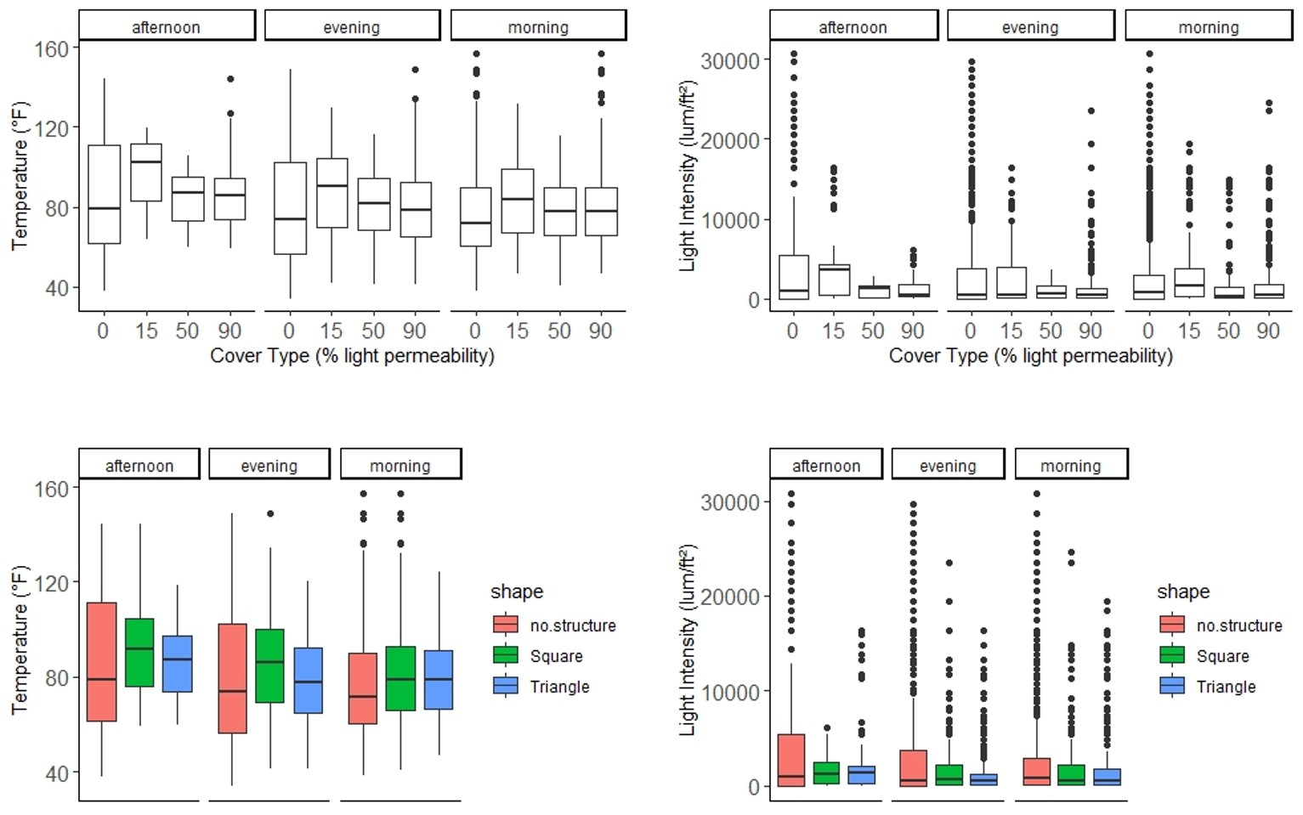

**Figure 2.** Box plot showing the relationship between temperature (ºF) and the different blockage intensities and shape for the three time blocks. These relationships are also shown for light intensity (lum/ft2). Solid middle lines shows the median of the data, whilst whiskers show 1.5 standard deviation. Solid dots are outliers >1.5 interquartile range (IQR).

**Discussion**

This study demonstrates that UPSS is in fact a cheaper and more easily-assembled alternative that is able to modify its canopy’s microclimate.

**Funding**

This research was made possible through a Natural Sciences and Engineering Research Council of Canada (NSERC) grant awarded to CJL and the Mitacs Globalink award, alongside York University Faculty of Graduate Studies (FGS) award granted to NG and MZ.

**Acknowledgements**

We are thankful to BLM for allowing us to conduct research in their land. We are grateful to M. MacDonald for her help in designing the project and editing the manuscript. We also thank J. Braun, M. Owen, and S. Haas for their feedback on statistical analyses.