shrub.open.shelter comparison

Nargol Ghazian

04/03/2020

#GOALS  
  
##1.Describe how to built UPSS.  
##2.Exploring UPSS effects on canopy microclimate, including temperature and light intensity, relative to the open and shrub.  
##3.Understanding how different light permeabilities and shelter shapes influence the above parameters.

library (tidyverse)

## Warning: package 'tidyverse' was built under R version 3.6.2

## -- Attaching packages ----------------------- tidyverse 1.3.0 --

## v ggplot2 3.2.1 v purrr 0.3.3  
## v tibble 2.1.3 v dplyr 0.8.3  
## v tidyr 1.0.0 v stringr 1.4.0  
## v readr 1.3.1 v forcats 0.4.0

## Warning: package 'forcats' was built under R version 3.6.2

## -- Conflicts -------------------------- tidyverse_conflicts() --  
## x dplyr::filter() masks stats::filter()  
## x dplyr::lag() masks stats::lag()

library(ggplot2)  
#import datasets  
panoche.climate.2019<-read.csv("C:/Users/Nargol Ghazian/Desktop/Animal-Behaviour-and-Climate-project/CH3/panoche_climate_hourly 2019.csv")  
  
mean.daily.panoche <- read.csv("C:/Users/Nargol Ghazian/Desktop/Animal-Behaviour-and-Climate-project/CH3/weather station climate.csv")  
  
str(panoche.climate.2019)

## 'data.frame': 8760 obs. of 28 variables:  
## $ station.id : int 56 56 56 56 56 56 56 56 56 56 ...  
## $ site : Factor w/ 2 levels "","panoche": 2 2 2 2 2 2 2 2 2 2 ...  
## $ station.name: Factor w/ 2 levels "","Los Banos": 2 2 2 2 2 2 2 2 2 2 ...  
## $ CIMIS.Region: Factor w/ 2 levels "","San Joaquin Valley": 2 2 2 2 2 2 2 2 2 2 ...  
## $ hour : int 1 2 3 4 5 6 7 8 9 10 ...  
## $ date : Factor w/ 27 levels "","5/18/2019",..: 2 2 2 2 2 2 2 2 2 2 ...  
## $ month : int 5 5 5 5 5 5 5 5 5 5 ...  
## $ day : int 18 18 18 18 18 18 18 18 18 18 ...  
## $ year : int 2019 2019 2019 2019 2019 2019 2019 2019 2019 2019 ...  
## $ precip : num 0 0 0 0 0 0 0 0 0 0 ...  
## $ radiation : int NA NA NA NA NA 57 176 432 597 723 ...  
## $ air.temp : num 8.7 9.2 8.8 7.6 6.6 7 10.3 13.7 16 17.5 ...  
## $ wind.speed : num 1.4 1.3 0.9 1.2 1.2 0.6 1 0.9 1.4 3 ...  
## $ soil.temp : num 18.1 18 18 17.9 17.8 17.7 17.6 17.5 17.4 17.3 ...  
## $ air.temp.F : num 47.7 48.6 47.8 45.7 43.9 ...  
## $ X : logi NA NA NA NA NA NA ...  
## $ X.1 : logi NA NA NA NA NA NA ...  
## $ X.2 : logi NA NA NA NA NA NA ...  
## $ X.3 : logi NA NA NA NA NA NA ...  
## $ X.4 : logi NA NA NA NA NA NA ...  
## $ X.5 : logi NA NA NA NA NA NA ...  
## $ X.6 : logi NA NA NA NA NA NA ...  
## $ X.7 : logi NA NA NA NA NA NA ...  
## $ X.8 : logi NA NA NA NA NA NA ...  
## $ X.9 : logi NA NA NA NA NA NA ...  
## $ X.10 : logi NA NA NA NA NA NA ...  
## $ X.11 : logi NA NA NA NA NA NA ...  
## $ X.12 : Factor w/ 3 levels " ","R","Y": 1 1 1 1 1 1 1 1 1 1 ...

na.omit (panoche.climate.2019)#exclude missing values

## [1] station.id site station.name CIMIS.Region hour   
## [6] date month day year precip   
## [11] radiation air.temp wind.speed soil.temp air.temp.F   
## [16] X X.1 X.2 X.3 X.4   
## [21] X.5 X.6 X.7 X.8 X.9   
## [26] X.10 X.11 X.12   
## <0 rows> (or 0-length row.names)

head(is.na(panoche.climate.2019))#check for missing values

## station.id site station.name CIMIS.Region hour date month day  
## [1,] FALSE FALSE FALSE FALSE FALSE FALSE FALSE FALSE  
## [2,] FALSE FALSE FALSE FALSE FALSE FALSE FALSE FALSE  
## [3,] FALSE FALSE FALSE FALSE FALSE FALSE FALSE FALSE  
## [4,] FALSE FALSE FALSE FALSE FALSE FALSE FALSE FALSE  
## [5,] FALSE FALSE FALSE FALSE FALSE FALSE FALSE FALSE  
## [6,] FALSE FALSE FALSE FALSE FALSE FALSE FALSE FALSE  
## year precip radiation air.temp wind.speed soil.temp air.temp.F X  
## [1,] FALSE FALSE TRUE FALSE FALSE FALSE FALSE TRUE  
## [2,] FALSE FALSE TRUE FALSE FALSE FALSE FALSE TRUE  
## [3,] FALSE FALSE TRUE FALSE FALSE FALSE FALSE TRUE  
## [4,] FALSE FALSE TRUE FALSE FALSE FALSE FALSE TRUE  
## [5,] FALSE FALSE TRUE FALSE FALSE FALSE FALSE TRUE  
## [6,] FALSE FALSE FALSE FALSE FALSE FALSE FALSE TRUE  
## X.1 X.2 X.3 X.4 X.5 X.6 X.7 X.8 X.9 X.10 X.11 X.12  
## [1,] TRUE TRUE TRUE TRUE TRUE TRUE TRUE TRUE TRUE TRUE TRUE FALSE  
## [2,] TRUE TRUE TRUE TRUE TRUE TRUE TRUE TRUE TRUE TRUE TRUE FALSE  
## [3,] TRUE TRUE TRUE TRUE TRUE TRUE TRUE TRUE TRUE TRUE TRUE FALSE  
## [4,] TRUE TRUE TRUE TRUE TRUE TRUE TRUE TRUE TRUE TRUE TRUE FALSE  
## [5,] TRUE TRUE TRUE TRUE TRUE TRUE TRUE TRUE TRUE TRUE TRUE FALSE  
## [6,] TRUE TRUE TRUE TRUE TRUE TRUE TRUE TRUE TRUE TRUE TRUE FALSE

head(na.omit (mean.daily.panoche))

## station.name site sensor lat long date year month day  
## 1 los banos panoche station -120.867 37.0563 5/18/2019 2019 5 18  
## 2 los banos panoche station -120.867 37.0563 5/19/2019 2019 5 19  
## 3 los banos panoche station -120.867 37.0563 5/20/2019 2019 5 20  
## 4 los banos panoche station -120.867 37.0563 5/21/2019 2019 5 21  
## 5 los banos panoche station -120.867 37.0563 5/22/2019 2019 5 22  
## 6 los banos panoche station -120.867 37.0563 5/23/2019 2019 5 23  
## temp.max temp.min temp.mean  
## 1 83.1 55.2 69.15  
## 2 83.3 55.4 69.35  
## 3 83.5 55.4 69.45  
## 4 83.7 55.6 69.65  
## 5 83.9 55.8 69.85  
## 6 84.2 55.9 70.05

#DATA VIZ MACRO (WEATHER STATION)   
##macro-climate plots  
ggplot (panoche.climate.2019, aes((hour), air.temp)) + geom_smooth() + xlab("Hour (0-24)") + ylab ("Temperature (°C)")+ theme_classic()+ theme(axis.text=element_text(size=12))+ theme(axis.text=element_text(size=12))#how air temperature changed during 24h period in 2019 during study period

## `geom_smooth()` using method = 'gam' and formula 'y ~ s(x, bs = "cs")'

## Warning: Removed 8136 rows containing non-finite values (stat_smooth).

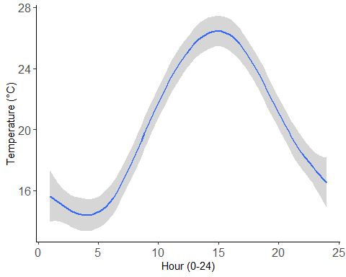

ggplot (panoche.climate.2019, aes((day), air.temp)) + geom_smooth() + xlab("Day") + ylab ("Temperature (°C)")+ theme_classic()+ theme(axis.text=element_text(size=12))+ theme(axis.text=element_text(size=12))#air temperature over the days of the study period

## `geom_smooth()` using method = 'gam' and formula 'y ~ s(x, bs = "cs")'

## Warning: Removed 8136 rows containing non-finite values (stat_smooth).

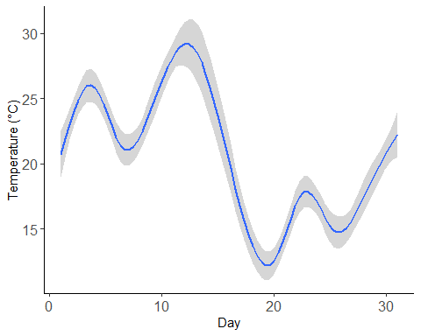

ggplot (panoche.climate.2019, aes((hour), soil.temp)) + geom_smooth() + xlab("Hour (0-24)") + ylab ("Temperature (°C)")+ theme_classic()+ theme(axis.text=element_text(size=12))+ theme(axis.text=element_text(size=12))#how soil temperature changed during 24h period in 2019 during study period

## `geom_smooth()` using method = 'gam' and formula 'y ~ s(x, bs = "cs")'

## Warning: Removed 8136 rows containing non-finite values (stat_smooth).

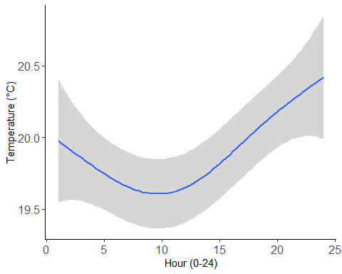

ggplot (panoche.climate.2019, aes((day), soil.temp)) + geom_smooth() + xlab("Day") + ylab ("Temperature (°C)")+ theme_classic()+ theme(axis.text=element_text(size=12))+ theme(axis.text=element_text(size=12))#how soil temperature changed during 24h period in 2019 during study period

## `geom_smooth()` using method = 'gam' and formula 'y ~ s(x, bs = "cs")'

## Warning: Removed 8136 rows containing non-finite values (stat_smooth).

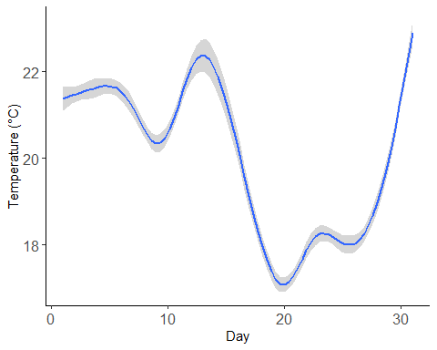

ggplot (panoche.climate.2019, aes((hour), radiation)) + geom_smooth() + xlab("Hour (0-24)") + ylab ("Solar Radiation (W/m²)")+ theme_classic()+ theme(axis.text=element_text(size=12))+ theme(axis.text=element_text(size=12))#how solar radiation changed during 24h period in 2019 during study period

## `geom_smooth()` using method = 'gam' and formula 'y ~ s(x, bs = "cs")'

## Warning: Removed 8347 rows containing non-finite values (stat_smooth).

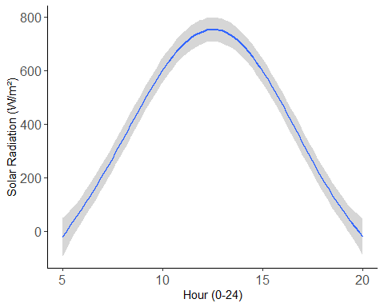

ggplot (panoche.climate.2019, aes((day), radiation)) + geom_smooth() + xlab("Day") + ylab ("Solar Radiation (W/m²)")+ theme_classic()+ theme(axis.text=element_text(size=12))+ theme(axis.text=element_text(size=12))#sunlight experinced over the the study period

## `geom_smooth()` using method = 'gam' and formula 'y ~ s(x, bs = "cs")'

## Warning: Removed 8347 rows containing non-finite values (stat_smooth).

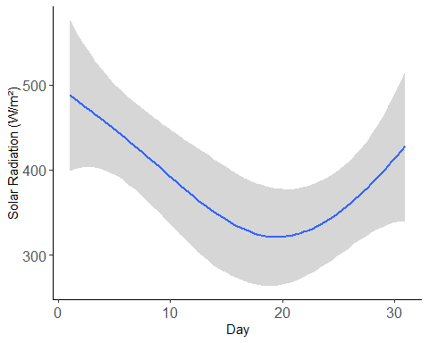

library (ggbeeswarm)

## Warning: package 'ggbeeswarm' was built under R version 3.6.3

ggplot (panoche.climate.2019, aes(as.factor(date), air.temp)) + geom_boxplot() + xlab("Date") + ylab ("Temperature (°C)")+ geom_quasirandom(alpha=0.05)+ theme_classic()+ theme(axis.text=element_text(size=12))+ theme(axis.text=element_text(size=12))+ theme(axis.text.x = element_text(angle = 90))+ geom_smooth(se=FALSE, color="black", aes(group=1))#daily air temperature averages

## Warning: Removed 8136 rows containing non-finite values (stat_boxplot).

## `geom_smooth()` using method = 'gam' and formula 'y ~ s(x, bs = "cs")'

## Warning: Removed 8136 rows containing non-finite values (stat_smooth).

## Warning: Removed 8136 rows containing missing values  
## (position_quasirandom).

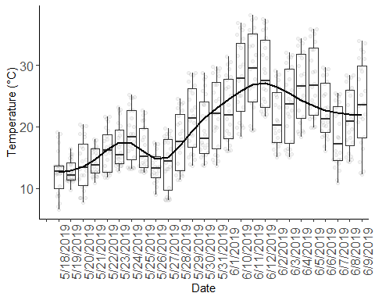

#DATA VIZ MICRO  
##micro-climate plots  
##let's try some plots for shelter, shrub, and open  
  
shelter.shrub.open <- read.csv("C:/Users/Nargol Ghazian/Desktop/Animal-Behaviour-and-Climate-project/CH3/shrub_contrast_final.csv")#import dataset  
  
ggplot(shelter.shrub.open, aes((microsite), temp, fill=microsite)) + geom_boxplot() + xlab("Microsite") + ylab ("Temperature (°F)")+ theme_classic()+ theme(axis.text=element_text(size=12))+theme(axis.text.x = element_text(angle = 90))+theme(axis.title.x=element_blank(),  
 axis.text.x=element_blank(),  
 axis.ticks.x=element_blank())+ labs(fill = "Microsite")+ stat_summary(fun.y=mean, colour="black", geom="point", shape=18, size=3,show_guide = FALSE)#Boxplot temperaure by microsite

## Warning: `show_guide` has been deprecated. Please use `show.legend`  
## instead.

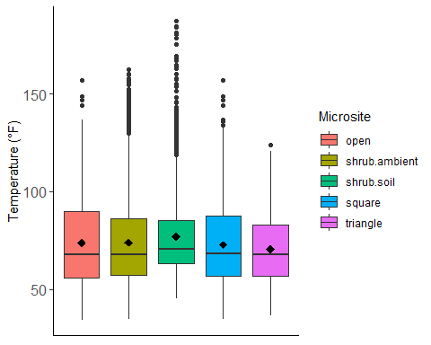

ggplot(shelter.shrub.open, aes((microsite), intensity, fill=microsite)) + geom_boxplot() + xlab("Microsite") + ylab ("Solar Radiation (lum/ft²)")+ theme_classic()+ theme(axis.text=element_text(size=12))+theme(axis.text.x = element_text(angle = 90))+theme(axis.title.x=element_blank(),  
 axis.text.x=element_blank(),  
 axis.ticks.x=element_blank())+ labs(fill = "Microsite")+ stat_summary(fun.y=mean, colour="black", geom="point", shape=18, size=3,show_guide = FALSE)#Boxplot light intensity by microsite

## Warning: `show_guide` has been deprecated. Please use `show.legend`  
## instead.

## Warning: Removed 9330 rows containing non-finite values (stat_boxplot).

## Warning: Removed 9330 rows containing non-finite values (stat_summary).

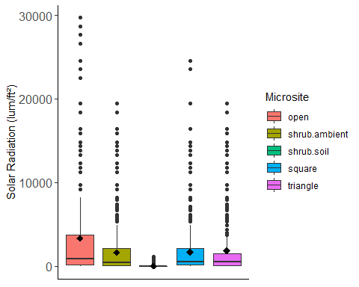

ggplot(shelter.shrub.open, aes((day), temp, color=microsite)) + geom_smooth() + xlab("Day") + ylab ("Temperature (°F)")+ theme_classic()+ theme(axis.text=element_text(size=12))

## `geom_smooth()` using method = 'gam' and formula 'y ~ s(x, bs = "cs")'

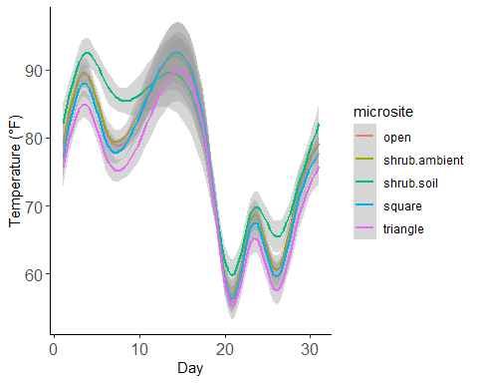

ggplot(shelter.shrub.open, aes((day), intensity, color=microsite)) + geom_smooth() + xlab("Day") + ylab ("Solar Radiation (lum/ft²)")+ theme_classic()+ theme(axis.text=element_text(size=12))

## `geom_smooth()` using method = 'gam' and formula 'y ~ s(x, bs = "cs")'

## Warning: Removed 9330 rows containing non-finite values (stat_smooth).

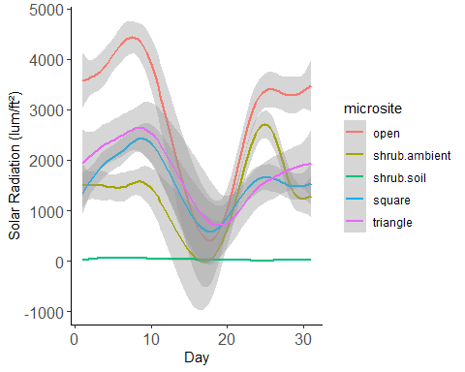

#visualizing mean, median, and mode with histograms  
ggplot(shelter.shrub.open, aes(temp, fill = microsite)) +  
 geom_histogram(binwidth = 5) +  
 scale_fill_brewer(palette = "Set1")+ labs(fill = "", x = "Temperature (°F)", y = "Frequency")+theme_classic()+ theme(axis.text=element_text(size=12))+labs(fill = "Microsite")

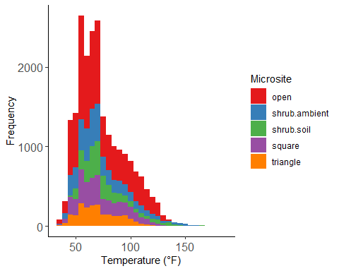

library(ggpubr)

## Loading required package: magrittr

##   
## Attaching package: 'magrittr'

## The following object is masked from 'package:purrr':  
##   
## set_names

## The following object is masked from 'package:tidyr':  
##   
## extract

ggplot(shelter.shrub.open, aes(temp, fill = microsite)) +  
 geom_histogram(binwidth = 5) +  
 scale_fill_brewer(palette = "Set1")+ labs(fill = "", x = "Temperature (°F)", y = "Frequency")+theme_classic()+ theme(axis.text=element_text(size=12))+ stat_central_tendency(aes(color = microsite), type = "mean", color="green", linetype = 2)+ stat_central_tendency(type = "median", color = "blue", linetype = 2)+ facet_grid(~microsite)+theme(legend.position = "none")

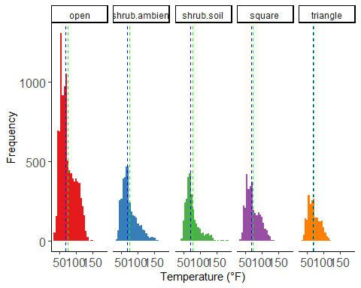

ggplot(shelter.shrub.open, aes(temp, fill = microsite)) +  
 geom_density() +  
 scale_fill_brewer(palette = "Set1")+ labs(fill = "", x = "Temperature (°F)", y = "Frequency")+theme_classic()+ theme(axis.text=element_text(size=12))+labs(fill = "Microsite")

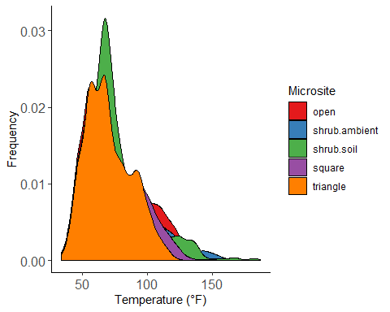

ggplot(shelter.shrub.open, aes(temp, fill = microsite)) +  
 geom_density() +  
 scale_fill_brewer(palette = "Set1")+ labs(fill = "", x = "Temperature (°F)", y = "Frequency")+theme_classic()+ theme(axis.text=element_text(size=12))+ stat_central_tendency(aes(color = microsite), type = "mean", color="green", linetype = 2)+ stat_central_tendency(type = "median", color = "blue", linetype = 2)+ facet_grid(~microsite)+theme(legend.position = "none")

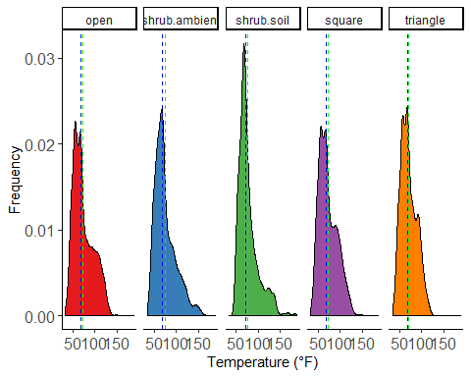

#EDA  
#explore normality   
#can't do Shapiro-Wilk dataset too large   
library(ggpubr)  
  
ggqqplot(shelter.shrub.open$temp)#Data are positively(right) skewed, Gaussian

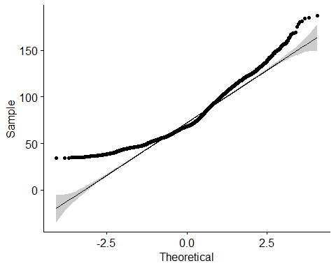

hist(shelter.shrub.open$temp)

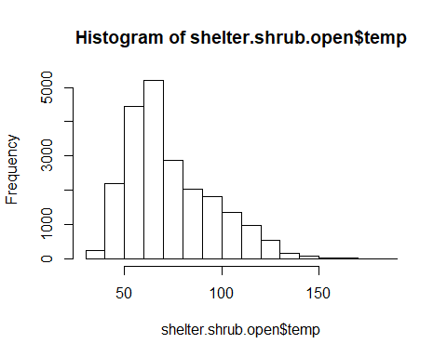

ggqqplot(shelter.shrub.open$intensity)#Data follow a poisson distribution

## Warning: Removed 9330 rows containing non-finite values (stat_qq).

## Warning: Removed 9330 rows containing non-finite values (stat_qq_line).  
  
## Warning: Removed 9330 rows containing non-finite values (stat_qq_line).

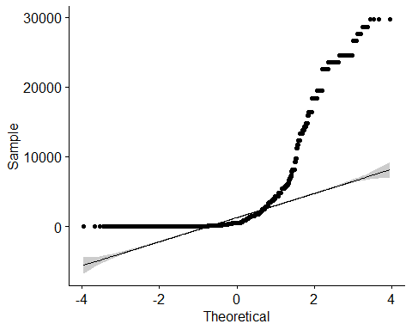

hist(shelter.shrub.open$intensity)

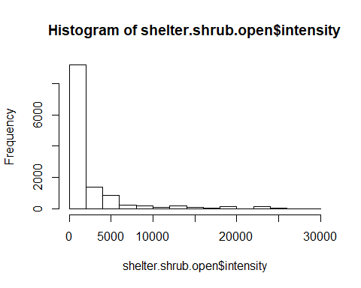

#Neither intensity nor temperature follow a normal distribution

#explore light and temperature relationship  
macro.micro.contrast <- read.csv("C:/Users/Nargol Ghazian/Desktop/Animal-Behaviour-and-Climate-project/CH3/micro-macro-contrast.csv")  
  
cor.test(macro.micro.contrast$temp, macro.micro.contrast$intensity, method = "kendall")#light and temperature are correlated p<0.0001, tau=0.2813

##   
## Kendall's rank correlation tau  
##   
## data: macro.micro.contrast$temp and macro.micro.contrast$intensity  
## z = 47.868, p-value < 2.2e-16  
## alternative hypothesis: true tau is not equal to 0  
## sample estimates:  
## tau   
## 0.2813518

#scatterplot for the relationship  
ggplot(macro.micro.contrast, aes(temp, intensity))+ geom_point()+ ylab("Light Intensity (lum/ft²)")+ xlab("Temperature (°F)")+geom_smooth(method='glm', se=FALSE)+theme_classic()#Perhaps too dense too look at

## Warning: Removed 9541 rows containing non-finite values (stat_smooth).

## Warning: Removed 9541 rows containing missing values (geom_point).

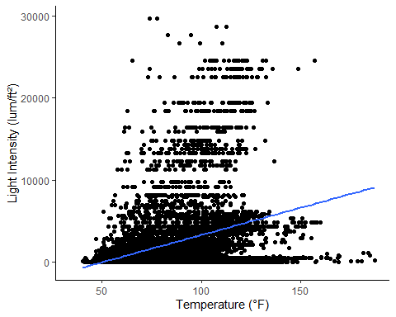

ggplot(macro.micro.contrast, aes(temp, intensity))+geom_point()+ ylab("Light Intensity (lum/ft²)")+ xlab("Temperature (°F)")+geom_smooth(method='glm', se=FALSE)+ facet_grid(~microsite)+ theme_classic()#faceted by microsite

## Warning: Removed 9541 rows containing non-finite values (stat_smooth).  
  
## Warning: Removed 9541 rows containing missing values (geom_point).

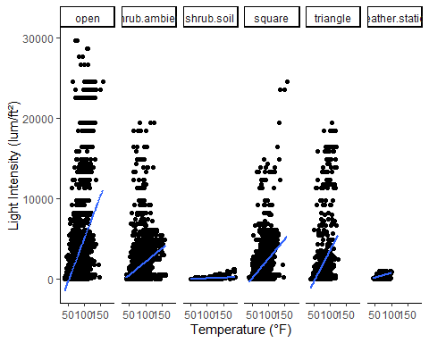

#MODELS  
##model hypotheses  
##pair-wise comparison  
lm.temp <- glm(temp~as.factor(microsite), data = shelter.shrub.open, family="gaussian")  
summary (lm.temp)

##   
## Call:  
## glm(formula = temp ~ as.factor(microsite), family = "gaussian",   
## data = shelter.shrub.open)  
##   
## Deviance Residuals:   
## Min 1Q Median 3Q Max   
## -39.543 -16.496 -5.442 13.796 110.218   
##   
## Coefficients:  
## Estimate Std. Error t value Pr(>|t|)   
## (Intercept) 73.6902 0.2214 332.819 < 2e-16 ***  
## as.factor(microsite)shrub.ambient 0.2471 0.4179 0.591 0.5544   
## as.factor(microsite)shrub.soil 3.3369 0.4760 7.011 2.44e-12 ***  
## as.factor(microsite)square -1.0049 0.4414 -2.277 0.0228 *   
## as.factor(microsite)triangle -3.1949 0.5171 -6.179 6.56e-10 ***  
## ---  
## Signif. codes: 0 '***' 0.001 '**' 0.01 '*' 0.05 '.' 0.1 ' ' 1  
##   
## (Dispersion parameter for gaussian family taken to be 483.3702)  
##   
## Null deviance: 10668889 on 21959 degrees of freedom  
## Residual deviance: 10612393 on 21955 degrees of freedom  
## AIC: 198057  
##   
## Number of Fisher Scoring iterations: 2

library (emmeans)

## Welcome to emmeans.  
## NOTE -- Important change from versions <= 1.41:  
## Indicator predictors are now treated as 2-level factors by default.  
## To revert to old behavior, use emm_options(cov.keep = character(0))

anova(lm.temp, test = "Chisq")

## Analysis of Deviance Table  
##   
## Model: gaussian, link: identity  
##   
## Response: temp  
##   
## Terms added sequentially (first to last)  
##   
##   
## Df Deviance Resid. Df Resid. Dev Pr(>Chi)   
## NULL 21959 10668889   
## as.factor(microsite) 4 56496 21955 10612393 < 2.2e-16 ***  
## ---  
## Signif. codes: 0 '***' 0.001 '**' 0.01 '*' 0.05 '.' 0.1 ' ' 1

emmeans1 <- emmeans(lm.temp, pairwise~microsite)  
  
  
lm.intensity <- glm(intensity~as.factor(microsite), data=shelter.shrub.open, family = "quasipoisson")  
summary (lm.intensity)

##   
## Call:  
## glm(formula = intensity ~ as.factor(microsite), family = "quasipoisson",   
## data = shelter.shrub.open)  
##   
## Deviance Residuals:   
## Min 1Q Median 3Q Max   
## -81.516 -56.469 -33.933 2.815 293.607   
##   
## Coefficients:  
## Estimate Std. Error t value Pr(>|t|)   
## (Intercept) 8.11118 0.01800 450.56 <2e-16 ***  
## as.factor(microsite)shrub.ambient -0.71605 0.04520 -15.84 <2e-16 ***  
## as.factor(microsite)shrub.soil -4.58886 0.41459 -11.07 <2e-16 ***  
## as.factor(microsite)square -0.68732 0.04727 -14.54 <2e-16 ***  
## as.factor(microsite)triangle -0.58210 0.05431 -10.72 <2e-16 ***  
## ---  
## Signif. codes: 0 '***' 0.001 '**' 0.01 '*' 0.05 '.' 0.1 ' ' 1  
##   
## (Dispersion parameter for quasipoisson family taken to be 6402.7)  
##   
## Null deviance: 62739687 on 12629 degrees of freedom  
## Residual deviance: 54663384 on 12625 degrees of freedom  
## (9330 observations deleted due to missingness)  
## AIC: NA  
##   
## Number of Fisher Scoring iterations: 6

anova(lm.intensity, test = "Chisq")

## Analysis of Deviance Table  
##   
## Model: quasipoisson, link: log  
##   
## Response: intensity  
##   
## Terms added sequentially (first to last)  
##   
##   
## Df Deviance Resid. Df Resid. Dev Pr(>Chi)   
## NULL 12629 62739687   
## as.factor(microsite) 4 8076303 12625 54663384 < 2.2e-16 ***  
## ---  
## Signif. codes: 0 '***' 0.001 '**' 0.01 '*' 0.05 '.' 0.1 ' ' 1

emmeans(lm.temp, pairwise~microsite)

## $emmeans  
## microsite emmean SE df asymp.LCL asymp.UCL  
## open 73.7 0.221 Inf 73.3 74.1  
## shrub.ambient 73.9 0.354 Inf 73.2 74.6  
## shrub.soil 77.0 0.421 Inf 76.2 77.9  
## square 72.7 0.382 Inf 71.9 73.4  
## triangle 70.5 0.467 Inf 69.6 71.4  
##   
## Confidence level used: 0.95   
##   
## $contrasts  
## contrast estimate SE df z.ratio p.value  
## open - shrub.ambient -0.247 0.418 Inf -0.591 0.9764   
## open - shrub.soil -3.337 0.476 Inf -7.011 <.0001   
## open - square 1.005 0.441 Inf 2.277 0.1525   
## open - triangle 3.195 0.517 Inf 6.179 <.0001   
## shrub.ambient - shrub.soil -3.090 0.551 Inf -5.612 <.0001   
## shrub.ambient - square 1.252 0.521 Inf 2.403 0.1144   
## shrub.ambient - triangle 3.442 0.586 Inf 5.869 <.0001   
## shrub.soil - square 4.342 0.569 Inf 7.636 <.0001   
## shrub.soil - triangle 6.532 0.629 Inf 10.382 <.0001   
## square - triangle 2.190 0.603 Inf 3.629 0.0026   
##   
## P value adjustment: tukey method for comparing a family of 5 estimates

emmeans (lm.intensity, pairwise~microsite)

## $emmeans  
## microsite emmean SE df asymp.LCL asymp.UCL  
## open 8.111 0.01800 Inf 8.076 8.146  
## shrub.ambient 7.395 0.04146 Inf 7.314 7.476  
## shrub.soil 3.522 0.41420 Inf 2.711 4.334  
## square 7.424 0.04371 Inf 7.338 7.510  
## triangle 7.529 0.05124 Inf 7.429 7.630  
##   
## Results are given on the log (not the response) scale.   
## Confidence level used: 0.95   
##   
## $contrasts  
## contrast estimate SE df z.ratio p.value  
## open - shrub.ambient 0.7161 0.0452 Inf 15.842 <.0001   
## open - shrub.soil 4.5889 0.4146 Inf 11.068 <.0001   
## open - square 0.6873 0.0473 Inf 14.539 <.0001   
## open - triangle 0.5821 0.0543 Inf 10.718 <.0001   
## shrub.ambient - shrub.soil 3.8728 0.4163 Inf 9.304 <.0001   
## shrub.ambient - square -0.0287 0.0602 Inf -0.477 0.9895   
## shrub.ambient - triangle -0.1340 0.0659 Inf -2.032 0.2505   
## shrub.soil - square -3.9015 0.4165 Inf -9.367 <.0001   
## shrub.soil - triangle -4.0068 0.4174 Inf -9.600 <.0001   
## square - triangle -0.1052 0.0674 Inf -1.562 0.5218   
##   
## Results are given on the log (not the response) scale.   
## P value adjustment: tukey method for comparing a family of 5 estimates

#let's look at shape and blockage intensity more closely  
lm.intensity.cover <- glm(intensity~as.factor(microsite)* as.factor(cover.type), data = shelter.shrub.open, family="quasipoisson")  
summary(lm.intensity.cover)

##   
## Call:  
## glm(formula = intensity ~ as.factor(microsite) * as.factor(cover.type),   
## family = "quasipoisson", data = shelter.shrub.open)  
##   
## Deviance Residuals:   
## Min 1Q Median 3Q Max   
## -96.10 -62.62 -36.88 11.77 283.81   
##   
## Coefficients: (4 not defined because of singularities)  
## Estimate Std. Error  
## (Intercept) 8.11118 0.01919  
## as.factor(microsite)square 0.88597 1.29959  
## as.factor(microsite)triangle 0.26721 1.29313  
## as.factor(cover.type)15 0.06131 1.29484  
## as.factor(cover.type)50 -1.74241 1.30409  
## as.factor(cover.type)90 -1.44916 1.29722  
## as.factor(microsite)square:as.factor(cover.type)15 -1.51219 0.16493  
## as.factor(microsite)triangle:as.factor(cover.type)15 NA NA  
## as.factor(microsite)square:as.factor(cover.type)50 -0.14144 0.23367  
## as.factor(microsite)triangle:as.factor(cover.type)50 NA NA  
## as.factor(microsite)square:as.factor(cover.type)90 NA NA  
## as.factor(microsite)triangle:as.factor(cover.type)90 NA NA  
## t value Pr(>|t|)   
## (Intercept) 422.662 <2e-16 ***  
## as.factor(microsite)square 0.682 0.495   
## as.factor(microsite)triangle 0.207 0.836   
## as.factor(cover.type)15 0.047 0.962   
## as.factor(cover.type)50 -1.336 0.182   
## as.factor(cover.type)90 -1.117 0.264   
## as.factor(microsite)square:as.factor(cover.type)15 -9.169 <2e-16 ***  
## as.factor(microsite)triangle:as.factor(cover.type)15 NA NA   
## as.factor(microsite)square:as.factor(cover.type)50 -0.605 0.545   
## as.factor(microsite)triangle:as.factor(cover.type)50 NA NA   
## as.factor(microsite)square:as.factor(cover.type)90 NA NA   
## as.factor(microsite)triangle:as.factor(cover.type)90 NA NA   
## ---  
## Signif. codes: 0 '***' 0.001 '**' 0.01 '*' 0.05 '.' 0.1 ' ' 1  
##   
## (Dispersion parameter for quasipoisson family taken to be 7275.726)  
##   
## Null deviance: 49995391 on 9239 degrees of freedom  
## Residual deviance: 46263220 on 9232 degrees of freedom  
## (12720 observations deleted due to missingness)  
## AIC: NA  
##   
## Number of Fisher Scoring iterations: 6

anova (lm.intensity.cover, test="Chisq")#all variables are significant

## Analysis of Deviance Table  
##   
## Model: quasipoisson, link: log  
##   
## Response: intensity  
##   
## Terms added sequentially (first to last)  
##   
##   
## Df Deviance Resid. Df  
## NULL 9239  
## as.factor(microsite) 2 2083990 9237  
## as.factor(cover.type) 3 909263 9234  
## as.factor(microsite):as.factor(cover.type) 2 738919 9232  
## Resid. Dev Pr(>Chi)   
## NULL 49995391   
## as.factor(microsite) 47911401 < 2.2e-16 ***  
## as.factor(cover.type) 47002139 < 2.2e-16 ***  
## as.factor(microsite):as.factor(cover.type) 46263220 < 2.2e-16 ***  
## ---  
## Signif. codes: 0 '***' 0.001 '**' 0.01 '*' 0.05 '.' 0.1 ' ' 1

emmeans(lm.intensity.cover, pairwise~microsite|cover.type)# square-triangle different at 15% and 90%

## $emmeans  
## cover.type = 0:  
## microsite emmean SE df asymp.LCL asymp.UCL  
## open 8.111 0.01919 Inf 8.074 8.149  
## square nonEst NA NA NA NA  
## triangle 8.378 1.29299 Inf 5.844 10.913  
##   
## cover.type = 15:  
## microsite emmean SE df asymp.LCL asymp.UCL  
## open nonEst NA NA NA NA  
## square 7.546 0.07511 Inf 7.399 7.693  
## triangle 8.440 0.06924 Inf 8.304 8.575  
##   
## cover.type = 50:  
## microsite emmean SE df asymp.LCL asymp.UCL  
## open nonEst NA NA NA NA  
## square 7.113 0.09481 Inf 6.927 7.299  
## triangle 6.636 0.16984 Inf 6.303 6.969  
##   
## cover.type = 90:  
## microsite emmean SE df asymp.LCL asymp.UCL  
## open nonEst NA NA NA NA  
## square 7.548 0.07623 Inf 7.399 7.697  
## triangle 6.929 0.10467 Inf 6.724 7.134  
##   
## Results are given on the log (not the response) scale.   
## Confidence level used: 0.95   
##   
## $contrasts  
## cover.type = 0:  
## contrast estimate SE df z.ratio p.value  
## open - square nonEst NA NA NA NA   
## open - triangle -0.267 1.293 Inf -0.207 0.9767   
## square - triangle nonEst NA NA NA NA   
##   
## cover.type = 15:  
## contrast estimate SE df z.ratio p.value  
## open - square nonEst NA NA NA NA   
## open - triangle nonEst NA NA NA NA   
## square - triangle -0.893 0.102 Inf -8.746 <.0001   
##   
## cover.type = 50:  
## contrast estimate SE df z.ratio p.value  
## open - square nonEst NA NA NA NA   
## open - triangle nonEst NA NA NA NA   
## square - triangle 0.477 0.195 Inf 2.454 0.0376   
##   
## cover.type = 90:  
## contrast estimate SE df z.ratio p.value  
## open - square nonEst NA NA NA NA   
## open - triangle nonEst NA NA NA NA   
## square - triangle 0.619 0.129 Inf 4.779 <.0001   
##   
## Results are given on the log (not the response) scale.   
## P value adjustment: tukey method for comparing a family of 3 estimates

lm.temp.cover <- glm(temp~as.factor(microsite)* as.factor(cover.type), data = shelter.shrub.open, family="gaussian")  
summary(lm.temp.cover)

##   
## Call:  
## glm(formula = temp ~ as.factor(microsite) * as.factor(cover.type),   
## family = "gaussian", data = shelter.shrub.open)  
##   
## Deviance Residuals:   
## Min 1Q Median 3Q Max   
## -40.064 -16.940 -5.098 15.257 84.418   
##   
## Coefficients: (4 not defined because of singularities)  
## Estimate Std. Error  
## (Intercept) 73.6902 0.2168  
## as.factor(microsite)square 30.1200 21.5514  
## as.factor(microsite)triangle 26.5928 21.5320  
## as.factor(cover.type)15 -26.4645 21.5505  
## as.factor(cover.type)50 -30.1952 21.5505  
## as.factor(cover.type)90 -31.2449 21.5405  
## as.factor(microsite)square:as.factor(cover.type)15 -2.4960 1.4509  
## as.factor(microsite)triangle:as.factor(cover.type)15 NA NA  
## as.factor(microsite)square:as.factor(cover.type)50 -2.9435 1.4487  
## as.factor(microsite)triangle:as.factor(cover.type)50 NA NA  
## as.factor(microsite)square:as.factor(cover.type)90 NA NA  
## as.factor(microsite)triangle:as.factor(cover.type)90 NA NA  
## t value Pr(>|t|)   
## (Intercept) 339.849 <2e-16 ***  
## as.factor(microsite)square 1.398 0.1623   
## as.factor(microsite)triangle 1.235 0.2168   
## as.factor(cover.type)15 -1.228 0.2195   
## as.factor(cover.type)50 -1.401 0.1612   
## as.factor(cover.type)90 -1.451 0.1469   
## as.factor(microsite)square:as.factor(cover.type)15 -1.720 0.0854 .   
## as.factor(microsite)triangle:as.factor(cover.type)15 NA NA   
## as.factor(microsite)square:as.factor(cover.type)50 -2.032 0.0422 *   
## as.factor(microsite)triangle:as.factor(cover.type)50 NA NA   
## as.factor(microsite)square:as.factor(cover.type)90 NA NA   
## as.factor(microsite)triangle:as.factor(cover.type)90 NA NA   
## ---  
## Signif. codes: 0 '***' 0.001 '**' 0.01 '*' 0.05 '.' 0.1 ' ' 1  
##   
## (Dispersion parameter for gaussian family taken to be 463.5796)  
##   
## Null deviance: 7168340 on 15388 degrees of freedom  
## Residual deviance: 7130318 on 15381 degrees of freedom  
## (6571 observations deleted due to missingness)  
## AIC: 138155  
##   
## Number of Fisher Scoring iterations: 2

anova (lm.temp.cover, test="Chisq")#all variables are significant

## Analysis of Deviance Table  
##   
## Model: gaussian, link: identity  
##   
## Response: temp  
##   
## Terms added sequentially (first to last)  
##   
##   
## Df Deviance Resid. Df  
## NULL 15388  
## as.factor(microsite) 2 18912.1 15386  
## as.factor(cover.type) 3 16739.0 15383  
## as.factor(microsite):as.factor(cover.type) 2 2370.6 15381  
## Resid. Dev Pr(>Chi)   
## NULL 7168340   
## as.factor(microsite) 7149427 1.384e-09 ***  
## as.factor(cover.type) 7132688 7.104e-08 ***  
## as.factor(microsite):as.factor(cover.type) 7130318 0.07755 .   
## ---  
## Signif. codes: 0 '***' 0.001 '**' 0.01 '*' 0.05 '.' 0.1 ' ' 1

emmeans(lm.temp.cover, pairwise~microsite|cover.type)# square-triangle different at 15% and 90%

## $emmeans  
## cover.type = 0:  
## microsite emmean SE df asymp.LCL asymp.UCL  
## open 73.7 0.217 Inf 73.3 74.1  
## square nonEst NA NA NA NA  
## triangle 100.3 21.531 Inf 58.1 142.5  
##   
## cover.type = 15:  
## microsite emmean SE df asymp.LCL asymp.UCL  
## open nonEst NA NA NA NA  
## square 74.8 0.649 Inf 73.6 76.1  
## triangle 73.8 0.920 Inf 72.0 75.6  
##   
## cover.type = 50:  
## microsite emmean SE df asymp.LCL asymp.UCL  
## open nonEst NA NA NA NA  
## square 70.7 0.644 Inf 69.4 71.9  
## triangle 70.1 0.920 Inf 68.3 71.9  
##   
## cover.type = 90:  
## microsite emmean SE df asymp.LCL asymp.UCL  
## open nonEst NA NA NA NA  
## square 72.6 0.650 Inf 71.3 73.8  
## triangle 69.0 0.644 Inf 67.8 70.3  
##   
## Confidence level used: 0.95   
##   
## $contrasts  
## cover.type = 0:  
## contrast estimate SE df z.ratio p.value  
## open - square nonEst NA NA NA NA   
## open - triangle -26.593 21.532 Inf -1.235 0.4324   
## square - triangle nonEst NA NA NA NA   
##   
## cover.type = 15:  
## contrast estimate SE df z.ratio p.value  
## open - square nonEst NA NA NA NA   
## open - triangle nonEst NA NA NA NA   
## square - triangle 1.031 1.126 Inf 0.916 0.6301   
##   
## cover.type = 50:  
## contrast estimate SE df z.ratio p.value  
## open - square nonEst NA NA NA NA   
## open - triangle nonEst NA NA NA NA   
## square - triangle 0.584 1.123 Inf 0.520 0.8616   
##   
## cover.type = 90:  
## contrast estimate SE df z.ratio p.value  
## open - square nonEst NA NA NA NA   
## open - triangle nonEst NA NA NA NA   
## square - triangle 3.527 0.915 Inf 3.853 0.0003   
##   
## P value adjustment: tukey method for comparing a family of 3 estimates

#let's create a heatmap  
ggplot(shelter.shrub.open, aes(as.factor(day), as.factor(microsite), fill=temp))+ geom_tile()+ xlab("Day") + ylab ("Microsite")+theme(axis.text.x = element_text(angle = 90))+ scale_fill_distiller (palette='OrRd')+ theme_classic()+ labs(fill = "Temperature (°F)")

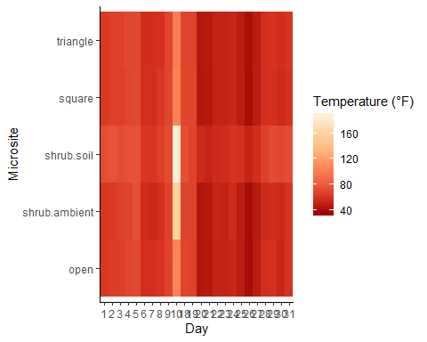

#geom_jitter plot for max and min of intensity for each microsite  
ggplot(shelter.shrub.open, aes(x = as.factor(microsite), y = intensity)) +  
 scale_y_log10() +  
 geom_jitter(position = position_jitter(width = 0.1, height = 0), alpha = 1/4) +  
 stat_summary(fun.y = min, colour = "blue", geom = "point", size = 5) +  
 stat_summary(fun.y = max, colour = "orange", geom = "point", size = 5)+ xlab("")+ ylab("Solar Radiation (lum/ft²)")+theme_classic()

## Warning: Removed 9330 rows containing non-finite values (stat_summary).  
  
## Warning: Removed 9330 rows containing non-finite values (stat_summary).

## Warning: Removed 9330 rows containing missing values (geom_point).

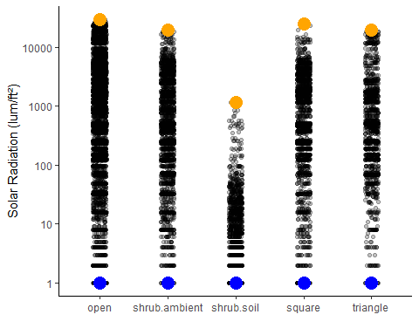

#faceted by microsite  
ggplot(shelter.shrub.open, aes(x = as.factor(day), y = intensity)) +  
 scale_y_log10() +  
 geom_jitter(position = position_jitter(width = 0.1, height = 0), alpha = 1/4) +  
 stat_summary(fun.y = min, colour = "blue", geom = "point", size = 5) +  
 stat_summary(fun.y = max, colour = "orange", geom = "point", size = 5)+ xlab("Day")+ ylab("Light Intensity (lum/ft²)")+theme_classic()+ facet_grid(~microsite)+ coord_flip()+ theme(axis.text.x = element_text(angle = 90))

## Warning: Removed 9330 rows containing non-finite values (stat_summary).

## Warning: Removed 9330 rows containing non-finite values (stat_summary).

## Warning: Removed 9330 rows containing missing values (geom_point).

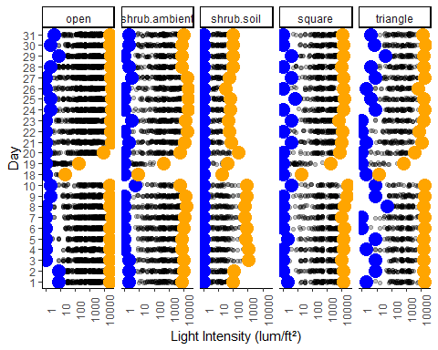

#MACRO-MICRO CLIMATE CONTRAST  
##test between macro-climate and micro-climate  
  
  
library (ggplot2)  
ggplot(macro.micro.contrast, aes((microsite), temp, fill=microsite)) + geom_boxplot() + xlab("Site") + ylab ("Temperature (°F)")+ theme_classic()+ theme(axis.text=element_text(size=12))+theme(axis.text.x = element_text(angle = 90))+ theme(axis.title.x=element_blank(),  
 axis.text.x=element_blank(),  
 axis.ticks.x=element_blank())+ labs(fill = "Site")+ stat_summary(fun.y=mean, colour="black", geom="point", shape=18, size=3,show_guide = FALSE)

## Warning: `show_guide` has been deprecated. Please use `show.legend`  
## instead.

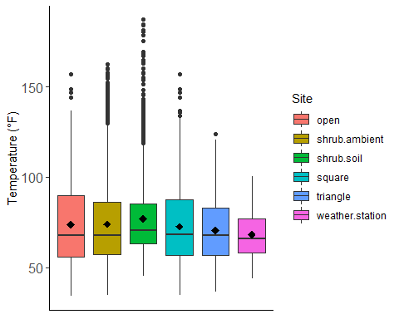

#weather station data are significantly differnt from shrub, open, and square.  
  
lm.site <- glm(temp~as.factor(microsite), data = macro.micro.contrast, family="gaussian")  
summary (lm.site)

##   
## Call:  
## glm(formula = temp ~ as.factor(microsite), family = "gaussian",   
## data = macro.micro.contrast)  
##   
## Deviance Residuals:   
## Min 1Q Median 3Q Max   
## -39.543 -16.315 -5.344 13.475 110.218   
##   
## Coefficients:  
## Estimate Std. Error t value Pr(>|t|)  
## (Intercept) 73.6902 0.2193 335.970 < 2e-16  
## as.factor(microsite)shrub.ambient 0.2471 0.4140 0.597 0.5506  
## as.factor(microsite)shrub.soil 3.3369 0.4715 7.077 1.51e-12  
## as.factor(microsite)square -1.0049 0.4373 -2.298 0.0216  
## as.factor(microsite)triangle -3.1949 0.5122 -6.238 4.52e-10  
## as.factor(microsite)weather.station -5.4202 0.8990 -6.029 1.68e-09  
##   
## (Intercept) ***  
## as.factor(microsite)shrub.ambient   
## as.factor(microsite)shrub.soil ***  
## as.factor(microsite)square *   
## as.factor(microsite)triangle ***  
## as.factor(microsite)weather.station ***  
## ---  
## Signif. codes: 0 '***' 0.001 '**' 0.01 '*' 0.05 '.' 0.1 ' ' 1  
##   
## (Dispersion parameter for gaussian family taken to be 474.3471)  
##   
## Null deviance: 10784021 on 22583 degrees of freedom  
## Residual deviance: 10709809 on 22578 degrees of freedom  
## AIC: 203260  
##   
## Number of Fisher Scoring iterations: 2

library (emmeans)  
anova(lm.site, test = "Chisq")

## Analysis of Deviance Table  
##   
## Model: gaussian, link: identity  
##   
## Response: temp  
##   
## Terms added sequentially (first to last)  
##   
##   
## Df Deviance Resid. Df Resid. Dev Pr(>Chi)   
## NULL 22583 10784021   
## as.factor(microsite) 5 74212 22578 10709809 < 2.2e-16 ***  
## ---  
## Signif. codes: 0 '***' 0.001 '**' 0.01 '*' 0.05 '.' 0.1 ' ' 1

emmeans(lm.site, pairwise~microsite)

## $emmeans  
## microsite emmean SE df asymp.LCL asymp.UCL  
## open 73.7 0.219 Inf 73.3 74.1  
## shrub.ambient 73.9 0.351 Inf 73.2 74.6  
## shrub.soil 77.0 0.417 Inf 76.2 77.8  
## square 72.7 0.378 Inf 71.9 73.4  
## triangle 70.5 0.463 Inf 69.6 71.4  
## weather.station 68.3 0.872 Inf 66.6 70.0  
##   
## Confidence level used: 0.95   
##   
## $contrasts  
## contrast estimate SE df z.ratio p.value  
## open - shrub.ambient -0.247 0.414 Inf -0.597 0.9913   
## open - shrub.soil -3.337 0.471 Inf -7.077 <.0001   
## open - square 1.005 0.437 Inf 2.298 0.1947   
## open - triangle 3.195 0.512 Inf 6.238 <.0001   
## open - weather.station 5.420 0.899 Inf 6.029 <.0001   
## shrub.ambient - shrub.soil -3.090 0.545 Inf -5.665 <.0001   
## shrub.ambient - square 1.252 0.516 Inf 2.426 0.1473   
## shrub.ambient - triangle 3.442 0.581 Inf 5.925 <.0001   
## shrub.ambient - weather.station 5.667 0.940 Inf 6.030 <.0001   
## shrub.soil - square 4.342 0.563 Inf 7.708 <.0001   
## shrub.soil - triangle 6.532 0.623 Inf 10.480 <.0001   
## shrub.soil - weather.station 8.757 0.967 Inf 9.059 <.0001   
## square - triangle 2.190 0.598 Inf 3.664 0.0034   
## square - weather.station 4.415 0.950 Inf 4.646 <.0001   
## triangle - weather.station 2.225 0.987 Inf 2.254 0.2131   
##   
## P value adjustment: tukey method for comparing a family of 6 estimates

#CONCLUSIONS  
  
##1.Temperature and sunlight intensity are correlated.  
##2.Shelters function similar to shrubs when lowering temperature and light.  
##3.Triangle at 90% is best at loweting both parameters.  
##4.The open experienced the most variation.   
##5.Weather station data were different square, shrub, and the open.