**CHAPTER 1**

**INTRODUCTION TO PIEZOELECTRIC MATERIALS**

**1.1 HISTORY**

In the year 1880 Pierre Curie and Jacques Curie discovered that some crystals when compressed in particular directions show positive and negative charges on certain positions of their surfaces. The amount of charges produced is proportional to the pressure applied and these charges were diminished when the pressure is withdrawn. They observed this phenomenon in the following crystals: zinc blende, sodium chlorate, boracites, tourmaline, quartz, calamine, topaz, tartaric acid, cane sugar, and Rochelle salt. Hankel proposed the name “piezoelectricity”. The word “piezo” is a Greek word which means “to press”, therefore piezoelectricity means electricity generated form pressure. The direct piezoelectric effect is defined as electric polarization produced by mechanical strain in crystals belonging to certain classes. In the converse piezoelectric effect a piezoelectric crystal gets strained, when electrically polarized, by an amount proportional to polarizing field [Curie *et al*., 1880, Walter., 1946, Moheimani & Fleming., 2006].

**1.2 PIEZOELECTRIC DIRECT AND CONVERSE EFFECTS**

The domains of the piezoelectric ceramic element are aligned by the poling process. In the poling process the piezoelectric ceramic element is subjected to a strong DC electric field, usually at temperature slightly below the Curie temperature. When a poled piezoelectric ceramic is mechanically strained it becomes electrically polarized, producing an electrical charge on the surface of the materials (direct piezoelectric effect), piezoelectric sensors work on the basis of this particular property.

The electrodes attached on the surface of the piezoelectric material helps to collect electric charge generated and to apply the electric field to the piezoelectric element.

When an electric field is applied to the poled piezoelectric ceramic through electrodes on its surfaces, the piezoelectric material gets strained (converse effect). The converse effect property is used for actuator purposes. Figure 1.1 shows the converse piezoelectric effect.

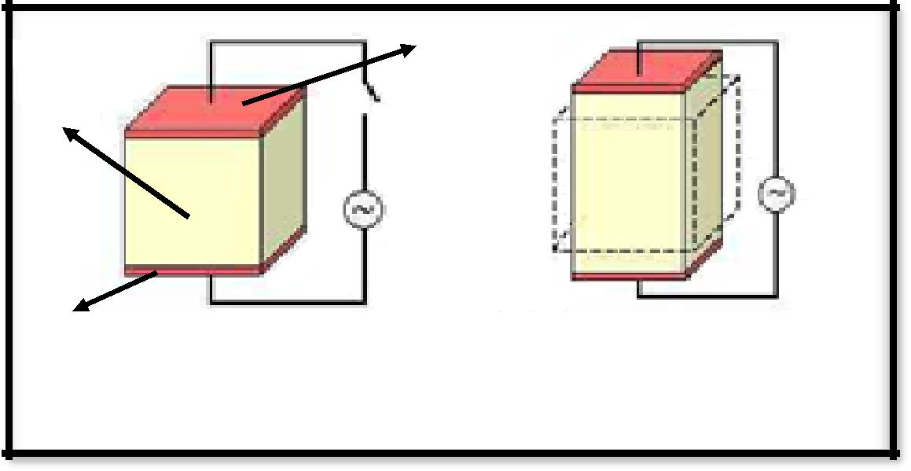Based on the converse and direct effects, a piezoelectric material can act as a transducer to convert mechanical to electrical or electrical to mechanical energy. When piezoelectric transducer converts the electrical energy to mechanical energy it is called as piezo-motor/ actuator, and when it converts the mechanical energy to electrical energy it is called as piezo-generator/ sensor. The sensing and the actuation capabilities of the piezoelectric materials depend mostly on the coupling coefficient, the direction of the polarization, and on the charge coefficients (d31 and d33). Figure 1.2 in the form of block diagrams shows the transducer characteristics of the piezoelectric materials.

Electrode (pink)

Piezoelectric material

Electrode (pink)

**Electric Current off** **Electric Current on**

**Figure 1.1: Piezoelectric material.**

|  |  |
| --- | --- |
|  |  |
|  |  |



|  |  |  |
| --- | --- | --- |
| **Electrical** | **Piezoelectric** | **Mechanical** |
| **Energy** | **Material** | **Energy** |



**Figure 1.2: Piezoelectric Transducer.**

**1.3 PIEZOELECTRIC MATERIALS**

Some of the typical piezoelectric materials include quartz, barium titanante, lead titanate, cadmium sulphide, lead zirconate titanate (PZT), lead lanthanum zirconate titanate, lead magnesium niobate, piezoelectric polymer polyvinylidene fluoride (PVDF), polyvinyl fluoride (PVF). The piezoelectric ceramics are highly brittle and they have better electromechanical properties when compared to the piezoelectric polymers. This section gives in brief introduction about the various classes of piezoelectric materials: single crystal materials, piezo-ceramics, piezo-polymers, piezo-composites, and piezo-films.

**1.3.1 Single Crystals**

Quartz, lithium nibonate (LiNbO3), and lithium tantalite (LiTaO3) are some of the most popular single crystals materials. The single crystals are anisotropic in general and have different properties depending on the cut of the materials and direction of bulk or surface wave propagation. These materials are essential used for frequency stabilized oscillators and surface acoustic devices applications [Schwartz., 2009].

**1.3.2 Piezoelectric Ceramics**

Piezoelectric ceramics are widely used at present for a large number of applications. Most of the piezoelectric ceramics have perovskite structure. This ideal structure consists of a simple cubic cell that has a large cation “A” at the corner, a smaller cation “B” in the body center, and oxygen O in the centers of the faces.

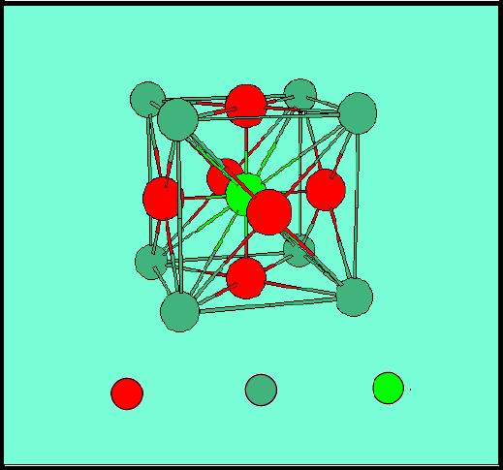

**O-2 (Oxygen)** **Ba+2 (Barium) Ti+4 (Titanium)**

**Figure 1.3: Crystalline structure of a Barium Titanate (Perovskite structure).**

For the case of Barium Titanate ceramic, the large cation A is Ba+2, smaller cation B is Ti+4. The unit cell of perovskite cubic structure of Barium Titanate is shown in figure 1.3. The piezoelectric properties of the perovskite-structured materials can be easily tailored for applications by incorporating various cations in the perovskite structure. Barium Titanate (BaTiO3) and Lead Titanate (PbTiO3) are the common examples of the perovskite piezoelectric ceramic materials [Moheimani & Fleming., 2006, & Schwartz., 2009].

**1.3.3 Polymers**

The polymers like polypropylene, polystyrene, poly (methyl methacrylate), vinyl acetate, and odd number nylons are known to possess piezoelectric properties. However, strong piezoelectric effects have been observed only in polyvinylidene fluoride (PVDF or PVF2) and PVDF copolymers. The molecular structure of PVDF consists of a repeated monomer unit (-CF2-CH2-)n

The permanent dipole polarization of PVDF is obtained through a technological process that involves stretching and poling of extruded thin sheets of polymer. These piezoelectric polymers are mostly used for directional microphones and ultrasonic hydrophones applications [Schwartz., 2009].

**1.3.4 Composites**

Piezo-composites comprised piezoelectric ceramics and polymers are promising materials because of excellent tailored properties. These materials have many advantages including high coupling factors, low acoustic impedance, mechanical flexibility, a broad bandwidth in combination with low mechanical quality factor. They are especially useful for underwater sonar and medical diagnostic ultrasonic transducers [Schwartz., 2009].

**1.3.5 Thin Films**

Both zinc oxide (ZnO) and aluminum nitride (AlN) are simple binary compounds that have Wurtzite type structure, which can sputter-deposited in a c-axis oriented thin films on variety of substrates. ZnO has reasonable piezoelectric coupling and its thin films are widely used in bulk acoustic and SAW devices [Schwartz., 2009].

**1.4 PIEZOELECTRIC COEFFICIENTS**

The physical meaning of various piezoelectric coefficients (dij, gij, Sij, kij, and eij) will be discussed in this section. These coefficients play an important role in the performance of the piezoelectric materials [Moheimani., *et al*, 2006].

**1.4.1 Piezoelectric Constant (dij)**

It is defined as the ratio of the strain in j-axis to the electric field applied along the i-axis, when all external stresses are held constant. For example d31 is the ratio of strain along axis 1 to the electric field applied along the axis 3.

**1.5.2 Piezoelectric Constant (gij)**

It is the ratio of strain developed along the j-axis to the charge (per unit area) deposited on electrodes perpendicular to the i-axis.

**1.4.3 Elastic Compliance (Eij)**

It is the ratio of the strain in the i-direction to the stress in the j-direction, given that there is no charge of stress along the other two directions.

**1.4.4 Dielectric Coefficient, (eij)**

Determines the charge per unit area in the i-axis due to an electric field applied in the j-axis. The relative dielectric constant is defined as the ratio of the absolute permittivity of the material by permittivity of the free space.

**1.4.5 Piezoelectric Coupling Coefficient (kij)**

This coefficient represents the ability of a piezoelectric material to transform electrical energy to mechanical energy and vice versa. This transformation of energy between mechanical and electrical domains is employed in both sensors and actuators made from piezoelectric materials. The ij index indicates that the stress, or perpendicular to the i-axis. The coupling coefficient in terms of piezoelectric constants written as:





**1.5 PIEZOELECTRIC SENSOR FORMULATIONS**

The piezoelectric material has the properties of producing electrical charges when deformed mechanically; this is called direct piezoelectric effect .This characteristic makes piezoelectric transducers suitable for sensing applications.

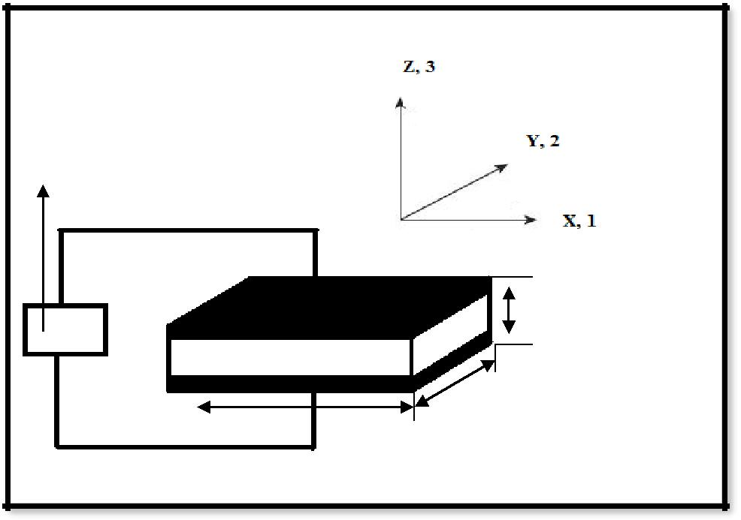

**Voltmeter**

0

**t**

**L**

**w**

**Figure 1.4: Piezoelectric sensor.**

The resulting electric displacement vector, **D** when a piezoelectric sensor is subjected to a stress field , **S** can be written as shown below (Eq.1.6), assuming applied electric field is zero [Moheimani., *et al*, 2006 & Preumont., 2002].

**D = d S**

where, **d** is coupling vector.

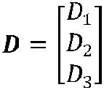The displacement vector **D,** stress-field vector **S,** and the coupling vector **d** can be written as shown below:

Where D1,D2,D3 are the displacement vectors shown in thwe above matrices

Here D can be defined as the displacement vector

d has been defined as coupling vector

S1

S2

S = S3

S23

S31

S12

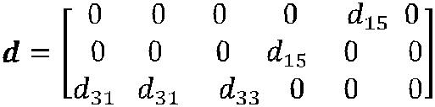

where,

D1, D2, and D3 are the electric displacements in the directions 1, 2, and 3 respectively. The generated charge, q is given in Eq.1.7 [Moheimani., *et al*, 2006 & Preumont., 2002]:

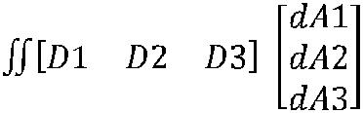



where,

dA1, dA2, and dA3 are the areas of the differential electrodes in (2-3), (1-3), and (1-2) planes, respectively.

For the case when the strains/stress applied along the direction-1:







The voltage generated, **V** is given by the expression [Preumont., 2002]:





where, **C** is the capacitance of the piezoelectric sensors

Combining equations giveS:





From equation the following conclusions can be drawn: Sensor voltage output (V) is directly proportional to the applied strain ( **1**); inversely proportional to the capacitance C of the piezoelectric sensor; and directly proportional to the material properties such as Young‟s modulus and piezoelectric charge coefficient.

**1.6 PIEZOELECTRIC ACTUATION**

Many configurations have been developed in order to utilize the actuation capability of the piezoelectric material effectively. Piezoelectric bimorph configuration is one of the most widely used transducer configuration to convert mechanical to electrical and electrical to mechanical energy. The piezoelectric bimorphs can be classified into two heterogeneous bimorphs and homogeneous bimorphs. In heterogeneous bimorph one element serves only an elastic function and the other serves two functions electric and elastic where as in the homogeneous bimorphs both the elements serve both functions, electric and elastic. In this section the formulations for heterogeneous bimorph configuration is discussed.

The effective bending moment produced by the heterogeneous bimorph configuration is a function of the thickness ratio of the piezoelectric layer and elastic layer [Cunningham *et al*., 1997]. With the following assumptions Cunningham *et al*. . The piezoelectric bimorphs can be classified into two heterogeneous bimorphs and homogeneous bimorphs. In heterogeneous bimorph one element serves only an elastic function and the other serves two functions electric and elastic where as in the homogeneous bimorphs both the elements serve both functions, electric and elastic.

In this section the formulation s for heterogeneous bimorph configuration is discussed.derived the equation for the effective bending moment and interfacial stress for a heterogeneous piezoelectric bimorph configuration:

(i) The composite structure is assumed to be very thin

(ii)A linear strain distribution is assumed across the thickness of the composite structure

(iii)The elastic layer is fully covered by piezoelectric layer

(iv)The electric field strength is held constant

(v)The bonding layer thickness is assumed zero (i.e. perfect bonding

Figure 3 shows a schematic of a heterogeneous piezoelectric bimorph configuration. In the figure D is the distance of neutral axis from the lower edge of the elastic layer.

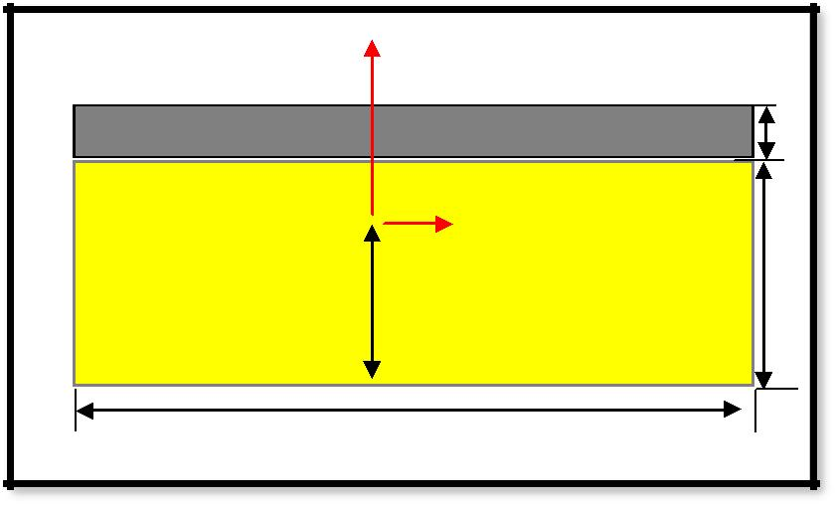

|  |  |  |  |  |
| --- | --- | --- | --- | --- |
|  | **Y** | |  |  |
| **Piezoelectric Layer** | | |  |  |
| **piezo electric layer**  **neutral axis** | | X |  |  |
| ----------------------------------------------------------- | | |  |  |
|  | **Elastic Layer** | |  |  |
|  |  |  |
|  | **D** | |  |  |
|  | **L** | |  |  |

**Figure 1.5: Piezoelectric layer bonded to the elastic layer**

Expression for the D is given by [Cunningham *et al*., 1997]





Where, T=Tp/Te (thickness ratio)

The stress strain relationship for a piezoactuator is given by the equation [Cunningham *et al*., 1997]

pp p 





Where,

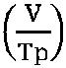

& E= Ep/Ee



The stress strain expression for the elastic layer is given by the following expression [Cunningham *et al*., 1997]

|  |  |
| --- | --- |
| e = Ee e |  |

**=** (Y+D) / Te

The interface stress expression can be determined by use of moment equilibrium condition about neutral axis [Cunningham *et al*., 1997]





The interface stress [Cunningham *et al*., 1997],

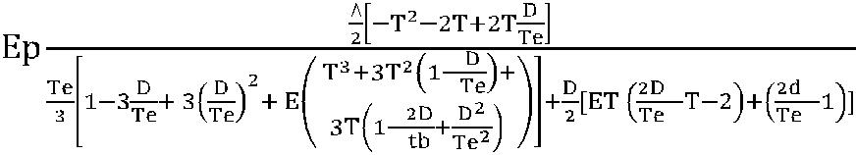



The effective bending moment M applied to the elastic layer by piezoelectric layer can be expressed as [Cunningham *et al*., 1997]:



M= 

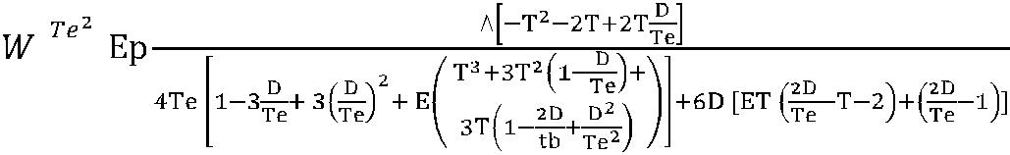



From the equations we can conclude that the interface stress and the effective bending moment are the function of the parameters D, the thickness ratio T (Tp/Te) and also the young‟s modulus ratio E (Ep/Ee). D is again the function of T and E. Hence by controlling the value of the parameters T & E one can control the upper value of effective bending moment and interface stress. With an optimum value of the T & E we can achieve maximum effective bending moment and interface stress. This optimum piezoelectric heterogeneous bimorph configuration can be used as an embedded actuator in a smart joint to control the bending stress and forces acting on the joint.

**1.7 APPLICATIONS OF PIEZOELECTRIC MATERIALS**

The discovery of piezoelectricity generated significant interest within the European scientific community. Subsequently, roughly within 30 years of its discovery, and prior to World War I, the study of piezoelectricity was viewed as a credible scientific activity. The first serious application for piezoelectric materials an ultrasonic submarine detector appeared during World War I was built by Paul Langevin and his co-workers in France. This device was used to transmit a high-frequency chirp signal into the water and to measure the depth by timing the return echo. Since then piezoelectric crystals were employed in many classic applications such as sonar applications, frequency stabilizers, ultrasonic transducers, microphones, accelerometer, microphones, piezo-ignition systems, sensitive hydrophones and ceramic phono cartridges etc [Moheimani., *et al*, 2006].

Piezoelectric vibration control has shown promise in a variety of applications ranging from consumer/sporting products/satellite/fighter aircraft vibration control systems. Some of the companies like HEAD and K2 have invested in high-performance and novelty items such as composite piezoelectric tennis racquets, skis, and snowboards

. These products typically involve the use of a shunted piezoelectric transducer to decrease vibration, which will increase the user comfort, better handling and performance. The next generation hard disk drives may also incorporate piezoelectric vibration control systems in a number of ways [Moheimani & Fleming., 2006].

The piezoelectric materials have been extensively used in the aerospace devices, structural health monitoring, vibration control, and energy harvesting applications. In the aircraft structures application the piezoelectric materials are used in the jet tailfins, helicopter rotor blades, morphing wings and telecommunication satellites. A considerable research effort has been undertaken on the structural control of military aircraft. Piezoelectric materials are also used in the noise control applications which include: suppression of acoustic radiation form underwater submersibles, launch vehicle structural and acoustic noise mitigation, acoustic transmission reduction panels, and active antenna structures. A primary consideration in the design of space structures is the vibration experienced during launch. In future, structures incorporating piezoelectric transducers may form the basis of lightweight, high performance mechanical components for use in space applications. Energy harvesting is another important application area of these materials [Moheimani & Fleming., 2006].

The piezoelectric actuators are also being studied as a potential means of reducing the buffeting loads on twin tail fighter aircraft flying at high angle of attack. The activated piezoelectric actuators will counteract to the torsional and bending stresses induced by the buffeting loads. In the Figure 1.6 we can see the 1/6th scale active vertical tail model containing the embedded LaRC-MFC TM (Macro Fiber Composite) actuators built at NASA-Langley .

This device was used to transmit a high-frequency chirp signal into the water and to measure the depth by timing the return echo. Since then piezoelectric crystals were employed in many classic applications such as sonar applications, frequency stabilizers, ultrasonic transducers, microphones, accelerometer, microphones, piezo-ignition systems, sensitive hydrophones and ceramic phono cartridges etc [Moheimani., *et al*, 2006].

Piezoelectric vibration control has shown promise in a variety of applications ranging from consumer/sporting products/satellite/fighter aircraft vibration control systems. Some of the companies like HEAD and K2 have invested in high-performance and novelty items such as composite piezoelectric tennis racquets, skis, and snowboards

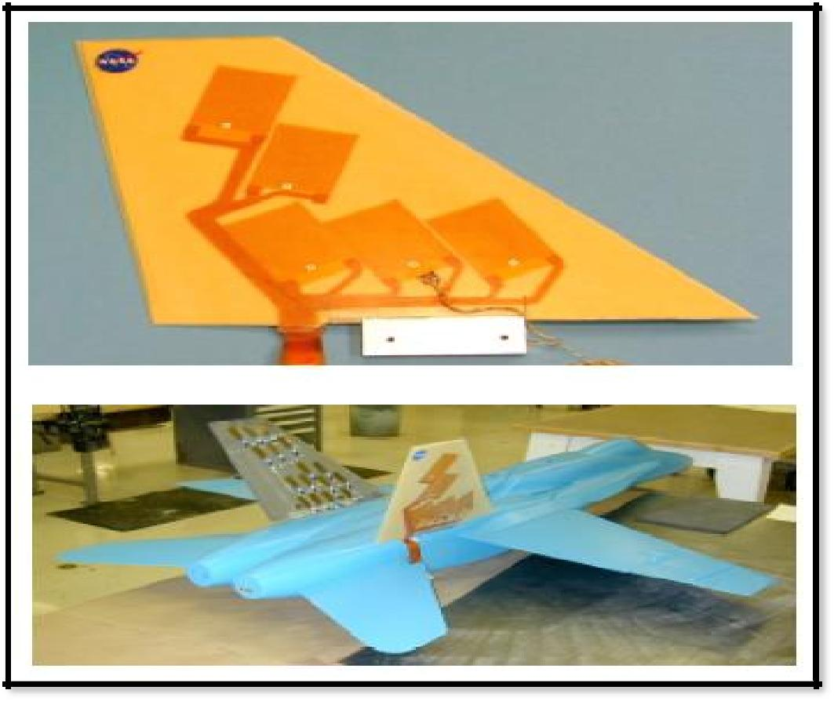

**Figure 1.6 : 1/6th scale LaRC-MFCTM buffet load alleviation wind tunnel model [Wilkie et al., 2000].**

The figure 1.7 shows the design of the shoe energy harvester system, which contains the polyvinylidene fluoride (PVDF) piezoelectric film insert and metal spring with coupled generator system. This PVDF insert in the shoe is used to recover some of the power in the process of walking. The natural flexing of the shoe when walking provides the necessary deflection for generating power from the piezoelectric film insert. The figured out that if you carry a 100-pound pack and walk at 2-3 mph you can generate 45.6 mW of power. That's enough to the power an iPod, or maybe a head-mounted flashlight. This magic back up can be effectively used for the military applications [Sodano et al., 2007].

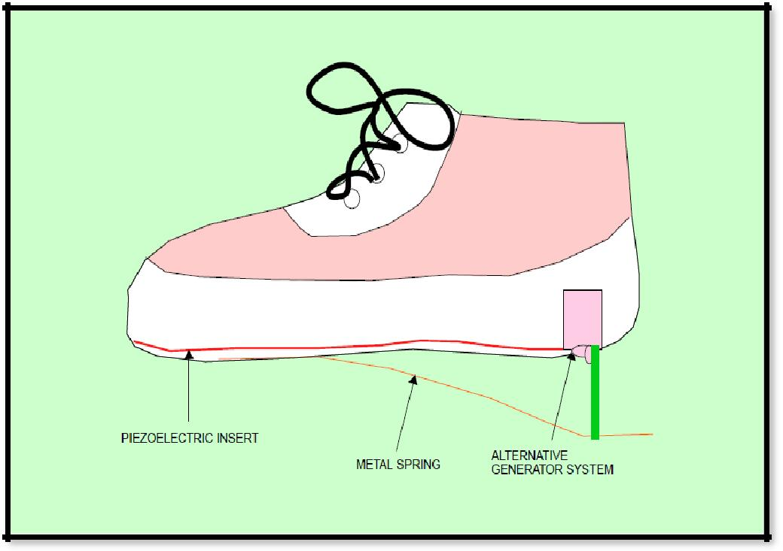

**Figure 1.7: Shoe energy harvesting system [Starner., 1996]**

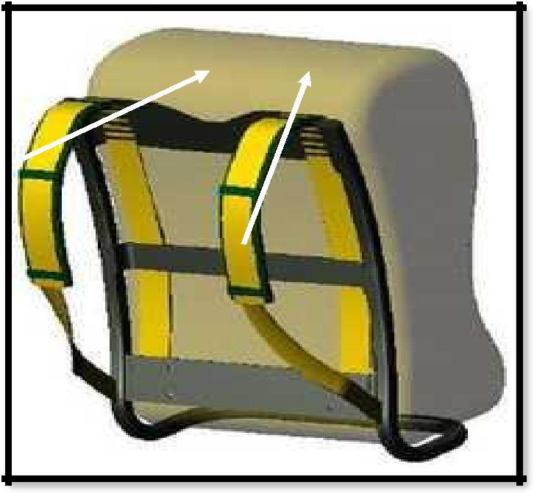

**Straps containing the PVDF strips**

**Figure 1.8: Magic backpack straps power generator [Sodano et al., 2007].**

The figure 1.9 shows the piezoelectric linear motor/ actuator and piezoelectric Z- axis nano-positioning stage from Pyhsik Instruments. The figure 1.10 illustrates one of the applications where the piezoelectric materials have been used for the structural health monitoring. In this application piezoelectric materials have been used to assess the wear status of the wheel.

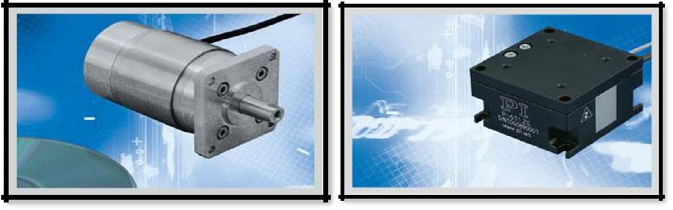

|  |  |  |
| --- | --- | --- |
| **(a)** | **(b)** |  |
|  |  |

**Figure 1.9: (a) N 215 Linear piezoelectric motor (Pyhsik Instruments), (b) P-611 piezoelectric Z-axis nano-positioning stage (Pyhsik Instruments).**

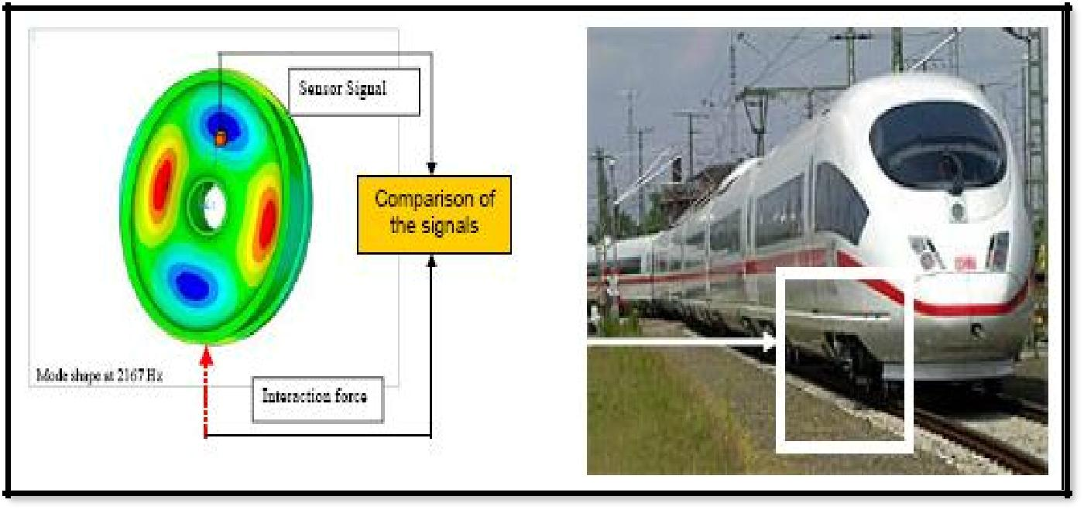

**Figure 1.10: The proposed method for the assessment of the roughness of the wheel. A piezoelectric sensor detects the vibrations of the wheel, leading to an assessment of its wear status [Nuffer & Bein, 2006].**

**HAPTER 2: SMART JOINT**

**2.1 INTRODUCTION TO SMART STRUCTURES**

A structure is an assembly that serves an engineering function. Smart structures are those which possess characteristics close to, and, if possible, exceeding, those found in biological structures. A smart structure has the ability to respond adaptively in a pre-designed useful and efficient manner to changes in the environmental conditions, as also any changes in its own condition [Vinod., 2007 & Schwartz., 2009].

A smart configuration would be that in which normal loads are taken care of in normal conditions, and the abnormal loads are tackled by activating suitable actuation systems. Even the normal loads, corrosion and other aging effects can render the original passive design unsuitable (even unsafe) with the passage of time. If continuous monitoring can be built into the design through distributed, embedded, smart sensors, timely repairs can be taken up, thus saving costs and ensuring higher degrees of safety. In brief smart structures can monitor their own health and can activate their actuation system depending upon the external loading situations [Vinod., 2007].

Smart structures are gaining the importance in many current and future structural applications, as these structures which can monitor and detect their own integrity and can act as per the surrounding environment situations. These smart structures are capable of sensing and reacting to their environment in a predictable and desired manner, through the integration of various elements, such as sensors, actuators, power sources, signal processors, and communications network. Smart structures use the smart materials as their major functional element

**2.2 SMART MATERIALS**

Smart materials are the materials which have one or more properties which alter significantly in a controlled fashion by external stimuli, such as stress, temperature, moisture, pH, electric or magnetic fields etc. Many smart materials were invented more than 30 years ago, but their development and improvement over the past three decades has led to new, more varied uses of these adaptable materials.

Some of the common smart materials are piezoelectric materials, shape memory polymers & alloys, magnetic shape memory alloys, temperature responsive polymers, pH sensitive polymers etc. The property of the smart materials to change their properties in a controlled fashion is used to monitor the health of the structures and detect the various loads acting on the structure. These smart materials have been employed in many important applications, such as aerospace applications, automobile applications, civil engineering structures such as dams, bridges, highways and buildings, health monitoring systems, nondestructive evaluation technologies etc [Schwartz., 2009].

Piezoelectric materials are the most popular smart material, which have been used for many self adaptive smart structures. In general, smart structures are designed in the form of laminated composites and the piezoelectric materials are embedded on these structures.

**2.3 SMART JOINT**

The piezoelectric materials have been widely used in many important engineering applications including structural health monitoring, sensing, actuation, and energy harvesting. Cheng *et al*, 2006 used the piezoelectric materials to develop the smart joint systems. The smart joint is a structure which has the piezoelectric materials embedded in them, the integration of piezoelectric.layers with an adjustable electric field can smartly control the peel/shear stress distribution at the bond-line and the stress concentration can be dramatically reduced. By adjusting the applied electric field on the piezoelectric layer in the developed smart joint system, one can produce the additional forces and moments which would act oppositely to those developed internally, there by alleviating the stress concentration in the joint edges. This would in turn, improve the performance of the adhesively bonded joint [Konka., *et al*, 2009].

Figure 2.1 gives the details about the position of the high stress concentration regions (highlighted with the circle) in the conventional adhesive bonding joint systems. The high level of stress concentrations in the joint edges (critical locations) is the main reason for the failure of the adhesively bonded joint system. Figure 2.2 illustrates the details of the newly developed smart adhesively bonded joint systems. The newly developed joint system has the piezoelectric materials embedded on them at the critical locations of the joint. By adjusting the applied electric field on the embedded piezoelectric layer in this new joint system.

Figure 2.3 illustrates the details of smart joint control system. The main functions of the piezoelectric materials in the smart joint are threefold: (i) to detect the various loads that act on the composite joint; (ii) to produce the force in order to provide counter balancing force to the force acting on the joint and thereby to reduce the stress concentrations in the joint; and (iii) to convert impact energy acting on the joint to electrical power. The plot in the figure 2.3 illustrates reduction in the stress concentration level in the joint by adaptively using the piezoelectric materials [Konka., *et al*, 2009].

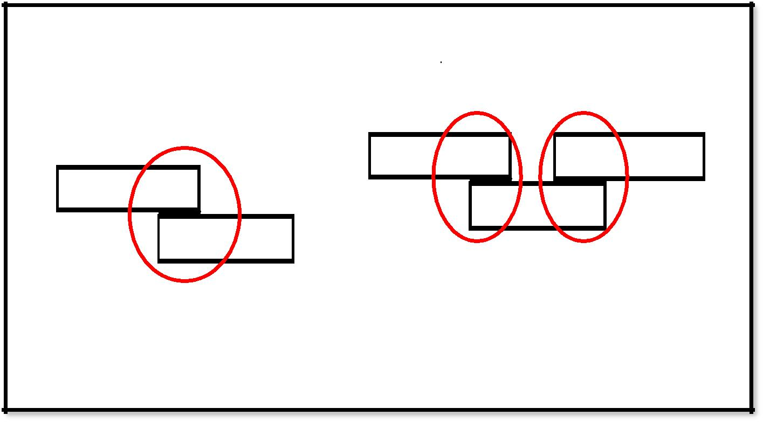

1. **(b)**

**Figure 2.1: The conventional adhesive bonding joint systems (a) Single-lap joint (b) Single-strap joint [Cheng., *et al*, 2006].**

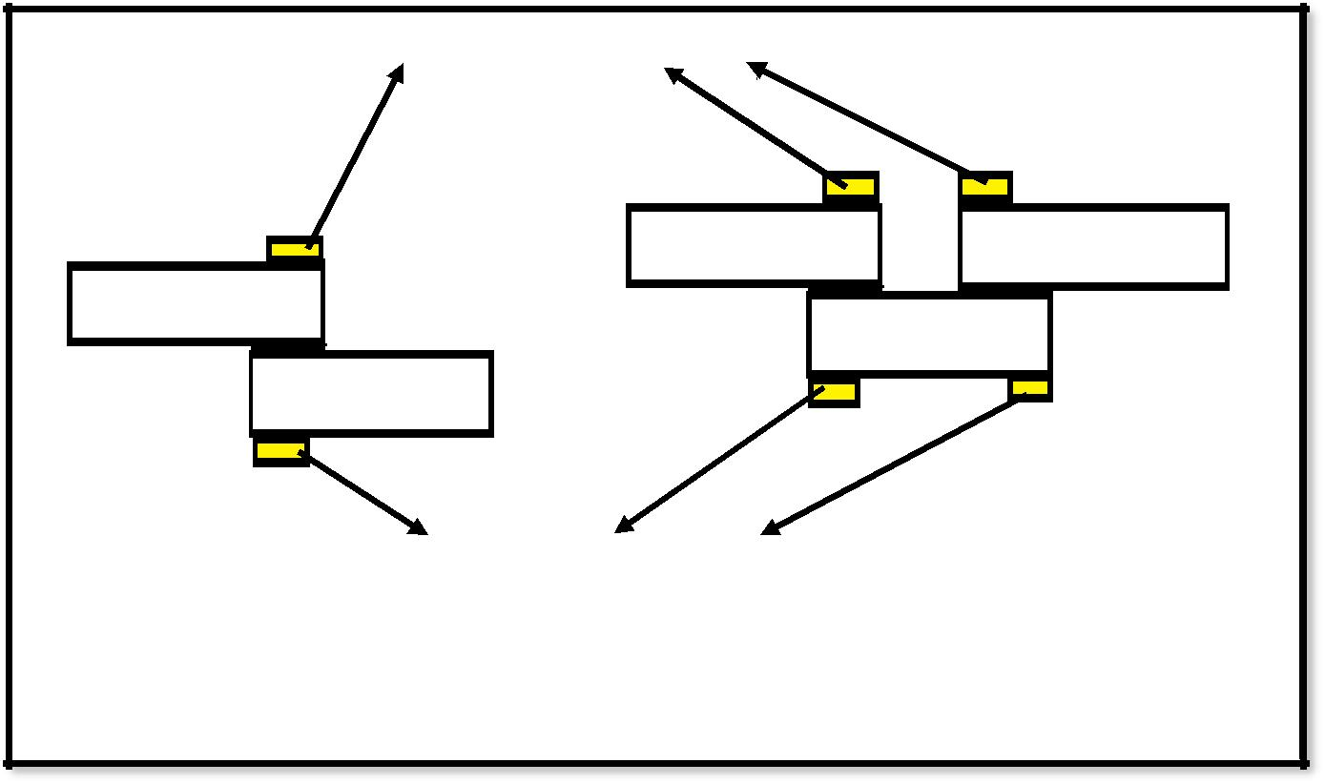

|  |  |  |  |
| --- | --- | --- | --- |
|  | **Piezoelectric Patch (Yellow)** |  |  |
|  | **(b)** |  |
| **(a)** |  |  |
|  |  |  |
|  |  |  |  |
|  |  |  |  |

**Piezoelectric Patch (Yellow)**

**Figure 2.2: Illustrations of the smart adhesive bonding joint systems: (a) Smart single-lap joint (b) Smart single-strap joint [Cheng., *et al*, 2006].**

|  |
| --- |
| **Composite (Blue)** |
| **Piezoelectric** |
| **Layers** |
|  |
| **Adhesive** | **Charge amplifier** |
|  |
|  |  |

**piezo driver**

**stress with piezo electric**

**Figure 2.3: A smart strap joint with piezoelectric materials embedded inside the joint**

|  |  |  |
| --- | --- | --- |
|  |  |  |

**CHAPTER 3**

**EXPERIMENTATION**

The sensing and the force generation capabilities of the piezoelectric materials play an important role in the proper functioning of the smart adhesive joint system. Piezoelectric materials should be able to provide the strain amplitude and dynamic information (such as frequency and wave-format) at the various points on the structure. By obtaining this kind of information from piezoelectric materials we can monitor the health of the structure continuously and detect the various loads acting on the structure. The main aim of this study is to investigate and compare the sensing and force generation capabilities of the various composite piezoelectric materials in order to use them as an embedded sensor and actuator in the smart joint system. A brief description of the experiments performed is given in this chapter. In the first set of experiments the sensing capability of the piezoelectric materials under various dynamic loading conditions has been investigated. In the second set of experiment the force generation capabilities of the piezoelectric materials were investigated with respect to various input voltages.

**3.1 PIEZOELECTRIC COMPOSITES MATERIALS USED FOR EXPERIMENTS**

Experiments were performed on three different types of piezoelectric composite products mentioned above. This section discusses the various details & configuration of the piezoelectric composite products used for the experiments. The MFC and the PFC are basically composed of the piezoelectric fibers, whereas the QP is composed of piezoelectric sheets.

**3.1.1 MACRO FIBER COMPOSITE (MFC)**

MFC was first developed by NASA‟s Langley Research Center in 2003. The major advantages of MFC are their high strain energy density, controlled directional actuation, relatively high performance in achieving in controlled actuation, flexibility, conformability, and durability.

Due to the MFC‟s construction using PZT fibers, the overall strength of the material is greatly increased when compared to that of the base material [Wilkie., *et al*, 2000].Figure 3.1 illustrates the construction details of the MFC. The MFC contains PZT fibers of rectangular cross-section, which gives the maximum contact area between the PZT fibers and the interdigitated electrodes due to the larger surface area when compared to the PZT fibers of circular cross-section, that results in more efficient transfer of electric field to the PZT fibers [Wilkie., *et al*, 2000]. The MFC piezoelectric module used in our experiments is type M2807 P2 (Smart Materials Corp.). This module contains one layer of PZT fibers, as mentioned above the fibers are of rectangular cross-section (width=350 µm, thickness=175µm). They are of PZT-5A1-Navy- II type material and the properties are shown in the Table 1.

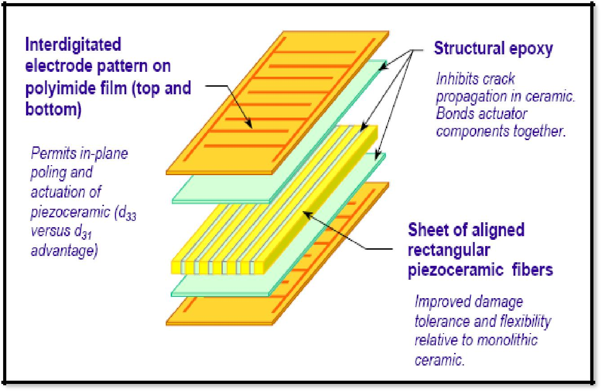

**Figure 3.1: Construction Details of Macro Fiber Composite [Ref: Smart materials corp].**

**3.1.2 PIEZOELECTRIC FIBER COMPOSITE (PFC)**

The PFC has high degree of structural flexibility and comprises of uni-directionally aligned piezoelectric fibers of circular cross-section. The fibers are surrounded by a resin matrix system which provides damage tolerance through load transfer mechanisms. Electrical inputs/outputs are delivered through a separate interdigitated electrode layer [Advanced Cerametrics, Inc.].

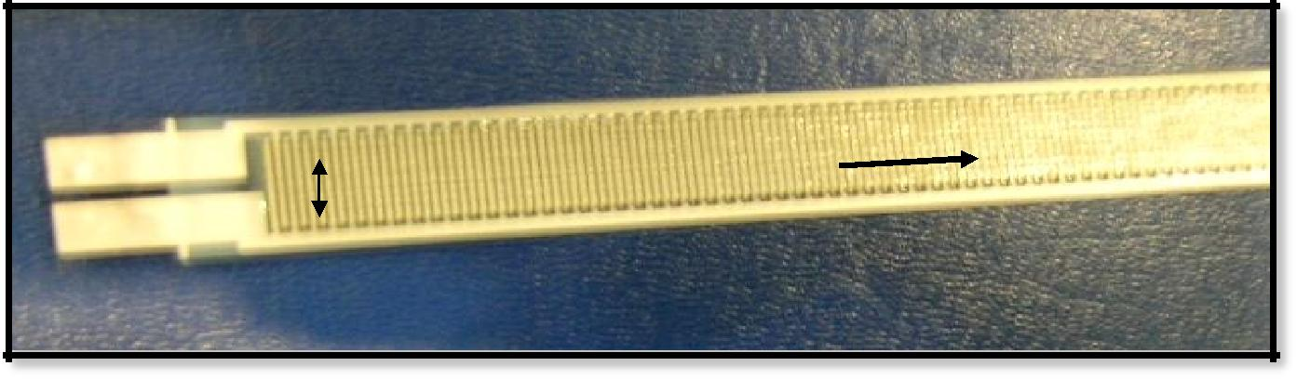

**Interdigitated**

**Electrodes**

**Fibers Orientation**

**Figure 3.2: Piezoelectric Fiber Composite (PFC).**

**3.1.3 QUICK PACK (QP)**

Quick Pack contains two layers of piezoelectric layers, 250 microns of thickness (bimorph configuration). They are surrounded with the Kapton and Epoxy matrix system as a protective layer and this matrix system adds to the flexibility of the overall product [Mide technological corp.]. The Quick Pack modules used are QP22b and QPV22bL (fig: 3.4) from Mide Technological corp. The thickness of the piezoelectric sheets is about 250 microns. The base piezoelectric material used for this product is PZT-5H-Navy II type and the properties are shown in Table 1. Figure 3.3 gives the construction details of the Quick pack modules

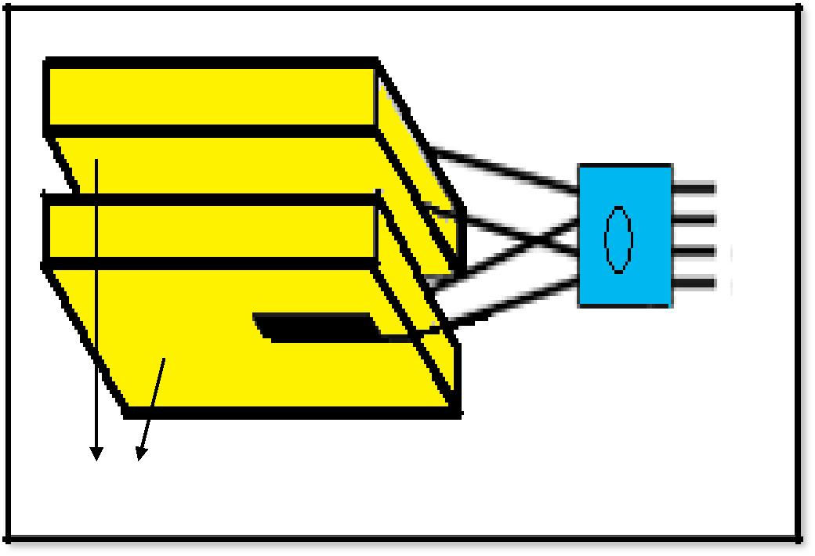

**Connector Pins**

**Piezoelectric Sheets**

**Figure 3.3: Construction detail of Quick packs**

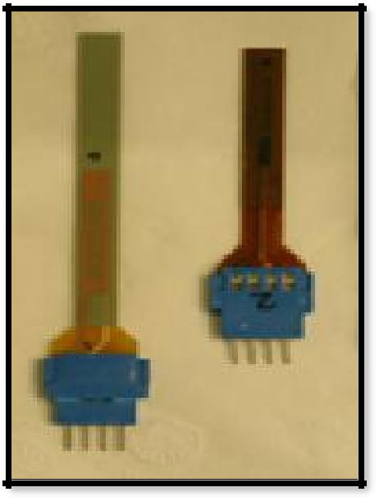

**QP22B**

**QPV22BL**

**Figure 3.4: Quick Pack modules used for experiment**

**Table 1: Properties of base piezoelectric material for PFC, QP, and MFC**

|  |  |  |  |  |
| --- | --- | --- | --- | --- |
| **Properties** | **Units** | **PFC** | **QP** | **MFC** |
|  |  |  |  |  |
| **d31** (strain constant) | m/V or | -1.73E-10 | -1.75E-10 | -1.85E-10 |
|  | Coul/N |  |  |  |
|  |  |  |  |  |
| **d33** (strain constant) | m/V or | 3.80E-10 | 3.50E-10 | 4.40E-10 |
|  | Coul/N |  |  |  |
|  |  |  |  |  |
| **g33** (voltage constant) | Vm/N | 2.50E-02 | 2.42E-02 | 2.55E-02 |
|  |  |  |  |  |
| **k33** (coupling factor) |  | 0.72 | 0.7 | 0.72 |
|  |  |  |  |  |
| **k31** (coupling factor) |  | 0.36 | 0.35 | 0.33 |
|  |  |  |  |  |
| **K** (dielectric constant- |  | 1725 | 1800 | 1850 |
| 1kHz) |  |  |  |  |
| **tan de** (dielectric loss) | % | 2 | 1.8 | 0.012 |
|  |  |  |  |  |
| **r** (density) | g/cm3 | 7.5 | 7.7 | 7.7 |
|  |  |  |  |  |
| **Tc** (curie temperature) | °C | 350 | 350 | 335 |
|  |  |  |  |  |
| **C11**(compliance) | m2/N | 1.52E-11 | 1.44E-11 | 1.85E-11 |
|  |  |  |  |  |
| **C33** (compliance) | m2/N | 1.83E-11 | 1.80E-11 | 2.07E-11 |
|  |  |  |  |  |

**3.2 SENSING CAPABILITY**

In this experiment the sensing capabilities of the piezoelectric materials were investigated at three different dynamic loading conditions (tensile, bending, and compression). The most common types of loads that act on joints are usually tensile, compression, and bending. Since the piezoelectric materials will be embedded in a joint in order to detect the loads acting on the joint, hence the responses of these products with respect to these types of loads were required to be investigated.

A Dynamic Mechanical Analyzer (DMA- TA Instruments 2980) was used to provide controlled input dynamic loading. The DMA machine can provide/measure the displacements of micro-level amplitudes, forces of milli-newton level. Piezoelectric products are mounted on the DMA clamps, one end of the piezoelectric material is fixed with one of the clamps and the other end is screwed on to the top of the movable shaft, which is located at the center of the clamps

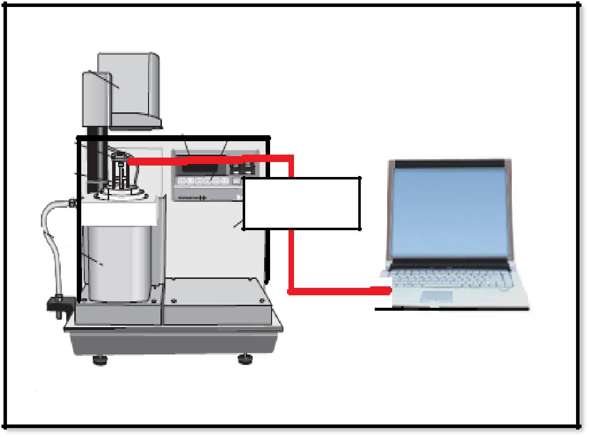

piezo electic material mounted on

DMA clamps

DAQ interface

**3.5: Block diagram of experimental**

The details of the experimental setup are shown in Figs. 3.5 & 3.6. Figure 3.7 shows various types of loading conditions imposed on piezoelectric beam configuration. **setup**

were imposed on the piezoelectric materials by using the dual cantilever (Fig. 3.8), tensile (Fig. 3.9) and compression clamps (Fig.3.10) of the DMA machine respectively.

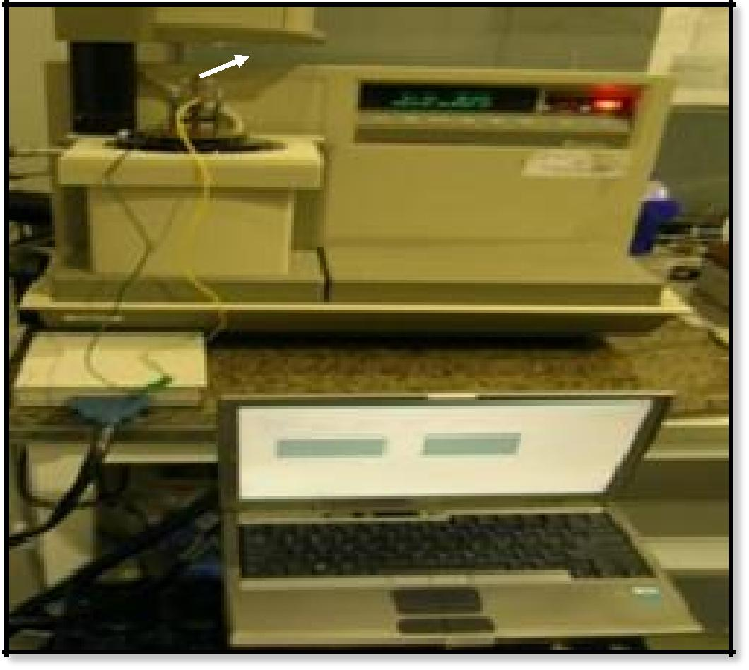

**Piezoelectric material mounted on DMA clamp**

**DMA 2980**

**DAQ Interface**

**Laptop**

**Figure 3.6: Experimental setup**

The frequencies are varied from 5.0 Hz to 60 Hz and amplitudes varied from 10µm to 300µm for bending; 1.0 µm to 10µm for longitudinal vibrations; and 5 µm to 15µm for compressive loading. Low amplitude ranges (1.0 µm to 10µm) are selected for longitudinal vibration because inputting amplitudes above these ranges exceeded the maximum permissible strain of the products. The corresponding output voltages from the piezoelectric materials are recorded using a DAQ interface on the computer. By following the procedure and experimental setup mentioned above we investigated the sensing capabilities of the piezoelectric materaials at various types of dynamic loading conditions. Two kinds of characteristic curves have been obtained (i) constant frequency curves (ii) constant strain curves, from the above experiments. Constant frequency curves are obtained by keeping the frequency of dynamic loading vibration constant and varying the strain levels, where as the constant strain curves are obtained.

. The experimental procedure for testing the force generation capability is explained in the next section.

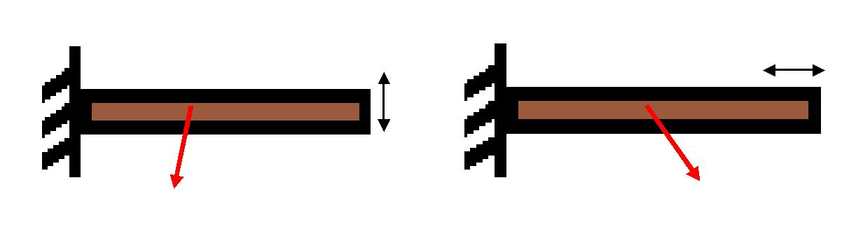

|  |  |
| --- | --- |
| **(a)** | **(b)** |
|  |  |

Piezoelectric Material

Piezoelectric Material

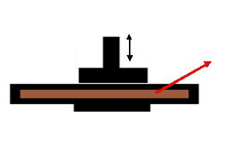

**(c)**

Piezoelectric Material

**Figure 3.7: Loading conditions (a) Transverse, (b) Longitudinal, (c) Compressive**

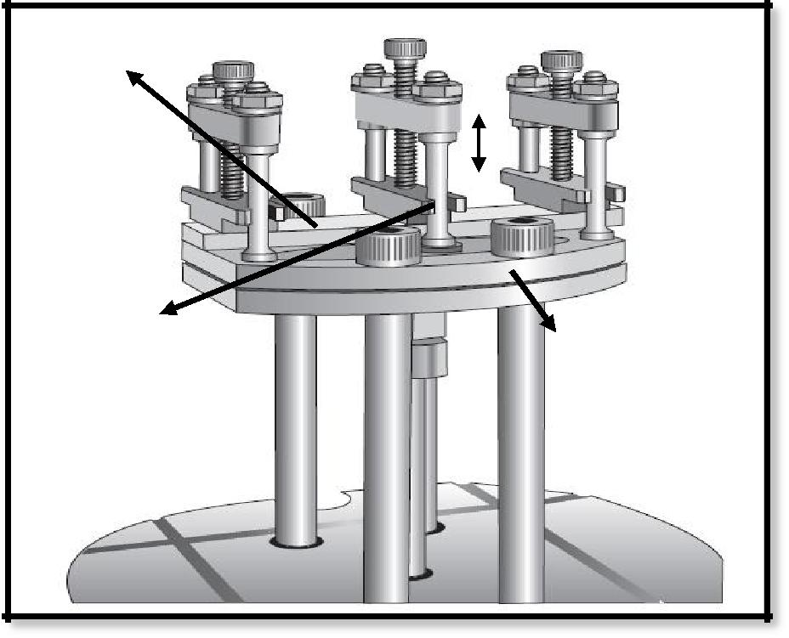

sample

Movable clamp

Constant clamp

**Figure 3.8: Dual Cantilever Clamp with sample [Ref: DMA user manual]**

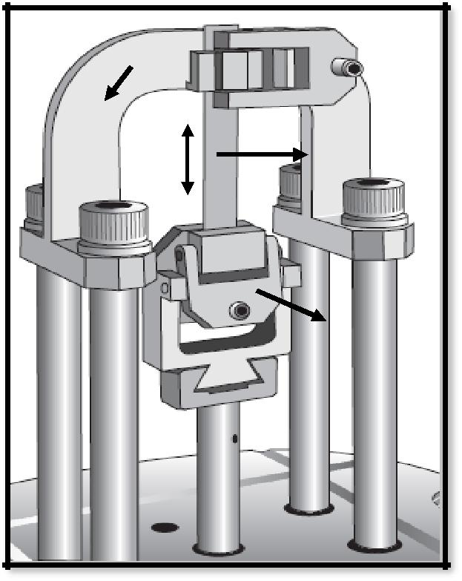

|  |  |  |
| --- | --- | --- |
| **Fixed** |  |  |
| **Clamp** | **Sample** |  |
|  |  |

**Movable**

**Clamp**

**Figure 3.9: Tensile Clamp [Ref: DMA user manual]**

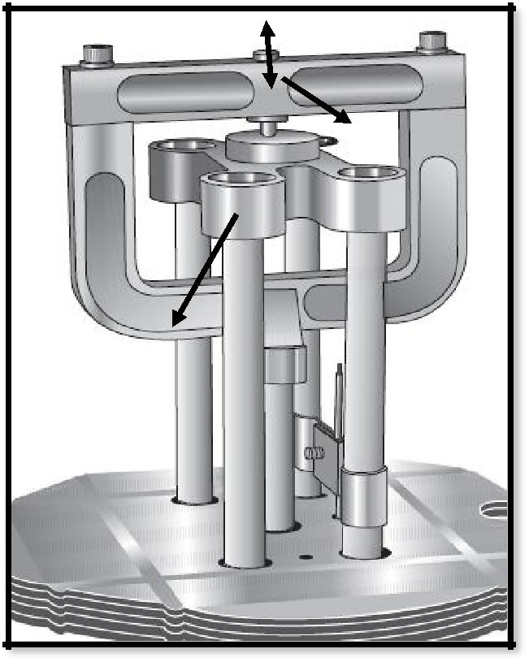

**Movable clamp**

**Fixed clamp**

**Figure 3.10: Compression Clamp**

**3.3 FORCE GENERATION CAPABILITY**

The main aim of this experiment is to measure the amount of force that the piezoelectric materials can generate with various input voltages. In this experiment we investigated the amount of tensile and bending forces produced by these piezoelectric materials. The reason for not using the strain gauges is because the force generation from the piezoelectric material is small and the strain gauges cannot be used for measuring such small forces.

In this experiment the stress relaxation mode of DMA machine is used. A pre-strain is applied initially on the piezoelectric material by using DMA machine and the force required to maintain that initial pre-strain before and after applying the voltage is observed with respect to various input voltage ranging from 1.0 V to 30V. The difference in the values of the force from both cases gives the amount of force produced by the piezoelectric materials by actuation. Figures 3.11 & 3.12 shows the tensile and dual cantilever clamps of the DMA machine which were used for measuring tensile and bending forces produced by the piezoelectric material.

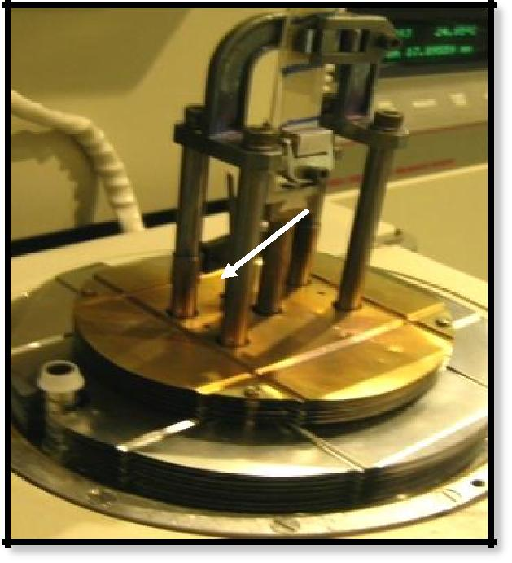

**Figure 3.11: Tensile Clamp**

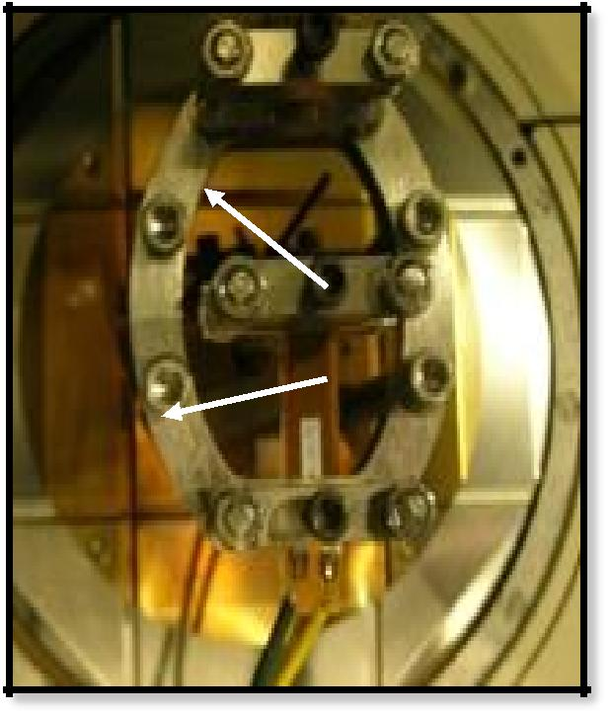

 **Movable Clamp**

**Movable Clamp**

**Sample**

**Figure 3.12: Dual Cantilever Clamp.**

By following the procedure and experimental setup above, we investigated the force generation capabilities of the piezoelectric materials with respect to the change in the electric field applied.

CONCLUSION

In first chapter emphasis has been made to introduce the readers to the basics of the piezoelectric materials and the various applications of these materials. The wide range applications shown in this chapter gives us an idea about the growing popularity of these materials in various fieldsexperimental setup and the procedure used for the experiments.

The experiments were designed to test the sensing and force generation capabilities of the piezoelectric materials. The details of the products (MFC, PFC, & QP) used for the experiments is also illustrated briefly in this section. By following the experimental procedure mentioned in the section 3.2 & 3.3 the sensing and the force generation capabilities of the piezoelectric materials were investigated and compared

**REFERENCES**

Anderson, E. H., and Hagood, N.W., 1994. “Simultaneous Piezoelectric Sensing/Actuation: Analysis and Application to Controlled Structures,” *Journal of Sound and Vibration*, 174(5):617-639.

Arafa, M., Baz, A., 2000. “Energy-dissipation characteristics of active piezoelectric damping composites,” *Computer Science and Technology*, 60 pp. 2759-2768.

Cheng, J.Q., Taheri, F., & Han, H., 2006. “Strength Improvement of Smart Adhesive Bonded Joint System by Partially Integrated Piezoelectric Patches,” *J. Adhesion Sci. Techno*., 20(6): 503-518.

Cheng, J.Q., and Taheri, F., 2006. “A smart single-lap adhesive joint integrated with partially distributed piezoelectric patches,” *Int. J. of Solids and Structures*, 43(5): 1079-1092.

Chopra, I., 1996. “Review of Current Status of Smart Structures and Integrated Systems”. *SPIE* *Smart Structures and Integrated Systems*, 2717:20-62.

Crawely, E.F. and de Luis, J., 1987.” Use of Piezoelectric Actuators as Element of Intelligent

Structures,” *AIAA Journal*, 25(10):1373-1385.

Curies, P., & Curie, J., 1880. “Development of polar electricity in hemihedral crystals with inclined faces”. *Bulletin de la Societe Mineralique de France*, 3 90-3.

Cunningham, M.J., Jenkins, D.F.L., & Bakush, M.M., 1997. “Experimental investigation of optimum thickness of a piezoelectric element for cantilever actuation,” *IEE Proc.-Sci. Meas.*