Assignment #4 Report – Nari Shin  
  
Default MLP:  
  
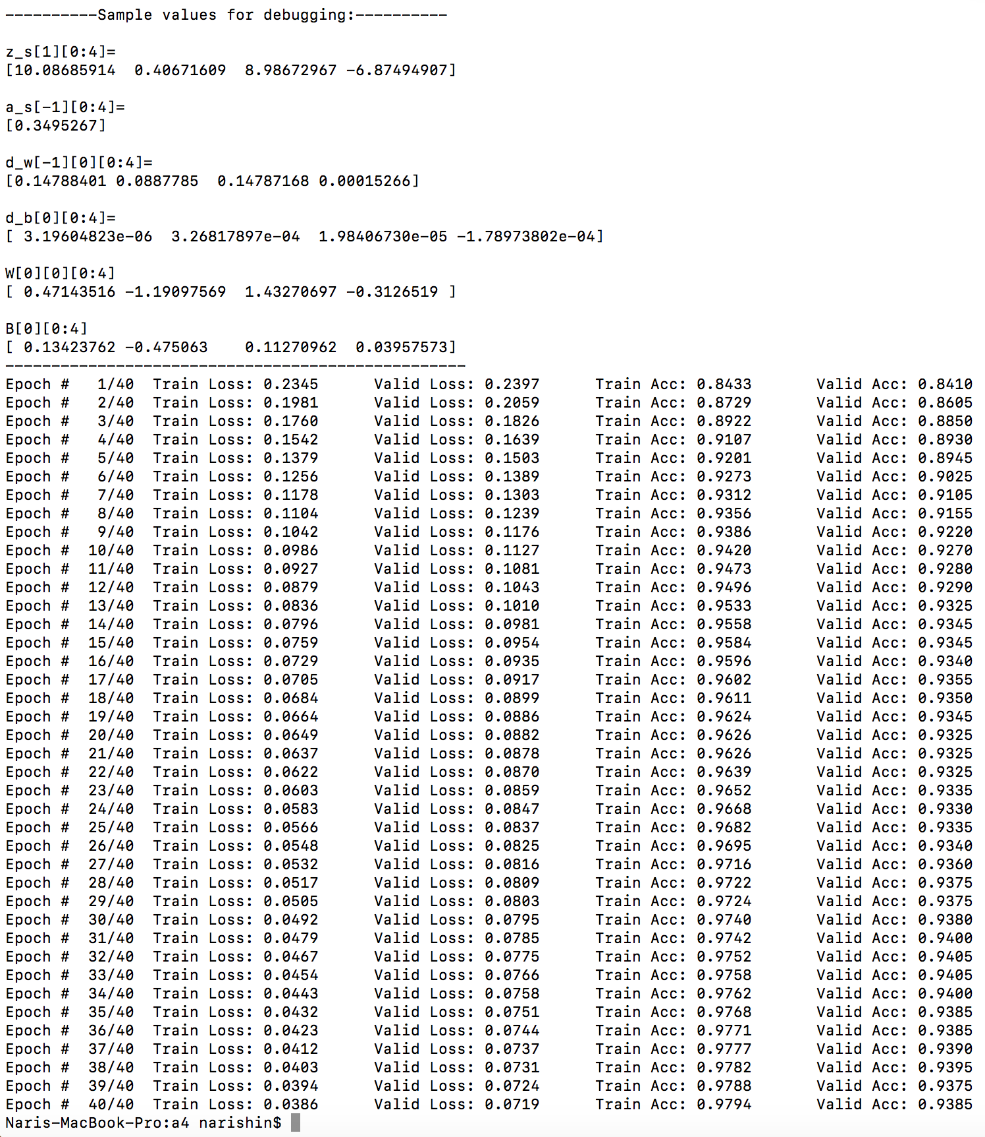

Simple Perceptron:

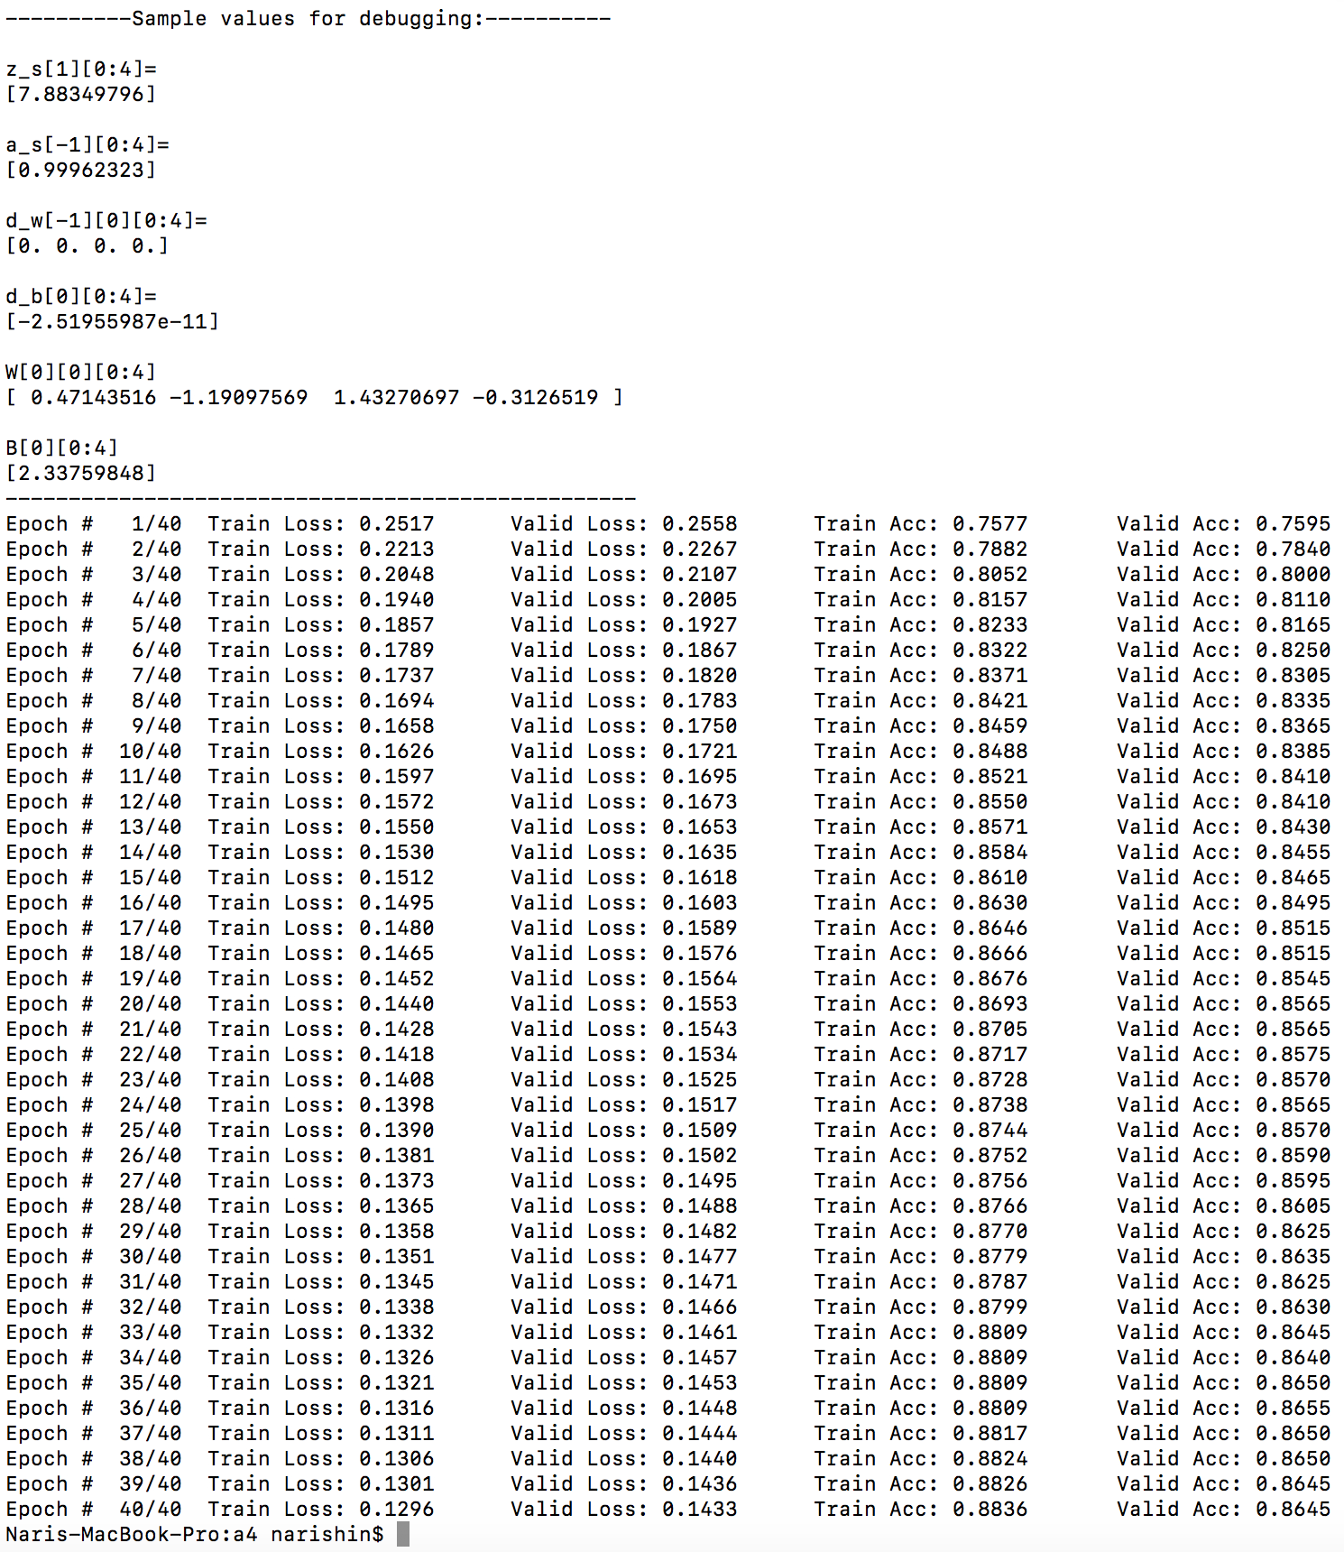

Evaluation:   
For MLP we have 97.9% train accuracy and 93.8% validation accuracy.  
For Simple Perceptron we have 88.4% train accuracy and 86.4% validation accuracy.  
As we can see MLP obtained a higher accuracy than simple perceptron.

Feedback:   
The most interesting part of the course that I found was the problem-solving areas and how we used algorithms to solve puzzles (like pacman). I thought the sat problem and neural networks was hard to understand and grasp at first, but it was interesting information to learn and I found some overlap with my other courses that had similar topics. Changes that I would suggest is to change the assignment scheduling somewhat because having an assignment due in the middle of finals is quite difficult. Other than that, it was an interesting course and I feel like I learned a lot from it. I spent around 30 hours on this assignment.