Table of Contents

Disease Progression and Multimorbidity Trajectory Prediction
Final Project Report

Executive Summary
This project developed a reproducible machine learning workflow for predicting disease progression and multimorbidity risk using synthetic electronic health record (EHR) data from 2018 to 2024. Predictors use records through 2021-12-31; future outcomes cover 2022-01-01 through 2024-12-31.
The final feature table contains 100,000 patients and 99 columns. Across five model families (a majority-class baseline, logistic regression, random forest, XGBoost, and LightGBM), gradient boosting performed best on both targets:
- Future hospitalization: XGBoost, ROC-AUC 0.694 (logistic regression a close baseline at 0.686). This target is highly imbalanced (4.55% positive).
- Multimorbidity progression: XGBoost, ROC-AUC 0.865, F1 0.774, on the at-risk cohort of 41,654 patients who begin with fewer than two conditions.
Beyond ranking models, the project adds calibration and threshold analysis, SHAP explainability, and a Kaplan-Meier / Cox survival analysis of time to multimorbidity progression.

1. Introduction and Motivation
Healthcare teams need earlier signals of patients who may progress into multimorbidity or require future hospital care, so that limited follow-up capacity can be directed where it matters most. This project asks whether patient demographics, baseline diagnoses, laboratory history, medication history, and prior hospitalization patterns — all known at a fixed cutoff — can predict:
- future hospitalization risk (2022–2024),
- future ICU admission risk,
- future 30-day readmission risk, and
- progression into multimorbidity among patients with fewer than two baseline conditions.

2. Related Work
Multimorbidity risk stratification and hospital utilization prediction are established areas in clinical machine learning. Comorbidity indices such as the Charlson index summarize disease burden, and gradient-boosted trees and regularized logistic regression are common, strong baselines for tabular EHR prediction. Time-to-event methods (Kaplan-Meier estimation and Cox proportional hazards regression) are the standard tools for modeling when an event occurs rather than only whether it occurs. This project follows these conventions on a synthetic dataset that mimics the structure of real EHR extracts.

3. Data Description and Exploratory Analysis
The synthetic dataset comprises five linked tables — patients, diagnoses, laboratory results, medications, and hospital outcomes — keyed by patient_id. Exploratory analysis characterized the baseline condition burden (mean 1.87 distinct conditions per patient), the most common conditions and their co-occurrence, and condition trajectories over time.
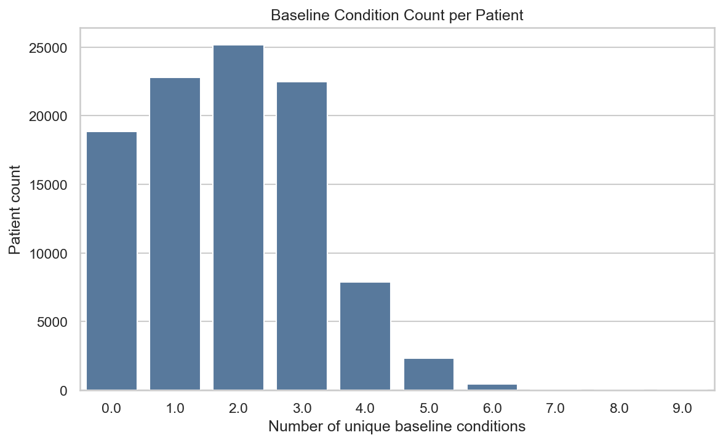
Baseline condition count per patient
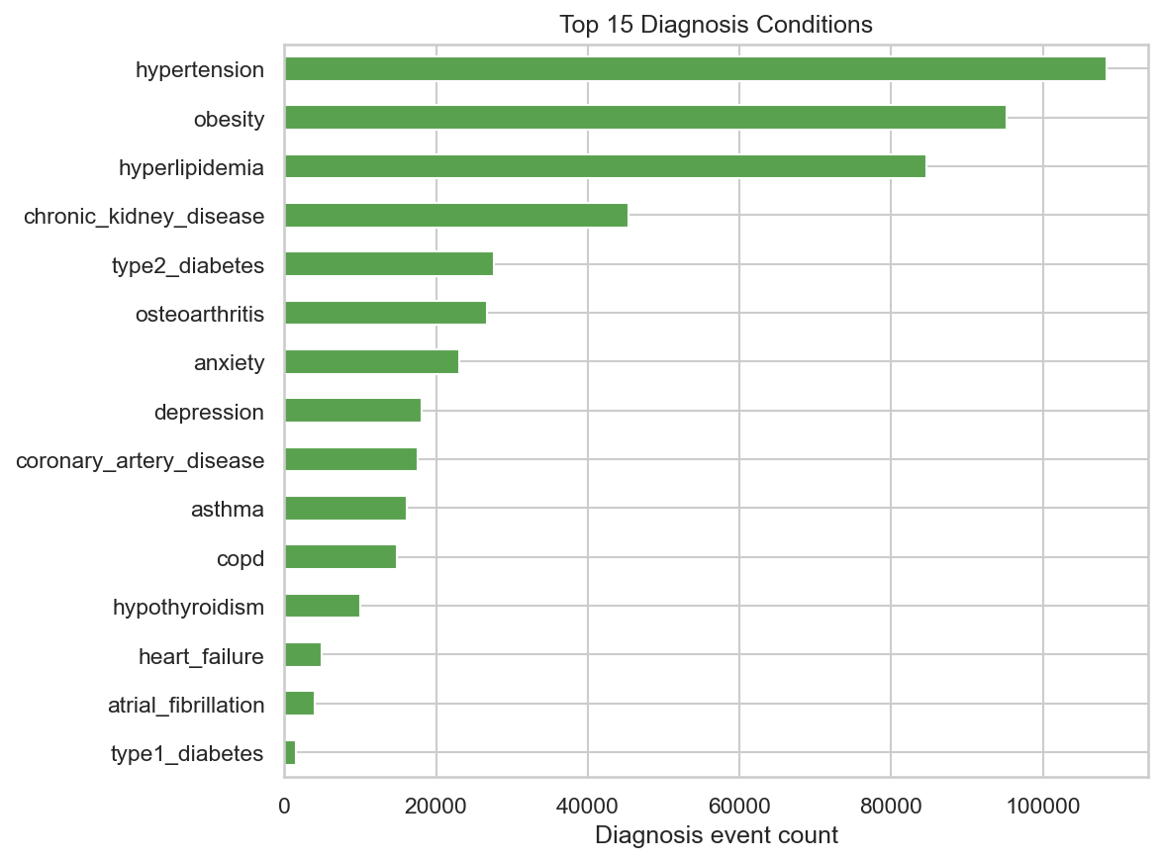
Top diagnosis conditions
Observed outcome rates in the modeling dataset:
Outcome | Rate
Future hospitalization | 4.55%
Future ICU admission | 0.10%
Future 30-day readmission | 0.68%
Multimorbidity progression | 18.11%

4. Data Pre-processing and Feature Engineering
Raw tables were cleaned with type coercion, date parsing, and clinical range checks (e.g. implausible ages or blood pressures set to missing rather than modeled). Diagnosis records were exploded into a tidy condition-event table combining primary and secondary diagnoses.
Features are engineered per patient using only events on or before the 2021-12-31 cutoff: baseline condition counts and one-hot condition flags, visit and specialty counts, laboratory summaries (counts, abnormal rates, and per-test mean/max values), medication summaries (counts, adherence, duration, indications), and prior hospitalization statistics.

Leakage-aware design
- Predictors are derived strictly from pre-cutoff dated events.
- The patient-level all-time dx_* columns are dropped, because they may encode diagnoses made after the cutoff.
- All target columns are excluded from the model matrix by get_modeling_matrices, which is enforced by automated tests.

5. Technical Approach
Two prediction targets are modeled:
- Future hospitalization is predicted for all 100,000 patients.
- Multimorbidity progression is predicted only within the at-risk cohort of 41,654 patients who start with fewer than two baseline conditions, since progression is undefined for patients who are already multimorbid.
For each target we train a majority-class baseline (DummyClassifier), logistic regression, random forest, XGBoost, and LightGBM inside scikit-learn pipelines that impute, scale, and one-hot encode features. Class imbalance is handled with balanced class weights (and scale_pos_weight for XGBoost). A stratified 75/25 train/test split is used throughout with a fixed random seed.

6. Test, Validation, and Evaluation Metrics
Because both targets are imbalanced, accuracy alone is misleading. Models are evaluated with ROC-AUC, average precision, precision, recall, and F1 on the held-out test split. A majority-class baseline is always included so that lift over the trivial predictor is explicit.

7. Modeling Results and Findings

Future hospitalization (all patients)
Model | ROC-AUC | Avg precision | Precision | Recall | F1
XGBoost | 0.694 | 0.090 | 0.073 | 0.677 | 0.132
Logistic regression | 0.686 | 0.087 | 0.077 | 0.617 | 0.137
Random forest | 0.685 | 0.086 | 0.127 | 0.024 | 0.040
LightGBM | 0.675 | 0.084 | 0.078 | 0.453 | 0.134
Dummy (majority) | 0.500 | 0.045 | 0.000 | 0.000 | 0.000

Multimorbidity progression (at-risk cohort)
Model | ROC-AUC | Avg precision | Precision | Recall | F1
XGBoost | 0.865 | 0.777 | 0.697 | 0.869 | 0.774
LightGBM | 0.862 | 0.770 | 0.691 | 0.865 | 0.768
Random forest | 0.861 | 0.760 | 0.701 | 0.852 | 0.769
Logistic regression | 0.853 | 0.764 | 0.696 | 0.831 | 0.757
Dummy (majority) | 0.500 | 0.435 | 0.000 | 0.000 | 0.000
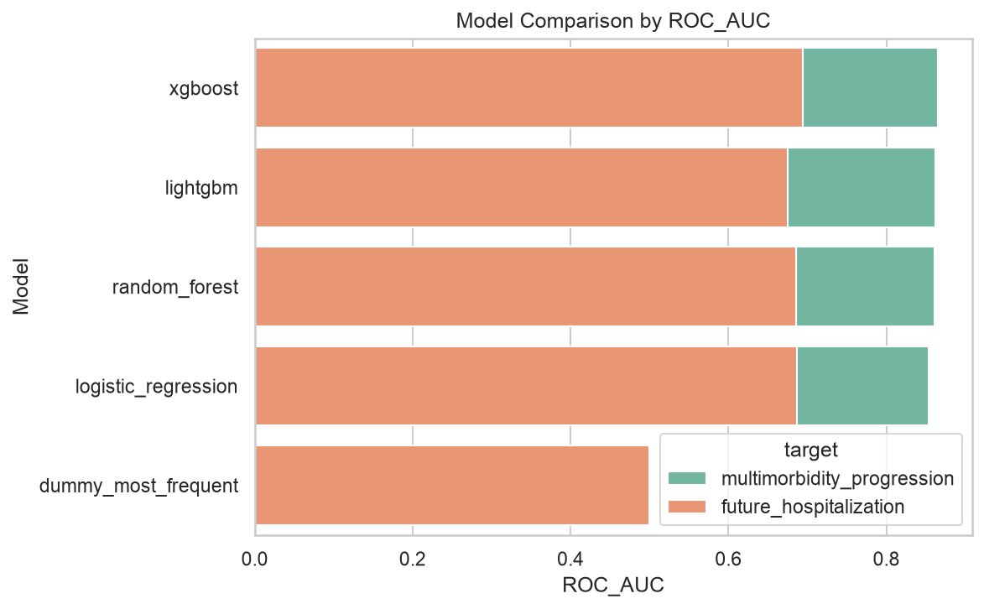
Model comparison by ROC-AUC
Multimorbidity progression is highly predictable from baseline history, while future hospitalization is a much harder, rarer signal where all models offer modest but real lift over the baseline.

8. Calibration and Threshold Analysis
Because care teams act on a risk threshold rather than a model ranking, the best hospitalization model (XGBoost) was analyzed for calibration and threshold trade-offs.
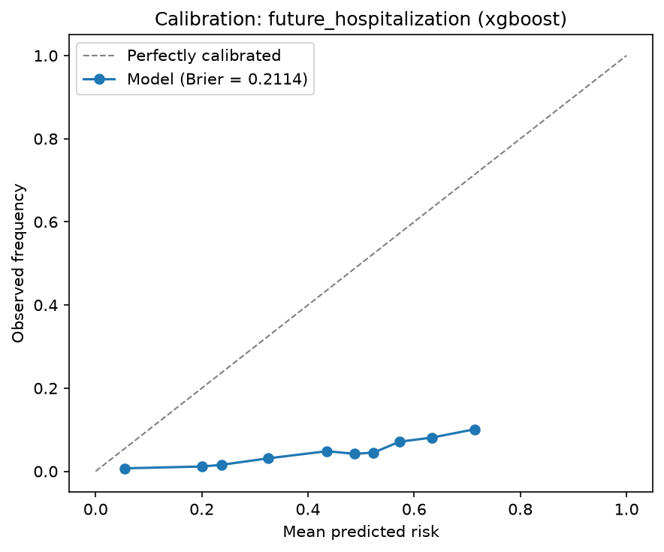
Calibration curve
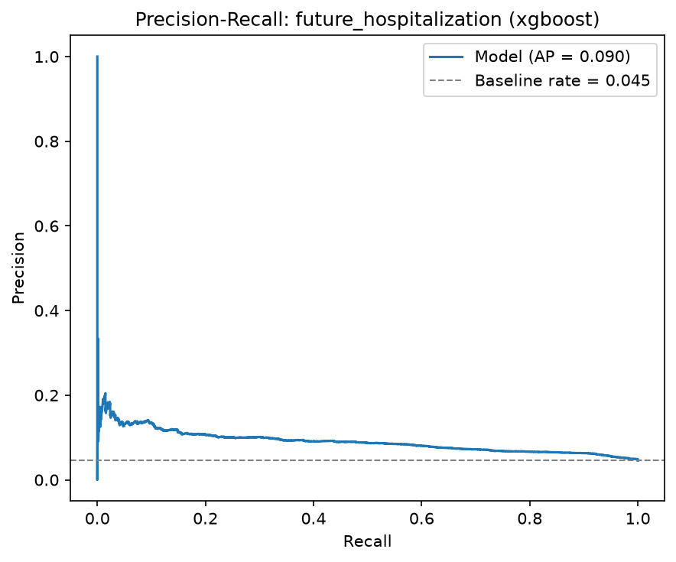
Precision-recall curve
The model ranks patients well (ROC-AUC 0.694) but is poorly calibrated (Brier score 0.211): class weighting inflates predicted probabilities, so the raw scores should be treated as a ranking rather than as literal risks. The threshold table (outputs/tables/threshold_analysis.csv) shows the trade-off — for example, a 0.5 threshold flags 42% of patients at 68% recall and 7% precision. Recalibrating (e.g. with CalibratedClassifierCV) is recommended before using absolute thresholds clinically.

9. Explainability
SHAP TreeExplainer was applied to the best tree model for each target.
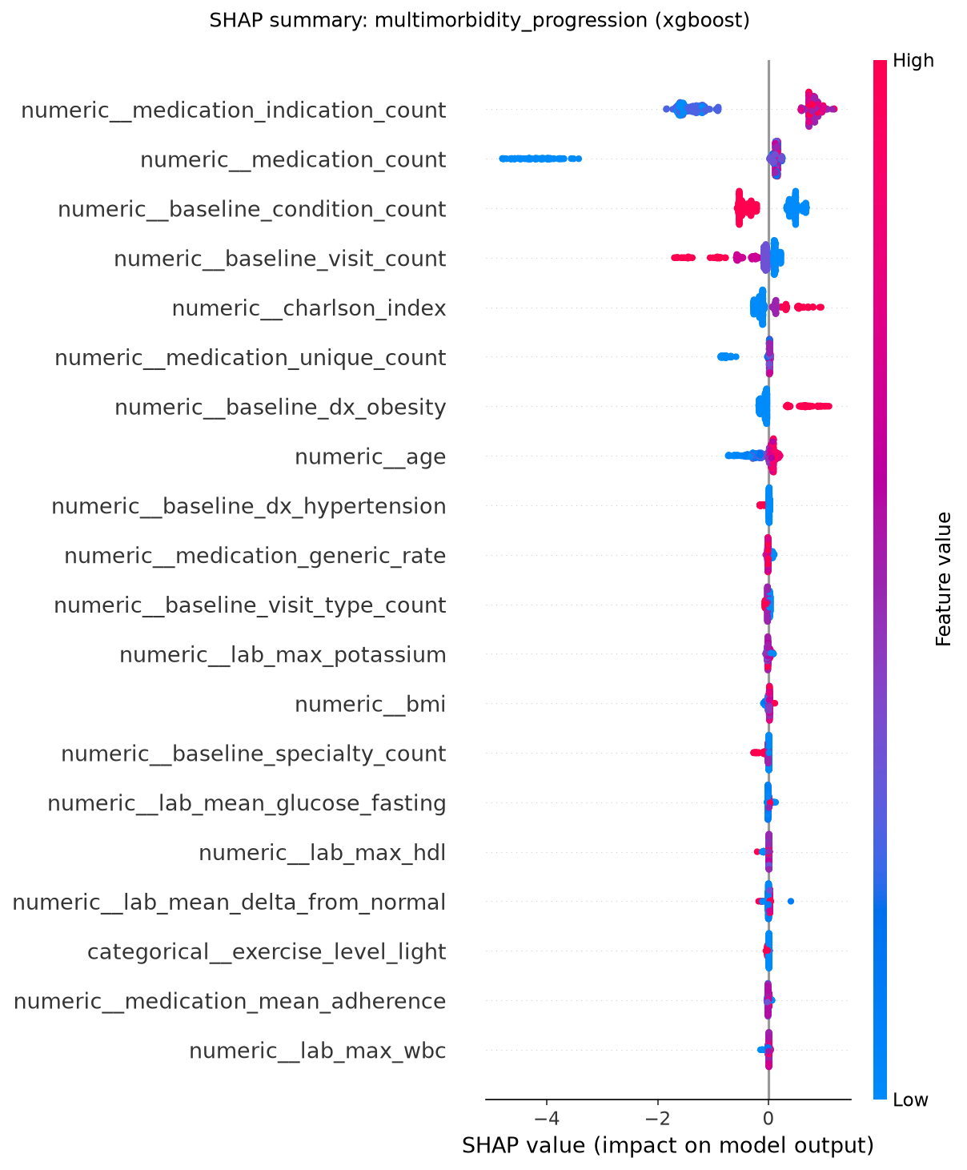
SHAP summary: multimorbidity progression
- Future hospitalization: prior hospitalization count, age, and Charlson index dominate — classic utilization and comorbidity drivers.
- Multimorbidity progression: medication indication count and total medication count (polypharmacy proxies), baseline condition count, and visit count are the strongest contributors.
Plain feature importance is retained as an environment-independent fallback.

10. Survival Analysis
Time to multimorbidity progression was analyzed for the at-risk cohort, with the event being the day a patient reaches two distinct conditions and censoring at the horizon. The survival event counts match the classification target exactly (18,107 events), confirming a consistent definition.
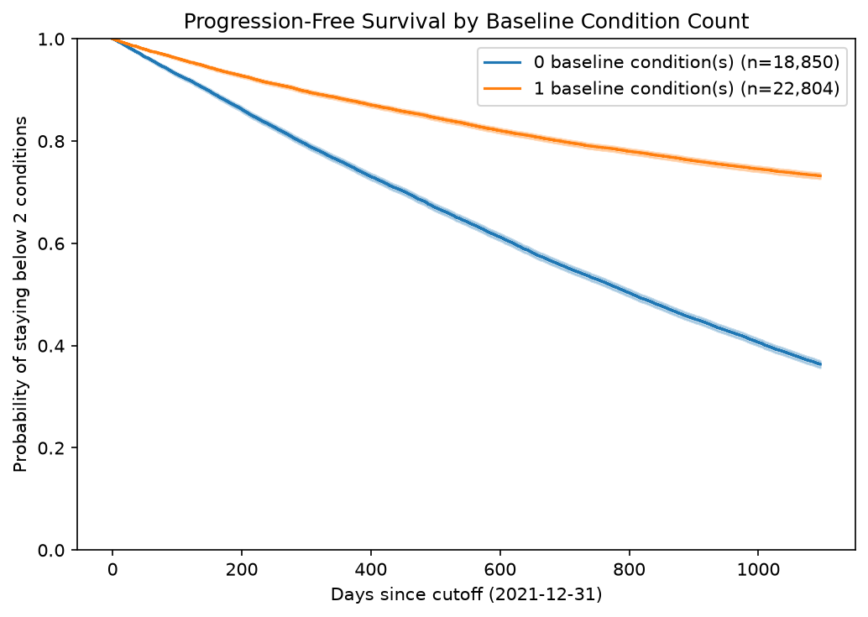
Kaplan-Meier progression-free survival
A Cox proportional hazards model (outputs/tables/cox_model_summary.csv) shows older age (hazard ratio ~1.02 per year) and higher Charlson index (HR ~1.49) increase the progression hazard, as expected. Counterintuitively, patients starting with one condition progress slower than those starting with none (HR ~0.37); this is a property of the synthetic data — zero-condition patients accumulate two new conditions more readily than one-condition patients add their second — and is noted here as a data characteristic rather than a modeling error.

11. Limitations and Validity
- The data is synthetic; results do not transfer to real patients.
- Future hospitalization, ICU, and readmission are rare events; metrics for the rarest targets are unstable and were not fully modeled.
- The best hospitalization model is miscalibrated and needs recalibration before its probabilities are used as absolute risks.
- Some findings (e.g. the baseline-condition-count hazard) reflect quirks of the synthetic generator.

12. Future Work
- Recalibrate risk probabilities and tune operating thresholds per care setting.
- Model the rarer ICU and readmission targets with resampling or specialized loss functions.
- Extend survival analysis to time-to-first-hospitalization and competing risks.
- Validate the workflow on an independent synthetic or de-identified EHR dataset.

13. Reproducibility
The project ships reusable helpers in src/, ten ordered notebooks, and a lightweight pipeline runner:
python run_pipeline.py --step features # build the modeling dataset
python run_pipeline.py --step models # train baseline + advanced models
python run_pipeline.py --step evaluate # metrics + comparison figures
python run_pipeline.py --step calibrate # threshold + calibration analysis
python run_pipeline.py --step explain # SHAP summary + top-features table
python run_pipeline.py --step survival # Kaplan-Meier + Cox model
python run_pipeline.py --step all # run every step in order
Leakage-prevention and output-existence tests run with pytest tests/. A Streamlit dashboard (streamlit run app/streamlit_app.py) summarizes the dataset, metrics, figures, reports, and a single-patient risk lookup. See HANDOFF.md for full setup, current metrics, and known limitations.

