Pharma Cold Chain Data Warehouse and Analytics Platform
Phase 1, Milestone 1: Progress Report | Sales and Demand Intelligence (SDI) Mart
Course: Intelligent Data Architectures | Date: 11 November 2026
Prepared by: Ayesha Salahuddin (29157), Narin Nadeem (29167) | Orchestrator: Apache Airflow 3.4.0 (Docker/Celery)

1. Executive Summary
Phase 1 delivers the Sales and Demand Intelligence (SDI) data mart, integrating master data (63 cold-chain medicine SKUs), historical pharmacy transactions (500,000 records), and hospital demand records (27,216 records). The target for Milestone 1 is a fully automated, observable data engineering pipeline from raw CSV files to an analytical SQL query layer, orchestrated end-to-end via Apache Airflow.
Status Overview: The end-to-end pipeline was executed and validated via both the Airflow CLI and the Airflow Web UI (CeleryExecutor). All four pipeline tasks completed successfully with a total UI execution runtime of 3 minutes 22 seconds, processing 520,000 sales transactions and 28,728 hospital demand records into DuckDB with SCD Type 2 dimension tracking.
Pipeline Component | Technology / Engine | Implementation Status
Environment Architecture | Docker Desktop (WSL 2), Celery, Redis | Completed (Allocated 5 GB RAM via .wslconfig)
Synthetic Data Generator | Python (oversample.py) | Completed (Generates 2026 records; continuous IDs)
Staging & Validation Layer | PostgreSQL 16 (ingest_staging.py) | Completed (COPY ingestion, rejects table, metrics log)
Dimensional Star Schema | DuckDB (build_datamart.py) | Completed (SCD Type 2 on Dim_Medicine, 2 fact tables)
Analytical Query Layer | DuckDB SQL (run_queries.py) | Completed (13 to 16 ms sub-second execution speeds)
Airflow DAG Orchestration | Apache Airflow 3.4.0 (CeleryExecutor) | Completed (All 4 tasks green via UI trigger in 3m 22s)
Automated File-Watcher | Python directory sensor | Scheduled for Milestone 2 implementation
2. Pipeline Architecture & Task Sequencing
The orchestration workflow is defined in dags/phase1_sdi_pipeline.py and executes four sequential tasks without manual intervention:
Task 1: synthesize_incremental_batches (oversample.py): Inspects existing transaction sequences across data/raw/ and data/landing/ to identify the maximum record IDs. Synthesizes incremental batches for 2026 sales and hospital demand using verified master SKU records, writing new files into data/landing/.
Task 2: stage_and_validate_postgres (ingest_staging.py): Truncates staging tables, validates business constraints (non-null IDs, positive unit prices, non-negative demand counts), dumps malformed records into staging.stg_rejected_records, loads validated data via PostgreSQL COPY, and records batch metrics into staging.pipeline_metrics_batch.
Task 3: transform_duckdb_star_schema (build_datamart.py): Extracts staged data from PostgreSQL and constructs the analytical star schema inside data/warehouse.duckdb. Builds Fact_Sales, Fact_HospitalDemand, Dim_Date, Dim_Hospital, Dim_Channel, and Dim_Medicine with SCD Type 2 tracking.
Task 4: run_analytical_and_storage_queries (run_queries.py): Executes three core business analytical queries against DuckDB, benchmarks query execution latency in milliseconds, and appends telemetry to Query_Execution_Log.
3. Data Generation & Oversampling Methodology
Historical source datasets concluded on 2025-12-31 (sales) and 2025-12-01 (hospital demand). To simulate live operational warehouse workflows, oversample.py creates incremental data batches advancing into 2026:
• The generator queries both raw and landing directories to establish global sequence maximums. Incremental transactions increment sequentially (e.g., SALE-000500001 onward), eliminating primary key collisions across multi-batch pipeline refreshes.
• The initial manual baseline loaded 25,000 sales rows and 2,721 hospital records. The production DAG generates 2 batches per execution: 10,000 sales transactions and 756 hospital demand records (63 SKUs × 12 hospitals = exactly one operational month) per batch.
• Only verified MedicineIDs from 01_master_data.csv are referenced. Financial metrics (revenue, wholesale cost, gross margin) and demand fulfillment metrics are recomputed deterministically to preserve distribution fidelity.
4. Ingestion, Data Quality, and Observability
Data ingestion enforces automated validation rules prior to analytical modeling. Ingestion metrics from the latest execution batch confirm successful processing:
File Name | Domain | Records Loaded | Ingestion Latency
01_master_data.csv | Master Medicine SKU Catalogue | 63 | 0.10 s
05_pharmacy_sales_data.csv | Historical Sales Transactions | 500,000 | 28.57 s
incremental_sales_*.csv | Synthetic 2026 Sales Batches | 20,000 (2 × 10,000) | 1.10 s
06_hospital_demand_data.csv | Historical Hospital Demand Logs | 27,216 | 0.93 s
incremental_hosp_*.csv | Synthetic 2026 Monthly Demand | 1,512 (2 × 756) | 0.11 s
Data Quality Enforcement: Any record containing null identifiers, non-positive pricing (UnitPrice <= 0), or negative consumed inventory is excluded from staging tables and directed to staging.stg_rejected_records with raw payload logs and error reasons. Zero rejections were triggered on the validated synthetic files.
5. Dimensional Modeling & Star Schema (SDI Mart)
The data mart is implemented inside DuckDB as a fact constellation star schema, separating analytical measures from contextual dimensions:
Table Name | Table Type | Record Count | Key Attributes & Purpose
Fact_Sales | Fact Table | 520,000+ | QuantitySold, UnitPrice, TotalRevenue, Discount, COGS, GrossMargin
Fact_HospitalDemand | Fact Table | 28,728+ | ForecastQty, RequestedQty, ApprovedQty, ConsumedQty, UnfulfilledDemand
Dim_Medicine | Dimension | 64 | SCD Type 2 tracking (RowEffectiveDate, RowExpiryDate, IsCurrent)
Dim_Date | Dimension | 1,127 | Calendar dimension: DateKey, FullDate, Year, Quarter, Month, Day
Dim_Hospital | Dimension | 12 | Hospital details: HospitalType, City, TotalBeds, ICUBeds, TraumaLevel
Dim_Channel | Dimension | 9 | Sales channel classification and pharmacy operation types
Summary_Hospital_Fulfillment | Supporting Rollup | 12 | Pre-aggregated fulfillment summary optimizing query latency
Query_Execution_Log | Observability | Historical | Tracks QueryID, QueryName, ExecutionTimeMs, Timestamp
SCD Type 2 Implementation: Dim_Medicine maintains 64 records for 63 products. When medicine pricing or regulatory storage thresholds update, the existing record is closed out with an updated RowExpiryDate and IsCurrent = FALSE, while a new record is created with IsCurrent = TRUE, preserving transaction lineage.
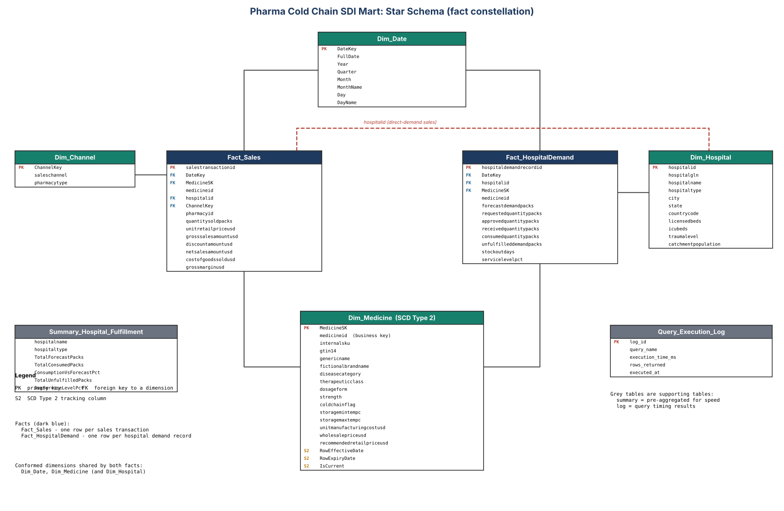
6. Analytical Query Layer & Query Optimization
Three business queries were executed against DuckDB to validate analytical responsiveness:
Analytical Business Query | Business Objective | Execution Time (ms)
Q1: Hospital Fulfillment Ratio | Compares forecast vs. actual consumption and unfulfilled demand | 15.64 ms
Q2: Sales Channel Margin Analysis | Evaluates gross revenue and margin split across retail, hospital, e-comm | 14.28 ms
Q3: Cold Chain Velocity Analysis | Ranks fast-moving vs. slow-moving cold chain SKUs by therapeutic category | 13.03 ms
7. Orchestration & Technical Obstacles Resolved
Airflow 3 Worker JWT Authentication (Resolved): During initial UI executions, the first task failed immediately while worker logs reported 'Invalid auth token' and the API server logged 'Signature verification failed'. Airflow 3 requires an identical shared secret across distributed services. Added AIRFLOW__API_AUTH__JWT_SECRET to docker-compose.yaml under x-airflow-common. Recreated containers; all 4 tasks subsequently executed with Success under triggering user 'admin' in 3m 22s.
WSL 2 Docker Memory Crash (Resolved): DuckDB transformations on 520,000+ rows initially hung and triggered SIGBUS crashes due to the default 3.65 GB WSL memory cap. Created %USERPROFILE%\.wslconfig with memory=5GB, expanding allocation to 4.8 GiB and eliminating out-of-memory container terminations.
Airflow UI Authentication Lockout (Resolved): Airflow 3 Simple Auth Manager generated dynamic random passwords at container initialization. Configured AIRFLOW__CORE__SIMPLE_AUTH_MANAGER_ALL_ADMINS: 'true' in docker-compose.yaml to ensure predictable administrative access during evaluation.
Staging Ingestion Idempotency (Resolved): Prevented duplicate loading across incremental runs by implementing table truncation on staging followed by dynamic tracking of processed landing file names in pipeline_metrics_batch.


