Narku's Collection
A full-stack web application to manage a personal collection of books, CDs, video games, and board games. The app provides a user-friendly interface for adding and viewing items in each category and is built with a responsive design to ensure accessibility across all devices.

Table of Contents
- Features
- Technologies Used
- Screenshots
- Setup Instructions
- Usage

Features
- Responsive Design: The application layout adjusts to fit screens of all sizes, ensuring a mobile-friendly user experience.
- CRUD Operations: Users can add books to their collection via a form that submits data to a MariaDB database. Data is then retrieved and displayed in a table format.
- Category Navigation: A navigation bar allows users to switch between categories, making it easy to manage different types of items.
- User Interface: The interface is designed with a simple, intuitive layout that includes a form for data entry and a table for data display.

Technologies Used

Frontend
- HTML: For structuring the application’s pages.
- CSS: For styling the application with a responsive layout.

Middleware
- PHP: For server-side scripting and database connection.
- jQuery: For client-side scripting and enhanced interactivity.

Backend
- MariaDB: A relational database used to store collection data.

Screenshots

Home Page
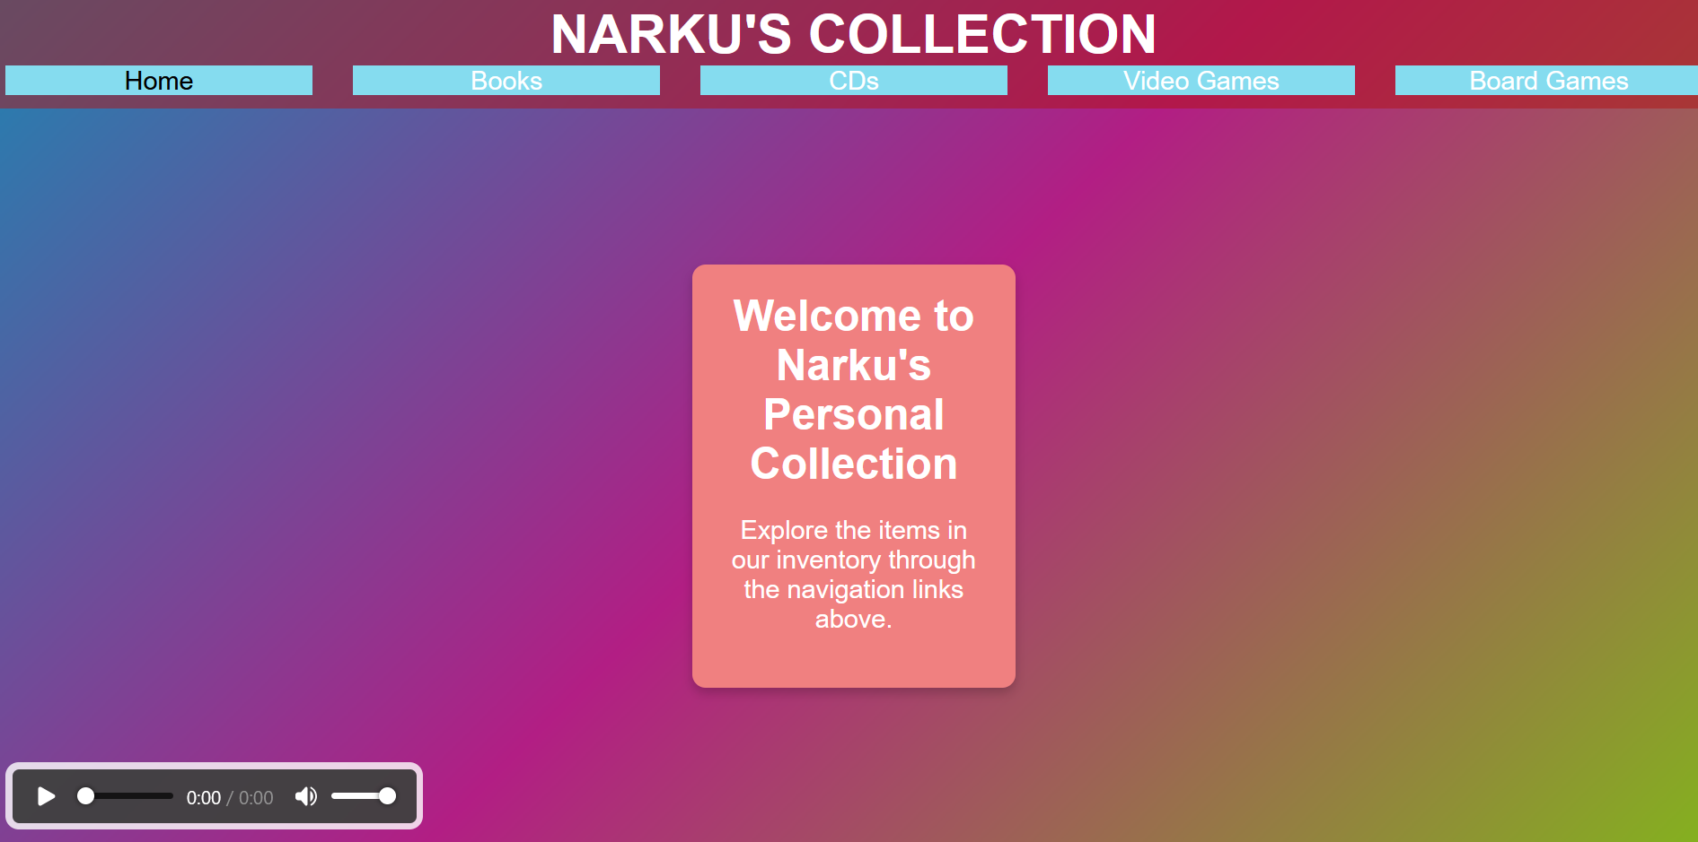
This page serves as the welcome page of the application, featuring the title and a navigation bar with different categories.

Book Collection Form and Table

Add a Book Form
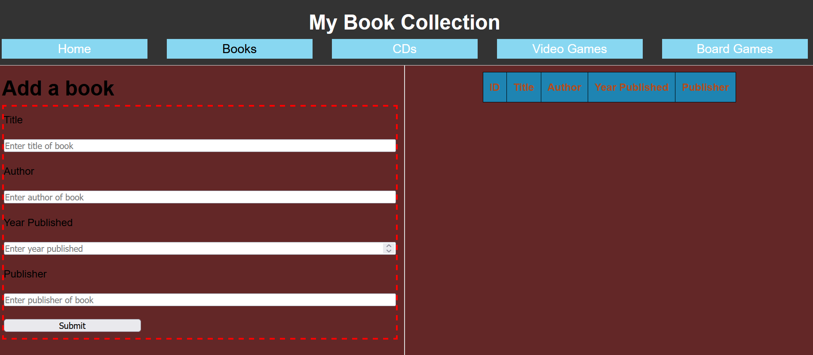
Users can fill out this form to add a book to their collection, which is then stored in the MariaDB database.

Book List
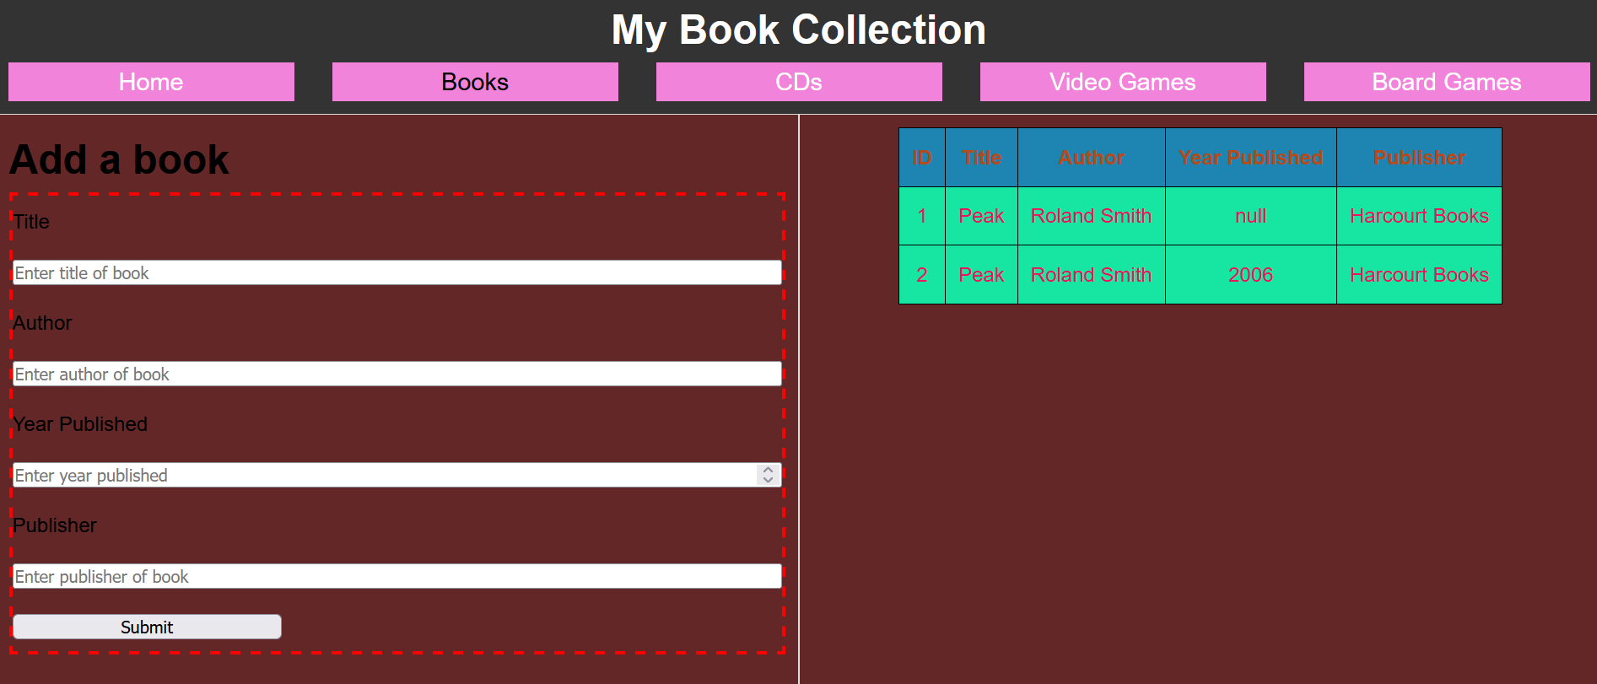
This page displays all the books that have been added to the collection, with data retrieved from the database and shown in a table format.

Setup Instructions

Prerequisites
- Web Server: Apache or any server capable of running PHP.
- Database Server: MariaDB.
- Software: XAMPP (recommended) or any LAMP stack.

Installation Steps
- Clone the Repository:
bash
Copy code
git clone https://github.com/yourusername/repositoryname.git
cd repositoryname
- Set up MariaDB Database:
  - Open MariaDB in your terminal or use a database management tool (e.g., phpMyAdmin).
  - Create a database for the collection:
sql
Copy code
CREATE DATABASE narku_collection;
  - Create a table for books:
sql
Copy code
USE narku_collection;
CREATE TABLE books (
id INT PRIMARY KEY AUTO_INCREMENT,
title VARCHAR(255),
author VARCHAR(255),
year_published INT,
publisher VARCHAR(255)
);
- Update Database Connection in PHP:
  - Go to the config.php file in the repository and update the database connection settings with your MariaDB credentials:
php
Copy code
$host = 'localhost';
$db = 'narku_collection';
$user = 'yourusername';
$password = 'yourpassword';
- Start Your Local Server:
  - If using XAMPP, start Apache and MySQL.
  - Place the project files in the htdocs folder of your XAMPP installation or the appropriate directory for your server.
- Access the Application:
  - Open your browser and go to http://localhost/repositoryname.

Usage
- Adding Books:
  - Navigate to the Books section.
  - Fill in the form with the title, author, year published, and publisher.
  - Click Submit to add the book to the database.
- Viewing Books:
  - Once books are added, they will be displayed in a table format on the same page.
  - You can view details such as the book’s ID, title, author, year published, and publisher.

With this application, you can manage and track your personal collection of books, CDs, video games, and board games easily! Enjoy using Narku's Collection.

