EDUINSIGHT
Student Performance Business Intelligence & Decision Dashboard
Project Report

1. Executive Summary
EduInsight is a Python-based business intelligence prototype that converts student performance data into meaningful KPIs, visual insights, risk indicators and recommended actions. The design follows the masterclass principle that a strong analytics project should move from data to information, insights, decisions and finally action.

2. Problem Statement
Educational data can contain academic, behavioral, environmental and support-related variables, but decision makers need a concise way to understand what is happening, which factors matter, which students may need support, and what actions can be considered.

3. Objectives
- Build an executive-style dashboard for student performance.
- Represent a small set of meaningful KPIs instead of overwhelming the user with charts.
- Explore relationships between study habits, attendance, resources, motivation and exam scores.
- Use machine learning to estimate exam scores from available student attributes.
- Surface support-risk groups and translate analytical findings into practical actions.

4. Dataset
The project uses the public Kaggle dataset 'Student Performance Factors'. The dataset contains academic, personal, family, school and lifestyle variables and uses Exam_Score as the outcome. Source: https://www.kaggle.com/datasets/lainguyn123/student-performance-factors
Submission note: the masterclass instructed students not to use the exact dataset used as the internship learning dataset. The selected dataset should therefore be checked against the cohort's learning materials before final submission.

5. Business Intelligence Framework
Level | EduInsight implementation | Decision purpose
KPIs | Students, average score, average attendance, support count | Understand current performance
Trends | Score distribution, motivation groups, study/score relationship | See patterns
Drivers | Random Forest feature importance | Understand influential variables
Risk | Configurable score threshold | Identify groups needing attention
Action | Attendance, study-plan, tutoring and resource actions | Turn insight into intervention

6. System Design
The application is intentionally implemented as one Python file so that the code submission matches the requirement for a single .py file. Streamlit provides the interface, Pandas/NumPy perform data processing, Plotly creates interactive charts, and Scikit-learn provides the prediction pipeline.
Flow: CSV → Cleaning → KPI calculation → Visualization → ML model → Risk → Action

7. Dashboard Preview
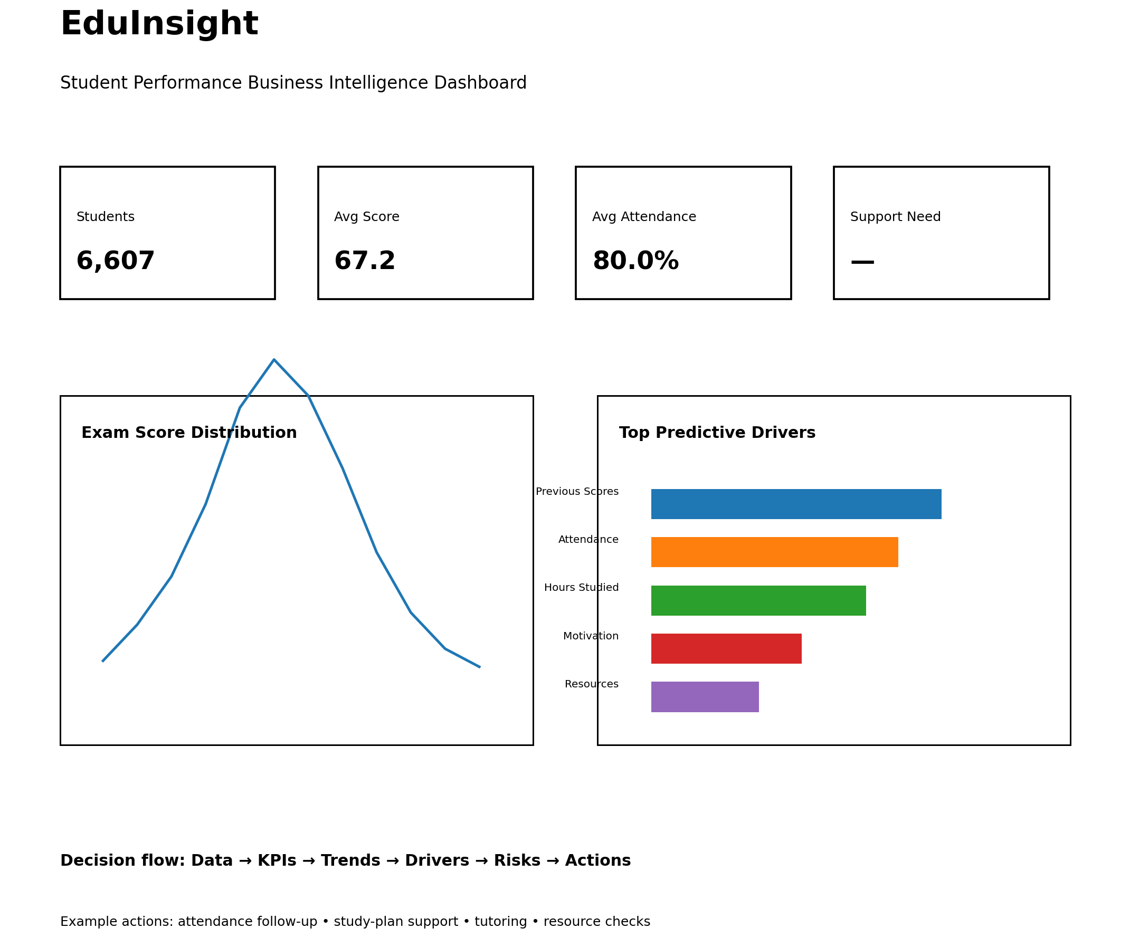
Figure 1. Illustrative preview of the EduInsight dashboard. The live dashboard calculates values from the selected CSV.

8. Machine Learning Method
A Random Forest Regression model is trained after separating the target Exam_Score from the input variables. Numerical values are median-imputed. Categorical values are most-frequent imputed and one-hot encoded. The data is split into training and test sets. The application reports Mean Absolute Error (MAE) and R² at runtime and displays the most important transformed features.

9. Risk and Action Logic
A configurable exam-score threshold is used to identify a support group. The dashboard does not label a student permanently; it only provides a screening signal for human review.
- Low attendance → follow-up and attendance improvement plan.
- Low study time → structured study schedule.
- Weak previous performance → mentoring and progress tracking.
- Low resource access → check learning-material and digital-resource availability.
- Low motivation → engagement activities and frequent feedback.

10. Expected Outcome
The expected outcome is a compact decision dashboard that helps a user move from raw student data to clear KPIs, patterns, potential drivers, support risks and practical actions.

11. Technologies Used
- Python
- Streamlit
- Pandas
- NumPy
- Plotly
- Scikit-learn
- Random Forest Regression

12. How to Run
1. Download StudentPerformanceFactors.csv from the dataset source and place it beside eduinsight.py.
2. Open a terminal in the project folder.
3. Run: pip install -r requirements.txt
4. Run: streamlit run eduinsight.py
5. Open the local Streamlit URL shown in the terminal.

13. Submission Files
- eduinsight.py — project code
- requirements.txt — dependencies
- README.md — project overview/setup
- Project_Report.docx — report

14. Conclusion
EduInsight demonstrates the central business-intelligence idea from the session: the purpose of a project is not to maximize code or charts, but to convert data into understandable insights that support better decisions and actions.

