2014-2015

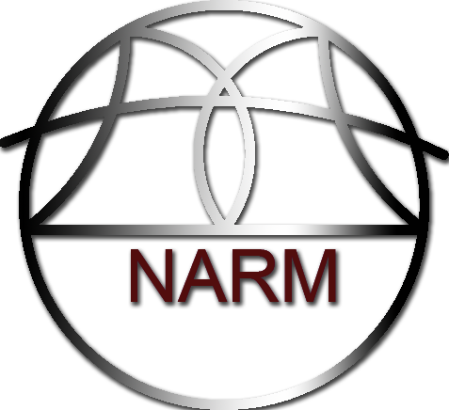

www.facebook.com/narm.robotics

PROSPECTUS

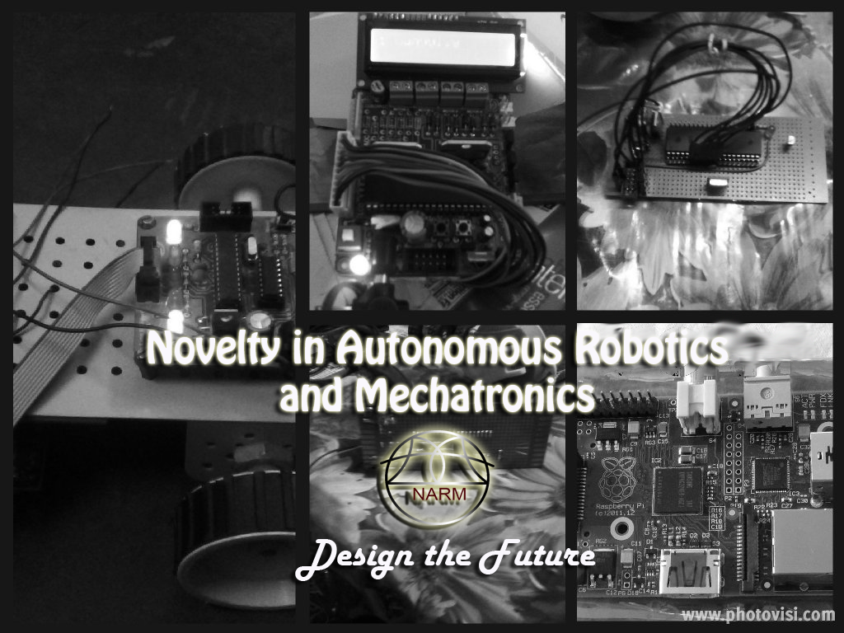Contents

1. **About The Narm Venture**
2. Our Achievements
3. Our Mission
4. **Structure of the Narm Venture**
5. The Narm Core Team
6. Research and Innovation Division
7. The Promotional Team
8. The Narm Robocon Team
9. The Advisory Team
10. **Our Yearly Memorandum / Program**
11. The Training Phase
12. Research and Development Phase
13. Promotional Phase
14. Competition Phase
15. **Our Current Projects**
16. The 7-Dof Intelligent Robotic Arm
17. The Micro-Mouse
18. Advanced Line Follower
19. The M-POD
20. **Our Financial Overview**
21. One year Budget Plan
22. Research Expenditure
23. Travel Expenditure
24. **Promotional Plans**
25. Sponsorships & Collaboration
26. The ‘Innovate With Us’ Campaign
27. The NARM Blog
28. Online YouTube Channel
29. **How to Join the NARM Venture**
30. The induction Process
31. Online Membership Process

About Us

Four students from different branches during the spring of 2013 joined hands to learn about microcontrollers and the different technologies used in making of autonomous robots. Our primary purpose then was to design autonomous robots to participate in different competition held in college fests across India. It took us immense dedication and hard work especially since there was no external or professional aid involved which could better our learning process. After 2-3 months of sleepless surfing of the internet, we learnt more or less sufficient about microcontrollers and automation to design our own autonomous line follower. Our project was a successful one but there were many discrepancies in the line follower that we designed unlike the professional ones. We took no time to rejoice in glory but instead we focused quickly on other major autonomous robots competition that were being held. In no time, we successfully designed our obstacle avoider, edge avoider robot, phototrophic and photophobic robots. Our robots won competitions across India including the IURL (Indo-Us Robo League).

After that, we thought of redesigning our robots and modifying it so it can help society in different ways. We modified our existing line follower to make a solar-powered line follower which could water plants around it. We speculated that this line follower could improve the campus of our university by maintaining the environment. Unfortunately, even this robot lacked the professional accuracy and required high maintenance which rendered it useless.

After the line follower project was scraped, we planned to participate in the NSSC (National Students Space Challenge) held at IIT Kharagpur. Inspired by the problem statement, we worked to design a 5-DOF mechanical arm controlled by a remote operator which could be used by a ground station to pick and place objects in a different planet. Unfortunately, the requirements for this competition were minimal and our arm project became seemingly complex for the competition and thus we crossed all deadlines for designing the robot. The 7-DOF arm project was just halfway complete on 9th December, 2013 when there was a mechanical failure in the arm and we did not have enough funds to procure the materials needed for making amends. Since our project was incomplete, we couldn’t participate in any completion but we presented our research at BARC (Bhabha Atomic Research Centre), Mumbai. Dr. Prabir Pal and Dr. Sanjeev Sharma from BARC appreciated our project and spoke about their research on the 7-DOF Arm. I expressed my desire to collaborate my project with theirs to design a better 7-DOF. They agreed to collaborate with us in the 7-DOF arm for two months (from May-July) to design an intelligent 7-DOF Robotic Arm capable of autonomous control on condition that the final Robotic Arm will be used at BARC to transfer nuclear waste from the reactors to the treatment plant and all research must remain confidential under DAE (Department of Atomic Energy) Act Terms. The NARM team expanded when different students from 1st year contacted us in order to learn about mechatronics and different application. Our newly expanded NARM team constituting of 15 members participated in all the robotics events of ojass-14 where we won the most Innovative robot award in RoboSoccer and Kurukshetra.

Our Achievements

Since, our team started its work quite recently, we do not have many achievements under our banner. What we have is hope and prospect and a few research collaborations and innovative awards.

* 7-DOF Intelligent Robotic Arm Project selected for collaboration with BARC
* Worked on the project “Computer Science for Disabled Children” under Eernie Steeves, Carnegie Mellon University
* Selected for working on the BitCoins Project in Amsterdam over github
* Innovative award in ROBO SOCCER in Ojass-14
* Innovative award in KURUKSHETRA in Ojass-14

Our Mission

-“Design the Future”

With this motto in mind, NARM strives to design technologies which help in the betterment of life. The Research division designs many technologies which are ground breaking cornerstones in research in Mechatronics. In short, we help mankind climb the evolutionary ladder faster.

This venture has 3 aspects with equal priority : The Competition , The Research and The Club.  
While, we participate in National and International Competitions, we also have a dedicated team responsible only for research and development of new robotic technology. We also have the NARM Club whose main aim is to spread robotic awareness in the college.

The NARM Venture operates on several levels where each level has a particular mission. The details on how each department inside the NARM Venture operates is given within the section titled the ‘Structure of the Team’.

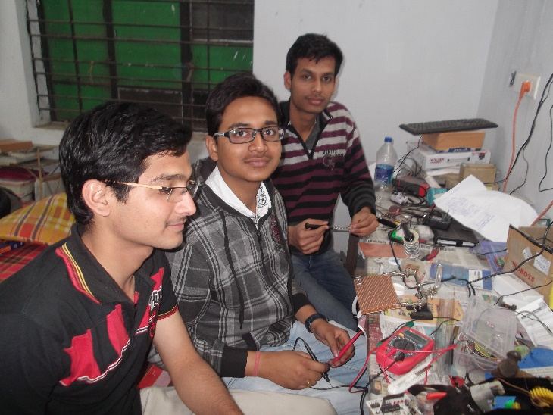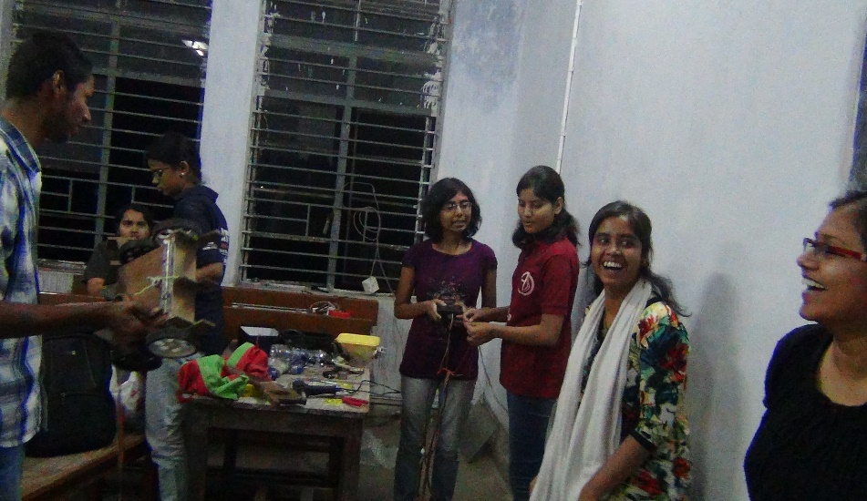

Structure of the NARM Venture

The NARM Team functions with its well-defined structure and a proper hierarchy in everyone’s position in the team. The Core Team of NARM is the head of entire NARM and each subsequent department has a head controlling all divisions and teams under him while each team has a captain controlling his team. The main structure of the team in its hierarchical order is given below.

# The NARM Core Team

The Core team of NARM constitutes of 5 members at maximum including the Team Captain and is responsible for controlling all the departments of NARM directly under it. The NARM Venture and the NARM Team both converge in the Core team to function efficiently. The decision of the core team, headed by the Head of NARM Venture, is final and binding in all aspects of NARM.

The main functions of the core team are given below:

1. Decide on the annual budget
2. Decide on the current research focus for the R&D division
3. Decide on which competitions to participate in the year
4. Plan the entire yearly schedule for different aspects of NARM

The 5 members of the Core Team are:

1. Head of NARM Venture
2. Captain of NARM Team
3. Head of Research & Innovation Division
4. Head of Promotional Division
5. Head of Advisory Team

# Research and Innovation Division

The Research and Innovation division is the most important aspect of NARM and it is responsible for all research that takes place in the field of robotics. The Head of Research and Innovation Division decides on a particular research and divides the research among the different divisions of NARM and gives them a duration to complete their research. The different divisions in R&D and their functions are:

1. Mechanical:   
   Students interested in Mechanical Engineering can join this division. This division is responsible for designing and making the structure of any robot so that the device is strain free and is not prone to mechanical failure. Solar and other alternative energy source based robots are designed in this division. The teams in this department are:
   1. Solar Robotics:   
      In Solar Robotics, students conducts research on different types of solar cells (monocrystalline and polycrystalline), the miller engine circuit and other different interfaces to increase the efficiency of the solar cell. The power requirement and the size factor of a robot are given to the solar robotics team and they are required to design the entire power system of the robot powered by solar cells.
   2. Structure Designing:  
      This team designs the entire structure for the robot. The size factor, torque, strain and other mechanical factors are given to them and they design the entire structure of the robot in precisely two steps. First, they design the entire structure on a CAD Modelling software. Next, the model is analyzed for failure using an analysis software like ANSYS. A proper material is selected for the fabrication that satisfies all the mechanical requirements for the project like density, stress, etc. and the entire structure is made from the material.
2. Electronics  
   The Electronics division designs all the electronic components for the robot including the motherboard design, sensor design and wireless communication circuit and protocol design. The different teams working under the electronics division are:
   1. **Signal Processing:**This team designs all the circuitry for long-range and short-range communication between different devices. It develops algorithms and communication protocols for long range communication and develops algorithms for different serial communication protocols like I2C, SPI, TWI, UART and USART.
   2. **Microcontrollers:**This division designs motherboard for different microcontroller and makes circuitry and add-ons for easy interfacing with microcontroller. It has knowledge of the three major families of Microcontrollers 8051, PIC and AVR. It designs short header files for easy programming of the microcontrollers. It also studies about different types of sensors used in Robotics and designs modules for interfacing sensors and other electronic devices. It also tests new sensors for their rating and specifications and design datasheets based on it.
   3. ARM Cortex:  
      The Broadcom ARM Cortex is a relatively recent technology in the world of electronics and we are studying it to better develop our robots. The Raspberry Pi, Cubie Board are the two main development platforms we use for all projects involving the ARM processor. In this division, the power of the processor is used to develop on-site image processing and localization systems.
3. Computer Science  
   The Computer Science Department designs all the algorithms for making advanced robots. It is responsible for
   1. Algorithm Design:  
      This division designs algorithms for better control of autonomous robots by implementing a variety of control systems along with grid mapping using wavefront algorithm and localization to understand position. It researches on Artificial Intelligence algorithms used in Robotics and Stochastic Systems to make advanced robots.
   2. Device Driver Coding:  
      This division designs device drivers to interface our personal modules and array to existing robotics development systems. This team has an immense expertise in UNIX under FreeBSD and Linux, where it uses its expertise to design device drivers for Raspberry Pi and Wand Board so that the sensor arrays made by the electronics team easily fits in the design
   3. Machine Vision:  
      This is the most important part of completely autonomous Grade I robotics. The machine vision team designs image processing algorithms to detect different features in an image and detects structures for the images. It then samples a number of images from a camera at high frequency and establishes a pattern to detect what is happening in the environment. It then takes decision according to its environment. A patented algorithms has been designed in this field for better understanding of the environment and establishing human identity. PyCamera and Microsoft Kinect Vision are the main hardware components used in this division.

Promotional Division

The promotional division has the task of supervising mainly the advertising aspect of the team. For a team to work effectively, the thing which is of utmost importance is the requisite amount of funds in order to meet the various expenses of the team. Hence the job of promotional team is to post the latest developments within the team on blogging sites, think about various schemes for the improvement of the campus, use web development as well as android app development in order to design pages of our team containing the latest updates of our team and also the task of sponsorship. The promotional division has been further subdivided into various subcategories for productive working.

1. Educational team:   
   The job of the educational team is to post on the blogs the latest research or achievement made by our team in the field of either robotics or mechatronics. Their work is also to organize workshops within the campus in order to make people aware about the main work, goal, dreams and aspirations of the team. They also organize a training for newly recruited students to better understand robotics. Another motive behind organizing workshops is to motivate interested students to join the team and contribute their bit. They also have the work of recording video lectures on various topics concerned with the desired field of interest. Finally, they post these lectures in our online YouTube channel.
2. Campus improvement:   
   There goes a very apt saying: ‘charity begins at home’. Similarly, our team aims to incorporate innovation and mechanization and bring about changes within the campus. It inculcates innovation and creative thinking among the students of this institute as well as serves our promotional purpose. For eg. It aims to design and make such a line follower robot which can water plants.
3. Creative Team:   
   They have the task of designing webpages by using web development and android app development and giving information about the progress of the various tasks within the team along with our achievements and main objective in order to attract the attention mainly of the sponsors. They maintain our website and design apps for quick collaboration of projects among our members. This is also necessary so that anyone can get information about us through these pages or blogs and can give us his/her views or share any new concerned information with us.
4. Sponsorship team:   
   The prime objective of this team is to notify and convince the sponsors about the aim and strategies of the team and collect funds from the same in order to meet the monetary requirements of the team. The entire budget and sponsorship details is given later in this prospectus.

The NARM Robo-Con Team

The NARM Robo Con Team participates in the Robocon every year. Selected people from every department in the research division is selected a year in advance and they work all around the year according to the problem statement of that year’s Robocon. The problem statement which involves designing a robot that can perform a series of tasks which when completed award points to the concerned team. The total points are counted to declare the final winner. The total prize money is more than 30 lakhs and the event has more than 30,000 viewers alone in india.

The Advisory Team

The Advisory Team consists of the faculty advisor of the Robocon Team, the Research and Development Advisor and the Financial Advisor. The Research and Development Advisor helps us with all the proceedings required to efficiently conduct research and development in our college. The Financial Advisor advises on our sponsorship details and manages our list of sponsors.

Our Yearly Plan

# The Trainning Phase (September – December)

Robotics is a very advanced discipline and research in robotics is not possible without proper training. After recruiting new members in our team, we immediately start the training phase.   
The training phase occurs for the respective departments of Research and Development and are conducted by students from 2nd year, who are in the Educational Team. The training is divided into two or three modules and after each module there is a minor project and by the end of the training all students would have successfully worked and completed a major project. The syllabus for the training of three departments are given below:

# Research and Innovation Phase (November – March)

The Research and Innovation Phase is the most important aspect of NARM and it is the essence of this venture that makes it different from the rest. The R&D team never participate in any other aspect of NARM and contribute only to the research and development of robotic technology in India. The first meeting of NARM called the initiation is the birthplace and discussion of all innovation. In the first meeting of each academic year, the Core Team members decide on the areas that the R&D team should conduct their research during the year. The Research Team constitutes members from 2nd Year, 3rd Year and 4th Year and are divided into various groups as mentioned in the structure of the team. Based on the decisions of the Core Team, the Research and Innovation Head allocates an area of research to each team and gives them a deadline by which they are required to produce their findings in the form of a research paper/abstract under ‘National Institute of Technology, Jamshedpur’ , ‘NARM Roboticcs’ and the person concerned. The chief areas of research are decided by the latest and recent technologies and their applications in modern science, how research in the field will change/improve the environment of our college and the interests of members in different fields. Our current research focus:

# Promotional Phase (July-November)

In the promotional phase, we plan to visit prospective sponsors all over India and speak to them about our needs and will request them to sponsor us. Our sponsorship team constitutes members mainly from 2nd year and 3rd year. The promotional team other than acquiring sponsors also spread awareness on robotic technology and our robotic team. For this purpose, it might organize talks in our college and other colleges, it keeps a well maintained and up-to-date blog on various robotic technologies that we are currently working on. This team also maintains an updated YouTube channel containing video lectures of all our talks on different topics on robotics.

The most important function in the Promotional Phase is done by the ‘Campus Improvement’ Division. This team collaborates with student grievance bodies in the college like the Student Council and HEC members to provide innovative and technical solutions to existing problems in the college. This team thinks of a particular innovative solution to a problem and prepares a model and draft of the solution. It then forwards the solution to the innovative team who implement and design it. An example that we are working on is design of a robot which can cut grass, perform gardening and maintain the environment.

The Creative team works during this promotional phase where they design all brochures, templates and banners that would be required for events in the NARM venture. It also designs the T-shirt for different divisions of NARM. A website team in the creative develop and maintain a website for our team and its different aspects.

# Competition Phase (December – April)

Most of the competitions occur during this time of the year and small teams from 1st year and 2nd year participate in these competitions. Our main competitions are:

* ABU RoboCon (March-April) : The ABU Robocon is the largest robotic event in Asia with a huge number of viewers. The details on the problem statement of Robocon and its working is given in the NARM Robocon team section. This team works year round for this event and does not participate in other aspect of NARM
* Robogames (April): The Robogames is the world’s largest robotics event and it occurs in California every year. The problem statement of this event is very simple and involves making of a line follower and the best and fastest line follower wins the event. The IURL (Indo-Us Robo League) is a qualifier event for this competition.
* Kshitij (February) : The Robotics event of IIT KGP are a main attraction for all 1st year students in NARM and they participate in all events of Robotics. It serves as an exposure for them to participate in bigger competitions later.
* Techfest (January): This is annual technical fest of IIT Bombay. This is another main attraction for 1st year students wherein they take part in autonomous as well as manual robotics events.
* Ojass (March) : The annual techfest of our college is another main attraction for 1st year students and they strive to achieve well in the college techfest by working hard. The robots that our team made in last year’s Ojass are given below:





Our Current Projects

# 7-DOF INTELLIGENT ROBOTIC ARM (Lead by : Ravi Raushan)

Imagine working in an inaccessible coal mine or inside a volcano where there is every chance of the worker dying due to environmental hazards. This robotic Arm will replace human labour in the near future. With video feedback mechanism and wireless control, this robot arm can go to any place on Earth or even other planets and operate with easy remote control from a place very far away.

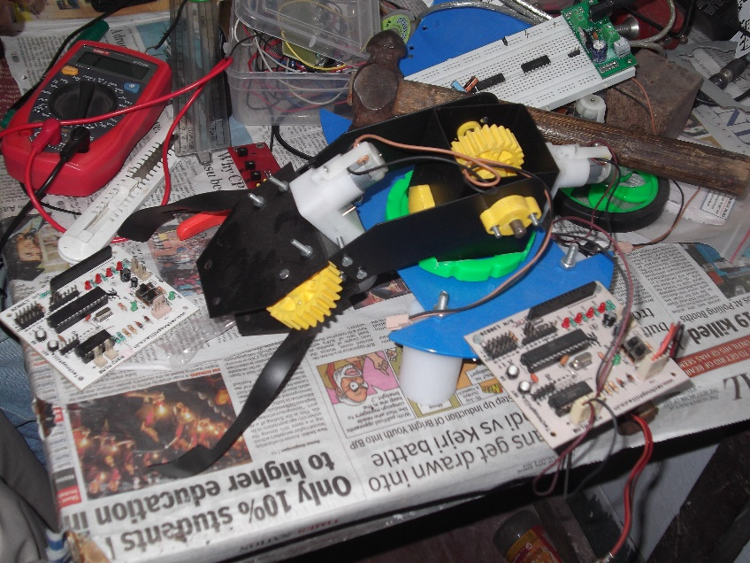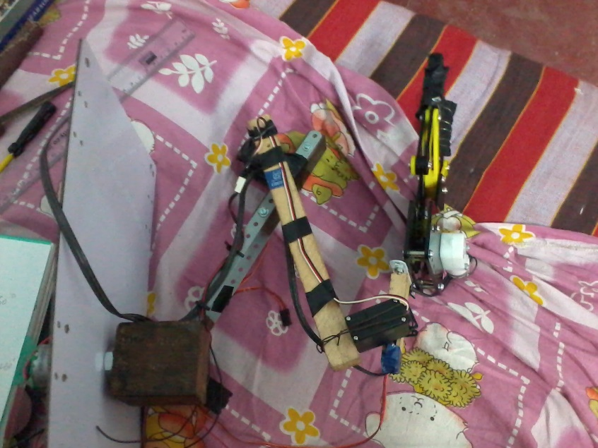The 7-DOF robotic mobile manipulator can be further enhanced with Artificial Intelligence (AI) algorithms to automatically detect entities from its environment and fabricate its own algorithms to solve tasks. One common example is the task to make coffee where milk, coffee, water and sugar is given.  
Furthermore, the robotic arm can be equipped with advanced image processing techniques of pattern analysis whereby it can detect complex structures like human faces and automatically respond to them.

# THE MICRO-MOUSE (Lead by: Arjun Pansari)

This project was inspired by the work of Dr. Pranav Mistry on the revolutionizing 6th Sense Technology. In this project, we created a tiny and simple mouse-like device which could be used to control the mouse pointer of any computer. It works on Linux-based OS and we are trying to get it working under Windows as well. This small device has 4 buttons – Left Click, Right Click, Scroll up and Scroll down and a powerful optical sensor and a camera which together is used to detect movement. A device driver for this device to work in Linux has been programmed by our Computer Science Team. The snapshots of the project is given below:

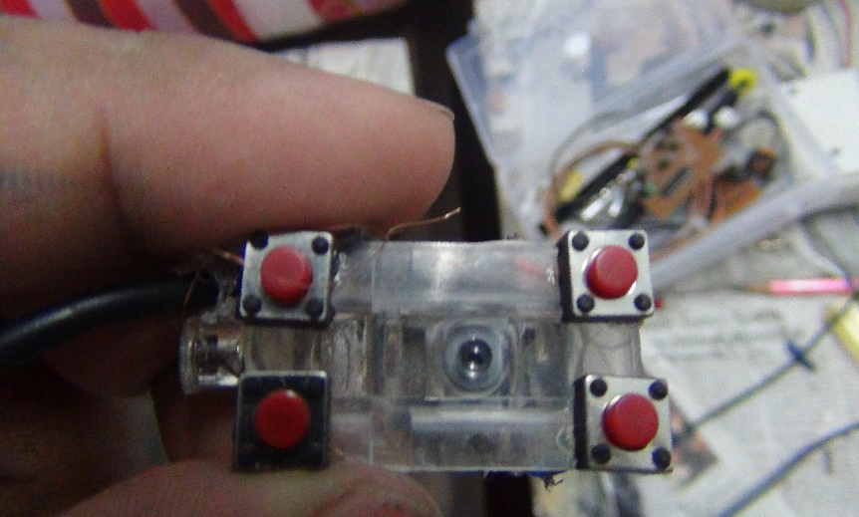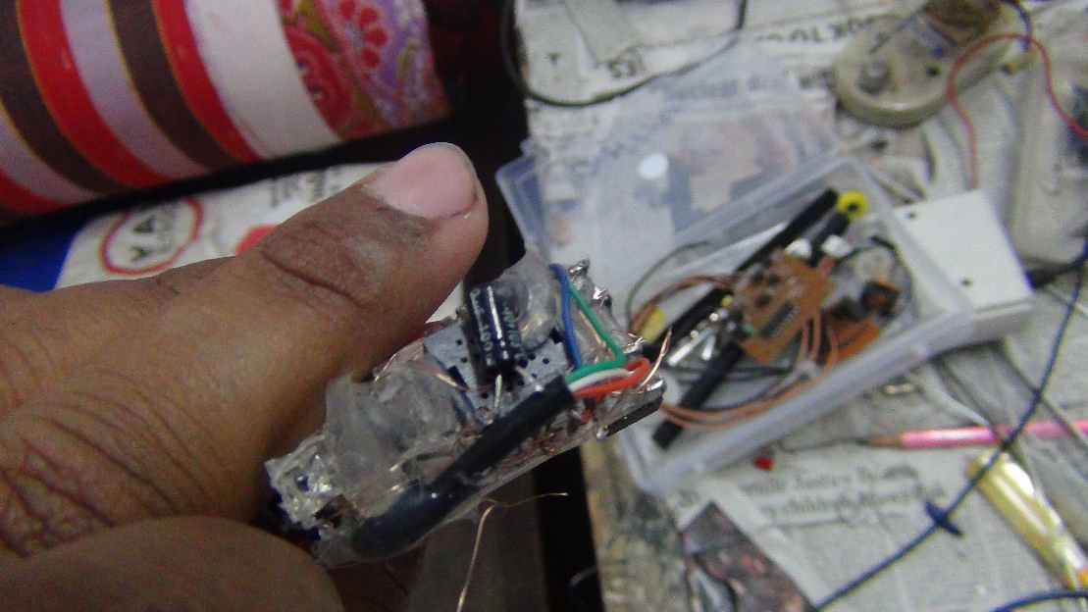

# ADVANCED LINE FOLLOWER (Lead by: Shubhojyoti Ganguly)

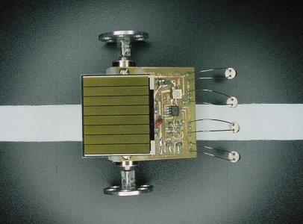This project was inspired by our failure in the line following competition IURL (Indo-Us Robo League) held at IIT Bombay. We strived to design better and faster line followers for the chief purpose of competitions all around India. We designed a line follower run by PID algorithm and then redesigned it using a double PID and a fuzzy-logic based algorithm. It is currently in a testing phase and has several problem which we are trying to rectify. Previously, we also designed a solar powered line follower capable of watering plants in and around the college campus. The solar panel is a 6V -500mA amorphous type solar panel which is run by a Miller Engine circuit for balancing. The snapshots are given below.

# M-POD (Lead by: Shubhojyoti Ganguly)

The M-Pod is a music playing device that looks similar to a long tablet but it can be used to create entire music sequence. It is still in research/design phase and might take more than a year to completion. It can be used to first create a beat sample, add a background mix, add effects to it and make a song. The entire project details are given in the github repository.

Our Financial Overview

# 2014-2015 Budget Plan

Our entire budget plan is divided amongst the different aspects of NARM with each department head controlling his allocation from the total fund. The first meeting every year is the meeting where we decide on the entire budget. The budget is divided among the current number of projects we are working on and the NARM Robocon Team.

The budget for each project we are currently working on is given below:

7-DOF Intelligent Robotic Arm

|  |  |  |
| --- | --- | --- |
| **Instrument** | **Seller Link and Name** | **Price** |
| Digital Oscilloscope **DS1052E** | Adafruit (oscilloscope) | Rs. 25,000(395 usd) |
| Mitutoyo Digital Callipers | Adafruit ([D_Calliper](C:\\Users\\Shubhojyoti Ganguly\\AppData\\Roaming\\Microsoft\\Word\\Mitutoyo - Absolute Digimatic Digital Calipers, 6 in. [500-196-20] ID  294 - $155.00   Adafruit Industries, Unique & fun DIY electronics and kits.htm)) | Rs. 9,691(155 usd) |
| Hakko Soldering Iron | Hakko (Digital Control Iron) | Rs. 6,877(110 usd) |
| Laser Range Finder | Sparkfun, Adafruit | Rs 10,000 |
| Makerbot 3-D Printer | Adafruit | Rs 1.44 lacs (3000 usd) |
| USB Microscope | Adafruit | Rs. 10,000 |
| AutoRanging Multimeter | Sparkfun | Rs. 3,300 |
| Arduino Mega R3 | Arduino | Rs 3,697 |
| PiFace Digital | Crazypi (Element14) | Rs 2,986 |
| PiCamera Module | CrazyPi (Element14) | Rs 3,300 |
| Bosch 32 pc Tool Set | Flipkart.com | Rs 3,900 |
| California to India | Custom Duty for above items | Rs 65,000 |

Total Cost: Rs. 2,93,751

Micro-Mouse

|  |  |  |
| --- | --- | --- |
| **Instrument** | **Seller Link and Name** | **Price** |
| ADNS-5020-EN Optical Mouse Sensor | Parts.arrow.com | Rs. 800 |
| 555 timer and other minor components | Local shops in Bistupur | Rs. 200 |
| 2.4 GHz Wireless Transmission module | Extreme Electronics | Rs. 800 |

Total Cost : Rs 1800

Advanced Line Follower

|  |  |  |
| --- | --- | --- |
| **Instrument** | **Seller Link and Name** | **Price** |
| ADNS-5020-EN Optical Mouse Sensor | Parts.arrow.com | Rs. 800 |
| 555 timer and other minor components | Local shops in Bistupur | Rs. 200 |
| 2.4 GHz Wireless Transmission module | Extreme Electronics | Rs. 800 |

|  |  |  |
| --- | --- | --- |
| **Instrument** | **Seller Link and Name** | **Price** |
| 30:1 Pololu Micro Motor | MG Super Labs | Rs. 1,800 x 4 = Rs. 7,200 |
| Encoder of micromotors | MG Super Labs | Rs. 1,200 x4= Rs. 4,800 |
| QTR-8A Reflectance Sensor | Explore labs | Rs. 120 x 8 = Rs. 960 |
| NCP 1402 5v switching regulator | MG Super Labs | Rs. 400 |
| Micromotor Metal Bracket | MG Super Labs | Rs 600 x2 =Rs. 1200 |
| Polycarbonate chasis | MG Super Labs | Rs. 989 |
| 32x7mm plastic wheels | MG Super Labs | Rs. 499 x2= Rs 998 |
| Arduino Mega R3 | Arduino | Rs 3,697 |
| USB Programmer | MG Super Labs | Rs. 1200 |

Total Cost: Rs. 21,444

# Research Expenditure

The research expenditure is a separate fund for conducting research on projects yet to be developed. A number of areas where research is to be conducted is decided before hand and a target goal is set beforehand to conduct research on the particular area. The result of this research is the publication of journals and papers. The intellectual material so generated is copyrighted and is to be used only by NARM Robotics and other collaborating teams within the college.

Total Cost: Rs. 40,000

# Travel and Accomodation Expenditure

# Total Cost : Rs. 29,800

# Total Budget : Rs. 3,86,795

Our Promotional Plans

How to Join the NARM Venture

# The Induction Process (September - November)

We believe a proper team with all member co-operating amongst themselves and working in a very healthy environment is crucial for success in a team venture. That is why, we have a rigorous induction process for taking part in the NARM Venture. Our entire induction process is outline below:

# Online Membership

Students who are not selected via the Induction process can apply for an online membership too. Students from other colleges can also join this venture by the online membership process.  
This process is selected solely based on a person’s merit and nothing else. This will give access to all private projects of this venture.