Importing requried labries

In [1]:

import pandas as pd

import numpy as np

from sklearn import linear_model

from sklearn.preprocessing import LabelEncoder

from sklearn.model_selection import train_test_split

In [2]:

cardata=pd.read_csv("/content/CAR DETAILS FROM CAR DEKHO.csv")

cardata.head()

Out[2]:

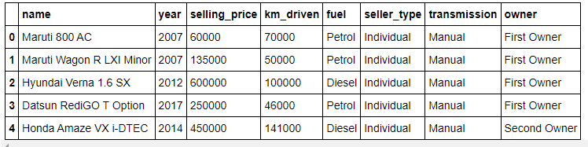

information about dataframe

In [3]:

cardata.info()

<class 'pandas.core.frame.DataFrame'>

RangeIndex: 4340 entries, 0 to 4339

Data columns (total 8 columns):

# Column Non-Null Count Dtype

--- ------ -------------- -----

0 name 4340 non-null object

1 year 4340 non-null int64

2 selling_price 4340 non-null int64

3 km_driven 4340 non-null int64

4 fuel 4340 non-null object

5 seller_type 4340 non-null object

6 transmission 4340 non-null object

7 owner 4340 non-null object

dtypes: int64(3), object(5)

memory usage: 271.4+ KB

seperating dependent and independent variables

In [4]:

input_data=cardata.drop(["name"],axis=1)

target_data=cardata.selling_price

Checking data

In [5]:

print(input_data.head())

print(target_data.head())

year selling_price km_driven ... seller_type transmission owner

0 2007 60000 70000 ... Individual Manual First Owner

1 2007 135000 50000 ... Individual Manual First Owner

2 2012 600000 100000 ... Individual Manual First Owner

3 2017 250000 46000 ... Individual Manual First Owner

4 2014 450000 141000 ... Individual Manual Second Owner

[5 rows x 7 columns]

0 60000

1 135000

2 600000

3 250000

4 450000

Name: selling_price, dtype: int64

Encoding the categorical columns

In [6]:

enc=LabelEncoder()

input_data['seller_type']=enc.fit_transform(input_data['seller_type'])

input_data["transmission"]=enc.fit_transform(input_data['transmission'])

input_data["owner"]=enc.fit_transform(input_data['owner'])

input_data["fuel"]=enc.fit_transform(input_data['fuel'])

In [8]:

cardata.fuel.value_counts()

Out[8]:

Diesel 2153

Petrol 2123

CNG 40

LPG 23

Electric 1

Name: fuel, dtype: int64

In [9]:

input_data.head(10)

Out[9]:

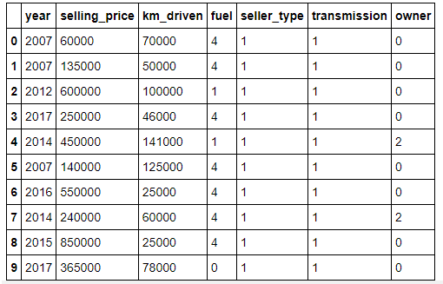

In [10]:

import seaborn as sns

import matplotlib.pyplot as plt

plt.style.use('seaborn-white')

plotting relation of each independent variable with dependent variable

In [11]:

plt.figure(figsize=(25,5))

plt.subplot(1,5,1)

sns.scatterplot(x=input_data["km_driven"],y=input_data['selling_price'])

plt.subplot(1,5,2)

sns.scatterplot(x=input_data['transmission'],y=input_data['selling_price'])

plt.subplot(1,5,3)

sns.scatterplot(x=input_data['seller_type'],y=input_data['selling_price'])

plt.subplot(1,5,4)

sns.scatterplot(x=input_data['fuel'],y=input_data['selling_price'])

plt.subplot(1,5,5)

sns.scatterplot(x=input_data['owner'],y=input_data['selling_price'])

Out[11]:

<matplotlib.axes._subplots.AxesSubplot at 0x7ff71916f450>

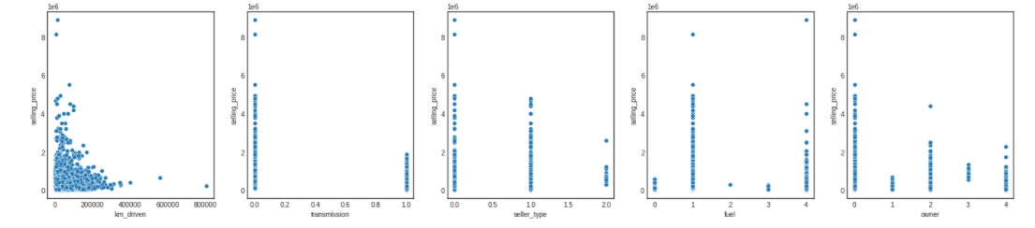

Splitting data into training and testing data

In [12]:

x_train,x_test,y_train,y_test=train_test_split(input_data,target_data,test_size=0.3,random_state=32)

print(x_train.shape)

print(x_test.shape)

(3038, 7)

(1302, 7)

Instantiating Linear Regression model

In [13]:

model=linear_model.LinearRegression()

In [14]:

model.fit(x_train,y_train)

Out[14]:

LinearRegression(copy_X=True, fit_intercept=True, n_jobs=None, normalize=False)

In [15]:

y_pred=model.predict(x_test)

Evaluation metrics

In [16]:

from sklearn.metrics import r2_score,mean_squared_error,mean_absolute_error

r2_score(y_test,y_pred)

Out[16]:

1.0

In [17]:

mean_squared_error(y_test,y_pred)

Out[17]:

1.660773336078694e-20

In [18]:

mean_absolute_error(y_test,y_pred)

Out[18]:

5.902355170584128e-11

Testing the model with real independent values from dataset

In [19]:

pred=model.predict([[2007,135000,50000,4,1,1,0]])

print(pred)

[135000.]

In [20]:

target_data[1]

Out[20]:

135000

In [ ]:

Both the predicted and actual values are same so our model is performing well