
APEX MOTORS INC.
Annual Report
Fiscal Year 2025
Austin, Texas • Founded 2015 • 1,240 Employees
Prepared for shareholders and prospective partners. This report summarizes Apex Motors’ financial, operational, and regional performance for the twelve months ended December 31, 2025.

Executive Summary
Apex Motors closed fiscal year 2025 with $612.4 million in revenue on 16,070 vehicles sold, marking the company’s strongest year since its 2015 founding. Growth accelerated each quarter, with Q4 alone contributing $181.1 million in revenue and 4,610 units — a 34% increase over Q1.
The results were driven by strong demand for the Apex SUV Trailblazer, continued expansion in the South region, and steady gains in average transaction price as the company shifted its mix toward higher-margin SUV and truck models. Customer satisfaction held at 4.6 out of 5, among the highest in the industry.

FY2025 Financial Highlights
Quarter | Units Sold | Revenue (USD)
Q1 2025 | 3,420 | $128,500,000
Q2 2025 | 3,890 | $146,000,000
Q3 2025 | 4,150 | $156,800,000
Q4 2025 | 4,610 | $181,100,000
FY2025 Total | 16,070 | $612,400,000

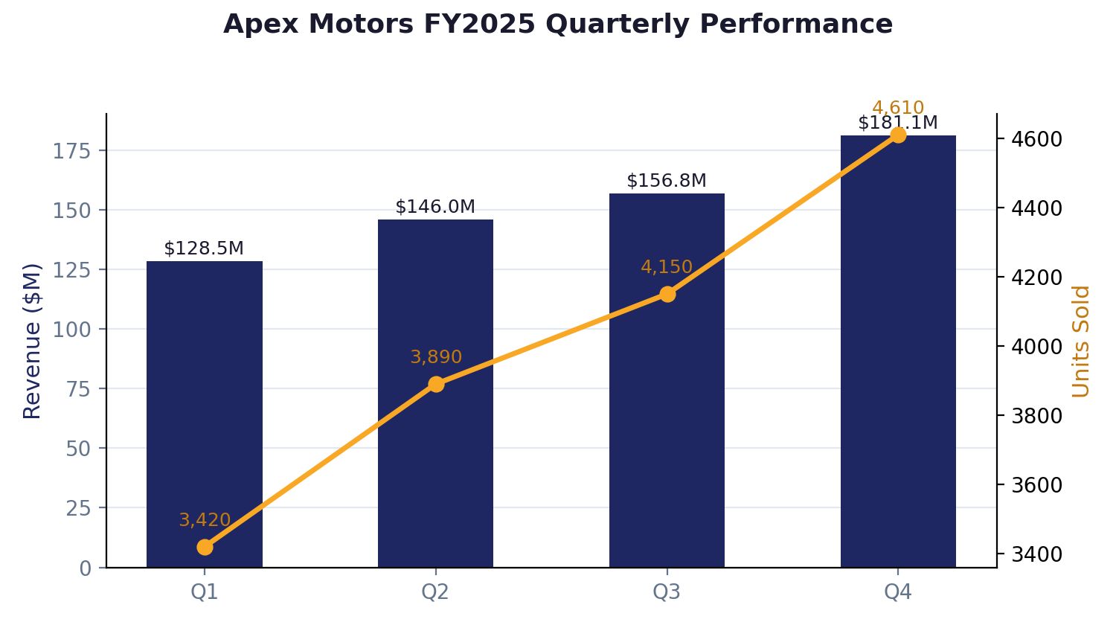
Figure 1. Quarterly revenue and unit sales, FY2025.

Regional Performance
Apex Motors sells through four regional networks: North, South, East, and West. The South region remained the company’s largest market for the third consecutive year, accounting for nearly a third of total unit sales, reflecting strong dealer density and continued population growth across the region.
Region | Units Sold | Share of FY2025 Sales
North | 4,250 | 26.4%
South | 5,150 | 32.0%
East | 3,180 | 19.8%
West | 3,490 | 21.7%
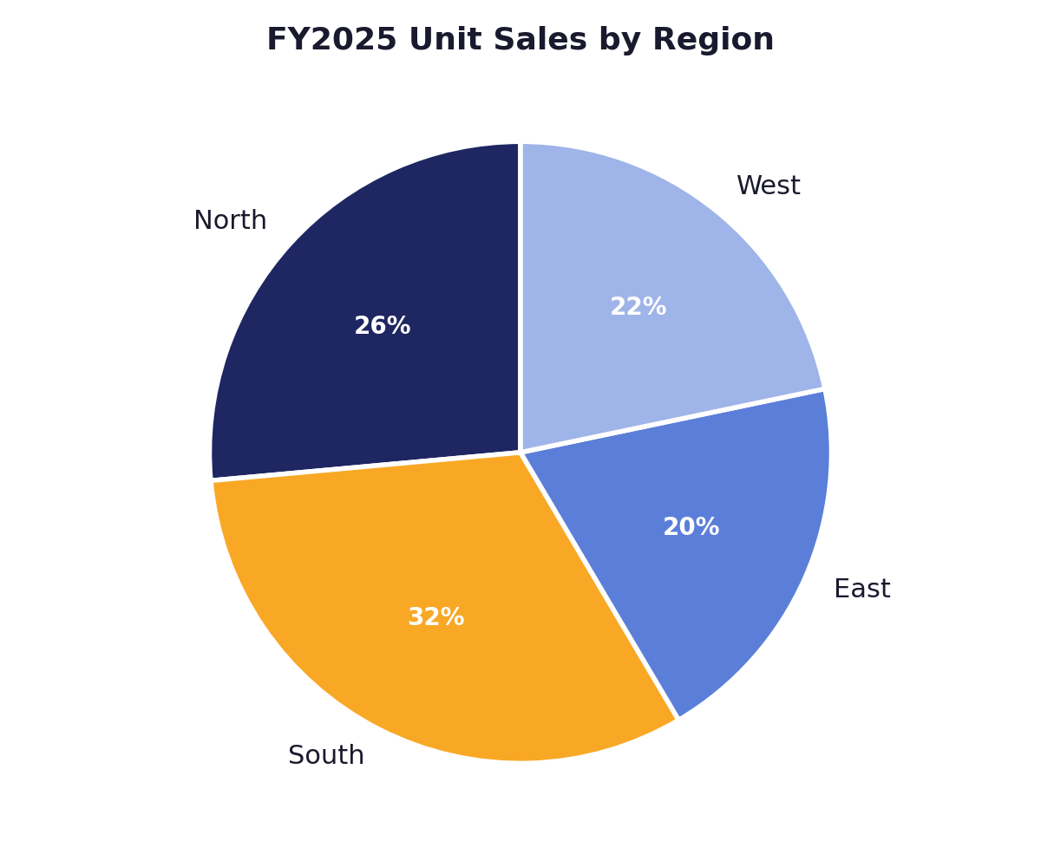
Figure 2. FY2025 unit sales by region.
East remains the company’s smallest region by volume, and management has identified it as a priority for FY2026 expansion alongside two new regional service centers planned for the year.

Product Lineup
Apex Motors’ five-model lineup spans the sedan, SUV, pickup truck, electric hatchback, and coupe segments. The Apex SUV Trailblazer was the company’s top seller in FY2025, while the Apex EV Volt-X posted the fastest year-over-year growth as electric vehicle demand continued to build.
Model | Body Type | Starting Price | FY2025 Units
Apex Sedan LX | Sedan | $32,500 | 4,820
Apex SUV Trailblazer | SUV | $41,200 | 5,640
Apex Truck Workhorse | Pickup Truck | $44,800 | 2,910
Apex EV Volt-X | Electric Hatchback | $46,900 | 1,850
Apex Coupe Spark | Coupe | $35,600 | 850
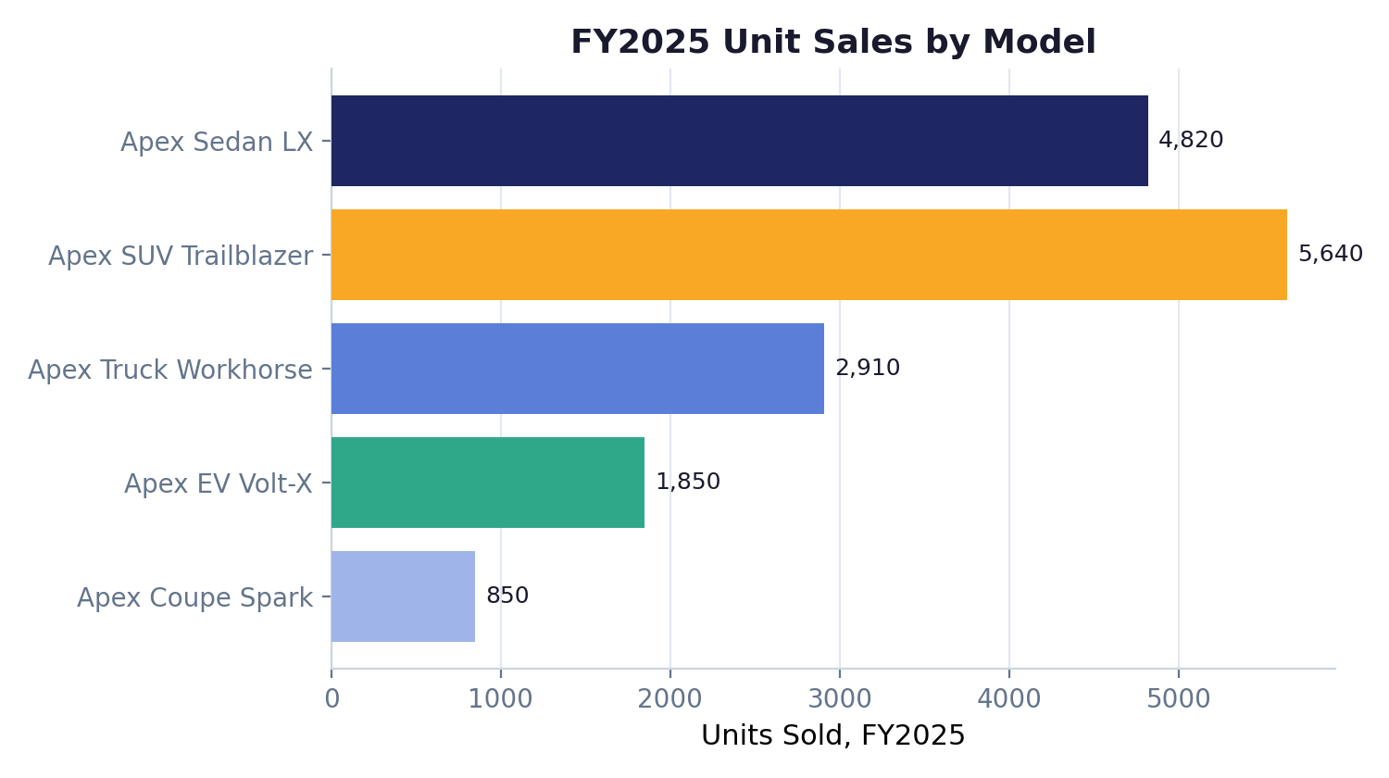
Figure 3. FY2025 unit sales by model.

Workforce
Apex Motors employed 1,240 people as of fiscal year-end 2025, spread across manufacturing, sales, corporate functions, and research & development. Manufacturing remains the largest department, reflecting the company’s vertically integrated production model at its Austin facility.
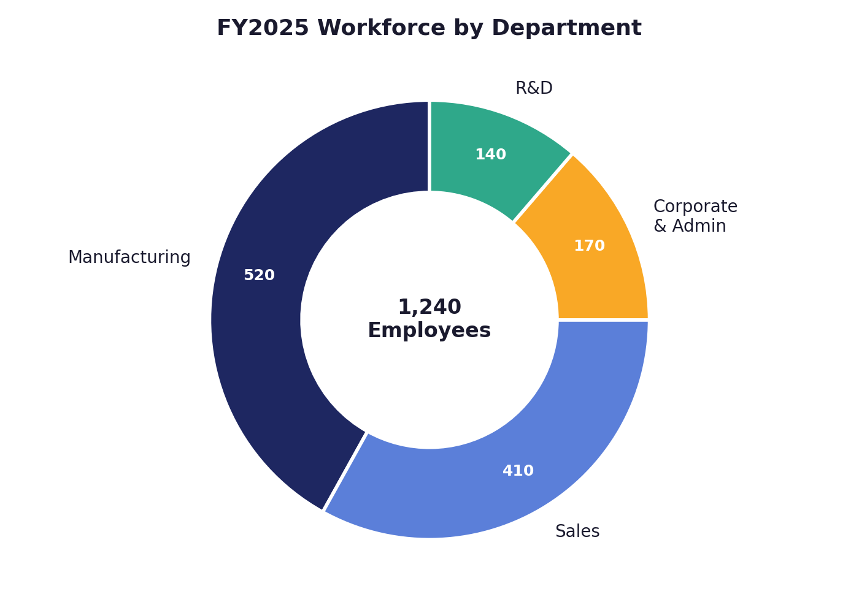
Figure 4. FY2025 workforce by department.

FY2026 Outlook
Management is targeting 12% unit sales growth for FY2026, supported by a planned 3,000-unit increase in Apex EV Volt-X production capacity and the opening of two new regional service centers, with East region expansion as a key priority.
The company will continue to invest in customer experience initiatives aimed at lifting its CSAT score from 4.6 toward a target of 5.0, while maintaining disciplined cost management across its manufacturing and supply chain operations.
This report was prepared by Apex Motors Inc. for informational purposes and does not constitute investment advice.

