software ENGINEERING: process and tools

student no: s371129

student name: narmadha bandla

submitted TO: charles yeo

Report On

**Guess the Number game** using **Test Driven Development Python**

content page:

1.introduction…………………………………………………………………………………………………2

2.process……………………………………………………………………………………………………………2

3.conclusion…………………………………………………………………………………………………….6

1.introduction:

The objective of this project is to develop a “Guess the number” game using Test Driven Development (TDD) in python. The game involves generating a random four-digit number, and the player’s goal is to guess this number. The program will supply clues represented by ‘circle’ and ‘x’ symbols, denoting accurate digits placed correctly or incorrectly. The game will continue until the player correctly guesses the number or decides to quit. The game requirements are:

* Generate a random four-digit number.
* Prompt the player for guesses until they guess correctly or quit.
* Provide ‘circle’ and ‘X’ indications to assist in assessing the accuracy of each guess.
* Display the number of attempts taken.
* Allow the player to choose to play again or quit.

2.PROCESS:

Test case1:

Test setup: Begin by setting up the testing environment and creating test cases for each requirement.

1.Write initial state cases based on the requirements. These tests will initially fail since the corresponding functionality is not yet implemented.

2.Construct the fundamental game logic to satisfy the requirements and make the initial tests pass.

3. ‘generate_random_number’ function produces a four-digit number within specified range. And then implementation using python’s random module.

4.The obejective is to generate a random four-digit number between 1000 and 9999.

Screenshots example:

guess_game contain a actual logic for ‘generate_random_number’ function.

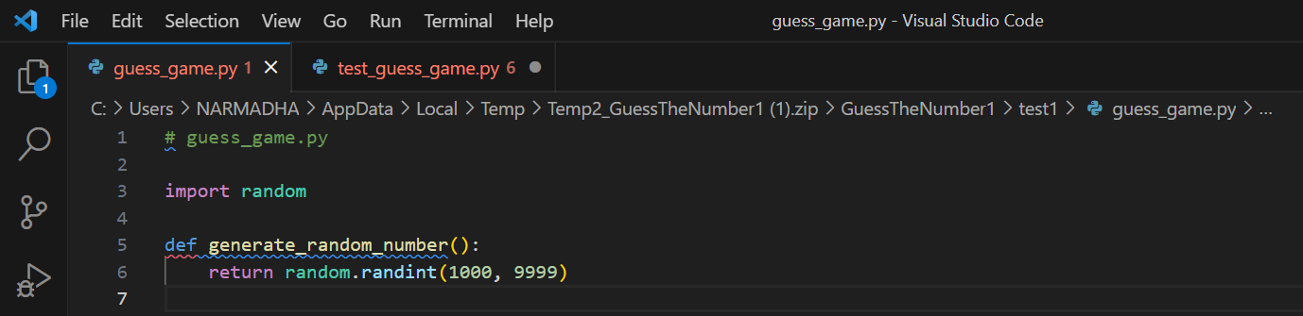

Using function to produce a four-digit number.

test_guess_game contain test case for generate_random_number’ function. i have done unit testing here.

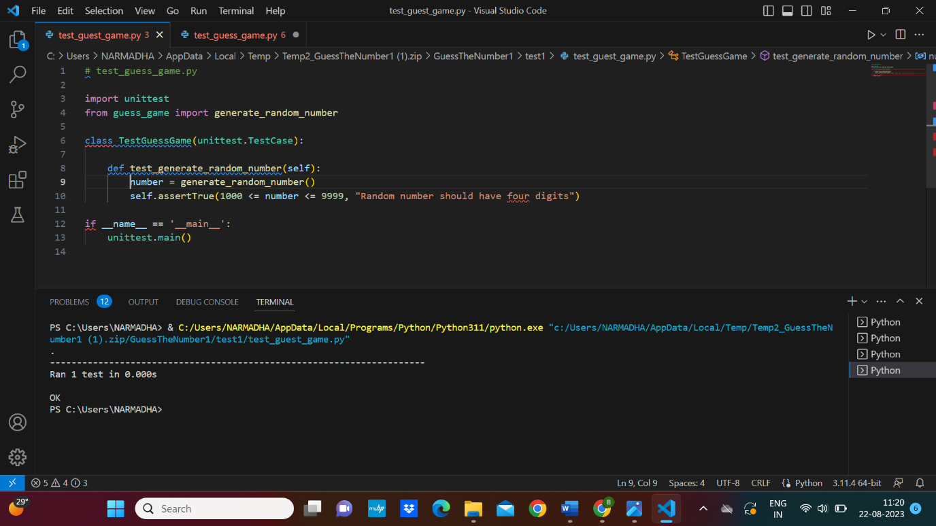 The TDD process applied to requirement 1(Generate a random four-digit number.

Test case2:

Test setup: the purpose of this test case to validate the ‘check_guess’ functions accuracy providing feedback on the player’s guess.

1.The implementation of the check_guess function in green phase.

2. ‘circle’ symbol indicates that a digit in the player’s guess is correct and is in the right position

In the secret number.

3. an ‘X’ symbol indicates that a digit in the player’s guess is correct but is in the wrong position in the secret number.

4. if a digit in the player’s guess matches a digit in the secret number but is not in the same position, it is represented by an X.

5. The combination of circles and X’s helps players deduce the secret number by iteratively adjusting their guesses bases on the provided feedback.

guess_game contain a check guess game logic.

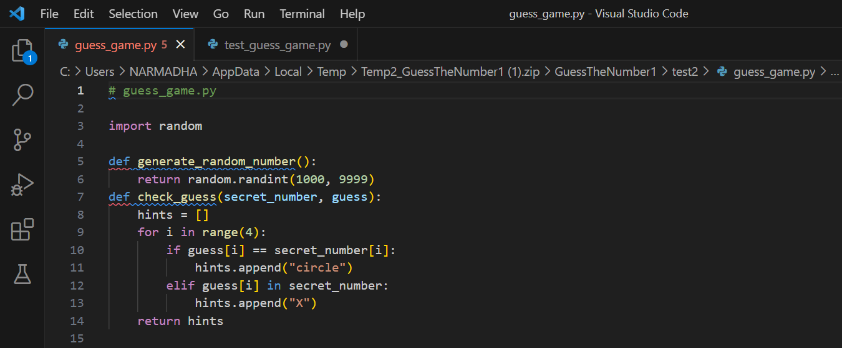

Implementation of guess the number using function.

test_guess_game contains test cases for test_check_guess function. I have done unit testing here.

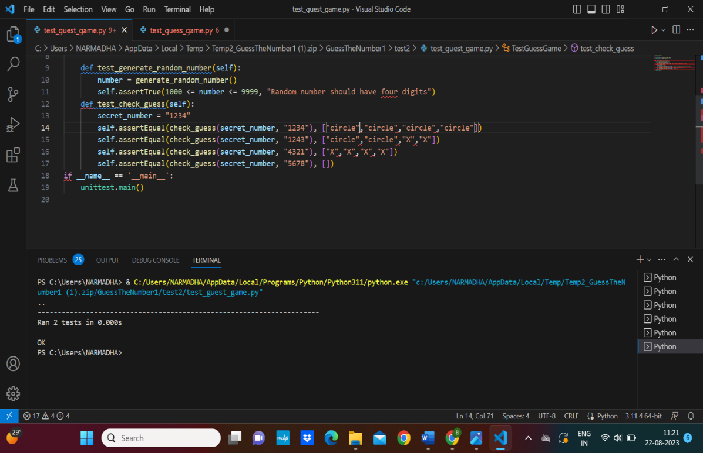

Unit test suites the testing function in guess the game.

Test case3:

Test setup: this test case focuses on validating the ‘game_loop’ function’s behavior upon successfully guessing the number.

1.a winning scenario by setting the secret number and generating a mock random number.

2.import unittest this imports the ‘unittest’ module, which provides the framework for writing and running unit tests.

3.this helps ensure that the game functions correctly and helps catch potential issues early in the development process.

4. The TDD offers code confidence and writing tests before code ensures that the code works as intended. Passing tests provide confidence in the correctness of the code.

Guess_game contains actual game_loop() function

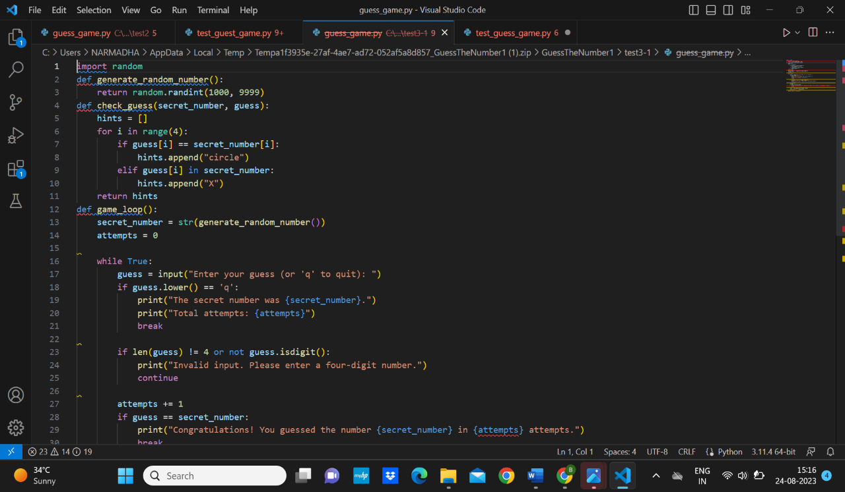

This is the implementation of code for guess the number.

Test_guess_game is a test case for test_check_guess function. I have performed unit testing here.

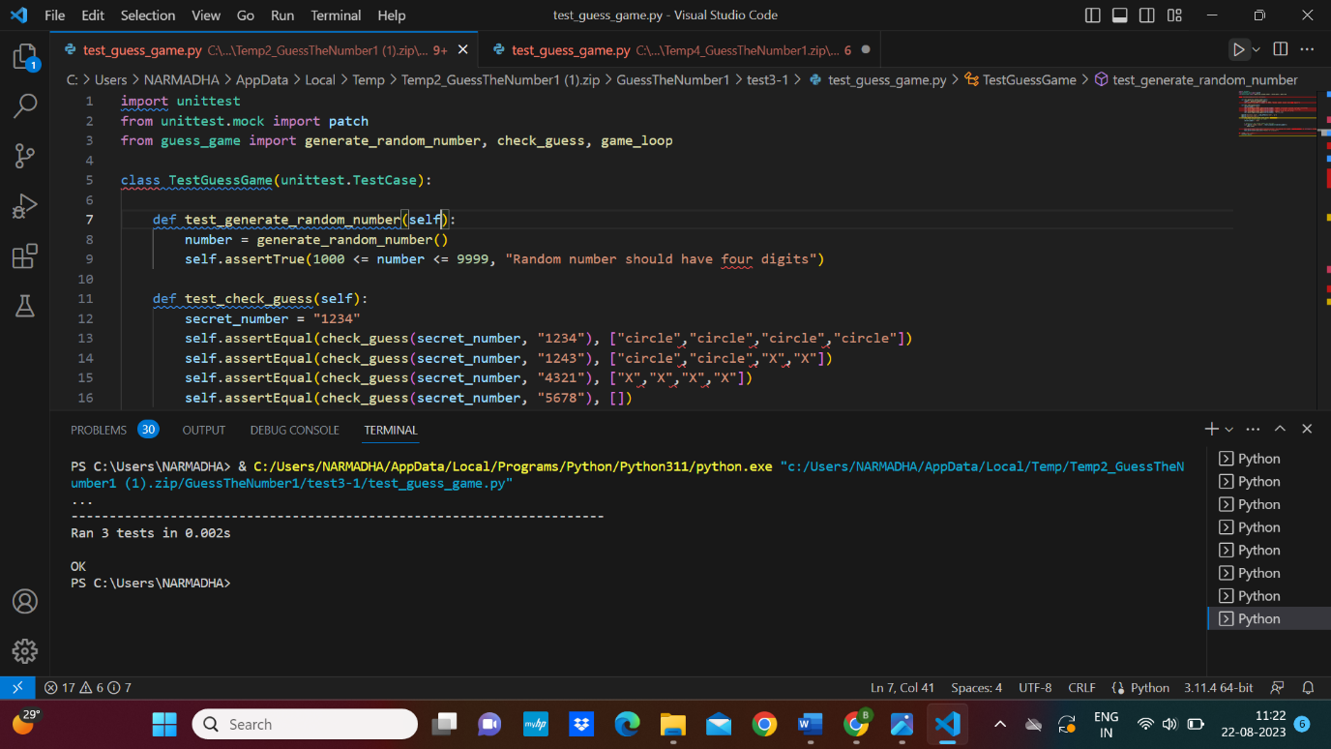

This is the unit tests for the functions and code for guessing the numbers.

3.conclusion:

In conclusion, this project utilized test driven development to create a python based “Guess the Number” game. By adhering to the TDD methodology, each requirement underwent through testing and was implemented before proceeding to the next. This approach enhances the reliability and maintainability of the codebase by detecting issues early in the development cycle. The experience underscores the importance of comprehensive testing.

GitHub link: