WEEK 8 TASK

Database Relationship Analysis using Joins

An e-commerce company stores customer, product, order, and payment details in separate tables. The management team wants to combine these tables using SQL Joins to understand customer purchases, order details, sales revenue, and payment status.
Students use INNER JOIN, LEFT JOIN, and RIGHT JOIN to retrieve related information, identify customers who have not purchased products, analyze purchase history, and generate business reports.
1. Customer Table
- Customer_ID: Unique ID for each customer. It is the Primary Key.
- Customer_Name: Stores the name of the customer.
- Email: Stores the customer's email address.
- City: Stores the customer's city.

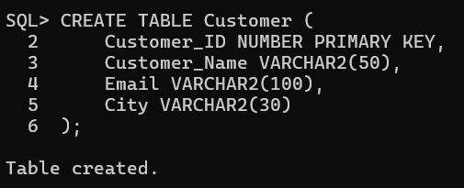

2. Orders Table
- Order_ID: Unique ID for each order. It is the Primary Key.
- Customer_ID: Identifies the customer who placed the order. It is a Foreign Key.
- Order_Date: Stores the date of the order.
- Total_Amount: Stores the total amount of the order.
- Order_Status: Stores the current status of the order.

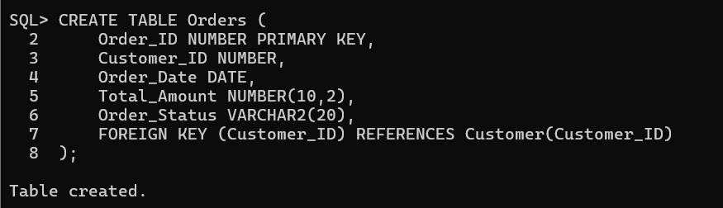
3. Product Table
- Product_ID: Unique ID for each product. It is the Primary Key.
- Product_Name: Stores the name of the product.
- Price: Stores the price of the product.
- Category_ID: Identifies the category to which the product belongs.

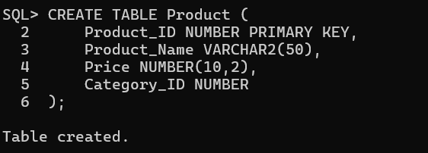
4. Payment Table
- Payment_ID: Unique ID for each payment. It is the Primary Key.
- Order_ID: Identifies the order for which payment is made. It is a Foreign Key.
- Payment_Mode: Stores the payment method, such as cash, UPI, or card.
- Payment_Status: Stores the payment status, such as successful or failed.

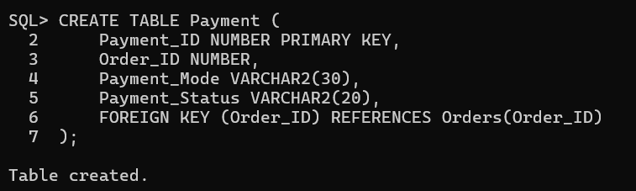

2. Implement INNER JOIN
INNER JOIN is used to combine data from two or more tables.
It displays only the records that match in both tables.
It uses the ON condition to connect tables using a common attribute.
1. Display customer details along with their orders.
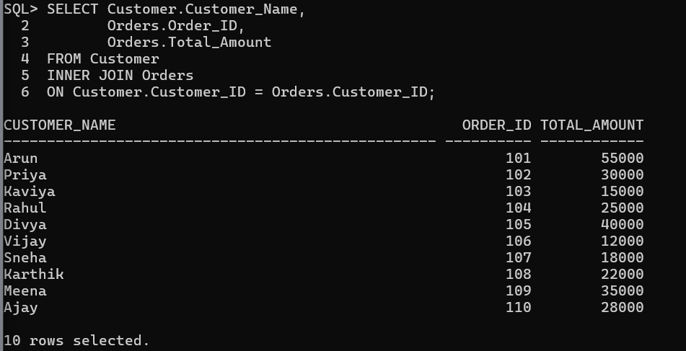
2. Display order details with payment information.
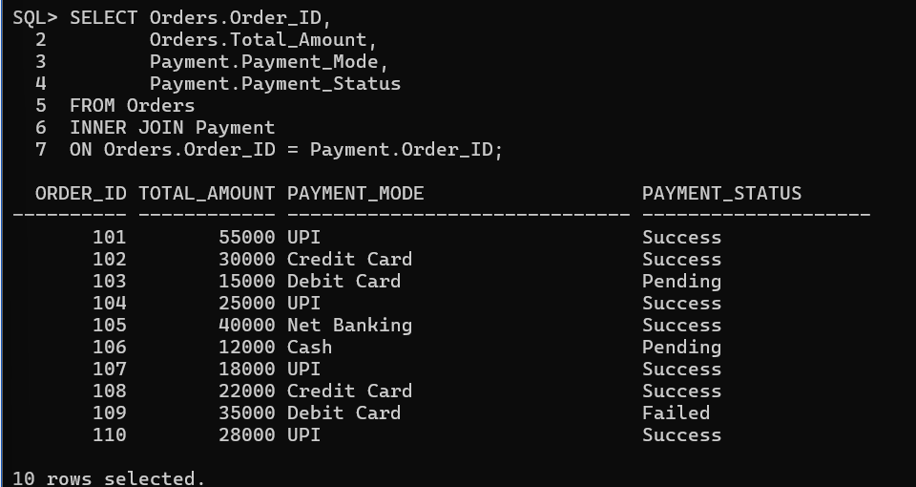

3. Retrieve products purchased by customers. 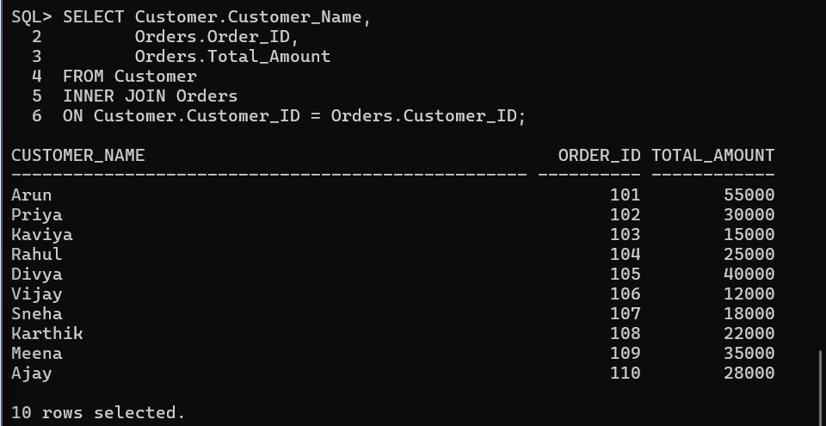
3. Implement LEFT JOIN
LEFT JOIN combines data from two tables.
It displays all records from the left table and matching records from the right table.
If there is no matching record, the right table values will show as NULL.
1. Display all customers including customers who have not placed orders.
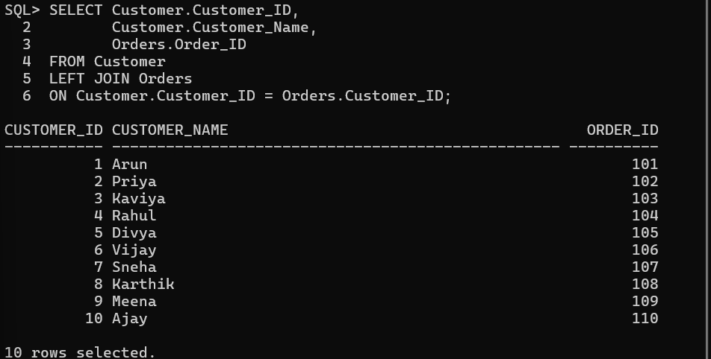

2. Find customers without any purchases. 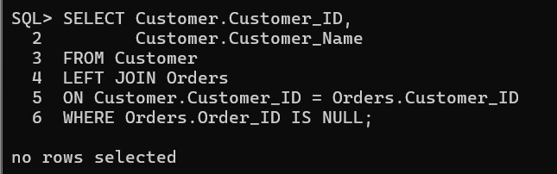
3. Display all products including products with no sales.
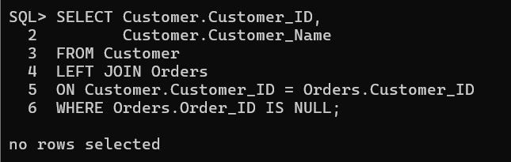

4. Implement RIGHT JOIN
RIGHT JOIN combines data from two tables.
It returns all records from the right table and matching records from the left table.
If there is no matching record, the left table columns display NULL.

- Display all orders with customer information.
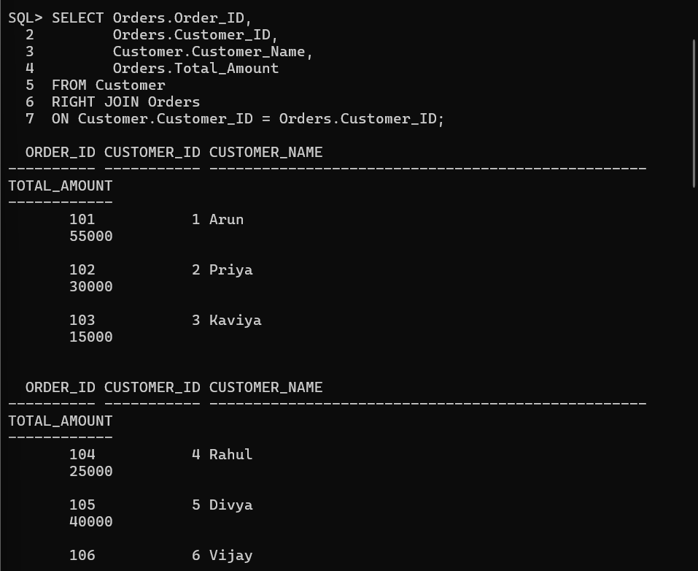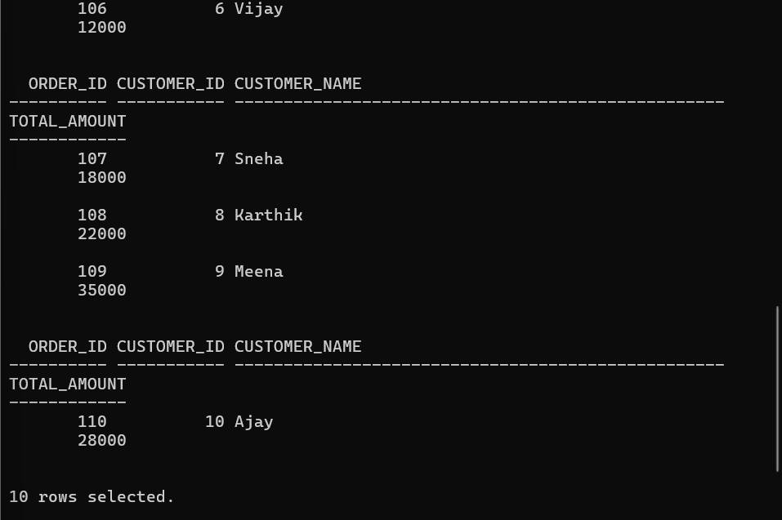
2. Find orders where customer details are missing.
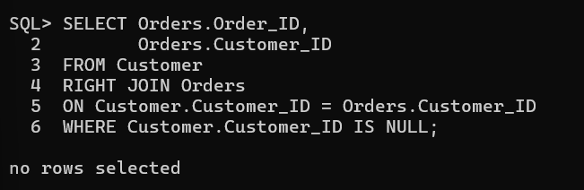
3. Display all payment records with order details.
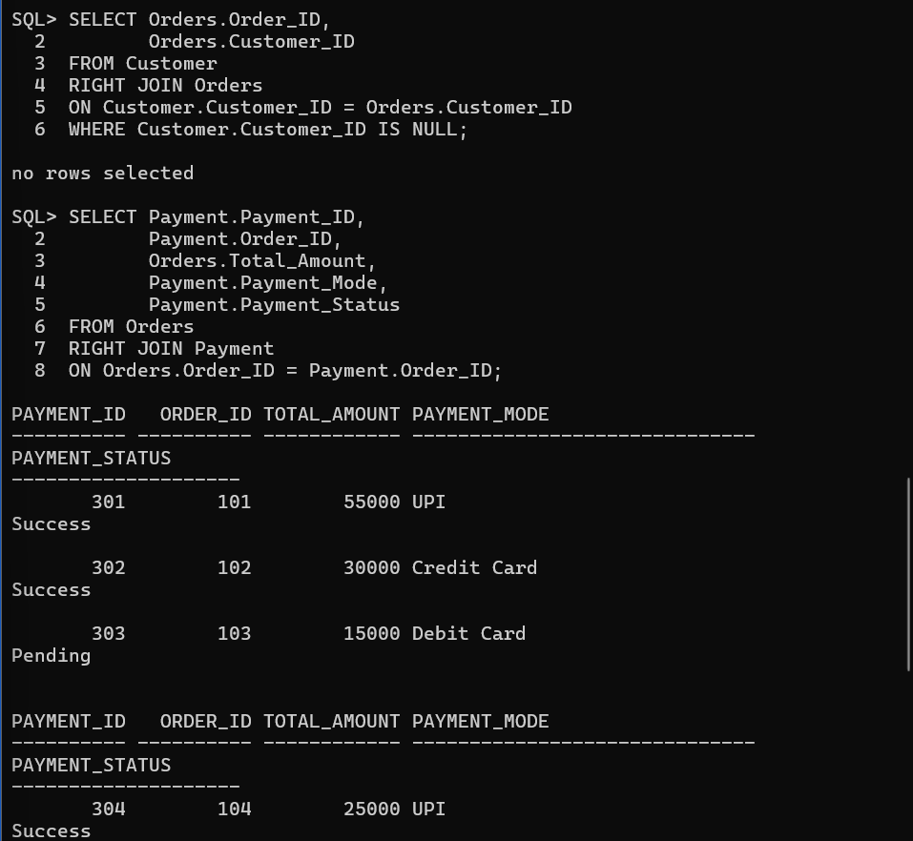

5. Retrieve Complete Order Details
This query combines Customer, Orders, Order_Items, Product, and Payment tables using INNER JOIN.
It displays the customer name, product name, quantity, order date, total amount, and payment status in a complete order report.

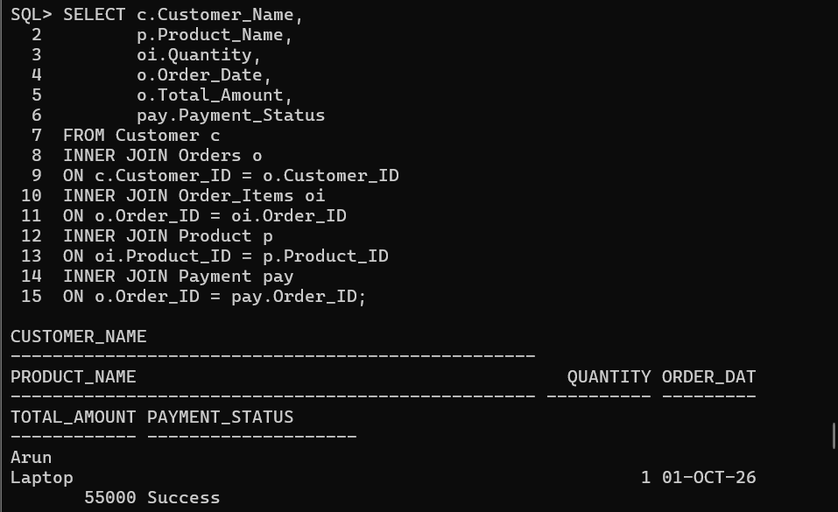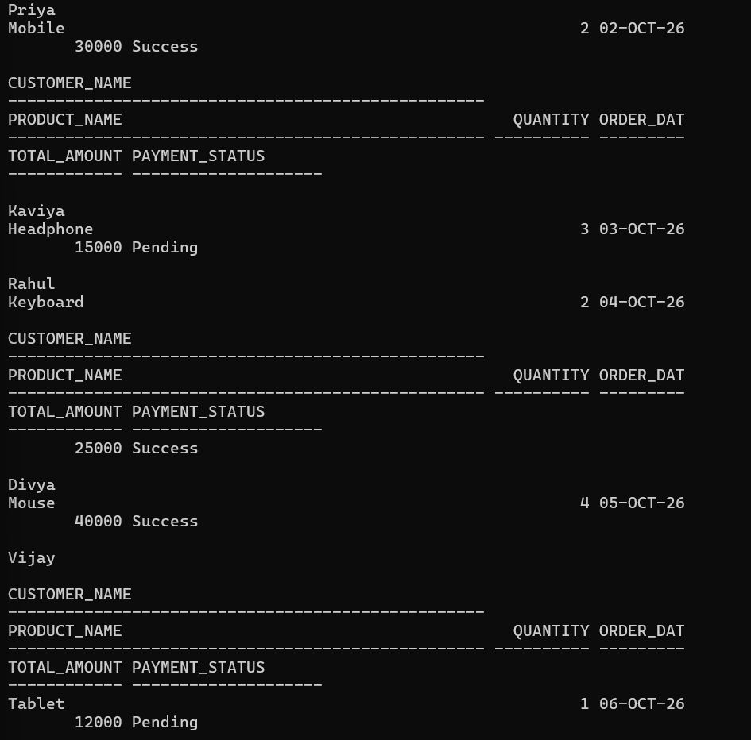
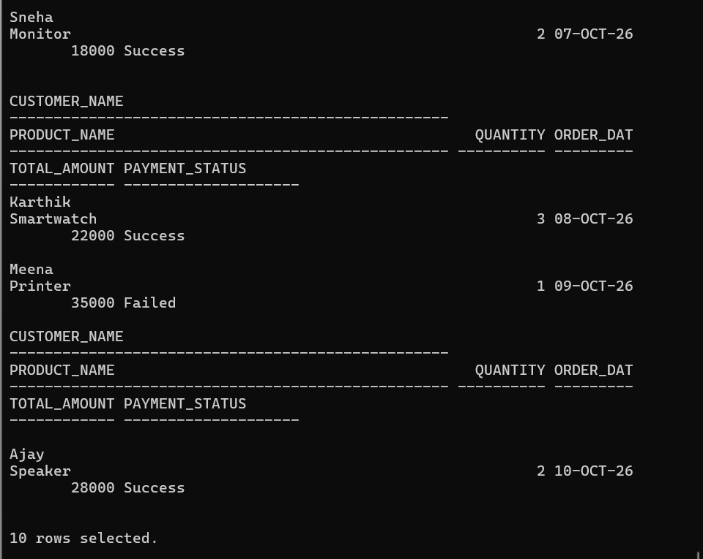

6. Display Customer Purchase History

Customer Purchase History helps track the products purchased by each customer and their total spending.
It also identifies the number of orders placed and the latest purchase details of each customer.

1. All products purchased by a customer.
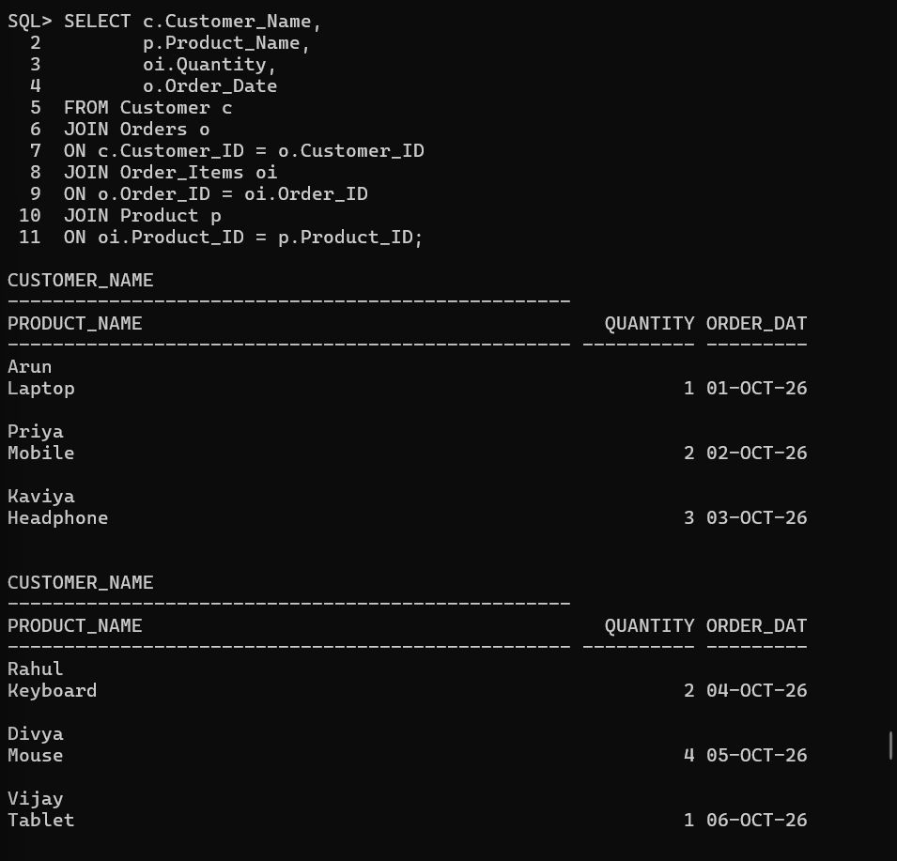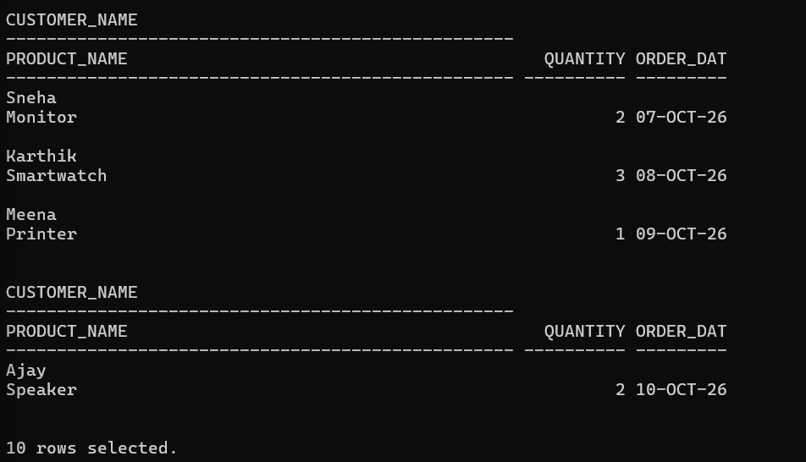
2. Total amount spent by each customer.
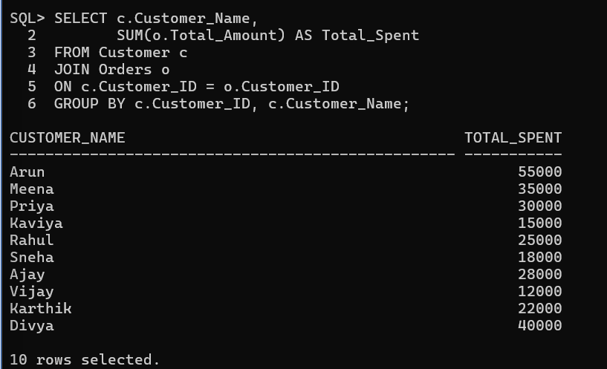
3. Number of orders placed by each customer.
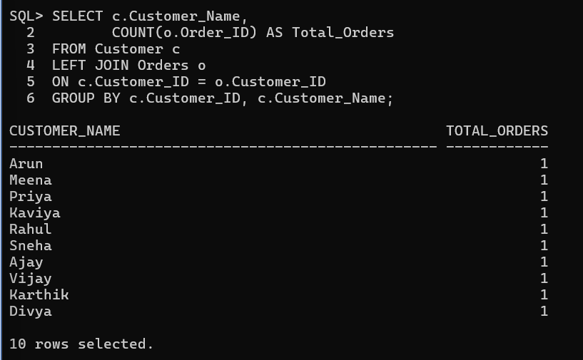

4. Latest purchase details of customers.
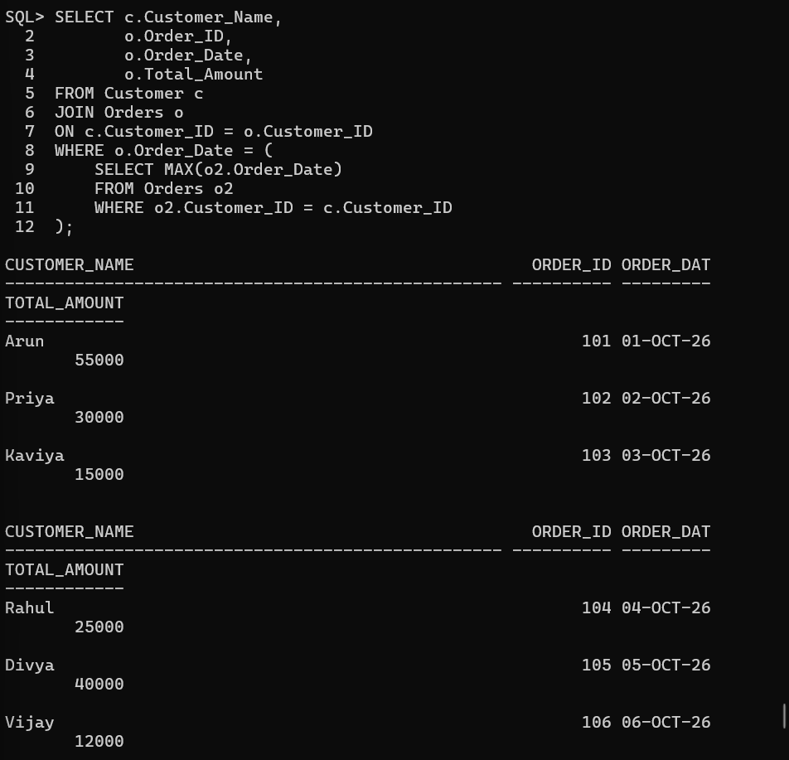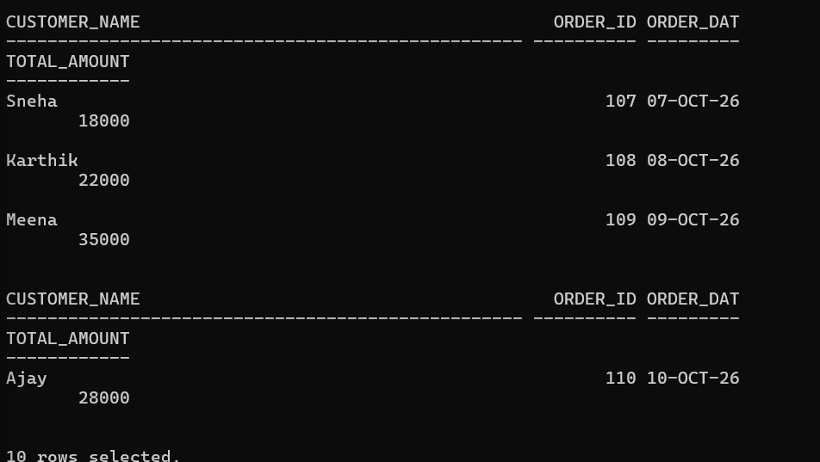
7. Generate Multi-Table Business Reports
Report 1: Customer Order Report:
Requirements:
- Retrieve Customer_Name from the Customer table.
- Retrieve Order_ID, Order_Date, and Order_Status from the Orders table.
- Use INNER JOIN to connect both tables using Customer_ID.
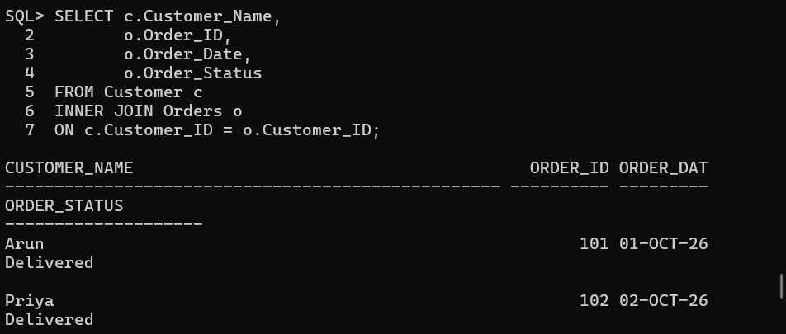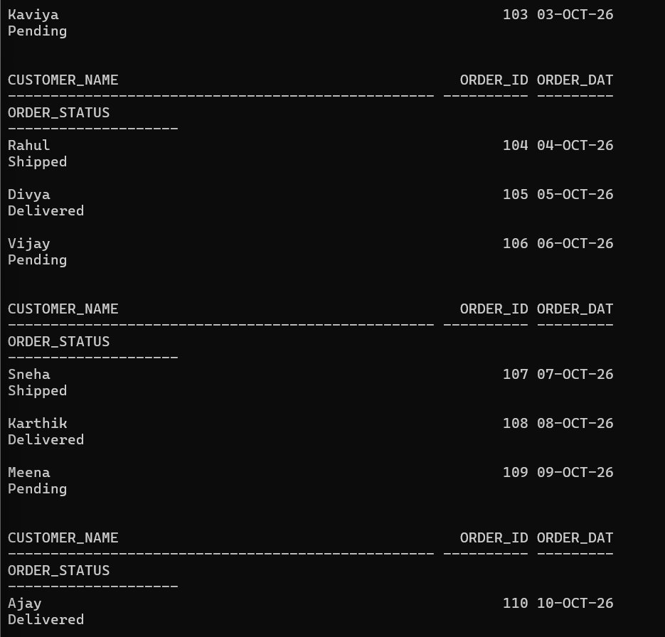

Report 2: Sales Report
Requirements:
- Retrieve Product_Name from the Product table.
- Calculate Quantity_Sold using SUM(Quantity) from the Order_Items table.
- Calculate Total_Revenue using Price × Quantity.
- Use INNER JOIN to connect Product and Order_Items tables using Product_ID.
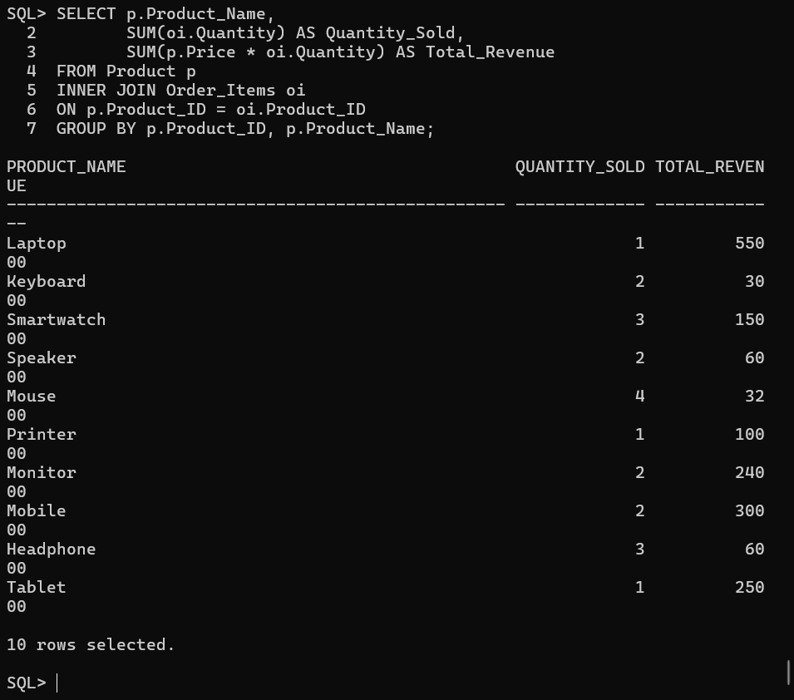 Report 3: Payment Analysis Report
Requirements:
- Retrieve Payment_Mode from the Payment table.
- Count the number of transactions using COUNT(*).
- Count successful payments using the SUM() function and CASE condition.
- Group the results by Payment_Mode.
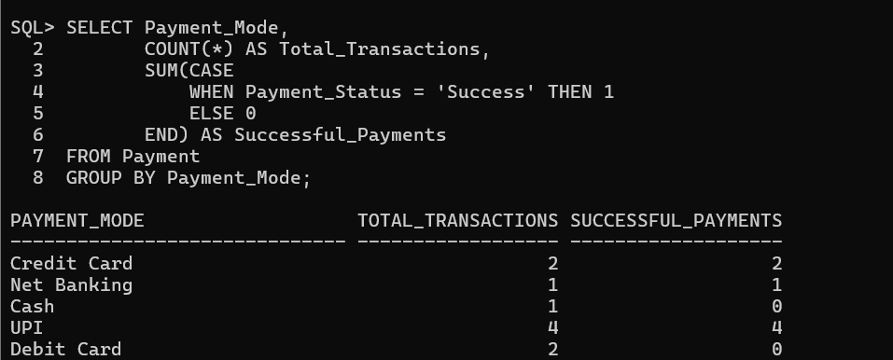
Report 4: Customer Purchase Analysis
1. Top Purchasing Customers
Requirements:
- Retrieve Customer_Name from the Customer table.
- Calculate the total amount spent by each customer.
- Display customers in descending order of spending.
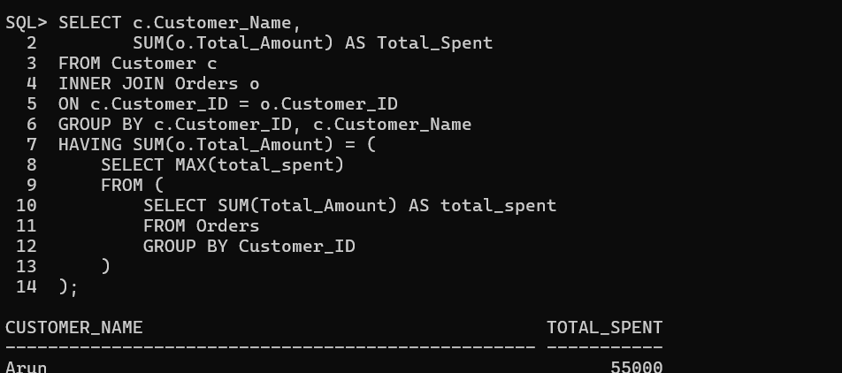

Conclusion
This project helped us understand how to use SQL Joins to combine related tables in a database. We used INNER JOIN, LEFT JOIN, and RIGHT JOIN to retrieve customer, order, product, and payment details. We also generated business reports to analyze customer purchases, sales revenue, and payment status. Thus, SQL Joins help organize data and support effective business decision-making.

