Q1: THE GEOGRAPHIC STORY
Geographic Distribution of Electoral Change in the 2026 Tamil Nadu Assembly Election
Prepared by: Narmatha Annadurai | Data Analyst
AtliQ Media Research Documentation | Codebasics Resume Project Challenge
Headline Finding
Tamil Nadu did not shift uniformly in 2026. The highest regional flip rate was 93.8% in Chennai Metro, while the lowest was 45.5% in Delta, showing a 48.3 percentage-point spread in electoral change across regions.

1. Executive Summary
This research document answers Q1 from the Codebasics RPC challenge: how seat distribution shifted across Tamil Nadu's six editorial regions between 2021 and 2026, and where major formations gained or lost ground.
It does not explain why voters behaved differently and does not predict future elections.
- All 234 constituencies were analyzed using ac_number as the primary key.
- 163 constituencies changed winning party between 2021 and 2026; 71 retained the same winning party.
- Regional flip rates varied from 93.8% in Chennai Metro to 45.5% in Delta.
- TVK won 108 seats in 2026, but the seat share varied sharply by region.
- DMK changed from 133 seats in 2021 to 59 seats in 2026, a net change of -74 seats.

2. Research Question and Business Relevance
Research Question: How did the seat distribution shift across Tamil Nadu's six regions between 2021 and 2026? Where did each major formation gain or lose ground?
For a media client, the value of this question is simple: statewide totals explain the final result, but regional analysis explains where the result took shape. This helps AtliQ Media build a fact-based segment that is more informative than a statewide headline alone.

3. Source Framework

Source | Purpose | Use in this report
tn_2021_results.csv | Candidate-level 2021 results | 4,232 records; 234 constituencies
tn_2026_results.csv | Candidate-level 2026 results | 4,257 records; 234 constituencies
constituency_master.csv | Constituency metadata | 234 ACs with district, region, reserved status
Codebasics brief and research question file | Project rules and Q1 scope | Non-partisan, ECI-data-only analysis
Allowed public references named in brief | ECI portal, ECI statistical reports, CEO Tamil Nadu, data.gov.in, IndiaVotes | Used as source framework; calculations use the provided starter datasets

4. Data Validation Framework
- Primary key: ac_number was used for joins and comparisons to avoid constituency-name spelling variation.
- Winner logic: within each constituency, the candidate with the maximum vote count was selected as winner.
- Coverage check: 2021 results, 2026 results, and constituency master each contain 234 constituencies.
- Reconciliation check: regional totals sum to 234 and party seat counts sum to 234 in each election year.
- Compliance check: findings are descriptive and do not use exit polls, demographics, surveys, social media, or news commentary.

5. Methodology and Calculations
Metric | Meaning | Formula / Logic
Winner | Candidate with highest votes in each AC | max(votes) by ac_number
Flip | Winning party changed between 2021 and 2026 | party_2021 != party_2026
Flip rate | Share of ACs that flipped in a region | flips / total seats * 100
Regional seat share | Party seats as share of regional seats | party seats / region total * 100
Seat change | Difference in party seats between 2026 and 2021 | 2026 seats - 2021 seats

6. Statewide Baseline
KPI | Verified Value
Total constituencies analyzed | 234
Flipped constituencies | 163
Retained constituencies | 71
Statewide flip rate | 69.7%
TVK seats in 2026 | 108
DMK seats in 2021 | 133
DMK seats in 2026 | 59
DMK net change | -74

7. Regional Seat Distribution
This table provides the verified Q1 foundation. It shows how each region was distributed in 2021 and 2026, using major parties plus an Others category for readability.
Region | Total | 2021 TVK | 2021 DMK | 2021 AIADMK | 2021 Others | 2026 TVK | 2026 DMK | 2026 AIADMK | 2026 Others | Flips | Flip Rate
Chennai Metro | 32 | 0 | 29 | 0 | 3 | 29 | 2 | 1 | 0 | 30 | 93.8%
North | 37 | 0 | 19 | 12 | 6 | 15 | 4 | 15 | 3 | 27 | 73.0%
Central | 41 | 0 | 21 | 15 | 5 | 12 | 8 | 15 | 6 | 26 | 63.4%
Kongu | 33 | 0 | 10 | 19 | 4 | 16 | 9 | 7 | 1 | 27 | 81.8%
Delta | 33 | 0 | 23 | 4 | 6 | 10 | 14 | 4 | 5 | 15 | 45.5%
South | 58 | 0 | 31 | 16 | 11 | 26 | 22 | 5 | 5 | 38 | 65.5%

the statewide shift was not evenly spread. Chennai Metro had almost complete change in winning parties, while Delta retained a larger share of earlier winners.

8. Regional Flip Rate Trend
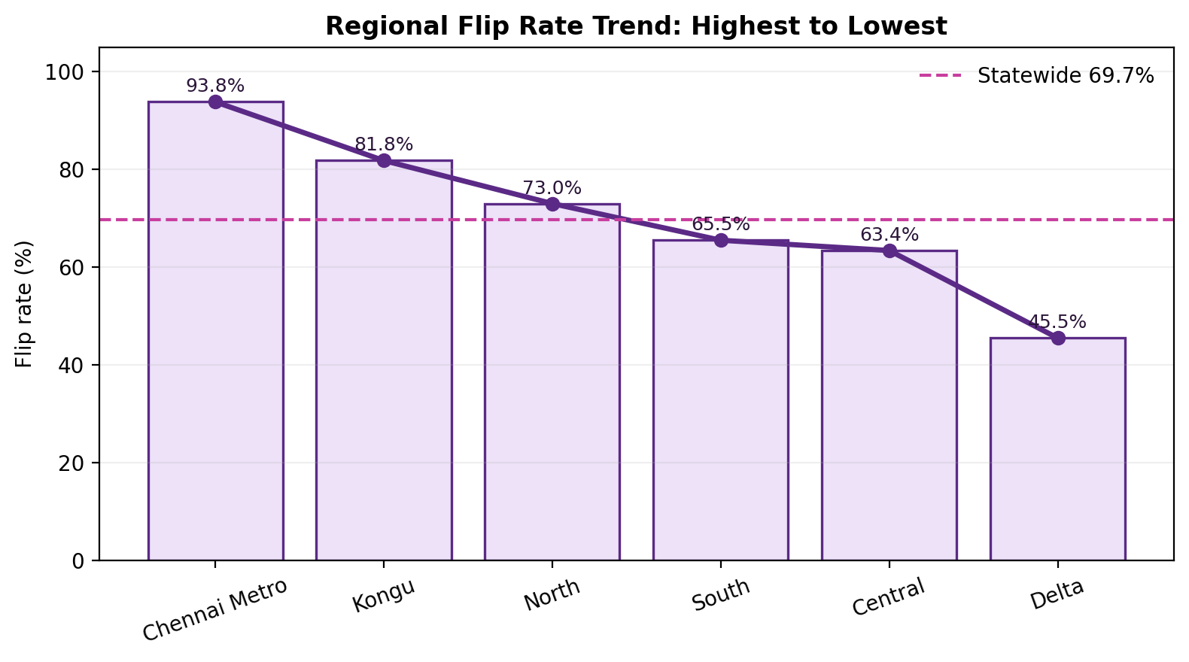
The trend line is ordered from highest to lowest flip rate. It is not a time-series trend; it is a ranked regional volatility trend that shows the decline from the most changed region to the least changed region.
Region | Flips | Total | Flip Rate
Chennai Metro | 30 | 32 | 93.8%
Kongu | 27 | 33 | 81.8%
North | 27 | 37 | 73.0%
South | 38 | 58 | 65.5%
Central | 26 | 41 | 63.4%
Delta | 15 | 33 | 45.5%
Trend Line Note
so The line drops from 93.8% in Chennai Metro to 45.5% in Delta. This visual supports the main story: electoral change was regionally concentrated rather than uniform .

9. TVK Regional Seat Performance
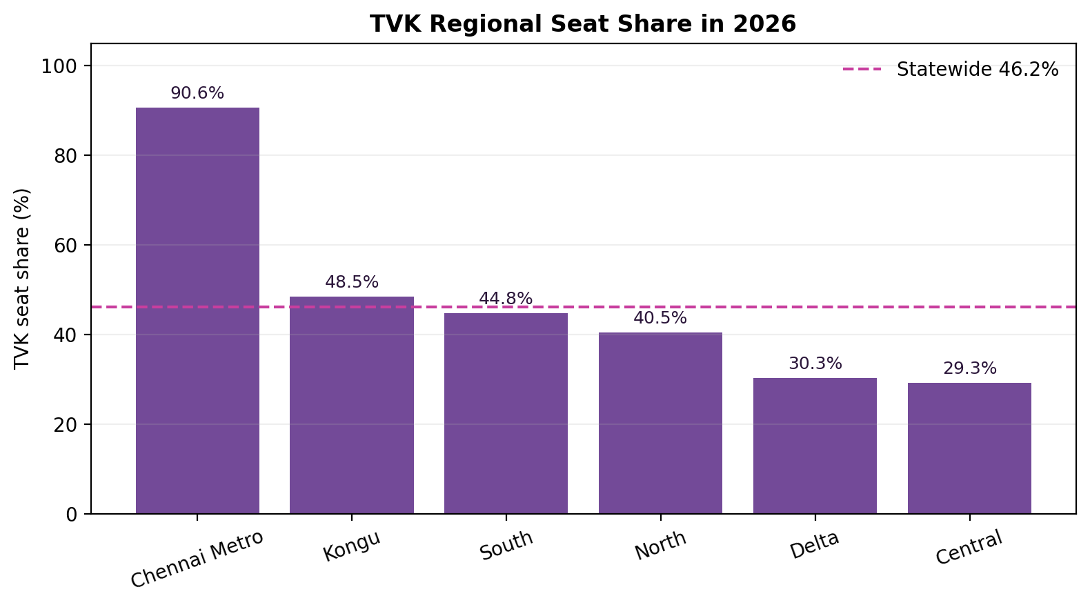
Region | Total | 2026 TVK | TVK Seat Share | Vs Statewide Avg
Chennai Metro | 32 | 29 | 90.6% | 1.96x
Kongu | 33 | 16 | 48.5% | 1.05x
South | 58 | 26 | 44.8% | 0.97x
North | 37 | 15 | 40.5% | 0.88x
Delta | 33 | 10 | 30.3% | 0.66x
Central | 41 | 12 | 29.3% | 0.63x
TVK's 2026 seat distribution was uneven across regions. Its highest regional share was Chennai Metro at 90.6%, while Delta was 30.3%. This supports the geographic story without making any claim about voter motivation.

10. DMK Regional Seat Change
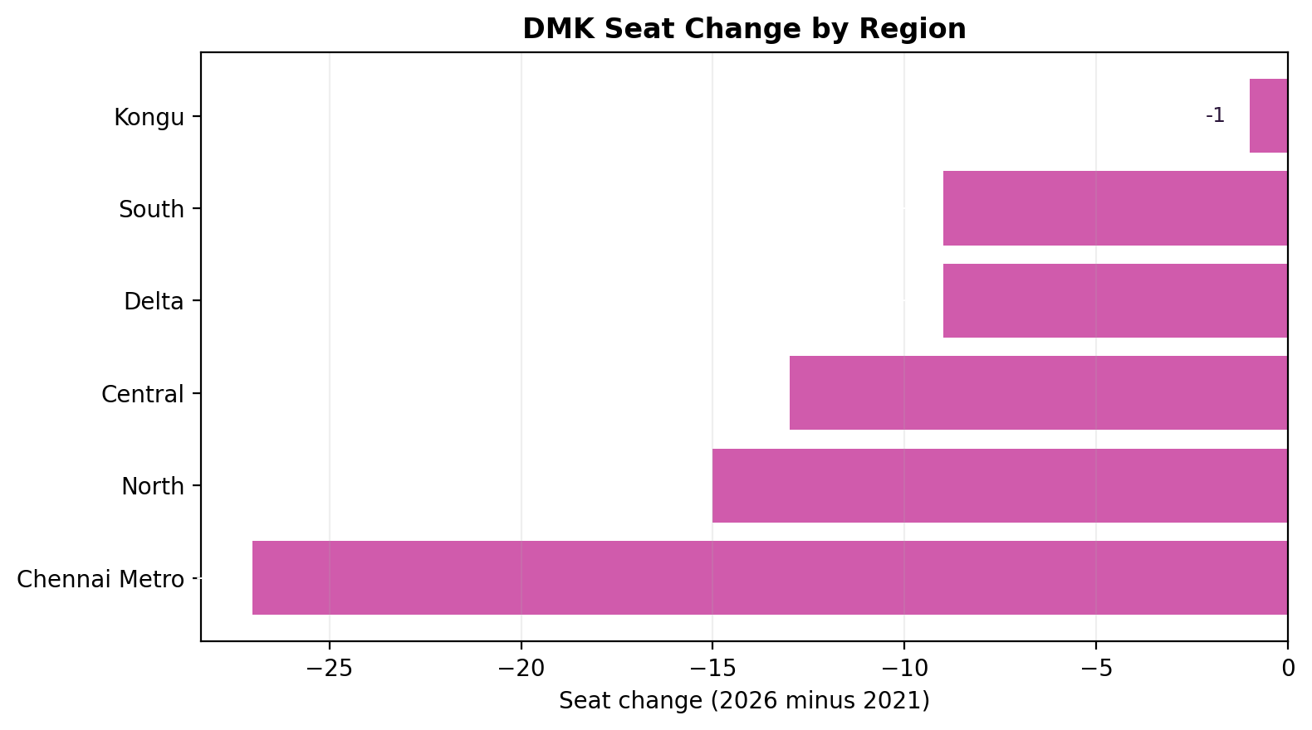
Region | 2021 DMK | 2026 DMK | Seat Change | % Change
Chennai Metro | 29 | 2 | -27 | -93.1%
North | 19 | 4 | -15 | -78.9%
Central | 21 | 8 | -13 | -61.9%
Delta | 23 | 14 | -9 | -39.1%
South | 31 | 22 | -9 | -29.0%
Kongu | 10 | 9 | -1 | -10.0%
DMK's overall change from 133 to 59 seats did not occur equally across all regions. The largest numerical declines were in Chennai Metro, North, and Central; Kongu showed the smallest change in DMK seat count.

11. 2026 Regional Control
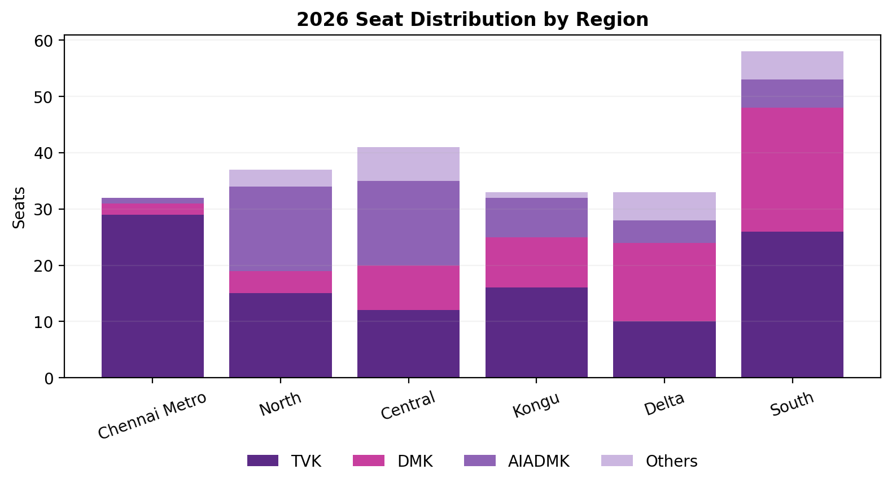
This chart shows how 2026 seats were distributed by region for 2026

12. Key Findings for AtliQ Media
- Finding 1: Regional change was uneven. The 48.3-point spread between Chennai Metro and Delta is the clearest evidence.
- Finding 2: TVK was the largest 2026 seat winner statewide, but its regional seat share varied widely.
- Finding 3: DMK's seat decline was geographically uneven, with larger changes in some regions than others.
- Finding 4: A regional view gives a stronger television story than statewide totals alone because it shows where the change appeared.

13. Editorial Recommendation
Recommended segment headline: Tamil Nadu did not vote as one state - it moved differently across six regions.
So here are the Recommended on-screen sequence:
- Start with statewide flip count: 163 of 234 seats changed winning party.
- Move to the regional flip-rate trend line.
- Highlight Chennai Metro as highest-change and Delta as lowest-change.
- Close with regional seat distribution to show why statewide totals hide important variation.

14. Limitations
This analysis identifies where electoral change occurred and how much change occurred. It does not explain why the change occurred.
- No demographic data was used.
- No exit polls, opinion polls, social media data, news articles, or campaign data were used.
2026 results are based on the provided 2026 candidate-level results file;

15. Final Answer to Q1
Electoral change in the 2026 Tamil Nadu Assembly election was not uniform across Tamil Nadu. Regional variation was substantial and observable. Chennai Metro recorded the highest flip rate, Delta recorded the lowest, and party seat distributions varied sharply across regions. For AtliQ Media, the strongest story is geographic: the 2026 result is better explained by showing how different regions changed, not only by showing statewide seat totals.

Appendix A: Statewide Party Seat Counts
Party | 2021 Seats
DMK | 133
AIADMK | 66
INC | 18
PMK | 5
VCK | 4
BJP | 4
CPI | 2
CPI(M) | 2
Party | 2026 Seats
TVK | 108
DMK | 59
AIADMK | 47
INC | 5
PMK | 4
IUML | 2
CPI | 2
VCK | 2
CPI(M) | 2
BJP | 1
DMDK | 1
AMMK | 1
note: This report uses the Codebasics challenge brief, metadata file, research question file, and the provided ECI-style starter datasets. Allowed official references named in the brief include ECI results portal, ECI statistical reports, CEO Tamil Nadu, data.gov.in, and IndiaVotes; all calculations in this report are derived from the provided CSV files.

