Q2: THE FLIP STORY
Constituency Realignment in the 2026 Tamil Nadu Assembly Election
Research Documentation for AtliQ Media Leadership
Prepared by: Narmatha Annadurai
Codebasics Resume Project Challenge | May 2026
234  Total constituencies | 163  Flipped seats | 71  Retained seats | 69.7%  Statewide flip rate

1. Executive Summary
This report answers the second research question from the Codebasics RPC data pack: in how many constituencies did the winning party change between the 2021 and 2026 Tamil Nadu Assembly elections, and what pattern emerges from those shifts? The analysis compares the winning party in every Assembly Constituency using AC Number as the primary key.
The verified result is that 163 of 234 constituencies changed winning party, while 71 retained the same winning party. This gives a statewide flip rate of 69.7%. The single largest transition path was DMK -> TVK with 65 constituencies, followed by AIADMK -> TVK with 26 constituencies and DMK -> AIADMK with 22 constituencies.
The key story for AtliQ Media: the 2026 election was not just a change in seat totals. It was a constituency-level realignment where nearly seven out of ten seats moved from one winning party to another.

2. Research Question and Story Purpose
Research Question 2 from the challenge brief says: In how many constituencies did the winning party change between 2021 and 2026? Visualise the shifts, and identify the pattern that emerges.
For a television audience, this question matters because it translates a statewide result into a concrete measure of movement. Seat totals show the final scoreboard. The flip story shows how much of the map actually changed hands.

3. Data Sources Used
Source | What it contains | How it was used
tn_2021_results.csv | Candidate-level 2021 election results | Winner identification for 2021
tn_2026_results.csv | Candidate-level 2026 election results | Winner identification for 2026
constituency_master.csv | AC, district, region and reservation metadata | Regional mapping and validation
How_to_Submit.docx | Submission rules and evaluation rubric | Neutrality, reproducibility and storytelling alignment
Readme-first-brief.docx | Problem statement and challenge rules | AtliQ Media context and non-partisan scope
research_questions_and_recommendations.docx | Research question definitions | Q2 framing and report scope

Important scope rule: this report uses only election-result data. It does not use exit polls, opinion polls, news articles, demographic inference, or social media claims.

4. Data Validation Framework
- AC Number was used as the primary key to avoid constituency-name spelling differences between files.
- Winner was identified as the candidate with the highest vote count in each constituency.
- The 2021 and 2026 winner tables were joined on AC Number.
- A constituency was marked as flipped only when the winning party changed between 2021 and 2026.
- All 234 constituencies were reconciled after the join.
- Regional counts were validated against the constituency master mapping.
Validation Check | Result | Interpretation
2021 winner records | 234 | 234 expected constituencies
2026 winner records | 234 | 234 expected constituencies
Joined winner records | 234 | All AC Numbers matched
Duplicate winning records | 0 | No tied maximum vote winners detected
Flipped constituencies | 163 | Winning party changed
Retained constituencies | 71 | Winning party stayed the same

5. Methodology
The methodology is deliberately simple and reproducible.
- Group each year by AC Number.
- Select the row with the maximum votes as the constituency winner.
- Create a 2021 winner table and a 2026 winner table.
- Join both tables by AC Number.
- Compare party_2021 and party_2026.
- Classify constituencies as Flipped or Retained.
- Aggregate the result statewide, by party transition, and by region.
Flip Rate Formula: Flip Rate = (Number of constituencies where winning party changed / Total constituencies) x 100

6. Statewide Realignment Overview
Across Tamil Nadu, 163 constituencies flipped and 71 retained the same winning party. This means 69.7% of constituencies recorded a different winning party in 2026 compared with 2021.
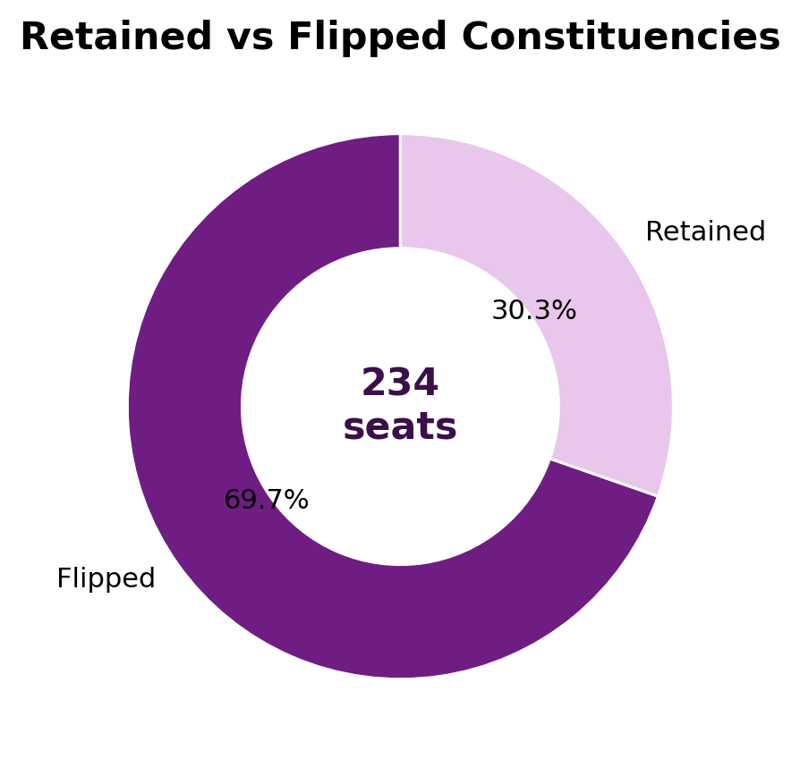
Metric | Value | Meaning
Total constituencies | 234 | Full Assembly map
Flipped constituencies | 163 | Winning party changed
Retained constituencies | 71 | Winning party stayed the same
Flip rate | 69.7% | Constituency-level change intensity

Nearly seven out of ten constituencies changed winning party. This is the clearest one-line measure of the scale of electoral movement.

7. Party-to-Party Transition Analysis
The transition table below shows the largest winner movements after removing retained seats. These are the constituency paths that changed from one winning party in 2021 to another winning party in 2026.
2021 Winner | 2026 Winner | Constituencies
DMK | TVK | 65
AIADMK | TVK | 26
DMK | AIADMK | 22
AIADMK | DMK | 15
INC | TVK | 11
DMK | PMK | 3
BJP | DMK | 2
BJP | TVK | 2
PMK | TVK | 2
PMK | AIADMK | 2
INC | DMDK | 1
VCK | DMK | 1

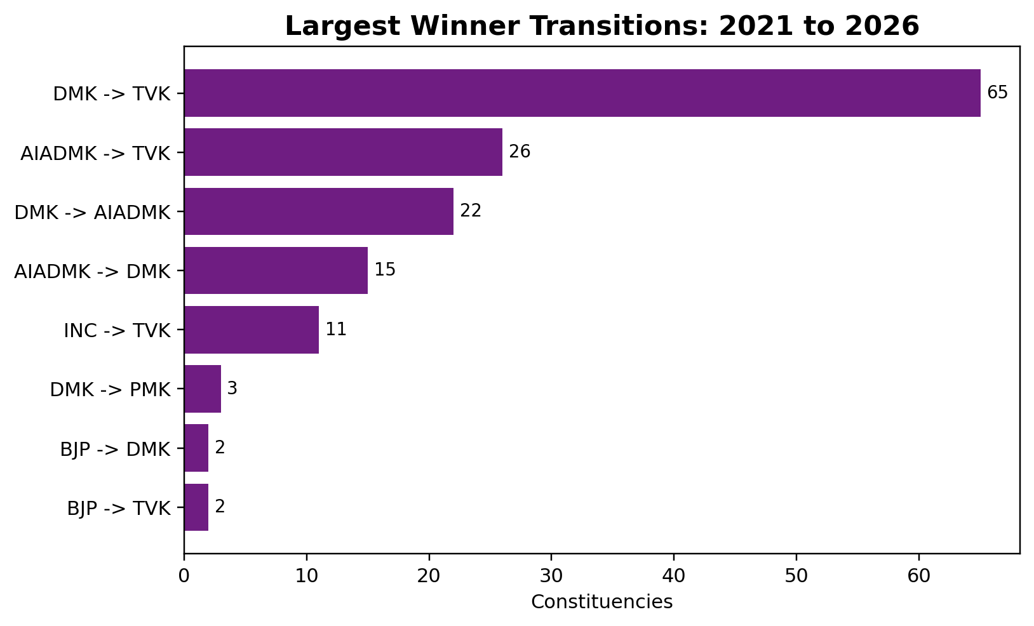
Key observation: DMK -> TVK is the largest single transition path with 65 constituencies. AIADMK -> TVK is the second largest transition path with 26 constituencies. Together, these two paths account for 91 of the 163 flipped constituencies.

8. Transition Matrix for Sankey Visualisation
This table is designed as a Sankey-ready transition matrix. Rows show the 2021 winning party. Columns show where those constituencies moved in 2026. The matrix includes retained seats as diagonal or same-party movement.
2021 Winner | TVK | DMK | AIADMK | INC | Others | 2021 Total
DMK | 65 | 40 | 22 | 0 | 6 | 133
AIADMK | 26 | 15 | 22 | 1 | 2 | 66
INC | 11 | 1 | 0 | 4 | 2 | 18
BJP | 2 | 2 | 0 | 0 | 0 | 4
PMK | 2 | 0 | 2 | 0 | 1 | 5
VCK | 1 | 1 | 1 | 0 | 1 | 4
CPI | 0 | 0 | 0 | 0 | 2 | 2
CPI(M) | 1 | 0 | 0 | 0 | 1 | 2

How to read it: In the DMK row, 65 constituencies moved from DMK in 2021 to TVK in 2026, 40 stayed with DMK, and 22 moved from DMK to AIADMK. This is a movement table, not a vote-share table.

9. Retained Seat Base
Retained seats are constituencies where the same party won in both 2021 and 2026. This helps separate complete constituency turnover from areas of continuity.
Party | Retained Constituencies
DMK | 40
AIADMK | 22
INC | 4
CPI | 2
CPI(M) | 1
PMK | 1
VCK | 1

DMK retained 40 constituencies and AIADMK retained 22 constituencies. These two retained bases account for 62 of the 71 retained seats.

10. Regional Flip Intensity
The flip story is not only statewide. Regional distribution shows where constituency-level winner movement was most intense.
Region | Total | Flipped | Retained | Flip Rate %
Chennai Metro | 32 | 30 | 2 | 93.8
Kongu | 33 | 27 | 6 | 81.8
North | 37 | 27 | 10 | 73.0
South | 58 | 38 | 20 | 65.5
Central | 41 | 26 | 15 | 63.4
Delta | 33 | 15 | 18 | 45.5

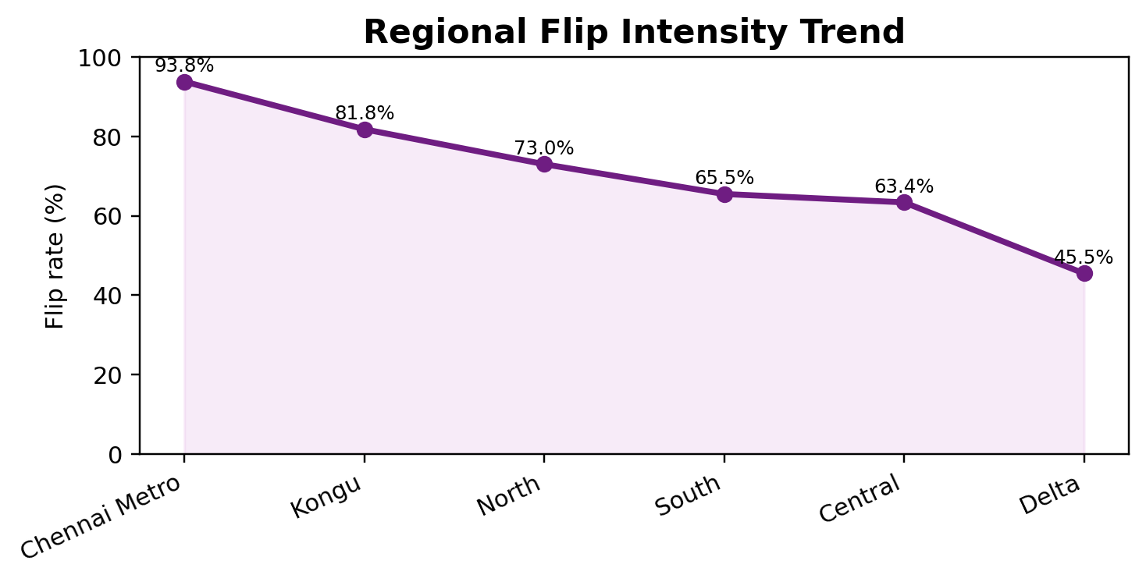
Chennai Metro recorded the highest flip intensity at 93.8%, followed by Kongu at 81.8% and North at 73.0%. Delta recorded the lowest flip intensity at 45.5%. The line shows that electoral movement was uneven across regions rather than uniform across the state.

11. District-Level Watchlist
The district table below is included as a research-support view. It is not used to make causal claims. It simply identifies districts with high observed flip rates among districts with at least three Assembly Constituencies in the dataset.
District | Total | Flipped | Flip Rate %
Madurai | 10 | 10 | 100.0
Tiruvallur | 10 | 10 | 100.0
Sivaganga | 4 | 4 | 100.0
Nilgiris | 3 | 3 | 100.0
Vellore | 13 | 12 | 92.3
Kanchipuram | 11 | 10 | 90.9
Coimbatore | 10 | 9 | 90.0
Chennai | 16 | 14 | 87.5
Tirupur | 8 | 7 | 87.5
Krishnagiri | 6 | 5 | 83.3

12. Net Seat Movement Context
The flip analysis is about constituency movement. The table below connects that movement back to overall party seat change. This helps to understand the relationship between transition paths and final seat totals.
Party | 2021 Seats | 2026 Seats | Seat Change
TVK | 0 | 108 | 108
IUML | 0 | 2 | 2
AMMK | 0 | 1 | 1
DMDK | 0 | 1 | 1
CPI | 2 | 2 | 0
CPI(M) | 2 | 2 | 0
PMK | 5 | 4 | -1
VCK | 4 | 2 | -2
BJP | 4 | 1 | -3
INC | 18 | 5 | -13
AIADMK | 66 | 47 | -19
DMK | 133 | 59 | -74

13. Key Findings for AtliQ Media
- 163 of 234 constituencies changed winning party, producing a statewide flip rate of 69.7%.
- The largest transition path was DMK -> TVK with 65 constituencies.
- TVK did not retain any prior seats because it had zero seats in 2021; all 108 TVK wins in 2026 are new winner positions in this comparison.
- Chennai Metro, Kongu and North recorded the highest regional flip intensity.
- Delta recorded the lowest regional flip intensity, with 15 of 33 constituencies changing winning party.

14. Editorial Recommendation
Recommended headline for the show: Nearly seven out of ten Tamil Nadu constituencies changed winning party in 2026.
Recommended visual: Use a Sankey chart to show the largest movement paths, led by DMK -> TVK, AIADMK -> TVK, DMK -> AIADMK and AIADMK -> DMK. Follow it with a regional flip-rate chart to show that the movement was geographically uneven.
Suggested anchor line: The final seat count tells us who won. The flip story tells us how much of Tamil Nadu actually changed hands.

15. Limitations and Neutrality Notes
- This report identifies which constituencies changed winning party. It does not explain why they changed.
- No voter-behavior claims are made because the data does not include voter surveys, exit polls or demographic variables.
- No predictions are made about future elections.
- The report avoids praise or criticism of any party, leader, community or region.
- All conclusions are descriptive and based on constituency-level election results.

16. Final Answer to Q2
The 2026 Tamil Nadu Assembly election produced 163 constituency flips out of 234 seats. The dominant pattern was large-scale movement into TVK, especially through DMK -> TVK and AIADMK -> TVK transition paths, alongside a retained base of 71 constituencies. The movement was substantial statewide and uneven by region.

