Q6: Margin of Victory Story
Electoral Competitiveness and Victory Margin Analysis
2021 vs 2026 Tamil Nadu Assembly Election
Prepared by: Narmatha Annadurai | Data Analyst, AtliQ Media | Codebasics RPC Challenge | May 2026

1. Executive Summary
This report answers the margin-of-victory research question for the 2026 Tamil Nadu Assembly Election. While the flip story explains how many seats changed winner and the geographic story explains where change was concentrated, the margin story explains how decisive those outcomes were. The analysis compares 2021 and 2026 victory margins, winner vote-share thresholds, closest contests, and regional competitiveness patterns using only the Codebasics election result datasets and ECI-style constituency results.
234  Seats analyzed | 16,784  2026 avg margin | 11,416  2026 median margin | 103  Seats under 5%

Core finding: The 2026 election was more competitive by margin than 2021. The average victory margin declined from 22,871 votes in 2021 to 16,784 votes in 2026, a change of 6,086 votes (-26.6%). The number of winners securing more than 50% of valid votes fell from 84 seats to 14 seats, while winners below 35% of valid votes increased from 2 to 61.

2. Research Question
Q6: How did the average margin of victory change between 2021 and 2026? In how many constituencies did the winner secure more than 50% of valid votes? In how many constituencies did the winner secure less than 35%?

3. Data Sources and RPC Rules Applied
Files used: tn_2021_results.csv, tn_2026_results.csv, and constituency_master.csv. The metadata states that both election files contain candidate-level results across all 234 constituencies, and the constituency master provides the official AC number, constituency name, region, district, and reservation category used for joins and validation.
Challenge rules followed: this report uses only election result data, does not use exit polls or news commentary, avoids causal explanations, and does not make predictions. All findings are descriptive and focus on measured outcomes.

4. Methodology and Calculations
For each constituency, candidates were sorted by vote count. The candidate with the highest votes was treated as the winner, and the candidate with the second-highest votes was treated as the runner-up.
Victory Margin (votes) = Winner votes - Runner-up votes. Winner Share % = Winner votes / Valid votes excluding NOTA × 100. Margin % = Victory margin / Valid votes excluding NOTA × 100. AC number was used as the primary key for constituency-level validation.

5. Statewide Margin Comparison
Year | Seats | Avg Margin (votes) | Median Margin (votes) | Avg Margin % | Median Margin % | Winner >50% | Winner <35%
2021 | 234 | 22,871 | 19,131 | 11.8% | 9.6% | 84 | 2
2026 | 234 | 16,784 | 11,416 | 7.7% | 5.7% | 14 | 61

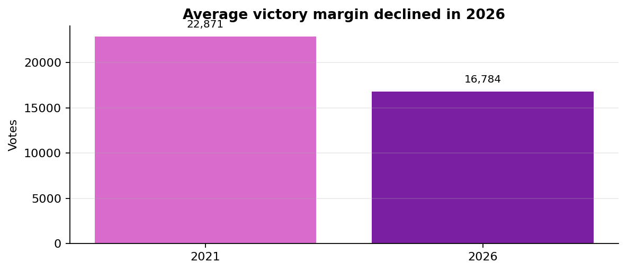
Interpretation: The average margin reduced by 6,086 votes, and the average margin percentage reduced by 4.1 percentage points. The median margin also moved lower, from 19,131 votes in 2021 to 11,416 votes in 2026. This indicates that the typical winning seat was closer in 2026 than in 2021.

6. Margin Bucket Analysis
To make margin pressure easier to explain to a television audience, constituencies were grouped into margin-percentage buckets. A lower bucket means the result was closer.
Margin Bucket | 2021 Seats | 2026 Seats
<1% | 16 | 29
1-5% | 50 | 74
5-10% | 55 | 65
10-20% | 76 | 49
>20% | 37 | 17

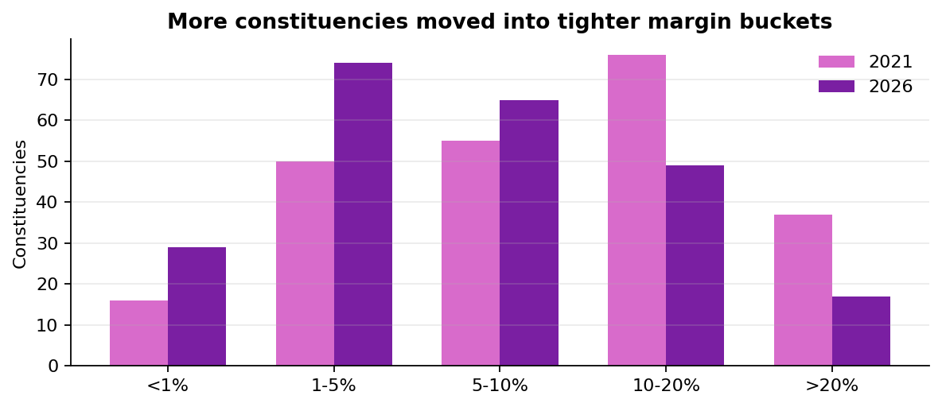
Key observation: seats below a 5% margin increased from 66 in 2021 to 103 in 2026. Seats with margins above 20% declined from 37 to 17.

7. Winner Vote-Share Thresholds
The research question specifically asks how many winners crossed 50% of valid votes and how many won with less than 35%.
Winner Vote Share Bucket | 2021 Seats | 2026 Seats
<35% | 2 | 61
35-40% | 11 | 89
40-45% | 36 | 51
45-50% | 101 | 19
>50% | 84 | 14

Answer: in 2026, 14 winners secured more than 50% of valid votes, compared with 84 in 2021. In 2026, 61 winners secured less than 35% of valid votes, compared with 2 in 2021.

8. Top 10 Closest Constituencies in 2026
The closest contests show where very small vote differences separated the winner and runner-up. These are the seats where margin pressure was most visible in the result data.
Constituency | Region | Winner | Runner-up | Victory Margin | Winner Share % | Margin %
Tiruppattur | South | TVK | DMK | 1 | 38.8% | 0.000%
Veppanahalli | North | DMK | AIADMK | 138 | 33.8% | 0.062%
Kanniyakumari | South | AIADMK | DMK | 214 | 31.5% | 0.090%
Polur | North | TVK | DMDK | 227 | 32.2% | 0.108%
Tirukkoyilur | Central | AIADMK | TVK | 285 | 33.7% | 0.131%
Paramathi-Velur | Central | AIADMK | DMK | 308 | 32.6% | 0.163%
Kulithalai | Kongu | DMK | TVK | 579 | 32.7% | 0.278%
Kumbakonam | Delta | TVK | DMK | 679 | 37.9% | 0.328%
Palani | South | AIADMK | TVK | 693 | 32.2% | 0.333%
Tindivanam | Central | VCK | AIADMK | 734 | 32.7% | 0.376%

The closest contest was Tiruppattur, where the victory margin was only 1 vote. Four of the top ten closest constituencies had margins below 250 votes.

9. Top 10 Largest Victory Margins in 2026
The largest margins show the opposite end of the distribution: constituencies where the winner had a comparatively larger vote gap over the runner-up.
Constituency | Region | Winner | Runner-up | Victory Margin | Winner Share % | Margin %
Edappadi | Central | AIADMK | IND | 98,110 | 58.0% | 38.2%
Shozhinganallur | Chennai Metro | TVK | DMK | 96,780 | 49.5% | 21.7%
Madavaram | Chennai Metro | TVK | DMK | 94,985 | 52.8% | 26.3%
Avadi | Chennai Metro | TVK | DMK | 76,311 | 52.4% | 22.2%
Salem (West) | Central | TVK | PMK | 74,867 | 51.6% | 32.1%
Poonamallee | Chennai Metro | TVK | DMK | 72,740 | 52.5% | 23.7%
Tiruppur (North) | Kongu | TVK | AIADMK | 69,992 | 50.1% | 26.7%
Viralimalai | Delta | AIADMK | TVK | 62,073 | 52.0% | 30.5%
Maduravoyal | Chennai Metro | TVK | DMK | 61,509 | 48.5% | 21.0%
Ambattur | Chennai Metro | TVK | DMK | 58,781 | 51.6% | 22.7%

10. Regional Competitiveness Trend
The regional trend line below orders regions by average margin percentage in 2026. Lower average margin percentage indicates a more competitive regional result profile.
Region | Avg Margin (votes) | Median Margin (votes) | Avg Margin % | Seats under 5% margin | Total Seats
South | 11,787 | 9,808 | 5.8% | 31 | 58
Kongu | 14,054 | 9,693 | 6.4% | 16 | 33
Delta | 13,187 | 10,062 | 6.6% | 14 | 33
Central | 14,512 | 10,663 | 6.6% | 20 | 41
North | 14,811 | 7,194 | 6.7% | 20 | 37
Chennai Metro | 37,560 | 29,290 | 16.1% | 2 | 32

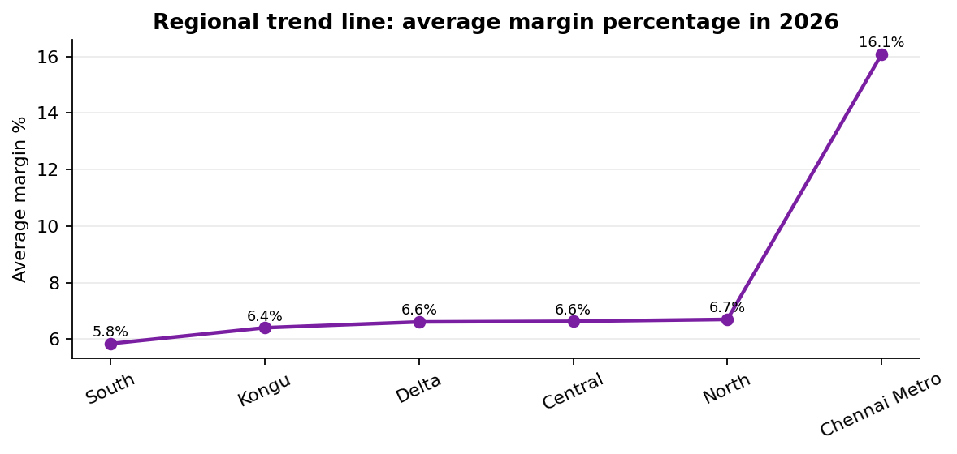
Key observation: South recorded the lowest average margin percentage, while Chennai Metro recorded the highest. This does not explain why the regions differed; it only describes how decisive the 2026 constituency results were by region.

11. Winner Party Margin Profile
The following table summarizes margin characteristics by winning party in 2026. It is included as an analytical profile, not as a causal explanation.
Winner | Seats | Avg Margin (votes) | Median Margin (votes) | Avg Winner Share %
TVK | 108 | 22,631 | 15,969 | 41.0%
DMK | 59 | 9,572 | 7,589 | 37.1%
AIADMK | 47 | 15,920 | 10,245 | 37.8%
INC | 5 | 7,737 | 2,833 | 35.9%
PMK | 4 | 13,235 | 15,568 | 37.0%
IUML | 2 | 2,024 | 2,024 | 34.0%
CPI | 2 | 9,081 | 9,081 | 38.6%
CPI(M) | 2 | 8,924 | 8,924 | 37.7%
VCK | 2 | 16,898 | 16,898 | 39.1%
AMMK | 1 | 1,566 | 1,566 | 35.3%

12. Data Validation Framework
Validation checks performed:
- All 234 AC numbers were present in both election years.
- Winner and runner-up were derived directly from vote counts.
- Valid votes were calculated excluding NOTA for winner-share and margin-percentage calculations.
- The statewide seat count reconciles to 234 constituencies.
- No turnout analysis was included because the 2026 turnout field is blank in the provided dataset.

13. Limitations
This report identifies how close or decisive constituency results were. It does not explain why margins changed. The dataset does not include voter demographics, campaign strategy, media exposure, exit polls, or survey responses. Therefore, all conclusions are descriptive and limited to official election result fields.

14. Editorial Recommendation for AtliQ Media
Recommended segment headline: The 2026 election was not only a story of seat change; it was also a story of tighter contests.
Recommended on-screen angle: combine the statewide margin decline, the increase in seats under 5% margin, and the top 10 closest constituencies. This gives viewers a simple explanation of how competitive the election was without using partisan or causal language.

15. Final Answer to Q6
Average victory margin declined from 22,871 votes in 2021 to 16,784 votes in 2026. The number of winners above 50% of valid votes declined from 84 to 14. The number of winners below 35% increased from 2 to 61. Overall, the 2026 results show a more competitive margin profile than 2021.

