DECODING THE 2026
TAMIL NADU ASSEMBLY ELECTION
Research Dossier Final
Project for AtliQ Media
Prepared by: Narmatha Annadurai
Codebasics Resume Project Challenge
May 2026
headline: Tamil Nadu did not move as one uniform story. The 2026 election is clearer when viewed through three connected lenses: where change occurred, how much changed, and how competitive the contests became.

Table of Contents
1. Executive Summary
2. Problem Statement
3. Business Objective
4. Project Scope and Rules
5. Data Sources and Validation Framework
6. Research Question Selection
7. Story Architecture
8. Story 01: Geographic Distribution of Change
9. Story 02: Constituency Realignment
10. Story 03: Margin of Victory and Competitiveness
11. Cross-Story Findings
12. AtliQ Media Editorial Recommendation
13. Technical Skills Demonstrated
14. Limitations and Neutrality Statement
15. Appendix

1. Executive Summary
This research dossier documents the full analytical approach used for the Codebasics Resume Project Challenge: Decoding the 2026 Tamil Nadu Assembly Election. The client scenario is AtliQ Media, a national news network preparing a one-hour fact-based election show using public election data.
The project avoids partisan commentary and focuses on descriptive data storytelling. Instead of asking why voters behaved differently, the analysis asks what happened in the results, where it happened, and how clearly it can be communicated to a television audience.
- Statewide movement was substantial: 163 of 234 constituencies changed winning party, giving a flip rate of 69.7%.
- The geographic pattern was uneven: Chennai Metro recorded the highest regional flip rate at 93.8%, while Delta recorded the lowest at 45.5%.
- The largest winner transition was DMK -> TVK, accounting for 65 constituencies.
- The margin story showed tighter contests in 2026: average victory margin fell from 22,871 votes in 2021 to 16,784 votes in 2026.
- Only 13 winners crossed 50% vote share in 2026, compared with 70 winners in 2021.
Executive takeaway: The strongest show framing is not simply who won the state. The stronger data is how change varied by region, how many seats changed hands, and how close several contests became.

2. Problem Statement
AtliQ Media needs a clean, simple, fact-based story for the 2026 Tamil Nadu Assembly election. The challenge brief explicitly discourages heated debate, partisan language, predictions, or explanations of voter motivation. The analyst's task is to choose the most meaningful stories from the election results and present them in a way that a general audience can understand.
- Build a narrative from public election result data.
- Identify two or three strong stories rather than listing every possible metric.
- Use clear charts and executive-level recommendations for AtliQ leadership.
- Maintain strict neutrality: no praise, criticism, demographic claims, or causal claims.

3. Business Objective
Item | Detail
Audience need | A clear election story that viewers can understand quickly.
AtliQ need | A segment structure that is factual, visual, and differentiated from debate-style coverage.
Analyst objective | Convert constituency-level results into a concise editorial narrative.
Success measure | A reviewer should remember the headline finding after watching the video or reading the deck.

4. Project Scope and Rules
The analysis was intentionally limited to outcome data. This was done to stay within the Codebasics rules and to avoid unsupported claims.
Item | Detail
Included | Constituency results, party winners, vote counts, margins, regional mapping, reservation status.
Excluded | Exit polls, social media, news opinion pieces, demographic inference, voter motivation, campaign strategy.
Tone rule | Neutral, descriptive language only.
Story rule | Pick connected stories and explain them clearly rather than answering every question superficially.

5. Data Sources and Validation Framework
The analysis uses the Codebasics starter data pack and the official source framework described in the challenge files.
Source | Purpose
tn_2021_results.csv | Candidate-level 2021 Tamil Nadu Assembly results; 4,232 records across 234 constituencies.
tn_2026_results.csv | Candidate-level 2026 Tamil Nadu Assembly results; 4,257 records across 234 constituencies.
constituency_master.csv | Master list of 234 constituencies with district, region, and reservation category.
ECI Results Portal | Official 2026 constituency-wise results source referenced by the challenge.
ECI Statistical Reports | Official historical election reports source referenced by the challenge.
CEO Tamil Nadu / OGD / IndiaVotes | Permitted cross-reference resources documented in the challenge brief.

5.1 Validation Process
1. Used AC Number as the primary key to avoid constituency spelling variation between files.
2. Identified each constituency winner using the maximum vote count.
3. Joined winner tables from 2021 and 2026 using AC Number.
4. Validated that 234 constituencies were present in 2021, 2026, and the master file.
5. Reconciled statewide party totals, regional totals, flip counts, and margin calculations.
6. Kept all conclusions descriptive and tied to observable results.

6. Research Question Selection
The challenge provided six possible research directions. The final submission selected three because they connect into one clear narrative arc for AtliQ Media.
Research Direction | Decision | Reason
Q1 Geographic Story | Selected | Shows where seat distribution changed across six regions. This became the primary story.
Q2 Flip Story | Selected | Measures how many constituencies changed winning party and shows the scale of realignment.
Q6 Margin Story | Selected | Adds the competitiveness layer: how decisive or close the results were.
Q3 Vote Share Story | Not selected | Important, but attribution such as where TVK votes came from can invite unsupported interpretation without voter-level data.
Q4 Reserved Seat Story | Not selected | Useful but less connected to the central regional realignment narrative chosen for the show.
Q5 Turnout Story | Not selected | 2026 turnout was blank in the starter file and would require additional sourcing; it would also shift the narrative away from the core three-story arc.

7. Story Architecture
The selected stories are arranged so that each one answers a different audience question.
Story | Audience Question | Analytical Lens
Story 01: Geographic Distribution | Where did change occur? | Regional flip rates and regional party performance.
Story 02: Constituency Realignment | How much changed? | Flipped vs retained seats and transition paths.
Story 03: Margin of Victory | How competitive was it? | Average margins, close contests, and winner vote-share thresholds.

Narrative logic: Q2 establishes scale, Q1 explains geography, and Q6 adds competitiveness. Together, they form a complete election-results story without using causal claims.

8. Story 01: Geographic Distribution of Change
Q1 asks how seat distribution shifted across Tamil Nadu's six regions between 2021 and 2026. This is the strongest story because it turns statewide results into a regional narrative.
Region | Total | Flips | Flip Rate | 2021 DMK | 2026 DMK | 2026 TVK | 2026 AIADMK
Chennai Metro | 32 | 30 | 93.8% | 29 | 2 | 29 | 1
North | 37 | 27 | 73.0% | 19 | 4 | 15 | 15
Central | 41 | 26 | 63.4% | 21 | 8 | 12 | 15
Kongu | 33 | 27 | 81.8% | 10 | 9 | 16 | 7
South | 58 | 38 | 65.5% | 31 | 22 | 26 | 5
Delta | 33 | 15 | 45.5% | 23 | 14 | 10 | 4

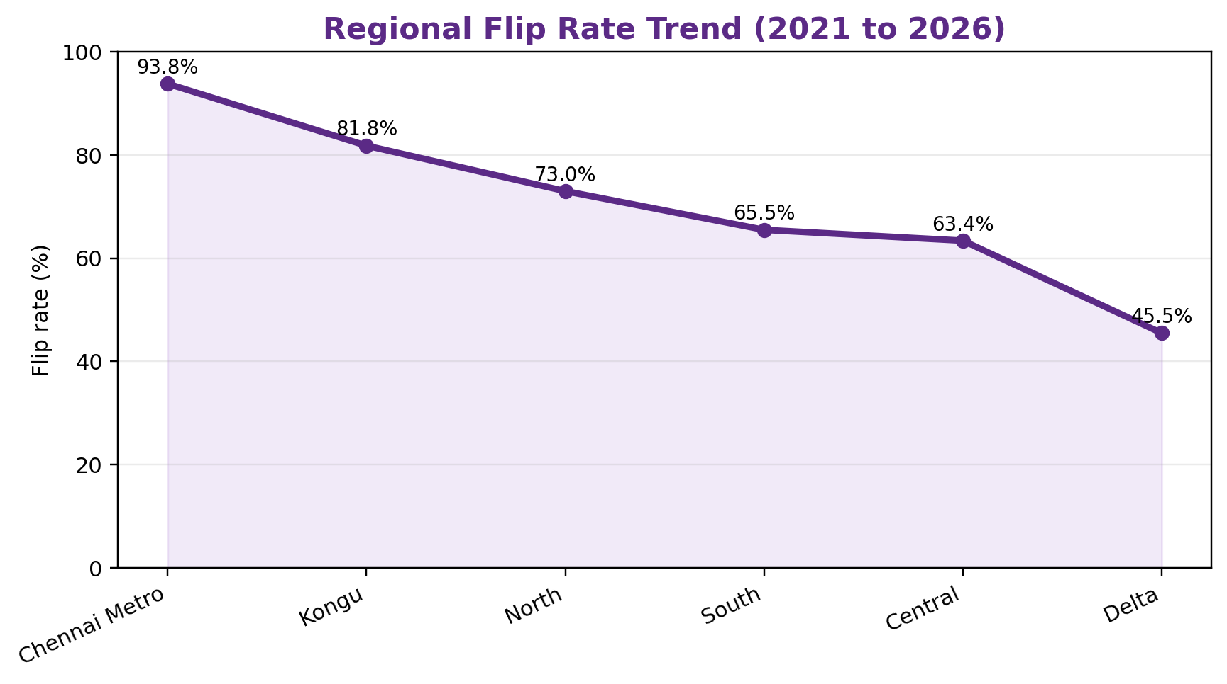

8.1 Key Q1 Findings
- Chennai Metro had the highest flip rate: 30 of 32 constituencies changed winning party (93.8%).
- Delta had the lowest flip rate: 15 of 33 constituencies changed winning party (45.5%).
- Kongu recorded a high flip rate of 81.8%, even though DMK changed only from 10 seats to 9 seats in that region.
- TVK seat share was highest in Chennai Metro at 90.6% and lowest in Delta at 30.3%.
- This supports the editorial statement that statewide totals alone hide important regional variation.
Region | TVK Seats | Regional Seat Share | Performance Ratio
Chennai Metro | 29 | 90.6% | 1.96x
North | 15 | 40.5% | 0.88x
Central | 12 | 29.3% | 0.63x
Kongu | 16 | 48.5% | 1.05x
South | 26 | 44.8% | 0.97x
Delta | 10 | 30.3% | 0.66x

Region | 2021 DMK | 2026 DMK | Seat Change | % Change
Chennai Metro | 29 | 2 | -27 | -93.1%
North | 19 | 4 | -15 | -78.9%
Central | 21 | 8 | -13 | -61.9%
Delta | 23 | 14 | -9 | -39.1%
South | 31 | 22 | -9 | -29.0%
Kongu | 10 | 9 | -1 | -10.0%

9. Story 02: Constituency Realignment
Q2 measures how many constituencies changed winning party between 2021 and 2026. This story gives AtliQ the simplest quantitative hook: the scale of change.
Metric | Value
Total constituencies | 234
Flipped constituencies | 163
Retained constituencies | 71
Statewide flip rate | 69.7%
Largest transition | DMK -> TVK (65 constituencies)

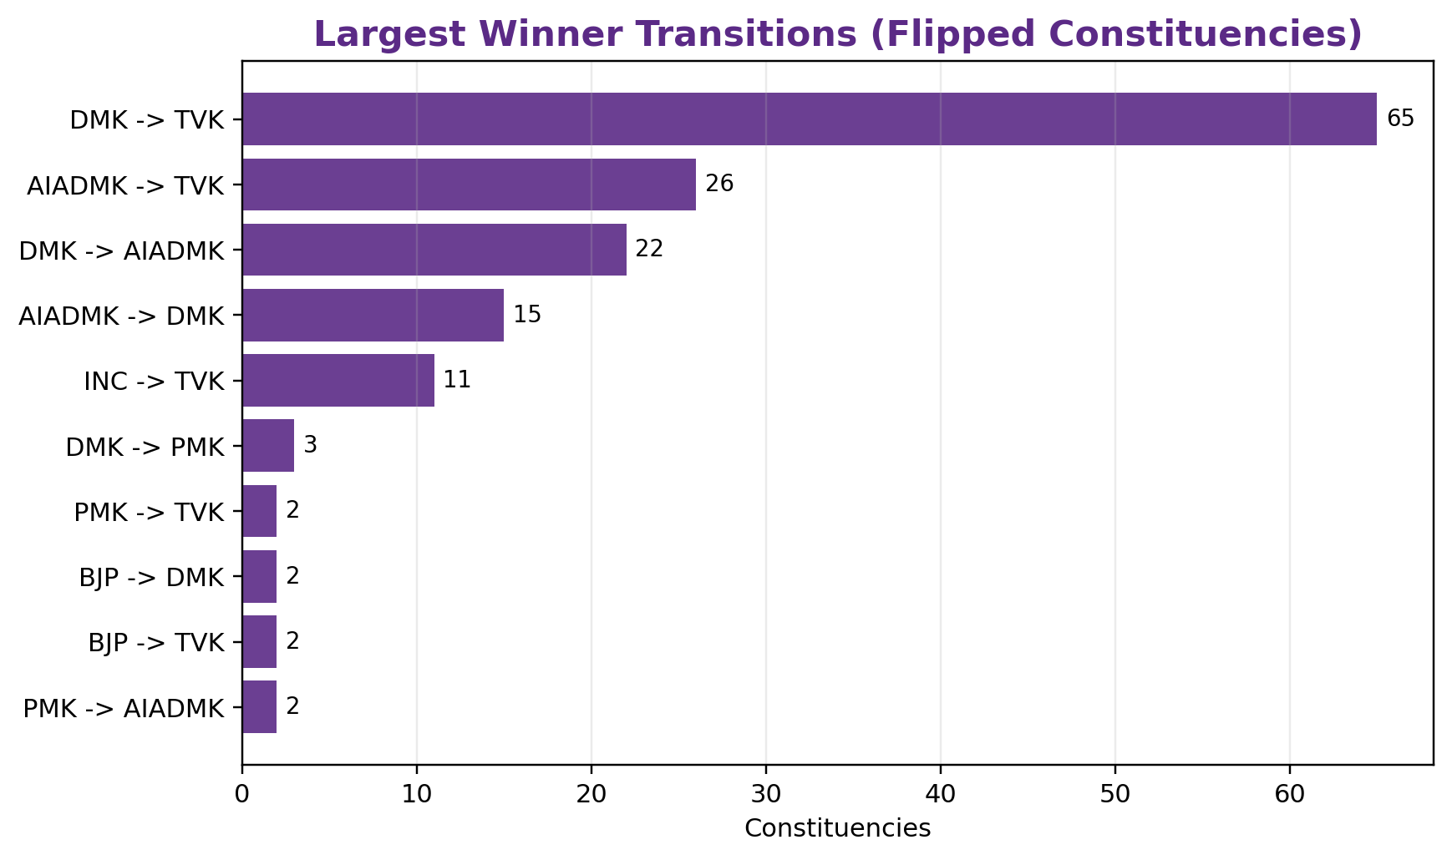
2021 Winner | 2026 Winner | Seats
DMK | TVK | 65
AIADMK | TVK | 26
DMK | AIADMK | 22
AIADMK | DMK | 15
INC | TVK | 11
DMK | PMK | 3
PMK | AIADMK | 2
BJP | TVK | 2
PMK | TVK | 2
BJP | DMK | 2

9.1 Key Q2 Findings
- 163 constituencies changed winning party, while 71 retained the same winning party.
- The largest transition path was DMK -> TVK, with 65 constituencies.
- AIADMK -> TVK was the second-largest transition path, with 26 constituencies.
- The transition matrix shows that the 2026 result was not only about one party total; it involved multiple movement paths across the state.

10. Story 03: Margin of Victory and Competitiveness
Q6 examines how decisive the constituency results were. This story adds depth by showing whether seats were won comfortably or through narrow margins.
Metric | 2021 | 2026 | Change
Average victory margin (votes) | 22,871 | 16,784 | -6,086
Median victory margin (votes) | 19,131 | 11,416 | -7,716
Average margin percentage | 11.7% | 7.7% | -4.0 pts
Winners above 50% vote share | 70 | 13 | -57
Winners below 35% vote share | 2 | 64 | 62

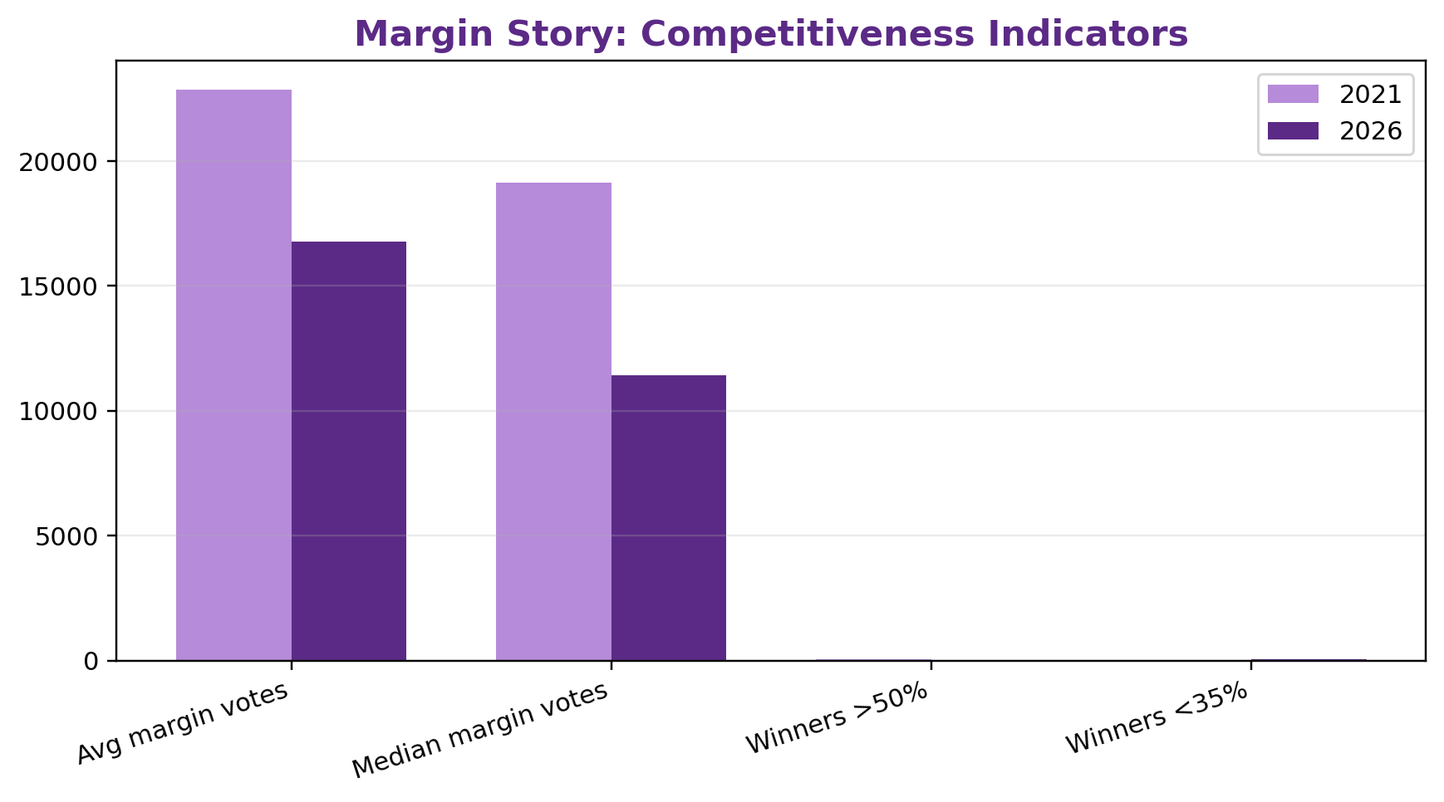

10.1 Closest 2026 Constituencies
Constituency | region | Winner | Runner-up | Margin Votes | Margin % | Winner Share
Tiruppattur | South | TVK | DMK | 1 | 0.00% | 38.7%
Veppanahalli | North | DMK | AIADMK | 138 | 0.06% | 33.6%
Kanniyakumari | South | AIADMK | DMK | 214 | 0.09% | 31.4%
Polur | North | TVK | DMDK | 227 | 0.11% | 32.1%
Tirukkoyilur | Central | AIADMK | TVK | 285 | 0.13% | 33.6%
Paramathi-Velur | Central | AIADMK | DMK | 308 | 0.16% | 32.5%
Kulithalai | Kongu | DMK | TVK | 579 | 0.28% | 32.6%
Kumbakonam | Delta | TVK | DMK | 679 | 0.33% | 37.8%
Palani | South | AIADMK | TVK | 693 | 0.33% | 32.1%
Tindivanam | Central | VCK | AIADMK | 734 | 0.37% | 32.6%

10.2 Regional Competitiveness Indicators
Region | Avg Margin 2026 | Median Margin 2026 | Close Seats <1%
Central | 14,512 | 10,663 | 7 / 41
Chennai Metro | 37,560 | 29,290 | 0 / 32
Delta | 13,187 | 10,062 | 6 / 33
Kongu | 14,054 | 9,693 | 4 / 33
North | 14,811 | 7,194 | 2 / 37
South | 11,787 | 9,808 | 10 / 58

10.3 Key Q6 Findings
- Average victory margin fell from 22,871 votes in 2021 to 16,784 votes in 2026.
- Median victory margin fell from 19,131 votes in 2021 to 11,416 votes in 2026.
- Winners above 50% vote share declined from 70 in 2021 to 13 in 2026.
- Winners below 35% vote share increased from 2 in 2021 to 64 in 2026.
- The closest 2026 contest was Tiruppattur, decided by 1 vote.

11. Cross-Story Findings
- The scale of change was large: nearly seven in ten constituencies changed winning party.
- The geography of change was uneven: Chennai Metro and Kongu recorded the highest regional flip rates, while Delta was the most stable region by flip rate.
- The competitiveness layer strengthened the story: 2026 had lower average and median victory margins than 2021.
- The three stories connect naturally: Q2 shows scale, Q1 shows location, and Q6 shows margin pressure.
- The analysis remains descriptive and does not explain why voters or regions behaved differently.

12. AtliQ Media Editorial Recommendation
Recommended headline: Tamil Nadu did not move as one uniform story: the 2026 election is best explained through regional change, constituency realignment, and close contests.

Segment | Title | Purpose
Opening hook | The Great Realignment | Lead with 163 of 234 constituencies changing winning party.
Main story | The Geography of Change | Show the regional flip trend: Chennai Metro highest, Delta lowest.
Depth segment | The Closest Battles | Use margin analysis to show how competitive several seats became.
Closing line | Beyond statewide totals | Recommend regional and constituency-level graphics instead of only statewide party totals.

12.1 Recommended Visuals for the Show
- Regional flip-rate trend chart.
- Transition matrix or Sankey diagram for winner movement.
- Top 10 closest constituencies table.
- KPI cards: 234 total seats, 163 flipped, 71 retained, 69.7% flip rate.
- Regional comparison cards showing highest and lowest change.

13. Technical Skills Demonstrated
Skill Area | Evidence in Project
Data cleaning | Handled constituency spelling differences by using AC Number as the primary key.
Data modeling | Built winner tables for 2021 and 2026 and joined them for comparative analysis.
Validation | Reconciled constituency totals, party totals, regional totals, flips, and margins.
Exploratory analysis | Compared party performance by region and transition path.
Statistical analysis | Calculated margins, vote shares, medians, averages, and threshold counts.
Storytelling | Reduced six possible research questions into three connected stories.
Stakeholder communication | Converted technical results into AtliQ-ready recommendations and visual hooks.

14. Limitations and Neutrality Statement
This project intentionally follows the Codebasics neutrality rule. It does not explain why any party won or lost and does not predict future elections.
- No exit polls or opinion polls were used.
- No news articles or social media sources were used to interpret voter behavior.
- No demographic claims were made about caste, religion, income, education, or community voting patterns.
- No causal language is used. The report describes observed election results only.
- The six-region grouping is the editorial grouping provided in the challenge dataset, not an official ECI regional classification.
- 2026 turnout analysis was not selected because turnout values were blank in the starter file and would require a separate external data collection workflow.

15. Appendix

15.1 Statewide Party Seat Counts
Party | 2021 Seats
DMK | 133
AIADMK | 66
INC | 18
PMK | 5
VCK | 4
BJP | 4
CPI | 2
CPI(M) | 2

Party | 2026 Seats
TVK | 108
DMK | 59
AIADMK | 47
INC | 5
PMK | 4
IUML | 2
VCK | 2
CPI | 2
CPI(M) | 2
BJP | 1
DMDK | 1
AMMK | 1

15.2 Metric Definitions
Term | Definition
Winner | Candidate with the highest votes in a constituency.
Flip | Constituency where the winning party changed between 2021 and 2026.
Retained seat | Constituency where the same party won in both years.
Victory margin | Winner votes minus runner-up votes.
Winner vote share | Winner votes divided by total constituency votes.
Regional flip rate | Flipped constituencies in region divided by total constituencies in region.

15.3 Reproduction Logic
1. Load 2021 and 2026 candidate-level results.
2. For each ac_number, sort candidates by votes and select rank 1 as winner and rank 2 as runner-up.
3. Join 2021 winners and 2026 winners on ac_number.
4. Join constituency_master on ac_number to attach region, district, and reservation fields.
5. Create flip flag where party_2021 is different from party_2026.
6. Aggregate by party, region, transition path, and margin category.

