Inventory Monitoring at Distribution Centers

AWS Machine Learning Nanodegree – Capstone Project

Author: Narmina Yadullayeva

## Domain Background

The Amazon Fulfillment Centers are highly active centers for innovation, enabling Amazon to distribute hundreds of products every day. These products are randomly placed in bins, which are transported by robots. However, it is not uncommon for products to be misplaced during handling, resulting in discrepancies between the recorded inventory of a bin and its actual contents.

## Problem Statement

The objective of this project is to develop a deployable ML solution that can accurately count the number of objects in each bin. Such a system would be useful for inventory tracking and ensuring the correct number of items are included in delivery shipments.

## Solution Statement

There are several approaches that can be taken to solve this problem, for example one can:

* Build classification model where each image is assigned with a number of items in the bin (class 0 – 1 item, class 1 = 2 items and so on).
* Build a solution that uses object detection model to detect distinct objects on the image and then uses detection count as a prediction.

For a matter of simplicity I will start with the first one and tackle the second one if there will be enough time.

To build this project I will be using AWS SageMaker and good machine learning engineering practices to fetch data from a database, preprocess it, and then train a machine learning model. This project will serve as a demonstration of end-to-end machine learning engineering skills that I have learned as a part of this nanodegree.

## Datasets and Inputs

To complete this project I will be using the [Amazon Bin Image Dataset](https://registry.opendata.aws/amazon-bin-imagery/" \t "_blank).

The Amazon Bin Image Dataset contains images and metadata from bins of a pod in an operating Amazon Fulfillment Center. The bin images in this dataset are captured as robot units carry pods as part of normal Amazon Fulfillment Center operations. You can download and find the details at [here](https://aws.amazon.com/ko/public-datasets/amazon-bin-images/).

The dataset contains 500,000 images of bins containing one or more objects. For each image there is a metadata file containing information about the image like the number of objects, it's dimension and the type of object. For this task, I will try to classify the number of objects in each bin.

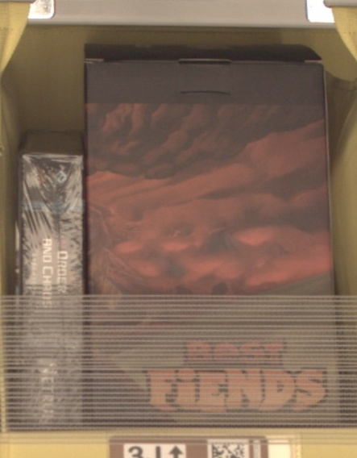

Figure 1: Example of image in the dataset

## Benchmark Model

After doing some research, I have found a couple of GitHub projects associated with the same problem and dataset:

* <https://github.com/pablo-tech/Image-Inventory-Reconciliation-with-SVM-and-CNN>
* <https://github.com/silverbottlep/abid_challenge>

From Pablo:

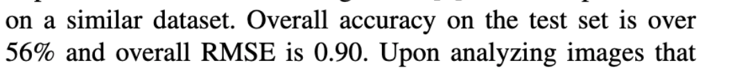

## From Abid:

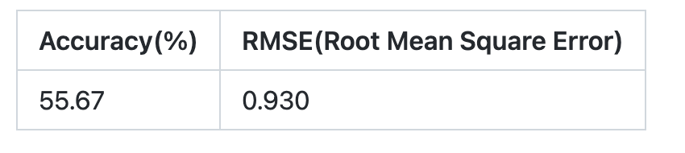

In this project I will be aiming to reproduce or beat these results.

## Evaluation Metrics

For classification problem I will be using Accuracy, RMSE, F1-score.

## Project Design

The steps I will be following:

1. Download data from Amazon S3
2. Put the data in an appropriate folder according to the number of objects contained in every image.
3. Split the dataset into training and test subsets, upload to S3.
4. Create a train.py script in order to train the model. This will load a pre-trained ResNet model and will modify FC in order to tune it to our specific dataset.
5. Launch the training using Sagemaker Training jobs; evaluate results.
6. Use hyperparameter tuning in order to obtain the set of hyperparameters combination with the best model performance.
7. Deploy the model to an endpoint so we can start using it to identify the number of objects in new images.

|  |  |
| --- | --- |
| CRITERIA | MEETS SPECIFICATIONS |
| Domain Background | Student briefly details background information of the domain from which the project is proposed. Historical information relevant to the project should be included. It should be clear how or why a problem in the domain can or should be solved. Related academic research should be appropriately cited. A discussion of the student's personal motivation for investigating a particular problem in the domain is encouraged but not required. |
| Problem Statement | Student clearly describes the problem that is to be solved. The problem is well defined and has at least one relevant potential solution. Additionally, the problem is quantifiable, measurable, and replicable. |
| Solution Statement | Student clearly describes a solution to the problem. The solution is applicable to the project domain and appropriate for the dataset(s) or input(s) given. Additionally, the solution is quantifiable, measurable, and replicable. |
| Datasets and Inputs | The dataset(s) and/or input(s) to be used in the project are thoroughly described. Information such as how the dataset or input is (was) obtained, and the characteristics of the dataset or input, should be included. It should be clear how the dataset(s) or input(s) will be used in the project and whether their use is appropriate given the context of the problem. |
| Benchmark Model | A benchmark model is provided that relates to the domain, problem statement, and intended solution. Ideally, the student's benchmark model provides context for existing methods or known information in the domain and problem given, which can then be objectively compared to the student's solution. The benchmark model is clearly defined and measurable. |
| Evaluation Metrics | Student proposes at least one evaluation metric that can be used to quantify the performance of both the benchmark model and the solution model presented. The evaluation metric(s) proposed are appropriate given the context of the data, the problem statement, and the intended solution. |
| Presentation | The proposal follows a well-organized structure and would be readily understood by its intended audience. Each section is written in a clear, concise and specific manner. Few grammatical and spelling mistakes are present. All resources used and referenced are properly cited. |
| Project Design | Student summarizes a theoretical workflow for approaching a solution given the problem. A discussion is made as to what strategies may be employed, what analysis of the data might be required, or which algorithms will be considered. The workflow and discussion provided align with the qualities of the project. Small visualizations, pseudocode, or diagrams are encouraged but not required. |