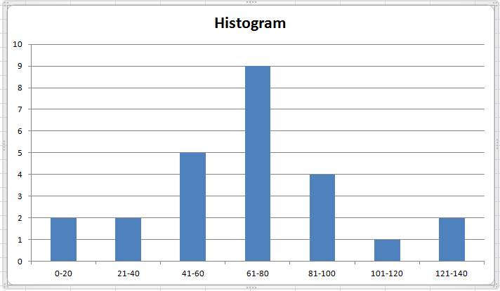

Histogram of 25 samples

Mean of distance=68.192

Root mean square error=27.56

……………………………………………………………………………………………………………………………………………………………

Mean for the first time calculation =0.00585

Root mean square error = 0.00305

bjhsdunvygjhb