Nestor Romero Leon

Student ID: 301133331

Introduction to Artificial Intelligence

Linear Regression Assignment – Exercise 1

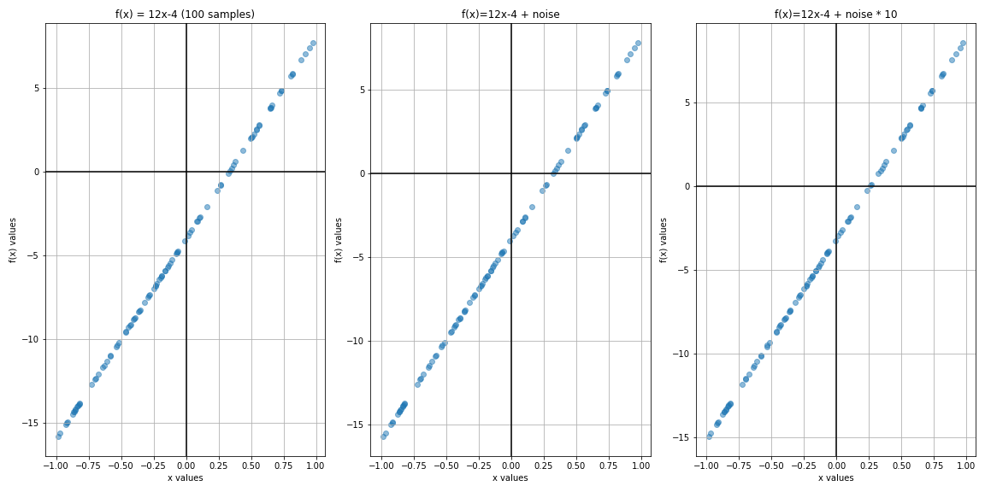

With the previous plots, the convergence of the points towards the equation is clear with the first 2 plots, the first with original sample data and the second with little noise, both plots show very little difference with small values of noise. In contrast, the third one shows the effect of noise when amplified. Here the noise makes f(x) data points have higher values and the scatter plot moves away from the original equation as noticeable with the x and y-axis intercepts