COMP258 – NEURAL NETWORKS

ASSIGNMENT 4

NESTOR ROMERO – 301133331

MODEL TRAINING SCREENSHOTS

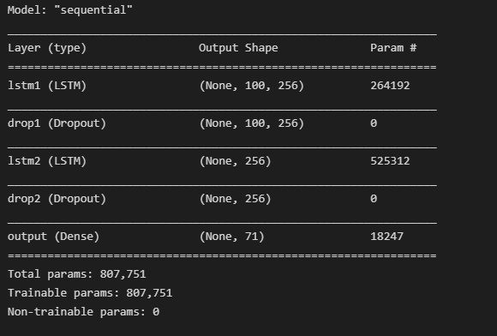

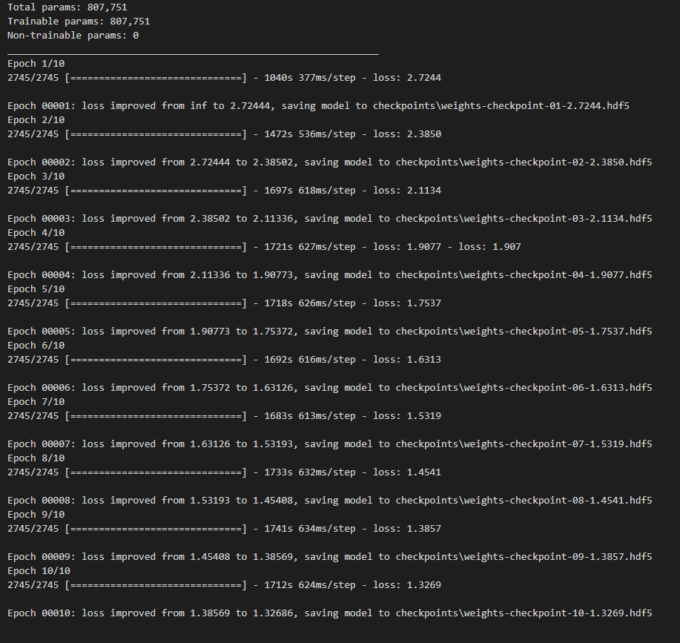

**REQUIRED TUNING**

Heavily commented sample code needed to be removed to improve the model behaviour

See example below

