1) Driver Configuration

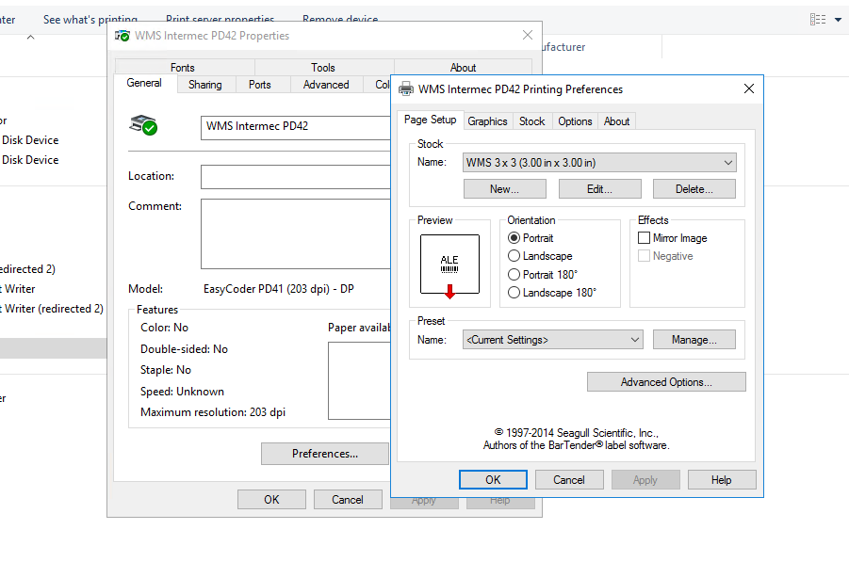

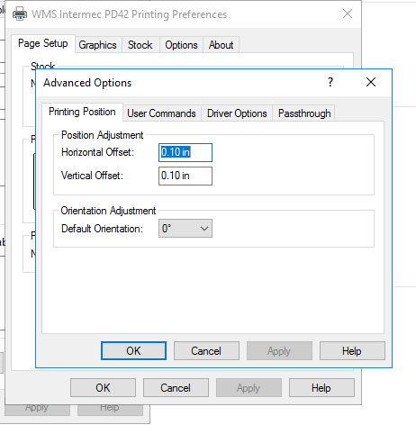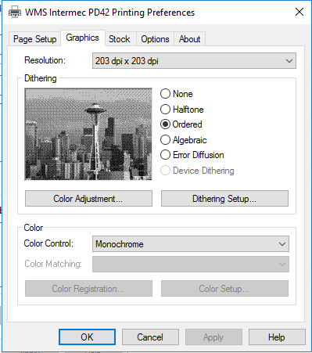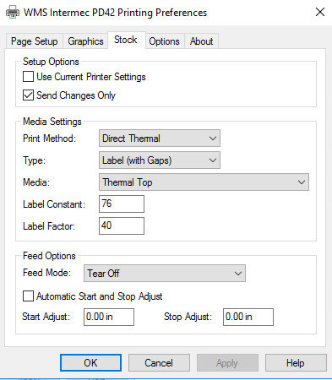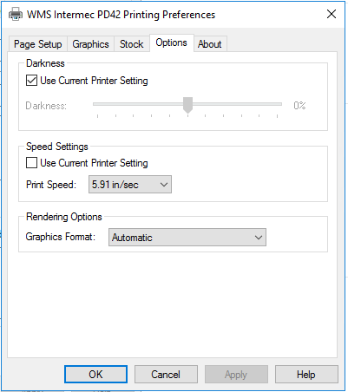

2) Config Parameter

**select**

**top** 1 bnvalue,

bndesc,

bndescalt,

bnflex1

**from**

wm_binary

**where**

orgcode = 'bgc'

**and** site = '91917'

**and** depot = '01'

**and** apps = 'WMS'

**and** bntype = 'PRINTER'

**and** bncode = 'LABEL';