1.

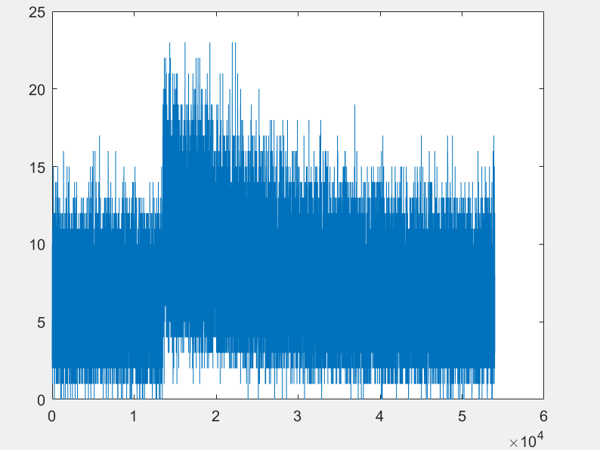

As shown above here I have taken one period or a 90-min orbit’s data(namely from 27000 to 81000) which is from the start of the second half of the first orbit tile the end of the first half of the second orbit. Then by observing the graph one can say that this can be easily modelled like an exponential distribution with mu = 1/(max(signal)). As the background changes with time but is a repetitive exponential function. One can compare and see that both the graphs are similar and will fit any 90 min orbit data as the max value will still be 23.

2. For question 2 I observe the data and see that there is a lot of noise or signal contamination. I first separate the noise as background data. As one can see on close observation that the background does change with time but stays within a sigma of 1 with mean equal to 0. I subtract the background from the data to get the signal filtered out and then plot it and look for the faintest star which is at the location pixel. Unfortunately my lab partner and I couldn’t discuss the last part.