1. 5sigma occurs at x = 411
2. I select a range of 10sigma for data injection
   1. 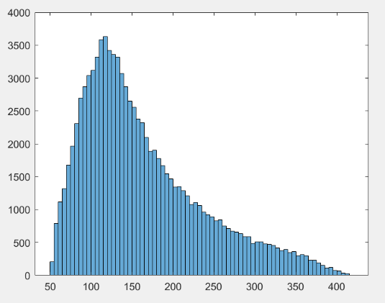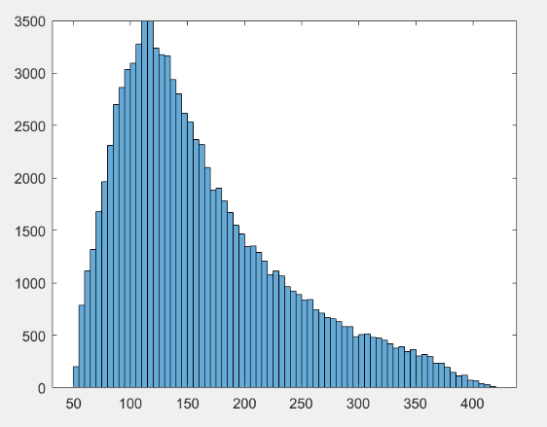The signal data injected has a noticeable change to the normal data i.e. without the signal injection. This shows that there are two different curves in there which is true as one histogram is of the signal data(the data injected) overlapping with the background data. Thus this creates a change in the overall peak x-value of the graph as shown below. (with the graph right showing the data injection)
   2. Yes our signal is biased towards the stronger side as the histogram peaks at a value >126GeV. No the histogram isn’t symmetric.
3. For this problem I used an interval of 30sigma
   1. 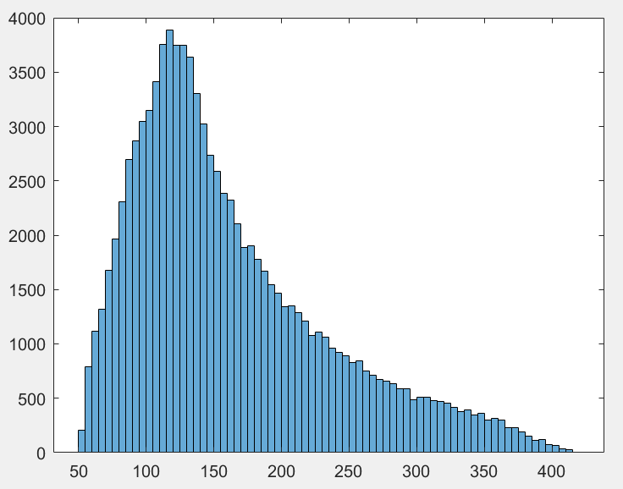Now when one compares the signal free data with injected data there’s a significant change in the graph and the x-peak values of the graph. As one can see from the graph below.
   2. Since I didn’t choose the same interval as problem 2. This is verified by the different shape of the histogram here. This graph here has moved towards the left from the (10sigma injected graph from above). This shows that as a much larger interval of signal data is added the graph will get skewed around the mean value around 126GeV.
   3. The histogram being created here can serve as a basis for analysis for larger intervals. As one can see the graph is almost symmetric, this is due to uncertainties in the measuring equipment. This graph can be used to calibrate for higher interval measurements as the uncertainty here can be extended to the whole data set and then a much more precise answer can be given.
   4. I observe an uncertainty of 81.78%.
   5. This means that the graph is unsymmetrical by this ratio. Thus as one can see in the graph that across the center line the right side of the graph is higher thus the pk-pk(rightside)/pk-pk(leftside) = 0.8178. This is what I understand from this uncertainty.
4. I select a 1 sigma range
   1. Yes observed as given.
   2. A pdf() extending to zero would mean that the signal is repeating constantly very quickly.
   3. The 95% confidence interval is [1 93410]