

Title

Math Solver

Submitted by

Mandeep Singh

Registration number 12100626

Roll number 19

Section K21WB

School of Computer Science & Engineering

Lovely Professional University, Phagwara, Punjab

Table of contents

1. Introduction
2. Scope of the project
3. Module
4. Design
5. Sample code
6. Outcome of project

1. Introduction

Mathematics is an essential subject that is fundamental to almost every field of study. Whether it's science, engineering, finance, or computer science, math plays a crucial role in problem-solving and decision-making. However, solving math problems can be challenging and time-consuming, especially for students and professionals who are always on the go. That's where the Math solver app comes in - a powerful tool designed to help users solve basic math problems quickly and efficiently.

The Math solver app is an Android application that provides a one-stop solution for various mathematical problems. The app includes features such as permutation and combination, logical operations, number conversion, unit conversion, and a simple calculator. The app's design is focused on simplicity, user-friendliness, and intuitive navigation, making it accessible to users of all mathematical proficiency levels. The app's features and functions are accessible in just a few clicks, making it easy for users to perform calculations quickly and efficiently.

2. Scope of the Project

The scope of the Math solver app is broad and covers a wide range of mathematical problems. The app is designed to help users solve basic math problems quickly and efficiently, making it an essential tool for students and professionals alike. The app's features, including permutation and combination, logical operations, number conversion, unit conversion, and a simple calculator, provide a comprehensive solution for various mathematical problems.

Permutation and combination are crucial concepts in probability and statistics, and the app's feature provides an easy-to-use interface for solving these types of problems. Logical operations, such as AND, OR, and XOR, are essential for digital logic and computer science and are also included in the app.

The number conversion feature provides an easy-to-use interface for converting numbers from one system to another, such as decimal to binary, octal, or hexadecimal. The unit converter feature provides an easy-to-use interface for converting units of measurement, such as length, weight, and temperature.

The simple calculator feature provides an intuitive and easy-to-use interface for performing basic mathematical operations such as addition, subtraction, multiplication, and division.

Overall, the Math solver app's scope is comprehensive and covers a wide range of mathematical problems, making it an essential tool for students, professionals, and anyone who needs to perform mathematical calculations on-the-go.

3. Modules

2.1 Permutation and Combination

he Permutation and Combination module is designed to solve problems related to probability and statistics. Users can enter the values of n and r, and the app will automatically calculate the permutation and combination for them. This module is useful for solving problems such as calculating the number of ways a group of people can be selected from a larger group or the number of possible combinations of items from a set. This module can also be used to solve problems related to arrangements and selection, such as selecting a committee from a group of people or arranging books on a shelf.

2.2 Logical Operation

The Logical Operation module allows users to perform logical operations such as AND, OR, NOR, and XOR. Users can enter values, and the app will automatically calculate the result of the operation. This module is useful for solving problems related to digital logic and computer science. For example, this module can be used to solve problems related to Boolean algebra, such as simplifying logic expressions or designing logic circuits. This module is also useful for solving problems related to circuit design, such as calculating the output of a circuit given its input values.

2.3 Number Conversion

The Number Conversion module is designed to convert numbers from one system to another, such as decimal to binary, octal, or hexadecimal. Users can enter a number in any system, and the app will automatically convert it to the desired system. This module is useful for solving problems related to computer science and digital logic. For example, this module can be used to convert binary numbers to decimal numbers, or to convert hexadecimal numbers to binary numbers. This module is also useful for solving problems related to networking, such as converting IP addresses from decimal to binary.

2.4 Unit Conversion

The Unit Conversion module allows users to convert units of measurement, such as length, weight, and temperature. Users can enter a value in any unit, and the app will automatically convert it to the desired unit. This module is useful for solving problems related to engineering, physics, and other fields that require unit conversion.

2.5 Simple Calculator

This module provides an intuitive and easy-to-use interface for performing basic mathematical operations such as addition, subtraction, multiplication, and division. Users can enter values and the app will automatically calculate the result. The module is useful for solving simple arithmetic problems and can be used by anyone who needs a quick and easy calculator.

The Math solver app provides a comprehensive solution for solving basic math problems. The app's modules are designed to be intuitive and easy-to-use, making it accessible to users of all levels of mathematical proficiency. The app's versatility, accuracy, and ease of use make it an ideal tool for anyone who needs to perform mathematical calculations quickly and efficiently. With the Math solver app, users can save time, improve their math skills, and perform calculations with ease, anytime and anywhere.

2.5 News

News module providing users with access to the latest news stories from a variety of sources. This module is designed to provide users with an intuitive and seamless experience. this module showcases a range of news articles with their respective titles and descriptions and allows you to read the full article by simply clicking on the "Read More" button. Our news module also features easy navigation with the help of the previous and next buttons, allowing you to browse through the news articles effortlessly. Additionally, we provide the name of the source for each article, ensuring that you can trust the authenticity of the news.

4. Design

1. Home page

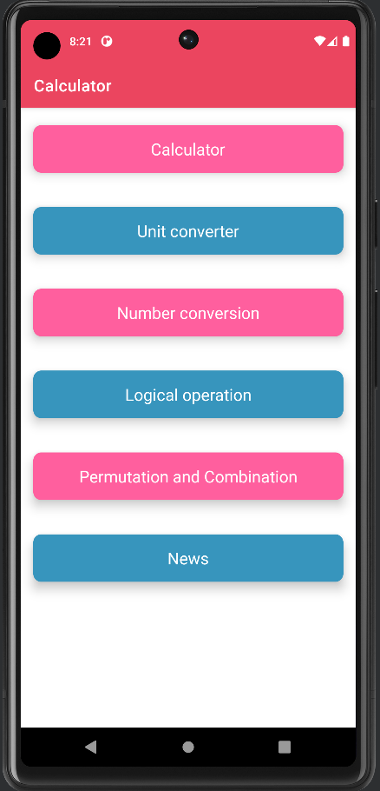

2. calculator

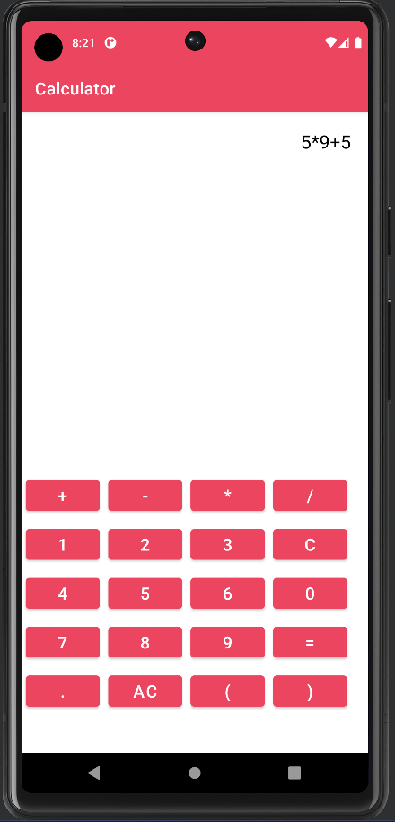

3.unit converter

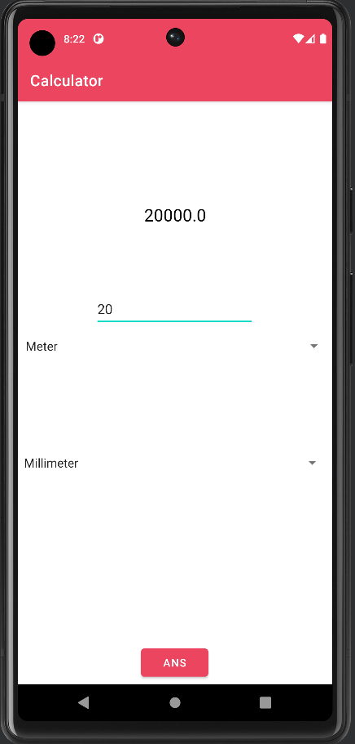

4. Number conversion

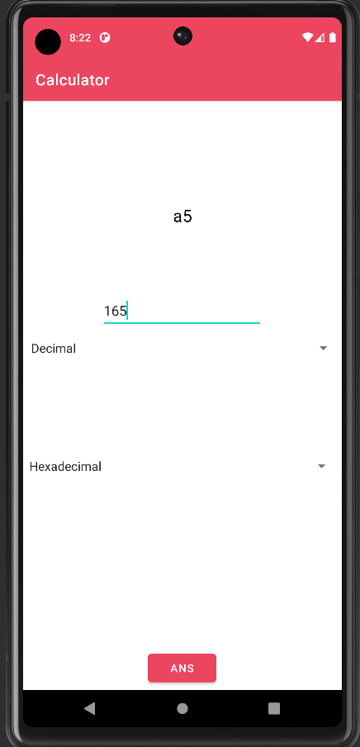

5. Logical Operation

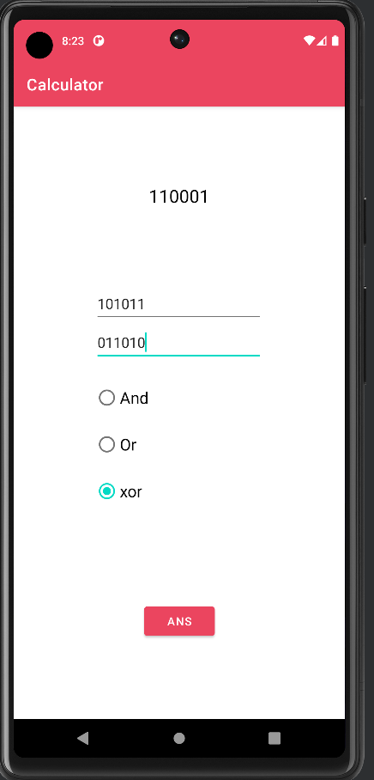

6. permutation and combination

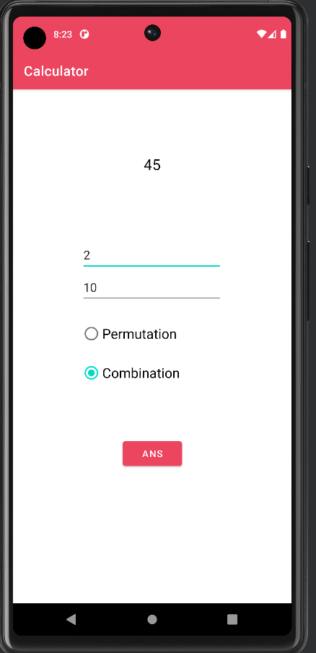

7. News



5. Sample code

GitHub link

<https://github.com/narottamandeep2003/Calculator>

Sample code

package com.example.calculator;  
  
import android.os.Bundle;  
import android.view.View;  
import android.widget.Button;  
import android.widget.EditText;  
import android.widget.RadioButton;  
import android.widget.RadioGroup;  
import android.widget.TextView;  
import android.widget.Toast;

class Solution{

int Permutation(int n, int k)  
 {  
 int P = 1;  
  
  
 for (int i = 0; i < k; i++)  
 P *= (n-i) ;  
  
 return P;  
 }  
  
}

int combination(int n,int r){  
 if (r > n)  
 return 0;  
 if (r == 0 || r == n)  
 return 1;  
 return combination(n-1,r-1)+combination(n-1,r);  
 }

public class PerCom extends AppCompatActivity {  
  
 @Override  
 protected void onCreate(Bundle savedInstanceState) {  
 super.onCreate(savedInstanceState);  
 setContentView(R.layout.*activity_per_com*);  
 TextView textView=findViewById(R.id.*text2*);  
 EditText editText1=findViewById(R.id.*editText1*);  
 EditText editText2=findViewById(R.id.*editText2*);  
  
 Button btn= findViewById(R.id.*button2*);  
 btn.setOnClickListener(view -> {  
  
 int n=Integer.*parseInt*(String.*valueOf*(editText1.getText()));  
 int r=Integer.*parseInt*(String.*valueOf*(editText2.getText()));  
 RadioGroup radioGroup=findViewById(R.id.*radioGroup*);  
 int selectedId = radioGroup.getCheckedRadioButtonId();  
 RadioButton radioButton = findViewById(selectedId);  
 if(selectedId==-1){  
 Toast.*makeText*(this, ""+(n+r), Toast.*LENGTH_SHORT*).show();  
 }  
 else{  
 if(radioButton.getText().equals("Combination")){  
 Solution s=new Solution();  
 textView.setText(String.*valueOf*(s.combination(n,r)));  
 Toast.*makeText*(this,textView.getText(), Toast.*LENGTH_SHORT*).show();  
 }  
 else {  
 Solution s=new Solution();  
 textView.setText(String.*valueOf*(s.Permutation(n,r)));  
 Toast.*makeText*(this,textView.getText(), Toast.*LENGTH_SHORT*).show();  
 }  
  
 }  
  
 textView.setVisibility(View.*VISIBLE*);  
 });  
 }  
}

6. Outcome of project

Math solver is an Android application designed to help students and professionals solve basic math problems quickly and efficiently. The app includes features such as permutation and combination, logical operations, number conversion, unit conversion, and a simple calculator. The app's design is focused on simplicity, user-friendliness, and intuitive navigation. The user interface is designed to be easy to use, with features and functions accessible in just a few clicks

Features:

Permutation and combination - This feature is useful for solving problems related to probability and statistics. Users can input the number of objects and the number of choices, and the app will provide the permutation and combination values.

Logical operations - The app includes logical operators such as AND, OR, NOR, and XOR, which are useful for solving problems related to digital logic and computer science.

Number conversion - This feature is useful for converting numbers from one system to another, such as decimal to binary, octal, or hexadecimal.

Unit converter - This feature is useful for converting units of measurement, such as length, weight, and temperature.

Simple calculator - The app also includes a simple calculator, which can perform basic mathematical operations such as addition, subtraction, multiplication, and division.