Practice Work 9
HTML & CSS Fundamentals

After completing PW 9, learners should be able to:
- identify the developer tools and integrated development environments (IDEs) used by web developers;
- understand the fundamental elements of a webpage, such as headings, paragraphs, images, links, lists, tables, forms, and more;
- develop a deep understanding of how web content is organized and how different elements work together to create a cohesive user experience;
- modify the structure, layout, and content of existing web pages to achieve desired outcomes
- create static web pages and understand the fundamental building blocks of the web;
- understand how to design user-friendly interfaces by utilizing HTML elements and CSS styles effectively;
- learn to inspect elements from browser;
- ​​enhance problem-solving skills by debugging HTML and CSS code and resolving common web design issues.

Practice work 9.
HTML & CSS Fundamentals

Suggested soft to complete the task: VSCode, SublimeText OR Online HTML Editors like Programiz, CodePen.
Additional resource: You can take the following free short course from codecademy to learn HTML basics: https://www.codecademy.com/learn/learn-html
Tutorial from: w3schools.com

Easy Level.
Task 1. Create a Sample CV Page 10%
Create a simple web page that displays your CV. The page should include the following sections: your name, education, skills, and hobbies. Use the appropriate HTML tags to structure your page. You should use:
- <h1> for your name or headings
- <p> for paragraphs
- <b> for bold text (e.g., for section titles), <i>, <u> italic and underlined text accordingly
- <img> to insert a photo
- <table> to display information in a tabular format (optional).
- 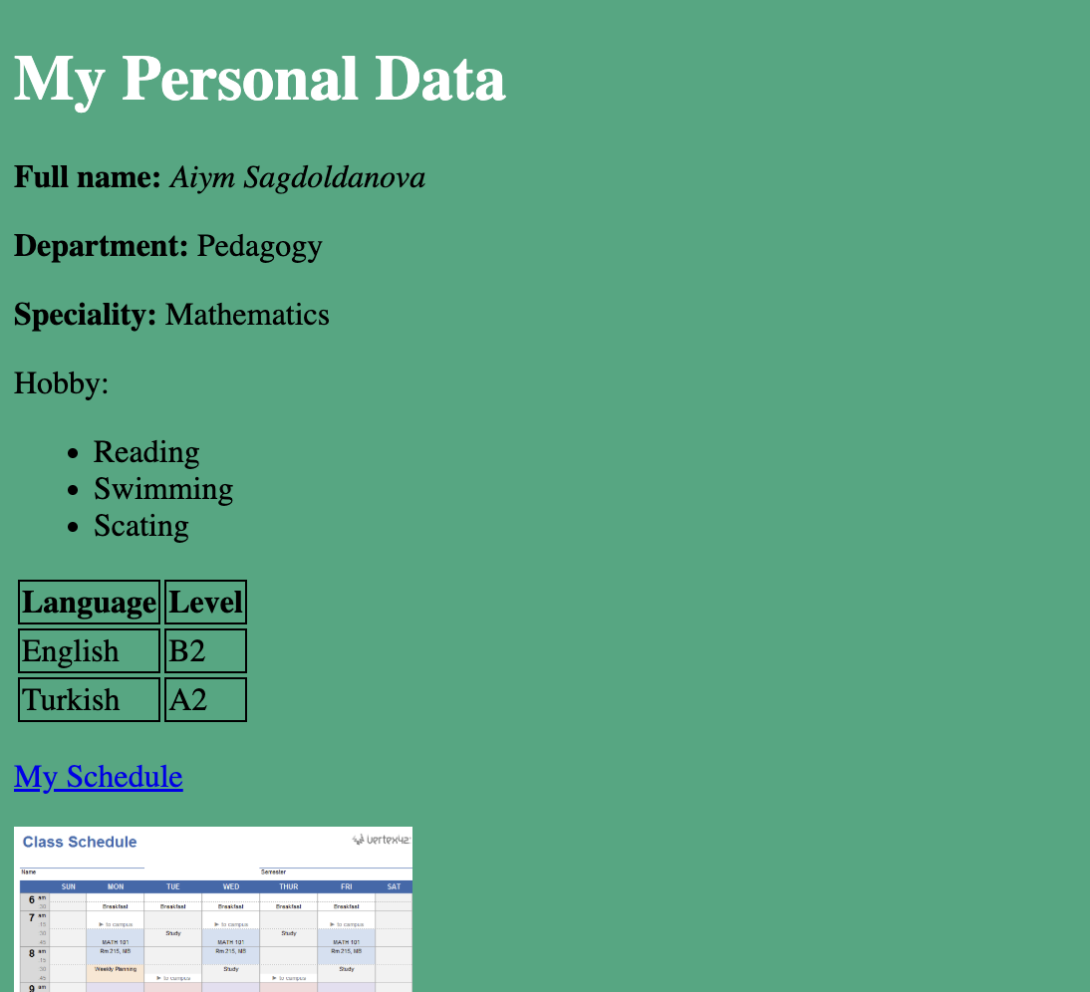

Easy Level.
Task 2. Create a Registration Form 10%
Design a registration form that asks for user input. The form should include fields for:
- Name
- Password
- Gender (use radio buttons)
- Country (use a dropdown menu)
- File attachment (use an input field for uploading a file)
Be sure to use the <input> tag with appropriate types, such as:
- <input type="text"> for the name
- <input type="password"> for the password
- <input type="radio"> for gender
- <input type="file"> for file attachment, etc.
- <select> for dropdown
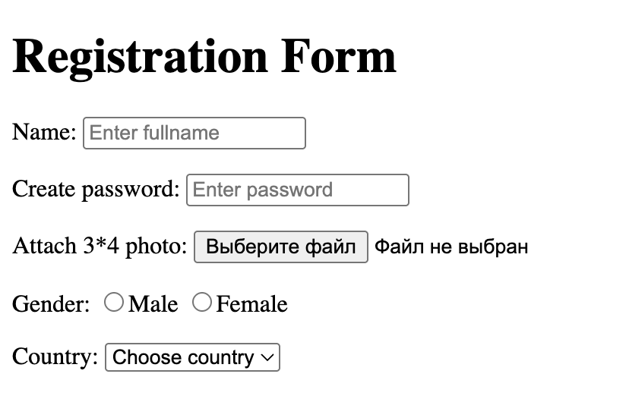

Middle level
Task 3: Create a Horizontal Menu 35%
Create a webpage that includes a horizontal navigation menu for world cities. The web page should display a list of cities with links that, when clicked, show information about each city. For this task, you will use HTML and CSS to structure and style the page.
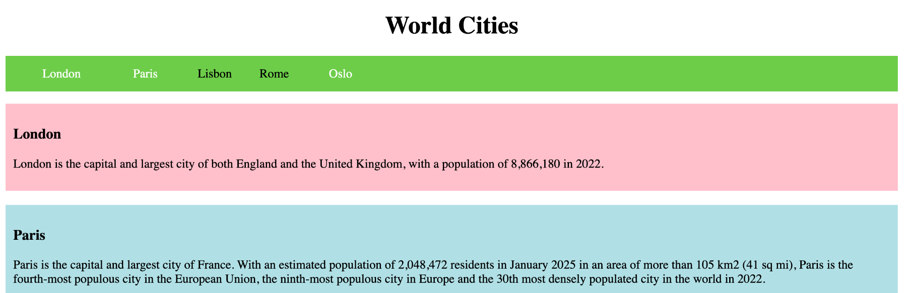
- Navigation Menu:
- Create an unordered list <ul> with list items <li>, each containing a link <a> to represent a world city (e.g., London, Paris, Oslo).
- Make sure the menu is displayed horizontally using CSS. You can achieve this by setting display: inline for the list items.
- Apply a background color to the menu and add padding to make it visually appealing. When a user hovers over a city link, change the background color to highlight it (e.g., yellow).
- City Information:
- For each city, create a separate section (using <div>), where you’ll display the name of the city (using <h3>) and a short description (using <p>).
- Each city section should be linked to the corresponding list item. When the user clicks on a city link, they should be taken to that city’s section on the page. Learn to use ID
- Styling:
- Use CSS to style the page. Make sure each city’s section has a distinct background color for better visibility.
- Use padding around the content to ensure it is spaced neatly.
- Ensure that the page is well-organized and visually clear.

Hard Level:
Task 4: Design the Google Homepage 45%
Recreate the layout of the Google homepage (google.com). Your version should include:
- A search bar in the center of the page,
- Google logo (can be represented as image),
- Buttons for "Google Search" and "I'm Feeling Lucky",
- Simple styling to make the page look similar to the actual Google homepage, using HTML and CSS.
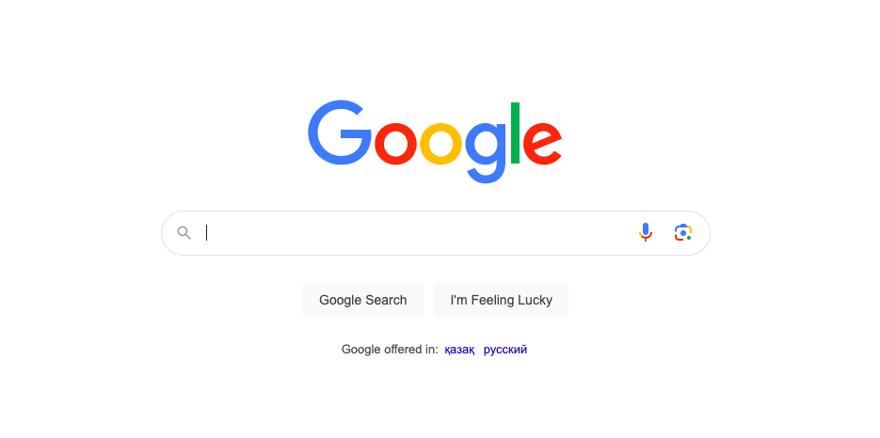
Logo: Add the Google logo at the top of the page. You can use the <img> tag with an image source (e.g., from a URL).
Search Bar: Create a search bar using the <input> tag. Style it to be centered and have rounded edges with appropriate padding.
Buttons: Add two buttons <button> below the search bar: "Google Search" and "I'm Feeling Lucky". Style the buttons with a simple background, rounded corners, and padding.
Styling: Use CSS to center the content on the page. Apply margins, padding, and width to elements like the search bar and buttons for a clean, neat layout.

