CSC 583: Natural Language Processing
Homework #4: N-gram Language Models
Asad Khan | CSC 583 | Fall 2026
Collaborators: none. GenAI tool used: Claude (Anthropic); see the disclosure note in Section 8.

1. Development Environment
I developed and ran the notebook locally in a uv-managed Python virtual environment, and ran every cell top to bottom in one pass before submitting, so all outputs are baked in.
Item | Detail
Platform | macOS 15.7.5, Apple Silicon (arm64)
Language / IDE | Python 3.13.8, Jupyter notebook (hw4_ngrams_AsadKhan.ipynb)
Libraries | NLTK 3.10.3 (FreqDist, ConditionalFreqDist, ngrams), pandas 3.0.6, matplotlib 3.11.2
Data | 1b_benchmark.train.tokens (61,530 sentences, 1,561,375 tokens) and 1b_benchmark.test.tokens (12,105 sentences, 306,181 tokens), read directly from the course GitHub with urllib
Table 1. Environment and data.

Part I: N-gram Modeling and Perplexity

2. How I built the N-gram models
The models are built in four steps, each a separate function in the notebook.
- Vocabulary (a separate pre-step). build_vocab() counts tokens in the training set only. The 54,059 types that occur fewer than 3 times are lumped into <unk>, then <STOP> is added. <START> is deliberately left out, because the model never predicts it, so it must not take part in normalising probabilities. The result is exactly 26,602 types, matching the assignment; the notebook asserts this.
- Mapping and padding. prepare(sentence, n) replaces out-of-vocabulary tokens with <unk>, adds n-1 <START> symbols in front and <STOP> at the end. Each line is its own sentence, so no n-gram crosses a line boundary. The test set goes through the same function with the training vocabulary (5.1% of test tokens become <unk>).
- Counting. unigram() builds an NLTK FreqDist over all tokens. bigram() passes the output of nltk.ngrams(tokens, 2) to nltk.ConditionalFreqDist, so cfd[w1] is the frequency distribution of the words that followed w1. trigram() does the same with 3-grams, using the tuple (w1, w2) as the condition.
- Probabilities. Each function returns a small NgramLM object holding the counts. Its prob() method is the maximum-likelihood estimate via NLTK's freq(): P(w | h) = c(h, w) / c(h), where c(h) is the number of times h was followed by anything (cfd[h].N()). This denominator handles <START> correctly: (<START>, <START>) occurs once per sentence. prob_laplace() gives the add-one estimate (Section 5).
Model | Conditions (contexts) | Distinct n-grams | n-gram tokens
Unigram | 1 (none) | 26,602 types | 1,622,905
Bigram | 26,602 | 510,391 | 1,622,905
Trigram | 510,364 | 1,116,132 | 1,622,905
Table 2. Size of the three models built from the training set. Every model scores 1,622,905 tokens: the 1,561,375 words plus one <STOP> per sentence.
As a sanity check, for several contexts (no context, <START>, the, (<START>, <START>), (of, the)) the probabilities summed over all 26,602 vocabulary words equal 1.0, both unsmoothed and with Laplace. Example probabilities: P(States | United) = 0.644 and P(York | <START>, New) = 0.325.

3. How I computed perplexity without smoothing
Perplexity is the inverse probability of the test text, normalised by the number of predicted tokens M. Multiplying hundreds of thousands of probabilities underflows to zero, so I use the equivalent log-space formula from the assignment:
PP = ( prod_{i=1..M} P(w_i | h_i) ) ^ (-1/M) = exp( -(1/M) * sum_{i=1..M} ln P(w_i | h_i) )

h_i = nothing (unigram), w_{i-1} (bigram), (w_{i-2}, w_{i-1}) (trigram)
In words: for every sentence I walk over each predicted token (every word plus <STOP>; <START> is only context, never predicted), add ln P(word | context) to a running total, and count the token in M. After all sentences, perplexity is e raised to minus the average log probability. Because M is summed over the whole file, this is the token-weighted average from the UW hints, and short sentences do not get extra weight. If any token has P = 0, ln 0 is minus infinity, so the function returns infinity and also reports how many zero-probability tokens it found.
log_sum = 0; M = 0; zeros = 0
for each sentence:
tokens = [<START>]*(n-1) + vocab-mapped words + [<STOP>]
for i = n-1 .. len(tokens)-1:
p = P(tokens[i] | previous n-1 tokens) # MLE: c(h, w) / c(h)
M += 1
if p == 0: zeros += 1 else: log_sum += ln(p)
return infinity if zeros > 0 else exp(-log_sum / M)
perplexity() and perplexity_laplace() share this loop and differ only in the probability function they pass in. To check the implementation, the notebook computes the unigram perplexity of a two-word sentence by hand and compares: both give 324.0839. No pre-made perplexity function is used.

4. Perplexity results
Model | Train, unsmoothed | Train, Laplace | Test, unsmoothed | Test, Laplace
Unigram | 976.54 | 977.51 | 896.50 | 898.56
Bigram | 77.07 | 1,442.31 | infinity | 1,665.39
Trigram | 7.87 | 6,244.42 | infinity | 9,649.61
Table 3. Perplexity of all three models, with and without Laplace smoothing (lower is better).
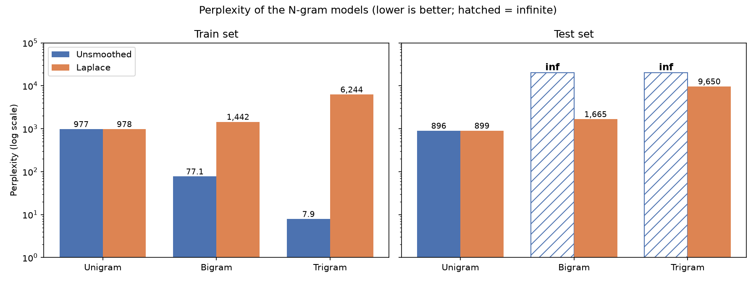
Figure 1. The same scores on a log scale. Hatched bars are infinite.
- Training set, unsmoothed: perplexity falls sharply with more context (977, 77, 7.9). Part of that is real, since two words of history predict the next word far better than none. But the trigram's 7.9 is mostly memorisation: there are 1.12M distinct trigrams in 1.62M tokens, so most trigram contexts were seen only once or twice.
- Test set, unsmoothed: only the unigram is finite. It is slightly lower than on training data (896.5 vs 976.5) because 5.1% of test words become <unk> versus 4.1% in training, and <unk> is a frequent, cheap token. The bigram and trigram are infinite because 66,335 test bigrams (20.8%) and 188,713 test trigrams (59.3%) never occurred in training (Table 4). For 66,334 test tokens the trigram has never even seen the two-word context.
- Laplace: every score becomes finite, but the bigram and trigram become far worse than the plain unigram, on both training and test data. Section 5 explains why.
Model | Test tokens with P = 0 | Unseen context | Seen context, unseen word
Unigram | 0 (0%) | 0 | 0
Bigram | 66,335 (20.8%) | 0 | 66,335
Trigram | 188,713 (59.3%) | 66,334 | 122,379
Table 4. Why the unsmoothed test perplexities are infinite (out of 318,286 scored test tokens).
For context only: if the zero-probability tokens are skipped, the bigram and trigram score 68.3 and 14.8. These are not valid perplexities, because they are measured on only 79% and 41% of the test tokens, the easy ones. They show that the higher-order models are sharp on what they have seen, and the whole problem is the unseen n-grams.

5. The downside of Laplace smoothing
Claim: Laplace smoothing adds one count for every one of the 26,602 vocabulary words to every context. For most bigram and trigram contexts this is far more than the real number of observations, so smoothing takes most of the probability away from the n-grams that were actually seen and spreads it over words that never follow that context. The model becomes much worse, and more context makes it worse rather than better. Four pieces of evidence:
Evidence 1: perplexity on the training data explodes. On text the model has already seen, smoothing should cost almost nothing. Instead:
Model | Train, unsmoothed | Train, Laplace | Laplace / unsmoothed
Unigram | 976.54 | 977.51 | 1.0x
Bigram | 77.07 | 1,442.31 | 18.7x
Trigram | 7.87 | 6,244.42 | 793x
Table 5. The unigram barely changes because its one context has 1.6M real counts; the sparse bigram and trigram contexts are swamped.
Evidence 2: observed n-grams lose almost all of their counts. Turning the Laplace probability back into an effective count, c* = (c + 1) c(h) / (c(h) + |V|), shows how much was given away:
N-gram | c(h) | c(h, w) | P_MLE -> P_Laplace | c* | c* / c
United States | 793 | 511 | 0.644 -> 0.019 | 14.8 | 2.9%
New York | 1,025 | 579 | 0.565 -> 0.021 | 21.5 | 3.7%
of the | 34,841 | 8,342 | 0.239 -> 0.136 | 4,730.9 | 56.7%
the United States | 527 | 430 | 0.816 -> 0.016 | 8.4 | 2.0%
one of the | 873 | 523 | 0.599 -> 0.019 | 16.7 | 3.2%
Table 6. Reconstituted counts. Only very frequent contexts such as "of" keep a reasonable share.
Evidence 3: most of the probability goes to unseen words. For a context with T distinct observed continuations, Laplace gives the never-seen words a combined (|V| - T) / (c(h) + |V|). Over the contexts the test set actually uses, the median is 90.2% for the bigram and 99.9% for the trigram; for 89.6% of test tokens the trigram context gives more than 90% of its probability to words it never saw follow it.
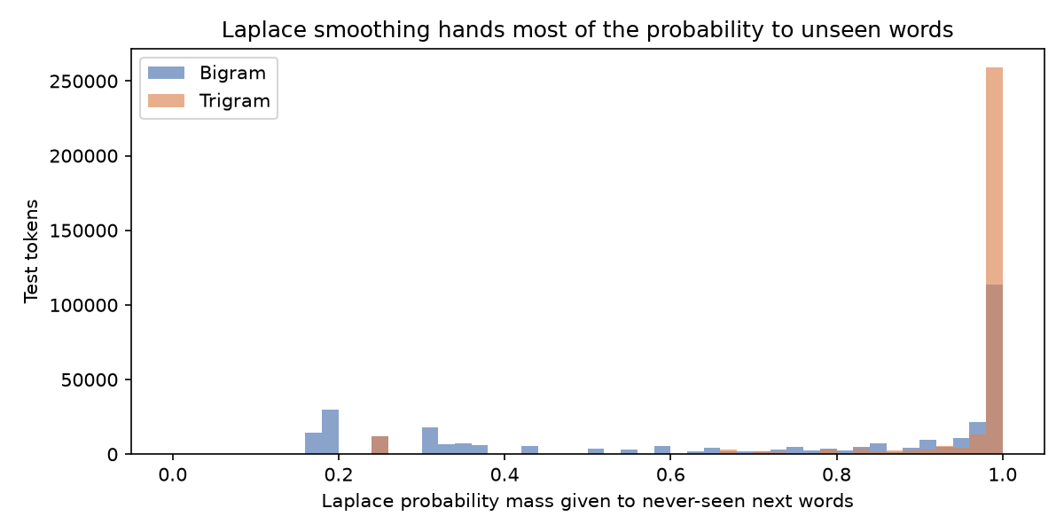
Figure 2. Share of Laplace probability mass given to never-seen next words, per test token.
Evidence 4: seen test n-grams become less likely, and the ranking reverses. Of the test bigrams that were seen in training, 97.6% get a lower probability with Laplace (median ratio 0.195); for trigrams it is 99.6% (median ratio 0.005). As a result the test perplexity ordering with Laplace is unigram 898.6 < bigram 1,665.4 < trigram 9,649.6, the opposite of what a well-smoothed model shows. Add-one fixes the infinite perplexities but is far too blunt for a 26,602-word vocabulary; a much smaller add-k, interpolation, backoff or Kneser-Ney would reserve far less mass for unseen events.
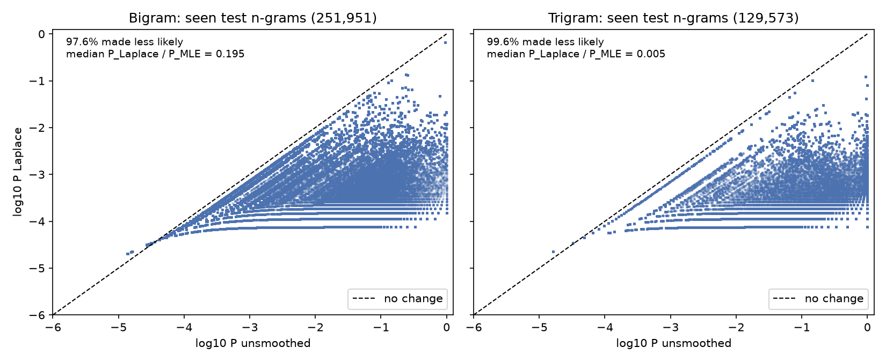
Figure 3. Each point is a seen test n-gram; points below the dashed line were made less likely by Laplace smoothing.

Part II: Text Generation from N-gram Models

6. How I generated text from the models
For Part II I merged the training and test sentences (73,635 sentences, 1,867,556 tokens), built a new vocabulary from the merged data with the same rule (fewer than 3 occurrences becomes <unk>, plus <STOP>; 29,479 types) and rebuilt the models with the same bigram() and trigram() functions. NLTK is used only to build the counts; the generation routine is my own, extending the NLTK book's chapter 2.4 example to trigrams and three strategies.
- Start from the padded history: [<START>] for the bigram, [<START>, <START>] for the trigram.
- Look up the current context (last one or two words) in the ConditionalFreqDist. Its FreqDist, sorted with most_common(), is the distribution over the next word.
- Pick the next word with the chosen strategy. The very first pick X forms the seed n-gram (<START>, X) or (<START>, <START>, X), so the seed is chosen by the same strategy.
- Append the word, slide the context window forward by one word and repeat. Stop when <STOP> is chosen or 100 words have been generated.
Because every word was generated from an n-gram that exists in the corpus, every context reached during generation has been seen, so no smoothing is needed. The three strategies:
- Greedy: always the most frequent next word (deterministic, so one sentence per model).
- Random sampling: draw a word with probability c(h, w) / c(h) using random.choices with the counts as weights.
- Top-p (nucleus) sampling: sort the next words by probability, keep the smallest set whose probabilities add up to at least p, renormalise and sample from that set. I tried p = 0.2, 0.5, 0.8 and 0.95. For the first word after <START> (5,536 possible words) the nucleus holds 2, 15, 314 and 2,491 words respectively.
All sampling uses a fixed seed (random.Random(583)), so the sentences below are reproducible from the notebook (Steps 12 to 16).

7. Generated sentences
Tokens are shown exactly as the model produces them (the corpus is pre-tokenized, so punctuation and 's are separate tokens, and <unk> is a real token of the model). None of the sentences below is a word-for-word copy of a corpus sentence; the notebook checks this.
Bigram | Generated sentence
Greedy | The <unk> , the <unk> , the <unk> , the <unk> , the <unk> , ... (repeats until the 100-word limit, never produces <STOP>)
Random 1 | It was about this week goes off a <unk> 's largest minority hiring someone to ensure that the manifestations , no legal damages .
Random 2 | The handwritten notes on Wednesday , Hyde 's administrative expenses for Travel Channel .
Random 3 | Another skier , but like the manufacturers to disclosures have registered to stay .
Top-p 0.8 | I think I 'd hoped to hear at about 10 November 's victory by a second week that the cold snap a series , if they were barred from their employees .
Top-p 0.8 | But he 's all the school , which was named for best .
Top-p 0.95 | He said today include Montana series .
Top-p 0.2 | The <unk> , the United States , "
Table 7. Sentences generated by the bigram model.
Trigram | Generated sentence
Greedy | The <unk> <unk> , <unk> , <unk> , <unk> , <unk> , <unk> , ... (repeats until the 100-word limit, never produces <STOP>)
Random 1 | At the meeting was taken to George Washington Parkway in northern Colombia after surrendering under the protection of human genetics .
Random 2 | In an election office in Kathmandu on Saturday night .
Random 3 | The ladies of " generation III + " reactors build on the back .
Top-p 0.2 | The announcement comes amid a flood of lawsuits linked to the media .
Top-p 0.2 | The government has been accused of failing to spot that Baby Peter was suffering from <unk> , <unk> <unk> , <unk> , the <unk> .
Top-p 0.5 | If it 's the love of her work cut out .
Top-p 0.95 | Liberals don 't want to ask how or why it was unlikely to be his last Prime Minister John Howard for refusing to offer .
Top-p 0.95 | India has allowed parents to learn the game .
Table 8. Sentences generated by the trigram model.
To back up my impressions with numbers, I generated 300 sentences per model and strategy and measured length, how often the 100-word limit was hit, diversity (distinct-2: unique word pairs divided by all word pairs), word-for-word copies of corpus sentences, and the share of <unk>:
Strategy | Avg words | % hit limit | distinct-2 | % copied | % <unk>
Greedy | 100 / 100 | 100 / 100 | 0.04 / 0.04 | 0 / 0 | 33.0 / 50.0
Top-p 0.2 | 9.1 / 21.9 | 0 / 1.0 | 0.15 / 0.17 | 14.3 / 0 | 22.2 / 19.5
Top-p 0.5 | 17.4 / 22.4 | 0 / 0.7 | 0.50 / 0.62 | 3.0 / 0 | 7.7 / 6.7
Top-p 0.8 | 19.0 / 24.9 | 0 / 1.0 | 0.77 / 0.79 | 1.0 / 0 | 5.4 / 4.2
Top-p 0.95 | 22.0 / 24.5 | 1.7 / 1.0 | 0.84 / 0.83 | 0.3 / 0.7 | 4.0 / 3.9
Random | 24.2 / 25.5 | 1.0 / 0.7 | 0.84 / 0.85 | 0.3 / 1.0 | 3.6 / 4.1
Table 9. Generation statistics, shown as bigram / trigram (300 samples each; greedy is a single deterministic sentence).
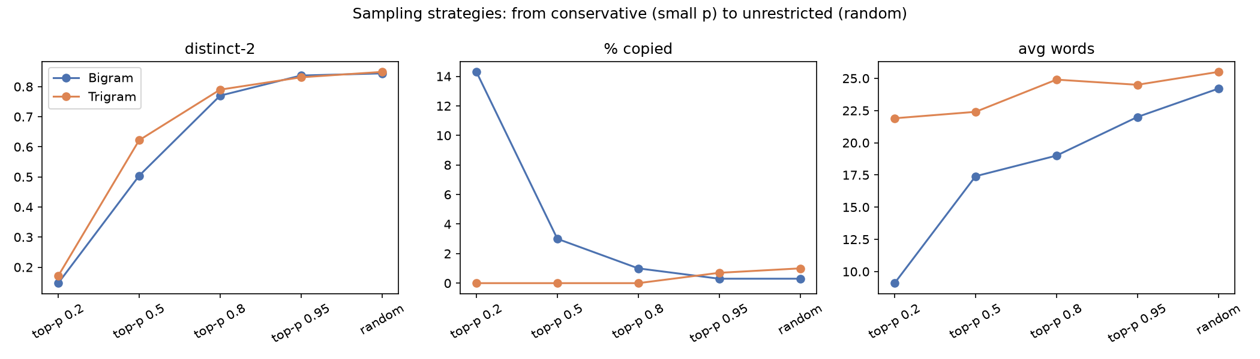
Figure 4. Diversity, copying and length as the strategy moves from conservative (small p) to unrestricted (random).
- Greedy gets stuck in a loop. The chain of most-likely words is a cycle that never reaches <STOP>: for the bigram, the -> <unk> (P = 0.057) -> , (0.131) -> the (0.067); for the trigram, (<unk>, ,) -> <unk> and (,, <unk>) -> ,. Choosing the best word at every step does not give the best sentence.
- Random sampling produces natural lengths (the corpus averages 25.4 words per sentence) and the most variety, but drifts between topics because the model only remembers one or two words. The trigram reads noticeably better within phrases than the bigram.
- Top-p moves smoothly between the two. Small p behaves like a noisy greedy search: short, generic sentences, about 20% <unk>, and low diversity (the bigram's 14% "copies" at p = 0.2 are tiny sentences such as "The <unk> ."). At p = 0.8 to 0.95 only the long tail of unlikely words is cut, which gave the best balance of variety and sensible word choices.
- Memorisation. Most trigram contexts have a single continuation, so the trigram often replays long stretches of real news sentences ("The government has been accused of failing to spot that Baby Peter was suffering from ..."), even though whole-sentence copies stay at 0 to 1%.

8. Reflections

What I learned
- An n-gram model is just a normalised count table. There is no training loop, and the hard part is everything around the counts: the vocabulary, the boundary symbols and what to do with zeros.
- Perplexity is the exponential of the average negative log probability, which is the same cross-entropy loss used to train modern neural language models. Working in log space is not optional at this scale.
- A low training perplexity can be pure memorisation: the trigram scored 7.9 on training data and infinity on new text.
- A fix can remove a failure and still make the model worse. Laplace smoothing turned infinite perplexities into finite ones, but made the bigram and trigram worse than a unigram.
- The decoding strategy matters as much as the model. The same counts produced an endless loop with greedy choice and fairly fluent sentences with top-p sampling.

How difficult I found it
Moderate. Building the models and the perplexity function was quick once the data structures were clear. Most of the time went into the details that decide whether the numbers are right (the vocabulary size, how <START> is counted, what to report when perplexity is infinite) and into collecting evidence for the Laplace and generation discussions rather than just stating conclusions.

Particular difficulties
- Getting the denominators right. The probability of a word after a context has to be divided by the number of times that context was followed by anything, not by the context's unigram count, or the <START> rows do not sum to one. Checking that every row sums to 1.0 caught this kind of mistake.
- Deciding how to report the unsmoothed test perplexity. Skipping the zero-probability tokens gives a tempting finite number, but it measures a different, easier subset of the data, so I report infinity and show the skipped-token value only as a diagnostic.
- Greedy generation never ended. Printing the chain of most-likely words showed the cycle through <unk> and the comma, which explained the result instead of just showing it.

What I would do differently next time
- Write the sanity checks (rows sum to one, a hand-computed perplexity, an expected vocabulary size) before the main code, since they are what made me confident in the results.
- Implement a better smoothing method, such as interpolation or Kneser-Ney, to see how much of the gap between the unigram and the trigram on test data it closes.
- Mask <unk> out during generation, or use subword tokens, so the generated text is more readable.

GenAI disclosure
I used Claude (Anthropic) as a coding assistant on this assignment: to help structure the notebook, to suggest the evidence used for the Laplace smoothing and generation analyses, and to help draft this write-up. I reviewed all code, ran the notebook myself and checked the numbers reported here against its outputs.

9. Files Submitted
- hw4_ngrams_AsadKhan.ipynb: the notebook for Parts I and II, with all outputs.
- HW4-WriteUp-AsadKhan.docx: this write-up.

