CSC 583 - Natural Language Processing
Homework #1 - Text Preprocessing
Asad Khan | Fall 2026
Collaborators: none. GenAI tool used: Claude (Anthropic) - see the disclosure note in Section 6.

1. Development Environment
I developed and ran this assignment locally rather than on Google Colab, inside a dedicated Python virtual environment so that the package versions are pinned and reproducible.
Item | Detail
Platform | macOS 15.7.5 (build 24G624), Apple Silicon (arm64)
Language | Python 3.13.8
Environment | Virtual environment (.venv), created with uv
IDE | JupyterLab notebook (hw1_text_preprocessing.ipynb)
NLP library | NLTK 3.10.3 - only sent_tokenize() and word_tokenize()
NLTK models | punkt, punkt_tab
Charting | matplotlib 3.11.2
Standard library | re, collections, math, urllib.request

Both input files are read directly from the course GitHub repository over HTTPS using urllib.request.urlopen(), as required - nothing is read from a local drive, and each file is read exactly once.

2. Results
Statistic | Task 1 - sample_2026.txt | Task 2 - war-and-peace.txt
# of paragraphs | 8 | 12,169
# of sentences | 31 | 31,911
# of tokens | 567 | 673,293
# of unique tokens | 274 | 18,288

3. Did my output match the sample output?
Yes - both output files match exactly, byte for byte. I verified this two ways: with the Unix diff command, and with a comparison cell inside the notebook that re-downloads the instructor's sample files from GitHub and compares them line by line.
- output1.txt matches output-sample.txt in full - all 279 lines, including every rank, token and count.
- output2.txt matches output-WaP-2026-500.txt across all 505 published lines (the 4 statistics lines, the separator line, and the top 500 ranked tokens).
Getting to that exact match was not immediate. Two discrepancies cost me most of my time on this assignment, and I think they are the interesting part of the work, so I describe both below.

Discrepancy 1 - the sentence count was one too high (and 245 too high on War and Peace)
My first working version produced 32 sentences for the sample file instead of 31, and 32,156 instead of 31,911 for War and Peace. Looking at the sample file, NLTK was breaking this line into two sentences:
"It wouldn't have (wouldn't've or had?)" | "bothered me if it only appeared in dialogue..."
The question mark followed by a closing parenthesis looked like a sentence ending to the Punkt model, even though the next word is lower case. My first guess was that the instructor had used an older version of NLTK, so I installed NLTK 3.8.1 and 3.9.1 in throwaway environments and re-ran the count - both gave 32 and 32,156 as well, so the version was not the cause.
The actual cause is the order of operations. I had been lower-casing the text after sentence segmentation. If instead the whole document is lower-cased before sent_tokenize() is called, Punkt loses the capitalisation cue it was using to start a new sentence, and both counts land exactly on the expected values (31 and 31,911). That one reordering fixed 246 sentence boundaries across the two files.

Discrepancy 2 - War and Peace had exactly one extra token and one extra type
After the sentence fix I was still off by one on Task 2: 673,294 tokens and 18,289 types instead of 673,293 and 18,288. The cause was a byte-order mark (BOM) - an invisible U+FEFF character at the very start of war-and-peace.txt. Decoding the downloaded bytes with "utf-8" keeps that character, my punctuation rule then peels it off the first word as its own token, and it becomes a bogus 18,289th word type. Decoding with "utf-8-sig" strips the BOM if present and both counts became exact. The sample file has no BOM, which is why Task 1 was unaffected and the bug stayed hidden.

4. How the tokenizer works
The pipeline runs in a fixed order, and the order matters:
- Lower-case the entire document first (see Discrepancy 1).
- Paragraphs: split on the regular expression \n\s*\n - a newline, any amount of whitespace, another newline. This is what handles "blank" lines that actually contain spaces or tabs. I strip the document first so a leading or trailing blank line is never counted.
- Sentences: NLTK sent_tokenize() on the whole document at once. Feeding it one paragraph at a time gave 33,553 sentences for War and Peace, because Punkt loses the surrounding context it uses to judge whether a period ends a sentence.
- Words: NLTK word_tokenize(), then my own two passes over the token list.
- Pass A - expand contractions. n't becomes not, and I look backwards at the previous token to repair the stems NLTK leaves behind (wo -> will, ca -> can, sha -> shall). 'll/'ve/'d/'re/'m become will/have/would/are/am. "'s" is left as a possessive except after let (-> us) and after he/she/it/that/here/there/what/when/where/which/who/how (-> is).
- Pass B - separate outer punctuation with the regex ^([^\w]*)(.*?)([^\w]*)$, which peels leading and trailing punctuation off while leaving punctuation inside a word alone. So $3.19 becomes $ and 3.19, while 3-star and e.g are left whole. A token that is entirely punctuation (... , -- , '' ) is passed through exactly as NLTK produced it.
Two cases needed extra care. First, NLTK does not fully split double contractions - it returns "wouldn't" + "'ve" rather than three pieces - so I detect an n't still attached to the end of a token and split it myself, giving would + not + have. Second, the possessive "'s" has to be exempted from the punctuation pass, otherwise the apostrophe would be peeled off and it would become " ' " + "s".
Sorting is a single key: (-count, token). The negative count sorts by frequency descending, and because Python compares tuples left to right, the token itself breaks ties in ascending lexicographic order, as the assignment requires.

5. Zipf's Law chart (Task 2)
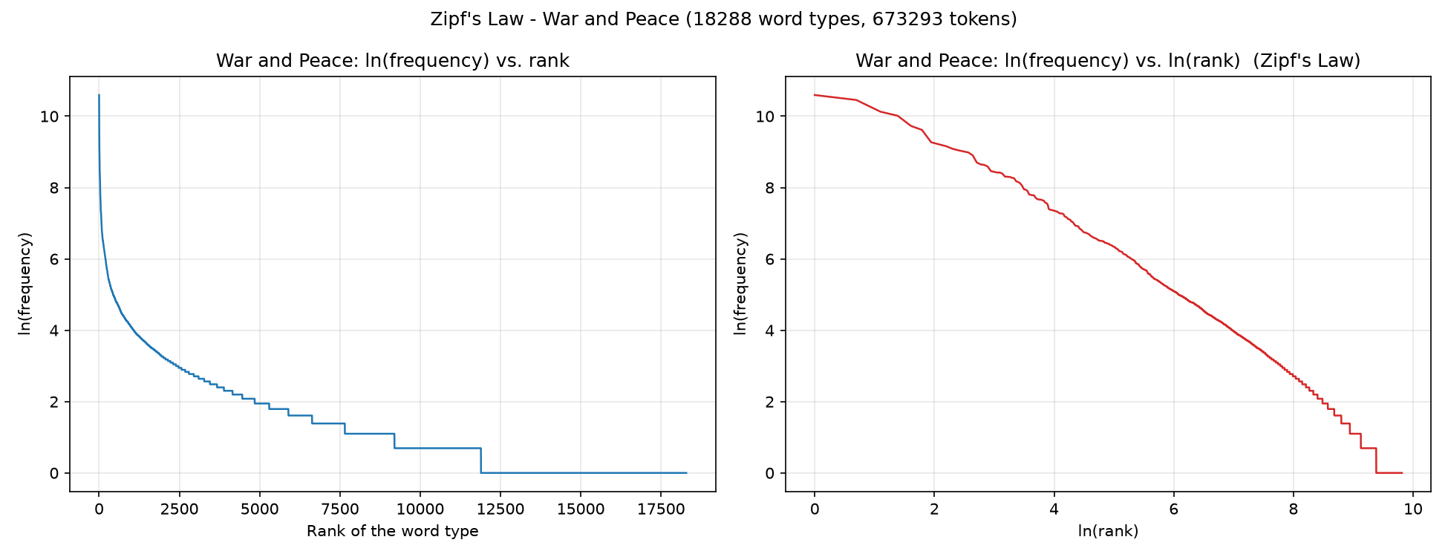
Left: the natural log of each word type's frequency plotted against its plain rank. Right: the same values plotted against the log of the rank.
Comments on the distribution:
- The left plot shows the shape Zipf's Law predicts - an extremely steep drop over the first few hundred ranks, then a very long, almost flat tail. Rank 1 is the comma at 39,882 occurrences; by rank 500 a token appears only 130 times.
- On the log-log plot the curve is close to a straight line, which is the real signature of Zipf's Law: frequency is roughly proportional to 1/rank raised to some power. Fitting a line to my data gives a slope of about -1.45, so this text falls off somewhat faster than the idealised slope of -1.
- The distribution is dominated by a tiny number of types. The 10 most frequent tokens account for 28.6% of all 673,293 tokens, and the top 100 account for 59.6% - so roughly half a percent of the vocabulary covers well over half the text.
- At the other end, 6,396 of the 18,288 word types (35.0%) occur exactly once. These hapax legomena create the flat step at ln(frequency) = 0 that stretches across the right-hand half of the left plot.
- Punctuation ranks very high because the assignment keeps it as tokens: the comma is rank 1 and the period is rank 3, ahead of every word except "the". The tokens '' and `` at ranks 9 and 11 are the opening and closing double quotes, which NLTK represents that way - a reflection of how much dialogue the novel contains.

6. Reflections

What I learned
- Tokenization is a pile of special cases, not one rule. The assignment's contraction table looks short, but won't/can't/shan't, double contractions, and the possessive-versus-"is" ambiguity in "'s" each needed their own branch.
- Order of operations in a preprocessing pipeline changes the answer. I would never have guessed that lower-casing before sentence segmentation rather than after would move the sentence count by 245 on a single book.
- Statistical sentence segmenters are guessing. Punkt is trained on text, so it is sensitive to capitalisation and to punctuation it has not seen much of - and that sensitivity is invisible until you compare against a reference.
- Encoding details are real bugs. A single invisible BOM character changed two of my four reported numbers.
- Reading a regular expression like ^([^\w]*)(.*?)([^\w]*)$ as three cooperating groups, and understanding why the middle one has to be non-greedy, made regex notation click for me in a way that exercises had not.

How difficult I found it
Moderate. Writing something that ran and produced plausible-looking numbers took maybe an hour; making those numbers match the instructor's sample exactly took considerably longer. The gap between "working" and "correct" was the whole assignment.

Particular difficulties
- The sentence count. Being off by exactly one on the sample file was maddening, because a single wrong boundary gives no clue about its cause. What finally worked was isolating the offending sentence pair, ruling out the NLTK version experimentally, and then questioning my own pipeline order.
- The off-by-one on War and Peace, which only made sense once I printed the repr() of the first characters of the file and saw \ufeff sitting there.
- Deciding exactly how far the punctuation rule reaches - in particular realising that "'s" has to be excluded from it after the contraction pass, and that pure-punctuation tokens must be passed through untouched rather than re-processed.

What I would do differently next time
- Build the comparison harness first. Once I had a cell that diffed my output against the sample line by line, every experiment took seconds; before that I was comparing numbers by eye.
- Print intermediate results earlier. The demonstration cell that walks one short sentence through all four stages would have shown me several issues immediately if I had written it at the start instead of near the end.
- Keep a short list of adversarial test strings from the beginning - prices, abbreviations, hyphenated words, double contractions, doubled punctuation - rather than discovering each case from a mismatch.

GenAI disclosure
I used Claude (Anthropic) while working on this assignment. It was most useful in diagnosing the two discrepancies described in Section 3 - specifically in suggesting that I test older NLTK versions to rule out a version difference, and in pointing at the lower-casing order and the BOM once I had narrowed the symptoms down. I reviewed and ran every experiment myself, and verified the final output against the sample files independently with diff.

7. How to run the code on a local system with a different input file
Requirements: Python 3.9 or newer, with nltk and matplotlib installed.
pip install nltk matplotlib
python -c "import nltk; nltk.download('punkt'); nltk.download('punkt_tab')"
Then open hw1_text_preprocessing.ipynb in Jupyter (or Google Colab) and run the cells top to bottom. To analyse a different file, there is a single entry point - the analyze() function - which takes the location of the input and the name of the output file to write:
result = analyze("https://raw.githubusercontent.com/<user>/<repo>/main/<file>.txt", "output3.txt")
That one call prints all four statistics and writes the ranked frequency file in the required format.
If the new file is on the local disk rather than a URL, change one line inside read_text_from_github() from:
raw_bytes = urlopen(url).read()
to:
raw_bytes = open(url, "rb").read()
and pass a file path instead of a URL. Everything downstream is unchanged, because the rest of the pipeline only ever sees the decoded string. Keeping the "utf-8-sig" decoding is recommended for any new input, since it is harmless on files without a BOM and prevents the off-by-one described in Section 3.
Files submitted: hw1_text_preprocessing.ipynb, output1.txt, output2.txt, and this write-up.

