2-3 Milestone One: Project Proposal
Narrwe Park
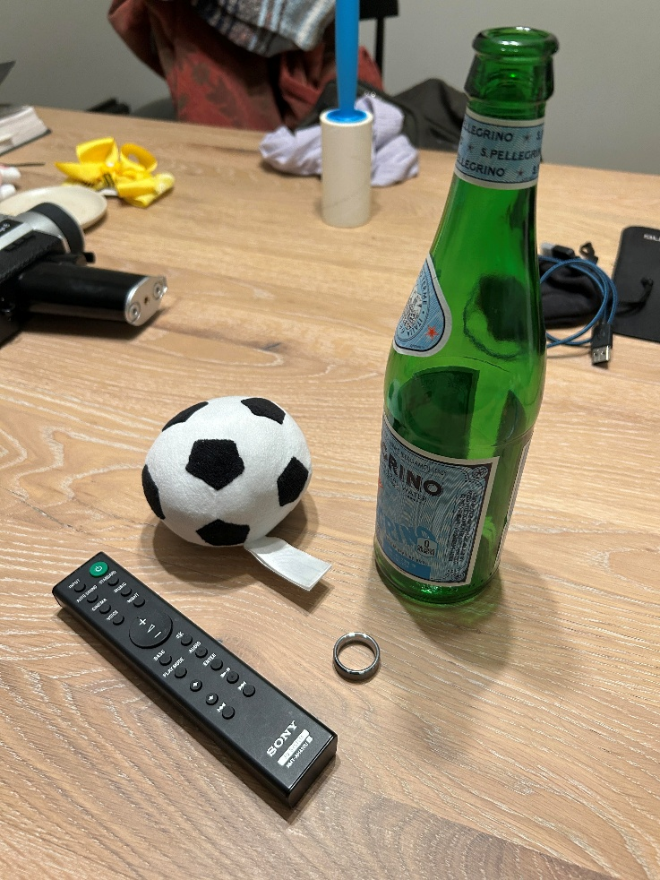
The image I propose to use in my project is shown on the above. These are items that I found on my table at home. The objects I will replicate in 3D are the toy soccer ball, glass bottle, remote control, and ring. The reason I selected these items is because, other than the ring, they are not so simple that only a single shape can be used to create them, but they are also not overwhelmingly complex such that tons of separate shapes are needed to build them.
The ring is one of the simpler objects. A flattened torus would create the general shape of it. It is difficult to see from the image, but the edges of the ring are sharp and defined instead of rounded. Boxes can be placed along the edges of the torus to provide the edge-like shape. The toy soccer ball’s main shape is the sphere. The tag attached to it is a flattened and elongated box. The pentagons on the ball can be created using a trapezoid and a triangle, so a flattened prism and flattened box can be used to add the pattern that gives the soccer ball-like look. The base of the remote control is an elongated box. Cylinders can be used to create the buttons on it. Lastly, the frame of the bottle would be created by using a cylinder for its base, a tapered cylinder for the neck, and a cylinder again for the mouth. A torus can be added to the edge of the mouth to create the lip of the bottle’s mouth. With these objects the shapes I would use in my project are the torus, prism, sphere, box, cylinder, tapered cylinder, and plane (for the table).
Each object is simple enough to be described by the component shapes that make it up but not so complicated that the description requires multiple paragraphs. I think the best course of action is to start with the simpler objects (i.e. the remote control and the ring) and move on to the more complex objects. I have each of the objects at home so I will be able to directly examine them if needed. I will need to keep the scale of the objects in mind as they vary quite a bit with the ring being roughly the same size as the lip of the bottle.

