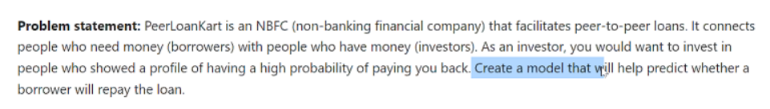

Target variable: **not.fully.paid**

**consider:**

1 not fully paid ,

0 fully paid.