**Overview:**

**✅ PHASE 1 – Core Process and CPU Simulation**

🔑 Goal: Get basic scheduling, process execution, and CPU behavior simulated.

**Focus:**

* Basic **CPU execution logic**
* **Process scheduling algorithms** (FCFS, SJF, RR)
* Process queue management
* CPU burst simulation, CLI interaction

**✅ PHASE 2 – Memory and Storage Simulation**

🔑 Goal: Integrate memory allocation and paging with your scheduler.

**Focus:**

* Memory allocation strategies (First Fit, Best Fit)
* Simulate RAM size, fragmentation
* Paging logic: logical to physical address mapping
* Optional: simulate swap space or limited RAM causing page faults

**✅ PHASE 3 – Advanced Features & Robustness**

🔑 Goal: Add complexity like deadlock detection, disk I/O, and simulate full OS behavior.

**Focus:**

* **Deadlock handling** via Banker's algorithm
* **Disk scheduling**: FCFS, SSTF, SCAN
* Introduce **interrupt simulation** and **error handling**
* Integrate with Main.java to unify all modules

**PHASE 1:**

✅ FCFS  
✅ SJF (preemptive & non-preemptive)  
✅ Priority (preemptive & non-preemptive)  
✅ Round Robin

is a solid and realistic plan. Here's how your code and logic will flow — visualized as a **conceptual flowchart with data flow explanation**.

**📦 Data Flow Description**

|  |  |
| --- | --- |
| **Step** | **What Happens** |
| **User Input** | Enter number of processes + their attributes |
| **Process Object Creation** | Each input is wrapped into a Process object |
| **Algorithm Selection** | User chooses which scheduling class to invoke |
| **Pass to Scheduler** | List<Process> passed to simulate() method in the class |
| **Scheduler Logic** | Time-driven or priority-driven execution |
| **Update Process States** | Each Process updated with final timings |
| **Print Results** | Results shown via System.out.println() |

**🔄 Internal Time-Driven Schedulers For:**

* SJF (Preemptive)
* Priority (Preemptive)
* Round Robin

They simulate **time unit by unit** like this:

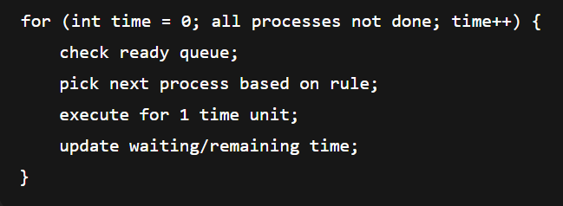

**⚖️ Non-Time-Driven Schedulers**

* FCFS
* SJF (Non-Preemptive)
* Priority (Non-Preemptive)

They simulate in one go per process:

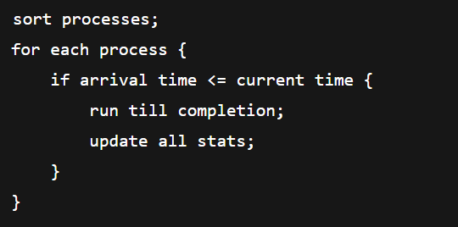

📦 Total Code Files in Phase 1: **8 Java files**

1. Main.java [CLI controller for Phase 1] → package phase1;

2. Process.java [Represents a process and its attributes] → package phase1.model;

[1 class per algorithm] → package phase1.scheduler;  
3. FCFS.java

4. SJFNonPreemptive.java

5. SJFPreemptive.java

6. PriorityNonPreemptive.java

7. PriorityPreemptive.java

8. RoundRobin.java

**PHASE 2:**