Project | IEEE 802.16 Broadband Wireless Access Working Group <http://ieee802.org/16>
Title | Proposed Updates for IEEE 802.16m System Requirements Document Based on Latest IMT-Advanced Requirements
Date Submitted | 2008-07-07
Source(s) | Hokyu Choi  Samsung Electronics  Sassan Ahmadi  Intel Corporation  Mohan Fong  Nortel Networks  Jianmin Lu  Huawei  Dong-Seung Kwon  ETRI | choihk@samsung.com  sassan.ahmadi@intel.com  mhfong@nortel.com  lujianmin@huawei.com  dskwon@etri.re.kr
Re: | Requirements for P802.16m-Advanced Air Interface
Abstract | This is to update IEEE 802.16m SRD (80216m-07/002r4) to reflect the latest ITU-R/ IMT-Advanced requirement decisions.
Purpose | Discuss and adopt (Change Request to update IEEE 802.16m SRD)
Notice | This document does not represent the agreed views of the IEEE 802.16 Working Group or any of its subgroups. It represents only the views of the participants listed in the “Source(s)” field above. It is offered as a basis for discussion. It is not binding on the contributor(s), who reserve(s) the right to add, amend or withdraw material contained herein.
Release | The contributor grants a free, irrevocable license to the IEEE to incorporate material contained in this contribution, and any modifications thereof, in the creation of an IEEE Standards publication; to copyright in the IEEE’s name any IEEE Standards publication even though it may include portions of this contribution; and at the IEEE’s sole discretion to permit others to reproduce in whole or in part the resulting IEEE Standards publication. The contributor also acknowledges and accepts that this contribution may be made public by IEEE 802.16.
Patent Policy | The contributor is familiar with the IEEE-SA Patent Policy and Procedures:  <http://standards.ieee.org/guides/bylaws/sect6-7.html#6> and <http://standards.ieee.org/guides/opman/sect6.html#6.3>.  Further information is located at <http://standards.ieee.org/board/pat/pat-material.html> and <http://standards.ieee.org/board/pat>.
Proposed Updates for IEEE 802.16m System Requirements Document Based on Latest IMT-Advanced Requirements

Hokyu Choi
Samsung Electronics

Sassan Ahmadi
Intel Corporation

Mohan Fong
Nortel Networks

Jianmin Lu
Huawei

Dong-Seung Kwon
ETRI

Introduction
In the 2nd ITU-R WP5D meeting (June 24th ~ July 1st, 2008) in Dubai, the technical system performance for IMT-Advanced radio interface [IMT.TECH] was finalized [1]. This contribution suggests to update the 802.16m SRD (80216m-07/002r4) in accordance with the decisions made in the meeting so that the system performance of 802.16m can be properly aligned with that of IMT-Advanced.

Proposal
The authors propose to adopt the proposed text changes below. Followings are the summary of proposed changes.
- Functional requirements of SRD (Section 6) to be updated in accordance with IMT-Advanced requirements
- Title of original Section 7 to be modified to specify that the section is intended for baseline performance requirements which shall be evaluated per the baseline configuration and baseline system assumptions detailed in Section 2 of the IEEE 802.16 Evaluation Methodology [2].
- New Section 8 to be added to capture the target performance requirements specified by the ITU-R which shall be evaluated according to the guidelines and evaluation criteria IMT.EVAL [3].

References
[1] ITU-R Document 5D/TEMP/89r1Cleanv2: Draft report on requirements related to technical system performance for IMT-Advanced radio interface(s) [IMT.TECH], June 2008
[2] IEEE 802.16 TGm, “IEEE 802.16m Evaluation Methodology Document,” IEEE 802.16m 08/004r2
[3] Draft new Report ITU-R M.[IMT.EVAL] , Guidelines for evaluation of radio interface technologies for IMT-Advanced [IMT.EVAL], June 2008

--------------------------Text Begins ------------------------

Overview

The 802.16m amendment shall be developed in accordance with the P802.16 project authorization request (PAR), as approved on 6 December 2006 [1], and with the Five Criteria Statement in IEEE 802.16-06/055r3 [2].
According to the PAR, the standard shall be developed as an amendment to IEEE Std 802.16 [3][4]. The resulting standard shall fit within the following scope:
This standard amends the IEEE 802.16 WirelessMAN-OFDMA specification to provide an advanced air interface for operation in licensed bands. It meets the cellular layer requirements of IMT-Advanced next generation mobile networks. This amendment provides continuing support for legacy WirelessMAN-OFDMA equipment.

And the standard will address the following purpose:
The purpose of this standard is to provide performance improvements necessary to support future advanced services and applications, such as those described by the ITU in Report ITU-R M.2072.

The standard is intended to be a candidate for consideration in the IMT-Advanced evaluation process being conducted by the International Telecommunications Union– Radio Communications Sector (ITU-R) [5]Error: Reference source not found[7].
This document represents the high-level system requirements for the 802.16m amendment. The IMT-Advanced system requirements described in the final version of ITU-R technical system performance [7] have been further included in this document. It must be noted that the IEEE 802.16m system requirements will be evaluated according to the methodology and guidelines specified in IEEE 802.16m evaluation methodology document [12], whereas IMT-Advanced requirements will be evaluated according to the guidelines and methodology provided in IMT.EVAL [6].
All content included in any draft of the 802.16m amendment shall meet these requirements. This document, however, shall be maintained and may evolve. These system requirements embodied herein are defined to ensure competitiveness of the evolved air interface with respect to other mobile broadband radio access technologies as well as to ensure support and satisfactory performance for emerging services and applications. These system requirements also call for significant gains and improvements relative to the preexisting IEEE 802.16 system that would justify the creation of the advanced air interface.
To accelerate the completion and evaluation of the standard, to improve the clarity and reduce complexity of the standard specification, and to further facilitate the deployment of new systems, the number of optional features should be minimized.

References
- IEEE 802.16m PAR, December 2006, http://standards.ieee.org/board/nes/projects/802-16m.pdf
- IEEE 802.16 WG, “Five Criteria Statement for P802.16m PAR Proposal,” IEEE 802.16-06/55r3, November 2006, http://ieee802.org/16/docs/06/80216-06_055r3.pdf
- IEEE Std 802.16-2004: Part 16: IEEE Standard for Local and metropolitan area networks: Air Interface for Fixed Broadband Wireless Access Systems, June 2004
- IEEE Std. 802.16e-2005, IEEE Standard for Local and metropolitan area networks, Part 16: Air Interface for Fixed and Mobile Broadband Wireless Access Systems, Amendment 2: Physical and Medium Access Control Layers for Combined Fixed and Mobile Operation in Licensed Bands, and IEEE Std. 802.16-2004/Cor1-2005, Corrigendum 1, December 2005
- Recommendation ITU-R M.1645: Framework and overall objectives of the future development of IMT-2000 and systems beyond IMT-2000, January 2003
- Draft new Report ITU-R M.[IMT.EVAL] , Guidelines for evaluation of radio interface technologies for IMT-Advanced [IMT.EVAL], June 2008.
- ITU-R Document 5D/TEMP/89r1, Draft new Report ITU-R M.[IMT.TECH], Requirements related to technical system performance for IMT-Advanced radio interface(s) [IMT.TECH] , June 2008.
- WiMAX Forum™ Mobile System Profile, Release 1.0 Approved Specification (Revision 1.4.0: 2007-05-02), http://www.wimaxforum.org/technology/documents
- FCC Docket no 94-102 this includes order numbers 96-264, 99-96, 99-245.
- Communications Assistance for Law Enforcement Act of 1994 (CALEA), Pub. L. No. 103-414, 108 Stat. 4279.
- Communications Assistance for Law Enforcement Act and Broadband Access and Services First Report and Order and Further Notice of Proposed Rulemaking. ET Docket No. 04-295, RM-10865, 20 FCC Rcd 14989 (2005).
- IEEE 802.16 TGm, “IEEE 802.16m Evaluation Methodology Document,” IEEE 802.16m-08/004r2.

Definitions

Sector A sector is a physical partition of a cell. Cells are typically partitioned into three or more sectors. One or more antennas per sector may be used at the BS to provide coverage to users within each sector.

Cell A collection of sectors (typically 3) belonging to the same BS

WirelessMAN-OFDMA Reference System A system compliant with a subset of the WirelessMAN-OFDMA capabilities specified by IEEE 802.16-2004 and amended by IEEE 802.16e-2005 and IEEE 802.16Cor2/D3, where the subset is defined by WiMAX Forum Mobile System Profile, Release 1.0 (Revision 1.4.0: 2007-05-02) [8], excluding specific frequency ranges specified in the section 4.1.1.2 (Band Class Index)

Legacy MS A mobile station (MS) compliant with the WirelessMAN-OFDMA Reference System

Legacy BS A BS compliant with the WirelessMAN-OFDMA Reference System

IEEE 802.16m MS An MS compliant with the IEEE 802.16 WirelessMAN-OFDMA specification specified by IEEE 802.16-2004 and amended by IEEE 802.16e-2005 and IEEE 802.16m

IEEE 802.16m BS A BS compliant with the IEEE 802.16 WirelessMAN-OFDMA specification specified by IEEE 802.16-2004 and amended by IEEE 802.16e-2005 and IEEE 802.16m

H-FDD MS A half-duplex FDD MS is defined as an FDD MS that is not required to transmit and receive simultaneously

Abbreviations and acronyms

BS | base station
CALEA | Communications Assistance for Law Enforcement Act
CPE | customer premises equipment
DL | downlink
E-MBS | enhanced multicast broadcast service
FDD | frequency division duplex
H-FDD | half-duplex frequency division duplex
IP | Internet Protocol
ITU-R | International Telecommunications Union – Radio Communications Sector
LAN | local area network
LBS | location based services
MAC | medium access control layer
MBS | multicast broadcast service
MBSFN | multicast broadcast single frequency network
MIH | media independent handover
MIMO | multiple input multiple output
MS | mobile station
NCMS | network control and management services
OFDMA | orthogonal frequency division multiple access
PAN | personal area network
PAR | project authorization request
PDU | protocol data unit
PHY | physical layer
QoS | quality of service
RAN | radio access network
RAT | radio access technology
RRM | radio resource management
RS | relay station
TDD | time division duplex
UL | uplink
VoIP | voice over IP
WAN | wide area network

General requirements
This section contains general requirements for IEEE 802.16m systems. These requirements are intended to address and supplement the requirements specified by the ITU-R for IMT-Advanced systems.
IEEE802.16m shall meet the IMT-Advanced requirements.
All enhancements included as part of IEEE 802.16m should promote the concept of continued evolution, allowing IEEE 802.16 to maintain competitive performance as technology advances beyond 802.16m.
Some of the requirements in this document are separated for the mobile station (MS) and the base station (BS). Such requirements shall be construed as minimum performance requirements for the MSs and BSs.

Legacy support
IEEE 802.16m shall provide continuing support and interoperability for legacy WirelessMAN-OFDMA equipment, including MSs and BSs. Specifically, the features, functions and protocols enabled in IEEE 802.16m shall support the features, functions and protocols employed by WirelessMAN-OFDMA legacy equipment. IEEE 802.16m shall provide the ability to disable legacy support.
This continuing support shall be limited to the WirelessMAN-OFDMA Reference System which is defined as system compliant with a subset of the WirelessMAN OFDMA capabilities specified by IEEE 802.16-2004 and amended by IEEE 802.16e-2005 and IEEE 802.16Cor2/D3, where the subset is defined by WiMAX Forum Mobile System Profile, Release 1.0 (Revision 1.4.0: 2007-05-02), excluding specific frequency ranges specified in the section 4.1.1.2 (Band Class Index).
The following are backward compatibility requirements:
- An IEEE 802.16m MS shall be able to operate with a legacy BS, at a level of performance equivalent to that of a legacy MS.
- Systems based on IEEE 802.16m and the WirelessMAN-OFDMA Reference System shall be able to operate on the same RF carrier, with the same channel bandwidth; and should be able to operate on the same RF carrier with different channel bandwidths.
- An IEEE 802.16m BS shall support a mix of IEEE 802.16m and legacy MSs when both are operating on the same RF carrier. The system performance with such a mix should improve with the fraction of IEEE 802.16m MSs attached to the BS.
- An IEEE 802.16m BS shall support handover of a legacy MS to and from a legacy BS and to and from IEEE 802.16m BS, at a level of performance equivalent to handover between two legacy BSs.
- An IEEE 802.16m BS shall be able to support a legacy MS while also supporting IEEE 802.16m MSs on the same RF carrier, at a level of performance equivalent to that a legacy BS provides to a legacy MS.

Complexity
IEEE 802.16m should minimize complexity of the architecture and protocols and avoid excessive system complexity. It should enable interoperability of access networks, support low cost devices and minimize total cost of ownership.
IEEE 802.16m should only provide enhancements in areas where the WirelessMAN-OFDMA Reference System does not meet the requirements.
The IEEE 802.16m system shall satisfy the performance requirements in Section 7.0. In addition, the complexity of MSs and BSs shall be minimized by adhering to the following:
- The functional and performance requirements shall be met with mandatory features only.
- Optional features shall be considered only if they provide significant functional and performance improvements over mandatory features.
- Support of multiple mandatory features which are functionally similar and/or have similar impact on performance shall be avoided.
- The number of states of protocols and procedures should be minimized.

Services
IEEE 802.16m should support legacy services more efficiently than the WirelessMAN-OFDMA Reference System as well as facilitate the introduction of new/emerging types of services.
IEEE 802.16m and its services architecture shall be flexible in order to support services required for next generation mobile networks, such as those identified by Report ITU-R M.2072 and IMT-Advanced (IMT.SERV).
IEEE 802.16m shall support different quality of service (QoS) levels for different services. IMT-Advanced QoS requirements shall be supported including end-to-end latency, throughput, and error performance.

Operating frequencies
IEEE 802.16m systems shall operate in RF frequencies less than 6 GHz and be deployable in licensed spectrum allocated to the mobile and fixed broadband services and shall be able to operate in frequencies identified for IMT-Advanced.
The following frequency bands have been identified for IMT and/or IMT-2000 by WARC-92, WRC-2000 and WRC-07
- 450-470 MHz
- 698-960 MHz
- 1710-2025 MHz
- 2110-2200 MHz
- 2300-2400 MHz
- 2500-2690 MHz
- 3400-3600 MHz

ITU-R has developed frequency arrangements for the bands identified by WARC-92 and WRC-2000, which are described in Recommendation ITU-R M.1036-3. For the frequency bands that were identified at WRC-07, further work on the frequency arrangements is ongoing within the framework of ITU-R.

An 802.16m compliant system shall meet the following coexistence requirements:
a) IEEE 802.16m shall be capable of coexisting with other IMT-Advanced technologies.
b) IEEE 802.16m shall be capable of coexisting with other IMT-2000 technologies.
The IEEE 802.16m system should be able to use spectrum flexibly to provide TDD and FDD duplex modes. The IEEE 802.16m system should be able to aggregate multiple channels in more than one frequency band within the scope of a single MAC protocol instance.

Operating bandwidths
Scalable bandwidth is the ability to operate with different bandwidth allocations. IEEE 802.16m shall support scalable bandwidths from 5 to 40 MHz. This bandwidth may be supported by single or multiple RF carriers. Other bandwidths shall be considered as necessary to meet operator requirements.

Duplex schemes

IEEE 802.16m shall support both Time Division Duplex (TDD) and Frequency Division Duplex (FDD) operational modes. The FDD mode shall support both full-duplex and half-duplex MS operation. Specifically, a half-duplex FDD (H-FDD) MS is defined as an FDD MS that is not required to transmit and receive simultaneously.
A BS supporting FDD mode shall be able to simultaneously support half duplex and full duplex terminals operating on the same RF carrier. The MS supporting FDD mode shall use either H-FDD or FDD.
IEEE 802.16m shall support both unpaired and paired frequency allocations, with fixed duplexing frequency separations when operating in FDD mode.
System performance in the desired bandwidths specified in Section 5.5 should be optimized for both TDD and FDD independently while retaining as much commonality as possible.
In TDD mode, the DL/UL ratio should be adjustable. In the extreme, the IEEE 802.16m system should be capable of supporting downlink-only configurations on a given carrier.
In FDD mode, the UL and DL channel bandwidths may be different and should be configurable (e.g. 10MHz downlink, 5MHz uplink).

Support of advanced antenna techniques
The IEEE 802.16m standard shall define minimum antenna requirements for the BS and MS. For the BS, a minimum of two transmit and two receive antennas shall be supported. For the MS, a minimum of one transmit and two received antennas shall be supported. This minimum is consistent with a 2x2 downlink configuration and a 1x2 uplink configuration.
IEEE 802.16m shall support MIMO, beamforming operation or other advanced antenna techniques. IEEE 802.16m shall further support single-user and multi-user MIMO techniques.

Support for government mandates and public safety
IEEE 802.16m shall be able to support public safety first responders, military and emergency services such as call-prioritization, pre-emption, and push-to-talk.
The IEEE 802.16m system shall support regional regulatory requirements, such as Emergency Services (E9-1-1) [9] and the Communications Assistance for Law Enforcement Act (CALEA) [10] [11].

Functional requirements
This section contains system level functional requirements targeting higher peak rates, lower latency, lower system overhead as well as PHY/MAC features enabling improved service security, QoS and radio resource management (RRM).
The functional requirements described in this document shall be met with a system comprised solely of IEEE 802.16m compliant MSs and BSs.

Peak Spectral Efficiency
This section defines the peak spectral efficiency achievable between a BS and an MS under ideal conditions. The peak spectral efficiency is the highest theoretical data rate (normalized by bandwidth), which is the received data bits assuming error-free conditions assignable to a single mobile station, when all available radio resources for the corresponding link direction are utilized (that is excluding radio resources that are used for physical layer synchronization, reference signals or pilots, guard bands and guard times).
IEEE 802.16m shall support the peak, expressed as a normalized peak rate (i.e. absolute maximum supported data rate divided by the occupied channel bandwidth) as specified in Table 1.
Table 1–Normalized peak data rate
Requirement  Type | Link direction | MIMO Configuration | Normalized peak rate  (bps/Hz)
Baseline | Downlink | 2x2 | 8.0
Baseline | Uplink | 1x2 | 2.8
Target | Downlink | 4x4 | 15.0
Target | Uplink | 2x4 | 6.75

Notes applicable to Table 1:
- The baseline requirement denotes the minimum peak data rate achievable between a BS and an MS equipped with the minimum supported antenna configuration defined in Section 5.7.
- The target requirement denotes the minimum peak data rate achievable between a BS and an MS equipped with a higher order antenna configuration, as specified in Table 1, which exceeds the minimum MS antenna configuration.
- Other MIMO antenna configurations beyond those of Table 1 can be used. For example, the extended uplink requirement for the 2x4 configuration would apply to an uplink 2x2 configuration etc.
- The specified requirements of normalized peak rates are not distinguished by duplex mode. Rather, 100% of available radio resources are assumed – for the purposes of computing Table 1– allocable to downlink and uplink respectively regardless of duplexing mode. For example, for TDD, when assessing downlink performance, all available radio resources are assigned for downlink transmission.

- The specified minimum supported normalized peak rates are applicable to all bandwidths in Section 5.5.

Latency
Latency should be further reduced as compared to the WirelessMAN-OFDMA Reference System for all aspects of the system including the air link, state transition delay, access delay, and handover.

User- Plane Latency
The User Plane latency is defined in terms of the one-way transit time between a packet being available at the IP layer (Tx reference point) in either the MS/ BS and the availability of this packet at IP layer (Rx reference point) in the BS / MS. User plane packet delay includes delay introduced by associated protocols and control signaling assuming the MS is in the active state.

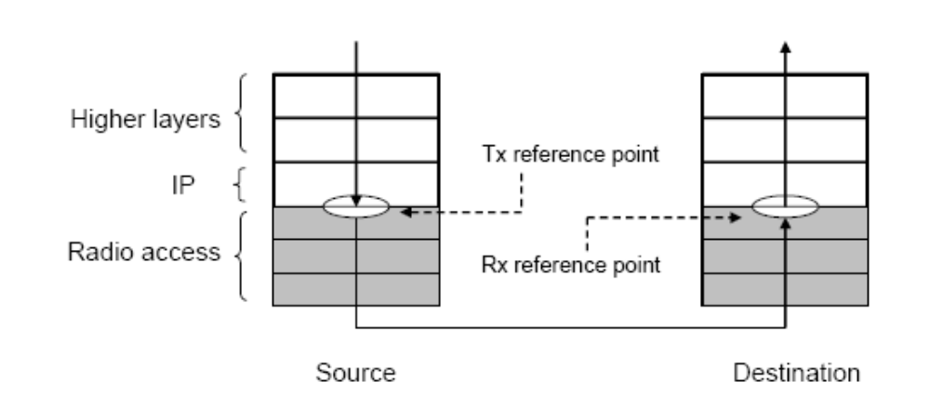
Figure 1-Illustration of reference points for the maximum data latency

The latency requirements specified in Table 2 shall be met by the system, under unloaded conditions (i.e. single user with single data stream) for small IP packet (e.g. 0 byte payload + IP header) for both downlink and uplink.
Table 2–uUser- plane latency
Link direction | User-plane Latency  (ms)
Downlink (BS->MS) | 10
Uplink (MS->BS) | 10

Control Plane Latency
Control plane latency is measured as transition time from IDLE_STATE to ACTIVE_STATE.
IDLE_STATE to ACTIVE_STATE transition time (excluding downlink paging delay and wire-line network signaling delay) is defined as the time it takes for a device to go from an idle state (fully authenticated/registered and monitoring the control channel) to an active state when it begins exchanging data with the network on a traffic channel measured from the paging.

Table 3–-Maximum cControl- plane latency
Metric | Control-plane latency  (ms)
IDLE_STATE to ACTIVE_STATE | 100 ms

Handover interruption time
This section addresses handover interruption time requirements applicable to handovers between 802.16m BSs for intra- and inter-frequency handover.
The handover interruption times specified in Table 4 apply to handover of IEEE 802.16m MS between IEEE 802.16m BSs operating in the absence of legacy MSs under normal operating conditions.
The handover interruption time is defined as the time duration that an MS cannot exchange user plane packets with any BS. . The handover interruption time includes the time required to execute any radio access network procedure, radio resource control signaling protocol, or other message exchanges between the user equipment and the radio access network. For the purposes of determining handover interruption time, interactions with the core network (i.e., network entities beyond the radio access network) are assumed to occur in zero time. It is also assumed that all necessary attributes of the target channel (that is, downlink synchronization is achieved and uplink access procedures, if applicable, are successfully completed) are known at initiation of the handover from the serving channel to the target channel.

Table 4–Handover interruption times
Handover type |  | Interruption time  (ms)
Intra-frequency |  | 27.5
Inter-frequency | within a spectrum band | 40
Inter-frequency | between spectrum bands | 60
In addition inter-system handovers between the 802.16m system and at least one IMT system shall be supported, but are not subject to the limits in Table 4.

QoS
IEEE 802.16m shall support QoS classes, enabling an optimal matching of service, application and protocol requirements (including higher layer signaling) to radio access network (RAN) resources and radio characteristics. This includes enabling new applications such as interactive gaming [5].
IEEE 802.16m shall provide support for preserving QoS during handover with other RATs when it is feasible.

Radio resource management
IEEE 802.16m shall enable the advanced RRM for efficient utilization of radio resources. This may be achieved by appropriate measurement/reporting, interference management and flexible resource allocation mechanisms.

Reporting
IEEE 802.16m shall enable advanced RRM by enabling the collection of reliable statistics over different timescales, including system (e.g. dropped call statistics, BS loading condition, channel occupancy), user (e.g. terminal capabilities, mobility statistics, and battery life), flow, packet, etc.

Interference management
IEEE 802.16m shall support interference mitigation schemes.
IEEE 802.16m shall support flexible frequency re-use schemes.

Security
IEEE 802.16m shall include a security function which provides the necessary means to achieve:
- protection of the integrity of the system (e.g. system access, stability and availability)
- protection and confidentiality of user-generated traffic and user-related data (e.g. location privacy, user identity)
- secure access to, secure provisioning and availability of services provided by the system
The impact of security procedures on the performance of other system procedures, such as handover procedures, shall be minimized.
The security function should be self-contained and capable of maintaining security without relying on specific behaviors on the part of algorithms/protocols at any other functions or layers outside the security function. Such dependencies, if and when necessary, shall be explicitly specified.

Handover
IEEE 802.16m shall support handover within and between all cell types in an IEEE802.16m system. IEEE 802.16m shall provide handover with WirelessMAN-OFDMA Reference Systems in accordance with Section 5.1.
IEEE 802.16m shall provide support for handover with other RATs. However, an IEEE 802.16m MS is not required to be multi-mode.
IEEE 802.16m shall provide service continuity during handover for both inter-RAT and intra-RAT handover.
IEEE 802.16m should support IEEE 802.21 Media Independent Handover (MIH) Services.
Mobility procedures should be fully compatible with the IEEE 802.16 Network Control and Management Services (NCMS).

Enhanced multicast broadcast service
IEEE 802.16m shall provide support for an enhanced multicast broadcast service (E-MBS), providing enhanced multicast and broadcast spectral efficiency, as specified in Table 14 in Section 7.5.
IEEE 802.16m shall support E-MBS delivery via a dedicated carrier.
IEEE 802.16m shall support switching between broadcast and unicast services, including the case when broadcast and unicast services are deployed on different frequencies.

MBS channel reselection delay and interruption times
E-MBS functionality defined as part of IEEE 802.16m shall support the following requirements for maximum MBS channel change interruption times when applied to broadcast streaming media.

Table 5–MBS channel reselection maximum interruption times
MBS channel  reselection mode | Max. interruption time  (s)
Intra-frequency | 1.0
Inter-frequency | 1.5

Note that requirements of Table 5 apply to the interruption time between terminating delivery of MAC PDU’s from a first MBS service to the MAC layer of the MS, and the time of commencement of delivery of MAC PDU’s from a second MBS service to the MS MAC layer.

Location based services (LBS)
IEEE 802.16m shall provide support for high resolution location determination.

Reduction of user overhead
IEEE 802.16m shall provide improved mechanisms for reducing overhead as compared to the WirelessMAN-OFDMA Reference System in the bearer stream associated with headers of higher layer protocols.

System overhead
Overhead, including overhead for control signaling as well as overhead related to bearer data transfer, for all applications shall be reduced as far as feasible without compromising overall performance and ensuring proper support of systems features.

Enhanced power saving
IEEE 802.16m shall provide support for enhanced power saving functionality to help reduce power consumption in devices for all services and applications.

Multi-RAT operation
IEEE 802.16m shall support interworking functionality to allow efficient handover to other radio access technologies. Those of interest include:
- IEEE 802.11
- 3GPP GSM/EDGE, UTRA (FDD and TDD) and E-UTRA (FDD and TDD)
- 3GPP2 CDMA2000

Baseline performance requirements
This section describes the performance requirements for IEEE 802.16m systems. The baseline performance requirements are specified in terms of absolute performance and relative performance with respect to that of the WirelessMAN-OFDMA Reference System. The performance metrics will be evaluated per the baseline configuration and baseline system assumptions detailed in Section 2 of the IEEE 802.16 Evaluation Methodology [12].
For relative performance requirement, the performance goals are specified in terms of spectral efficiency performance relative to WirelessMAN-OFDMA Reference System using 2 transmit and 2 receive antennas at the BS and 1 transmit and 2 receive antennas at the MS.
Typical overhead as defined in the IEEE 802.16 Evaluation Methodology shall be accounted for when evaluating the performance.
Performance metrics are as specified in the evaluation methodology document.
The performance requirements shall be met without inclusion of the relay stations.
The performance requirements described in this document shall be met with a system comprised solely of IEEE 802.16m compliant MSs and BSs.

User throughput
The user throughput and capacities in the following subsections shall use the same channel mixes specified for the baseline configuration in section 2.3 of the IEEE 802.16m evaluation methodology document.

Relative performance
The targets for average user-throughput and cell-edge user throughput of downlink/uplink for data only system for baseline antenna configuration are shown in Table 6. Both targets should be achieved relative to WirelessMAN-OFDMA Reference System performance as per antenna configuration defined above.

Table 6–Relative throughput of a data only system
Metric | DL data  (xWirelessMAN-OFDMA Reference System ) | UL data  (xWirelessMAN-OFDMA Reference System )
Average user throughput | > 2x | >2x
Cell edge user throughput | > 2x | >2x

Absolute performance
The downlink/uplink average user throughput and cell-edge user throughput targets for a data-only system with baseline antenna configuration are shown in Table 7.

Table 7–Absolute throughput of data only system
Metric | DL data  (bits/second/Hz) | UL data  (bits/second/Hz)
Average user throughput | 0.26 | 0.13
Cell edge user throughput | 0.09 | 0.05

Sector throughput and VoIP capacity
Sector throughput is as defined in the evaluation methodology document [12]. It is the total unidirectional sustained throughput (downlink/uplink), excluding MAC & PHY layer overheads, across all users scheduled on the same RF channel. Sector throughput requirements must be supported for user distributions defined in the 16m evaluation methodology in a fully loaded cell surrounded by other fully loaded cells using the same RF channel (i.e. an interference limited environment with full frequency reuse).

Relative sector throughput and VoIP capacity

Table 8–Relative sector throughput (bps/Hz/sector)
DL  (xWirelessMAN-OFDMA Reference System ) | UL  (xWirelessMAN-OFDMA Reference System )
>2x | >2x

Table 9–Relative VoIP capacity
Capacity
(xWirelessMAN-OFDMA Reference System )
>1.5x

Absolute sector throughput and VoIP capacity

Table 10–Sector throughput (bps/Hz/sector)
DL | UL
2.6 | 1.3

Table 11–VoIP capacity
Capacity
(Active Users/MHz/sector)
> 30
VoIP capacity assumes a 12.2 kbps codec with a 50% activity factor such that the percentage of users in outage is less than 2% where a user is defined to have experienced a voice outage if less than 98% of the VoIP packets have been delivered successfully to the user within a one way radio access delay bound of 50 ms.
The packet delay is defined based on the 98 percentile of the CDF of all individual users 98 packet delay percentiles (i.e., first for each user the 98 percentile of the packet delay CDF is determined then the 98 percentile of the CDF that describes the distribution of the individual user delay percentiles is obtained).

Mobility
Mobility shall be supported across the IEEE 802.16m network. IEEE 802.16m shall be optimized for low speeds such as mobility classes from stationary to pedestrian and provide high performance for higher mobility classes. The performance shall be degraded gracefully at the highest mobility. In addition, the IEEE 802.16m shall support maintaining the connection up to the highest supported speed.
Table 12 summarizes the mobility performance.

Table 12–Mobility support
Mobility | Performance
Stationary, Pedestrian 0 - 10 km/h | Optimized
Vehicular 10 - 120 km/h | Graceful degradation as a function of vehicular speed
High Speed Vehicular 120 - 350 km/h | System should be able to maintain connection
Vehicular speeds in excess of 350 km/h and up to 500 km/h may be considered depending on frequency band and deployment.

Cell coverage
IEEE 802.16m shall provide significantly improved coverage with respect to the WirelessMAN-OFDMA Reference System.
Based on the same configuration, the link budget of the limiting link (e.g. DL MAP, UL bearer) of IEEE 802.16m shall be improved by at least 3 dB compared to the WirelessMAN-OFDMA Reference System.
IEEE 802.16m shall support legacy cell sizes allowing for co-location of WirelessMAN OFDMA Reference System deployments.
IEEE 802.16m should be able to scale transmit power/link budget (e.g. power classes) to provide wider and deeper coverage to address different operational scenarios.
Support for larger cell sizes should not compromise the performance of smaller cells. It is also required to support increased number of simultaneous users and enhanced user penetration rates. Specifically, IEEE 802.16m shall support the deployment scenarios captured in Table 13 in terms of maximum cell range.
IEEE 802.16m should be sufficiently flexible to support a variety of coverage scenarios for which the performance targets of Sections 6 and 7 should be met. Reference scenarios shall be defined that are representative of current WirelessMAN-OFDMA Reference System deployments.
Note that cell coverage is calculated based on both control channel and traffic channel coverage in the uplink and downlink.
Table 13–Deployment scenarios
Cell range | Performance target
Up to 5 km | Optimized  Performance targets defined in Sections 7.1-7.3 should be met
5-30 km | Graceful degradation in system/edge spectral efficiency
30-100 km | System should be functional (thermal noise limited scenario)

Enhanced multicast-broadcast service
As outlined in Section 6, IEEE 802.16m shall support enhanced multicast-broadcast service for IMT-Advanced multimedia multicast broadcast services in a spectrally efficient manner.
The IEEE 802.16m enhanced multicast-broadcast service may support large cells (e.g. 50 km).
Minimum performance requirements for E-MBS, expressed in terms of spectral efficiency over 95% coverage area, appear in Table 14.

Table 14–MBS minimum spectral efficiency vs. inter-site distance
Inter-site distance  (km) | Min. spectral efficiency  (bps/Hz)
0.5 | 4
1.5 | 2

The following notes apply to Error: Reference source not foundTable 14:
- The performance requirements apply to a wide-area multi-cell multicast broadcast single frequency network (MBSFN).
- The specified spectral efficiencies neglect overhead due to ancillary functions (such as synchronization and common control channel) and apply to both mixed unicast-broadcast and dedicated MBS carriers, where the performance is scalable with carrier frequency bandwidth.

Location-based services performance
IEEE 802.16m systems (this may include MS, BS, or both depending on the solution) should provide support for LBS. IEEE 802.16m systems should satisfy the requirements in Table 15.

Table 15–Location-based service requirements
Feature | Requirement | Comments
Location determination latency | < 30 s
Handset-based position accuracy  (in meters) | 50 meter (67%-tile of the CDF  of the position accuracy)  150 meter (95%-tile of the CDF  of the position accuracy) | Need to meet E911 Phase II Requirements
Network-based position accuracy  (in meters) | 100 meter (67%-tile of the CDF  of the position accuracy)  300 meter (95%-tile of the CDF  of the position accuracy) | Need to meet E911 Phase II Requirements

Target performance requirements
This section describes the target performance requirements for IEEE 802.16m system. These target requirements are intended to achieve the requirements specified by the ITU-R for IMT-Advanced systems [7] and shall be evaluated according to the guidelines and evaluation criteria specified in IMT.EVAL [6].
The performance requirements described in this section shall be met with a system comprised solely of IEEE 802.16m compliant MSs and BSs.
The target performance goals are specified in terms of spectral efficiency assuming an antenna configuration of downlink 4x2 and uplink 2x4.

Sector spectral efficiency
Sector spectral efficiency is defined as the aggregate throughput of all users (the number of correctly received bits, i.e. the number of bits contained in the SDUs delivered to Layer 3, over a certain period of time) divided by the product of the effective bandwidth, the frequency reuse factor and the number of sectors. The sector spectral efficiency is measured in bits/second/Hz/sector. The downlink/uplink sector spectral efficiency for various test environments are shown in Table 16.

Table 16–Sector spectral efficiency
Test environment | Downlink (bits/second/Hz/sector) | Uplink (bits/second/Hz/sector)
Indoor | 3 | 2.25
Microcellular | 2.6 | 1.80
Base coverage urban | 2.2 | 1.4
High speed | 1.1 | 0.7

Cell edge user spectral efficiency
The cell edge user spectral efficiency is defined as 5% point of CDF of the normalized user throughput. The normalized user throughput is defined as the average user throughput (i.e., the number of correctly received bits by users, i.e. the number of bits contained in the SDU delivered to Layer 3, over a certain period of time) divided by the total spectrum as is measured in bits/second/Hz. The downlink/ uplink cell edge user spectral efficiency for various test environments are shown in Table 1722.

Table 17–Cell edge user spectral efficiency
Test environment | Downlink (bits/second/Hz) | Uplink (bits/second/Hz)
Indoor | 0.1 | 0.07
Microcellular | 0.075 | 0.05
Base coverage urban | 0.06 | 0.03
High speed | 0.04 | 0.015

VoIP capacity
VoIP capacity was derived assuming a 12.2 kbps codec with a 50% activity factor such that the percentage of users in outage is less than 2% where a user is defined to have experienced a voice outage if less than 98% of the VoIP packets have been delivered successfully to the user within a one way radio access delay bound of 50 ms.
The VoIP capacity is the minimum of the calculated capacity for either link direction divided by the effective bandwidth in the respective link direction. In other words, the effective bandwidth is the operating bandwidth normalized appropriately considering the uplink/downlink ratio.
Table 18 shows the minimum VoIP capacity for various test environments.

Table 18–VoIP capacity
Test environment | Min. VoIP capacity (Active users/sector/MHz)
Indoor | 50
Microcellular | 40
Base coverage urban | 40
High speed | 30

Mobility
The four classes of mobility are defined in section 7.3: Stationary, Pedestrian, Vehicular and High speed vehicular. Table 19 defines the mobility classes that shall be supported in the respective test environment.
Table 19–Test environments for mobility classes supported
 | Test environments
 | Indoor | Microcellular | Base coverage urban | High speed
Mobility classes supported | Stationary, pedestrian | Stationary, pedestrian,  Vehicular (up to 30 km/h) | Stationary, pedestrian, vehicular | High speed vehicular, vehicular

A mobility class is supported if the traffic channel link data rate, normalized by bandwidth, on the uplink, is as shown in Table 20, when the user is moving at the maximum speed in that mobility class in each of the test environments.
Table 20–Traffic channel link data rates
Test environment | Bits/second/Hz | Speed (km/h)
Indoor | 1.0 | 10
Microcellular | 0.75 | 30
Base Coverage Urban | 0.55 | 120
High Speed | 0.25 | 350

Operational requirements

Support for multi-hop relay
IEEE 802.16m should provide mechanisms to enable multi-hop relays including those that may involve advanced antenna technique transmission.

Synchronization
IEEE 802.16m shall support the ability to synchronize frame timing and frame counters across the entire system deployed in a given geographic area, including synchronization among all BSs and MSs operating on the same or on different carrier frequencies and among neighboring IEEE 802.16m systems, whether operated by the same operator or not. The requirement for frame timing synchronization is key to coexistence of TDD systems and would be useful, but not essential, for FDD systems as well.

Co-deployment with other networks

Co-deployment requirements
It is envisaged that IEEE 802.16m can be deployed in the same or overlapping geographical areas with other wireless networks based on different RAT (Radio Access Technologies). They may or may not have the same network topology. They may or may not be operating on the same device. Moreover, it is anticipated that IEEE 802.16m is to be deployed in the same (on a co-channel and non-co-channel basis) or adjacent RF bands as non IEEE 802.16m legacy networks. For instance, these non-802.16 networks may operate in the adjacent licensed frequency bands such as CDMA2000, 3GPP (e.g., GSM, UMTS, HSDPA/HSUPA, LTE), in unlicensed bands such as 802.11 and 802.15.1 networks, or in the same frequency band on an adjacent carrier such as TD-SCDMA. The 802.16m standard shall provide a method whereby coexistence of networks specified on the basis of the IEEE 802.16m amendment with these networks as well as other IEEE 802.16 networks can be achieved from the perspective of both being an interferer and being a victim depending on the coexistence scenarios of section 9.3.2

Coexistence scenarios
Depending on the bands where IEEE 802.16m is expected to be deployed, different coexistence requirements (also due to unknown outcome of WRC 2007 for IMT-Advanced) should be envisaged.

- IEEE 802.16m and non 802.16m systems may be deployed in the same licensed band. Adjacent channels may be used for deployment of 802.16m and non-802.16m systems.

- IEEE 802.16m may be deployed in a licensed band adjacent to an unlicensed band in which non 802.16m systems are deployed. Hence additional coexistence mechanisms may be required to reduce interference.

- IEEE 802.16m may be required to share bands:
  - on a co-channel basis with other 802.16m systems.
  - on a co-channel basis with non 802.16 systems where 802.16m is either the primary or non-primary system
  - on a non co-channel basis with non 802.16 systems where 802.16m is either the primary or non-primary system

Support of self organizing mechanisms
IEEE 802.16m should support self organizing mechanisms including, but not limited to, the following:

- Self-configuration: means allowing real plug and play installation of network nodes and cells, i.e. self-adaptation of the initial configuration, including the update of neighbor nodes and neighbor cells as well as means for fast reconfiguration and compensation in failure cases.

- Self-optimization: means allowing automated or autonomous optimization of network performance with respect to service availability, QoS, network efficiency and throughput.

Usage models (informative)

IEEE 802.16m should support a wide range of deployment scenarios and usage models including a) those considered during formulation of the existing standards and b) as envisioned by IMT-Advanced requirements. The examples provided in this section are informative only.
IEEE 802.16m should support different usage models. More specifically, it should cover (but not be restricted to):
1) Higher data rates and improved performance (compared to WirelessMAN-OFDMA Reference System) in legacy cell sizes (of several kilometers radius).
2) Very high data rates in smaller cells
3) High mobility optimized scenarios
4) Deployment with Multi-hop Relay Networks
5) Co-Deployment with Other Networks
6) Provision for PAN/LAN/WAN Collocation / Coexistence
This section is informative only. It includes service and application scenarios and deployment scenarios. The deployment scenarios described in the following sections include topologies, networks and frequency reuse schemes where 802.16m MSs and BSs are exclusively used, where a mix of 802.16m and 802.16e (migration from legacy to new systems), a scenario where fixed and mobile relay stations (used for coverage and throughput enhancements) are used and a scenario optimized for high mobility. It also describes deployments with other systems.

Service and application scenarios
The types of services that can be provided by IEEE802.16m-based packet-switched network can include:
- Voice services (e.g. VoIP and conference call)
- Data services (e.g., Email, instant messaging, web browsing, file transfer, internet gaming, white boarding)
- Multimedia services (e.g., Audio and/or video streaming, broadcast, interactive conferencing)
To meet IMT-Advanced requirements, IEEE 802.16m may also support new services, new features, and new devices. For example, real-time gaming or real-time video streaming service over high definition screens may be a typical service in the future. High priority E-commerce, telemetric, Broadcast/Multicast for TV, news, and advertisement over the handheld may be popular services as well.

Deployment scenarios

The IEEE 802.16m RAT should be suitable for deployment in a number of propagation environments including
- Outdoor environments including outdoor-to-indoor environments that may include metallic film windows and Earthquake reinforced buildings (e.g., rural, urban, suburban)
- Indoor environments (e.g., hot-spot, overlay for improved coverage and/or capacity)
The end users in an IEEE802.16m-based network also should be supportable with different levels of mobility including
- Fixed/Stationary (e.g., CPE with fixed antenna)
- Pedestrian or quasi-static (e.g., portable devices)
- Mobile (e.g., handsets)
- High mobility

Frequency reuse
In the usage model example of cellular networks, a network coverage area can be served by a number of BSs each of which may further contain a certain number of sectors. For areas that need enhanced coverage or require additional throughput, flexible frequency reuse schemes can be employed. The frequency reuse scheme should allow for both hard reuse and soft reuse, where soft reuse refers the case where the power on some of the tones is reduced rather than not used. IEEE 802.16m should allow for adaptive frequency reuse schemes, which enable frequency reuse when; e.g., coverage improvement is necessary.
IEEE 802.16m should support the flexibility of applying different reuse patterns in different zones. For example, the MBS can employ reuse 1 pattern, while other unicast services can employ another reuse pattern.
In the consideration of the frequency reuse planning, the resulting system signal to interference ratio should be maintained to satisfy the minimum system performance requirement and this interference should include all co-channel and adjacent channel interferences resulting from the same system and from other co-existing systems.
In an IEEE 802.16m system, different frequency reuse patterns may be used in every BS.

Deployment with multi-hop relay networks
IEEE 802.16m aims to develop an air interface providing high transmission rate as specified in the IMT-Advanced requirements. The target transmission rate is much higher than that defined in the IEEE 802.16e standard. Cost effective provisioning of high data rate coverage over a wide area as well as to avoid coverage holes in the deployment areas are important deployment requirements. Intelligent relays are an effective technology to achieve those goals with lower investment costs and lower operational costs. In addition, upgrading the networks in order to support higher data rates is equivalent to an increase of signal-to-interference plus noise ratio (SINR) at the receivers’ front-end. Also, through deployment the network providers have to avoid coverage area holes.
A traditional solution to increase the receiver’s SINR is to deploy additional BSs or repeaters to serve the coverage area holes with required data rates. Unfortunately, the cost of BS is high and the wire-line backhaul may not be available everywhere. On the other hand, repeater has the problem of amplifying the interference and has no intelligence of signal control and processing. In order to achieve a more cost-effective solution, relay stations (RS) capable of decoding and forwarding the signals from source to destination through radio interface should be considered. Here, RSs do not need a wire-line backhaul; the deployment cost of RSs is expected to be much lower than the cost of BSs. The system performance could be further improved by the intelligent resource scheduling and cooperative transmission in systems employing intelligent relays.
Deploying RS can improve IEEE 802.16m network in different dimensions. The following figures illustrate the different benefits that can be achieved by deploying RS within an IEEE802.16m network.
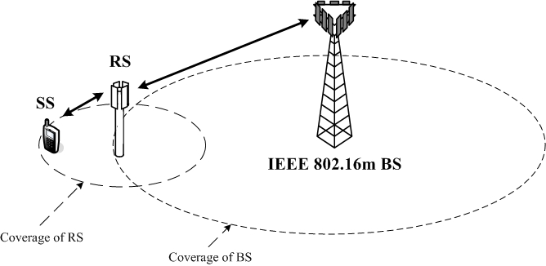
Figure 2–Coverage extension by deploying RS in a IEEE 802.16m network

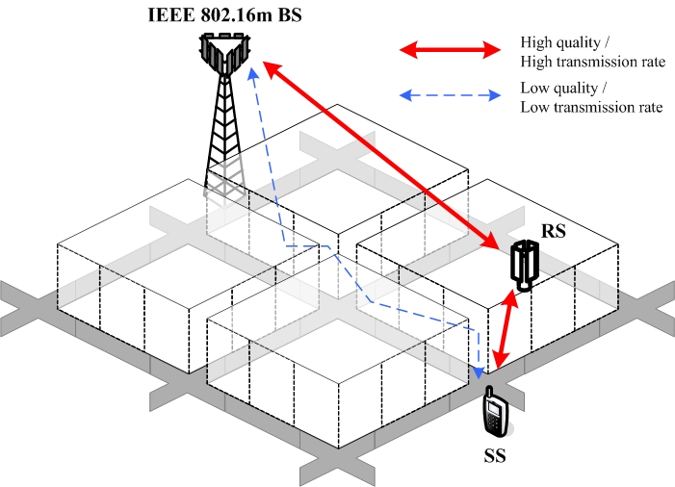
Figure 3–Deploying RS can enhance transmission rate for the SS located in shaded area or cell boundary

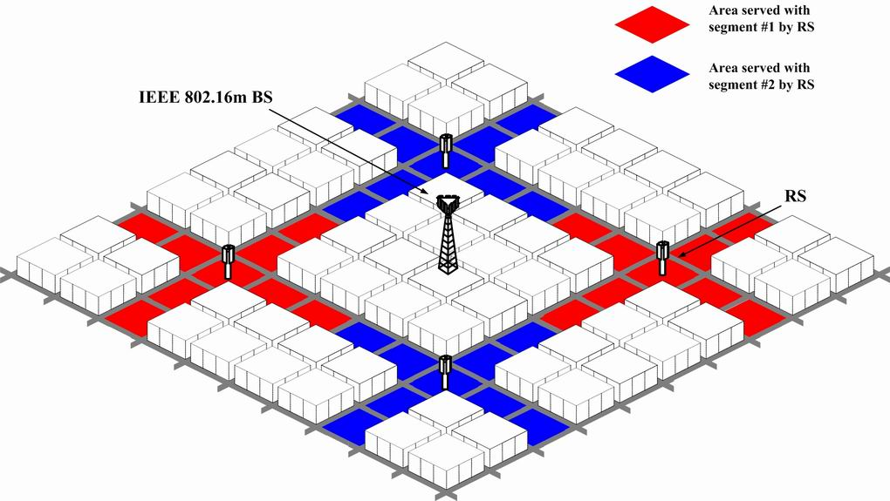
Figure 4–More aggressive radio resource reuse by deploying RS in IEEE 802.16m network

High mobility optimized scenario
IEEE802.16m should provide services to high-speed users. In this scenario, the speed of the MSs is usually higher than 120 km/h and can be up to 350 km/h. The MSs may experience large penetration loss. The service environment may change dynamically and rapidly. The air interface may be optimized for high-speed users.

Provision for PAN/LAN/WAN collocation / coexistence
As a provision for proper operation of various wireless access technologies on multi-radio terminals, IEEE 802.16m should provide methods to mitigate interference from other wireless radios on the same (collocated) device given minimum adjacent channel isolation. As a result, an IEEE 802.16m radio will not suffer from interference from other wireless devices, or cause destructive interference to other wireless devices. Currently, Wi-Fi and Bluetooth radios are likely to coexist/collocate with an IEEE 802.16m radio.

Very high data rates in smaller cells
IEEE 802.16m should efficiently provide very high data rates and service continuity in smaller cells including indoor pico cells, femto cells, and hot-spots. The small cells may be deployed as an overlay to larger outdoor cells. The operation in small cells should not cause significant interference to the outdoor cells or other wireless devices, or alternatively suffer from interference caused by other wireless devices.

