**ITN (Version 7.00) Final PT Skills Assessment (PTSA) Exam Answers**

**Topology**

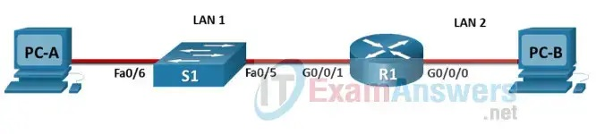

**Device Names Table**

You will receive one of three possible scenarios. In order to use the logical topology diagram that is provided with the instructions, use the device names in the Device Names Table.

| **Topology Diagram Name** | **Your Scenario Name** |
| --- | --- |
| R1 | R1 |
| S1 | S1 |
| PC-A | PC-A |
| PC-B | PC-B |

**Addressing Requirements Table**

| **Item** | **Requirements** |
| --- | --- |
| Network Address | 192.168.10.0/24 |
| LAN 1 subnet host requirements | 100 |
| LAN 2 subnet host requirements | 50 |
| R1 G0/0/1 | First host address in LAN 1 subnet |
| R1 G0/0/0 | First host address in LAN 2 subnet |
| S1 SVI | Second host address in LAN 1 subnet |
| PC-A | Last host address in LAN 1 subnet |
| PC-B | Last host address in LAN 2 subne |

**ITN Final PT Skills Assessment (PTSA)**

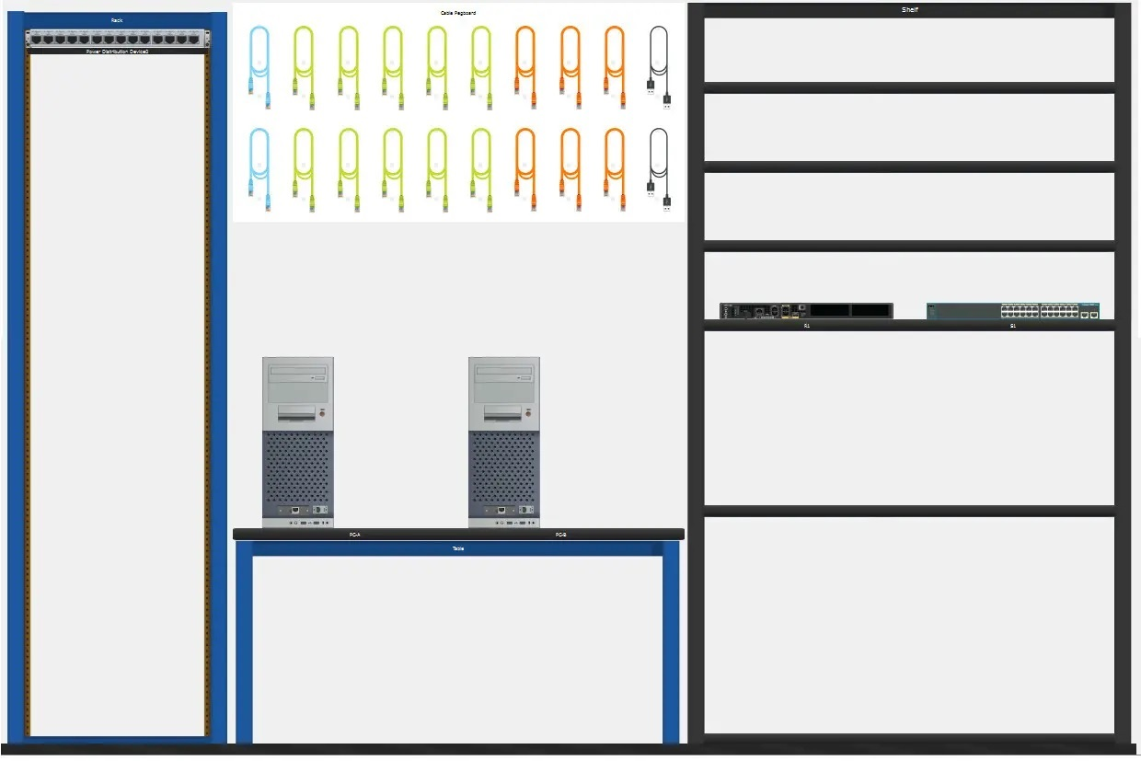

A few things to keep in mind while completing this activity:

1. Do not use the browser Back button or close or reload any exam windows during the exam.
2. Do not close Packet Tracer when you are done. It will close automatically.
3. Click the Submit Assessment button in the browser window to submit your work.

**Assessment Objectives**

* **Part 1: Build the Network**
* **Part 2: Develop an IP Addressing Scheme**
* **Part 3: Configure Basic Device Settings**
* **Part 4: Configure Security Settings on R1 and S1**
* **Part 5: Configure the Hosts and Verify Connectivity**

**Instructions**

In this assessment you will configure the R1 router and S1 switch, as you have done in the activities in this course. You will also connect two PCs using a switch and a router that are in the main wiring closet. You will subnet the 192.168.10.0/24 network to provide IPv4 addresses for two subnets that will support the required number of hosts. The larger subnet (LAN 1) requires 100 hosts and the smaller subnet (LAN 2) requires 50 hosts.

No [**subnet calculators**](https://itexamanswers.net/quick-vlsm-calculator-online-ipv4-subnetting-tool.html) may be used.

**Part 1: Build the Network**

a. Build the network according to the logical topology by placing the required equipment in the wiring closet equipment rack.

b. Cable the network devices in the closet as shown in the topology diagram.

c. Connect the hosts as shown in the topology diagram.

**Part 2: Develop an IP Addressing Scheme**

In this part of the assessment you will develop an IP addressing scheme. You will subnet an IPv4 network to create two subnets with the required number of hosts. You will also subnet an IPv6 network. You will then assign the addresses according to the requirements below.

Work with the following information:

IPv4 Network: 192.168.10.0/24

Required number of hosts in IPv4 LAN 1: 100

Required number of hosts in IPv4 LAN 2: 50

a. Record your subnet assignments according to the following requirements.

1) Assign the first IPv4 address of each subnet to a router interface

* LAN 1 is hosted on **R1 G0/0/1**
* LAN 2 is hosted on **R1 G0/0/0**

2) Assign the last IPv4 address of each subnet to the PC NIC.

3) Assign the second IPv4 address of LAN 1 to S1 SVI.

**Part 3: Configure Basic Device Settings**

Network devices must be configured over a direct console connection.

**Step 1: Configure Basic Settings**

a. Disable DNS lookup on **R1** and **S1**  
b. Configure router hostname using the name **R1**.  
c. Configure switch hostname using the name **S1**.  
d. Configure an appropriate banner on **R1** and **S1**.  
e. Allow console logins with the password **C@nsPassw!**

**Step 2: Configure Interfaces**

a. Configure **R1** G0/0/0 and G0/0/1 interfaces using the addressing from the previous part of this assessment:

* Interface description
* IPv4 address / subnet mask

b. Configure the **S1** VLAN 1 SVI interface using the addressing from the previous part of this assessment:

* Interface description
* IPv4 address / subnet mask
* The switch should be reachable from devices on other networks.

**Part 4: Configure Security Settings on R1 and S1**

**Step 1: Configure enhanced password security**

a. Configure **NoOneShouldKnow** as the encrypted privileged EXEC password  
b. Encrypt all plaintext passwords  
c. Set minimum password length to **10** on **R1**.

**Step 2: Configure SSH on R1 and S1**

a. Configure **netsec.com** as the domain name  
b. Configure a local user netadmin with the encrypted password **Ci$co12345**  
c. Set login on vty lines to use local database.  
d. Configure the vty lines to accept SSH access only.  
e. Generate an RSA crypto key using 1024 bits modulus.

**Step 3: Secure switch ports on S1**

a. Shut down **all** unused ports on **S1**.  
b. Enter descriptions for all unused switch ports to indicate that they are intentionally shutdown.

**Part 5: Configure the Hosts and Verify Connectivity**

Configure both hosts with the IPv4 addresses that were assigned in Part 2 of this assessment.

**Solution of the Activity**

**Part 1: Build the Network**

Placing Switch S1 and Router R1 to wiring closet equipment rack.

* Using Copper Straight-Through cable to connect PC-A (FastEthernet0 port) and S1 (FastEthernet0/6 port)
* using Copper Straight-Through cable to connect all devices as shown in the topology diagram.

**Turn-on PCs and Router R1**

**Part 2: Develop an IP Addressing Scheme**

| **Item** | **Requirements** | **IPv4 Address** |
| --- | --- | --- |
| Network Address | 192.168.10.0/24 |  |
| LAN 1 subnet host requirements | 100 | 192.168.10.0/25 SM: 255.255.255.128 |
| LAN 2 subnet host requirements | 50 | 192.168.10.128/26 SM: 255.255.255.192 |
| R1 G0/0/1 | First host address in LAN 1 subnet | 192.168.10.1 |
| R1 G0/0/0 | First host address in LAN 2 subnet | 192.168.10.129 |
| S1 SVI | Second host address in LAN 1 subnet | 192.168.10.2 |
| PC-A | Last host address in LAN 1 subnet | 192.168.10.126 |
| PC-B | Last host address in LAN 2 subnet | 192.168.10.190 |

**Configuration for router R1**

**Using line console to connect PC-A and Router R1**

**Router R1 configuration script:**

enable

configure terminal

no ip domain-lookup

hostname R1

banner motd #Unauthorized access to this device is prohibited!#

interface g0/0/0

description Connect to Subnet B

ip address 192.168.10.129 255.255.255.192

no shutdown

exit

interface g0/0/1

description Connect to Subnet A

ip address 192.168.10.1 255.255.255.128

no shutdown

exit

enable secret **NoOneShouldKnow**

service password-encryption

security passwords min-length 10

ip domain-name netsec.com

username netadmin secret Ci$co12345

line console 0

password C@nsPassw!

login

exit

line vty 0 15

transport input ssh

login local

exit

crypto key generate rsa

1024

exit

copy running-config startup-config

**Configuration for Switch S1**

**Then, using Console cable to connect User-B and Switch**

**To show Console port on Switch, Right click Switch --> Inspect Rear --> Console port**

**Switch S1 configuration script**

enable

configure terminal

no ip domain-lookup

hostname **S1**

banner motd #Unauthorized access to this device is prohibited!#

interface vlan 1

description Switch Subnet A

ip address 192.168.10.2 255.255.255.128

no shutdown

exit

ip default-gateway 192.168.10.1

enable secret **NoOneShouldKnow**

service password-encryption

ip domain-name netsec.com

username netadmin secret Ci$co12345

line console 0

password C@nsPassw!

login

exit

line vty 0 15

transport input ssh

login local

exit

crypto key generate rsa

1024

int range f0/1 - 4, f0/7 - 24, g0/1 - 2

description Unused switch ports

shutdown

end

copy running-config startup-config

**Part 5: Configure the Hosts and Verify Connectivity**

On PCs, go to Desktop tab --> IP Configuration menu

| **PC-A Network Configuration** | |
| --- | --- |
| IPv4 Address | **192.168.10.126** |
| Subnet Mask | **255.255.255.128** |
| IPv4 Default Gateway | **192.168.10.1** |

| **PC-B Network Configuration** | |
| --- | --- |
| IPv4 Address | **192.168.10.190** |
| Subnet Mask | **255.255.255.192** |
| IPv4 Default Gateway | **192.168.10.129** |