**Report on Teach Back Session**

1. **Course Name : Discrete Mathematics**
2. **Course Coordinator : M Narasimhulu**
3. **Pedagogy Technique Used : Flipped Classes**
4. **Class & Semester : II B.Tech & II Semester (A-Section)**
5. **Date(s) :07/12/2022**
6. **No. of Participants : 63**
7. **Brief Report on the event:**

The flipped classroom sometimes referred to as the inverted classroom, is a modern instructional strategy that offers student-centered peer-assisted learning.

Step 1: Introduced the Concept Learning

Step 2: Learning material: Online reading

Step 3: Evaluating what students have learned with Team based Problem

Solving

**Goals/ objective of methods:**

* Create a collaborative learning environment in the classroom.
* Facilitate communication between Students.
* Increase student interest in content through motivation and active participation.

Find the transitive closures of these relations on {1*,* 2*,* 3*,* 4}.

**a)** {*(*1*,* 2*), (*2*,*1*), (*2*,*3*), (*3*,*4*), (*4*,*1*)*}

**b)** {*(*2*,* 1*), (*2*,*3*), (*3*,*1*), (*3*,*4*), (*4*,*1*), (*4*,* 3*)*}

**c)** {*(*1*,* 2*), (*1*,*3*), (*1*,*4*), (*2*,*3*), (*2*,*4*), (*3*,* 4*)*}

**d)** {*(*1*,* 1*), (*1*,*4*), (*2*,*1*), (*2*,*3*), (*3*,*1*), (*3*,* 2*), (*3*,*4*), (*4*,* 2*)*}

**Event Photos:**

Students are divided into Teams. And they are discussing and solving the given problem

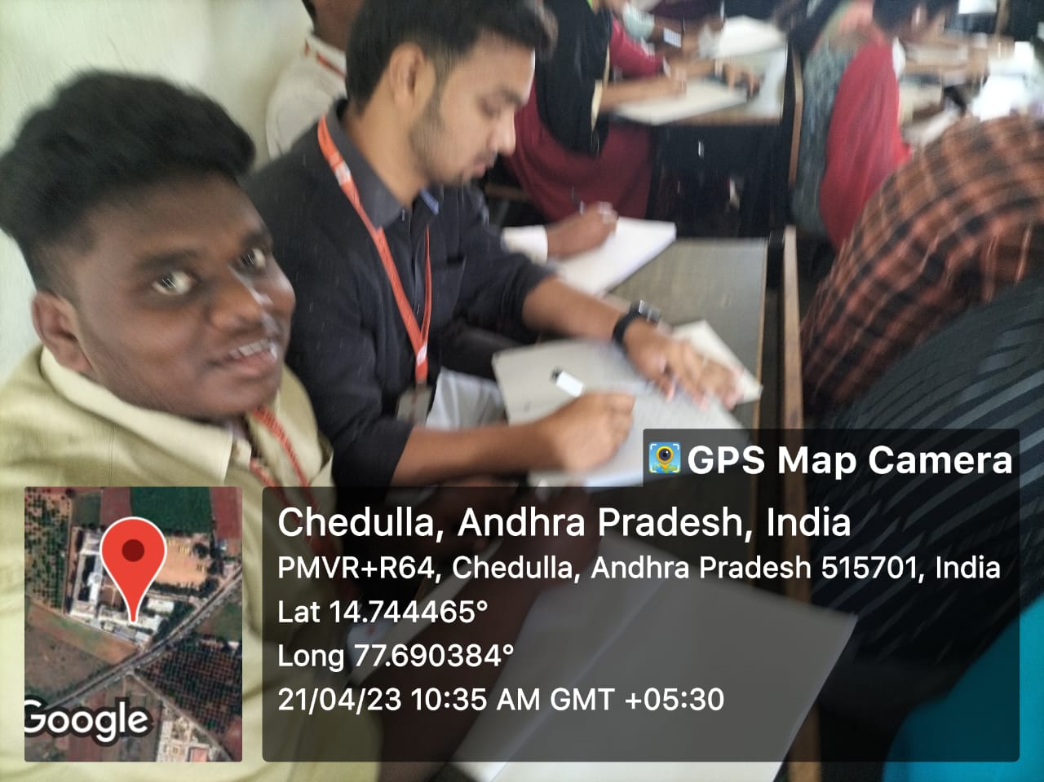 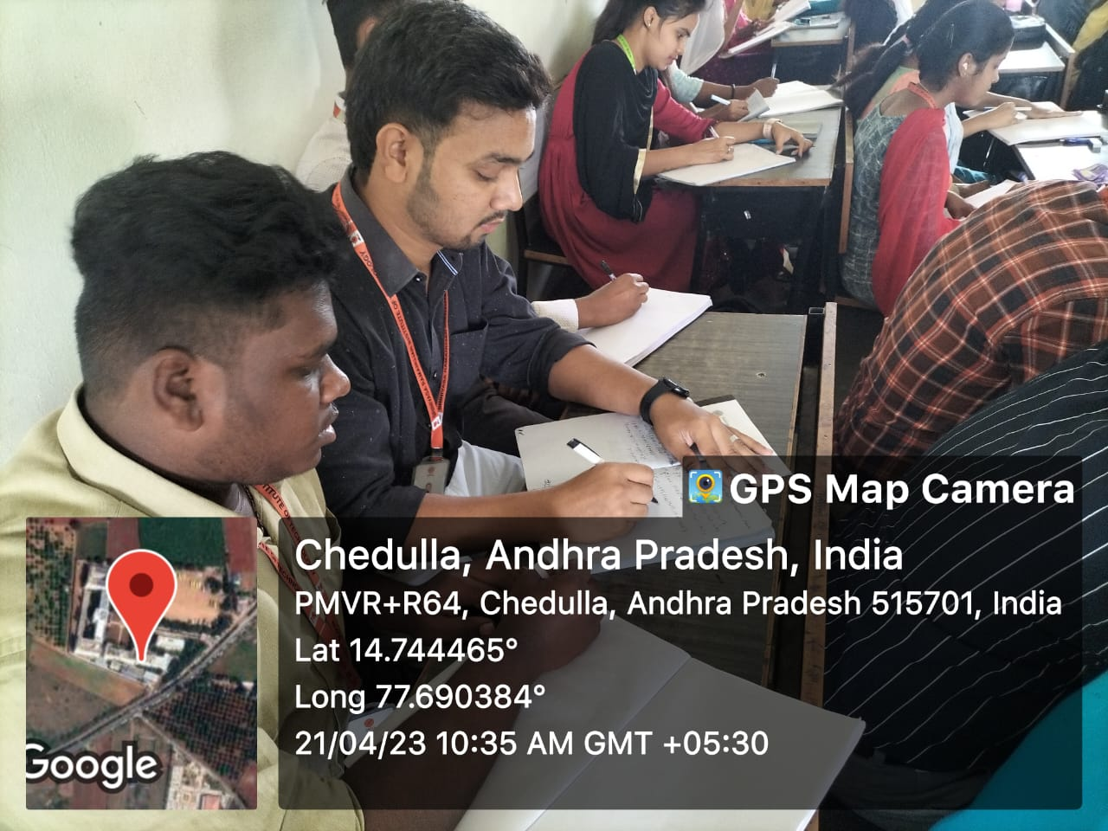

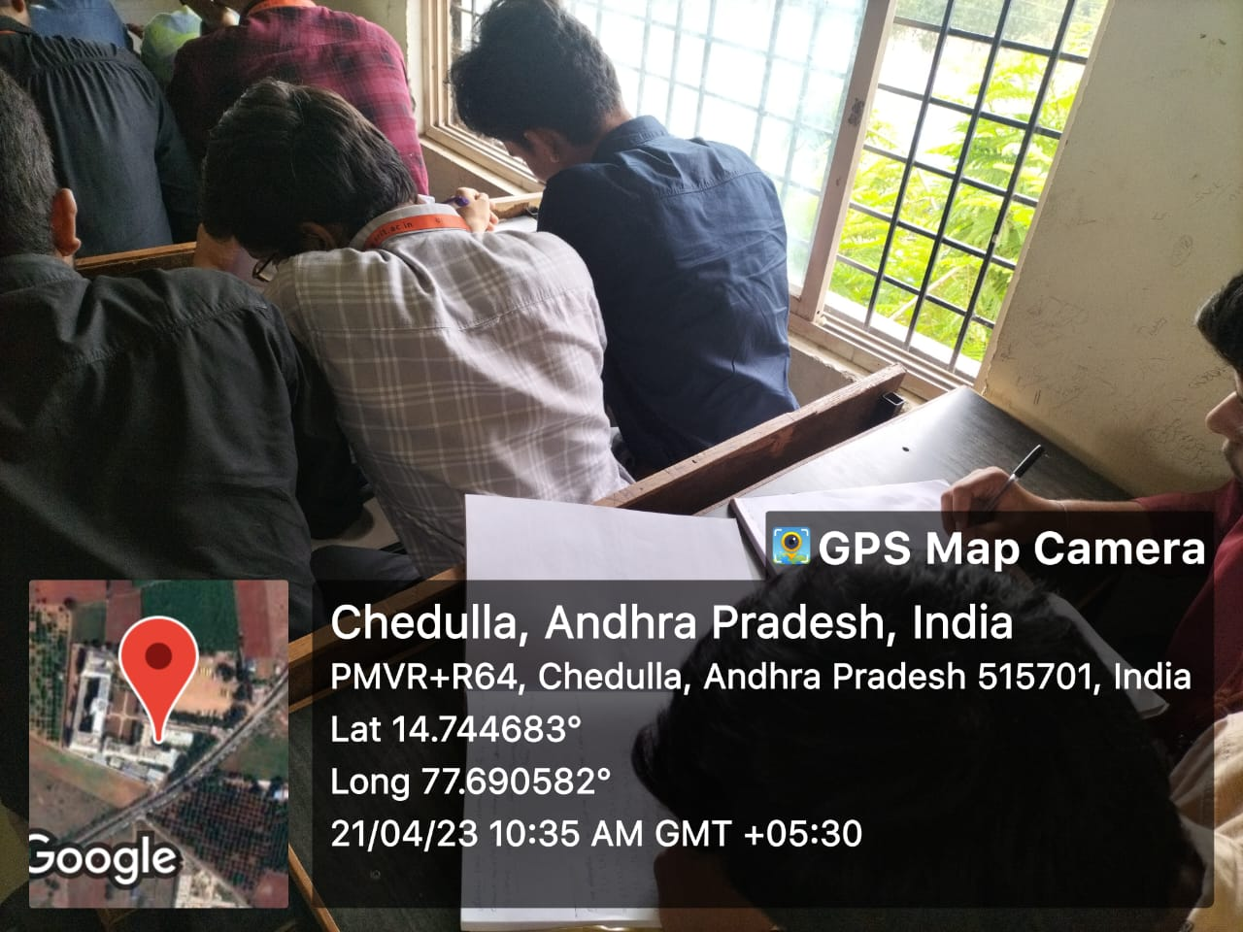 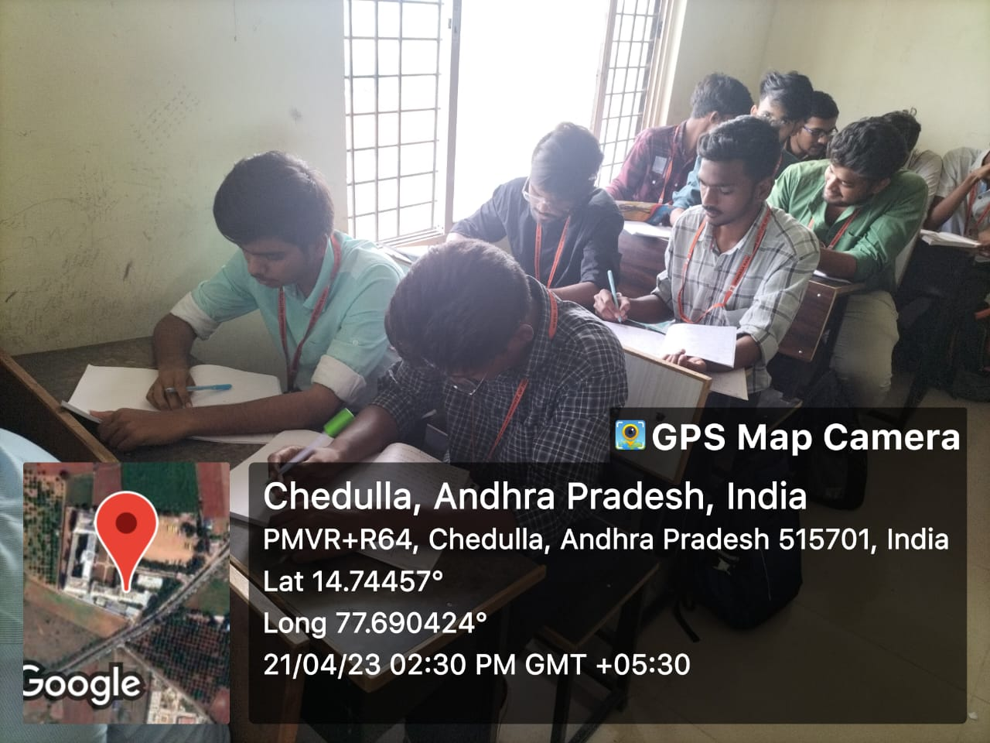

**List of Students Participated:**

| **S.No** | **Roll No** | **Student Name** |
| --- | --- | --- |
| 1 | 214G1A0502 | BAYAKATI SOM ABHISHEK |
| 2 | 214G1A0503 | PATHAN AL FARHEEN |
| 3 | 214G1A0504 | CHELURU AMBICA |
| 4 | 214G1A0505 | BANDI ANIL KUMAR |
| 5 | 214G1A0506 | K ARJUNESWARA RAO |
| 6 | 214G1A0507 | SETTIPI ASWARTHA REDDY |
| 7 | 214G1A0508 | KONDAKAVALI AYESHA |
| 8 | 214G1A0509 | SHAIK AYUB |
| 9 | 214G1A0510 | SATYALA BANU BEE |
| 10 | 214G1A0511 | CHINTA BHANUCHAND |
| 11 | 214G1A0512 | BHIMIREDDY BHARATHI |
| 12 | 214G1A0513 | YARRAGUNTA BHAVANA |
| 13 | 214G1A0514 | BHUMI REDDY BHUMIKA |
| 14 | 214G1A0515 | DEVARAKONDA BINDU |
| 15 | 214G1A0516 | YALLARI CHAITRA |
| 16 | 214G1A0517 | CHOUTAPALLI CHANDRA LEKHA |
| 17 | 214G1A0518 | THIPPIREDDY GARI DEEPIKA |
| 18 | 214G1A0519 | ANKE DHANA LAKSHMI |
| 19 | 214G1A0520 | SUGALI DINESH NAIK |
| 20 | 214G1A0521 | ROOPANAGUDI DIVYA SAI |
| 21 | 214G1A0522 | BOLLU DIVYA SREE |
| 22 | 214G1A0523 | KUMMARA DIVYA SREE |
| 23 | 214G1A0524 | VANKA DURGABHAVANI |
| 24 | 214G1A0525 | PALELLU DURGA |
| 25 | 214G1A0527 | DASARI GANESH |
| 26 | 214G1A0528 | G GANESH |
| 27 | 214G1A0529 | MANGALA GAYATHRI |
| 28 | 214G1A0530 | LINGALA GEETHA SERI |
| 29 | 214G1A0531 | MANGALA GOWTHAMI |
| 30 | 214G1A0532 | DUBASI HEMA LATHA |
| 31 | 214G1A0534 | PUTAKA HARSHA VARDHAN |
| 32 | 214G1A0535 | KASEPALLI HARSHIKA |
| 33 | 214G1A0536 | SUNDURU HEMACHANDRA KIRAN SREENIVAS |
| 34 | 214G1A0537 | MAHENDRAKAR HEMANTH KUMAR RAO |
| 35 | 214G1A0538 | DASARAJU JAHNAVI |
| 36 | 214G1A0540 | MODIEM JASWANTH REDDY |
| 37 | 214G1A0541 | SUNKARA KAVITHA |
| 38 | 214G1A0542 | VELPULA KEERTHANA |
| 39 | 214G1A0543 | KANCHAM KEERTHI REDDY |
| 40 | 214G1A0544 | THAMMINENI KIRANMAYEE SAI |
| 41 | 214G1A0545 | GADAMSHETTY KOUSHIK |
| 42 | 214G1A0546 | KUMMULURU KUSUMA |
| 43 | 214G1A0547 | GANGANA LAKSHMI NARASIMHA REDDY |
| 44 | 214G1A0548 | BOYA BHANU PRAKASH |
| 45 | 214G1A0549 | PAMISETTY LAVANYA |
| 46 | 214G1A0550 | DODDI LIKHITHA |
| 47 | 214G1A0552 | BUDDA LOKESH |
| 48 | 214G1A0553 | EDIGA LOUKYANJALI |
| 49 | 214G1A0554 | MALLUPEDDI MAHESH BABU |
| 50 | 214G1A0555 | BUKKACHERLA MANASA |
| 51 | 214G1A0556 | YERUKULA MANIDEEP SAI |
| 52 | 214G1A0557 | BOYA MEENAKSHI |
| 53 | 214G1A0559 | KHURESHI MOHAMMAD MANSOOR |
| 54 | 214G1A0561 | ANUMPALLI CHALLA MOUNIKA |
| 55 | 214G1A0562 | VAJRAKARUR MOUNIKA |
| 56 | 224G5A0501 | RAYAVELURU ANILA |
| 57 | 224G5A0503 | DANDU PURUSHOTHAM |
| 58 | 224G5A0504 | SAYA DEEPIKA SREE |
| 59 | 224G5A0505 | GUMMADI GOVARDHINI GOWD |
| 60 | 224G5A0506 | MADAM HEMALATHA |
| 61 | 224G5A0507 | DUBBALA JEEVAN KUMAR |
| 62 | 224G5A0508 | KUNCHEPU KUSUMA |
| 63 | 224G5A0509 | JABADE NANDITHA |

**Feed back of the pedagogy Activity:**

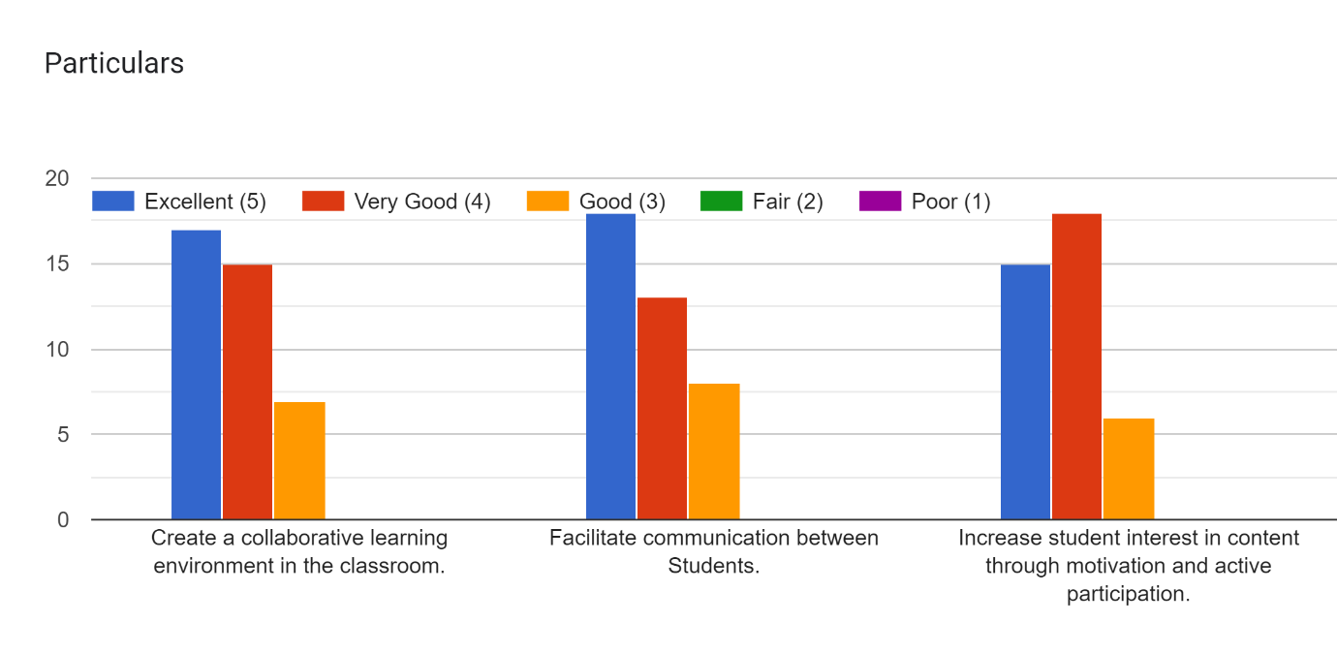

**Signature of the faculty Signature of the HOD**