**Report on Teach Back Session**

1. **Course Name : Discrete Mathematics**
2. **Course Coordinator : M Narasimhulu**
3. **Pedagogy Technique Used : Flipped Classes**
4. **Class & Semester : II B.Tech & II Semester (B-Section)**
5. **Date(s) :07/12/2022**
6. **No. of Participants : 64**
7. **Brief Report on the event:**

The flipped classroom sometimes referred to as the inverted classroom, is a modern instructional strategy that offers student-centered peer-assisted learning.

Step 1: Introduced the Concept Learning

Step 2: Learning material: Online reading

Step 3: Evaluating what students have learned with Team based Problem

Solving

**Goals/ objective of methods:**

* Create a collaborative learning environment in the classroom.
* Facilitate communication between Students.
* Increase student interest in content through motivation and active participation.

Find the transitive closures of these relations on {1*,* 2*,* 3*,* 4}.

a) {(a, c), (b, d), (c, a), (d, b), (e, d)}

b) {(b, c), (b, e), (c, e), (d, a), (e, b), (e, c)}

c) {(a, b), (a, c), (a, e), (b, a), (b, c), (c,a), (c,b), (d,a),

(e, d)}

d) {(a, e), (b, a), (b, d), (c,d), (d,a), (d, c), (e,a), (e,b),

(e, c), (e, e)}

**Event Photos:**

Students are divided into Teams. And they are discussing and solving the given problem

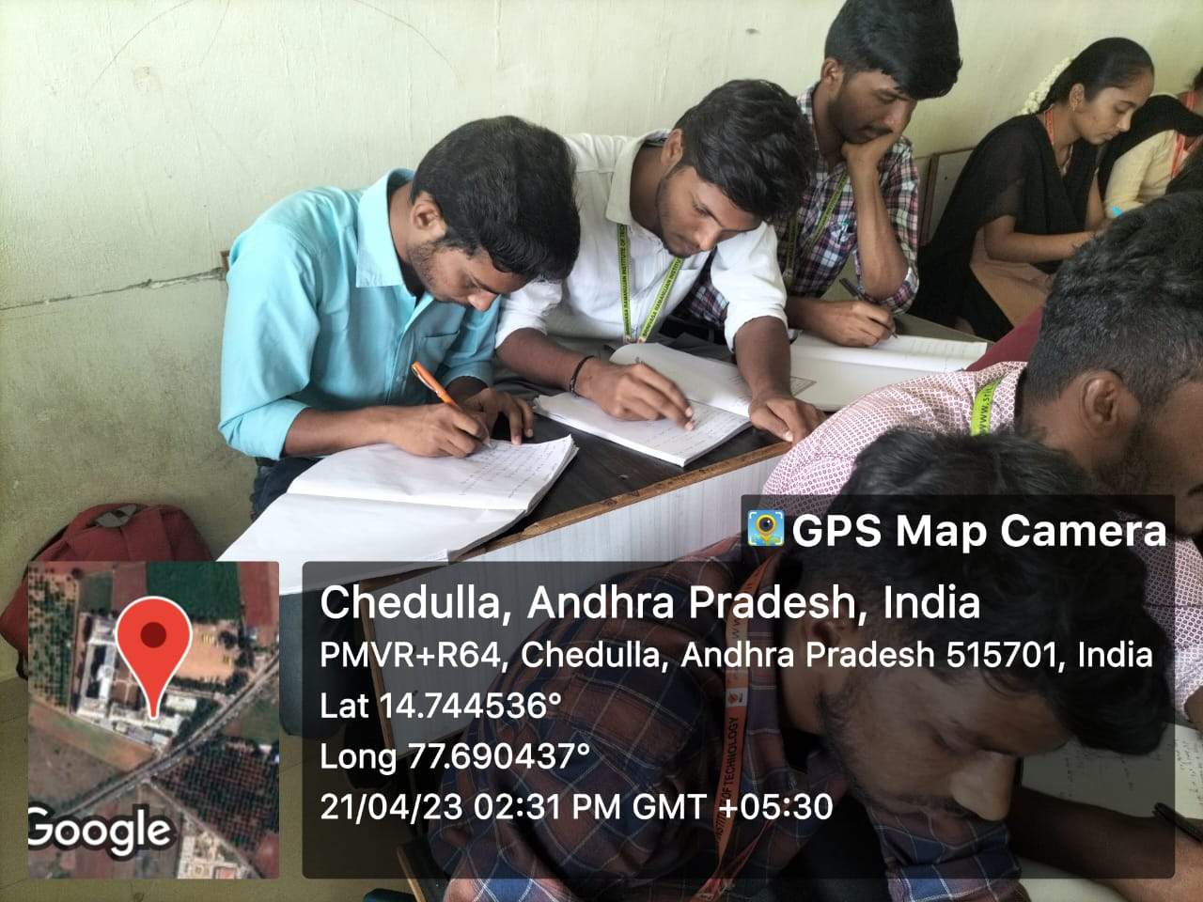 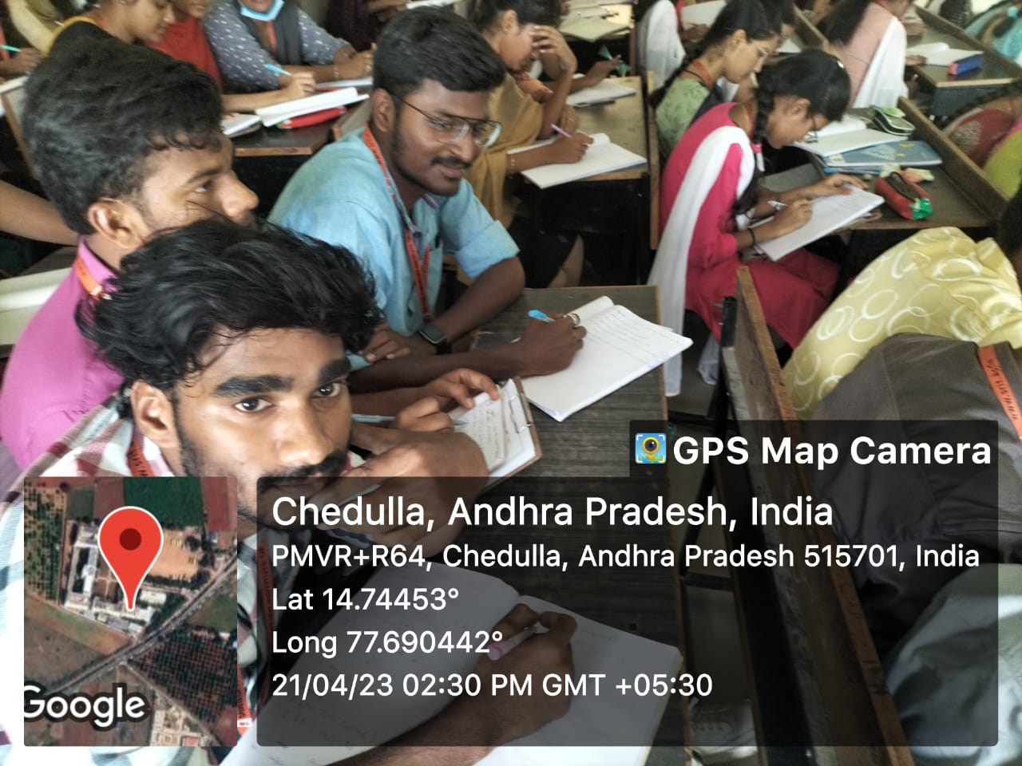

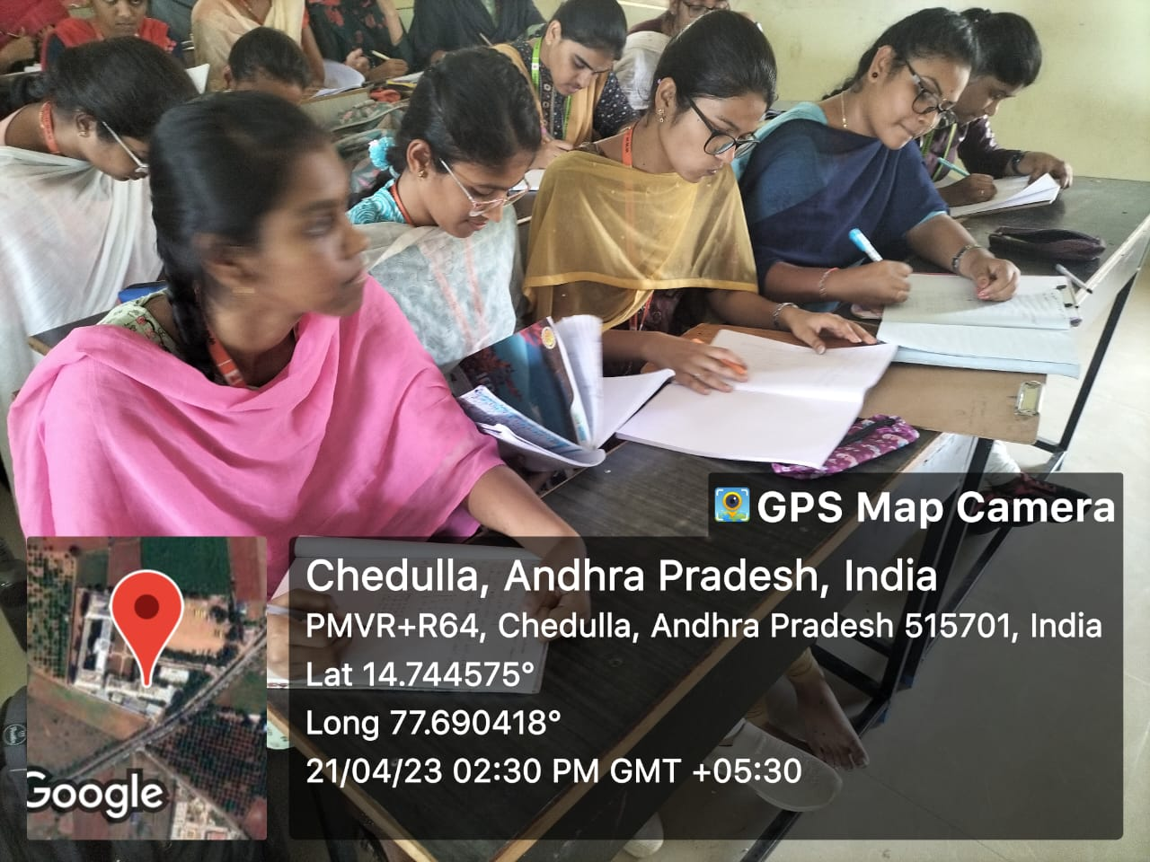 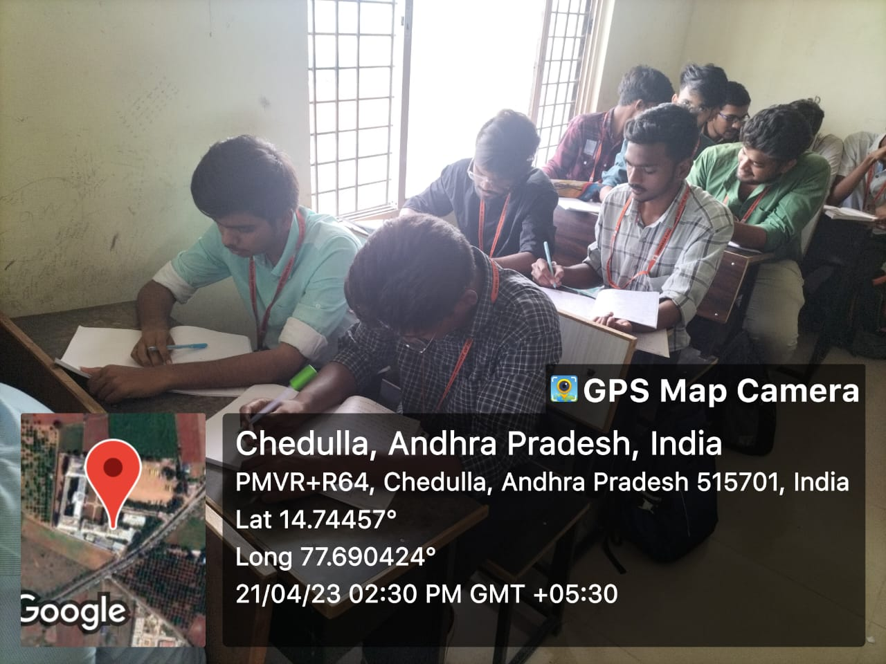

**List of Students Participated:**

| **S.No** | **Roll No** | **Student Name** |
| --- | --- | --- |
| 1 | 214G1A0564 | JANGUBHAI NADIRA ANJUM |
| 2 | 214G1A0565 | BULLE NAGA SHRAVAN |
| 3 | 214G1A0566 | BORRA NAGATEJADEEP REDDY |
| 4 | 214G1A0567 | MARKAPURAM NANDHINI |
| 5 | 214G1A0568 | BANAGANI NANDINI |
| 6 | 214G1A0569 | MALAPULA NARENDRA |
| 7 | 214G1A0570 | VENNAPUSA NAVADEEP REDDY |
| 8 | 214G1A0572 | PAPPURU NEERAJ |
| 9 | 214G1A0573 | ANTHAPU NEHA |
| 10 | 214G1A0574 | BANDARU PALLAVI |
| 11 | 214G1A0575 | MANNELA PALLAVI |
| 12 | 214G1A0576 | MEENAGA PALLAVI |
| 13 | 214G1A0578 | RAGIAKULA PRABHAS REDDY |
| 14 | 214G1A0579 | PULLAIAHGARI PRASHANTH KUMAR REDDY |
| 15 | 214G1A0580 | MADANA PUJAN KUMAR |
| 16 | 214G1A0582 | CHENNA RANGA SAHITHI |
| 17 | 214G1A0583 | M RAVITEJA |
| 18 | 214G1A0584 | BANDARI REVATHI |
| 19 | 214G1A0585 | DARISHA SAI DHANUSH |
| 20 | 214G1A0586 | GOURAVAM SAI HARITHA |
| 21 | 214G1A0587 | GOLLAPALLI SAI JAHNAVI |
| 22 | 214G1A0588 | GAJJALA SAI MEGHANA REDDY |
| 23 | 214G1A0590 | CHENNAREDDYGARI SAI PRASANNA |
| 24 | 214G1A0591 | GARADALA SAI PREETHIKA |
| 25 | 214G1A0592 | PINNU SAI SARANYA |
| 26 | 214G1A0593 | SUNKU SAMHITHA |
| 27 | 214G1A0594 | JAWALKAR NANDA KUMAR SAMYU |
| 28 | 214G1A0595 | BANDI SASI VARUN KUMAR REDDY |
| 29 | 214G1A0596 | DUDEKULA SHAGUPTHA NAAZ |
| 30 | 214G1A0597 | CHINTHALA SHARAN KUMAR |
| 31 | 214G1A0598 | ZAKKAM SHARON MELORA ANGEL |
| 32 | 214G1A0599 | BONTHALA SHASHIKALA |
| 33 | 214G1A05A1 | PALLI SIREESHA |
| 34 | 214G1A05A2 | BALA SIVA MANIKANTA |
| 35 | 214G1A05A3 | DEVARAKONDA SNEHALATHA |
| 36 | 214G1A05A4 | GUNDA SOBITHA RANI |
| 37 | 214G1A05A5 | PULLALAREVU SREEJA REDDY |
| 38 | 214G1A05A6 | AVULA SUJITH |
| 39 | 214G1A05A8 | KODAMALA SUNIL KUMAR |
| 40 | 214G1A05A9 | EDIGA SURENDRA GOUD |
| 41 | 214G1A05B0 | DANDUBOINA SURYA TEJA |
| 42 | 214G1A05B1 | KARRA TARUN |
| 43 | 214G1A05B2 | ANDRA THRISHA |
| 44 | 214G1A05B3 | PEGOLLA THRISHA |
| 45 | 214G1A05B4 | SURAM UDAYA SREE |
| 46 | 214G1A05B5 | GOLLA VANITHA |
| 47 | 214G1A05B6 | BOREDDY VARSHITHA |
| 48 | 214G1A05B7 | BOMMANA VARSHITHA REDDY |
| 49 | 214G1A05B8 | BATHINI VARUN KUMAR REDDY |
| 50 | 214G1A05B9 | DEVARAKONDA VISWATEJA |
| 51 | 214G1A05C1 | MANCHIKANTI VYSHNAVI |
| 52 | 214G1A05C2 | PAGADAM SETTY YASASWINI |
| 53 | 214G1A05C3 | GONEGONDLA YASHEELA |
| 54 | 214G1A05C4 | SUNDURU BINDU SAI |
| 55 | 214G1A05C5 | KOPPERLA PAVAN KUMAR REDDY |
| 56 | 214G1A05C6 | MANNALA SHILPA |
| 57 | 214G1A05C7 | YERRAGUNTA SREYA |
| 58 | 214G1A05C8 | LINGAM UDAY KUMAR |
| 59 | 214G1A05C9 | UMNABAD SUPREETH KUMAR REDDY |
| 60 | 224G5A0510 | NICHANAMETLA SAI SHANMUKHI |
| 61 | 224G5A0511 | ASADI SHABHAREESH |
| 62 | 224G5A0513 | AVULA SHRAVAN KUMAR REDDY |
| 63 | 224G5A0514 | PERAM TARUN KUMAR REDDY |
| 64 | 224G5A0515 | PANTHAM VENKATA RANJITH KUMAR REDDY |

**Feedback of Pedagogy Activity:**

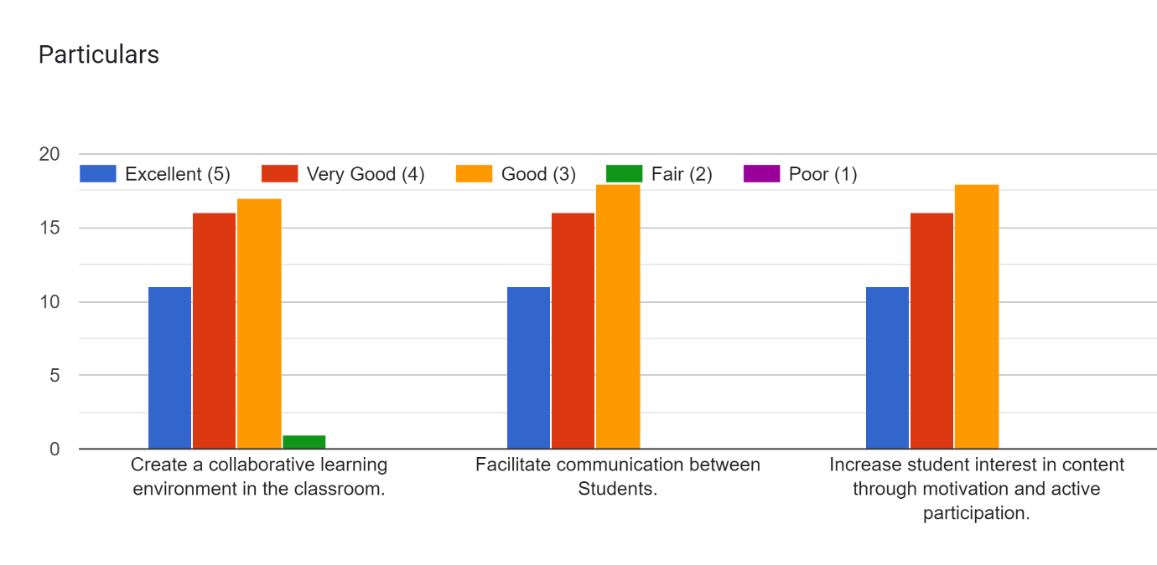

**Signature of the faculty Signature of the HOD**