**Remedial class time table:**

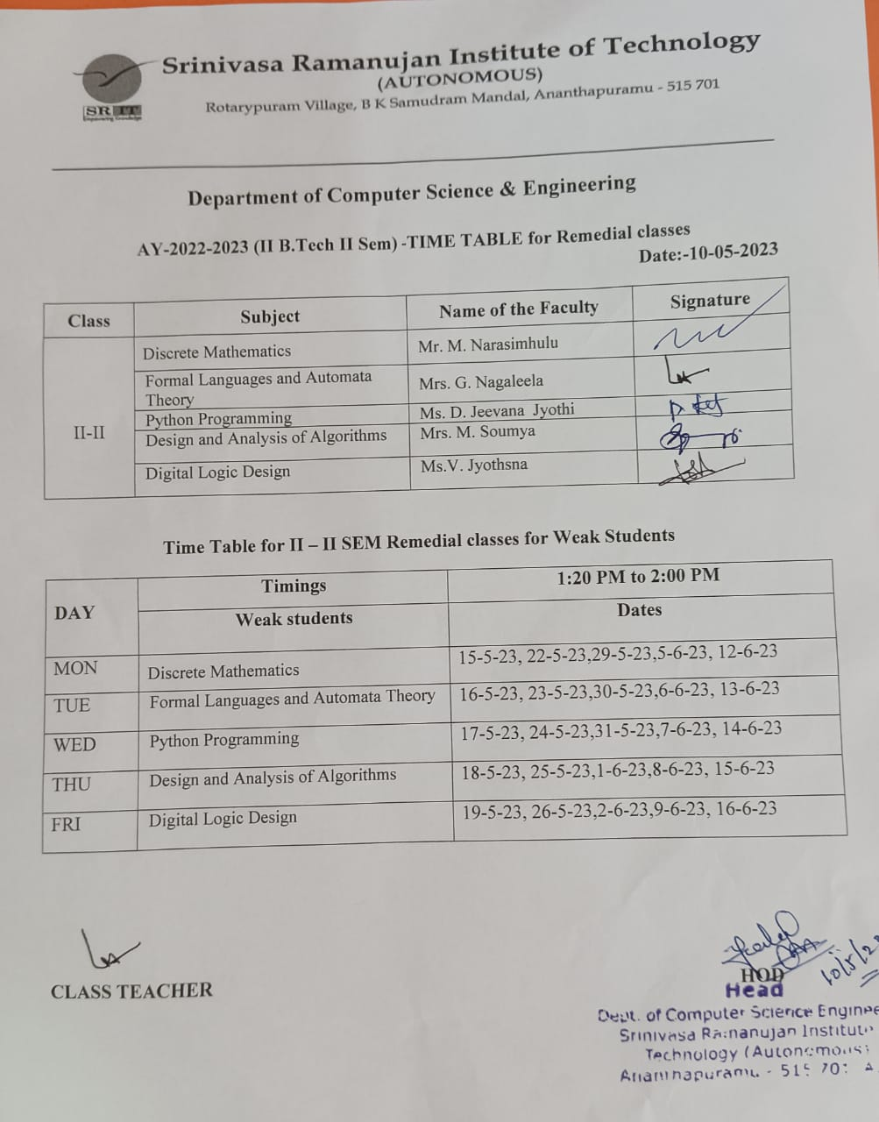

**Methodology to support weak students & encourage bright students:**

|  |  |  |  |  |  |  |
| --- | --- | --- | --- | --- | --- | --- |
| **Course Title:** | **Discrete Mathematics** | | | | **Course Code:** | **R204GA05401** |
| **Class & Sem:** | **II B. Tech I Sem** | | | | **Regulations:** | **SRIT-R20** |
| **Course Structure:** | **Theory** | **Tutorial** | **Lab** | **Theory** | **Core/Elective** | **Core** |
| **3** | **1** | **-** | **3** |
| **Instructor 1:** | **Mr. M. Narasimhulu** | | | | **AY:** | **2022-2023** |

**Methodology to support weak students:**

Student who scored less than 50% of marks in the I internal assessment test will be considered as a slow learner or weak student.

Conducted special classes to improve their academic performance.

**CSE-A & CSE-B:**

| **S.No.** | **Hall Ticket No.** | **Name of the student** | **Mid-1** |
| --- | --- | --- | --- |
| 1 | 214G1A0502 | ABHISHEK B S | 13 |
| 2 | 214G1A0503 | AL FARHEEN P | 14 |
| 3 | 214G1A0506 | ARJUNESWARA RAO K | 15 |
| 4 | 214G1A0507 | ASWARTHA REDDY S | 13 |
| 5 | 214G1A0509 | AYUB S | 11 |
| 6 | 214G1A0524 | DURGA BHAVANI V | 12 |
| 7 | 214G1A0526 | EZAAZ BASHA U | 14 |
| 8 | 214G1A0534 | HARSHA VARDHAN P | 8 |
| 9 | 214G1A0536 | HEMACHANDRA KIRAN SREENIVAS S | 13 |
| 10 | 214G1A0540 | JASWANTH REDDY M | 8 |
| 11 | 214G1A0545 | KOUSHIK G | 10 |
| 12 | 214G1A0547 | LAKSHMI NARASIMHA REDDY G | 3 |
| 13 | 214G1A0551 | LINGARAJU M | 7 |
| 14 | 214G1A0552 | LOKESH B | 14 |
| 15 | 214G1A0554 | MAHESH BABU M | 5 |
| 16 | 214G1A0556 | MANIDEEP SAI Y | 13 |
| 17 | 214G1A0558 | MOHAMMAD FAIZAAN SHAIK P | 15 |
| 18 | 214G1A0563 | MYTHREYA REDDY C | 10 |
| 19 | 214G1A0564 | NADIRA ANJUM J | 10 |
| 20 | 214G1A0576 | PALLAVI M (MEENUGA) | 10 |
| 21 | 214G1A0583 | RAVITEJA M | 11 |
| 22 | 214G1A0590 | SAI PRASANNA C | 12 |
| 23 | 214G1A0593 | SAMHITHA S | 11 |
| 24 | 214G1A0597 | SHARAN KUMAR C | 12 |
| 25 | 214G1A05A6 | SUJITH A | 13 |
| 26 | 214G1A05B0 | SURYA TEJA D | 15 |
| 27 | 214G1A05B1 | TARUN K | 8 |
| 28 | 214G1A05B7 | VARSHITHA REDDY B | 13 |
| 29 | 214G1A05B8 | VARUN KUMAR REDDY B | 11 |
| 30 | 214G1A05B9 | VISWATEJA D | 5 |
| 31 | 214G1A05C5 | PAVAN KUMAR REDDY K | 8 |
| 32 | 214G1A05C6 | SHILPA M | 9 |
| 33 | 214G1A05C9 | SUPREETH KUMAR REDDY U | 5 |
| 34 | 224G5A0502 | CHANDRASEKHAR R | 15 |
| 35 | 224G5A0503 | D PURUSHOTHAM | 14 |
| 36 | 224G5A0507 | JEEVAN KUMAR D | 15 |
| 37 | 224G5A0511 | SHABHAREESH A | 3 |
| 38 | 224G5A0515 | VENKATA RANJITH KUMAR REDDY P | 9 |

**Attendance:**

| **S.**  **No.** | **Hall**  **Ticket No.** | **Name**  **of the**  **student** | **No. of**  **special**  **classes**  **conducted** | **No. of**  **special**  **classes**  **Attended** |
| --- | --- | --- | --- | --- |
| 1 | 214G1A0502 | ABHISHEK B S | 5 | 3 |
| 2 | 214G1A0503 | AL FARHEEN P | 5 | 3 |
| 3 | 214G1A0506 | ARJUNESWARA RAO K | 5 | 3 |
| 4 | 214G1A0507 | ASWARTHA REDDY S | 5 | 3 |
| 5 | 214G1A0509 | AYUB S | 5 | 3 |
| 6 | 214G1A0524 | DURGA BHAVANI V | 5 | 3 |
| 7 | 214G1A0526 | EZAAZ BASHA U | 5 | 3 |
| 8 | 214G1A0534 | HARSHA VARDHAN P | 5 | 3 |
| 9 | 214G1A0536 | HEMACHANDRA KIRAN SREENIVAS S | 5 | 4 |
| 10 | 214G1A0540 | JASWANTH REDDY M | 5 | 4 |
| 11 | 214G1A0545 | KOUSHIK G | 5 | 1 |
| 12 | 214G1A0547 | LAKSHMI NARASIMHA REDDY G | 5 | 4 |
| 13 | 214G1A0551 | LINGARAJU M | 5 | 3 |
| 14 | 214G1A0552 | LOKESH B | 5 | 4 |
| 15 | 214G1A0554 | MAHESH BABU M | 5 | 4 |
| 16 | 214G1A0556 | MANIDEEP SAI Y | 5 | 3 |
| 17 | 214G1A0558 | MOHAMMAD FAIZAAN SHAIK P | 5 | 4 |
| 18 | 214G1A0563 | MYTHREYA REDDY C | 5 | 3 |
| 19 | 214G1A0564 | NADIRA ANJUM J | 5 | 4 |
| 20 | 214G1A0576 | PALLAVI M (MEENUGA) | 5 | 4 |
| 21 | 214G1A0583 | RAVITEJA M | 5 | 4 |
| 22 | 214G1A0590 | SAI PRASANNA C | 5 | 3 |
| 23 | 214G1A0593 | SAMHITHA S | 5 | 3 |
| 24 | 214G1A0597 | SHARAN KUMAR C | 5 | 4 |
| 25 | 214G1A05A6 | SUJITH A | 5 | 3 |
| 26 | 214G1A05B0 | SURYA TEJA D | 5 | 4 |
| 27 | 214G1A05B1 | TARUN K | 5 | 3 |
| 28 | 214G1A05B7 | VARSHITHA REDDY B | 5 | 4 |
| 29 | 214G1A05B8 | VARUN KUMAR REDDY B | 5 | 4 |
| 30 | 214G1A05B9 | VISWATEJA D | 5 | 4 |
| 31 | 214G1A05C5 | PAVAN KUMAR REDDY K | 5 | 4 |
| 32 | 214G1A05C6 | SHILPA M | 5 | 3 |
| 33 | 214G1A05C9 | SUPREETH KUMAR REDDY U | 5 | 2 |
| 34 | 224G5A0502 | CHANDRASEKHAR R | 5 | 2 |
| 35 | 224G5A0503 | D PURUSHOTHAM | 5 | 4 |
| 36 | 224G5A0507 | JEEVAN KUMAR D | 5 | 4 |
| 37 | 224G5A0511 | SHABHAREESH A | 5 | 4 |
| 38 | 224G5A0515 | VENKATA RANJITH KUMAR REDDY P | 5 | 5 |

**Course Name: Regulation :R20**

**Year & Sem: III-I CSE A&B AY:2022-23**

**Time Table for Special Classes (for Weak Students):**

| **S. No** | **Date** | **Time** | **Topics Discussed** |
| --- | --- | --- | --- |
| **UNIT-1** | | | |
| 1 | 15-05-2023 | 1:20 - 2:00 | Statements and Notations |
| Connectives |
| Well Formed Formulas |
| Truth Tables |
| Given Work on Truth Tables Construction |
| UNIT-2 | | | |
| 2 |  |  |  |
|  |
|  |
|  |
|  |
| UNIT-3 | | | |
| 3 |  |  |  |
|  |
|  |
|  |
|  |
|  |
| UNIT-4 | | | |
| 4 | 29-11-2022 | 1:20 - 2:00 |  |
|  |
|  |
|  |
|  |
|  |
| UNIT-5 | | | |
| 5 | 06-12-2022 | 1:20 - 2:00 |  |
|  |
|  |
|  |
|  |