**Report on Teach Back Session**

1. **Course Name : Operating Systems**
2. **Course Coordinator : M Narasimhulu**
3. **Pedagogy Technique Used :Teach Back Session**
4. **Class & Semester : III B.Tech & I Semester (B-Section)**
5. **Date(s) :07/12/2022**
6. **No. of Participants : 02**
7. **Brief Report on the event:**

Teach Back is generally defined as a procedure during which the students describe information they have been taught, using their own words, to confirm understanding of the information.

it is a is a modern instructional strategy that offers student-centered peer-assisted learning.

List of topics Selected by the students:

1. Directory Structure
2. Storage Systems-tape and Disc Storage

**Goals/ objective of methods:**

* Create a collaborative learning environment in the classroom.
* Facilitate communication between Students.
* Increase student interest in content through motivation and active participation.

**Event Photos:**

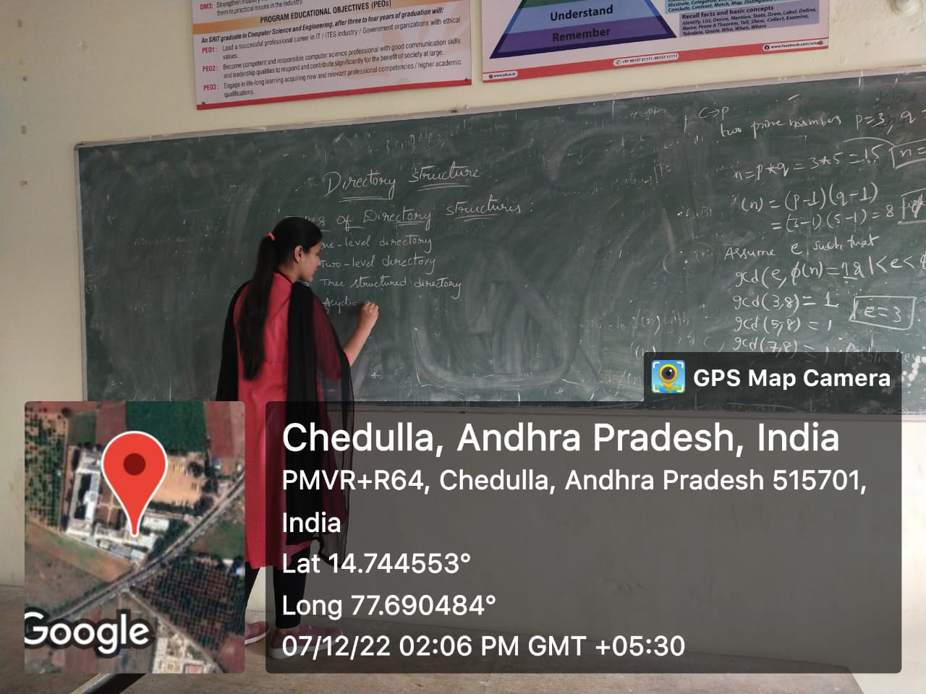

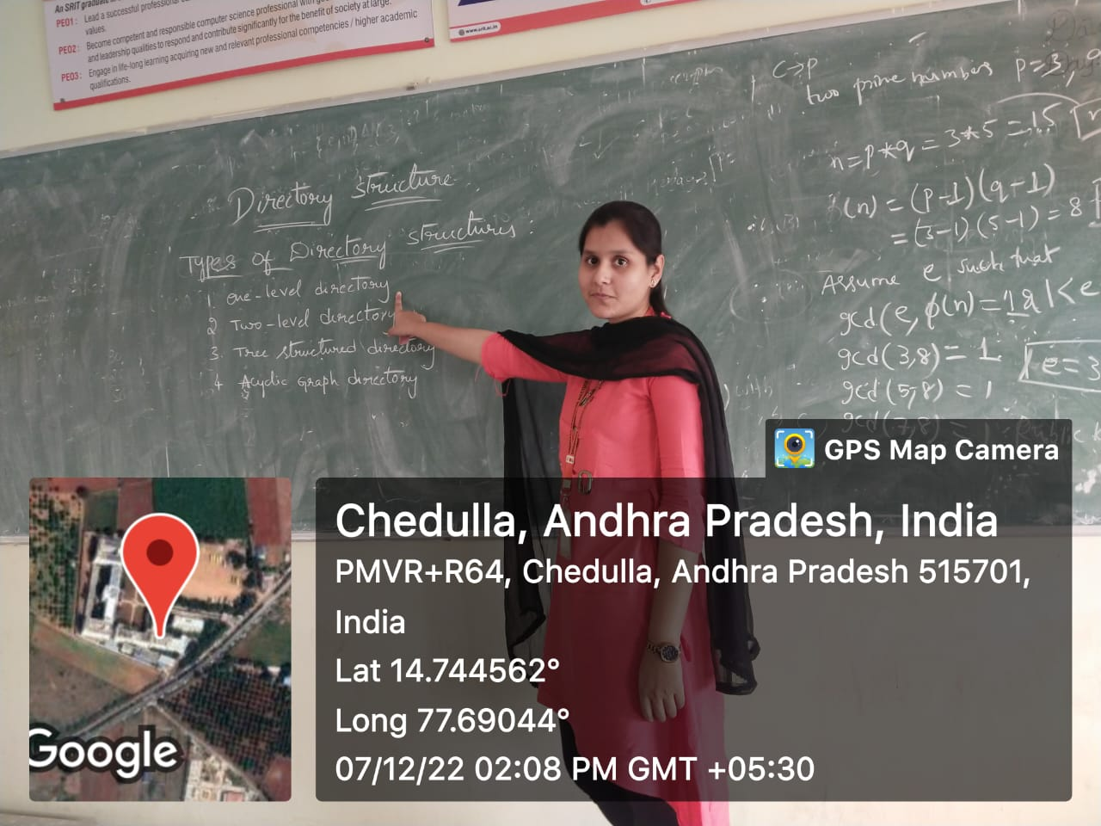

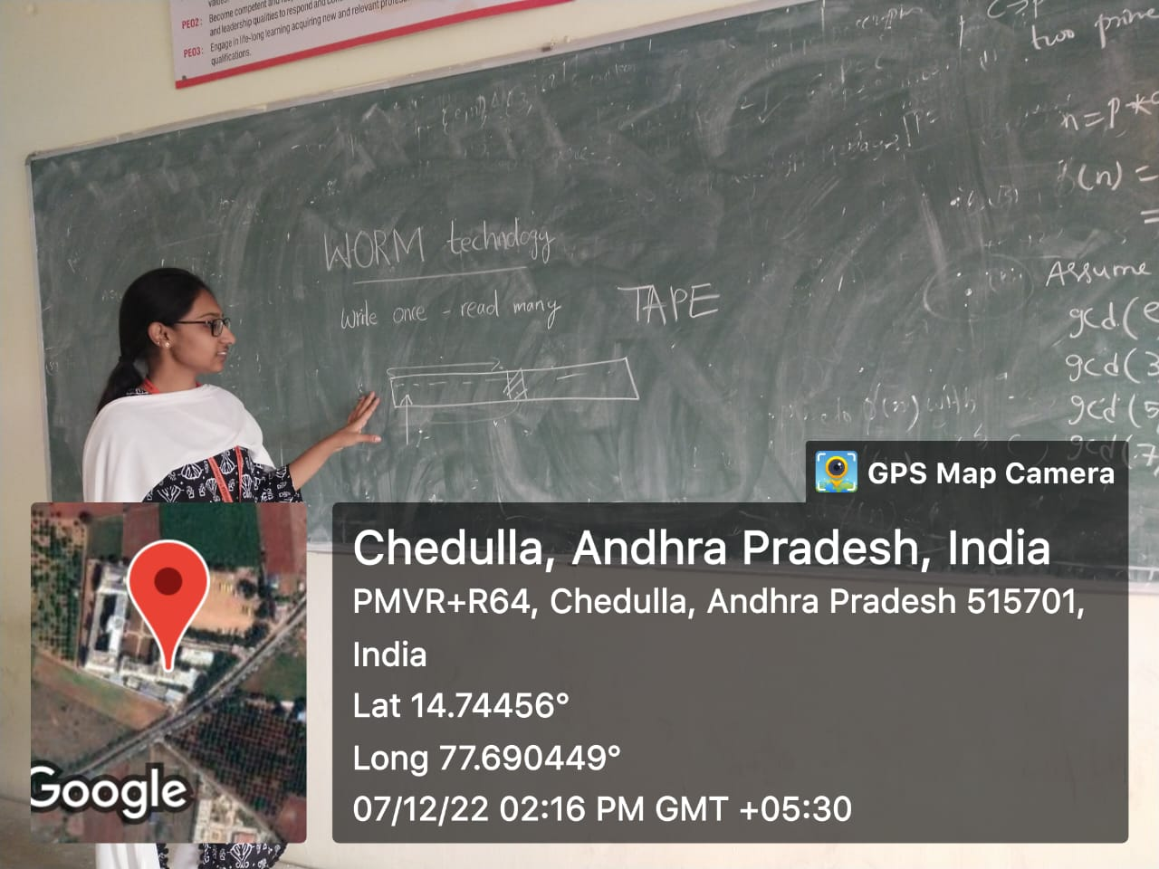

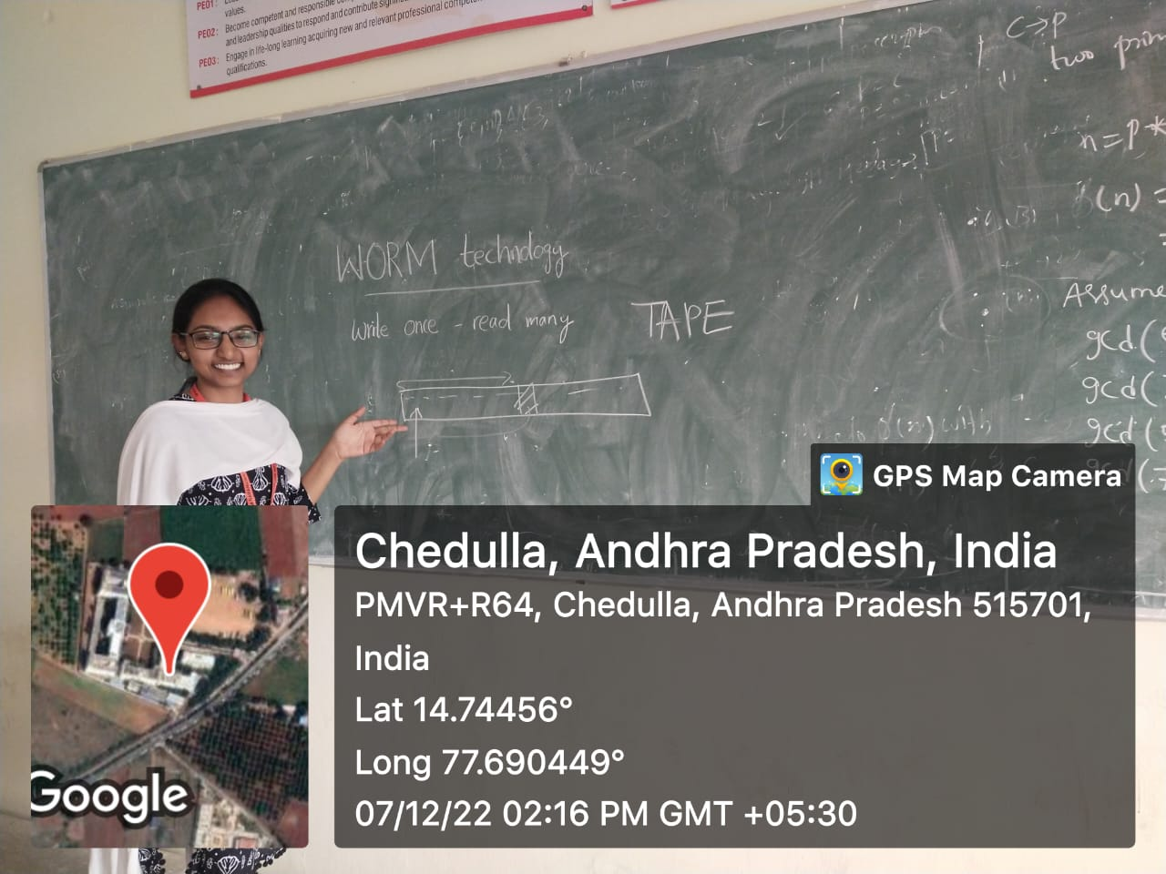

**List of Students Participated:**

|  |  |  |
| --- | --- | --- |
| **S.No** | **Roll No** | **Student Name** |
| **1** | **204G1A05C5** | **J R YASHASWINI** |
| **2** | **204G1A05C7** | **P GANA SREE AKSHAYA REDDY** |

**Signature of the faculty Signature of the HOD**