Data Preprocessing in Data Mining
Data preprocessing is the process of preparing raw data for analysis by cleaning and transforming it into a usable format. In data mining it refers to preparing raw data for mining by performing tasks like cleaning, transforming, and organizing it into a format suitable for mining algorithms.
- Goal is to improve the quality of the data.
- Helps in handling missing values, removing duplicates, and normalizing data.
- Ensures the accuracy and consistency of the dataset.
Steps in Data Preprocessing
Some key steps in data preprocessing are Data Cleaning, Data Integration, Data Transformation, and Data Reduction.
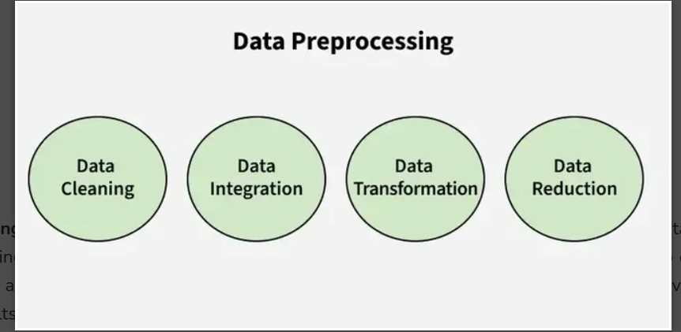
1. Data Cleaning: It is the process of identifying and correcting errors or inconsistencies in the dataset. It involves handling missing values, removing duplicates, and correcting incorrect or outlier data to ensure the dataset is accurate and reliable. Clean data is essential for effective analysis, as it improves the quality of results and enhances the performance of data models.
- Missing Values: This occur when data is absent from a dataset. You can either ignore the rows with missing data or fill the gaps manually, with the attribute mean, or by using the most probable value. This ensures the dataset remains accurate and complete for analysis.
- Noisy Data: It refers to irrelevant or incorrect data that is difficult for machines to interpret, often caused by errors in data collection or entry. It can be handled in several ways:
  - Binning Method: The data is sorted into equal segments, and each segment is smoothed by replacing values with the mean or boundary values.
  - Regression: Data can be smoothed by fitting it to a regression function, either linear or multiple, to predict values.
  - Clustering: This method groups similar data points together, with outliers either being undetected or falling outside the clusters. These techniques help remove noise and improve data quality.
- Removing Duplicates: It involves identifying and eliminating repeated data entries to ensure accuracy and consistency in the dataset. This process prevents errors and ensures reliable analysis by keeping only unique records.
2. Data Integration: It involves merging data from various sources into a single, unified dataset. It can be challenging due to differences in data formats, structures, and meanings. Techniques like record linkage and data fusion help in combining data efficiently, ensuring consistency and accuracy.
- Record Linkage is the process of identifying and matching records from different datasets that refer to the same entity, even if they are represented differently. It helps in combining data from various sources by finding corresponding records based on common identifiers or attributes.
- Data Fusion involves combining data from multiple sources to create a more comprehensive and accurate dataset. It integrates information that may be inconsistent or incomplete from different sources, ensuring a unified and richer dataset for analysis.
3. Data Transformation: It involves converting data into a format suitable for analysis. Common techniques include normalization, which scales data to a common range; standardization, which adjusts data to have zero mean and unit variance; and discretization, which converts continuous data into discrete categories. These techniques help prepare the data for more accurate analysis.
- Data Normalization: The process of scaling data to a common range to ensure consistency across variables.
- Discretization: Converting continuous data into discrete categories for easier analysis.
- Data Aggregation: Combining multiple data points into a summary form, such as averages or totals, to simplify analysis.
- Concept Hierarchy Generation: Organizing data into a hierarchy of concepts to provide a higher-level view for better understanding and analysis.
4. Data Reduction: It reduces the dataset’s size while maintaining key information. This can be done through feature selection, which chooses the most relevant features, and feature extraction, which transforms the data into a lower-dimensional space while preserving important details. It uses various reduction techniques such as,
- Dimensionality Reduction (e.g., Principal Component Analysis): A technique that reduces the number of variables in a dataset while retaining its essential information.
- Numerosity Reduction: Reducing the number of data points by methods like sampling to simplify the dataset without losing critical patterns.
- Data Compression: Reducing the size of data by encoding it in a more compact form, making it easier to store and process.

Uses of Data Preprocessing
Data preprocessing is utilized across various fields to ensure that raw data is transformed into a usable format for analysis and decision-making. Here are some key areas where data preprocessing is applied:
1. Data Warehousing: In data warehousing, preprocessing is essential for cleaning, integrating, and structuring data before it is stored in a centralized repository. This ensures the data is consistent and reliable for future queries and reporting.
2. Data Mining: Data preprocessing in data mining involves cleaning and transforming raw data to make it suitable for analysis. This step is crucial for identifying patterns and extracting insights from large datasets.
3. Machine Learning: In machine learning, preprocessing prepares raw data for model training. This includes handling missing values, normalizing features, encoding categorical variables, and splitting datasets into training and testing sets to improve model performance and accuracy.
4. Data Science: Data preprocessing is a fundamental step in data science projects, ensuring that the data used for analysis or building predictive models is clean, structured, and relevant. It enhances the overall quality of insights derived from the data.
5. Web Mining: In web mining, preprocessing helps analyze web usage logs to extract meaningful user behavior patterns. This can inform marketing strategies and improve user experience through personalized recommendations.
6. Business Intelligence (BI): Preprocessing supports BI by organizing and cleaning data to create dashboards and reports that provide actionable insights for decision-makers.
7. Deep Learning Purpose: Similar to machine learning, deep learning applications require preprocessing to normalize or enhance features of the input data, optimizing model training processes.
Advantages of Data Preprocessing
- Improved Data Quality: Ensures data is clean, consistent, and reliable for analysis.
- Better Model Performance: Reduces noise and irrelevant data, leading to more accurate predictions and insights.
- Efficient Data Analysis: Streamlines data for faster and easier processing.
- Enhanced Decision-Making: Provides clear and well-organized data for better business decisions.
Disadvantages of Data Preprocessing
- Time-Consuming: Requires significant time and effort to clean, transform, and organize data.
- Resource-Intensive: Demands computational power and skilled personnel for complex preprocessing tasks.
- Potential Data Loss: Incorrect handling may result in losing valuable information.
- Complexity: Handling large datasets or diverse formats can be challenging.
Data Preprocessing in Data Mining – FAQ’s
What is data pre-processing?
Data pre-processing increases the quality of the data thus making it fit to be analyzed. It minimizes errors, variations, and duplication, hence enhancing the possibility of getting the right results.
Which methods can be employed in data cleaning process?
Some of them are mechanisms of missing data which is imputed, cases of replicate instances, which can be deleted, noisy data that is binned or regressed, and similar data points that are grouped.
How does data transformation assist data mining?
Data transformation involves the process through which data is transformed into a more useful form as far as data analysis is concerned. Normalization, discretization and concept hierarchy generation are some of the methods used to align the data for enhanced mining.
SQL Functions (Aggregate and Scalar Functions)
SQL Functions are built-in programs that are used to perform different operations on the database.
There are two types of functions in SQL:
- Aggregate Functions
- Scalar Functions
SQL Aggregate Functions
SQL Aggregate Functions operate on a data group and return a singular output. They are mostly used with the GROUP BY clause to summarize data.
Some common Aggregate functions with Syntax and description are shown in the table below.
Aggregate Function | Description | Syntax
AVG() | Calculates the average value | SELECT AVG(column_name) FROM table_name;
COUNT() | Counts the number of rows | SELECT COUNT(column_name) FROM table_name
FIRST() | Returns the first value in an ordered set of values | SELECT FIRST(column_name) FROM table_name;
LAST() | Returns the last value in an ordered set of values | SELECT LAST(column_name) FROM table_name;
MAX() | Retrieves the maximum value from a column | SELECT MAX(column_name) FROM table_name;
MIN() | Retrieves the minimum value from a column | SELECT MIN(column_name) FROM table_name;
SUM() | Calculates the total sum of values in a numeric column | SELECT SUM(column_name) FROM table_name;
SQL Scalar functions
SQL Scalar Functions are built-in functions that operate on a single value and return a single value.
Scalar functions in SQL helps in efficient data manipulation and simplification of complex calculations in SQL queries.
Scalar function | Description | Syntax
UCASE() | Converts a string to uppercase | SELECT UCASE(column_name) FROM table_name;
LCASE() | Converts a string to lowercase | SELECT LCASE(column_name) FROM table_name;
MID() | Extracts a substring from a string | SELECT MID(column_name, start, length) FROM table_name;
LEN() | Returns the length of a string | SELECT LEN(column_name) FROM table_name;
ROUND() | Rounds a number to a specified number of decimals | SELECT ROUND(column_name, decimals) FROM table_name;
NOW() | Returns the current date and time | SELECT NOW();
FORMAT() | Formats a value with the specified format | SELECT FORMAT(column_name, format) FROM table_name;

SQL Functions Examples
Let’s look at some examples of SQL Functions. We will cover examples of SQL aggregate functions and scalar functions.
We will perform queries on the given SQL table:
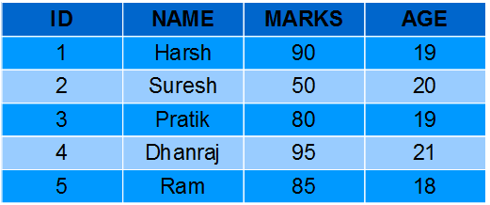

Aggregate Functions Examples
Let’s look at the examples of each aggregate function in SQL.
AVG() Function Example
Computing average marks of students.
Query:
SELECT AVG(MARKS) AS AvgMarks FROM Students;

Output:
AvgMarks
80
COUNT() Function Example
Computing total number of students.
Query:
SELECT COUNT(*) AS NumStudents FROM Students;
Output:
NumStudents
5
FIRST() Function Example
Fetching marks of first student from the Students table.
Query:
SELECT FIRST(MARKS) AS MarksFirst FROM Students;
Output:
MarksFirst
90
LAST() Function Example
Fetching marks of last student from the Students table.
Query:
SELECT LAST(MARKS) AS MarksLast FROM Students;
Output:
MarksLast
85
MAX() Function Example
Fetching maximum marks among students from the Students table.
Query:
SELECT MAX(MARKS) AS MaxMarks FROM Students;
Output:
MaxMarks
95
MIN() Function Example
Fetching minimum marks among students from the Students table.
Query:
SELECT MIN(MARKS) AS MinMarks FROM Students;
Output:
MinMarks
50
SUM() Function Example
Fetching summation of total marks among students from the Students table.
Query:
SELECT SUM(MARKS) AS TotalMarks FROM Students;
Output:
TotalMarks
400
Scalar Functions Examples
Let’s look at some examples of each Scalar Function in SQL.
UCASE() Function Example
Converting names of students from the table Students to uppercase.
Query:
SELECT UCASE(NAME) FROM Students;
Output:
NAME
HARSH
SURESH
PRATIK
DHANRAJ
RAM
LCASE() Function Example
Converting names of students from the table Students to lowercase.
Query:
SELECT LCASE(NAME) FROM Students;
Output:
NAME
harsh
suresh
pratik
dhanraj
ram
MID() Function Example
Fetching first four characters of names of students from the Students table.
Query:
SELECT MID(NAME,1,4) FROM Students;
Output:
NAME
HARS
SURE
PRAT
DHAN
RAM
LEN() Function Example
Fetching length of names of students from Students table.
Query:
SELECT LENGTH(NAME) FROM Students;

Output:
NAME
5
6
6
7
3
ROUND() Function Example
Fetching maximum marks among students from the Students table.
Query:
SELECT ROUND(MARKS,0) FROM Students;
Output:
MARKS
90
50
80
95
85

NOW() Function Example
Fetching current system time.
Query:
SELECT NAME, NOW() AS DateTime FROM Students;
Output:
NAME | DateTime
HARSH | 1/13/2017 1:30:11 PM
SURESH | 1/13/2017 1:30:11 PM
PRATIK | 1/13/2017 1:30:11 PM
DHANRAJ | 1/13/2017 1:30:11 PM
RAM | 1/13/2017 1:30:11 PM

FORMAT() Function Example
Formatting current date as ‘YYYY-MM-DD’.
Query:
SELECT NAME, FORMAT(Now(),'YYYY-MM-DD') AS Date FROM Students;
Output:
NAME | Date
HARSH | 2017-01-13
SURESH | 2017-01-13
PRATIK | 2017-01-13
DHANRAJ | 2017-01-13
RAM | 2017-01-13
Important Points About SQL Functions
- SQL functions are built-in programs that are used to manipulate data in various ways.
- There are different types of SQL functions – Aggregate functions and Scalar functions.
- Aggregate functions perform calculations on a group of values and return a single value. Example SUM, AVG, COUNT.
- Scalar functions operate on a single value and return a single value. Example UPPER, LOWER, SUBSTRING.
- SQL functions can be used in different SQL statements, such as SELECT, WHERE, GROUP BY, and ORDER BY, to improve data processing and analysis.
SQL Date and Time Functions
Handling date and time data in SQL is essential for many database operations. SQL provides a variety of date and time functions that help users work with date values, perform calculations, and format them as needed. Whether you’re adding intervals to dates, extracting parts of a date, or formatting the output, mastering SQL date functions is crucial for working with temporal data in databases.
In this article, we’ll explore the most common SQL date functions, including examples and use cases for each. We’ll cover functions like NOW(), CURDATE(), DATE_ADD(), DATE_SUB(), and many more, providing a clear understanding of how to use them effectively.
Common SQL Date Data Types
In SQL, dates are complicated for newbies, since while working with a database, the format of the data in the table must be matched with the input data to insert. In various scenarios instead of date, datetime (time is also involved with date) is used.
For storing a date or a date and time value in a database,SQL offers the following data types:
DATE | format YYYY-MM-DD
DATETIME | format: YYYY-MM-DD HH:MI: SS
TIMESTAMP | format: YYYY-MM-DD HH:MI: SS
YEAR | format YYYY or YY

SQL Date Functions
1. NOW()
The NOW() function retrieves the current date and time in YYYY-MM-DD HH:MI:SS format.
Query:
SELECT NOW();
Output:
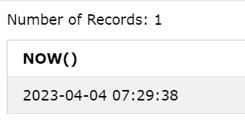
2. CURDATE()
CURDATE() returns the current date in YYYY-MM-DD format, without the time part.
Query:
SELECT CURDATE();
Output:
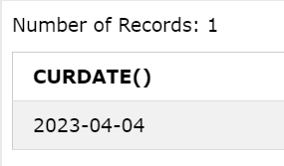
3. CURTIME()
The CURTIME() function returns the current time in HH:MI:SS format, excluding the date.
Query: SELECT CURTIME();
Output:
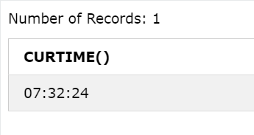
4. DATE()
Extracts the date part of a date or date/time expression. Example: For the below table named ‘Test’
Id | Name | BirthTime
4120 | Pratik | 1996-09-26 16:44:15.581
Query:
SELECT Name, DATE(BirthTime) AS BirthDate FROM Test;
Output:
Name | BirthDate
Pratik | 1996-09-26
5. EXTRACT()
The EXTRACT() function retrieves a specific part of a DATE, DATETIME, or TIMESTAMP value, such as the day, year, or second.
Syntax:
EXTRACT(unit FROM date);
Several units can be considered but only some are used such as MICROSECOND, SECOND, MINUTE, HOUR, DAY, WEEK, MONTH, QUARTER, YEAR, etc. And ‘date’ is a valid date expression. Example: For the below table named ‘Test’
Id | Name | BirthTime
4120 | Pratik | 1996-09-26 16:44:15.581

Query: SELECT Name, Extract(DAY FROM BirthTime) AS BirthDay FROM Test;
Output:
Name | Birthday
Pratik | 26
Query:
SELECT Name, Extract(YEAR FROM BirthTime) AS BirthYear FROM Test;
Output:
Name | BirthYear
Pratik | 1996
Query:
SELECT Name, Extract(SECOND FROM BirthTime) AS BirthSecond FROM Test;
Output:
Name | BirthSecond
Pratik | 581
6. DATE_ADD()
The DATE_ADD() function allows you to add a specified time interval to a date.
Syntax:
DATE_ADD(date, INTERVAL expr type);
Where, date – valid date expression, and expr is the number of intervals we want to add. and type can be one of the following: MICROSECOND, SECOND, MINUTE, HOUR, DAY, WEEK, MONTH, QUARTER, YEAR, etc. Example: For the below table named ‘Test’
Id | Name | BirthTime
4120 | Pratik | 1996-09-26 16:44:15.581

Query: SELECT Name, DATE_ADD(BirthTime, INTERVAL 1 YEAR) AS BirthTimeModified FROM Test;
Output:
Name | BirthTimeModified
Pratik | 1997-09-26 16:44:15.581
Query:
SELECT Name, DATE_ADD(BirthTime, INTERVAL 30 DAY) AS BirthDayModified FROM Test;
Output:
Name | BirthDayModified
Pratik | 1996-10-26 16:44:15.581
Query:
SELECT Name, DATE_ADD(BirthTime, INTERVAL4 HOUR) AS BirthHourModified FROM Test;
Output:
Name | BirthSecond
Pratik | 1996-10-26 20:44:15.581
7. DATEDIFF()
Returns the number of days between two dates.
Syntax:
DATEDIFF(interval,date1, date2);
interval – minute/hour/month/year,etc
date1 & date2- date/time expression
Query:
SELECT DATEDIFF(day, '2017-01-13', '2017-01-03') AS DateDiff;
Output:
DateDiff
0
8. DATE_FORMAT()
DATE_FORMAT() allows you to display DATE, DATETIME, or TIMESTAMP data in various formats, using placeholders.
Syntax:
DATE_FORMAT(date,format);
the date is a valid date and the format specifies the output format for the date/time. The formats that can be used are:
- %a-Abbreviated weekday name (Sun-Sat)
- %b-Abbreviated month name (Jan-Dec)
- %c-Month, numeric (0-12)
- %D-Day of month with English suffix (0th, 1st, 2nd, 3rd)
- %d-Day of the month, numeric (00-31)
- %e-Day of the month, numeric (0-31)
- %f-Microseconds (000000-999999)
- %H-Hour (00-23)
- %h-Hour (01-12)
- %I-Hour (01-12)
- %i-Minutes, numeric (00-59)
- %j-Day of the year (001-366)
- %k-Hour (0-23)
- %l-Hour (1-12)
- %M-Month name (January-December)
- %m-Month, numeric (00-12)
- %p-AM or PM
- %r-Time, 12-hour (hh:mm: ss followed by AM or PM)
- %S-Seconds (00-59)
- %s-Seconds (00-59)
- %T-Time, 24-hour (hh:mm: ss)
- %U-Week (00-53) where Sunday is the first day of the week
- %u-Week (00-53) where Monday is the first day of the week
- %V-Week (01-53) where Sunday is the first day of the week, used with %X
- %v-Week (01-53) where Monday is the first day of the week, used with %x
- %W-Weekday name (Sunday-Saturday)
- %w-Day of the week (0=Sunday, 6=Saturday)
- %X-Year for the week where Sunday is the first day of the week, four digits, used with %V
- %x-Year for the week where Monday is the first day of the week, four digits, used with %v
- %Y-Year, numeric, four digits
- %y-Year, numeric, two digits
SQL | String functions
SQL String Functions are powerful tools that allow us to manipulate, format, and extract specific parts of text data in our database. These functions are essential for tasks like cleaning up data, comparing strings, and combining text fields. Whether we’re working with names, addresses, or any form of textual data, mastering SQL string functions is crucial for efficient data handling and analysis.
In this article, we will dive deep into the most commonly used SQL string functions. We’ll explore their syntax, use cases, and examples to help us understand how to manipulate string data effectively in our SQL queries.
Common SQL String Functions
String functions are used to perform an operation on input string and return an output string. Following are the string functions defined in SQL:
1. CONCAT(): Concatenate Strings
The CONCAT() function is used to concatenate (combine) two or more strings into one string. It is useful when we want to merge fields like first and last names into a full name.
Query:
SELECT CONCAT('John', ' ', 'Doe') AS FullName;
Output:
John Doe
2. CHAR_LENGTH() / CHARACTER_LENGTH(): Find String Length
The CHAR_LENGTH() or LENGTH() function returns the length of a string in characters. It’s essential for validating or manipulating text data, especially when you need to know how many characters a string contains.
Query:
SELECT CHAR_LENGTH('Hello') AS StringLength;
Output:
5
3. UPPER() and LOWER(): Convert Text Case
These functions convert the text to uppercase or lowercase, respectively. They are useful for normalizing the case of text in a database.
Query:
SELECT UPPER('hello') AS UpperCase;
SELECT LOWER('HELLO') AS LowerCase;
Output:
HELLO
hello
4. LENGTH(): Length of String in Bytes
LENGTH() returns the length of a string in bytes. This can be useful for working with multi-byte character sets.
Query:
SELECT LENGTH('Hello') AS LengthInBytes;
Output:
5
5. REPLACE(): Replace Substring in String
The REPLACE() function replaces occurrences of a substring within a string with another substring. This is useful for cleaning up data, such as replacing invalid characters or formatting errors.
Query:
SELECT REPLACE('Hello World', 'World', 'SQL') AS UpdatedString;
Output:
Hello SQL
6. SUBSTRING() / SUBSTR(): Extract Part of a String
The SUBSTRING() (or SUBSTR()) function is used to extract a substring from a string, starting from a specified position. It is especially useful when we need to extract a specific part of a string, like extracting the domain from an email address.
Query:
SELECT SUBSTRING('Hello World', 1, 5) AS SubStringExample;
Output:
Hello
7. LEFT() and RIGHT(): Extract Substring from Left or Right
The LEFT() and RIGHT() functions allow you to extract a specified number of characters from the left or right side of a string, respectively. It is used for truncating strings for display.

Query:
SELECT LEFT('Hello World', 5) AS LeftString;
SELECT RIGHT('Hello World', 5) AS RightString;
Output:
Hello
World
8. INSTR(): Find Position of Substring
The INSTR() function is used to find the position of the first occurrence of a substring within a string. It returns the position (1-based index) of the substring. If the substring is not found, it returns 0. This function is particularly useful for locating specific characters or substrings in text data.
Query:
SELECT INSTR('Hello World', 'World') AS SubstringPosition;
Output:
7
9. TRIM(): Remove Leading and Trailing Spaces
The TRIM() function removes leading and trailing spaces (or other specified characters) from a string. By default, it trims spaces but can also remove specific characters using TRIM(character FROM string). This is helpful for cleaning text data, such as user inputs or database records.
Query:
SELECT TRIM(' ' FROM ' Hello World ') AS TrimmedString;
Output:
Hello World
10. REVERSE(): Reverse the String
The REVERSE() function reverses the characters in a string. It’s useful in situations where we need to process data backward, such as for password validation or certain pattern matching.

Query:
SELECT REVERSE('Hello') AS ReversedString;
Output:
olleH
Some Other String Function
In addition to the core string functions, SQL provides a variety of additional tools for advanced string manipulation. These are the some other SQL Functions.
ASCII(): This function is used to find the ASCII value of a character.
Syntax: SELECT ascii('t');
Output: 116
CONCAT_WS(): This function is used to add two words or strings with a symbol as concatenating symbol.
Syntax: SELECT CONCAT_WS('_', 'geeks', 'for', 'geeks');
Output: geeks_for_geeks
FIND_IN_SET(): This function is used to find a symbol from a set of symbols.
Syntax: SELECT FIND_IN_SET('b', 'a, b, c, d, e, f');
Output: 2
FORMAT(): This function is used to display a number in the given format.
Syntax: SELECT FORMAT(0.981 * 100, 'N2') + '%' AS PercentageOutput;
Output: ‘98.10%’
INSTR(): This function is used to find the occurrence of an alphabet.
Syntax: INSTR('geeks for geeks', 'e');
Output: 2 (the first occurrence of ‘e’)
LCASE(): This function is used to convert the given string into lower case.
Syntax: LCASE ("GeeksFor Geeks To Learn");
Output: geeksforgeeks to learn
LOCATE(): This function is used to find the nth position of the given word in a string.
Syntax: SELECT LOCATE('for', 'geeksforgeeks', 1);
Output: 6
LPAD(): This function is used to make the given string of the given size by adding the given symbol.
Syntax: LPAD('geeks', 8, '0');
Output:000geeks
MID(): This function is to find a word from the given position and of the given size.
Syntax: Mid ("geeksforgeeks", 6, 2);
Output: for
POSITION(): This function is used to find position of the first occurrence of the given alphabet.
Syntax: SELECT POSITION('e' IN 'geeksforgeeks');
Output: 2
REPEAT(): This function is used to write the given string again and again till the number of times mentioned.
Syntax: SELECT REPEAT('geeks', 2);
Output: geeksgeeks
REPLACE(): This function is used to cut the given string by removing the given sub string.
Syntax: REPLACE('123geeks123', '123');
Output: geeks
RPAD(): This function is used to make the given string as long as the given size by adding the given symbol on the right.
Syntax: RPAD('geeks', 8, '0');
Output: ‘geeks000’
RTRIM(): This function is used to cut the given sub string from the original string.
Syntax: RTRIM('geeksxyxzyyy', 'xyz');
Output: ‘geeks’
SPACE(): This function is used to write the given number of spaces.
Syntax: SELECT SPACE(7);
Output: ‘ ‘
STRCMP(): This function is used to compare 2 strings.
Syntax: SELECT STRCMP('google.com', 'geeksforgeeks.com');
Output: -1
Below is a table summarizing these functions, their purposes, and examples.
Function | Description | Example Query | Output
ASCII() | Find ASCII value of a character. | SELECT ASCII('A'); | 65
CONCAT_WS() | Concatenate with a delimiter. | SELECT CONCAT_WS('_', 'A', 'B'); | A_B
FIND_IN_SET() | Find position in a set. | SELECT FIND_IN_SET('b', 'a,b,c'); | 2
LOCATE() | Find nth occurrence. | SELECT LOCATE('e', 'geeksforgeeks', 1); | 2
LPAD() | Pad string from the left. | SELECT LPAD('geeks', 8, '0'); | 000geeks
POSITION() | Find character position. | SELECT POSITION('e' IN 'geeks'); | 2
REPEAT() | Repeat a string. | SELECT REPEAT('SQL', 3); | SQLSQLSQL
RTRIM() | Remove trailing characters. | SELECT RTRIM('SQLXYZ', 'XYZ'); | SQL

SQL | Numeric Function
SQL Numeric Functions are essential tools for performing mathematical and arithmetic operations on numeric data. These functions allow you to manipulate numbers, perform calculations, and aggregate data for reporting and analysis purposes. Understanding how to use SQL numeric functions is important for anyone working with data that involves calculations, such as financial, statistical, or inventory data.
In this article, we’ll dive deep into the most commonly used SQL numerical functions, providing detailed explanations, syntax, and real-world examples to help you understand how to use them effectively in your SQL queries.
What Are SQL Numeric Functions?
SQL Numeric Functions are used to perform operations on numeric data types such as INT, FLOAT, DECIMAL, DOUBLE, and others. These functions help you manipulate numbers in various ways, including performing arithmetic operations, rounding, formatting, and aggregating data.
Commonly Used SQL Numeric Functions
Following are the numeric functions defined in SQL
1. ABS() – Absolute Value
The ABS() function returns the absolute value of a number, which is the number without its sign (i.e., it converts negative numbers to positive).
Syntax:
SELECT ABS(number);
Example:
SELECT ABS(-25);
Output:
25
2. CEIL() or CEILING() – Round Number Up
The CEIL() (or CEILING()) function rounds a number up to the nearest integer, regardless of whether the decimal part is greater than or less than 0.5.
Syntax:
SELECT CEIL(number);
Example:
SELECT CEIL(12.34);
Output:
13
3. FLOOR() – Round Number Down
The FLOOR() function rounds a number down to the nearest integer, ignoring the decimal part.
Syntax:
SELECT FLOOR(number);
Example:
SELECT FLOOR(12.98);
Output:
12
4. ROUND() – Round a Number to a Specified Decimal Place
The ROUND() function rounds a number to a specified number of decimal places. It is very useful for financial calculations or whenever precise rounding is necessary.
Syntax:
SELECT ROUND(number, decimal_places);
Example:
SELECT ROUND(15.6789, 2);
Output:
15.68
5. TRUNCATE() – Remove Decimal Places
The TRUNCATE() function is used to remove the decimal portion of a number without rounding. It truncates the number to the specified number of decimal places.
Syntax:
SELECT TRUNCATE(number, decimal_places);
Example: SELECT TRUNCATE(12.98765, 2);
Output:
12.98
6. MOD() – Modulo or Remainder
The MOD() function returns the remainder of a division operation (i.e., it computes the modulus). This function is useful for tasks like determining even/odd numbers or finding remainders in mathematical operations.
Syntax:
SELECT MOD(dividend, divisor);
Example:
SELECT MOD(10, 3);
Output:
1
7. POWER() – Raise a Number to the Power of Another
The POWER() function is used to raise a number to the power of another number. It is often used in mathematical calculations like compound interest or growth rate.
Syntax:
SELECT POWER(base, exponent);
Example:
SELECT POWER(2, 3);
Output:
8
8. SQRT() – Square Root
The SQRT() function returns the square root of a number. This is useful for mathematical calculations involving geometry or statistical analysis.
Syntax:
SELECT SQRT(number);
Example:
SELECT SQRT(16);
Output:
4
9. EXP() – Exponential Function
The EXP() function returns the value of e raised to the power of a specified number, where e is the base of the natural logarithm (approximately 2.71828).
Syntax:
SELECT EXP(number);
Example:
SELECT EXP(1);
Output:
2.718281828459045
10. LOG() – Logarithm
The LOG() function returns the natural logarithm (base e) of a number. You can also use LOG(base, number) to calculate the logarithm of a number with a custom base.
Syntax:
SELECT LOG(number);
SELECT LOG(base, number);
Example:
SELECT LOG(100);
Output:
4.605170186
11. RAND() – Random Number
The RAND() function generates a random floating-point number between 0 and 1. This function is commonly used for simulations, lotteries, or generating random samples.
Syntax:
SELECT RAND();
Example:
SELECT RAND();
Output:
0.287372
A Statistical function is a mathematical function that helps us to process and analyze data to provide meaningful information about the dataset. For example mean, sum, min, max, standard deviation, etc.

Statistical Functions in SQL
Function | Output
AVG() | Calculates the average value of a numeric column.
SUM() | Calculates the sum of values in a numeric column.
COUNT() | Counts the number of rows in a result set or the number of non-null values in a column.
MIN() | Returns the minimum value in a column.
MAX() | Returns the maximum value in a column.
VAR() / VARIANCE() | Calculates the population variance of a numeric column.
STDDEV() / STDDEV_POP() | Calculates the population standard deviation of a numeric column.
CORR() | Calculates the correlation coefficient between two numeric columns.
COVAR_POP() | Calculates the population covariance between two numeric columns.
PERCENTILE_CONT() | Calculates a specified percentile value for a numeric column
1. AVG() Function
Calculate the average or arithmetic mean for a group of numbers or a numeric column.
Syntax:
SELECT AVG(column_name) FROM table_name;
Example Query:
SELECT AVG(marks) AS average_marks FROM studentDetails;
Output:
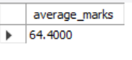AVG_MARKS
2. SUM() Function
The total of all numeric values in a group i.e. Calculates the total sum of values in a numeric column.
Syntax:
SELECT SUM(column_name) FROM table_name;
Example Query:
SELECT SUM(marks) AS total_marks FROM studentDetails;
Output:
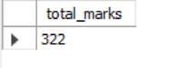Sum of marks
3. Count() Function
The number of cell locations in a range that contain a numeric character i.e Counts the number of rows in a result set or the number of non-null values in a column.
Syntax:
SELECT COUNT(*) FROM table_name;
SELECT COUNT(column_name) FROM table_name;
Example Query:
SELECT COUNT(studentID) AS total_students FROM studentDetails;
Output:
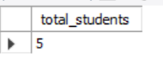Count of Student
Example Query:
select count(*) from studentdetails;
Output:
Return the count of rows that meet a specified condition .
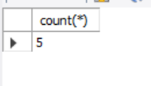count all rows
4. Max() Function
Returns the highest numeric value in a group of numbers.
Syntax:
SELECT MAX(column_name) FROM table_name;
Example Query:
SELECT MAX(marks) AS highest_marks FROM studentDetails;
Output:
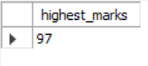Maximum marks

5. MIN() Function
Returns the lowest numeric value in a group of numbers.
Syntax:
SELECT MIN(column_name) FROM table_name;
Example Query:
SELECT MIN(marks) AS lowest_marks FROM studentDetails;
Output:
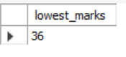Minimum marks
6. VAR() / VARIANCE() Function
Calculates the population variance of a numeric column
Syntax:
SELECT VAR(column_name) FROM table_name;
Example Query:
SELECT VARIANCE(marks) AS variance_marks FROM studentDetails;
Output:
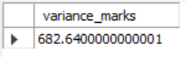Variance marks
7. STDDEV() / STDDEV_POP() Function
The standard deviation for a group of numbers based on a sample
Syntax:
SELECT STDDEV(column_name) FROM table_name;
Example Query:
SELECT STDDEV(marks) AS stddev_marks FROM studentDetails;
Output:
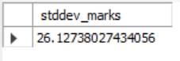Standrad deviation for marks
8. PERCENTILE_CONT() Function
Calculates a specified percentile value for a numeric column.
Syntax:
SELECT PERCENTILE_CONT(0.5) WITHIN GROUP (ORDER BY column_name) FROM table_name;
Example Query:
SELECT PERCENTILE_CONT(0.5) WITHIN GROUP (ORDER BY salary) AS median_salary
FROM employees;
Output:
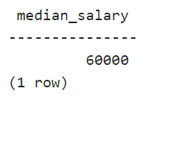Median salary of employee's
9. CORR() Function
Calculates the correlation coefficient between two numeric columns.
Syntax:
SELECT CORR(column1, column2) FROM table_name;
Example Query:
SELECT CORR(sales, profit) AS correlation_coefficient
FROM sales_data;
Output:
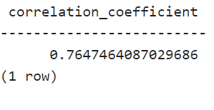correlation coefficient between 'sales' and 'profit'
10 .COVAR_POP() Function
Calculates the population covariance between two numeric columns.
Syntax:
SELECT COVAR_POP(column1, column2) FROM table_name;
Example Query:
SELECT COVAR_POP(revenue, expenses) AS population_covariance
FROM financial_data;
Output:
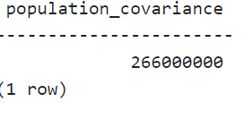

Types of Data Type Conversion in SQL
There are two main types of data type conversion in SQL.
- Implicit Data Type Conversion: This is done automatically by the database management system (DBMS) when SQL operations involve columns of different data types. For instance, a string value might automatically be converted into a numeric type if required by a mathematical operation.
- Explicit Data Type Conversion: This is done by the user, who specifies the conversion. This is necessary when SQL cannot automatically convert between data types, or when more control over the conversion is needed.
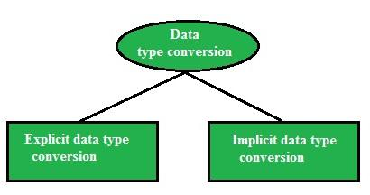
Implicit Data-Type Conversion
Implicit data type conversion, also known as automatic type casting, occurs when SQL automatically converts one data type to another without requiring any intervention from the user. The DBMS does this whenever it detects a need for the conversion, based on the context of the operation.
From | To
VARCHAR2 or CHAR | NUMBER
VARCHAR2 or CHAR | DATE
DATE | VARCHAR2
NUMBER | VARCHAR2
Example of Implicit Data Type Conversion
Consider the following example where we retrieve employees whose salary is greater than 15,000.
create table employees(
employee_id INT PRIMARY KEY ,
first_name VARCHAR(50) ,
salary INT);

INSERT INTO employees(employee_id,first_name,salary)
VALUES
(100,'Steven',24000),
(101,'Neena',17000),
(102,'Lex',17000),
(103,'John',11000),
(104,'Robert',12000),
(105,'Leo',10000);
Here, we want to retrieve the employee_id, first_name, and salary from the employees table whose salary is greater than 15000 then the query is
Query:
SELECT employee_id,first_name,salary
FROM employees
WHERE salary > 15000;

Output:
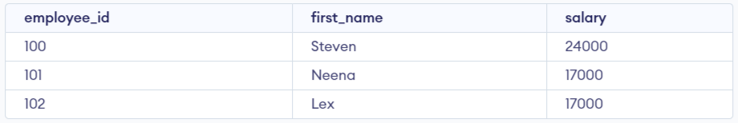
In the second query, we provide the value ‘15000’ as a string, and SQL automatically converts it to an integer to match the column data type.
Query:
SELECT employee_id,first_name,salary
FROM employees
WHERE salary > '15000';
Output:

Despite the second query using ‘15000’ as a string, SQL automatically converts it into an integer before comparing it to the salary column, which is an integer type. The results for both queries will be the same.
Explicit Data-Type Conversion
Explicit data type conversion, or type casting, occurs when the user explicitly specifies the conversion of a value from one type to another. This is necessary when SQL cannot automatically infer the correct conversion or when you want to ensure the data is handled in a specific way.
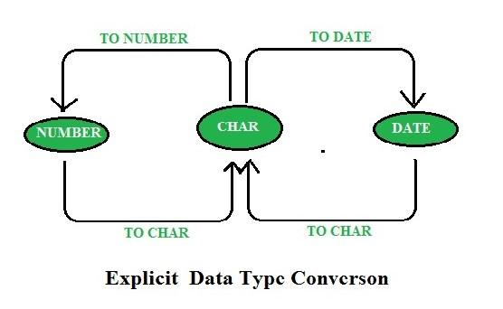
SQL provides several functions for explicit type conversion, including:
- TO_CHAR(): Converts numbers or dates to a string.
- TO_NUMBER(): Converts a string to a numeric type.
- TO_DATE(): Converts a string to a date.
Example of Explicit Data Type Conversion
Let’s use the TO_CHAR function to convert a numeric value (salary) into a formatted string.
SELECT employee_id, TO_CHAR(salary, '$99,999.00') AS formatted_salary
FROM employees
WHERE last_name = 'Ernst';
In this query:
The TO_CHAR function is used to format the salary field as a string with a dollar sign and thousands separator.
Output:
employee_id | formatted_salary
1001 | $24,500.00
1002 | $30,000.00
SQL Functions for Explicit Data Type Conversion
1. TO_CHAR Function
TO_CHAR function is used to typecast a numeric or date input to a character type with a format model (optional).
TO_CHAR(expression, ‘format_model’)
Using the TO_CHAR Function with Dates
TO_CHAR(date, ’format_model’)

The format model:
- Must be enclosed in single quotation marks and is case sensitive
- Can include any valid date format element in the query
- Has an fm element to remove padded blanks or suppress leading zeros
- Is separated from the date value by a comma
Example:
SELECT employee_id, TO_CHAR(hire_date, ’MM/YY’) Month_Hired
FROM employees
WHERE last_name = ’Higgins’;
Output :
EMPLOYEE_ID | MONTH_HIRED
205 | 06/94
Elements of the Date Format Model
YYYY | Full-year in Numbers
YEAR | Year spelled out
YY | Two-digit value of year
MM | Two-digit value for the month
MONTH | Full name of the month
MON | Three Letter abbreviation of the month
D | Number of Days in a Week
DY | Three-letter abbreviation of the day of the week
DAY | Full Name of the Day
DD | Numeric day of the month
Date Format Elements – Time Formats
Use the formats listed in the following tables to display time information and literals and to change numerals to spelled numbers.
ELEMENT | DESCRIPTION
AM or PM | Meridian indicator
A.M. or P.M. | Meridian indicator with periods
HH or HH12 or HH24 | Hour of day, or hour (1-12), or hour (0-23)
MI | Minute 0-59
SS | Second 0-59
SSSSS | Second past Mid Night 0-86399

Other Formats
ELEMENT | DESCRIPTION
/ . , | Punctuation is reproduced in the result
“of the” | The quoted string is reproduced in the result
Specifying Suffixes to Influence Number Display
ELEMENT | DESCRIPTION
TH | Ordinal Number (for example DDTH for 4TH
SP | Spelled outnumber (for example DDSP for FOUR
SPTH or THSP | spelled out ordinal numbers (for example DDSPTH for FOURTH
Example :
SELECT last_name, TO_CHAR(hire_date, ’fmDD Month YYYY’)
AS HIREDATE
FROM employees;
Output :
LASTNAME | HIIREDATE
Austin | 25 January 2005
Shubham | 20 June 2004
Nishant | 15 January 1999
Ankit | 15 July 1995
Vanshika | 5 August 2004
Kusum | 10 June 1994
Faviet | 11 March 2005
King | 9 April 1996
2. Using the TO_CHAR Function with Numbers
TO_CHAR(number, ’format_model’)
These are some of the format elements you can use with the TO_CHAR function to display a number value as a character :
9 | Represent a number
0 | Forces a zero to be displayed
$ | places a floating dollar sign
L | It uses the floating local currency symbol
. | Print a decimal point
, | Prints a Thousand indicator
Example :
SELECT TO_CHAR(salary, ’$99,999.00’) SALARY
FROM employees
WHERE last_name = ’Ernst’;
Output :
SALARY
$5000
Using the TO_NUMBER and TO_DATE Functions :
Convert a character string to a number format using the TO_NUMBER function :
TO_NUMBER(char[, ’format_model’])
Convert a character string to a date format using the TO_DATE function:
TO_DATE(char[, ’format_model’])
These functions have an fx modifier. This modifier specifies the exact matching for the character argument and date format model of a TO_DATE function.
Example :
SELECT last_name, hire_date
FROM employees
WHERE hire_date = TO_DATE(’May 24, 1999’, ’fxMonth DD, YYYY’);
Output :
LASTNAME | HIREDATE
Kumar | 24-MAY-1999

Types of SQL Operators
SQL operators can be categorized based on the type of operation they perform. Here are the primary types of SQL operators:
- Arithmetic Operator
- Comparison Operator
- Logical Operator
- Bitwise Operators
- Compound Operators
- Special Operators
Each of these operators is essential for performing different types of operations on data in SQL databases.
SQL Arithmetic Operators
Arithmetic operators in SQL are used to perform mathematical operations on numeric data types in SQL queries. Some common arithmetic operators:
Operator | Description
+ | The addition is used to perform an addition operation on the data values.
– | This operator is used for the subtraction of the data values.
/ | This operator works with the ‘ALL’ keyword and it calculates division operations.
* | This operator is used for multiplying data values.
% | Modulus is used to get the remainder when data is divided by another.
Example: Arithmetic Operations
In this example, we will retrieve all records from the “employee” table where the “emp_city” column does not start with the letter ‘A’.
Query:
SELECT * FROM employee WHERE emp_city NOT LIKE 'A%';
Output:
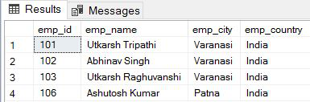
SQL Comparison Operators
Comparison Operators in SQL are used to compare one expression’s value to other expressions. SQL supports different types of comparison operator, which are described below:
Operator | Description
= | Equal to.
> | Greater than.
< | Less than.
>= | Greater than equal to.
<= | Less than equal to.
<> | Not equal to.
Example: Comparison Operation
In this example, we will retrieve all records from the “MATHS” table where the value in the “MARKS” column is equal to 50.
Query:
SELECT * FROM MATHS WHERE MARKS=50;
Output:
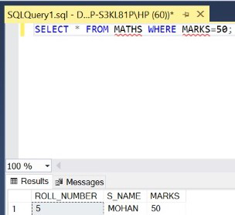
SQL Logical Operators
Logical Operators in SQL are used to combine or manipulate conditions in SQL queries to retrieve or manipulate data based on specified criteria..
Operator | Description
AND | Logical AND compares two Booleans as expressions and returns true when both expressions are true.
OR | Logical OR compares two Booleans as expressions and returns true when one of the expressions is true.
NOT | Not takes a single Boolean as an argument and change its value from false to true or from true to false.
Example: Logical Operation
In this example, retrieve all records from the “employee” table where the “emp_city” column is equal to ‘Allahabad‘ and the “emp_country” column is equal to ‘India’.
Query:
SELECT * FROM employee WHERE emp_city =
'Allahabad' AND emp_country = 'India';
Output:
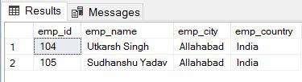
SQL Bitwise Operators
Bitwise operators in SQL are used to perform bitwise operations on binary values in SQL queries, manipulating individual bits to perform logical operations at the bit level. Some SQL Bitwise Operators are:
Operator | Description
& | Bitwise AND operator
| | Bitwise OR operator
^ | Bitwise XOR (exclusive OR) operator
~ | Bitwise NOT (complement) operator
<< | Left shift operator
>> | Right shift operator
SQL Compound Operators
Compound operators combine an operation with assignment. These operators modify the value of a column and store the result in the same column in a single step. Some Compound operators are:
Operator | Description
+= | Add and assign
-= | Subtract and assign
*= | Multiply and assign
/= | Divide and assign
%= | Modulo and assign
&= | Bitwise AND and assign
^= | Bitwise XOR and assign
|= | Bitwise OR and assign
SQL Special Operators
SQL also provides several special operators that serve specific functions such as filtering data based on a range, checking for existence, and comparing sets of values.
Operators | Description
ALL | ALL is used to select all records of a SELECT STATEMENT. It compares a value to every value in a list of results from a query. The ALL must be preceded by the comparison operators and evaluated to TRUE if the query returns no rows.
ANY | ANY compares a value to each value in a list of results from a query and evaluates to true if the result of an inner query contains at least one row.
BETWEEN | The SQL BETWEEN operator tests an expression against a range. The range consists of a beginning, followed by an AND keyword and an end expression.
IN | The IN operator checks a value within a set of values separated by commas and retrieves the rows from the table that match.
EXISTS | The EXISTS checks the existence of a result of a subquery. The EXISTS subquery tests whether a subquery fetches at least one row. When no data is returned then this operator returns ‘FALSE’.
SOME | SOME operator evaluates the condition between the outer and inner tables and evaluates to true if the final result returns any one row. If not, then it evaluates to false.
UNIQUE | The UNIQUE operator searches every unique row of a specified table.
Example: Special Operator (BETWEEN)
In this example, we will retrieve all records from the “employee” table where the “emp_id” column has a value that falls within the range of 101 to 104 (inclusive).
Query:
SELECT * FROM employee WHERE emp_id BETWEEN 101 AND 104;
Output:
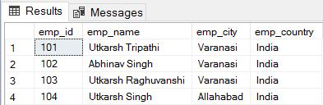

What are SQL Commands?
SQL Commands are like instructions to a table. It is used to interact with the database with some operations. It is also used to perform specific tasks, functions, and queries of data. SQL can perform various tasks like creating a table, adding data to tables, dropping the table, modifying the table, set permission for users.
SQL Commands are mainly categorized into five categories:
- DDL – Data Definition Language
- DQL – Data Query Language
- DML – Data Manipulation Language
- DCL – Data Control Language
- TCL – Transaction Control Language
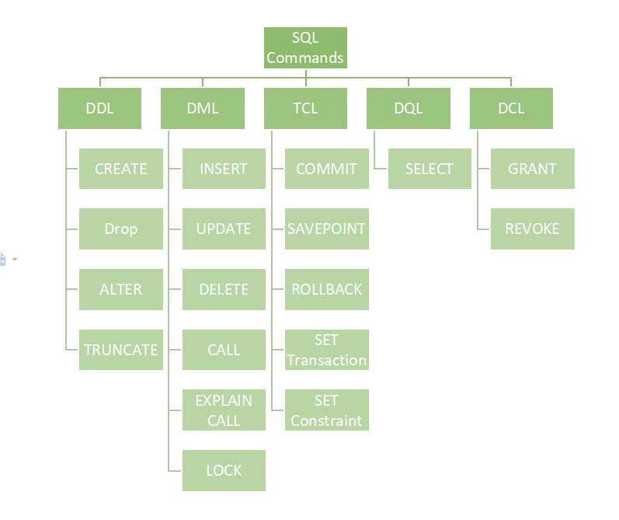

1. Data Definition Language (DDL) in SQL
DDL or Data Definition Language actually consists of the SQL commands that can be used to defining, altering, and deleting database structures such as tables, indexes, and schemas. It simply deals with descriptions of the database schema and is used to create and modify the structure of database objects in the database
Common DDL Commands
Command | Description | Syntax
CREATE | Create database or its objects (table, index, function, views, store procedure, and triggers) | CREATE TABLE table_name (column1 data_type, column2 data_type, ...);
DROP | Delete objects from the database | DROP TABLE table_name;
ALTER | Alter the structure of the database | ALTER TABLE table_name ADD COLUMN column_name data_type;
TRUNCATE | Remove all records from a table, including all spaces allocated for the records are removed | TRUNCATE TABLE table_name;
COMMENT | Add comments to the data dictionary | COMMENT 'comment_text' ON TABLE table_name;
RENAME | Rename an object existing in the database | RENAME TABLE old_table_name TO new_table_name;
Example of DDL
CREATE TABLE employees (
employee_id INT PRIMARY KEY,
first_name VARCHAR(50),
last_name VARCHAR(50),
hire_date DATE
);
In this example, a new table called employees is created with columns for employee ID, first name, last name, and hire date.
2. Data Query Language (DQL) in SQL
DQL statements are used for performing queries on the data within schema objects. The purpose of the DQL Command is to get some schema relation based on the query passed to it. This command allows getting the data out of the database to perform operations with it. When a SELECT is fired against a table or tables the result is compiled into a further temporary table, which is displayed or perhaps received by the program.
DQL Command
Command | Description | Syntax
SELECT | It is used to retrieve data from the database | SELECT column1, column2, ...FROM table_name WHERE condition;
Example of DQL
SELECT first_name, last_name, hire_date
FROM employees
WHERE department = 'Sales'
ORDER BY hire_date DESC;
This query retrieves employees’ first and last names, along with their hire dates, from the employees table, specifically for those in the ‘Sales’ department, sorted by hire date.
3. Data Manipulation Language (DML) in SQL
The SQL commands that deal with the manipulation of data present in the database belong to DML or Data Manipulation Language and this includes most of the SQL statements. It is the component of the SQL statement that controls access to data and to the database. Basically, DCL statements are grouped with DML statements.

Common DML Commands
Command | Description | Syntax
INSERT | Insert data into a table | INSERT INTO table_name (column1, column2, ...) VALUES (value1, value2, ...);
UPDATE | Update existing data within a table | UPDATE table_name SET column1 = value1, column2 = value2 WHERE condition;
DELETE | Delete records from a database table | DELETE FROM table_name WHERE condition;
LOCK | Table control concurrency | LOCK TABLE table_name IN lock_mode;
CALL | Call a PL/SQL or JAVA subprogram | CALL procedure_name(arguments);
EXPLAIN PLAN | Describe the access path to data | EXPLAIN PLAN FOR SELECT * FROM table_name;

Example of DML
INSERT INTO employees (first_name, last_name, department) VALUES ('Jane', 'Smith', 'HR');
This query inserts a new record into the employees table with the first name ‘Jane’, last name ‘Smith’, and department ‘HR’.
4. Data Control Language (DCL) in SQL
DCL (Data Control Language) includes commands such as GRANT and REVOKE which mainly deal with the rights, permissions, and other controls of the database system. These commands are used to control access to data in the database by granting or revoking permissions.
Common DCL Commands
Command | Description | Syntax
GRANT | Assigns new privileges to a user account, allowing access to specific database objects, actions, or functions. | GRANT privilege_type [(column_list)] ON [object_type] object_name TO user [WITH GRANT OPTION];
REVOKE | Removes previously granted privileges from a user account, taking away their access to certain database objects or actions. | REVOKE [GRANT OPTION FOR] privilege_type [(column_list)] ON [object_type] object_name FROM user [CASCADE];

Example of DCL
GRANT SELECT, UPDATE ON employees TO user_name;
This command grants the user user_name the permissions to select and update records in the employees table.
5. Transaction Control Language (TCL) in SQL
Transactions group a set of tasks into a single execution unit. Each transaction begins with a specific task and ends when all the tasks in the group are successfully completed. If any of the tasks fail, the transaction fails. Therefore, a transaction has only two results: success or failure. We can explore more about transactions here.
Common TCL Commands
Command | Description | Syntax
BEGIN TRANSACTION | Starts a new transaction | BEGIN TRANSACTION [transaction_name];
COMMIT | Saves all changes made during the transaction | COMMIT;
ROLLBACK | Undoes all changes made during the transaction | ROLLBACK;
SAVEPOINT | Creates a savepoint within the current transaction | SAVEPOINT savepoint_name;
Example of TCL
BEGIN TRANSACTION;
UPDATE employees SET department = 'Marketing' WHERE department = 'Sales';
SAVEPOINT before_update;
UPDATE employees SET department = 'IT' WHERE department = 'HR';
ROLLBACK TO SAVEPOINT before_update;
COMMIT;
In this example, a transaction is started, changes are made, and a savepoint is set. If needed, the transaction can be rolled back to the savepoint before being committed.
Important SQL Commands
- SELECT: Used to retrieve data from a database.
- INSERT: Used to add new data to a database.
- UPDATE: Used to modify existing data in a database.
- DELETE: Used to remove data from a database.
- CREATE TABLE: Used to create a new table in a database.
- ALTER TABLE: Used to modify the structure of an existing table.
- DROP TABLE: Used to delete an entire table from a database.
- WHERE: Used to filter rows based on a specified condition.
- ORDER BY: Used to sort the result set in ascending or descending order.
- JOIN: Used to combine rows from two or more tables based on a related column between them.
What are the 5 basic SQL commands?
The five basic SQL commands are SELECT, INSERT, UPDATE, DELETE, and CREATE. These commands allow users to retrieve, add, modify, remove, and define database structures, forming the foundation for database management operations.
What are the 4 types of SQL commands?
- DDL (Data Definition Language): Commands like CREATE, ALTER, and DROP to define database structure.
- DML (Data Manipulation Language): Commands like SELECT, INSERT, UPDATE, and DELETE for data operations.
- DCL (Data Control Language): Commands like GRANT and REVOKE to manage permissions.
- TCL (Transaction Control Language): Commands like COMMIT, ROLLBACK, and SAVEPOINT to manage transactions.

What are DDL, DML, and DCL?
- DDL (Data Definition Language): Used to define and manage database schema (e.g., CREATE, ALTER).
- DML (Data Manipulation Language): Handles data retrieval and manipulation (e.g., SELECT, INSERT, UPDATE).
- DCL (Data Control Language): Manages user permissions and access control (e.g., GRANT, REVOKE).

CREATE DATABASE in SQL

The CREATE DATABASE command establishes a new database within your SQL ecosystem. A database is a repository that organizes data in structured formats through tables, views, stored procedures, and other components.

The syntax to use the CREATE DATABASE command in SQL is:
Syntax:
CREATE DATABASE database_name;
SHOW DATABASES command and it will return a list of databases that exist in our system. Now we will look for the name of the database (GeeksForGeeks) that we have just created.
SQL Query: SHOW DATABASES;
USE Database in SQL
Once your database is created, we can switch to that database to begin adding tables, inserting data, and performing queries. To do this, use the USE command.
Syntax: The syntax to use a database in SQL is: USE database_name
After running this command, any subsequent queries will apply to the GeeksForGeeks database. This allows you to work within the scope of the newly created database.
Delete a Database in SQL
If you ever need to remove a database, the DROP DATABASE command can be used to delete the database and all its contents: Syntex: DROP DATABASE database_name;
Be cautious when using this command, as it permanently deletes the database and all of its data.
SQL DROP DATABASE IF EXISTS
To avoid any error while running the DROP DATABASE command use the IF EXISTS clause, which will delete the database only if it exists in the system.
Syntax: DROP DATABASE IF EXISTS Database_Name;
FAQs
What is DROP DATABASE in MySQL?
DROP DATABASE in MySQL is a command used to permanently remove a database and all its associated data, tables, and objects. This action is irreversible, so be sure to back up important data before executing it. DROP DATABASE database_name;
How do I drop a database from SQL?
To drop a database in SQL, use the DROP DATABASE command followed by the database name. This deletes the database entirely, including all its tables and data.
DROP DATABASE database_name;
What is the difference between DROP DATABASE and DELETE DATABASE?
DROP DATABASE completely removes a database and its structure from the system, while DELETE DATABASE is not a valid SQL command. Deleting all data from a database can be done using the DELETE statement, but it does not remove the database itself.
How to Rename Database in SQL?
To rename a database in SQL, you’ll need to use the ALTER DATABASE command. The syntax varies slightly between different SQL platforms, but the core functionality remains the same. The ALTER DATABASE statement allows you to modify the properties of a database, including its name.
However, it’s important to note that while SQL Server uses the ALTER DATABASE statement with a MODIFY NAME clause, MySQL employs a different approach using the RENAME DATABASE statement.
To change the name of a database in SQL, use the syntax:
ALTER DATABASE [current_database_name] MODIFY NAME = [new_database_name];
To rename a database in MySQL use the query:
RENAME DATABASE [current_database_name] TO [new_database_name];

The USE DATABASE Statement
- The USE DATABASE statement is not a standard SQL command, but rather a variation of the USE command used in some SQL database management systems (DBMS) to select a specific database for the current session.
- This command sets the default database for subsequent queries in that session.
Syntax:
USE database_name;
Example of SQL Select Database
Let’s take a look at how to select a database in SQL, using MySQL as an example. Suppose you have a database called company_db that contains employee information.
- Create a Database: To begin, you can create a new database if it doesn’t already exist
CREATE DATABASE GeeksforGeeks;
- Select the Database: To set GeeksforGeeks as the active database, use the USE command
USE GeeksforGeeks;
Once you’ve selected the database, any queries you execute will be performed within the context of GeeksforGeeks until you select another database.
How to Query Data from the Selected Database
The SELECT statement in SQL is used to query and retrieve data from the tables within the selected database. Here are some key ways to use the SELECT statement effectively
Table: employees
id | name | age | department | salary
1 | Alice | 30 | Sales | 50000
2 | Bob | 40 | Marketing | 60000
3 | Charlie | 35 | Sales | 55000
4 | David | 28 | HR | 45000
5 | Eve | 45 | Marketing | 65000
6 | Frank | 50 | HR | 70000
7 | Grace | 29 | IT | 48000
8 | Hannah | 38 | IT | 53000
1. Basic SELECT Statement
SELECT * FROM employees;
Output:
id | name | age | department | salary
1 | Alice | 30 | Sales | 50000
2 | Bob | 40 | Marketing | 60000
3 | Charlie | 35 | Sales | 55000
4 | David | 28 | HR | 45000
5 | Eve | 45 | Marketing | 65000
6 | Frank | 50 | HR | 70000
7 | Grace | 29 | IT | 48000
8 | Hannah | 38 | IT | 53000
Explanation: Retrieves all columns and all rows from the employees table.
2. Selecting Specific Columns
SELECT name, age FROM employees;
Output:
name | age
Alice | 30
Bob | 40
Charlie | 35
David | 28
Eve | 45
Frank | 50
Grace | 29
Hannah | 38
Explanation: Retrieves only the name and age columns for all rows.
3. Filtering Results with WHERE
SELECT name, age FROM employees WHERE age >= 35;
Output:
name | age
Bob | 40
Charlie | 35
Eve | 45
Frank | 50
Hannah | 38
Explanation: Retrieves names and ages of employees older than 35.
4. Sorting Results with ORDER BY
SELECT name, age FROM employees ORDER BY age DESC;
Output:
name | age
Frank | 50
Eve | 45
Bob | 40
Hannah | 38
Charlie | 35
Alice | 30
Grace | 29
David | 28
Explanation: Retrieves names and ages of all employees sorted by age in descending order.
5. Limiting Results with LIMIT Clause
SELECT name, salary FROM employees ORDER BY salary DESC LIMIT 3;
Output:
name | salary
Frank | 70000
Eve | 65000
Bob | 60000
Explanation: Retrieves the top 3 highest-paid employees, ordered by salary in descending order.
6. Aggregating Data with GROUP BY and Aggregation Functions
SELECT department, AVG(salary) AS average_salary FROM employees GROUP BY department;
Output:
department | average_salary
Sales | 52500
Marketing | 62500
HR | 57500
IT | 50500

SQL CREATE TABLE Statement
To create a new table in the database, use the SQL CREATE TABLE statement. A table’s structure, including column names, data types, and constraints like NOT NULL, PRIMARY KEY, and CHECK, are defined when it is created in SQL.
The CREATE TABLE command is a crucial tool for database administration because of these limitations, which aid in ensuring data integrity. To create a table in SQL, use this CREATE TABLE
Syntax:
CREATE table table_name
(
Column1 datatype (size),
column2 datatype (size),
.
.
columnN datatype(size)
);
Key Terms
- table_name: The name you assign to the new table.
- column1, column2, … : The names of the columns in the table.
- datatype(size): Defines the data type and size of each column.
Example of SQL CREATE TABLE
Let’s look at examples of CREATE TABLE command in SQL and see how to create table in SQL.
CREATE TABLE in SQL and Insert Data
In this example, we will create a new table and insert data into it. Let us create a table to store data of Customers, so the table name is Customer, Columns are Name, Country, age, phone, and so on.
Query:
CREATE TABLE Customer(
CustomerID INT PRIMARY KEY,
CustomerName VARCHAR(50),
LastName VARCHAR(50),
Country VARCHAR(50),
Age INT CHECK (Age >= 0 AND Age <= 99),
Phone int(10)
);

Output:
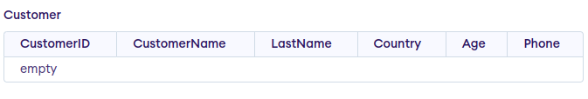
Insert Data into the Created Table
After creating the table, you can use INSERT INTO command to add data to it. Here’s how to add some sample records into the Customer table:
Syntax:
INSERT INTO table_name (column1, column2, …) VALUES (value1, value2, …);
Example Query
INSERT INTO Customer (CustomerID, CustomerName, LastName, Country, Age, Phone)
VALUES (1, 'Shubham', 'Thakur', 'India','23','xxxxxxxxxx'),
(2, 'Aman ', 'Chopra', 'Australia','21','xxxxxxxxxx'),
(3, 'Naveen', 'Tulasi', 'Sri lanka','24','xxxxxxxxxx'),
(4, 'Aditya', 'Arpan', 'Austria','21','xxxxxxxxxx'),
(5, 'Nishant. Salchichas S.A.', 'Jain', 'Spain','22','xxxxxxxxxx');
Output:
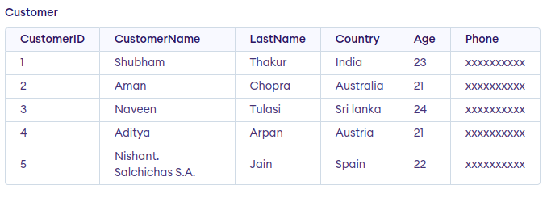
Create Table From Another Table(best option to create backup of the table or duplicate table)
We can also create a new table based on the structure (and optionally the data) of an existing table. The following query creates a new table called SubTable that contains CustomerID and CustomerName from the existing Customer table.
Syntax:
CREATE TABLE new_table_name AS
SELECT column1, column2,…
FROM existing_table_name
WHERE ….;
Query:
CREATE TABLE SubTable AS
SELECT CustomerID, CustomerName
FROM customer;
Output:
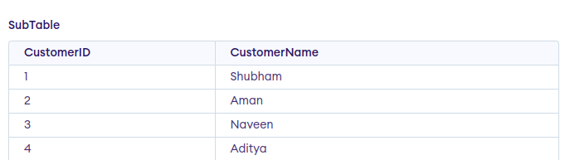
Note: We can use * instead of column name to copy whole table to another table.
Important Points About SQL CREATE TABLE Statement
- CREATE TABLE statement is used to create new table in a database.
- It defines the structure of table including name and datatype of columns.
- The DESC table_name; command can be used to display the structure of the created table
- We can also add constraint to table like NOT NULL, UNIQUE, CHECK, and DEFAULT.
- If you try to create a table that already exists, MySQL will throw an error. To avoid this, you can use the
- CREATE TABLE IF NOT EXISTS syntax.

How do you create a table in SQL?
- In SQL, you can create a table by using the CREATE TABLE command, then the table name and column definitions. Each column’s data type and limitations can be specified.

How to create a query in SQL?
- To create a query in SQL, you start with a SQL statement that retrieves or manipulates data, such as SELECT, INSERT, UPDATE, or DELETE.

How to create a duplicate table in SQL Server?
- In SQL Server, you can create a duplicate table using the CREATE TABLE AS SELECT statement. This approach copies the structure and optionally the data from an existing table to a new table.
DROP TABLE in SQL
- The DROP TABLE statement in SQL is used to delete a table and all of its data from the database permanently.
- This operation cannot be undone, and once the table is dropped all data in that table is lost.
- Once executed, this operation removes the table definition and all of its rows, so the table can no longer be accessed or used.
- This action is irreversible which means that once a table is dropped, it cannot be recovered unless there is a backup.
Syntax:
The syntax to use the DROP TABLE command in SQL is:
DROP TABLE table_name;
The syntax of the command remains the same in Oracle, SQL Server and MySQL.
Example of DROP TABLE in SQL
To demonstrate how to use the DROP TABLE command, let’s first create a database and a table, and then we will drop it.
Step1: First, we will create a database and table on which the SQL queries will be run.

CREATE DATABASE NewCafe;
USE NewCafe;

CREATE TABLE categories (
CategoryID INT NOT NULL PRIMARY KEY,
CategoryName NVARCHAR(50) NOT NULL,
ItemDescription NVARCHAR(50) NOT NULL
);

INSERT INTO categories (CategoryID, CategoryName, ItemDescription)
VALUES
(1, 'Beverages', 'Soft Drinks'),
(2, 'Condiments', 'Sweet and Savory Sauces'),
(3, 'Confections', 'Sweet Breads');

SELECT * FROM categories;
Output:
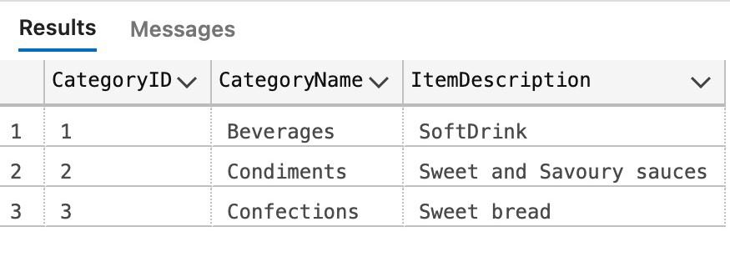
At this point, the categories table has been created with three rows of sample data.
Step2: Now, let’s use the DROP TABLE statement to delete the categories table permanently
Query:
DROP TABLE categories;

Important Points About SQL DROP TABLE
- The SQL DROP TABLE statement is used to delete tables in a database, along with all associated data, indexes, triggers, constraints and permission specifications.
- The table will be permanently disabled, so use this query with caution.
- Use DROP TABLE IF EXISTS query to prevent errors when dropping a table that does not exist
- When dropping a partitioned table, the DROP TABLE statement removes the table definition, all partitions, all data stored in those partitions, and all partition definitions.
- The DROP TABLE statement can be used to drop temporary tables by including the TEMPORARY keyword.
- To verify if a table is dropped, you can use the DESC command.

- What happens if I try to drop a table that doesn’t exist?
If you try to drop a non-existent table, SQL will return an error. To prevent this, you can use the DROP TABLE IF EXISTS statement, which will only execute the drop if the table exists.

- Can I recover a table after using the DROP TABLE command?
No, once a table is dropped, all its data, structure, and constraints are permanently deleted. You cannot recover it unless you have a backup of the database.

- Is there a difference between dropping a regular table and a temporary table?
Yes, when dropping a temporary table, you must include the TEMPORARY keyword in the DROP TABLE statement. This ensures that only the temporary table is deleted without affecting any regular tables in the database

SQL DELETE Statement
The SQL DELETE statement removes one or more rows from a database table based on a condition specified in the WHERE clause. It’s a DML (Data Manipulation Language) operation that modifies the data within the table without altering its structure.
Syntax: DELETE FROM table_name WHERE some_condition;
Parameter Explanation
- Some_condition: condition to choose a particular record.
- table_name: name of the table
Note: We can delete single as well as multiple records depending on the condition we provide in the WHERE clause. If we omit the WHERE clause then all of the records will be deleted and the table will be empty.
The sample table is as follows GFG_Employees:
Examples of SQL DELETE Statement
Assume we have created a table named GFG_Employee in SQL which contains the personal details of the Employee including their id, name, email and department etc. as shown below –
CREATE TABLE GFG_Employees (
id INT PRIMARY KEY,
name VARCHAR (20) ,
email VARCHAR (25),
department VARCHAR(20)
);

INSERT INTO GFG_Employees (id, name, email, department) VALUES
(1, 'Jessie', 'jessie23@gmail.com', 'Development'),
(2, 'Praveen', 'praveen_dagger@yahoo.com', 'HR'),
(3, 'Bisa', 'dragonBall@gmail.com', 'Sales'),
(4, 'Rithvik', 'msvv@hotmail.com', 'IT'),
(5, 'Suraj', 'srjsunny@gmail.com', 'Quality Assurance'),
(6, 'Om', 'OmShukla@yahoo.com', 'IT'),
(7, 'Naruto', 'uzumaki@konoha.com', 'Development');
Select * From GFG_Employees
Output
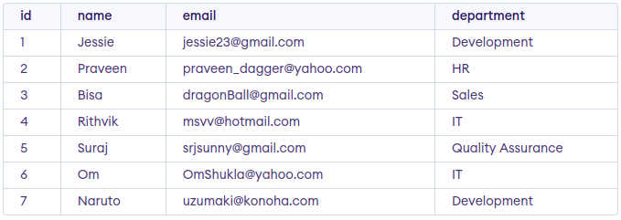
GFG_Employees
Example 1: Deleting Single Record
We can use the DELETE statement with a condition to delete a specific row from a table. The WHERE clause ensures only the intended record is removed. We can delete the records named Rithvik by using the below query:
Query:
DELETE FROM GFG_Employees WHERE NAME = 'Rithvik';
Output:
Example 2: Deleting Multiple Records
Delete the rows from the table GFG_Employees where the department is “Development”. This will delete 2 rows(the first row and the seventh row).
Query
DELETE FROM GFG_Employees WHERE department = 'Development';
Output
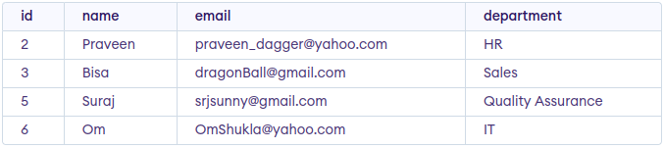
output
Example 3: Delete All of the Records
To remove all the entries from the table, you can use the following query:
Query:
DELETE FROM GFG_EMPLOyees;
Or
DELETE * FROM GFG_EMPLOyees;
Output:
All of the records in the table will be deleted, there are no records left to display. The table GFG_EMPLOyees will become empty.
Rolling Back DELETE Operations
Since the DELETE statement is a DML operation, it can be rolled back when executed in a statement. If you accidentally delete records or need to repeat the process, you can use the ROLLBACK command.
Query:
START TRANSACTION;
DELETE FROM GFG_Employees WHERE department = 'Development';
-- If needed, you can rollback the deletion
ROLLBACK;
Best Practices for Using SQL DELETE
- Use Transactions: Wrap DELETE statements in transactions to provide an option to roll back changes if necessary.
- Always Use a WHERE Clause: Avoid deleting all rows by accident. Always filter records using a WHERE clause to specify which rows to delete.
- Backup Data: Before performing large deletions, ensure that you have a backup of the data to avoid irreversible loss.
- Test on Development Server: Always test your DELETE queries on a development or staging environment to ensure they produce the desired result.
- Optimize Deletions: For large datasets, delete records in batches to reduce performance impact.

ALTER (RENAME) in SQL
In SQL, making structural changes to a database is often necessary. Whether it’s renaming a table or a column, adding new columns, or modifying data types, the SQL ALTER TABLE command plays a critical role. This command provides flexibility to manage and adjust database schemas without affecting the existing data.
What is the ALTER Command in SQL?
The structure of an existing table can be changed by users using the SQL ALTER TABLE command. If we need to rename a table, add a new column, or change the name of an existing column in SQL, the ALTER command is crucial for making schema changes without affecting the data that is already there. This is essential for tasks like:
- Renaming a table.
- Changing a column name.
- Adding or deleting columns.
- Modifying the data type of a column.
Syntax
1. Renaming a Table
ALTER TABLE table_name RENAME TO new_table_name;
2. Renaming a Column
ALTER TABLE table_name RENAME COLUMN old_column_name TO new_column_name;
3. Adding a New Column
ALTER TABLE table_name ADD column_name datatype;
4. Modifying a Column Data Type
ALTER TABLE table_name MODIFY COLUMN column_name new_datatype;
Examples of ALTER Command in SQL
Below are practical examples to help us understand how to use the ALTER command effectively in various scenarios. These examples includes renaming tables or columns, adding new columns, or changing column data types.
1. Create a Sample Table
First, let’s create a sample table to demonstrate the ALTER command:
CREATE TABLE Student (
id INT PRIMARY KEY,
name VARCHAR(50),
age INT,
email VARCHAR(50),
phone VARCHAR(20)
);
2. Insert Data into the Table
Let’s insert some data and then perform ALTER operation to understand better about alter command.
INSERT INTO Student (id, name, age, email, phone)
VALUES
(1, 'Amit', 20, 'amit@gmail.com', '9999999999'),
(2, 'Rahul', 22, 'rahul@yahoo.com', '8888888888'),
(3, 'Priya', 21, 'priya@hotmail.com', '7777777777'),
(4, 'Sonia', 23, 'sonia@gmail.com', '6666666666'),
(5, 'Kiran', 19, 'kiran@yahoo.com', '5555555555');
Output
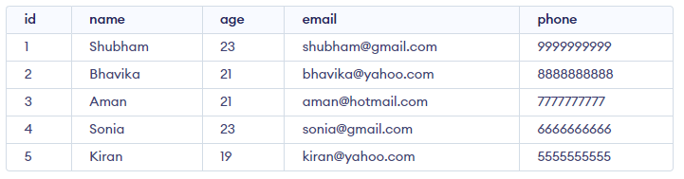
Student Table
Example 1: Rename a Column
Change the name of column name to FIRST_NAME in table Student. To change the column name of the existing table we have to use Column keyword before writing the existing column name to change
Syntax
ALTER TABLE Student RENAME COLUMN Column_NAME TO FIRST_NAME;
Query:
ALTER TABLE Student RENAME Column name TO FIRST_NAME;
Output
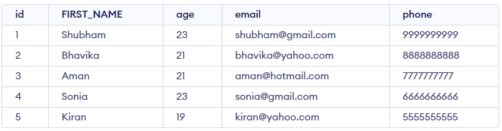
Output
Example 2: Rename a Table
In this example, the table name Student is changed to Student_Details using the ALTER TABLE command, making the name more descriptive and relevant to its content.
Query:
ALTER TABLE Student RENAME TO Student_Details;
Output
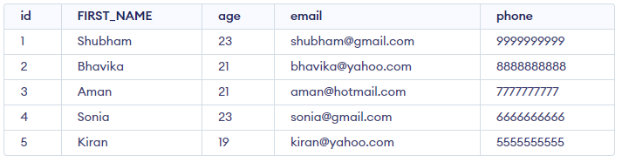
Student_Details table
Example 3: Add a New Column
To add a new column to the existing table, we first need to select the table with ALTER TABLE command table_name, and then we will write the name of the new column and its datatype with ADD column_name datatype. Let’s have a look below to understand better.
Syntax
ALTER TABLE table_name ADD column_name datatype;
Query:
ALTER TABLE Student ADD marks INT;
Output
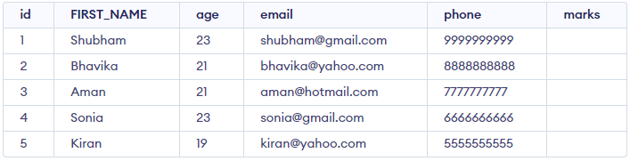
Output
5. Modify a Column Data Type
In the example, the phone column is updated from VARCHAR(20) to BIGINT to store numerical data more efficiently and ensure data integrity for phone numbers without unnecessary characters.
Syntax
ALTER TABLE table_name MODIFY COLUMN column_name new_datatype;
Query:
ALTER TABLE Student_Details MODIFY COLUMN phone BIGINT;
Output
id | name | age | email | phone
1 | Amit | 20 | amit@gmail.com | 9999999999
2 | Rahul | 22 | rahul@yahoo.com | 8888888888
3 | Priya | 21 | priya@hotmail.com | 7777777777
4 | Sonia | 23 | sonia@gmail.com | 6666666666
5 | Kiran | 19 | kiran@yahoo.com | 5555555555

Explanation:
- The phone column now has a BIGINT data type, suitable for storing large numeric values.
- Existing data remains unchanged but is stored as integers instead of strings.
Conclusion
The SQL ALTER TABLE command is an effective way to modify the structure of an already-existing tables in a database. When necessary, we can use ALTER TABLE to rename the entire table, rename a specific column in SQL, or change a column name to something more descriptive. This command is important for database administration since it also enables the addition of new columns and the modification of data types.
FAQs
How do you rename using ALTER in SQL?
You can rename a table or column in SQL using the ALTER command with the RENAME keyword. To rename a table:
ALTER TABLE old_table_name RENAME TO new_table_name;
To rename a column: ALTER TABLE table_name RENAME COLUMN old_column_name
TO new_column_name;
How do I rename a SQL name?
To rename a database object like a table, column, or index in SQL, use the ALTER statement. For tables: ALTER TABLE old_table_name RENAME TO new_table_name;
How do you rename items in SQL?
You can rename SQL items (tables, columns, etc.) using the ALTER statement. For instance, to rename a column: ALTER TABLE table_name RENAME COLUMN old_column TO new_column; Different databases (like MySQL, SQL Server, PostgreSQL) may have variations in syntax.

What is the SQL DROP Command?
In SQL, the DROP command is used to permanently remove an object from a database, such as a table, database, index, or view. When we DROP a table, both the data and the structure of the object are permanently removed from the database leaving no trace of the object.
Syntax:
DROP object object_name ;
Key Terms
- object: The type of object you want to drop (e.g., TABLE, DATABASE).
- object_name: The name of the object to be deleted.
DROP Command Examples
Let’s look at some examples of the DROP statement in SQL.
1. DROP Table
To delete an entire table, including its data and structure:
Syntax:
DROP TABLE table_name;
2. DROP database
To delete an entire database and all of its associated tables:
Syntax:
DROP DATABASE database_name;
What is SQL TRUNCATE Command?
The TRUNCATE command is a Data Definition Language (DDL) action that removes all rows from a table but preserves the structure of the table for future use. Although TRUNCATE is similar to the DELETE command (without the WHERE clause), it is much faster because it bypasses certain integrity constraints and locks. It was officially introduced in the SQL:2008 standard.
Syntax:
TRUNCATE TABLE table_name;
Key Terms
- table_name: Name of the table to be truncated.
- DATABASE name: student_data

Key Differences Between DROP and TRUNCATE
The key differences between DROP and TRUNCATE statements are explained in the following table:
Feature | DROP | TRUNCATE
Effect on Table Structure | Completely removes both the data and the table structure | Removes all rows but preserves the table structure
Data Deletion | Deletes both data and table definition | Deletes only the data, not the table structure
Recovery | Non-recoverable; once dropped, the table cannot be restored (unless you have backups) | Can be rolled back if used in a transaction (if supported by the DBMS)
Triggers | Does not activate triggers associated with the table | Does not activate DELETE triggers
Performance | Slower due to data and structural removal | Faster, especially for large datasets
Usage | Used when you want to completely remove a table or database | Used to quickly remove all rows from a table but keep the structure for future use

In this article, We will learn about the difference between DROP and TRUNCATE in SQL in detail.
DROP in SQL
- DROP is a DDL(Data Definition Language) command that is used to remove table definition and indexes, data, constraints, triggers etc for that table.
- Performance-wise the DROP command is quick to perform but slower than TRUNCATE because it gives rise to complications.
- Unlike DELETE we can’t rollback the data after using the DROP command. In the DROP command, table space is freed from memory because it permanently deletes the table as well as all its contents.
S.NO | DROP | TRUNCATE
1. | The DROP command is used to remove the table definition and its contents. | The TRUNCATE command is used to delete all the rows from the table.
2. | In the DROP command, table space is freed from memory. | The TRUNCATE command does not free the table space from memory.
3. | DROP is a DDL (Data Definition Language) command. | TRUNCATE is also a DDL (Data Definition Language) command.
4. | In the DROP command, the view of the table does not exist. | In the TRUNCATE command, the view of the table exists.
5. | In the DROP command, integrity constraints will be removed. | In the TRUNCATE command, integrity constraints will not be removed.
6. | In the DROP command, undo space is not used. | In the TRUNCATE command, undo space is used but less than DELETE.
7. | The DROP command is quick to perform but gives rise to complications. | The TRUNCATE command is faster than DROP.
Syntax of DROP command:
DROP TABLE table_name;
TRUNCATE in SQL
- TRUNCATE is a DDL(Data Definition Language) command. It is used to delete all the tuples from the table.
- Like the DROP command, the TRUNCATE command also does not contain a WHERE clause.
- The TRUNCATE command is faster than both the DROP and the DELETE command.
- Like the DROP command we also can’t rollback the data after using the this command.
Syntax of TRUNCATE command:
TRUNCATE TABLE table_name;

Difference Between DROP and TRUNCATE
Here’s the difference between the DROP and TRUNCATE commands in SQL in tabular format
What is the difference between DROP and TRUNCATE in SQL?
The DROP command removes a table and its structure from the database entirely, freeing up the space used by the table. The TRUNCATE command, on the other hand, deletes all rows from a table without removing the table structure, and it does not free up the space occupied by the table.
Can we rollback DROP?
No, the DROP command is not reversible. Once a table is dropped, it cannot be recovered, as this action permanently deletes the table structure and its data.
Can we rollback after TRUNCATE?
No, the TRUNCATE command cannot be rolled back in most databases because it is a DDL (Data Definition Language) operation. This command instantly deletes all rows in the table without generating individual row delete transactions, making it non-reversible. Does not remove integrity constraints associated with the table.
What is the difference between DROP and TRUNCATE in SQL?
DROP removes both the table and its data permanently from the database, while TRUNCATE only removes the data, keeping the table structure for future use.
What is TRUNCATE in SQL?
TRUNCATE removes all rows from a table without affecting the structure, making it faster than DELETE as it doesn’t log individual row deletions.

SQL Query to Create a Backup Table:
Backup tables are essential during complex data changes or migrations because they let us safely restore the original data if something goes wrong. Here are the key reasons why creating them is essential:
- Data Integrity: Protecting the original dataset from accidental loss or corruption.
- Disaster Recovery: Ensuring that the data can be restored in case of failure or errors during modifications.
- Safe Experimentation: Making changes to data without affecting the live dataset.
- Data Migration: Moving data from one system or table to another without losing original records.

How to Create Backup Tables in SQL
We can create a backup of a table by creating a duplicate or copy of original database. This is particularly useful for preserving the original table before performing updates, deletions, or other modifications. Below is a detailed explanation of the syntax and terms used for this operation.
Syntax
CREATE TABLE Table_Name AS SELECT * FROM Source_Table_Name;
Key Terms
- Table_Name: Specifies the name of the new backup table.
- AS: Acts as an alias, enabling the SQL query to copy data from the source table into the backup table.

1.Backup Table with All Columns and Data
In this example, we will create a backup table “stud_1” of “student_information” table by creating a copy of “student_information” table that duplicates all columns and their data..
Query:
CREATE TABLE stud_1 AS SELECT * FROM student_information;
SELECT * FROM stud_1;

2. SQL Backup Table with Specific Column Data Example
In this example, we create a backup table, “stud_2”, by copying only selected columns from the “student_information” table using a SELECT statement.
Query:
CREATE TABLE stud_2 AS SELECT id, student_name FROM student_information;
SELECT * FROM stud_2;
3. Backup Table Without Data
So, to create a table without any data being copied we can use the WHERE clause which needs to return a FALSE value. For example, we can use WHERE 2<2 or WHERE 1=2.
In this example, we will create a backup table “geeks_student” of “student_information” table by creating a copy of “student_information” table and copying its all columns without data.
Query:
CREATE TABLE geeks_student AS SELECT * FROM student_information
WHERE 1!=1;
SELECT * FROM geeks_student;
4. Backup Table with Specific Columns and No Data
In this example, we will create a backup table “geek_student” of“student_information” table by creating a copy of “student_information” table and copying specific columns without data.
Query:
CREATE TABLE specific_empty_backup AS
SELECT ID, Student_Name FROM student_information WHERE 1=2;
SELECT * FROM specific_empty_backup;

Limitations of CREATE TABLE AS SELECT
While convenient, CREATE TABLE AS SELECT has key limitations:
- Constraints Are Not Copied: Constraints such as PRIMARY KEY, FOREIGN KEY, UNIQUE, CHECK, and DEFAULT are not carried over to the new table.
- Indexes and Triggers Are Not Copied: Any indexes or triggers from the base table won’t transfer to the backup
- Manual Effort Required for Full Duplication: To fully replicate the original table structure including constraints and indexes, manual setup is necessary.

How to Create Backup Tables with Constraints
To copy the structure of a table along with its constraints, the CREATE TABLE AS SELECT statement is not sufficient. Instead, we need to define the table structure manually and then copy the data.

Example: Adding Constraints After Table Creation

1. Create a table without constraints:
CREATE TABLE student_backup AS SELECT * FROM student_information;

2. Add constraints to the backup table
ALTER TABLE student_backup ADD PRIMARY KEY (ID);

Example: Define Table with Constraints and Copy Data

3. Define the new table with constraints
CREATE TABLE student_backup (
ID INT PRIMARY KEY,
Age INT,
Student_Name VARCHAR(50),
Gender VARCHAR(10)
);

4. Copy data into the new table
INSERT INTO student_backup SELECT * FROM student_information;

1)How to make a backup table in SQL?
To create a backup table in SQL, use the CREATE TABLE statement with a SELECT * query to copy the contents of the original table into a new one:
CREATE TABLE backup_table AS SELECT * FROM original_table;
2)How to create SQL backup?
In SQL, creating a backup involves using the database management system’s specific tools, such as mysqldump for MySQL, or pg_dump for PostgreSQL. These tools generate a dump file of the database or table:
mysqldump -u username -p database_name > backup.sql
3)How do I save a created table in SQL?
To save a created table, simply use the CREATE TABLE statement to define its structure and data, then execute the query. SQL databases automatically save the table when the statement is committed.
CREATE TABLE table_name (column1 datatype, column2 datatype,.);

What Are Temporary Tables in SQL?
A temporary table in SQL is a special type of table that is created and stored in the system’s temporary database (such as TempDB in SQL Server). This table is primarily used to store and generate important mediation results when executing a query, stored procedure, or session.
Temporary tables are automatically deleted when the session or transaction that created them ends, making them perfect for temporary or intermediate data storage. They are particularly useful in situations where you need to perform calculations or data transformations without changing the permanent database structure.
To Create a Temporary Table
CREATE TABLE #EmpDetails (id INT, name VARCHAR(25))
To Insert Values Into Temporary Table
INSERT INTO #EmpDetails VALUES (01, 'Lalit'), (02, 'Atharva')
To Select Values from the Temporary Table
SELECT * FROM #EmpDetails
Types of Temporary Tables in SQL
There are 2 types of Temporary Tables:
1)Local Temporary Table
2)Global Temporary Table.
1)Local Temporary Table
A Local Temp Table is available only for the session that has created it. It is automatically dropped (deleted) when the connection that has created it, is closed. To create Local Temporary Table Single “#” is used as the prefix of a table name. Also, the user can drop this temporary table by using the “DROP TABLE #EmpDetails” query. There will be Random Numbers are appended to the Name of Table Name. If the Temporary Table is created inside the stored procedure, it get dropped automatically upon the completion of stored procedure execution.
Example:
CREATE PROCEDURE ProcTemp
AS
BEGIN
CREATE TABLE #EmpDetails
INSERT INTO #EmpDetails VALUES ( 01, 'Lalit'), ( 02, 'Atharva')
SELECT * FROM #EmpDetails
END
EXECUTE ProcTemp
Global Temporary Table: To create a Global Temporary Table, add the “##” symbol before the table name.
Example:
CREATE TABLE ##EmpDetails (id INT, name VARCHAR(25))
Global Temporary Tables are visible to all connections and Dropped when the last connection referencing the table is closed. Global Table Name must have an Unique Table Name. There will be no random Numbers suffixed at the end of the Table Name.
Differences Between Local and Global Temporary Tables
Feature | Local Temporary Table | Global Temporary Table
Prefix | # (Single hash) | ## (Double hash)
Scope | Only the session that created it | Available to all sessions
Lifetime | Automatically dropped when the session ends | Dropped when the last connection referencing the table ends
Accessibility | Only the creating session can access it | All sessions can access it
Usage | Session-specific data storage | Shared temporary data storage for multiple sessions
🔹 Types of Temporary Tables:
- Local Temporary Table (#table_name)
- Global Temporary Table (##table_name)

🔸 1. Local Temporary Table
- Prefix with a single # (e.g., #TempTable)
- Visible only to the session that created it
- Automatically dropped when the session ends
Example:
CREATE TABLE #TempTable (
ID INT,
Name VARCHAR(100)
);
INSERT INTO #TempTable VALUES (1, 'Alice'), (2, 'Bob');
SELECT * FROM #TempTable;

🔸 2. Global Temporary Table
- Prefix with ## (e.g., ##GlobalTemp)
- Visible to all sessions
- Dropped when the last session using it ends
Example:
CREATE TABLE ##GlobalTemp (
ID INT,
City VARCHAR(50)
);
INSERT INTO ##GlobalTemp VALUES (1, 'Pune'), (2, 'Mumbai');
SELECT * FROM ##GlobalTemp;

🔸 Features of Temporary Tables:
- Stored in the tempdb system database.
- Can have indexes, constraints, etc.
- Useful in stored procedures, complex queries, ETL processes, etc.

🔹 Temporary Table vs Table Variable (in SQL Server):
Feature | Temporary Table | Table Variable
Scope | Session | Batch or procedure
Transaction Support | Yes | Limited
Indexes | Allowed | Limited support
Statistics | Maintained | Not maintained

🔹 When to Use Temporary Tables:
- When you need to break complex queries into steps
- To store intermediate results
- When working with large data sets
- In stored procedures to improve performance

SQL ALTER TABLE STATEMENT
The ALTER TABLE statement in SQL is used to modify an existing table structure in a database without losing any data. It allows you to add, remove, or modify columns, change data types, or apply constraints to improve data integrity and ensure that the table meets evolving business requirements. It allows for structural changes like adding new columns, modifying existing ones, deleting columns, and renaming columns within a table. To alter/modify the table use the ALTER TABLE syntax:
Syntax:
ALTER TABLE table_name[ADD | DROP | MODIFY] column_name datatype;
Key Terms
- table_name refers to the name of the table you want to modify.
- ADD is used to add a new column.
- DROP is used to remove an existing column.
- MODIFY is used to change the datatype or definition of an existing column.
Common Use Cases for SQL ALTER TABLE
1. ADD – To add a new column to the table
The ADD clause is used to add a new column to an existing table. You must specify the name of the new column and its data type.
Query:
ALTER TABLE table_name ADD column_name datatype;
2. MODIFY/ALTER – To change the data type of an existing column
The MODIFY (or ALTER COLUMN in some databases like SQL Server) clause is used to modify the definition of an existing column, such as changing its data type or size.
Query:
ALTER TABLE table_name MODIFY COLUMN column_name datatype;
3. DROP – To delete an existing column from the table
The DROP clause allows you to remove a column from a table. Be cautious when using this command as it will permanently remove the column and its data.
Query:
ALTER TABLE table_name DROP COLUMN column_name;
4. RENAME COLUMN – To rename an existing column
We can rename an existing column using the RENAME COLUMN clause. This allows you to change the name of a column while preserving its data type and content.
Query:
ALTER TABLE table_name RENAME COLUMN old_name TO new_name;
5. RENAME TO – To rename the table itself
We can rename an entire table using the RENAME TO clause. This changes the name of the table while preserving its structure and data.
ALTER TABLE table_name RENAME TO new_table_name;
SQL ALTER TABLE Examples
Below are various examples demonstrating different use cases of the ALTER TABLE statement in SQL. These examples showcase how to add, modify, drop, and rename columns or tables, providing a clear understanding of the flexibility and utility of the ALTER TABLE statement.
1. Adding a New Column to a Table
To add a new column to an existing table, you can use the ADD clause. Here’s an example where we add a column named email to the employee table:
ALTER TABLE Students ADD Email varchar(255);
2. Removing a Column from a Table
We can remove an existing column from a table using the DROP COLUMN clause. Here’s an example where we remove the phone_number column from the employee table:
ALTER TABLE Students DROP COLUMN Email;
3. Modifying an Existing Column’s Data Type
To change the data type or size of an existing column, you can use the MODIFY clause. For instance, if you want to change the data type of the salary column from INT to DECIMAL, you can use:
ALTER TABLE table_name MODIFY COLUMN column_name datatype;
SQL ALTER TABLE Queries
Let’s explore the ALTER TABLE queries using a Student table with columns ROLL_NO and NAME, and demonstrate various modifications such as adding, modifying, and dropping columns. Here’s how you can execute these operations:
ROLL_NO | NAME
1 | Ram
2 | Abhi
3 | Rahul
4 | Tanu
1. Add Columns (AGE and COURSE) to the Student Table
To add new columns AGE and COURSE to the Student table, you can use the ALTER TABLE statement with the ADD clause.
Query:
ALTER TABLE Student ADD (AGE number(3),COURSE varchar(40));

Output:
ROLL_NO | NAME
1 | Ram
2 | Abhi
3 | Rahul
4 | Tanu
Explanation: This adds the AGE column with a numeric data type and the COURSE column with a VARCHAR(40) type. The columns are added to the table, but the values are empty initially.
2. Modify Column COURSE to Reduce its Size
If you want to reduce the size of the COURSE column from VARCHAR(40) to VARCHAR(20), you can modify the column’s data type using the MODIFY clause.
Query:
ALTER TABLE Student MODIFY COURSE varchar(20);
Explanation: After running the above query, the COURSE column’s data type will now allow a maximum of 20 characters instead of 40. This modifies the column’s size limit.
3. Drop the COURSE Column from the Student Table
To remove the COURSE column completely from the Student table, you can use the DROP COLUMN clause.
Query:
ALTER TABLE Student DROP COLUMN COURSE;

Output:
ROLL_NO | NAME
1 | Ram
2 | Abhi
3 | Rahul
4 | Tanu
Explanation: After executing this query, the COURSE column is permanently removed from the table, leaving just the ROLL_NO, NAME, and AGE columns.
SELECT Statement in SQL
The SELECT statement in SQL is used to fetch or retrieve data from a database. It allows users to access the data and retrieve specific data based on specific conditions.
We can fetch either the entire table or according to some specified rules. The data returned is stored in a result table. With the SELECT clause of a SELECT command statement, we specify the columns that we want to be displayed in the query result
Syntax:
The syntax for the SELECT statement is:
SELECT column1,column2…. FROM table_name ;

SELECT Statement Example
CREATE TABLE:
CREATE TABLE Customer(
CustomerID INT PRIMARY KEY,
CustomerName VARCHAR(50),
LastName VARCHAR(50),
Country VARCHAR(50),
Age int(2),
Phone int(10)
);
-- Insert some sample data into the Customers table
INSERT INTO Customer (CustomerID, CustomerName, LastName, Country, Age, Phone)
VALUES (1, 'Shubham', 'Thakur', 'India','23','xxxxxxxxxx'),
(2, 'Aman ', 'Chopra', 'Australia','21','xxxxxxxxxx'),
(3, 'Naveen', 'Tulasi', 'Sri lanka','24','xxxxxxxxxx'),
(4, 'Aditya', 'Arpan', 'Austria','21','xxxxxxxxxx'),
(5, 'Nishant. Salchichas S.A.', 'Jain', 'Spain','22','xxxxxxxxxx');
Example 1: Retrieve Data using SELECT Query
In this example, we will fetch CustomerName, LastName from the table Customer:
Query:
SELECT CustomerName, LastName FROM Customer;
Output:
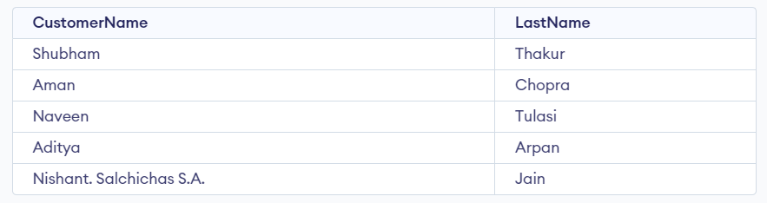
Example 2: Fetch All Table using SELECT Statement
In this example, we will fetch all the fields from the table Customer:
Query:
SELECT * FROM Customer;
Output:
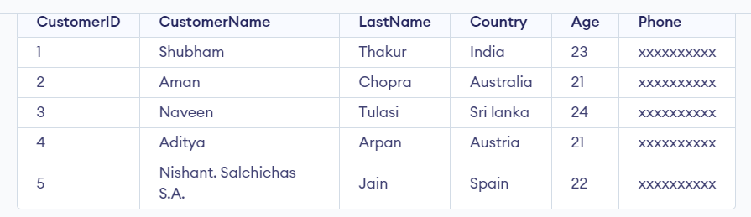
Example 3: SELECT Statement with WHERE Clause
Suppose we want to see table values with specific conditions then WHERE Clause is used with select statement.
Query:
SELECT CustomerName FROM Customer where Age = '21';
Output:
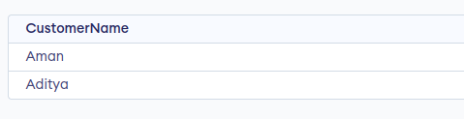
Example 4: SQL SELECT Statement with GROUP BY Clause
In this example, we will use SELECT statement with GROUP BY Clause
Query:
SELECT COUNT (item), Customer_id FROM Orders GROUP BY order_id;
Output:
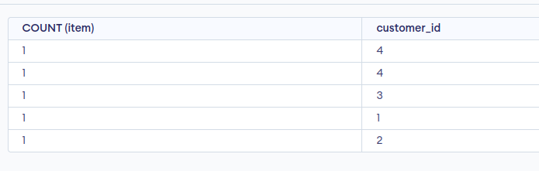
Example 5: SELECT Statement with HAVING Clause
Consider the following database for HAVING Clause:
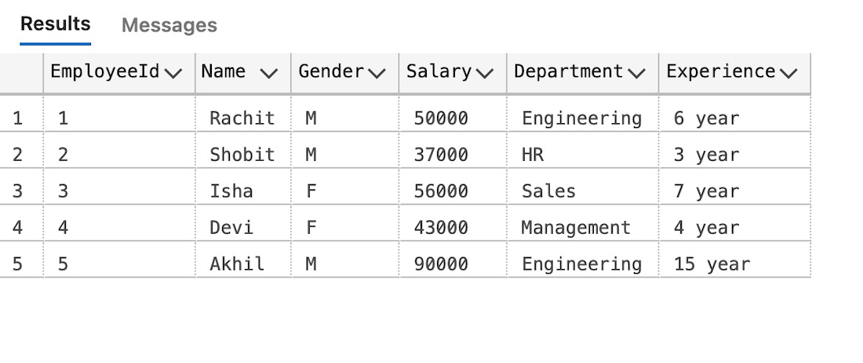

Query:
SELECT Department, sum(Salary) as Salary
FROM employee
GROUP BY department
HAVING SUM(Salary) >= 50000;
Output:
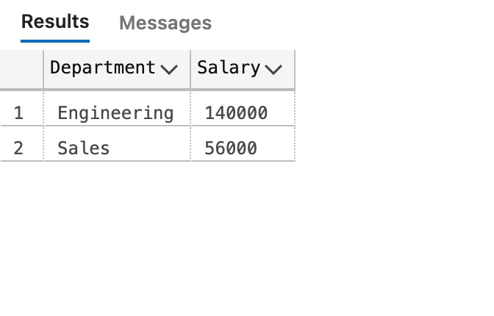
Example 6: SELECT Statement with ORDER BY clause in SQL
In this example, we will use SELECT Statement with ORDER BY clause
Query:
SELECT * FROM Customer ORDER BY Age DESC;
Output:
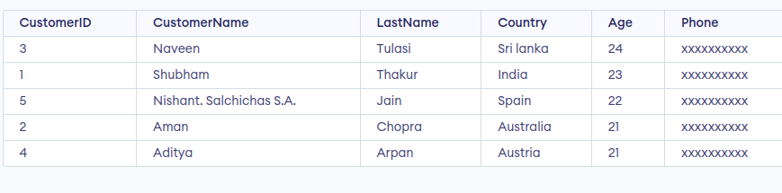
Important Points with SQL SELECT Statement
- It is used to access records from one or more database tables and views.
- The SELECT statement retrieves selected data based on specified conditions.
- The result of a SELECT statement is stored in a result set or result table.
- The SELECT statement can be used to access specific columns or all columns from a table.
- It can be combined with clauses like WHERE, GROUP BY, HAVING, and ORDER BY for more refined data retrieval.
- The SELECT statement is versatile and allows users to fetch data based on various criteria efficiently.

SQL TOP, LIMIT, FETCH FIRST Clause(as part of OFFSET-FETCH).
SQL TOP, LIMIT, and FETCH FIRST clauses are used to retrieve a specific number of records from a table. These clauses are especially useful in large datasets with thousands of records.
When working with large data sets in SQL, limiting the number of rows returned by a query can improve performance and make the data more manageable. The SQL SELECT TOP, LIMIT, and FETCH FIRST statements accomplish this purpose by limiting the result set to a specified number of row groups.
SQL SELECT TOP Clause
The SELECT TOP clause in SQL only returns the specified number of rows from the table. It is valuable on enormous tables with a large number of records. Returning countless records can affect execution.
Note: Not all database systems support the SELECT TOP clause.
Syntax:
SELECT column1, column2, … TOP count
FROM table_name
[WHERE conditions]
[ORDER BY expression [ ASC | DESC ]];
Here,
- column1, column2 = names of columns
- count = number of records to be fetched
- WHERE conditions: Optional. Filters the data based on conditions.
- ORDER BY expression: Optional. Sorts the result set in ascending or descending order.

SQL SELECT TOP Clause Example
Let’s understand this using an example of SQL SELECT TOP statement.
We will use the following table for this example:
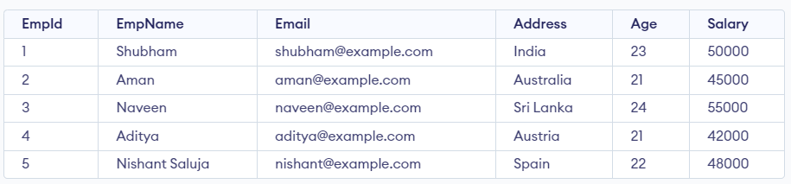
Demo SQL Table
Write the following SQL queries to create this table
CREATE TABLE Employee (
EmpId INTEGER PRIMARY KEY,
EmpName VARCHAR(225) NOT NULL,
Email VARCHAR(225) NOT NULL,
Address VARCHAR(225) NOT NULL,
Age INT NOT NULL,
Salary MONEY NOT NULL
);
INSERT INTO Employee (EmpId, EmpName, Email, Address, Age, Salary)
VALUES (1, 'Shubham', 'shubham@example.com', 'India', 23, 50000.00),
(2, 'Aman', 'aman@example.com', 'Australia', 21, 45000.00),
(3, 'Naveen', 'naveen@example.com', 'Sri Lanka', 24, 55000.00),
(4, 'Aditya', 'aditya@example.com', 'Austria', 21, 42000.00),
(5, 'Nishant Saluja', 'nishant@example.com', 'Spain', 22, 48000.00);

Example 1: Using SELECT TOP Clause in SQL
In this example, we will fetch the top 4 rows from the table.
Query:
SELECT TOP 4*
FROM Employee;
Output:
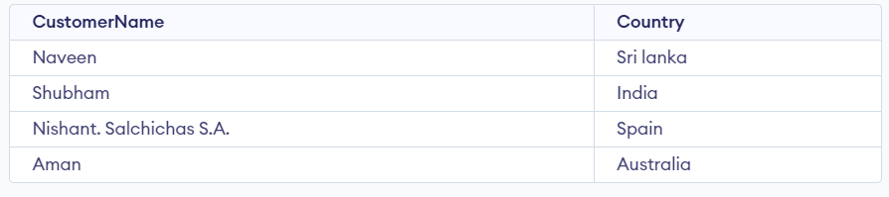
SELECT TOP Clause Output

Example 2: SQL SELECT TOP with ORDER BY Clause
In this example, we will use the SQL SELECT TOP clause with ORDER BY clause to sort the data in the results set.
Query
SELECT TOP 4*
FROM Employee
ORDER BY Salary DESC;
Output:
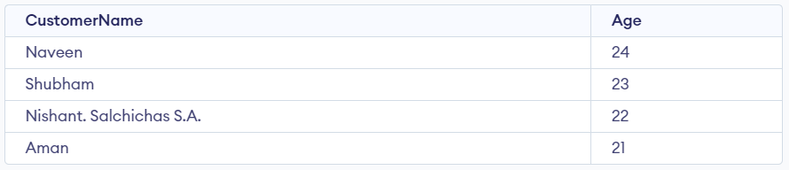
SQL SELECT TOP with ORDER BY Clause Example Output
Example 3: SQL SELECT TOP Clause with WHERE Clause Example
In this example, we will use the SELECT TOP clause with WHERE clause to filter data on specific conditions
Query:
SELECT TOP 2* FROM Employee
WHERE Salary>2000
ORDER BY Salary;
Output:
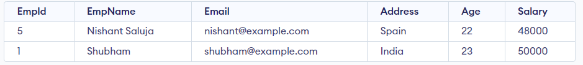
The above query will select all the employees according to the given condition (i.e. all Employees except the employee whose salary is less than 2000 will be selected) then the result will be sorted by Salary in ascending order (The ORDER BY keyword sorts the records in ascending order by default). Finally, the first 2 rows would be returned by the above query.

Example 4: SQL SELECT TOP PERCENT Clause Example
The PERCENT keyword is utilized to select the primary and percent of all-out rows. For example,
Query:
SELECT TOP 50 PERCENT*
FROM Employee;
Output:
SQL SELECT TOP PERCENT Clause Example Output
Here, the above query will select the first 50% of employee records out of the total number of records(i.e., the first 3 rows will be returned).
Example 5: SQL TOP PERCENT with WHERE Clause Example
We can also include some situations using the TOP PERCENT with the WHERE clause in the above query.
Query:
SELECT TOP 50 PERCENT*
FROM Employee
WHERE Salary<50000;
Output:
SQL TOP PERCENT with WHERE Clause Example Output
The above query will select the Top 50% of the records out of the total number of records from the table according to the given condition such that it returns only the Top 50% of the records with the employee whose salary is less than 5000 (i.e, 2 rows will be returned)

SQL LIMIT Clause limits the number of results returned in the results set. The LIMIT Clause is utilized with the accompanying database systems:
- MySQL
- PostgreSQL
- SQLite

SQL LIMIT Clause Example
Since the LIMIT Clause is not supported in SQL Server we need to create a table in MySQL/PostgreSQL/SQLite. We will use the LIMIT clause in MySQL
CREATE TABLE Employee (
EmpId INTEGER PRIMARY KEY,
EmpName VARCHAR(225) NOT NULL,
Email VARCHAR(225) NOT NULL,
Address VARCHAR(225) NOT NULL,
Age INT NOT NULL,
Salary INT NOT NULL
);

INSERT INTO Employee (EmpId, EmpName, Email, Address, Age, Salary)
VALUES (1, 'Shubham', 'shubham@example.com', 'India', 23, 50000.00),
(2, 'Aman', 'aman@example.com', 'Australia', 21, 45000.00),
(3, 'Naveen', 'naveen@example.com', 'Sri Lanka', 24, 55000.00),
(4, 'Aditya', 'aditya@example.com', 'Austria', 21, 42000.00),
(5, 'Nishant Saluja', 'nishant@example.com', 'Spain', 22, 48000.00);

SELECT * FROM Employee ;
Output:
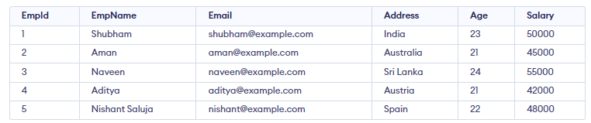
Demo Table Created

Example 1: SELECT LIMIT Clause in SQL
Query: SELECT * FROM Employee LIMIT 2;
Output:
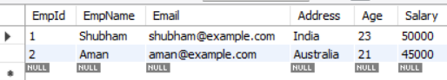
LIMIT Clause in SQL Example Ouptut
Example 2: SQL LIMIT with WHERE Clause
The accompanying query selects the initial 4 records from the Employee table with a given condition.
Query:
SELECT * FROM Employee WHERE Salary = 45000 LIMIT 2;
Output:
SQL LIMIT with WHERE Clause Example Output
The above query will select all the employees according to the imposed condition (i.e. it selects the limited 2 records from the table where salary is 2000). Finally, the first 2 rows would be returned by the above query.
Example 3: SQL LIMIT With OFFSET Clause
The OFFSET keyword is utilized to indicate beginning rows from where to select rows. For instance, the OFFSET clause is used to skip a number of rows before starting to return rows from the query
Query:
SELECT * FROM Employee LIMIT 2 OFFSET 2;
Output:
SQL LIMIT With OFFSET Clause Example Output
Here, the above query selects 2 rows from the beginning of the third row (i.e., OFFSET 2 means, the initial 2 rows are excluded or avoided).

SQL FETCH FIRST Clause
SQL FETCH FIRST clause fetches the first given number of rows from the table.
It is supported in database systems like:
- IBM DB2
- Oracle
- PostgreSQL
Syntax:
The syntax to use the FETCH FIRST clause in SQL is:
SELECT columns FROM table WHERE condition FETCH FIRST n ROWS ONLY;
Here, n: desired number of rows
Example 1: SQL FETCH FIRST Clause
We will use the same “Employee” table as used in previous examples.
FETCH FIRST clause in SQL Example
In this example, we will fetch the first 3 rows from the table.
Query:
SELECT * FROM Employee FETCH FIRST 3 ROWS ONLY;
Output:
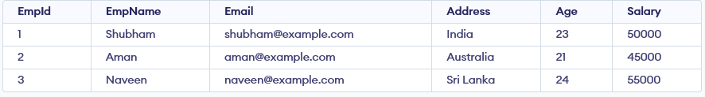
FETCH FIRST Clause in SQL Example Output
Here, the above query will fetch the first 3 rows only from the table. We can also include some situations using the FETCH FIRST PERCENT and WHERE Clause in the above query.
Example 2: SQL FETCH FIRST PERCENT
In this example, we will fetch first 50% of the data from the table
Query:
SELECT * FROM Employee FETCH FIRST (SELECT CEIL(COUNT(*) / 2) FROM Employee) ROWS ONLY;
Output:
SQL FETCH FIRST PERCENT Example Output
Here, the above query fetches the first 50% of the total number of rows (i.e., 2 rows) from the table.
Example 3: SQL FETCH FIRST with WHERE Clause
The “FETCH FIRST” syntax is not supported in MySQL. The correct syntax for limiting the number of rows in MySQL is by using the LIMIT clause.
Query:
SELECT *FROM Employee WHERE Salary = 45000 FETCH FIRST 1 ROW ONLY;
Output:
SQL FETCH FIRST with WHERE CLAUSE Example Output

SELECT FIRST in SQL
In SQL, the SELECT FIRST clause is used to fetch the first row or record from a table or result set. This operation can be useful when you want to retrieve a single, specific entry, such as the first record of a list, or when you need to implement certain functionalities in applications like employee management systems, inventory systems, or billing systems.
Note: The SELECT FIRST clause is not universally supported across all SQL platforms. Some variations of the FIRST clause in other databases are LIMIT, TOP, or FETCH FIRST.
Syntax:
The syntax to use the SELECT FIRST clause in SQL is:
SELECT FIRST (columnName) FROM tableName;
Example of SQL SELECT FIRST
Example: Retrieve the First Record from a Table
In this example, we will select the first name for the table “stationary”.
Name | Price | Quantity
Pen | 1.5 | 100
Pencil | 1.0 | 150
Notebook | 3.0 | 200
SELECT FIRST (Name) AS First_name FROM Stationary;
Example: Using SELECT FIRST with ORDER BY
We can use the SELECT FIRST clause in conjunction with the ORDER BY clause to sort the records before fetching the first record.
SELECT FIRST(Name) AS First_name
FROM Stationary
ORDER BY Price ASC;
Important Points About SQL SELECT FIRST
- The SELECT FIRST command in SQL is used to retrieve only the top row from a table.
- SELECT FIRST can be beneficial for various purposes like login-related functions on websites or implementing billing systems.
- The SELECT FIRST clause is not universally supported across all SQL systems. It is primarily used in MS Access.
- It can used with other clauses like ORDER BY.

SQL – SELECT LAST
Retrieving the last record is a common requirement in many applications. Whether you’re dealing with log files, e-commerce transactions, or tracking user activity, you generally need the ability to query the latest data from a table. Since SELECT LAST() is not universally supported, we need to use other approaches to extract the last record efficiently.
CREATE TABLE Student_Information (
ID INT PRIMARY KEY,
Age INT,
Student_Name VARCHAR(50),
Sex VARCHAR(10)
);
-- Inserting sample records
INSERT INTO Student_Information (ID, Age, Student_Name, Sex)
VALUES (1, 22, 'Harry', 'Male');
INSERT INTO Student_Information (ID, Age, Student_Name, Sex)
VALUES (2, 23, 'Vishal', 'Male');
INSERT INTO Student_Information (ID, Age, Student_Name, Sex)
VALUES (3, 20, 'Snehal', 'Female');
INSERT INTO Student_Information (ID, Age, Student_Name, Sex)
VALUES (4, 25, 'Ram', 'Male');
INSERT INTO Student_Information (ID, Age, Student_Name, Sex)
VALUES (5, 24, 'Hina', 'Female');
Method 2: By Sorting the Data
We can use the ORDER BY statement and LIMIT clause to extract the last data. The basic idea is to sort the sort the table in descending order and then we will limit the number of rows to 1. In this way, we will get the output as the last row of the table. And then we can select the entry which we want to retrieve.
MYSQL syntax :
SELECT col_name(s) FROM Table_Name
ORDER BY appr_col_name DESC
LIMIT 1;
Example:
SELECT id FROM Student_Information1
ORDER BY age DESC
LIMIT 3;
col_name(s): The name of the column(s).
appr_col_name: Appropriate column name to perform ORDER BY.
Method 3: By using Subquery and AGGREGATE MAX()
Subquery is nothing but a query inside another query that maintains a parent-child relationship. The inner query will execute first followed by the outer query. Here, in this method, the basic idea is to get the maximum ID using aggregate function MAX and then select the student name associated with that maximum ID. In this way, we can extract the last student’s name from the table.

SELECT col_name(s) FROM Table_Name
WHERE appr_col_name = (
SELECT MAX(appr_col_name)
FROM Table_Name
);
Example:
SELECT * FROM Student_Information1
WHERE age= (
SELECT MAX(age)
FROM Student_Information1
);
col_name(s): The name of the column(s).
appr_col_name: Appropriate column name. For example ID.
Method 4: By Comparative or Relative Approach
In this method also, we are going to use a subquery. The basic idea is to filter out the rows and to check that no such row exists having higher ID values than the row we are going to extract. This will help in getting the row with maximum ID and hence we can retrieve the last information. It is a complex query and is an iterative approach in which we are going to use the NOT EXISTS statement. This method will take more time to execute if there are more records in the table.
SELECT col_name(s) FROM Table_Name t1
WHERE NOT EXISTS(
SELECT * FROM Table_Name t2
WHERE t2.appr_col_name > t1.appr_col_name
);

SELECT age FROM Student_Information1 as t1
WHERE NOT EXISTS(
SELECT * FROM Student_Information1 as t2
WHERE t2.age > t1.age
);
col_name(s): The name of the column(s).
appr_col_name: Appropriate column name. For example ID.
What is RANDOM() in SQL?
The RANDOM() function is used to generate random values and can be applied to return random rows or records from a table in SQL. It has many real-life applications. Some common use cases include:
- There are a lot of employees in an organization. Suppose, if the event manager wants to mail any ten random employees then he/she can use the RANDOM( ) in SQL to get the Email Id of the ten random employees.
- It can also be used to display random questions during an online exam or MCQ from a pool of questions.

Example 1: Using RAND() in MySQL
SELECT col_1,col_2, ... FROM Table_Name ORDER BY RAND()

col_1 : Column 1
col_2 : Column 2
The above query will return the entire table for the specific columns mentioned and the rows will be random and changing position every time we run the query. To get a single row randomly, we can use the LIMIT Clause and set to only one row. ORDER BY clause in the query is used to order the row(s) randomly.

SELECT col_1,col_2, ... FROM Table_Name ORDER BY RAND() LIMIT 1
What is the SQL SELECT IN Statement?
SQL SELECT IN Statement allows to specify multiple values in the WHERE clause. It is similar to using multiple OR conditions. It is particularly useful for filtering records based on a list of values or the results of a subquery. This makes it useful for checking whether a value belongs to a predefined set, simplifying queries that would otherwise require multiple OR conditions.
Syntax 1: SELECT IN for a list of values
Using the IN operator to provide a list of values:
SELECT column1, column2, ..., column FROM table_name
WHERE column_name IN (val-1, val-2, ..., val-N);
Parameters:
- column1, column2, …, columnN: The columns you want to retrieve.
- table_name: The table from which to retrieve the columns.
- column_name: The column you want to filter.
- val-1, val-2, …, val-N: The list of values you want to match.
Syntax 2: SELECT IN with a Subquery
Using the IN operator on values returned by another subquery:
SELECT column1, column2....columnN FROM table_name1
WHERE column_name IN (SELECT column_name FROM table_name2);
Parameters:
- table_name1: The primary table from which to retrieve the columns.
- table_name2: The secondary table used in the subquery to provide the list of values.

Example 1: Using SELECT IN with a List of Values
In this example, we will use SELECT IN statement on a list of values in WHERE Clause.
SELECT * FROM STUDENT WHERE course_id IN (1, 2, 3);
Example 2: SELECT IN with a Sub-query
In this example, we will use SELECT IN to provide a subquery to WHERE clause.
SELECT * FROM STUDENT WHERE course_id
IN (SELECT course_id FROM COURSE WHERE duration_of_course = 3);
Important Points about SQL SELECT IN Statement
- The SQL SELECT IN statement allows you to specify multiple values in the WHERE clause.
- The IN operator is functionally similar to using multiple OR conditions.
For example:, WHERE column_name IN (val-1, val-2, ..., val-N) is equivalent to
WHERE column_name = val-1 OR column_name = val-2 OR ... OR column_name = val-N.
- The IN operator can be used with both static lists of values and subqueries.

SQL SELECT DATE
In SQL, date and time values are stored in DATE, DATETIME, TIME, TIMESTAMP, and YEAR data types, depending on your use case and the database system you’re using. To retrieve these values, we use the SELECT statement.
Syntax:
SELECT column_name FROM table_name
WHERE date_column = ‘YYYY-MM-DD’;
- column_name: The column from which you want to retrieve the data.
- table_name: The table where the date column resides.
- date_column: The column that contains date values.
- ‘YYYY-MM-DD’: The date format used to filter the records.

Example of SQL SELECT DATE
Let’s create an Employee table with a column hire_date of type DATE, which stores the hiring date of employees.
CREATE TABLE Employee (
EmpID INT,
FirstName VARCHAR(255),
LastName VARCHAR(255),
HireDate DATE
);
INSERT INTO Employee (EmpID, FirstName, LastName, HireDate)
VALUES
(1, 'John', 'Doe', '2022-01-15'),
(2, 'Jane', 'Smith', '2021-06-30'),
(3, 'Alice', 'Johnson', '2020-08-25');
Example: Select Employees Hired on a Specific Date
SELECT FirstName, LastName, HireDate
FROM Employee WHERE HireDate = '2022-01-15';
--Example of SQL SELECT DATE
-- Let’s create an Employee table with a column hire_date of type DATE, which stores the hiring date of employees.
CREATE TABLE Employee1 (
EmpID INT,
FirstName VARCHAR(255),
LastName VARCHAR(255),
HireDate DATE
);

INSERT INTO Employee1 (EmpID, FirstName, LastName, HireDate)
VALUES (1, 'John', 'Doe', '2022-01-15'),(2, 'Jane', 'Smith', '2021-06-30'),
(3, 'Alice', 'Johnson', '2020-08-25');
select * from employee1;
-- Example: Select Employees Hired on a Specific Date
SELECT FirstName, LastName, HireDate
FROM Employee1 WHERE HireDate = '2022-01-15';
-- This SQL query retrieves the FirstName, LastName, and HireDate of the employee who was hired on 2022-01-15.
-- Using SQL SELECT Date Functions for Filtering
-- These SQL functions allow you to extract specific components (like year, month, or day) from a DATE or DATETIME column.
-- YEAR(): Extracts the year from a date.
-- MONTH(): Extracts the month from a date.
-- DAY(): Extracts the day from a date.
Example 1: Select Employees Hired in a Specific Year
SELECT FirstName, LastName, HireDate FROM Employee1
WHERE YEAR(HireDate) = 2021;
Example 2: Select Employees Hired in a Specific Month
SELECT FirstName, LastName, HireDate
FROM Employee1 WHERE MONTH(HireDate) = 6;

Advanced Date Functions
-- CURDATE() and NOW()
-- CURDATE(): Returns the current date (without the time component).
-- NOW(): Returns the current date and time.
-- Example 1: Select Employees Hired Before Today
SELECT FirstName, LastName, HireDate
FROM Employee1 WHERE HireDate < CURDATE();
Using SQL BETWEEN for Date Ranges
-- The BETWEEN operator allows you to filter records within a specified date range.
-- This can be useful when you need to retrieve data between two specific dates,
-- such as all transactions made within a certain period or all employees hired during a specific quarter.
-- Example 1: Select Employees Hired Between Two Dates
SELECT FirstName, LastName, HireDate
FROM Employee1 WHERE HireDate BETWEEN '2021-01-01' AND '2022-01-01';
select * from employee1;

SQL Query to Insert Multiple Rows:
Insertion in a table is a DML (Data manipulation language) operation in SQL. When we want to store data we need to insert the data into the database. We use the INSERT statement to insert the data into the database.
Inserting multiple rows can be done in several ways. The most common methods include using a simple INSERT statement with multiple value sets, utilizing the INSERT INTO … SELECT syntax, and using transactions for batch inserts. Before we dive into these techniques, let’s first create a sample table structure to work with.
Creating a Table: Create a table employee_details with 4 columns using the following SQL query:
Query:
CREATE TABLE Employees (
EmployeeID INT PRIMARY KEY,
EmployeeName VARCHAR(100),
Age INT,
Department VARCHAR(50)
);
Basic INSERT for Multiple Rows
The simplest method to insert multiple rows is by using a single INSERT INTO statement followed by multiple sets of values. This approach allows you to insert multiple records in one go, improving efficiency.
Query:
INSERT INTO Employees (EmployeeID, EmployeeName, Age, Department)
VALUES
(1, 'John Doe', 30, 'Engineering'),
(2, 'Jane Smith', 28, 'Marketing'),
(3, 'Sam Brown', 35, 'Sales'),
(4, 'Lucy Green', 25, 'Human Resources');
Using INSERT INTO … SELECT for Inserting Multiple Rows
The INSERT INTO … SELECT method is useful when you need to insert multiple rows into a table based on the results of another query or a different table. This method is often used for transferring data between tables or inserting derived data into a target table.
NewEmployees table
CREATE TABLE NewEmployees (
EmployeeID INT PRIMARY KEY,
EmployeeName VARCHAR(100),
Age INT,
Department VARCHAR(50)
);
INSERT INTO NewEmployees (EmployeeID, EmployeeName, Age, Department)
VALUES
(5, 'Alice Johnson', 29, 'HR'),
(6, 'Bob Martin', 32, 'Finance'),
(7, 'Charlie Baker', 28, 'Marketing'),
(8, 'David Lee', 40, 'Engineering'),
(9, 'Eva Davis', 22, 'Sales');

In this example, the INSERT INTO … SELECT statement copies data from the NewEmployees table to the Employees table, but only inserts those records where the employee’s age is greater than 30.
Query:
INSERT INTO Employees (EmployeeID, EmployeeName, Age, Department)
SELECT EmployeeID, EmployeeName, Age, Department
FROM NewEmployees WHERE Age > 30;
What is an SQL Transaction?
A transaction in SQL is a sequence of one or more SQL statements executed as a single unit of work. These statements could be performing operations like INSERT, UPDATE, or DELETE. The main idea behind a transaction is that all changes made within it should either be completely successful or fully undone in case of failure. In the case of an error, a rollback ensures that no partial changes are saved.
The SQL transaction must adhere to four key properties known as ACID:
- Atomicity: The outcome of a transaction can either be completely successful or completely unsuccessful. The whole transaction must be rolled back if one part of it fails.
- Consistency: Transactions maintain integrity restrictions by moving the database from one valid state to another.
- Isolation: Concurrent transactions are isolated from one another, assuring the accuracy of the data.
- Durability: Once a transaction is committed, its modifications remain in effect even in the event of a system failure.

The SQL Transaction Process
Transactions are controlled using specific SQL commands. The most common commands used for managing transactions are:
- BEGIN TRANSACTION: Starts a transaction.
- COMMIT: Commits the transaction, saving all changes made.
- ROLLBACK: Rolls back the transaction, undoing all changes made since the BEGIN TRANSACTION.
- SAVEPOINT: Marks a point within a transaction to which you can later roll back.
Example of SQL Transaction with a Bank Transfer Scenario
Let’s look at an example of a bank transfer between two accounts. This example demonstrates the usage of multiple queries in a single transaction.
BEGIN TRANSACTION;
-- Deduct $150 from Account A
UPDATE Accounts
SET Balance = Balance - 150
WHERE AccountID = 'A';
-- Add $150 to Account B
UPDATE Accounts
SET Balance = Balance + 150
WHERE AccountID = 'B';
-- Commit the transaction if both operations succeed
COMMIT;
If any error occurs, such as an issue with the UPDATE query, you can use ROLLBACK to undo all changes made during the transaction:
ROLLBACK;
This ensures that the system doesn’t end up in an inconsistent state, such as deducting money from one account without adding it to another.

SQL Transaction Control Commands
In SQL, transaction control commands manage the execution of SQL operations, ensuring the integrity and reliability of database transactions. These commands help manage the start, commit, and rollback of changes made to the database. Below are the key transaction control commands in SQL, explained with syntax and examples for each.
1. BEGIN TRANSACTION Command
The BEGIN TRANSACTION command marks the beginning of a new transaction. All SQL statements that follow this command will be part of the same transaction until a COMMIT or ROLLBACK is encountered. This command doesn’t make any changes to the database, it just starts the transaction.
Syntax:
BEGIN TRANSACTION transaction_name ;
Example
BEGIN TRANSACTION TransferFunds;
2. COMMIT Command
The COMMIT command is used to save all changes made during the current transaction to the database. Once a transaction is committed, the changes are permanent.
Syntax:
COMMIT;
Here is the sample Student table that will be used to perform the operations in this example. This table contains basic student details such as ID, name, age, and other relevant information that will be manipulated using various transaction control commands.
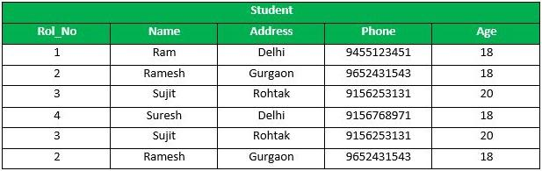
Student Table
Example
Following is an example which would delete those records from the table which have age = 20 and then COMMIT the changes in the database.
DELETE FROM Student WHERE AGE = 20;
COMMIT;
Output
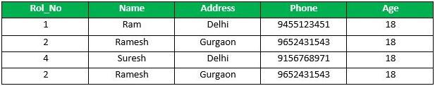
output
3. ROLLBACK Command
The ROLLBACK command is used to undo all changes made in the current transaction. It is used when an error occurs or when the desired changes cannot be completed. The database will revert to the state it was in before the BEGIN TRANSACTION was executed.
Syntax: ROLLBACK;
Example
Delete those records from the table which have age = 20 and then ROLLBACK the changes in the database. In this case, the DELETE operation is undone, and the changes to the database are not saved.
DELETE FROM Student WHERE AGE = 20;
ROLLBACK;
Output
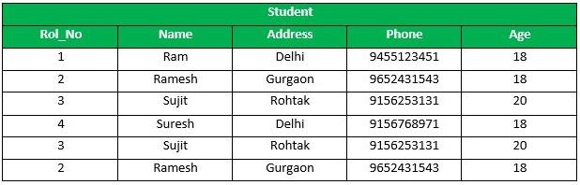
output
4. SAVEPOINT Command
A SAVEPOINT is used to create a checkpoint within a transaction. We can roll back to a specific SAVEPOINT instead of rolling back the entire transaction. This allows us to undo part of the transaction rather than the entire transaction.
Syntax:
SAVEPOINT SAVEPOINT_NAME;
Example
SAVEPOINT SP1;
//Savepoint created.
DELETE FROM Student WHERE AGE = 20;
//deleted
SAVEPOINT SP2;
//Savepoint created.
Output
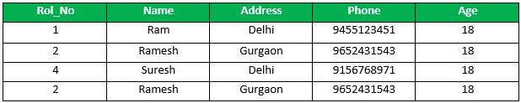
output
Explanation:
From the above example Sample table1, Delete those records from the table which have age = 20 and then ROLLBACK the changes in the database by keeping Savepoints. Here SP1 is first SAVEPOINT created before deletion. In this example one deletion have taken place. After deletion again SAVEPOINT SP2 is created.
5. ROLLBACK TO SAVEPOINT
The ROLLBACK TO SAVEPOINT command allows us to roll back the transaction to a specific savepoint, effectively undoing changes made after that point.
Syntax:
ROLLBACK TO SAVEPOINT SAVEPOINT_NAME;
Example
Deletion have been taken place, let us assume that we have changed our mind and decided to ROLLBACK to the SAVEPOINT that we identified as SP1 which is before deletion. So, In this case the DELETE operation is undone, and the transaction is returned to the state it was in at the SP1 savepoint.
ROLLBACK TO SP1;
//Rollback completed
Output
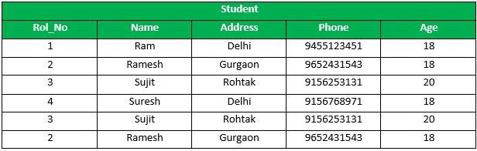
output
6. RELEASE SAVEPOINT Command
This command is used to remove a SAVEPOINT that we have created. Once a SAVEPOINT has been released, we can no longer use the ROLLBACK command to undo transactions performed since the last SAVEPOINT. It is used to initiate a database transaction and used to specify characteristics of the transaction that follows.
Syntax:
RELEASE SAVEPOINT SAVEPOINT_NAME
Example
Once the savepoint SP2 is released, we can no longer roll back to it.
RELEASE SAVEPOINT SP2;
-- Release the second savepoint.
Summary of Transaction Control Commands
Command | Purpose | Example
BEGIN TRANSACTION | Starts a new transaction. | BEGIN TRANSACTION TransferFunds;
COMMIT | Saves all changes made during the transaction. | COMMIT;
ROLLBACK | Undoes changes made during the transaction. | ROLLBACK;
SAVEPOINT | Creates a point in the transaction to which you can roll back. | SAVEPOINT SP1;
ROLLBACK TO SAVEPOINT | Rolls back the transaction to a specific savepoint. | ROLLBACK TO SP1;
RELEASE SAVEPOINT | Removes a savepoint from the transaction. | RELEASE SAVEPOINT SP2;
Types of SQL Transactions
There are different types of transactions based on their nature and the specific operations they perform:
- Read Transactions: Used to only read the data, typically with SELECT queries.
- Write Transactions: These involve modifying the data in the database with INSERT, UPDATE, or DELETE operations.
- Distributed Transactions: These transactions span multiple databases and ensure consistency across them.
- Implicit Transactions: Automatically started by SQL Server for certain operations.
- Explicit Transactions: Manually controlled transactions where the user begins and ends the transaction using
- BEGIN TRANSACTION, COMMIT, and ROLLBACK.
How to Monitor and Optimize SQL Transactions
Optimizing SQL transactions is critical for performance. Here are some best practices:
- Keep Transactions Short: Avoid long-running transactions as they can lock tables and reduce concurrency.
- Use Proper Indexing: Proper indexing on tables involved in the transaction can greatly improve performance.
- Avoid Transaction Blocking: Ensure transactions don’t block others unnecessarily, causing delays.
- Commit Early: Try to commit as soon as the transaction is complete to release resources.
Example:
BEGIN TRANSACTION;
INSERT INTO Customers (CustomerID, CustomerName, ContactName, Country) VALUES (5, 'Sarah White', 'John White', 'Canada');
INSERT INTO Customers (CustomerID, CustomerName, ContactName, Country) VALUES (6, 'Mohamed Ibrahim', 'Ahmed Ibrahim', 'UAE');
-- If any error occurs, the transaction will be rolled back
COMMIT;
In this example, the BEGIN TRANSACTION starts the transaction, and the COMMIT command commits the changes to the database. If any INSERT operation fails, the transaction can be rolled back using ROLLBACK to avoid partial data insertion.

SQL INSERT INTO Statement
The INSERT INTO statement in SQL is used to add new rows of data to a table in a database. There are two main ways to use the INSERT INTO statement by specifying the columns and values explicitly or by inserting values for all columns without specifying them. There are two primary syntaxes of INSERT INTO statements depending on the requirements. The two syntaxes are:
Syntax 1: Inserting Only Values
This method is used when you want to insert data into all columns, without specifying column names:
INSERT INTO table_name VALUES (value1, value2, value3..);
Parameters:
- table_name: name of the table.
- value1, value2: value of first column, second column,… for the new record
Syntax 2. Column Names And Values Both
In the second method we will specify both the columns which we want to fill and their corresponding values as shown below:
INSERT INTO table_name (column1, column2, column3)
VALUES ( value1, value2, value);
Parameters:
- table_name: name of the table.
- column1, column2..: name of first column, second column.
- value1, value2, value..: the values for each specified column of the new record.

Examples of SQL INSERT INTO
For better understanding, let’s look at the SQL INSERT INTO statement with examples.
Let us first create a table named ‘Student‘.
CREATE DATABASE StudentDB;
USE StudentDB;
CREATE TABLE Student (
ROLL_NO INT PRIMARY KEY,
NAME VARCHAR(50),
ADDRESS VARCHAR(100),
PHONE VARCHAR(15),
AGE INT
);
INSERT INTO Student (ROLL_NO, NAME, ADDRESS, PHONE, AGE) VALUES
(1, 'Ram', 'Delhi', 'XXXXXXXXXX', 18),
(2, 'Ramesh', 'Gurgaon', 'XXXXXXXXXX', 18),
(3, 'Sujit', 'Rohtak', 'XXXXXXXXXX', 20),
(4, 'Suresh', 'Rohtak', 'XXXXXXXXXX', 18);
Created Table:
ROLL_NO | NAME | ADDRESS | PHONE | AGE
1 | Ram | Delhi | xxxxxxxxxxxxxx | 18
2 | RAMESH | GURGAON | xxxxxxxxxxxxxx | 18
3 | SUJIT | ROHTAK | xxxxxxxxxxxxxx | 20
4 | SURESH | ROHTAK | xxxxxxxxxxxxxx | 18
3 | SUJIT | ROHTAK | xxxxxxxxxxxxxx | 20
2 | RAMESH | GURGAON | xxxxxxxxxxxxxx | 18
Now, Suppose we want to add values.
Example 1: Inserting Only New Values Using INSERT INTO Example
If we want to insert only values then we use the following query.
Query:
INSERT INTO Student
VALUES ('5','HARSH','WEST BENGAL', 'XXXXXXXXXX','19');
Output:
The table Student will now look like this:
ROLL_NO | NAME | ADDRESS | PHONE | Age
1 | Ram | Delhi | XXXXXXXXXX | 18
2 | RAMESH | GURGAON | XXXXXXXXXX | 18
3 | SUJIT | ROHTAK | XXXXXXXXXX | 20
4 | SURESH | Delhi | XXXXXXXXXX | 18
3 | SUJIT | ROHTAK | XXXXXXXXXX | 20
2 | RAMESH | GURGAON | XXXXXXXXXX | 18
5 | HARSH | WEST BENGAL | XXXXXXXXXX | 19
Example 2: Insert Values to Specified Columns Using INSERT INTO Example
If we want to insert values in the specified columns then we use the following query.
Query:
INSERT INTO Student (ROLL_NO, NAME, Age)
VALUES ('5','PRATIK','19');
Output:
The table Student will now look like this:
ROLL_NO | NAME | ADDRESS | PHONE | Age
1 | Ram | Delhi | XXXXXXXXXX | 18
2 | RAMESH | GURGAON | XXXXXXXXXX | 18
3 | SUJIT | ROHTAK | XXXXXXXXXX | 20
4 | SURESH | Delhi | XXXXXXXXXX | 18
3 | SUJIT | ROHTAK | XXXXXXXXXX | 20
2 | RAMESH | GURGAON | XXXXXXXXXX | 18
5 | PRATIK | null | null | 19
Note: Columns not included in the INSERT statement are filled with default values (typically NULL).

Insert Multiple Rows in MySQL
You can insert multiple rows in a single query using INSERT INTO:
INSERT INTO Student (ROLL_NO, NAME, AGE, ADDRESS, PHONE)
VALUES
(6, 'Amit Kumar', 15, 'Delhi', 'XXXXXXXXXX'),
(7, 'Gauri Rao', 18, 'Bangalore', 'XXXXXXXXXX'),
(8, 'Manav Bhatt', 17, 'New Delhi', 'XXXXXXXXXX'),
(9, 'Riya Kapoor', 10, 'Udaipur', 'XXXXXXXXXX');
Output:
ROLL_NO | NAME | ADDRESS | PHONE | AGE
1 | Ram | Delhi | XXXXXXXXXX | 18
2 | Ramesh | Gurgaon | XXXXXXXXXX | 18
3 | Sujit | Rohtak | XXXXXXXXXX | 20
4 | Suresh | Rohtak | XXXXXXXXXX | 18
5 | Pratik | NULL | NULL | 19
6 | Amit Kumar | Delhi | XXXXXXXXXX | 15
7 | Gauri Rao | Bangalore | XXXXXXXXXX | 18
8 | Manav Bhatt | New Delhi | XXXXXXXXXX | 17
9 | Riya Kapoor | Udaipur | XXXXXXXXXX | 10
If a user wants to insert more than 1000 rows, multiple insert statements, bulk insert or derived table must be used.

Using SQL INSERT INTO SELECT
The SQL INSERT INTO SELECT statement is used to copy data from one table and insert it into another table. The use of this statement is similar to that of the INSERT INTO statement.
The difference is that the SELECT statement is used here to select data from a different table. The different ways of using INSERT INTO SELECT statement are shown below:
Syntax of INSERT INTO SELECT
There are two syntaxes for using INSERT INTO SELECT statement, depending on it’s use.
1. Copy All Columns and Insert
The syntax for using INSERT INTO SELECT query to insert all data from a table to another table:
INSERT INTO first_table
SELECT * FROM second_table;
Parameters:
- first_table: name of first table.
- second_table: name of second table.
We have used the SELECT statement to copy the data from one table and the INSERT INTO statement to insert from a different table.
2. Copy Specific Columns and Insert
The syntax for using INSERT INTO SELECT query to insert specific data from a table to another table:
INSERT INTO first_table(names_of_columns1)
SELECT names_of_columns2
FROM second_table;

Parameters:
- first_table: name of first table. second_table: name of second table.
- names of columns1: name of columns separated by comma(,) for table 1.
- names of columns2: name of columns separated by comma(,) for table 2.
We have used the SELECT statement to copy the data of the selected columns only from the second table and the INSERT INTO statement to insert in the first table.
3. Copy Specific Rows and Insert
We can copy specific rows from a table to insert into another table by using the WHERE clause with the SELECT statement. We have to provide appropriate conditions in the WHERE clause to select specific rows.
The syntax for using INSERT INTO SELECT query to insert specific rows from table
INSERT INTO table1
SELECT * FROM table2
WHERE condition;
Parameters:
- first_table: name of first table.
- second_table: name of second table.
- condition: condition to select specific rows.
Examples of SQL INSERT INTO SELECT
Let’s look at some examples of INSERT INTO SELECT statement to understand it better.
Suppose there is a LateralStudent database.
ROLL_NO | NAME | ADDRESS | PHONE | Age
7 | SOUVIK | HYDERABAD | XXXXXXXXXX | 18
8 | NIRAJ | NOIDA | XXXXXXXXXX | 19
9 | SOMESH | ROHTAK | XXXXXXXXXX | 20
Example 1: Inserting all rows and columns using INSERT INTO SELECT example
If we want to insert only values then we use the following query:
Query:
INSERT INTO Student
SELECT * FROM LateralStudent;
Output:
This query will insert all the data of the table LateralStudent in the table Student. The table Student will now look like this,
ROLL_NO | NAME | ADDRESS | PHONE | Age
1 | Ram | Delhi | XXXXXXXXXX | 18
2 | RAMESH | GURGAON | XXXXXXXXXX | 18
3 | SUJIT | ROHTAK | XXXXXXXXXX | 20
4 | SURESH | Delhi | XXXXXXXXXX | 18
3 | SUJIT | ROHTAK | XXXXXXXXXX | 20
2 | RAMESH | GURGAON | XXXXXXXXXX | 18
7 | SOUVIK | DUMDUM | XXXXXXXXXX | 18
8 | NIRAJ | NOIDA | XXXXXXXXXX | 19
9 | SOMESH | ROHTAK | XXXXXXXXXX | 20
Example 2: Inserting specific columns using INSERT INTO SELECT
If we want to insert values in the specified columns then we use the following query:
Query:
INSERT INTO Student(ROLL_NO,NAME,Age)
SELECT ROLL_NO, NAME, Age FROM LateralStudent;
Output:
This query will insert the data in the columns ROLL_NO, NAME, and Age of the table LateralStudent in the table Student and the remaining columns in the Student table will be filled by null which is the default value of the remaining columns. The table Student will now look like this,
ROLL_NO | NAME | ADDRESS | PHONE | Age
1 | Ram | Delhi | XXXXXXXXXX | 18
2 | RAMESH | GURGAON | XXXXXXXXXX | 18
3 | SUJIT | ROHTAK | XXXXXXXXXX | 20
4 | SURESH | Delhi | XXXXXXXXXX | 18
3 | SUJIT | ROHTAK | XXXXXXXXXX | 20
2 | RAMESH | GURGAON | XXXXXXXXXX | 18
7 | SOUVIK | null | null | 18
8 | NIRAJ | null | null | 19
9 | SOMESH | null | null | 20
Example 3: Insert specific rows using INSERT INTO SELECT
INSERT INTO Student
SELECT * FROM LateralStudent WHERE Age = 18;
Output:
This query will select only the first row from table LateralStudent to insert into the table Student. The table Student will now look like this,
ROLL_NO | NAME | ADDRESS | PHONE | Age
1 | Ram | Delhi | XXXXXXXXXX | 18
2 | RAMESH | GURGAON | XXXXXXXXXX | 18
3 | SUJIT | ROHTAK | XXXXXXXXXX | 20
4 | SURESH | Delhi | XXXXXXXXXX | 18
3 | SUJIT | ROHTAK | XXXXXXXXXX | 20
2 | RAMESH | GURGAON | XXXXXXXXXX | 18
7 | SOUVIK | DUMDUM | XXXXXXXXXX | 18
Important Points About SQL INSERT INTO Statement
- The ‘INSERT INTO‘ statement is used to add new records to a table in a database
- It allows inserting multiple records in a single statement by providing multiple sets of values.
- If you don’t specify column names, the statement assumes all columns and the values must be in the same order as the table definition.
- Columns not included in the INSERT statement will be filled with default values, which are typically NULL.
- Using a single INSERT INTO statement for multiple rows improves efficiency and reduces potential errors.
UPDATE Statement in SQL
The UPDATE statement in SQL is used to update the data of an existing table in the database. We can update single columns as well as multiple columns using the UPDATE statement as per our requirement.
Syntax:
The syntax for SQL UPDATE Statement is :
UPDATE table_name SET column1 = value1, column2 = value2,…
WHERE condition;
Where,
- table_name: name of the table
- column1: name of first, second, third column….
- value1: new value for first, second, third column….
- condition: condition to select the rows for which the

Parameter Explanation
- UPDATE: Command is used to update the column value in the table.
- WHERE: Specifies the condition which we want to implement on the table.
Note: In the above query the SET statement is used to set new values to the particular column and the WHERE clause is used to select the rows for which the columns are needed to be updated. If we have not used the WHERE clause then the columns in all the rows will be updated. So the WHERE clause is used to choose the particular rows.
How to Use the SQL UPDATE Statement
Let’s see the SQL update statement with examples.
First we will create a table, on which we will use the UPDATE Statement. To create the table, write the following query
Query:
CREATE TABLE Customer(
CustomerID INT PRIMARY KEY,
CustomerName VARCHAR(50),
LastName VARCHAR(50),
Country VARCHAR(50),
Age int(2),
Phone int(10)
);

-- Insert some sample data into the Customers table
INSERT INTO Customer (CustomerID, CustomerName, LastName, Country, Age, Phone)
VALUES (1, 'Shubham', 'Thakur', 'India','23','xxxxxxxxxx'),
(2, 'Aman ', 'Chopra', 'Australia','21','xxxxxxxxxx'),
(3, 'Naveen', 'Tulasi', 'Sri lanka','24','xxxxxxxxxx'),
(4, 'Aditya', 'Arpan', 'Austria','21','xxxxxxxxxx'),
(5, 'Nishant. Salchichas S.A.', 'Jain', 'Spain','22','xxxxxxxxxx');
The created table will look like this:
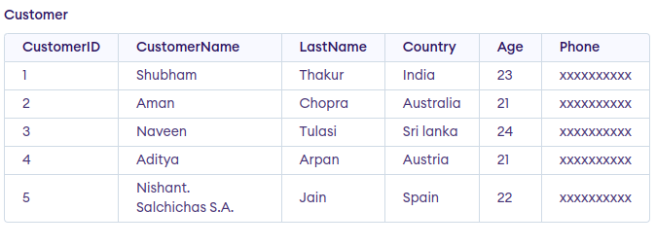
Example 1: Update Single Column Using UPDATE Statement
Update the column NAME and set the value to ‘Nitin’ in the rows where the Age is 22.
Query:
UPDATE Customer SET CustomerName = 'Nitin' WHERE Age = 22;

Output:
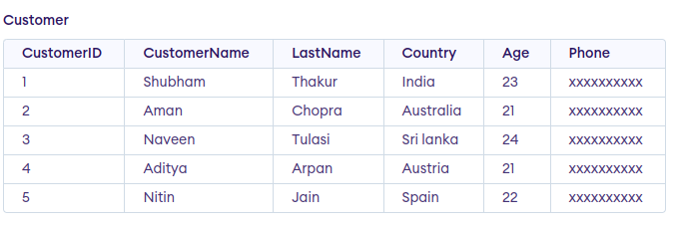
Example 2: Updating Multiple Columns using UPDATE Statement
Update the columns NAME to ‘Satyam’ and Country to ‘USA’ where CustomerID is 1.
Query:
UPDATE Customer SET CustomerName = 'Satyam', Country = 'USA'
WHERE CustomerID = 1;
Output:
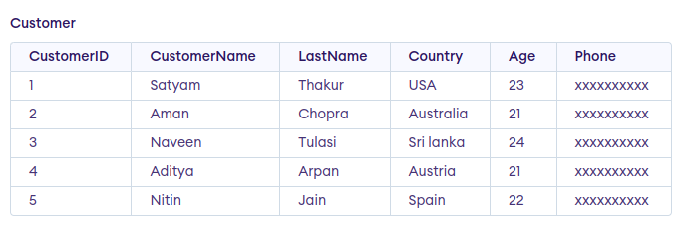
Note: For updating multiple columns we have used comma(,) to separate the names and values of two columns.

Omitting WHERE Clause in UPDATE Statement
If we omit the WHERE clause from the update query then all of the rows will get updated.
Query:
UPDATE Customer SET CustomerName = 'Shubham';
Output:
The table Customer will now look like this,
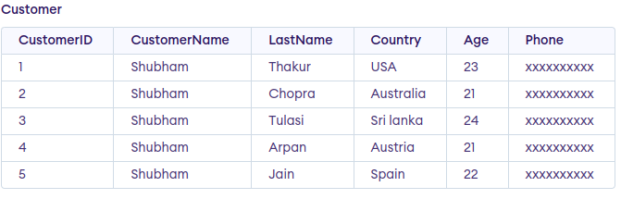
Important Points About SQL UPDATE Statement
- SQL UPDATE Statement is used to update data in an existing table in the database.
- The UPDATE statement can update single or multiple columns using the SET clause.
- The WHERE clause is used to specify the condition for selecting the rows to be updated.
- Omitting the WHERE clause in an UPDATE statement will result in updating all rows in the table.

SQL DELETE Statement
The SQL DELETE statement removes one or more rows from a database table based on a condition specified in the WHERE clause. It’s a DML (Data Manipulation Language) operation that modifies the data within the table without altering its structure.
Syntax:
DELETE FROM table_name WHERE some_condition;
Parameter Explanation
- Some_condition: condition to choose a particular record.
- table_name: name of the table
Note: We can delete single as well as multiple records depending on the condition we provide in the WHERE clause. If we omit the WHERE clause then all of the records will be deleted and the table will be empty.
Examples of SQL DELETE Statement
Assume we have created a table named GFG_Employee in SQL which contains the personal details of the Employee including their id, name, email and department etc. as shown below −
CREATE TABLE GFG_Employees (
id INT PRIMARY KEY,
name VARCHAR (20) ,
email VARCHAR (25),
department VARCHAR(20)
);

INSERT INTO GFG_Employees (id, name, email, department) VALUES
(1, 'Jessie', 'jessie23@gmail.com', 'Development'),
(2, 'Praveen', 'praveen_dagger@yahoo.com', 'HR'),
(3, 'Bisa', 'dragonBall@gmail.com', 'Sales'),
(4, 'Rithvik', 'msvv@hotmail.com', 'IT'),
(5, 'Suraj', 'srjsunny@gmail.com', 'Quality Assurance'),
(6, 'Om', 'OmShukla@yahoo.com', 'IT'),
(7, 'Naruto', 'uzumaki@konoha.com', 'Development');
Select * From GFG_Employees
Output

GFG_Employees
Example 1: Deleting Single Record
We can use the DELETE statement with a condition to delete a specific row from a table. The WHERE clause ensures only the intended record is removed. We can delete the records named Rithvik by using the below query:
Query:
DELETE FROM GFG_Employees WHERE NAME = 'Rithvik';
Output:

Example 2: Deleting Multiple Records
Delete the rows from the table GFG_Employees where the department is “Development”. This will delete 2 rows(the first row and the seventh row).
Query
DELETE FROM GFG_Employees WHERE department = 'Development';
Output

output
Example 3: Delete All of the Records
To remove all the entries from the table, you can use the following query:
Query:
DELETE FROM GFG_EMPLOyees;
Or
DELETE * FROM GFG_EMPLOyees;
Output:
All of the records in the table will be deleted, there are no records left to display. The table GFG_EMPLOyees will become empty.
output
Rolling Back DELETE Operations
Since the DELETE statement is a DML operation, it can be rolled back when executed in a statement. If you accidentally delete records or need to repeat the process, you can use the ROLLBACK command.
Query:
START TRANSACTION;
DELETE FROM GFG_Employees WHERE department = 'Development';
-- If needed, you can rollback the deletion
ROLLBACK;
Best Practices for Using SQL DELETE
- Use Transactions: Wrap DELETE statements in transactions to provide an option to roll back changes if necessary.
- Always Use a WHERE Clause: Avoid deleting all rows by accident. Always filter records using a WHERE clause to specify which rows to delete.
- Backup Data: Before performing large deletions, ensure that you have a backup of the data to avoid irreversible loss.
- Test on Development Server: Always test your DELETE queries on a development or staging environment to ensure they produce the desired result.
- Optimize Deletions: For large datasets, delete records in batches to reduce performance impact.

What is the ALTER Command in SQL?
The structure of an existing table can be changed by users using the SQL ALTER TABLE command. If we need to rename a table, add a new column, or change the name of an existing column in SQL, the ALTER command is crucial for making schema changes without affecting the data that is already there.
This is essential for tasks like:
- Renaming a table.
- Changing a column name.
- Adding or deleting columns.
- Modifying the data type of a column.
Syntax
1. Renaming a Table
ALTER TABLE table_name
RENAME TO new_table_name;
2. Renaming a Column
ALTER TABLE table_name
RENAME COLUMN old_column_name TO new_column_name;
3. Adding a New Column
ALTER TABLE table_name
ADD column_name datatype;
4. Modifying a Column Data Type
ALTER TABLE table_name
MODIFY COLUMN column_name new_datatype;

1. Create a Sample Table
First, let’s create a sample table to demonstrate the ALTER command:
CREATE TABLE Student (
id INT PRIMARY KEY,
name VARCHAR(50),
age INT,
email VARCHAR(50),
phone VARCHAR(20)
);
2. Insert Data into the Table
Let’s insert some data and then perform ALTER operation to understand better about alter command.
INSERT INTO Student (id, name, age, email, phone)
VALUES
(1, 'Amit', 20, 'amit@gmail.com', '9999999999'),
(2, 'Rahul', 22, 'rahul@yahoo.com', '8888888888'),
(3, 'Priya', 21, 'priya@hotmail.com', '7777777777'),
(4, 'Sonia', 23, 'sonia@gmail.com', '6666666666'),
(5, 'Kiran', 19, 'kiran@yahoo.com', '5555555555');
Output

Student Table

Example 1: Rename a Column
Change the name of column name to FIRST_NAME in table Student. To change the column name of the existing table we have to use Column keyword before writing the existing column name to change
Syntax
ALTER TABLE Student RENAME COLUMN Column_NAME TO FIRST_NAME;
Query:
ALTER TABLE Student RENAME Column name TO FIRST_NAME;
Output

Output
Example 2: Rename a Table
In this example, the table name Student is changed to Student_Details using the ALTER TABLE command, making the name more descriptive and relevant to its content.
Query:
ALTER TABLE Student RENAME TO Student_Details;

Output

Student_Details table
Example 3: Add a New Column
To add a new column to the existing table, we first need to select the table with ALTER TABLE command table_name, and then we will write the name of the new column and its datatype with ADD column_name datatype.
Syntax
ALTER TABLE table_name ADD column_name datatype;
Query:
ALTER TABLE Student ADD marks INT;
Output

Output

5. Modify a Column Data Type
In the example, the phone column is updated from VARCHAR(20) to BIGINT to store numerical data more efficiently and ensure data integrity for phone numbers without unnecessary characters.
Syntax
ALTER TABLE table_name
MODIFY COLUMN column_name new_datatype;
Query:
ALTER TABLE Student_Details
MODIFY COLUMN phone BIGINT;
Output
id | name | age | email | phone
1 | Amit | 20 | amit@gmail.com | 9999999999
2 | Rahul | 22 | rahul@yahoo.com | 8888888888
3 | Priya | 21 | priya@hotmail.com | 7777777777
4 | Sonia | 23 | sonia@gmail.com | 6666666666
5 | Kiran | 19 | kiran@yahoo.com | 5555555555
Explanation:
- The phone column now has a BIGINT data type, suitable for storing large numeric values.
- Existing data remains unchanged but is stored as integers instead of strings.

What is the SQL DROP Command?
In SQL, the DROP command is used to permanently remove an object from a database, such as a table, database, index, or view. When we DROP a table, both the data and the structure of the object are permanently removed from the database leaving no trace of the object.
Syntax:
DROP object object_name ;
Key Terms
- object: The type of object you want to drop (e.g., TABLE, DATABASE).
- object_name: The name of the object to be deleted.
DROP Command Examples
Let’s look at some examples of the DROP statement in SQL.
1. DROP Table
To delete an entire table, including its data and structure:
Syntax:
DROP TABLE table_name;
2. DROP database
To delete an entire database and all of its associated tables:
Syntax:
DROP DATABASE database_name;

What is SQL TRUNCATE Command?
The TRUNCATE command is a Data Definition Language (DDL) action that removes all rows from a table but preserves the structure of the table for future use. Although TRUNCATE is similar to the DELETE command (without the WHERE clause), it is much faster because it bypasses certain integrity constraints and locks. It was officially introduced in the SQL:2008 standard.
Syntax:
TRUNCATE TABLE table_name;
Key Terms
- table_name: Name of the table to be truncated.
- DATABASE name: student_data
Key Differences Between DROP and TRUNCATE
The key differences between DROP and TRUNCATE statements are explained in the following table:
Feature | DROP | TRUNCATE
Effect on Table Structure | Completely removes both the data and the table structure | Removes all rows but preserves the table structure
Data Deletion | Deletes both data and table definition | Deletes only the data, not the table structure
Recovery | Non-recoverable; once dropped, the table cannot be restored (unless you have backups) | Can be rolled back if used in a transaction (if supported by the DBMS)
Triggers | Does not activate triggers associated with the table | Does not activate DELETE triggers
Performance | Slower due to data and structural removal | Faster, especially for large datasets
Usage | Used when you want to completely remove a table or database | Used to quickly remove all rows from a table but keep the structure for future use
Examples of SQL DROP AND TRUNCATE Command
Let’s look at some examples of the DROP and TRUNCATE statements in SQL and understand their working. Consider the given database Student_data We will perform the examples on this particular table.
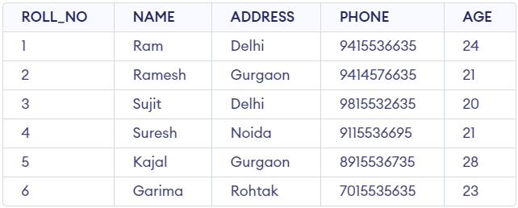
Student Table
DROP Database Example
In this example, we will drop a database called student_data:
DROP DATABASE student_data;
Running this query will completely delete the student_data database, including all tables and data.
DROP Table Example
In this example, we will drop the student_details table;
DROP TABLE student_details;
This query will permanently remove the student_details table, along with all its data, from the database.
TRUNCATE Table Example
In this example, we will truncate all data from a table (e.g., student_details) while keeping the table structure intact:
TRUNCATE TABLE Student_details;
After running the above query Student_details table will be truncated, i.e, the data will be deleted but the structure will remain in the memory for further operations.
Important Points About SQL DROP & TRUNCATE Command
SQL DROP Command:
- Completely removes a table or database from the database, including the data and structure.
- Is a permanent operation and cannot be rolled back.
- Removes integrity constraints and indexes associated with the table.
- Is slower compared to the TRUNCATE statement.
SQL TRUNCATE Command:
- Removes all the rows or data from a table, but preserves the table structure and columns.
- Is a faster operation compared to the DROP statement.
- Resets the identity column (if any) back to its seed value.
- Does not remove integrity constraints associated with the table.
DROP in SQL
- DROP is a DDL(Data Definition Language) command that is used to remove table definition and indexes, data, constraints, triggers etc for that table.
- Performance-wise the DROP command is quick to perform but slower than TRUNCATE because it gives rise to complications.
- Unlike DELETE we can’t rollback the data after using the DROP command. In the DROP command, table space is freed from memory because it permanently deletes the table as well as all its contents.
Syntax of DROP command:
DROP TABLE table_name;
TRUNCATE in SQL
- TRUNCATE is a DDL(Data Definition Language) command. It is used to delete all the tuples from the table.
- Like the DROP command, the TRUNCATE command also does not contain a WHERE clause.
- The TRUNCATE command is faster than both the DROP and the DELETE command.
- Like the DROP command we also can’t rollback the data after using the this command.
Syntax of TRUNCATE command:
TRUNCATE TABLE table_name;
Difference Between DROP and TRUNCATE
Here’s the difference between the DROP and TRUNCATE commands in SQL in tabular format:
S.NO | DROP | TRUNCATE
1. | The DROP command is used to remove the table definition and its contents. | The TRUNCATE command is used to delete all the rows from the table.
2. | In the DROP command, table space is freed from memory. | The TRUNCATE command does not free the table space from memory.
3. | DROP is a DDL (Data Definition Language) command. | TRUNCATE is also a DDL (Data Definition Language) command.
4. | In the DROP command, the view of the table does not exist. | In the TRUNCATE command, the view of the table exists.
5. | In the DROP command, integrity constraints will be removed. | In the TRUNCATE command, integrity constraints will not be removed.
6. | In the DROP command, undo space is not used. | In the TRUNCATE command, undo space is used but less than DELETE.
7. | The DROP command is quick to perform but gives rise to complications. | The TRUNCATE command is faster than DROP.

Difference between DELETE, DROP and TRUNCATE
In SQL, understanding the DELETE, DROP, and TRUNCATE commands is important for efficient data management. While these commands are all used to remove data, they differ significantly in functionality, usage, and performance. Knowing when and how to use each command can improve the efficiency and integrity of our database.
In this article, we will explain these commands, highlight their differences, and provide real-world examples and outputs to help us make informed decisions.
Comparison Between DELETE, DROP, and TRUNCATE
The following table lists all the major differences between DELETE, DROP, and TRUNCATE:
Parameter | DELETE | DROP | TRUNCATE
Type | DML | DDL | DDL
Purpose | Deletes specific rows based on condition | Deletes the entire table or database | Deletes all rows but retains table structure
Syntax | DELETE FROM table_name WHERE condition; | DROP TABLE table_name; | TRUNCATE TABLE table_name;
Rollback Support | Can be Rollback | Cannot be Rollback | Cannot be Rollback
Data Removal | Removes selected rows | Removes table and data completely | Removes all rows
Efficiency | Slower, as each row is processed individually | Instant removal, affecting schema | Faster than DELETE but slower than DROP
Triggers | Fires triggers | Does not fire triggers | Does not fire triggers
1. DELETE Command in SQL
The DELETE command is a Data Manipulation Language (DML) operation used to remove specific rows from a table based on a given condition. With the help of the “DELETE” command, we can either delete all the rows in one go or delete rows one by one. i.e., we can use it as per the requirement or the condition using the Where clause. It is comparatively slower than the TRUNCATE command
Syntax
- To delete all rows from the table
DELETE from;
- To delete specific rows based on a condition
DELETE FROM table_name WHERE condition;
Note :Here we can use the “ROLLBACK” command to restore the tuple because it does not auto-commit.
2. DROP
The DROP command is a Data Definition Language (DDL) operation used to completely remove a table, its structure, and all its data from the database. Once executed, the table is permanently deleted and cannot be recovered unless from a backup.
Syntax: DROP table <table_name>;
Note – Here we can’t restore the table by using the “ROLLBACK” command because it auto commits.
3. TRUNCATE
The TRUNCATE command is also a Data Definition Language (DDL) operation. It is used to remove all rows from a table efficiently, without deleting the table’s structure. By using this command the existence of all the rows of the table is lost. It is comparatively faster than the delete command as it deletes all the rows fastly.
Syntax: TRUNCATE table <table_name>;
Difference between DELETE and TRUNCATE
When managing large datasets in SQL, it’s essential to understand the differences between various commands used for removing data. Two commonly used SQL commands for data removal are DELETE and TRUNCATE. While both serve the purpose of removing rows from a table, they have distinct features and use cases that can significantly impact the performance of our database operations.
In this article, we will explain the differences between DELETE and TRUNCATE, including their syntax, advantages, and the best scenarios for their use. Understanding when to use DELETE, TRUNCATE, or even DROP TABLE can help us maintain optimal database performance.
What is the DELETE Command in SQL?
The DELETE command in SQL is part of the DML (Data Manipulation Language) category and is used to remove specific rows from a table based on a condition. We can delete all rows or filter which rows to delete by using a WHERE clause.
Syntax
DELETE FROM TableName
WHERE condition;

Example of DELETE Command
Let’s understand it with taking one simple example in which we will create one dummy table and then do the delete operation.
Employee Table
CREATE table Employee (
Emp_id int,
name VARCHAR(20),
country VARCHAR(20),
Salary INT);
--insert the data in the Employee Table
INSERT INTO Employee (Emp_id, name, country, Salary)
values (101, 'Mohit', 'India', 60000),
(103, 'Anish', 'England', 70000),
(104, 'Shubham', 'France', 100000),
(102, 'Danish', 'Sweden', 40000),
(105, 'Vivek', 'Wales', 50000),
(106, 'Rohan', 'Scotland', 30000);
Select * from Employee ;
Output
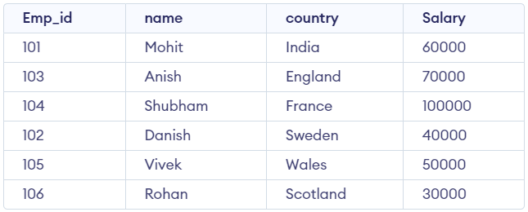
Employee Table
We must now create a query to remove the last entry with the value 106 for the Emp_id.
Query:
Delete from Employee where Emp_id = 106;
Output
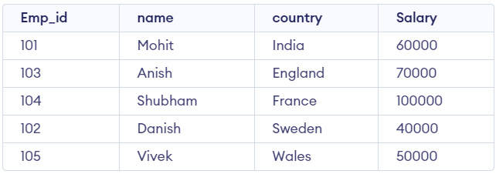
output
What is the TRUNCATE Command in SQL?
TRUNCATE is a DDL(Data Definition Language) command and is used to delete all the rows or tuples from a table. Unlike the DELETE command, the TRUNCATE command does not contain a WHERE clause. In the TRUNCATE command, the transaction log for each deleted data page is not recorded. We cannot roll back the data after using the TRUNCATE command. Unlike the DELETE command, the TRUNCATE command is fast.
Syntax
TRUNCATE TABLE TableName;
Example for TRUNCATE Command
Let’s see an example of using TRUNCATE to delete all rows from the Employee table. Unlike DELETE, TRUNCATE is faster because it does not log each row deletion and does not fire triggers.
Query: TRUNCATE TABLE Employee;
Rollback Example
We can use the ROLLBACK command to undo a TRUNCATE operation if no COMMIT has been issued. However, once executed, the data cannot be rolled back unless it is part of an active transaction.
Query:
BEGIN TRANSACTION;
TRUNCATE TABLE Employee;
SELECT * FROM Employee;
-- To undo the TRUNCATE operation
ROLLBACK TRANSACTION;
SELECT * FROM Employee;
Note that this rollback is only possible if a COMMIT has not been executed after the TRUNCATE command. Once a COMMIT is made, the changes cannot be undone.
Differences between DELETE and TRUNCATE
Delete | Truncate
The DELETE command is used to delete specified rows(one or more). | While this command is used to delete all the rows from a table.
It is a DML(Data Manipulation Language) command. | While it is a DDL(Data Definition Language) command.
There may be a WHERE clause in the DELETE command in order to filter the records. | While there may not be WHERE clause in the TRUNCATE command.
In the DELETE command, a tuple is locked before removing it. | While in this command, the data page is locked before removing the table data.
The DELETE statement removes rows one at a time and records an entry in the transaction log for each deleted row. | TRUNCATE TABLE removes the data by deallocating the data pages used to store the table data and records only the page deallocations in the transaction log.
DELETE command is slower than TRUNCATE command. | While the TRUNCATE command is faster than the DELETE command.
To use Delete you need DELETE permission on the table. | To use Truncate on a table we need at least ALTER permission on the table.
The identity of the fewer column retains the identity after using DELETE Statement on the table. | Identity the column is reset to its seed value if the table contains an identity column.
The delete can be used with indexed views. | Truncate cannot be used with indexed views.
This command can also active trigger. | This command does not active trigger.
DELETE statement occupies more transaction spaces than Truncate. | Truncate statement occupies less transaction spaces than DELETE.
Delete operations can be ROLLED back. | TRUNCATE cannot be Rolled back as it causes an implicit commit.
Delete doesn’t DROP the whole table. It acquires a lock on table and starts deleting the rows. | TRUNCATE first drops the table & then re-create it, which is faster than deleting individual rows.
How to Create Backup Tables in SQL
We can create a backup of a table by creating a duplicate or copy of original database. This is particularly useful for preserving the original table before performing updates, deletions, or other modifications. Below is a detailed explanation of the syntax and terms used for this operation.
Syntax
CREATE TABLE Table_Name AS SELECT * FROM Source_Table_Name;
Key Terms
- Table_Name: Specifies the name of the new backup table.
- AS: Acts as an alias, enabling the SQL query to copy data from the source table into the backup table.
Examples of SQL Backup Table Creation
Creating backup tables in SQL can involve duplicating all data, copying specific columns, or even creating an empty table with the same structure. Let’s look at some examples on how to copy/duplicate table in SQL to create a backup table in different scenarios:
1. Backup Table with All Columns and Data
In this example, we will create a backup table “stud_1” of “student_information” table by creating a copy of “student_information” table that duplicates all columns and their data..
Query: CREATE TABLE stud_1 AS SELECT * FROM student_information;
SELECT * FROM stud_1;
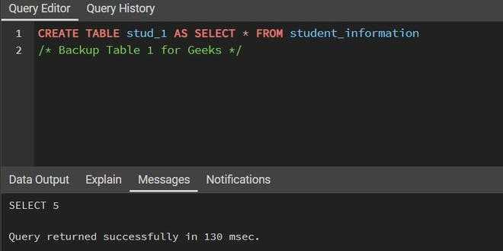
Query For Backup Table with All Columns Data
Output
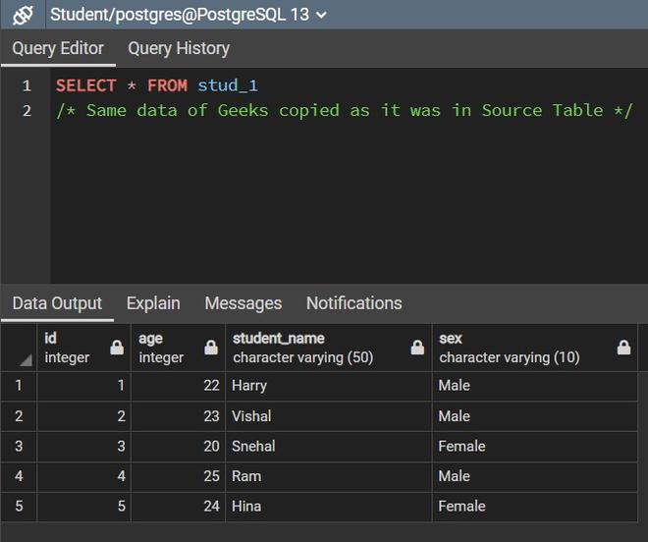
SQL Backup Table with All Columns Data Example Output
2. SQL Backup Table with Specific Column Data Example
In this example, we create a backup table, “stud_2”, by copying only selected columns from the “student_information” table using a SELECT statement.
Query:
CREATE TABLE stud_2 AS
SELECT id,student_name FROM student_information;
SELECT * FROM stud_2;
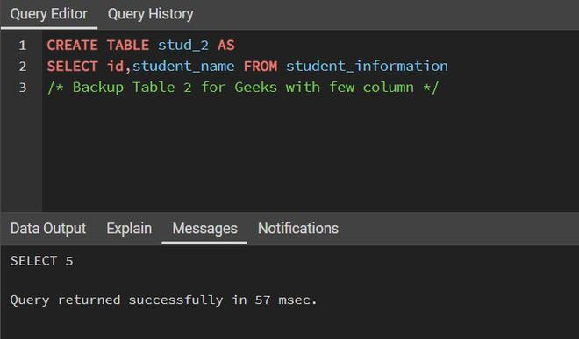
Query For Backup Table with Specific Column Data
Output
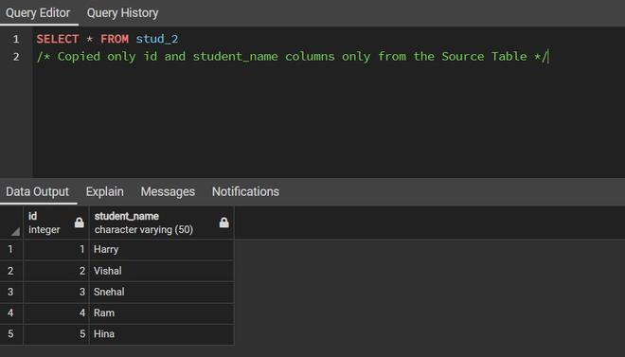
SQL Backup Table with Specific Column Data Example Output
Till now we have seen how to create a clone of the source table. In the above backup table, the data is also copied along with the table. However, we can also create a backup table without copying the data.

3. Backup Table Without Data
So, to create a table without any data being copied we can use the WHERE clause which needs to return a FALSE value.
For example, we can use WHERE 2<2 or WHERE 1=2.
In this example, we will create a backup table “geeks_student” of “student_information” table by creating a copy of “student_information” table and copying its all columns without data.
Query:
CREATE TABLE geeks_student AS SELECT * FROM student_information
WHERE 1!=1;
SELECT * FROM geeks_student;
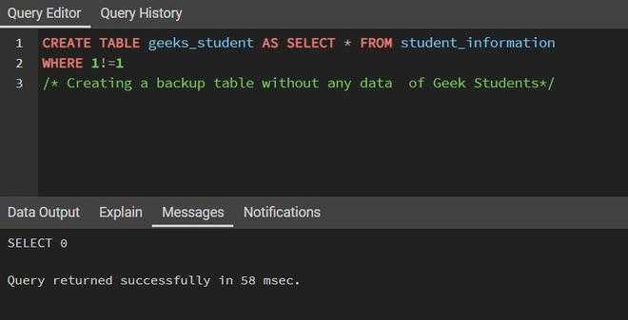
Query for Backup Table with No Data
Output
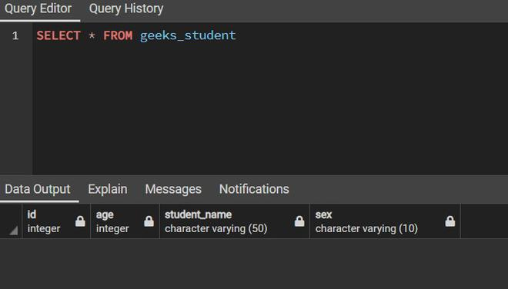
SQL Backup Table with No Data Example Output
4. Backup Table with Specific Columns and No Data
In this example, we will create a backup table “geek_student” of “student_information” table by creating a copy of “student_information” table and copying specific columns without data.
Query:
CREATE TABLE specific_empty_backup AS
SELECT ID, Student_Name FROM student_information WHERE 1=2;
SELECT * FROM specific_empty_backup;
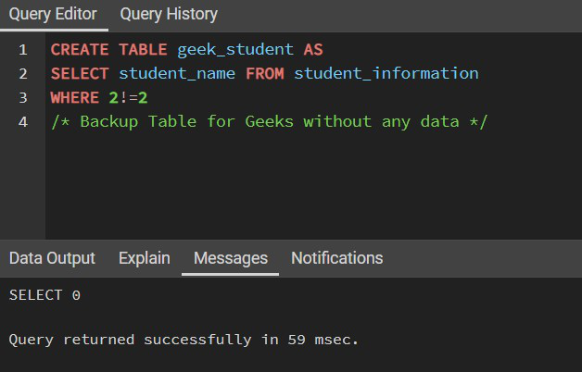
Query for Backup Table with Specific Columns and No Data
Output
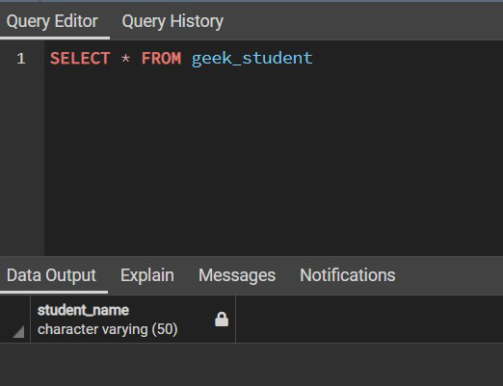
SQL Backup Table with Specific Columns and No Data Example Output
Limitations of CREATE TABLE AS SELECT
While convenient, CREATE TABLE AS SELECT has key limitations:
- Constraints Are Not Copied: Constraints such as PRIMARY KEY, FOREIGN KEY, UNIQUE, CHECK, and DEFAULT are not carried over to the new table.
- Indexes and Triggers Are Not Copied: Any indexes or triggers from the base table won’t transfer to the backup
- Manual Effort Required for Full Duplication: To fully replicate the original table structure including constraints and indexes, manual setup is necessary.
How to Create Backup Tables with Constraints
To copy the structure of a table along with its constraints, the CREATE TABLE AS SELECT statement is not sufficient. Instead, we need to define the table structure manually and then copy the data.
Example: Adding Constraints After Table Creation
1. Create a table without constraints:
CREATE TABLE student_backup AS SELECT * FROM student_information;
2. Add constraints to the backup table
ALTER TABLE student_backup ADD PRIMARY KEY (ID);
Example: Define Table with Constraints and Copy Data

1. Define the new table with constraints
CREATE TABLE student_backup (
ID INT PRIMARY KEY,
Age INT,
Student_Name VARCHAR(50),
Sex VARCHAR(10)
);
2. Copy data into the new table
INSERT INTO student_backup SELECT * FROM student_information;
SQL ALTER TABLE STATEMENT
The ALTER TABLE statement in SQL is used to modify an existing table structure in a database without losing any data. It allows you to add, remove, or modify columns, change data types, or apply constraints to improve data integrity and ensure that the table meets evolving business requirements. It allows for structural changes like adding new columns, modifying existing ones, deleting columns, and renaming columns within a table. To alter/modify the table use the ALTER TABLE syntax:
Syntax:
ALTER TABLE table_name
[ADD | DROP | MODIFY] column_name datatype;
Key Terms
- table_name refers to the name of the table you want to modify.
- ADD is used to add a new column.
- DROP is used to remove an existing column.
- MODIFY is used to change the datatype or definition of an existing column.

Common Use Cases for SQL ALTER TABLE
1. ADD – To add a new column to the table
The ADD clause is used to add a new column to an existing table. You must specify the name of the new column and its data type.
Query:
ALTER TABLE table_name ADD column_name datatype;
2. MODIFY/ALTER – To change the data type of an existing column
The MODIFY (or ALTER COLUMN in some databases like SQL Server) clause is used to modify the definition of an existing column, such as changing its data type or size.
Query:
ALTER TABLE table_name MODIFY COLUMN column_name datatype;
3. DROP – To delete an existing column from the table
The DROP clause allows you to remove a column from a table. Be cautious when using this command as it will permanently remove the column and its data.
Query:
ALTER TABLE table_name DROP COLUMN column_name;
4. RENAME COLUMN – To rename an existing column
We can rename an existing column using the RENAME COLUMN clause. This allows you to change the name of a column while preserving its data type and content.
Query:
ALTER TABLE table_name RENAME COLUMN old_name TO new_name;

5. RENAME TO – To rename the table itself
We can rename an entire table using the RENAME TO clause. This changes the name of the table while preserving its structure and data.
ALTER TABLE table_name RENAME TO new_table_name;
SQL ALTER TABLE Examples
Below are various examples demonstrating different use cases of the ALTER TABLE statement in SQL. These examples showcase how to add, modify, drop, and rename columns or tables, providing a clear understanding of the flexibility and utility of the ALTER TABLE statement.
1. Adding a New Column to a Table
To add a new column to an existing table, you can use the ADD clause. Here’s an example where we add a column named email to the employee table:
ALTER TABLE Students ADD Email varchar(255);
2. Removing a Column from a Table
We can remove an existing column from a table using the DROP COLUMN clause. Here’s an example where we remove the phone_number column from the employee table:
ALTER TABLE Students DROP COLUMN Email;
3. Modifying an Existing Column’s Data Type
To change the data type or size of an existing column, you can use the MODIFY clause. For instance, if you want to change the data type of the salary column from INT to DECIMAL, you can use:
ALTER TABLE table_name MODIFY COLUMN column_name datatype;

SQL ALTER TABLE Queries
Let’s explore the ALTER TABLE queries using a Student table with columns ROLL_NO and NAME, and demonstrate various modifications such as adding, modifying, and dropping columns. Here’s how you can execute these operations:
ROLL_NO | NAME
1 | Ram
2 | Abhi
3 | Rahul
4 | Tanu
1. Add Columns (AGE and COURSE) to the Student Table
To add new columns AGE and COURSE to the Student table, you can use the ALTER TABLE statement with the ADD clause.
Query:
ALTER TABLE Student ADD (AGE number(3),COURSE varchar(40));
Output:
ROLL_NO | NAME
1 | Ram
2 | Abhi
3 | Rahul
4 | Tanu
Explanation: This adds the AGE column with a numeric data type and the COURSE column with a VARCHAR(40) type. The columns are added to the table, but the values are empty initially.
2. Modify Column COURSE to Reduce its Size
If you want to reduce the size of the COURSE column from VARCHAR(40) to VARCHAR(20), you can modify the column’s data type using the MODIFY clause.
Query:
ALTER TABLE Student MODIFY COURSE varchar(20);
Explanation: After running the above query, the COURSE column’s data type will now allow a maximum of 20 characters instead of 40. This modifies the column’s size limit.
3. Drop the COURSE Column from the Student Table
To remove the COURSE column completely from the Student table, you can use the DROP COLUMN clause.
Query:
ALTER TABLE Student DROP COLUMN COURSE;
Output:
ROLL_NO | NAME
1 | Ram
2 | Abhi
3 | Rahul
4 | Tanu
Explanation: After executing this query, the COURSE column is permanently removed from the table, leaving just the ROLL_NO, NAME, and AGE columns.
SELECT Statement in SQL
The SELECT statement in SQL is used to fetch or retrieve data from a database. It allows users to access the data and retrieve specific data based on specific conditions.
We can fetch either the entire table or according to some specified rules. The data returned is stored in a result table. With the SELECT clause of a SELECT command statement, we specify the columns that we want to be displayed in the query result and, optionally, which column headings we prefer to see above the result table.
The SELECT clause is the first clause and is one of the last clauses of the select statement that the database server evaluates. The reason for this is that before we can determine what to include in the final result set, we need to know all of the possible columns that could be included in the final result set.
Syntax:
The syntax for the SELECT statement is:
SELECT column1,column2…. FROM table_name ;
CREATE TABLE Customer(
CustomerID INT PRIMARY KEY,
CustomerName VARCHAR(50),
LastName VARCHAR(50),
Country VARCHAR(50),
Age int(2),
Phone int(10));

-- Insert some sample data into the Customers table
INSERT INTO Customer (CustomerID, CustomerName, LastName, Country, Age, Phone)
VALUES (1, 'Shubham', 'Thakur', 'India','23','xxxxxxxxxx'),
(2, 'Aman ', 'Chopra', 'Australia','21','xxxxxxxxxx'),
(3, 'Naveen', 'Tulasi', 'Sri lanka','24','xxxxxxxxxx'),
(4, 'Aditya', 'Arpan', 'Austria','21','xxxxxxxxxx'),
(5, 'Nishant. Salchichas S.A.', 'Jain', 'Spain','22','xxxxxxxxxx');
Output:

Example 1: Retrieve Data using SELECT Query
In this example, we will fetch CustomerName, LastName from the table Customer:
Query:
SELECT CustomerName, LastName FROM Customer;
Output:

Example 2: Fetch All Table using SELECT Statement
In this example, we will fetch all the fields from the table Customer:
Query:
SELECT * FROM Customer;
Output:

Example 3: SELECT Statement with WHERE Clause
Suppose we want to see table values with specific conditions then WHERE Clause is used with select statement.
Query:
SELECT CustomerName FROM Customer where Age = '21';
Output:

Example 4: SQL SELECT Statement with GROUP BY Clause
In this example, we will use SELECT statement with GROUP BY Clause
SELECT COUNT (item), Customer_id FROM Orders GROUP BY order_id;

Output:

Example 5: SELECT Statement with HAVING Clause
Consider the following database for HAVING Clause:

Query:
SELECT Department, sum(Salary) as Salary
FROM employee
GROUP BY department
HAVING SUM(Salary) >= 50000;

Output:

Example 6: SELECT Statement with ORDER BY clause in SQL
In this example, we will use SELECT Statement with ORDER BY clause
Query:
SELECT * FROM Customer ORDER BY Age DESC;
Output:


Important Points with SQL SELECT Statement
- It is used to access records from one or more database tables and views.
- The SELECT statement retrieves selected data based on specified conditions.
- The result of a SELECT statement is stored in a result set or result table.
- The SELECT statement can be used to access specific columns or all columns from a table.
- It can be combined with clauses like WHERE, GROUP BY, HAVING, and ORDER BY for more refined data retrieval.
- The SELECT statement is versatile and allows users to fetch data based on various criteria efficiently.

SQL Query to Delete Duplicate Rows:

What Are Duplicate Rows?
Duplicate rows are records in a database table that have identical values in one or more columns. These rows often arise due to issues like multiple imports, user errors, or missing constraints like primary keys or unique indexes. Duplicate rows can lead to inaccurate reports, redundant data storage, and slower query performance, making it essential to remove them.
A SQL query to delete duplicate rows typically involves identifying duplicates using functions like ROW_NUMBER() or COUNT() and making sure that only one copy of each record is kept in the table.
Why Remove Duplicate Rows?
- Optimize memory usage by eliminating redundant data.
- Ensure data accuracy for reports and queries.
- Improve query performance by reducing data redundancy.

Steps to Delete Duplicate Rows in SQL
To effectively remove duplicate rows in SQL, we can follow a structured approach. Below are the steps to create a DETAILS table and demonstrate how to identify and delete duplicate records:
Step 1: Create the Sample Table
We will create a table named DETAILS to demonstrate how to identify and delete duplicate rows. This step helps in setting up the necessary structure to store sample data and perform operations like detecting duplicates and applying deletion techniques.
Query:
create table details (
sn int identity(1,1) primary key,
empname varchar(25) not null,
dept varchar(20) not null,
contactno bigint not null,
city varchar(15) not null
);
Step 2: Insert Data into the Table
Let’s insert some data, including duplicates, into the DETAILS table. This step allows us to copy real-world scenarios where duplicate records might occur, enabling us to demonstrate how to identify and remove them effectively.
Query:
insert into details (empname, dept, contactno, city)
values
('vishal', 'sales', 9193458625, 'gaziabad'),
('vipin', 'manager', 7352158944, 'bareilly'),
('rohit', 'it', 7830246946, 'kanpur'),
('rahul', 'marketing', 9635688441, 'meerut'),
('sanjay', 'sales', 9149335694, 'moradabad'),
('vipin', 'manager', 7352158944, 'bareilly'),
('vishal', 'sales', 9193458625, 'gaziabad'),
('aman', 'it', 78359941265, 'rampur');

Step 3: Identify Duplicate Rows
We Use the GROUP BY clause with the COUNT(*) function to find rows with duplicate values. This step helps us group the records by specific columns and count how many times each combination occurs, making it easier to identify duplicates that appear more than once in the table.
Query:
select empname, dept, contactno, city,
count(*) from details
group by empname,dept,contactno,city
having count(*)>1

Step 4: Retain Unique Rows
To identify unique rows, use the same query without the HAVING clause or filter rows with a count of 1. This step allows us to isolate the rows that appear only once in the table, ensuring that only the distinct records are retained while duplicates are removed.
Query:
select empname,dept,contactno,city,
count(*) from details
group by empname,dept,contactno,city
Step 5: Delete Duplicate Rows
Use the GROUP BY clause along with MIN(SN) to retain one unique row for each duplicate group. This method identifies the first occurrence of each duplicate combination based on the SN (serial number) and deletes the other duplicate rows.
Query:
delete from details
where sn not in (
select min(sn)
from details
group by empname, dept, contactno, city
);
select * from details;
Step 6: Alternative Approach Using CTE
Using a Common Table Expression (CTE), we can delete duplicates in a more structured way. CTEs provide a cleaner approach by allowing us to define a temporary result set that can be referenced within the DELETE statement. This method can be more readable and maintainable, especially when dealing with complex queries.
Query:
WITH CTE AS (
select sn, empname, dept, contactno, city,
row_number() over (partition by empname, dept, contactno, city order by sn) as rownum
from details
)
DELETE FROM CTE WHERE rownum > 1;

Installation of MySQL Connector:
This connector will connect our python program to database. Just run this command,
Command: pip install mysql-connector-python
Important steps for Python Database Programming:
- Import MySQL database Module
import mysql.connector
- For creating a connection between Python Program and Database. Using connect() method, We will connect the python program with our database.
connection = mysql.connector.connect(host=’localhost’, database='<database_name>’, user='<User_name>’, password='<password>’)
- Now, create a cursor object by using cursor() method for executing the SQL Queries and holding the result in an object.
cursor = connection.cursor()
- For executing SQL queries, we will use a cursor object. For example,
cursor.execute("select * from table_name")
- Finally, Once we are done with our operations, we have to close the resources.
cursor.close()
con.close()

