Method Overloading in java
Define: when a class has more than one method having the same name but with different parameters lists, this feature is called method overloading in java
-In other words , when you declare multiple methods with the same name but different method signature in a same class , these method are overloaded method in java
-method overloading is also called the compile time polymorphism also known as static polymorphism
-method overloading allows you to write cleaner and more organized code by grouping logically similar action under the same method name
-when you define multiple method with the same name but different parameters lists in a class java compiler differentiates overloaded method based on their method signature(method name + parameter list )
-A method name is defined by the method name and the list of parameters(number, type, order of parameter)
-return type of the method is not a part of the method signature , return type of the method does not play any role in resolving overloaded method
-at compile time , the compiler select the appropriate overloaded method to execute based on the reference type and the argument passed in the method call
-it matches the method call with the method signature that has the most compatible parameter list thus method overloading is resolved by the java compiler during compile-time, which is why it is also known as compile time polymorphism or static polymorphism
-JVM create the object at the runtime by the JVM but JVM does not play a role in selecting the overloaded method
Rules for implementing the overloading in java:
- The method name should be same, in other words all overloaded method must share the identical name/same name
- Parameter must be different , each overloaded method must have a unique list of the parameter Three way you can achieve this
i) data type of parameter
ii) no of parameter
iii) sequence (i.e order) of data type of parameter
3)return type of the method does not affect overloading ,if two methods have the same name and different return type, they cannot be overloaded if their parameter list is identical
4)access modifier do not affect method overloading, you can overload methods even if they have different access modifiers
5) method overloading can occur within the class or between the parent child class
Key feature of method overloading in the java
1.the call to overloaded method is bonded at compile-time, the compiler decides which overloaded method to call based on the reference type at the compile time , not at runtime object type
2.concept of method overloading is also known as compile time polymorphism in java because the method binding happens during compilation
3.method overloading is generally done in the same class but you can also do it in the subclass, you need to make a relationship between parent class and child class by using extends keyword for it
4.method overloading cannot be done by changing only return type of method because there may occur ambiguity and the java will throw an compile time error ,However overloaded method can have different return types if their parameter list is also different
5. we can also overload the private method in java
6.final method can be overloaded in java
7.main method can also be overloaded in java
8.we can also overload both static and instance method in java, method overloading is possible when two or more static methods with same name ,but the different in the list of parameters

When to use the method overloading
1)we need to define multiple method with the same name but different parameters and they perform the same or similar thing or operation
For example: you want to calculate the area of different shape (e.g circle, rectangle, triangle, using the method called area() but with different parameter type or counts
2)if the multiple methods perform different tasks, don’t use the method overloading concept
3)when to use same functionality with different types of data
4)when the no of parameters differs
5)to avoid multiple method names for similar tasks
6) when working with APIs/Libraries
7)Improves code readability and API design: you can call the same method name ,but java known which one to execute based on argument
8).to achieve compile time polymorphism
9)better encapsulation of behavior: keeps related logic under the same method name, reduces the confusion for developers using your class
Why method overloading is used in java
- To achieve the compile time polymorphism
- To reuse the same method name
- Clean and Consistent API design
- To allow the same logical operation to be used with different input without breaking existing code
- To make the program logically more readable and understandable
- Improve code readability and reduces redundancy

Method overloading example programme:
1.Method overloading by changing the number of arguments
=> i) void sum(int a, int b);
ii) void sum(int a, int b, int c);
2.Method overloading by changing data type of parameters
=>i)int sub(int a,int b);
ii) double sub(double a,double b);
at least one parameter will overload the method sub
3.Method overloading by changing sequence of data type of parameters
=>void multiply(int a,double b);
Void multiply(double a,int a);
4.Method Overloading Done in Subclass
class Parent{
void msg(int a,int b){
System.out.println(“hello parent overloaded method”); }}
Class Child extends Parent{
Void msg(double a,double b){
System.out.println(“hello child method);}}
Public class Test{
Public static void main(String args[]){
Child c=new Child();
a.msg(10,20);
a.msg(2.5,3);}}
5.overload main method in java
Class overlaod_class{
Public static void main(String args[]){
System.out.println(“main method with args”);
main();
}
Public static void main(){
System.out.println(“main without args”);
}
Public static void main(String args){
System.out.println(“main with string args”);
}}

Q1 identify the error in the following codec
class Test{
public static void m1(int a ){ }
public static int m1(int y){
return y
}}
Answer: Duplicate method error by the compiler, method overloading as method overloading related to the metho d signature not with the return type of the same method

Q2. Advantage of the method overloading
=>
1. In java method overloading provides the same method name to reuse in the program
2.it is useful to avoid repeating same code in different methods
3.we can achieve compile time polymorphism
4.make program more logical understandable, and readable
Q3. Dis-advantage of the method overloading
=>
1.too many overloaded method in a class can make the code harder to read,understand and maintain especially for begineer
2.for too many overloaded methods exists in a class ,maintenance or debugging can be complex and time consuming
3.if the method overloading is not used carefully ,it can lead to ambiguous method calls especially with type conversion
4. you cannot overload a method just by changing the return type. This restriction can limit the certain scenario and may require renaming methods unnessarily

Ambiguous method calls
Even if you try to overload with different return types, the compiler cannot figure out which one to call because method invocation doesn’t specify return type.
class Test {
int getValue() {
return 10;
}
double getValue() {
return 10.5;
}}
public class Demo {
public static void main(String[] args) {
Test t = new Test();
t.getValue(); // ❌ Ambiguity
}
}
❓ Why is it Ambiguous?
- The method call t.getValue(); does not specify a return type.
- Java compiler chooses a method based only on method name + parameter list, not on return type.
- Since both methods have same name and same parameters (none in this case) → compiler cannot decide which one to call.

✅ When it Works (if return value is assigned)
If you assign the return to a variable, then the compiler knows what you expect:
int x = t.getValue(); // calls int version
double y = t.getValue(); // calls double version
👉 In this case, there’s no ambiguity because the assignment type guides the compiler.
To avoid such ambiguity and ensure clear method resolution at compile time, Java enforces that overloaded methods must differ in parameters, not just return type.”
class Test {
public int GetValue() { return 10; }
public double GetValue() { return 10.5; }
}
class Program {
static void Main() {
Test t = new Test();
int x = t.GetValue(); // int version
double y = t.GetValue(); // double version
Console.WriteLine(x);
Console.WriteLine(y);
}
}
✅ This compiles and runs in C#, but ❌ not in Java.

Type conversion and casting in java
Define: the process of converting a value from one data type to another is known as type conversion in java
-type conversion is also known as type casting in java or simply casting
-if two data type are compatible with each other java will perform such conversion automatically or implicitly
-we can easily convert a primitive data type into another primitive data type by using type casting
-similar it is possible to convert a non-primitive data type(referenced data type) into another non-primitive data type by using type casting, but we cannot convert a primitive data type into an advanced(refered) data type by using type casting for that we use the wrapper class
Types of casting in java
1.Implicit type casting:
-automatic conversion(casting) done by java compiler internally is called implicit conversion or implicit type casting in java
-it is performed to convert a lower data type into a higher data type also known as automatic type promotion in java
-this type is also known as type promotion/widening conversion/type coercion
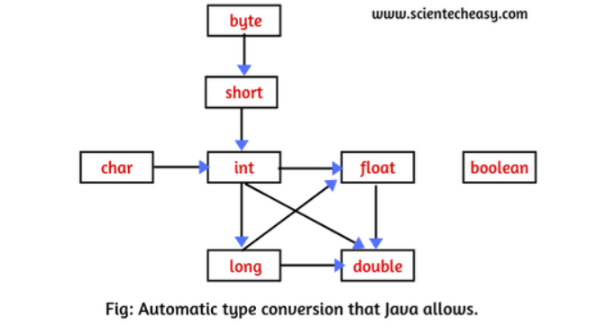
Automatic type Promotion rules in java
1)if byte ,short, and int are used in a mathematical expression java always convert the result into an int
2)if the single long is used in the expression, the whole expression is converted to long
3)if the float operand is used in an expression the whole expression is converted to float
4)if any operand is double , the result is promoted to double
5)Boolean value can not converted to another type
6)conversion from float to int causes truncation of the fraction part which represent the loss of precision.java does not allow this
7)conversion from double to float cause rounding of digits that may cause some of the value ‘s precision to be lost
8)Conversion from long to int is also not possible ,it causes the dropping of the excess higher order bits
Example:
-when you will perform the addition of an int and double it gives the result in a double, subtraction of long from float result in float
-an automatic type conversion take place in java , if these two condition are met:
i)the data types are compatible with each other
ii)the destination type is bigger than the source type
when these condition are met , a widening conversion will take place
the process of converting lower data type into higher data type is called widening
-widening is safe because there is no loss of data or accuracy or precision
Example :int type is always large enough to hold all bytes value therefore, therefore, no explicit casting is needed
-the widening conversion is possible in java when numeric type (int ,float) is compatible with each other
-no widening conversion is supported from numeric type to char or Boolean because the numeric type is incompatible with char or boolean ,also char and boolean are incompatible with each other
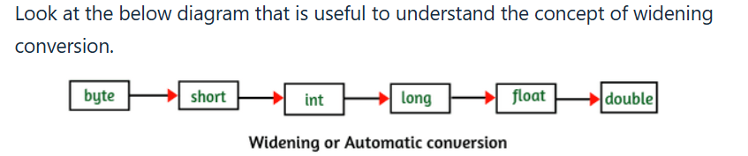
2.Explicit type casting
-the process of conversion of a higher data type into a lower data type is called narrowing conversion/explicit type conversion
-must use explicit type casting to create a conversion between two incompatible types
-this explicit type casting conversion is done by programmer manually ,not by the compiler automatically
-to perform this kind of type casting we will have to use a cast operator
-cast operator is used to cast a primitive value from one type to another, using a cast operator
-cast operator= (type_name) expression;
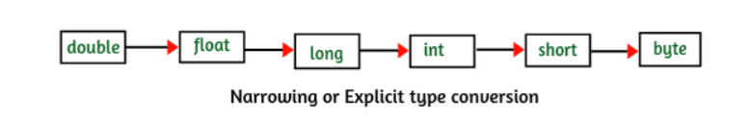
-programmer must manually specify the target type
double d = 9.7;
int i = (int) d; // double → int (explicit casting, fractional part lost)

Disadvantage:
i)when you will use type casing in java programming, you can lose some information or data
ii)accuracy can be lost while using type casting
iii)when a double is cast to an int , the fractional part of a double is discarded which cause the loss of fractional part of data
Aspect | Implicit Casting | Explicit Casting
Other Names | Type Promotion, Widening Conversion | Type Casting, Narrowing Conversion
Conversion Direction | Smaller → Larger (safe widening) | Larger → Smaller (may lose data)
Data Loss | No | Possible (precision loss, overflow, truncation)
Syntax | No special syntax needed | Requires (targetType)
Example | int x = 10; double y = x; | double d = 9.8; int i = (int) d;

Aspect | Implicit Casting (Type Promotion / Widening) | Explicit Casting (Type Casting / Narrowing)
Who Performs It | Done automatically by the Java compiler | Done manually by the programmer
Syntax | No cast operator required | Requires a cast operator (targetType)
Conversion Direction | Converts smaller type → larger type | Converts larger type → smaller type
Safety | Safe conversion (no risk of overflow) | Not safe, risk of overflow or truncation
Data Loss | No data loss occurs | Data loss may occur (precision/overflow)
Accuracy | Accuracy is always maintained | Accuracy may be compromised
Compiler Behavior | Compiler does it silently, no warnings | Compiler forces cast to make programmer aware
Use Case | Used in type promotion during expressions (e.g., int + double → double) | Used when intentional narrowing is needed (e.g., converting double to int)
Example | int x = 10; double y = x; | double d = 9.8; int i = (int) d;

Method Overloading with Automatic Type Promotion in Java
-while resolving overloaded methods if the exact match method is not available, you will not an immediate compile-time-error
-first compiler promotes the lower data type arguments to the higher data type arguments and then checks whether the match method is available or not ,if the matched method is available than it will be considered
-if the matched method is not available java compiler promotes arguments once again to higher type ,this process will be continued until all possible promotions are not checked
-still, if the match is not available we will get compile time error this process is called the automatic type promotion in method overloading
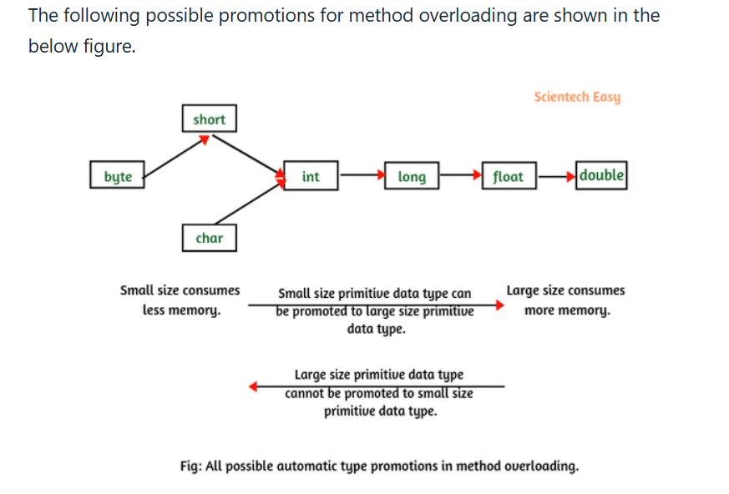

Example-1
Public Class first{
Static void m1(double a){
System.out.println(“double”);}
Static void m1(int a){
System.out.println(“int-arg”);}
Public static void main(String[]args){
m1(2); //exact match found because 2 is an integer
m1(1.5f);//exact match
}}
Output: int-arg
double-arg
Example-2
public class TypePro {
public void m1(double a) {
System.out.println(a*a);
}
public void m1(float a) {
System.out.println(a*a);
}
public static void main(String[] args) {
TypePro t = new TypePro();
t.m1(2); // Exact match is not found for passing argument 2 because 2 is an integer data type.
} }
Explanation:
1. When an exact match is not found for passing argument then the compiler finds the method with the smallest argument.
2. In the above example, float and double both belong to float category data type. Due to which an exact match is not found for passing argument 2 because 2 is an integer data type.
Therefore, the compiler finds the method with the smallest argument float rather than double. The float data type is a smaller size than double and consumes less memory.
Example 3:
package methodOverloading;
public class TypePro{
public void m1(double a) {
System.out.println(a+a);
}
public void m1(short a) {
System.out.println(a+a);
}
public static void main(String[] args) {
TypePro t = new TypePro();
t.m1(2); // Exact match is not found for passing argument 2 because 2 is an integer data type.
} }
Output:
4.0

Explanation:
1. In this example program, 2 is an integer whereas short belongs to integer category data type but small size primitive data type and double belongs to the float category data type. So, the exact match is not found.
2. Since the int (large size primitive data type) cannot be promoted to short (small size primitive data type). Therefore, 2 cannot be promoted to the short.
3. Since the small size primitive data type can be promoted to large size primitive data type. Therefore, 2 will be promoted to double and the compiler will call the method with a double argument.
Example 4:
package methodOverloading;
public class TypePro {
public void m1(byte a) {
System.out.println(a+a);
}
public void m1(short a) {
System.out.println(a+a);
}
public static void main(String[] args) {
TypePro t = new TypePro();
t.m1(10); // Exact match is not found because the method m1(byte) is not applicable for the argument (int).
} }
Output:
Compile time error

Explanation:
Since short and byte both are small size data types than int. Therefore, 10 cannot be promoted to them. The compiler will generate compile-time error.
Let’s take the most important example program for interview purpose.
Example 5:
package methodOverloading;
public class TypePro {
public void m1(int i) {
System.out.println("Hello");
}
public void m1(float f) {
System.out.println("Java");
}
public static void main(String[] args) {
TypePro t = new TypePro();
t.m1(10);
t.m1(10.5f);
t.m1('a');
t.m1(10l);
// t.m1(10.5); // Compile time error.
} }
Output:
Hello
Java
Hello
Java
Case 2:
Example 6:
public class TypePro {
public void m1(String s) {
System.out.println("Hello");
}
public void m1(Object o) {
System.out.println("Java");
}
public static void main(String[] args){
TypePro t = new TypePro();
t.m1(new Object()); // Exact match with object argument.
t.m1("Deep"); // Exact match with string argument.
t.m1(10);
t.m1(10.5f);
t.m1('a');
t.m1(null);
} }
Output:
Java
Hello
Java
Java
Java
Hello
Explanation:
1. The primitive data types such as boolean, byte, char, short, int, long, float, and double can be promoted to object.
2. In the case of null, null is valid for both string and object. So, which method will be called?
Since the object is the superclass of all the classes in Java. Thus, the object is a parent class and string is a child class.
While resolving the overloading method, the compiler always uses the presidency for the child type argument. So, the compiler will call the method with the string argument.
Case 3:
Example 7:
public class TypePro {
public void m1(String s) {
System.out.println("Hello");
}
public void m1(StringBuffer s) {
System.out.println("Java");
}
public static void main(String[] args){
TypePro t = new TypePro();
// t.m1(new Object() ); // Exact match not found because The method m1(String) is not applicable with object argument.
t.m1("Deep"); // Exact match with string argument.
t.m1(new StringBuffer()); // Exact match with string buffer parameter.
// t.m1(null); // The method m1(String) is ambiguous for the type TypePro.
} }
Output:
Hello
Java
Explanation:
1. The object is the parent class of both string class and the StringBuffer class. Here, String and StringBuffer both are child classes of the object class at the same level.
There is also no parent-child relationship between string and string buffer. So, both methods are matched at the same level. Therefore, the compiler is ambiguous for which method will be called?
Case 4:
Example 8:
public class Sum {
public void add(int a, float b) {
System.out.println(a+b);
}
public void add(float b, int a) {
System.out.println(a+b);
}
public static void main(String[] args) {
Sum s = new Sum();
s.add(10, 5.5f); // Exact matched.
s.add(10.5f, 1); // Exact matched.
// s.add(10, 10); // Ambiguous because both methods are matched. 10 is an int and can be promoted to float.
// s.add(10.5f, 10.2f); // No matched. Compile time error.
} }
Output:
15.5
11.5
Case 5:
Example 9:
public class Sum {
public void add(int x) {
System.out.println(x+x);
}
public void add(int... x){
// We can call this method by passing any int value including zero.
System.out.println(x);
}
public static void main(String[] args) {
Sum s = new Sum();
s.add(0); // Exact matched.
s.add(10); // Exact matched.
}
}
Output:
0
20

Case 6:
Example 10:
public class Animal {
}
public class Lion extends Animal {
}
public class FoodTest {
public void food(Animal a) {
System.out.println("Animals eat vegetarian and non-vegetarian food");
}
public void food(Lion l) {
System.out.println("Lions eat non-vegetarian food");
}
public static void main(String[] args) {
FoodTest ft = new FoodTest();
Animal a = new Animal(); // a is reference variable of Animal class and it is pointing the objects of Animal.
ft.food(a); // Exact matched.
Lion l = new Lion(); // l is reference variable of Lion class and it is pointing to the objects of Lion.
ft.food(l); // Exact matched.
Animal a1= new Animal();
ft.food(a1); // Exact matched.
ft.food(null); // Exact matched.
}
}
Output:
Animals eat vegetarian and non-vegetarian food
Lions eat non-vegetarian food
Animals eat vegetarian and non-vegetarian food
Lions eat non-vegetarian food
Explanation:
1. In method overloading, the resolution is always taken care of by the compiler based on the reference type only. Runtime object never plays any role in overloading.
2. In the case of null, Animal is the superclass of Lion class. See key points 2 of program 6.
Class Casting in Java | Generalization, Specialization
the process of the converting a one class type into another class type having the relationship between them through inheritance is called class casting (possible through type casting)
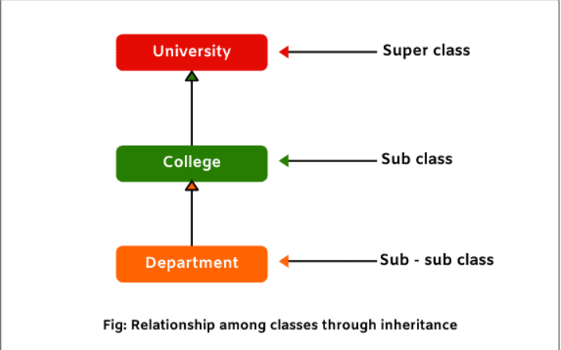

Generalization in Java with Example Program
the process of converting the subclass type into superclass type is called generalization in java
-this is because we are making the subclass to become more general so that the scope can be more widening
-this conversion is also called widening or upcasting in referenced data type
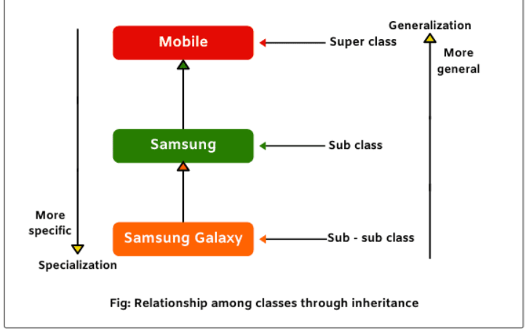
-if we talk about a mobile in general it may represent any kind of mobile
So here scope is widened
-suppose we talk about Samsung mobile then we come down one step in the hierarchy of inheritance and we have elimited any other kind of mobiles
-thus we are becoming more specific when we still come down to Samsung galaxy we are pointing only Samsung galaxy mobile and not any other Samsung mobile
-thus this is very specific this means that when we move down form superclass to subclass we are more specific
- thus we go back from subclasses to superclass we are becoming more general
-here we do not need a cast operator to perform generalization
-java compiler will do the implicit casting in generalization
public class A {
void m1() {
System.out.println("Superclass method");
}}
public class B extends A{
void m2() {
System.out.println("Subclass method");
}}
public class WideningTest {
public static void main(String[] args) {
A a; // a is a superclass reference variable.
a = (A)new B(); // generalization (widening) because a is referring to a subclass object.
a.m1();
}}
Output: Superclass method

Explanation:
1. In this example program, we have used superclass reference to refer to a subclass object. So, subclass object type will be converted into superclass type, as: a = (A)new B();
2. Now you can observe that we have called the m1() method of superclass but we are unable to call m2() method of subclass. This is because if we call m2() method as a.m2();, java compiler would generate an error message during compilation time.
So, in generalization, we can access all the methods of superclass but not subclass methods.
Suppose we override superclass method into subclass as shown in the below program 2, it is possible to access subclass method but not superclass method. Anyhow, we will get only 50% functionality of the program.
Example 2:override the superclass method in subclass to access subclass method through the generalization
public class A {
void m1() {
System.out.println("Superclass method"); }}
public class B extends A {
void m1() // Overriding superclass method.{
System.out.println("Subclass method");
}}
public class WideningTest {
public static void main(String[] args) {
A a; // a is a superclass reference variable.
a = (A)new B(); // generalization (widening) because a is referring to a subclass object.
a.m1(); }} Output: Subclass method
Specialization in Java with Example Program
- The conversion of a superclass type into subclass type is called specialization in java
- Specialization means going down from a more general form to more specific form , thus its scope is narrowed, hence this called narrowing or down casting in referenced data types
- Specialization is not safe because classes will be more and more specific ,in this case we will need cast operator
- Java will need cast operator
- Java compiler will do explicit casting in the specialization
public class A {
void m1() {
System.out.println("Superclass method");
}}
public class B extends A{
void m2(){
System.out.println("Subclass method");
}}
public class NarrowingTest {
public static void main(String[] args) {
B b; // b is a subclass reference variable.
b = (B)new A(); // specialization (narrowing) because b is referring to a superclass object.
a.m1();
}} Output:
Exception in thread "main" java.lang.ClassCastException:
inheritance.A cannot be cast to inheritance.B
Explanation:
As you observe in the above program, method call b.m1() is not executing the super class method. Similarly, if we call subclass method m2() as b.m2(); it will give the same error message. Hence, we cannot access any of the methods of the superclass or subclass in the specialization. We will get 0% functionality in this case.
The solution to this problem is available. We will not create an object of superclass as we did in the previous case. This time, we will create a reference of superclass to refer to subclass object and will use narrowing (specialization) concept. Look at the below example code.
Example 4:
public class A {
void m1() {
System.out.println("Superclass method");
}}
public class B extends A{
void m2() {
System.out.println("Subclass method");
}}
public class CastingTest {
public static void main(String[] args) {
A a; // a is a superclass reference variable.
a = new B(); // Superclass reference refers to the subclass object.
B b = (B)a; // Narrowing because we are converting class A's reference type as class B's type.
b.m1();
b.m2();
}}
Output:
Superclass method
Subclass method
Key Points to Remember:
1. If superclass reference refers to subclass object, all the methods of superclass are accessible but not subclass method.
2. If subclass reference refers to subclass object, all the methods of superclass and subclass are accessible because subclass objects avail a copy of superclass.
3. Generalization (widening) is performed by using subclass object, only methods of superclass are accessible. If we override methods of superclass into subclass, only subclass methods are accessible.
4. If specialization (narrowing) is performed by using superclass object, none of the superclass or subclass methods are accessible. It is useless.
5. If narrowing is performed by using subclass object, all the methods of superclass and subclasses can be accessed.

Upcasting and Downcasting in Java
What is Upcasting
When the reference variable of superclass refers to the object of subclass, it is known as upcasting in Java.
when the subclass object type is converted into the superclass type, this type of conversion is called upcasting. It is also called widening in Java.
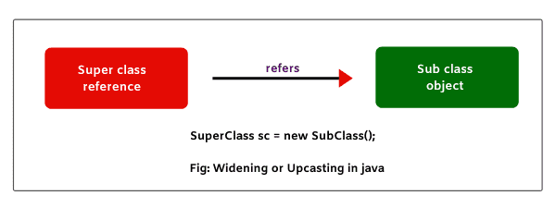
1. Superclass reference is used to refer to superclass object.
One o = new One();
In the above statement, class One’s reference o is pointing or referring to One’s object.
2. Similarly, subclass reference is used to point to subclass object.
Two t = new Two();
In this statement, class Two’s reference t is pointing to Two’s object.
In the above two statements, we do not need casting. This is because on the left side and on the right side of assignment operator (=), we have the same data type.
For example, in the first statement, o is a reference of class One. So, data type of o is One.
At right side of the assignment operator, we have a class One’s object. Data type of the class object is also One. Therefore, casting is not required in this case.

Till here, there is no need for casting. But when a reference of class refers to different class’s object, we need casting.
For example:
One o = new Two(); // class One's reference o is pointing to class Two's object.
In this statement, on the left side, the data type of reference o is One, but on the right side, we got object whose data type is Two. So, in this case, we will need casting.
We will convert object’s data type into class O using cast operator. We can do it like this:
One o = (One) new Two(); // Converting class Two's type into class One.
-Here, the subclass object type has converted into super class type. This kind of conversion is called upcasting or widening in Java.
-If we do not use the cast operator in the above case, even we will not get any error message. Java compiler will do the implicit casting.
Upcasting (Widening) Example Program
Let’s take an example program to see the effect of upcasting where superclass reference refers to subclass object.
Example 1:
public class One {
void m1() {
System.out.println("m1 method in class One");
} }
public class Two extends One {
void m2() {
System.out.println("m2 method in class Two");
} }
public class Test {
public static void main(String[] args)
{
One o = (One) new Two(); // Upcasting. Here, superclass reference o refers to subclass object.
o.m1();
// o.m2(); // Compile-time error message.
}
}
Output:
m1 method in class One
In this example program, superclass reference is pointing to subclass object. This means that subclass object type is converted into super class type. Now, observe that we are able to call m1() method of super class.
But when we are trying to call m2() method of subclass, we got error message: compile-time error. Hence, in upcasting or widening, we can call all methods of super class but not sub class methods.

Let’s take another example in which we will override the superclass method in subclass and will observe that can we access super class method and subclass method.
Example 2:
public class One {
void m1() {
System.out.println("m1 method in class One");
} }

public class Two extends One {
void m1() {
System.out.println("m1 method in class Two");
} }
public class Test {
public static void main(String[] args) {
One o = (One)new Two(); // Upcasting. Here, superclass reference o refers to subclass object.
o.m1();
}
}
Output:
m1 method in class Two
As you can observe in the program that it is possible to access sub class method but not super class method when super class method is overridden in sub class. This shows that you can access only 50% of the functionality.
Downcasting (Narrowing) in Java
When subclass reference refers to superclass object, it is called downcasting in Java.
when the subclass type is converted into superclass type, this type of conversion is called downcasting. It is also called narrowing in Java.
Look at the below figure where the subclass reference is pointing to a superclass object.
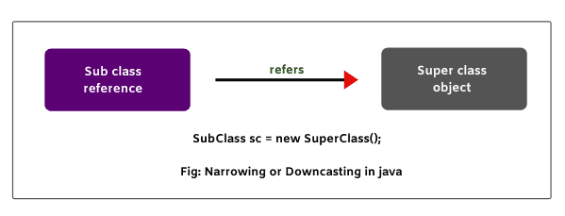
For example:
Two t = (Two) new One();
Here, we are converting superclass object type into subclass type. Therefore, we need a compulsory cast operator. If we perform it directly, Java compiler will give compile-time error.

Let’s consider the above example program where we will do downcasting and see what happens?
Example 3:
package classCasting;
public class One {
void m1() {
System.out.println("m1 method in class One");
}
}
public class Two extends One {
void m2() {
System.out.println("m2 method in class Two");
}
}
public class Test {
public static void main(String[] args) {
Two t = (Two) new One(); // Downcasting. Here, subclass reference t refers to superclass object.
t.m1();
t.m2();
}
}
Output:
Exception in thread "main" java.lang.ClassCastException:
classCasting.One cannot be cast to classCasting.Two
In the above example program, we have performed downcasting directly. Therefore, JVM is thrown an exception named ClassCastException at runtime.
So, with downcasting, we cannot access any of the methods of super class or subclass. So, let’s understand how downcasting is possible in Java?
How Downcasting is Possible?
To overcome this problem, we will have to modify the previous code. So, look at the following program code and modify it.
Example 4:
package classCasting;
public class One {
void m1() {
System.out.println("m1 method in class One");
}
}

public class Two extends One {
void m2() {
System.out.println("m2 method in class Two");
}
}
public class Test {
public static void main(String[] args)
{
One o = new Two(); // Superclass reference refers to subclass object.
Two t = (Two)o; // Converting super class reference type into subclass reference type.
t.m1(); // Calling m1 method using reference variable of subclass.
t.m2(); // Calling m1 method using reference variable of subclass.
}
}
Output:
m1 method in class One
m2 method in class Two
In the above example, the superclass reference type has converted into subclass reference type. Now, we can call both methods m1() and m2() using reference variable of sub class.
In the preceding code, you can observe that if we create an object of subclass, it is possible to access all the methods of superclass and subclass. In this way, downcasting is possible in Java.

