Step1: Install latest node.js

* We can use all node packages with npm command (node package manager) to manage dependencies.
* Make sure that you were installing in your default install directory i.e., c:/program files/nodejs.
* Because our IDE (Visual Studio) default configuration on above path.

Step2: Install the angular CLI (Command Line Interface)

* The angular cli should be installed on root folder (C:/InsuraceProject) which you created so that it will create node_modules where it will be having all the bundled of angular project
* To install please use the command npm install -g @angular/cli

Step3: creating angular project

* Create the project in the above path by using the command ng new applicationName
* While creating the project please make yes on routing and select scss for style sheets.
* SCSS is the advance style sheet by comparing CSS, please refer below snippet.
* 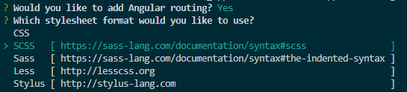
* After project created build the project with command ng build and to run the application use command ng serve then visit the browser with localhost:4200
* Ng build command is used mainly to build and publish in another server, when you using in your local you can directly use ng serve which it can take care building the application before serving.
* If you want to change the port or if you want to run another application use the command ng serve –port 4201

Step4: Importing existing project

* If you are importing the project by repository, please change the folder location in visual studio where you cloned.
* Just make update your node with latest npm i npm and use npm install
* Then you can directly serve using ng serve command.

Step5: Adding Bootstrap for styling.

* Before the bootstrap your styles will be a normal, please refer below snippet.
* 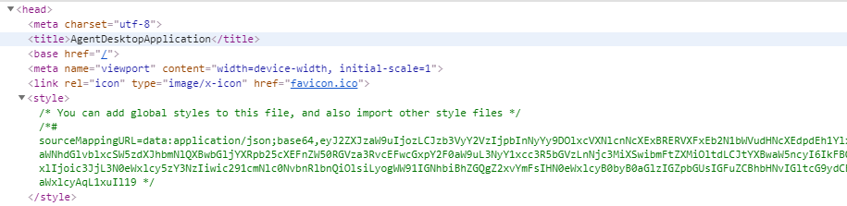
* Let install bootstrap using the command npm install bootstrap
* Once the installation is done open the angular.json and the bootstrap path in styles property
* 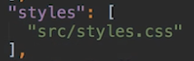 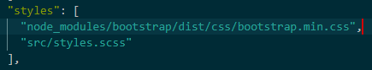
* Now after setting the path, you can check in the browser with bootstrap latest version.
* 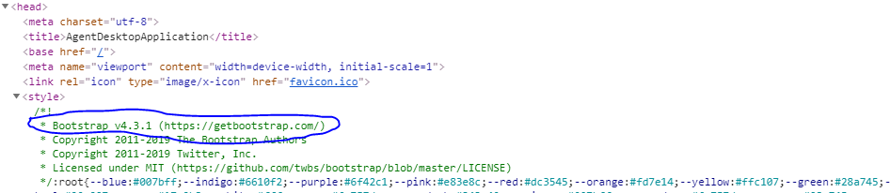
* Use the link to use all the styles related https://hackerthemes.com/bootstrap-cheatsheet/

Step6: How the angular app gets loaded and started.

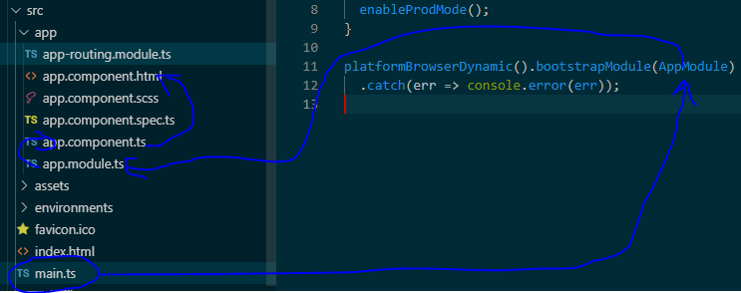

* First it will go to main.ts just like the main method in our application, on that whatever the class name (AppModule) you were seeing it will load that class from app.module.ts
* In app.module.ts file if you open the line of code is helps to load a component, bootstrap: [AppComponent] with that app.component.ts will be loaded.
* In app.component.ts file if you open you’ll see the below code
* @Component({
* selector: 'app-root',
* templateUrl: './app.component.html',
* styleUrls: ['./app.component.scss']
* })
* The above component will be loaded with selector some tag name, with that it will load the template url and app.component.html file will be loaded.
* If you see in index.html, we used in body tag i.e., <app-root></app-root>
* The meaning in index.html we are including the app.component.html file with the help of selector it will load in browser.
* 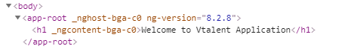

Step7: Let’s create another component

* Use the command to generate the component, ng generate component componentName

## Step8: App Routing Module

**Path: /src/app/app.routing.ts**

Routing for the Angular app is configured as an array of Routes, each component is mapped to a path so the Angular Router knows which component to display based on the URL in the browser address bar. The home route is secured by passing the AuthGuard to the canActivate property of the route.

The Routes array is passed to the RouterModule.forRoot() method which creates a routing module with all of the app routes configured, and also includes all of the Angular Router providers and directives such as the <router-outlet></router-outlet> directive. For more information on Angular Routing and Navigation see <https://angular.io/guide/router>.