**RecordNote**

**Version 1.0**

**User’s Manual**





**Suralta, Jhuls Bryan S.**

**BSIT 4**

**Revisions**

|  |  |
| --- | --- |
| **Date** | **Changes** |
| March 5, 2014 | Created an Icon for the Project  Created the Proper List Drop Box  Implemented Proper Manual Setup |

**Table of Contents**

**About 4**

**User Profile 4**

**The Application 4**

1. **Initial Activity 4**
2. **Creating a New RecordNote 5**
3. **Creating Columns 6**
4. **Editing Columns (only for Text types) 7**
5. **Color Pallet 8**
6. **RecordNote View 9**
7. **Type Of Records 12**

**List of Figures**

**Figure 1 4**

**Figure 2 5**

**Figure 3 6**

**Figure 4 6**

**Figure 5 7**

**Figure 6 8**

**Figure 7 9**

**Figure 8 10**

**Figure 9 11**

**Figure 10 12**

**List of Tables**

**Functionality Table 1 5**

**Functionality Table 2 5**

**Functionality Table 3 7**

**Functionality Table 4 7**

**Functionality Table 5 9**

**Functionality Table 6 10**

**Functionality Table 7 11**

**Functionality Table 8 12**

**About**

RecordNote is like an Excel app rather, but more of focus on making records, with the traditional column and row setup.

**User Profile**

For people who needs digital records and a way of recording it, hand held. Mostly people on sales are users of this kind of application, for listing prospects and monitoring purposes. Same goes for Doctors, for multi-tasking on different clients. All Digital, no paper.

**The Application**

1. 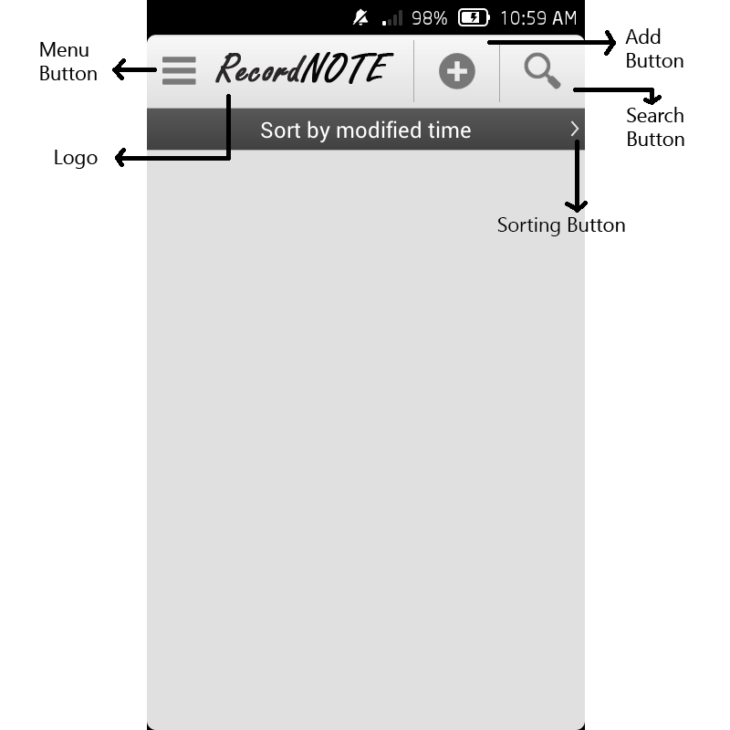**Initial Activity**

**Figure 1**

**Functionality Table 1**

|  |  |
| --- | --- |
| Menu Button | Opens the Side Menu(not implemented yet) |
| Add Button | Creates a New RecordNote |
| Search Button | Searches a Record |
| Sorting Button | Sorts the List of Records(not implemented yet) |

1. **Creating a New RecordNote**

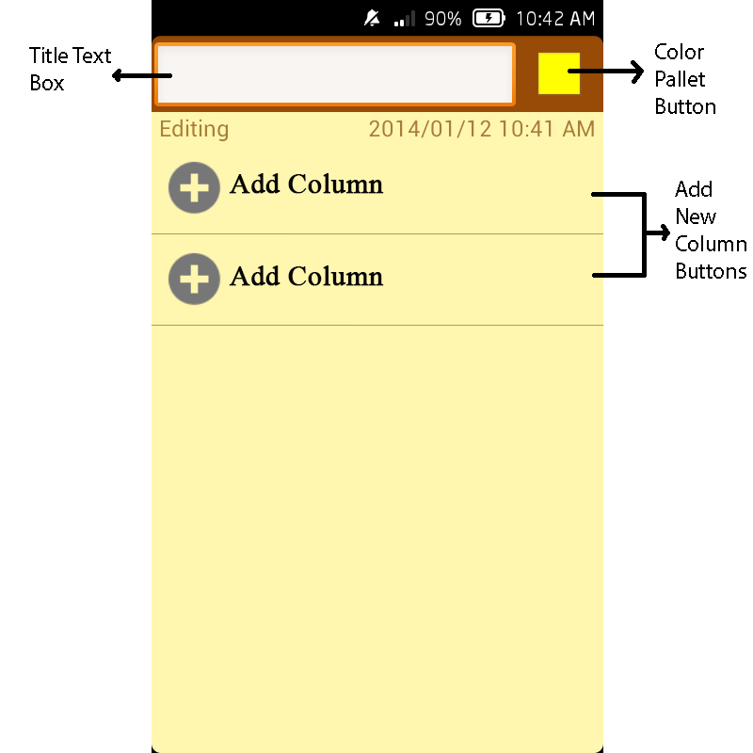

**Figure 2**

**Functionality Table 2**

|  |  |
| --- | --- |
| Title Text Box | For User Defined Title |
| Color Pallet Button | Opens the Color Pallet |
| Add New Column Buttons | Creates a new Column |

1. 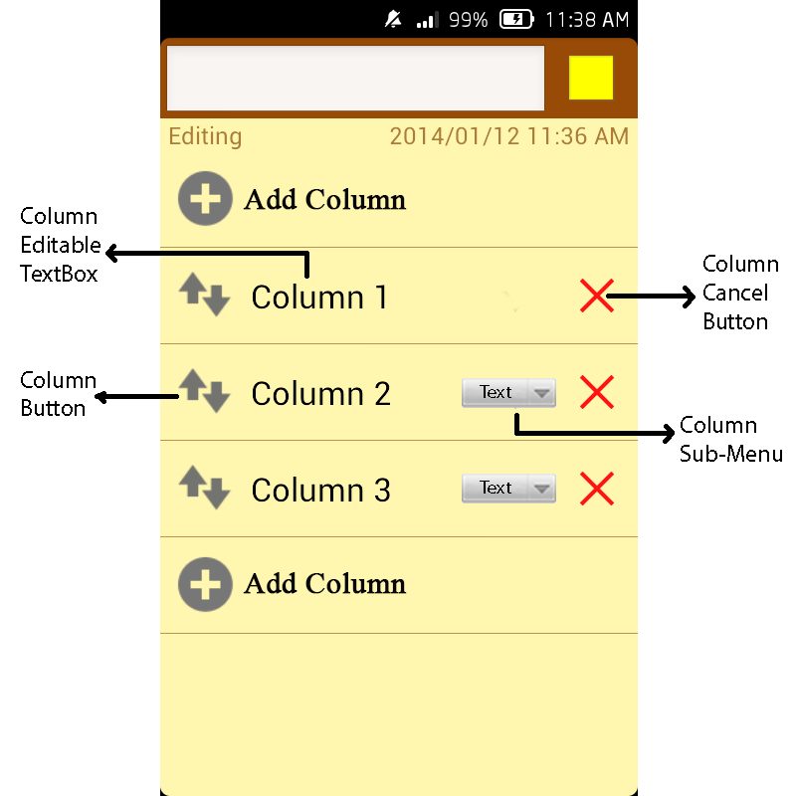**Creating Columns**

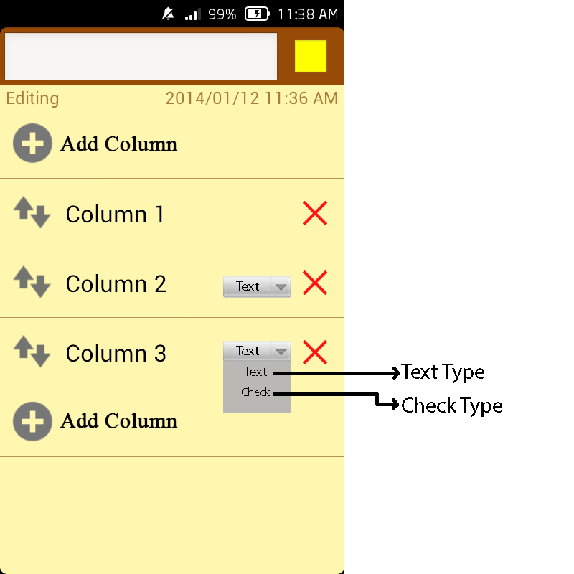**Figure 3**

**Figure 4**

**Functionality Table 3**

|  |  |
| --- | --- |
| Column Editable Text Box | Changes the Column Name/Label |
| Column Button | Opens the Activity of Creating Rows |
| Column Cancel Button | Deletes the Column |
| Column Sub-Menu | Opens a list of Column Types; see Figure 4 |

1. **Editing Columns (only for Text types)**

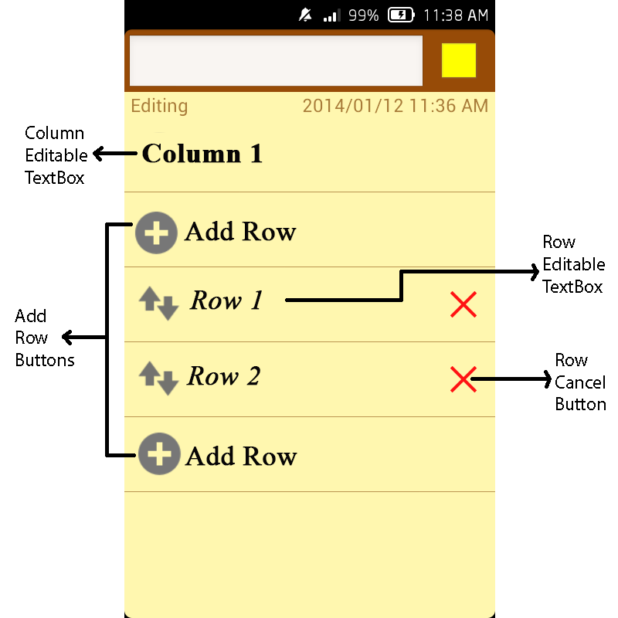

**Figure 5**

**Functionality Table 4**

|  |  |
| --- | --- |
| Column Editable TextBox | Changes the Column Name |
| Add Row Buttons | Creates New Rows |
| Row Editable TextBox | Changes the Row Text |
| Row Cancel Button | Deletes the Row |

1. **Color Pallet**

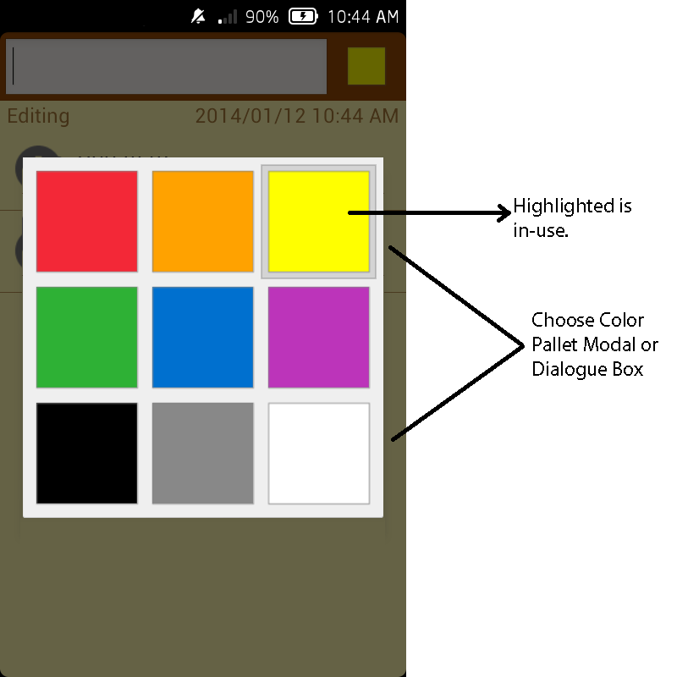

**Figure 6**

1. **RecordNote View**

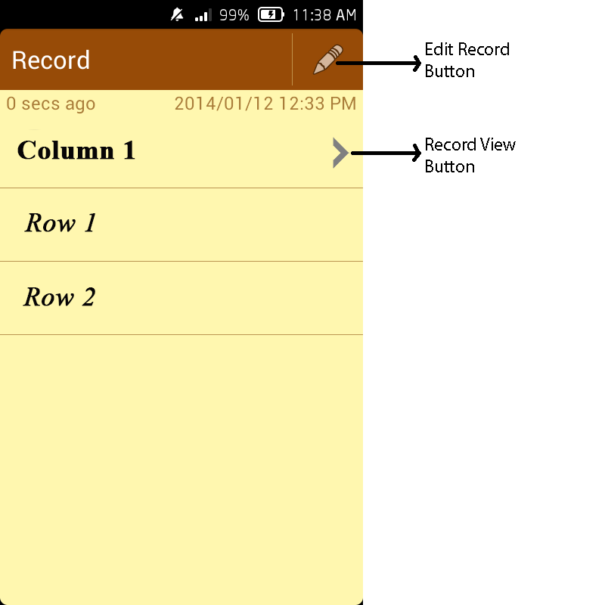

**Figure 7**

**Functionality Table 5**

|  |  |
| --- | --- |
| Edit Record Button | Allows you to enter editing again |
| Record View Button | Opens the Column Fragments |

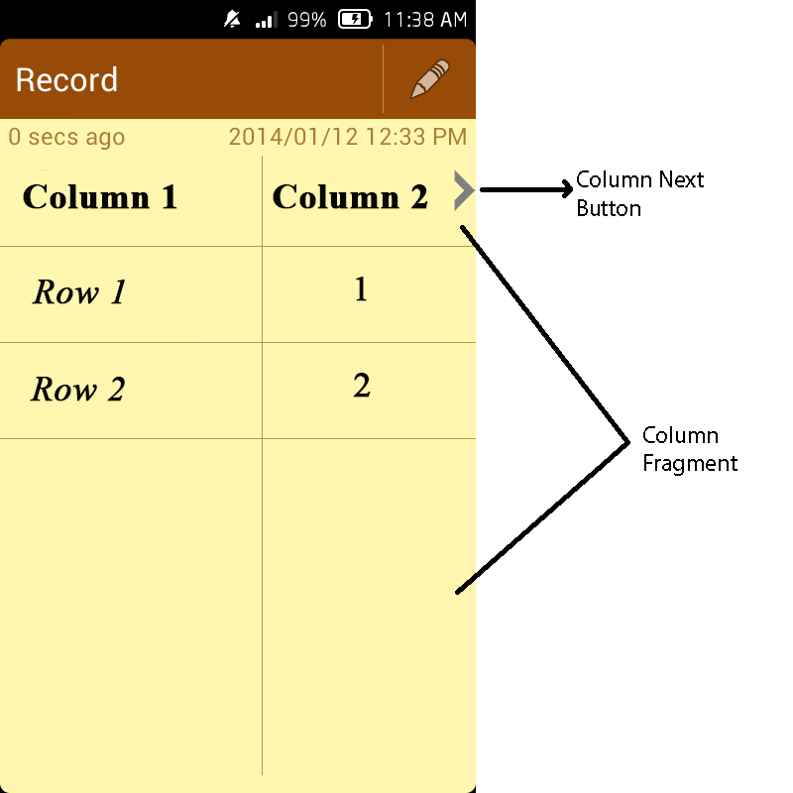

**Figure 8**

**Functionality Table 6**

|  |  |
| --- | --- |
| Column Next Button | Shows the next Column in the Column Fragment |
| Column Fragment | Displays the other Columns, while the Main Column is Open |

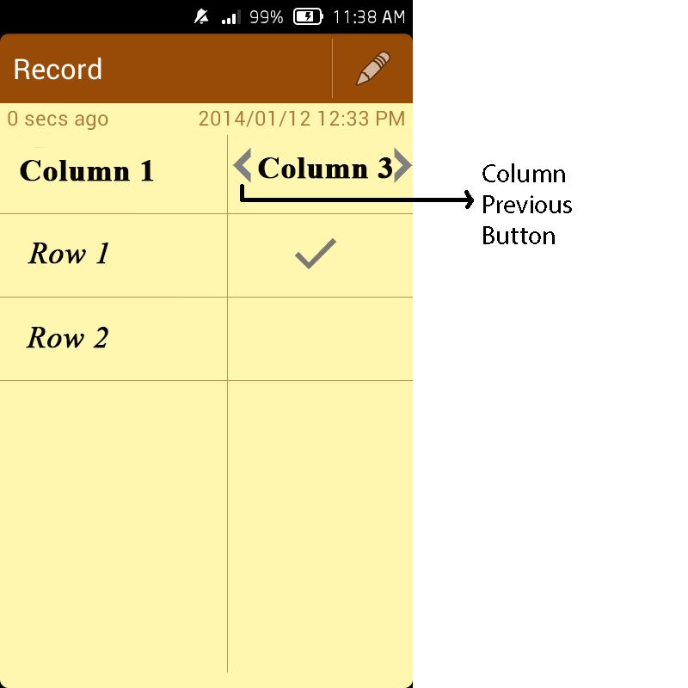

**Figure 9**

**Functionality Table 7**

|  |  |
| --- | --- |
| Column Previous Button | Shows the previous Column in the Column Fragment |

1. **Type Of Records**

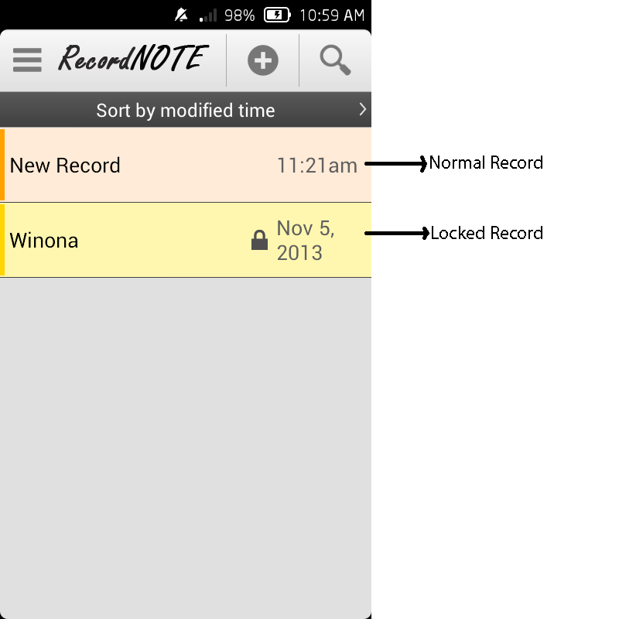

**Figure 10**

**Functionality Table 8**

|  |  |
| --- | --- |
| Normal Record | A Normal Record |
| Locked Record | A Locked Type Record(not yet implemented) |