title: "Scaffold — A Comprehensive Codebase Walkthrough"
author: "Project Documentation"
date: "July 2026"
geometry: margin=1in
fontsize: 11pt
mainfont: "Calibri"
monofont: "Cascadia Mono"

Foreword
This document is a single, exhaustive walkthrough of the Scaffold codebase — formerly branded as DevSpace, before the product's name was simplified. Scaffold is a real-time, all-in-one developer workspace built with Laravel 11 on the server and Inertia.js + React 19 on the client. The application is hosted on Render and uses Neon Postgres as its primary database. It began its life as a local XAMPP/MySQL project and was migrated to the hosted stack specifically because the GitHub App integration required HTTPS, public DNS, and a stable callback URL — things a localhost tunnel could not provide for production demos.
The goal of this document is simple: someone reading only this file should walk away with roughly 90 % of the working knowledge needed to navigate, modify, extend, debug, or deploy the application. No prior familiarity with the codebase is assumed. We move from the highest abstractions (what is Scaffold?) through every layer of architecture, file inventory, algorithm, integration, and operational detail, and end with the file index and glossary.

How to Read This Document
The doc is organized into 17 Parts plus two appendices. Each Part is self-contained — you can read them top-to-bottom, or jump to a specific Part if you need a targeted answer. Every Part ends with an Evidence section listing every file path that was consulted while writing it. Where the document quotes source verbatim (configuration values, channel authorization callbacks, etc.), the quote is followed by an annotation explaining what it controls.
If a fact could not be verified against the codebase (e.g. team-intent decisions, production-only configs), it is explicitly marked [ASK USER] or [TODO]. The existing docs/codebase/CONCERNS.md document collects the most important of these in one place — see Part XVII.

Conventions
- File paths are absolute relative to the project root (e.g. app/Models/User.php rather than App\Models\User).
- Code excerpts are wrapped in triple-backtick fences with the language hint (php, js, jsx, sh, apache, json, mermaid).
- Mermaid diagrams are embedded inline. Render them in any modern Markdown viewer or rely on the included SVG fallbacks.
- "Pusher protocol", "RS256", "PresenceChannel" and other technical acronyms are defined in Appendix B — Glossary.

Scope
This walkthrough covers every PHP file under app/, every JSX file under resources/js/, every configuration file under config/, every migration under database/migrations/, every Docker-related file under docker/, the Dockerfile at the project root, the test suite under tests/, the front-end build configuration (vite.config.js, package.json, composer.json), and the HTTP entry points (routes/web.php, routes/channels.php, routes/console.php, bootstrap/app.php). The 7 existing reference documents under docs/codebase/ (STACK.md, STRUCTURE.md, ARCHITECTURE.md, CONVENTIONS.md, INTEGRATIONS.md, TESTING.md, CONCERNS.md) are summarized but not duplicated; this document is the integrative narrative.

Part I — The Big Picture

1.1 What is Scaffold?
Scaffold is a project workspace for engineering teams. Each user signs up, creates one or more *Workspaces* (the top-level organizational unit), and inside each Workspace can create any number of *Projects*. Projects carry the work breakdown: *Tasks* (Kanban board + dependency graph), *Threads* (Reddit-style nested discussions), *Wikis* (markdown documentation with sidebar nav), *GitHub Integration* (sync tasks to GitHub Issues, surface branches/PRs/issues in a feed), *Reactions* (emoji reactions on every thread/comment/task), and *Notifications* (in-app via a real-time bell). Real-time presence, task locking, and editor baton are first-class features powered by Laravel Reverb WebSockets.
The product is a single-tenant developer tool — there is no organization concept above the *Workspace*; instead, each *Workspace* has exactly one *Owner* and zero or more *Members*. Permissions are binary: workspace owner can do anything, members can do most things (except delete the workspace, manage labels, or pin threads). Anyone else is forbidden via controller-level abort(403) checks — Policies/Gates are not used.

1.2 High-Level Architecture
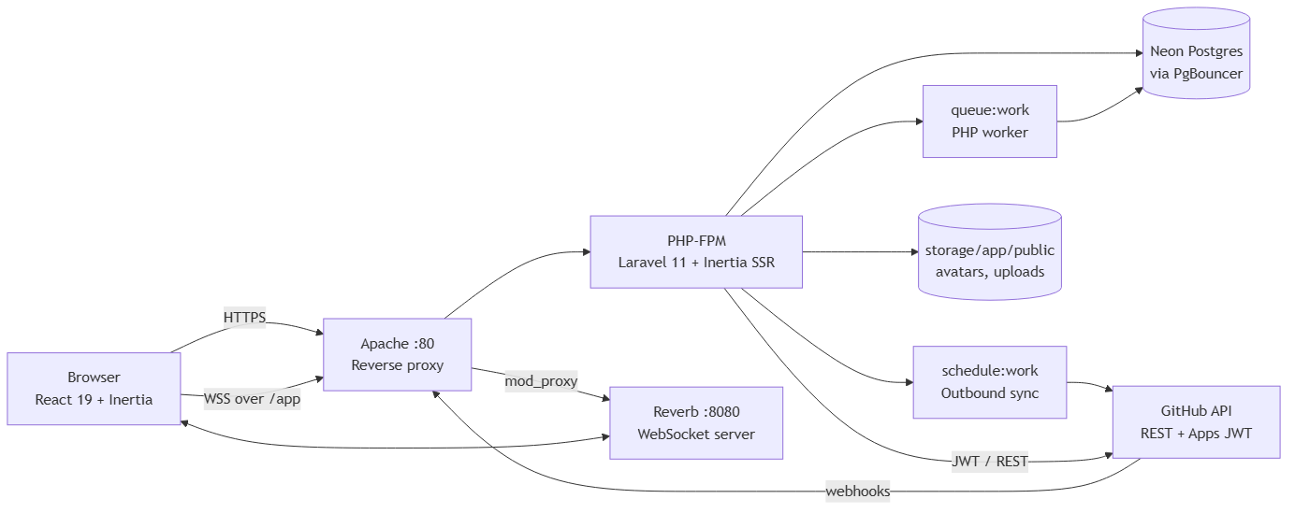
Figure 1: Diagram
The single Docker container is the entire backend (Apache + Laravel + Reverb + queue worker + scheduler). The database is hosted on Neon as a serverless Postgres instance over PgBouncer. The browser talks to Apache over HTTPS for HTML/Inertia payloads and over wss through a reverse-proxied path /app (and wss-pusher-protocol REST on /apps) for WebSocket events. GitHub integration is bidirectional: outbound API calls (creating/updating GitHub Issues from Scaffold tasks) and inbound webhooks (/webhooks/github, public, signature-verified).

1.3 Domain Map
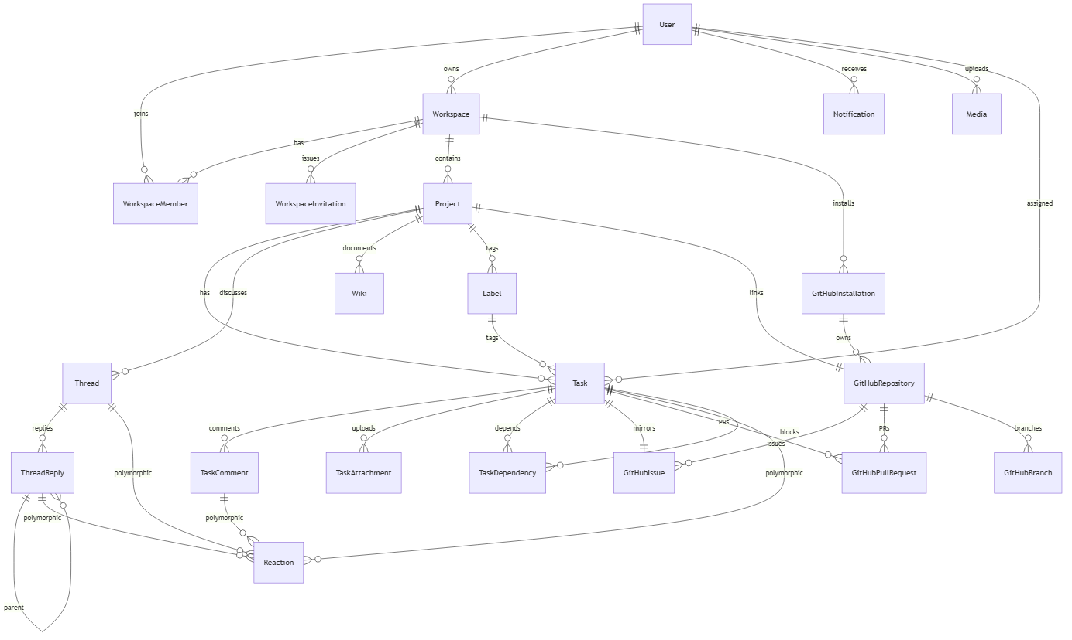
Figure 2: Diagram
Twenty-two tables. (Polymorphic target is the source of every *able_* column — media.mediable_*, reactions.reactable_*.) The full table inventory with column types appears in Part IV — The Database.

1.4 User Journey in One Sentence
A new user *registers* (with optional profile bio + recovery question), *creates a workspace*, *invites teammates* (who receive in-app notifications and accept via token URL), *creates a project*, *adds tasks* (which they can drag on a Kanban board or position in a flow graph; dependencies cannot form cycles thanks to a BFS guard), *discusses work in threaded conversations* (with nested replies, reactions, and a single "definitive answer" marker), *documents* their wiki pages, *links* a GitHub repository (after installing the GitHub App to mint an installation token), and *watches* commits/PRs/issues flow in via the activity feed as webhooks land.

1.5 Why These Tools?
Choice | Reason
Laravel 11 | Eloquent, queues, broadcasting, testing, and a route/binding system that lets us express nested resources (workspaces.projects.tasks) with almost no ceremony.
Inertia.js v3 | Eliminates the API layer for the read paths — every controller just calls Inertia::render('Page', $props). Three.js / Tailwind assets stay SSR-friendly.
React 19 + Vite 5 | Modern component model, fast HMR, typed-by-discipline via JSX. Vite produces a public/build directory that Apache serves directly.
Tailwind CSS 4 | Utility classes generated on-demand; no tailwind.config.js needed — config is in the CSS via @theme.
Laravel Reverb | First-party Laravel WebSocket server using the Pusher protocol. Auth via routes/channels.php. No third-party SaaS dependency.
Neon Postgres | Serverless Postgres with built-in branching and HTTP-friendly pooling. We pay only for actual usage during the demo.
GitHub Apps | Tokenless, per-installation access to repositories. Installation tokens are valid 1 hour; we cache them for 55 minutes to be safe.
Docker (single container) | Apache + Reverb + queue:work + schedule:work + reverb:start are all started from docker/start.sh. One Render service.

1.6 Evidence
- README.md — single-line product description
- routes/web.php — every HTTP surface the walkthrough refers to
- routes/channels.php — channel authorization (recapped in Part V)
- app/Models/*.php — 20 Eloquent models used in the ER diagram
- Dockerfile, docker/start.sh, docker/000-default.conf — single-container hosting
- config/database.php — pgsql connection with PDO::ATTR_EMULATE_PREPARES = true
- app/Database/PostgresConnection.php — Neon-specific boolean binding workaround

Part II — The Stack

2.1 Composer (`composer.json`)
The runtime consists of:
Package | Version | Purpose
php | ^8.2 | Runtime
laravel/framework | ^11.0 | Web framework, ORM, queues, broadcasting
inertiajs/inertia-laravel | * | SSR/CSR adapter — turns Eloquent models into React props
laravel/reverb | ^1.0 | WebSocket server (Pusher-protocol)
pusher/pusher-php-server | ^7.2 | Server SDK used by Reverb to publish events
firebase/php-jwt | ^7.0 | JWT minting for GitHub App authentication (RS256)
laravel/tinker | ^2.9 | REPL (dev only)
Development only: fakerphp/faker, laravel/pint, laravel/sail, mockery/mockery, nunomaduro/collision, phpunit/phpunit ^10.5, spatie/laravel-ignition.
No third-party Composer packages are used beyond Laravel + Inertia + Reverb + JWT + Pusher SDK. Everything else is hand-rolled — there is no Breeze, no Sanctum, no Spatie permissions, no Horizon. The auth flow is custom, the authorization checks are inline abort(403) calls, and there is no admin panel beyond the workspace owner.

2.2 NPM (`package.json`)
Runtime dependencies (delivered in public/build/assets/*.js):
- @inertiajs/react ^3.0.2 — Inertia React bindings (Link, useForm, usePage, router).
- @hello-pangea/dnd ^18.0.1 — Kanban drag-and-drop.
- @xyflow/react ^12.10.2 — Node graph (Flow view).
- @tailwindcss/vite ^4.2.2 + tailwindcss ^4.2.2 — Tailwind v4 (no JS config).
- @vitejs/plugin-react ^5.2.0 — Fast Refresh.
- react ^19.2.4 + react-dom ^19.2.4.
- react-markdown ^10.1.0 + remark-gfm ^4.0.1 + rehype-raw ^7.0.0 + rehype-sanitize ^6.0.0 — markdown rendering with GFM tables and sanitization.
- highlight.js ^11.11.1 — code-block syntax highlighting.
- date-fns ^4.1.0 — relative time ("2 hours ago").
- lucide-react ^1.7.0 — icon set.
Dev dependencies (build tooling):
- vite ^5.0, laravel-vite-plugin ^1.0.
- laravel-echo ^2.3.4, pusher-js ^8.5.0 — These are technically in devDependencies, but they are imported at runtime by resources/js/echo.js. See Part XVII — Concerns for the implications.
- axios ^1.6.4 — also imported at runtime by resources/js/bootstrap.js and many components.
> Deployment hazard: a future npm ci --omit=dev will strip Echo, Pusher, and axios from the bundle. package.json should move these to dependencies. The current Dockerfile only runs composer install --no-dev; npm ci is not invoked at all — the production build relies on the committed public/build/ directory.

2.3 Vite (`vite.config.js`)
plugins: [
tailwind(),
laravel({ input: ['resources/css/app.css', 'resources/js/app.jsx'], refresh: true }),
react(),
],
resolve: { alias: { '@': path.resolve(__dirname, 'resources/js') } },
Two entry points: the CSS (@tailwind base/components/utilities) and the JSX entry. Tailwind v4 needs no config file; the @tailwindcss/vite plugin does all the work. The @ alias lets components import via import Button from '@/components/ui/Button.jsx'.

2.4 Frontend Bootstrap Chain
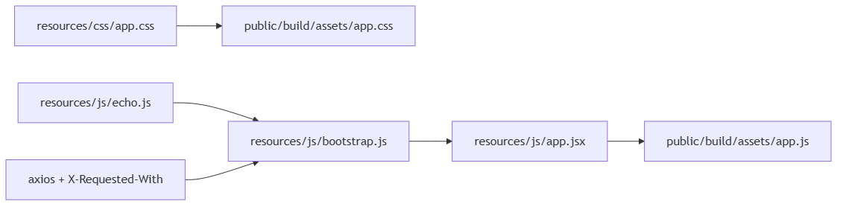
Figure 3: Diagram
resources/js/app.jsx calls createInertiaApp({ resolve: (name) => resolvePageComponent('./pages/${name}.jsx', import.meta.glob('./pages/**/*.jsx')) }). All 17 pages and 25 components are lazy-imported. Mounted into a React 19 root with <App {...props} />. Progress bar color is #8b5e3c (the Scaffold brown).

2.5 Database Drivers
config/database.php defines five connections:
- sqlite — test env (:memory:), default for DB_CONNECTION=sqlite.
- pgsql — the Neon connection. Sets PDO::ATTR_EMULATE_PREPARES = true and a search_path: 'public'. (See Part IV — The Database for why this matters.)
- mysql — local dev default. strict = true, engine = null, optional MYSQL_ATTR_SSL_CA.
- mariadb — mirror of mysql with utf8mb4_uca1400_ai_ci collation.
- sqlsrv — defined but unused.
Queue driver (config/queue.php) defaults to database (uses jobs table). Cache (config/cache.php) defaults to database (uses cache table). Sessions (config/session.php) default to database (uses the sessions table).

2.6 Reverb Configuration (`config/reverb.php`)
The full config (verbatim key blocks):
'servers' => [
'reverb' => [
'host' => env('REVERB_SERVER_HOST', '0.0.0.0'),
'port' => env('REVERB_SERVER_PORT', 8080),
'path' => env('REVERB_SERVER_PATH', ''),
'hostname' => env('REVERB_HOST'),
'options' => ['tls' => []], // TLS terminated at Apache
'max_request_size' => env('REVERB_MAX_REQUEST_SIZE', 10_000),
'scaling' => [
'enabled' => env('REVERB_SCALING_ENABLED', false),
'channel' => env('REVERB_SCALING_CHANNEL', 'reverb'),
'server' => [
'url' => env('REDIS_URL'),
'host' => env('REDIS_HOST', '127.0.0.1'),
'port' => env('REDIS_PORT', '6379'),
// ...
],
],
'pulse_ingest_interval' => env('REVERB_PULSE_INGEST_INTERVAL', 15),
'telescope_ingest_interval' => env('REVERB_TELESCOPE_INGEST_INTERVAL', 15),
],
],
'apps' => [
'provider' => 'config',
'apps' => [[
'key' => env('REVERB_APP_KEY'),
'secret' => env('REVERB_APP_SECRET'),
'app_id' => env('REVERB_APP_ID'),
'options' => [
'host' => env('REVERB_HOST'),
'port' => env('REVERB_PORT', 443),
'scheme' => env('REVERB_SCHEME', 'https'),
'useTLS' => env('REVERB_SCHEME', 'https') === 'https',
],
'allowed_origins' => ['*'], // open during demos; tighten for prod
'ping_interval' => env('REVERB_APP_PING_INTERVAL', 60),
'activity_timeout' => env('REVERB_APP_ACTIVITY_TIMEOUT', 30),
'max_connections' => env('REVERB_APP_MAX_CONNECTIONS'),
'max_message_size' => env('REVERB_APP_MAX_MESSAGE_SIZE', 10_000),
'accept_client_events_from' => env('REVERB_APP_ACCEPT_CLIENT_EVENTS_FROM', 'members'),
]],
],
What this controls**:
- The server binds 0.0.0.0:8080 (loopback to Apache via 127.0.0.1:8080). Apache vhost (Part III) proxies the public WebSocket traffic to /app.
- The app is a single Pusher-protocol application exposed at wss://host:port/app and https://host:port/apps. Clients need to know REVERB_APP_KEY (compiled into the front-end bundle as VITE_REVERB_APP_KEY).
- allowed_origins = ['*'] — any origin can connect. Authorization is delegated to routes/channels.php.
- accept_client_events_from = 'members' — only authenticated channel members can broadcast client events (e.g. the request-control whisper used in TaskModal). Unauthenticated POSTs to /apps/events return 403.
- scaling.enabled = false by default. Enabling requires Redis and a multi-instance deployment.
- Pulse and Telescope ingest intervals default to 15 s (Laravel Pulse/Telescope hooks for observability).

2.7 Evidence
- composer.json — every runtime + dev package
- package.json — every JS runtime + dev dependency
- vite.config.js — Vite config (Tailwind plugin + alias)
- config/reverb.php — Reverb server + app config (recapped above)
- config/broadcasting.php — broadcaster default = BROADCAST_CONNECTION, plus Pusher/Reverb/Ably/log/null
- config/database.php — connection definitions
- config/cache.php, config/queue.php, config/session.php — driver defaults
- config/services.php — github block (4 keys)
- resources/js/app.jsx, resources/js/bootstrap.js, resources/js/echo.js

Part III — From XAMPP to Render

3.1 The Origin Story
Scaffold began as a coursework project on a developer laptop running XAMPP (Apache + MySQL + PHP). The first cut used:
- PHP's built-in php artisan serve for the HTTP server.
- MySQL on 127.0.0.1:3306 via XAMPP's bundled MariaDB.
- Email via MAIL_MAILER=log (no real SMTP needed for development).
- Queue via QUEUE_CONNECTION=sync (jobs executed inline, never persisted).
For a localhost demo, every requirement was satisfied. The application booted, tasks could be created, the Kanban board updated locally, threads were nestable, and the wiki rendered markdown.
Then the GitHub App integration was added. GitHub Apps require:
1. A publicly accessible callback URL to receive installation events.
2. HTTPS (or GitHub will warn, and certain endpoints will refuse to talk).
3. A webhook URL that GitHub can POST to on push, PR, and issue events.
4. The ability to register the app's Webhook secret at production parity.
A localhost laptop behind a Cloudflare Tunnel can sometimes meet these — but it goes down when the laptop sleeps, it changes DNS when the ISP rotates IPs, and there's no way for a teammate to test a PR without screen-sharing. So the project was migrated to a hosted environment.

3.2 Why Render?
Render was chosen because:
- It supports a single Docker container (our Dockerfile) — no forcing a separate worker service for Reverb.
- It provides persistent disk mounts for /var/www/html/storage.
- It exposes a stable DNS name with free TLS via Let's Encrypt.
- It supports automatic deploys on Git push.
- It's free-tier affordable for a demo.

3.3 Why Neon?
Neon was chosen because:
- It's serverless Postgres — no DevOps overhead, no VM to manage, no backup cron.
- It supports branches (copy-on-write) so each PR can have its own database without spinning up a new instance.
- The free tier is generous enough for a demo.
- It's reachable over the public internet with TLS.
- It's PgBouncer-pooled, which is convenient but required us to add the PDO::ATTR_EMULATE_PREPARES = true workaround in config/database.php (see Part IV).

3.4 What the Migration Required
The migration was 90 % environment variables and 10 % code. Specifically:
Concern | XAMPP / Local | Render / Neon
HTTP server | php artisan serve | Apache 2 (via php:8.2-apache base image)
WebSocket | php artisan reverb:start standalone | reverb:start inside the same container
Database | MySQL on 127.0.0.1 | Neon Postgres over PgBouncer
Schema migration | php artisan migrate against MySQL | php artisan migrate --force against Postgres
Reverse proxy | none | Apache mod_proxy for /app and /apps
TLS | none | terminated by Render (Apache listens on 80 internally)
Migrations: $withinTransaction = false | not needed | required because PgBouncer rejects DDL inside a transaction
Booleans | integer 0/1 | Postgres boolean type → required PostgresConnection subclass to re-encode true/false strings under emulated prepares
Static assets | php artisan serve serves public/ | public/build/ committed; Apache serves it
Queue worker | not needed (sync) | php artisan queue:work background process
Scheduler | not used | php artisan schedule:work drives github:sync-outbound every 5 min

3.5 Hosting Topology
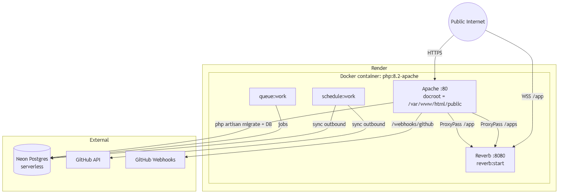
Figure 4: Diagram

3.6 What the Docker Container Actually Does
The Dockerfile is short and explicit:
FROM php:8.2-apache
RUN apt-get install -y git curl libpng-dev libonig-dev libxml2-dev zip unzip \
libpq-dev libzip-dev libfreetype6-dev libjpeg62-turbo-dev
RUN docker-php-ext-install pdo pdo_pgsql pgsql gd zip bcmath opcache pcntl
RUN a2enmod rewrite proxy proxy_http proxy_wstunnel
COPY docker/000-default.conf /etc/apache2/sites-available/000-default.conf
COPY --from=composer:latest /usr/bin/composer /usr/bin/composer
WORKDIR /var/www/html
COPY . .
RUN composer install --no-interaction --optimize-autoloader --no-dev
RUN chown -R www-data:www-data /var/www/html
EXPOSE 80
CMD ["/var/www/html/docker/start.sh"]
Apache is configured with mod_proxy, mod_proxy_http, and mod_proxy_wstunnel (the WebSocket tunneling module — without this, Apache cannot proxy WebSocket upgrades to Reverb).
The startup script (docker/start.sh) is the heart of the container:
#!/bin/sh
set -e
php artisan migrate --force
php artisan storage:link >/dev/null 2>&1 || true
php artisan queue:work --sleep=3 --tries=3 --timeout=90 &
php artisan schedule:work &
php artisan reverb:start --host=127.0.0.1 --port=8080 &
trap 'kill "$QUEUE_PID" "$SCHEDULE_PID" "$REVERB_PID" 2>/dev/null || true' TERM INT EXIT
apache2-foreground
Order matters:
1. Migrate first so the schema is current before any queue worker tries to read/write.
2. storage:link symlinks public/storage → storage/app/public. Errors swallowed because the symlink may already exist.
3. Queue worker starts in background; this is what processes ProcessGitHubWebhookJob and SyncOutboundGitHubIssueJob.
4. Scheduler starts in background; this drives Schedule::command('github:sync-outbound')->everyFiveMinutes().
5. Reverb starts in background on 127.0.0.1:8080 (loopback only — only Apache reaches it).
6. Apache starts in foreground — when this exits, the trap fires and kills the three background processes.
7. trap ensures a clean shutdown on TERM/INT/EXIT (otherwise orphaned PHP processes would linger).
The Apache vhost (docker/000-default.conf) sets up the reverse proxy:
<VirtualHost *:80>
DocumentRoot /var/www/html/public
<Directory /var/www/html/public>
Options -Indexes +FollowSymLinks
AllowOverride All
Require all granted
</Directory>
ProxyPass /app ws://127.0.0.1:8080/app
ProxyPassReverse /app ws://127.0.0.1:8080/app
ProxyPass /apps http://127.0.0.1:8080/apps
ProxyPassReverse /apps http://127.0.0.1:8080/apps
ErrorLog ${APACHE_LOG_DIR}/error.log
CustomLog ${APACHE_LOG_DIR}/access.log combined
</VirtualHost>
/app proxies WebSocket traffic (Reverb uses /app for the WebSocket endpoint). /apps proxies the Pusher HTTP API (subscribe to private channels, publish events) which Reverb exposes at /apps.

3.7 What the Front-End Needs at Build Time
The Reverb front-end is wired in resources/js/echo.js:
import Echo from 'laravel-echo';
import Pusher from 'pusher-js';
window.Pusher = Pusher;
window.Echo = new Echo({
broadcaster: 'reverb',
key: import.meta.env.VITE_REVERB_APP_KEY,
wsHost: import.meta.env.VITE_REVERB_HOST || window.location.hostname,
wsPort: import.meta.env.VITE_REVERB_PORT ? parseInt(import.meta.env.VITE_REVERB_PORT) : 80,
wssPort: import.meta.env.VITE_REVERB_PORT ? parseInt(import.meta.env.VITE_REVERB_PORT) : 443,
forceTLS: (import.meta.env.VITE_REVERB_SCHEME ?? 'https') === 'https',
enabledTransports: ['ws', 'wss'],
});
These VITE_* env vars are baked into the production bundle at vite build time. The Dockerfile does not run vite build; it relies on the committed public/build/ directory. This is a deployment hazard if you ever forget to rebuild after changing the env vars.

3.8 Evidence
- Dockerfile — base image, extensions, CMD
- docker/start.sh — startup orchestration
- docker/000-default.conf — Apache vhost + ProxyPass for /app + /apps
- config/database.php — PDO::ATTR_EMULATE_PREPARES = true
- config/services.php — GitHub App config
- app/Database/PostgresConnection.php — boolean re-encoding
- database/migrations/* — every migration has public $withinTransaction = false;
- routes/console.php — Schedule::command('github:sync-outbound')->everyFiveMinutes();
- resources/js/echo.js — front-end Reverb client
- vite.config.js — Tailwind plugin + @ alias

Part IV — The Database

4.1 Schema at a Glance
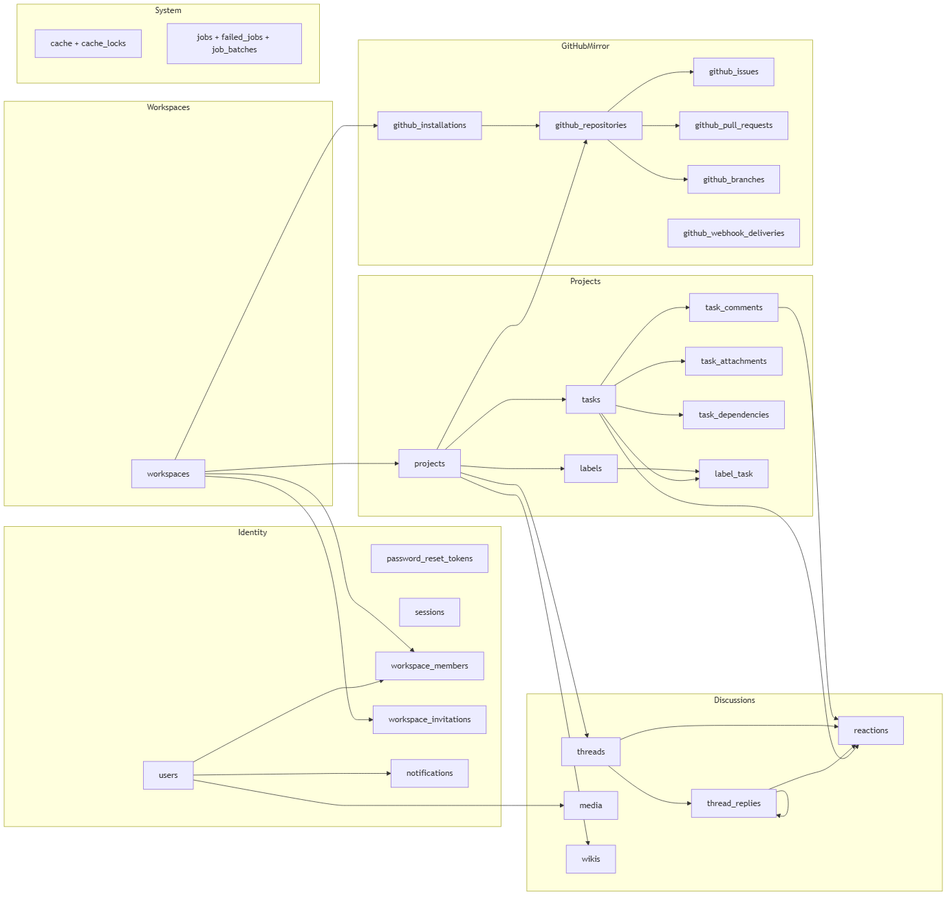
Figure 5: Diagram

4.2 Migrations — Full Inventory
> Every Laravel migration in database/migrations/ in chronological order. The down() actions are summarized; up() is the schema of record.

4.2.1 `0001_01_01_000000_create_users_table.php`
Creates three tables:
- users: id PK · name string · email string UNIQUE · email_verified_at timestamp NULL · password string · remember_token string NULL · created_at · updated_at.
- password_reset_tokens: email PK · token string · created_at NULL.
- sessions: id string PK · user_id BIGINT NULL INDEX (no FK) · ip_address string(45) NULL · user_agent text NULL · payload longText · last_activity integer INDEX.

4.2.2 `0001_01_01_000001_create_cache_table.php`
- cache: key PK string · value mediumText · expiration integer.
- cache_locks: key PK string · owner string · expiration integer.

4.2.3 `0001_01_01_000002_create_jobs_table.php`
- jobs: id PK · queue string INDEX · payload longText · attempts tinyint · reserved_at int NULL · available_at int · created_at int.
- job_batches: id PK string · name · total_jobs int · pending_jobs int · failed_jobs int · failed_job_ids longText · options mediumText NULL · cancelled_at int NULL · created_at int · finished_at int NULL.
- failed_jobs: id PK · uuid string UNIQUE · connection text · queue text · payload longText · exception longText · failed_at timestamp DEFAULT CURRENT_TIMESTAMP.

4.2.4 `2026_04_04_175139_create_workspaces_table.php`
Creates workspaces: id · name string · slug string UNIQUE · owner_id BIGINT FK→users.id ON DELETE CASCADE · created_at · updated_at.

4.2.5 `2026_04_06_094348_create_workspace_members_table.php`
Creates workspace_members: id · workspace_id BIGINT FK→workspaces.id ON DELETE CASCADE · user_id BIGINT FK→users.id ON DELETE CASCADE · role string DEFAULT 'member' · joined_at timestamp DEFAULT CURRENT_TIMESTAMP · timestamps · UNIQUE (workspace_id, user_id).

4.2.6 `2026_04_06_094349_create_workspace_invitations_table.php`
Creates workspace_invitations: id · workspace_id BIGINT FK→workspaces.id ON DELETE CASCADE · email string · token string UNIQUE · role string DEFAULT 'member' · expires_at timestamp · timestamps.
> Note: No composite unique — by design, multiple invitations can be sent to the same email if the prior was declined.

4.2.7 `2026_04_06_134153_create_projects_table.php`
Creates projects: id · workspace_id BIGINT FK→workspaces.id ON DELETE CASCADE · name string · slug string · description text NULL · timestamps · UNIQUE (workspace_id, slug).

4.2.8 `2026_04_06_141431_create_tasks_table.php`
Creates tasks: id · project_id BIGINT FK→projects.id ON DELETE CASCADE · assignee_id BIGINT NULL FK→users.id ON DELETE SET NULL · blocked_by_id BIGINT NULL FK→tasks.id ON DELETE SET NULL *(dropped later — see 4.2.13)* · title string · description text NULL · status enum backlog|in_progress|in_review|done DEFAULT backlog · priority enum low|medium|high|urgent DEFAULT medium · position int DEFAULT 0 · x_pos int DEFAULT 0 · y_pos int DEFAULT 0 · due_date date NULL · timestamps.

4.2.9 `2026_04_06_141432_create_task_comments_table.php`
Creates task_comments: id · task_id BIGINT FK→tasks.id ON DELETE CASCADE · user_id BIGINT FK→users.id ON DELETE CASCADE · body text · timestamps.

4.2.10 `2026_04_06_141433_create_labels_table.php`
Creates labels: id · project_id BIGINT FK→projects.id ON DELETE CASCADE · name string · color string DEFAULT '#4fffb0' · timestamps.
> ⚠️ Bug: down() drops label_task instead of labels — typo in the migration. Rolling back would leave a dangling label_task pivot.

4.2.11 `2026_04_06_141433_create_label_task_table.php`
Creates pivot label_task: label_id BIGINT FK→labels.id ON DELETE CASCADE · task_id BIGINT FK→tasks.id ON DELETE CASCADE · UNIQUE (label_id, task_id).
> ⚠️ Mirror bug: down() drops labels instead of label_task.

4.2.12 `2026_04_06_165320_create_task_dependencies_table.php`
Creates task_dependencies: id · task_id BIGINT FK→tasks.id ON DELETE CASCADE · depends_on_id BIGINT FK→tasks.id ON DELETE CASCADE · UNIQUE (task_id, depends_on_id).

4.2.13 `2026_04_07_120000_drop_blocked_by_id_from_tasks_table.php`
ALTER tasks — drops blocked_by_id column + its FK constraint. This is the migration that switched the dependency model from single-parent (blocked_by_id self-FK) to many-to-many (the task_dependencies pivot). down() re-adds blocked_by_id after assignee_id.

4.2.14 `2026_04_08_151502_add_color_to_workspace_members_table.php`
ALTER workspace_members — adds color string NULL after role. (This is the per-member accent color system: owner #f59e0b, member color chosen at accept-invite time from a 12-color palette, editable from the profile.)

4.2.15 `2026_04_09_141433_create_task_attachments_table.php`
Creates task_attachments: id · task_id BIGINT FK→tasks.id ON DELETE CASCADE · user_id BIGINT FK→users.id ON DELETE CASCADE · file_path string · file_name string · file_type string · file_size unsignedBigInteger · timestamps.
> ⚠️ No controller or route uses this table. TaskAttachmentController is imported in routes/web.php:10 but the file does not exist on disk. The model exists; uploads do not flow through it. Listed under concerns in Part XVII.

4.2.16 `2026_04_09_141436_add_checklist_to_tasks_table.php`
ALTER tasks — adds checklist JSON NULL after description. The TaskModal client component renders this as a click-to-toggle checklist with ghost-typing awareness.

4.2.17 `2026_04_09_154750_create_notifications_table.php`
Creates notifications: id · user_id BIGINT FK→users.id ON DELETE CASCADE · type string · notifiable_type string NULL · notifiable_id unsignedBigInteger NULL *(polymorphic pair, no index)* · data JSON · read_at timestamp NULL · timestamps.

4.2.18 `2026_04_09_154805_add_inviter_id_and_status_to_workspace_invitations_table.php`
ALTER workspace_invitations — adds inviter_id BIGINT NULL FK→users.id ON DELETE CASCADE · status enum pending|accepted|declined DEFAULT pending.

4.2.19 `2026_04_13_184316_create_media_table.php`
Creates media: id · user_id BIGINT FK→users.id ON DELETE CASCADE · mediable_id BIGINT NULL · mediable_type string NULL *(polymorphic pair via nullableMorphs — INDEXED)* · file_path string · file_name string · file_type string NULL · file_size unsignedBigInteger DEFAULT 0 · timestamps.

4.2.20 `2026_04_13_185024_create_threads_table.php`
Creates threads: id · project_id unsignedBigInteger *(no FK)* · user_id unsignedBigInteger *(no FK)* · title string NULL · body longText · is_pinned bool DEFAULT false · timestamps.
> Note: This migration declares unsignedBigInteger columns without constrained(). Application-layer referential integrity. Works in practice because the controllers verify parent ids before creating.

4.2.21 `2026_04_13_185025_create_reactions_table.php`
Creates reactions: id · user_id unsignedBigInteger *(no FK)* · reactable_id BIGINT · reactable_type string *(polymorphic via morphs — INDEXED)* · emoji string(10) · timestamps · UNIQUE unique_reaction (user_id, reactable_id, reactable_type, emoji).

4.2.22 `2026_04_13_185026_create_thread_replies_table.php`
Creates thread_replies: id · thread_id unsignedBigInteger *(no FK)* · user_id unsignedBigInteger *(no FK)* · parent_id unsignedBigInteger NULL *(self-ref — no FK)* · body longText · is_definitive bool DEFAULT false · timestamps.

4.2.23 `2026_06_26_211001_create_wikis_table.php`
Creates wikis: id · project_id BIGINT FK→projects.id ON DELETE CASCADE · user_id BIGINT NULL FK→users.id ON DELETE SET NULL · title string · slug string · content longText · timestamps · UNIQUE (project_id, slug).

4.2.24 `2026_06_26_211002_add_git_to_projects_table.php`
ALTER projects — adds git_repo_path string NULL · git_last_synced_commit string NULL. *(Both unused in the current GitHub App integration — vestigial from an earlier Git-data approach.)*

4.2.25 `2026_06_26_211003_add_tags_to_threads_table.php`
ALTER threads — adds tags text NULL. (Cast to array in the model. Filterable on the threads index via ?tag= query.)

4.2.26 `2026_07_04_000000_add_profile_fields_to_users_table.php`
ALTER users — adds title string NULL · bio text NULL · avatar_path string NULL.

4.2.27 `2026_07_08_131318_create_github_integration_tables.php`
Creates the entire GitHub mirror in one migration:
- github_installations: id · workspace_id BIGINT FK→workspaces.id ON DELETE CASCADE · github_installation_id unsignedBigInteger UNIQUE · account_login string · account_type string · avatar_url string NULL · timestamps.
- github_repositories: id · project_id BIGINT FK→projects.id ON DELETE CASCADE UNIQUE (1:1 with project) · github_installation_id BIGINT FK→github_installations.id ON DELETE CASCADE · github_repo_id unsignedBigInteger · full_name string · default_branch string · html_url string · timestamps.
- github_issues: id · task_id BIGINT FK→tasks.id ON DELETE CASCADE UNIQUE (1:1 with task) · github_repo_id BIGINT FK→github_repositories.id ON DELETE CASCADE · github_issue_id unsignedBigInteger NULL · issue_number int NULL · html_url string NULL · last_synced_hash string NULL · needs_sync bool DEFAULT false · needs_sync_since timestamp NULL · synced_at timestamp NULL · timestamps.
- github_pull_requests: id · task_id BIGINT NULL FK→tasks.id ON DELETE CASCADE · github_repo_id BIGINT FK→github_repositories.id ON DELETE CASCADE · pr_number int · title string · state string · head_branch string · base_branch string · html_url string · is_draft bool DEFAULT false · timestamps.
- github_branches: id · github_repo_id BIGINT FK→github_repositories.id ON DELETE CASCADE · name string · last_commit_sha string · timestamps.
- github_webhook_deliveries: delivery_id string PK *(non-incrementing)* · event_type string · processed_at timestamp · timestamps = false. This is the dedupe table — every GitHub webhook delivery is logged before processing.

4.2.28 `2026_07_19_120000_add_recovery_question_to_users_table.php`
ALTER users — adds recovery_question string NULL · recovery_answer string NULL (hashed, normalized).

4.2.29 `2026_07_19_130000_add_editing_state_to_threads_and_replies.php`
ALTER threads + thread_replies — adds threads.edited_at timestamp NULL; adds thread_replies.is_deleted bool DEFAULT false + thread_replies.edited_at timestamp NULL. (The is_deleted flag is the soft-delete mechanism for thread replies — the row stays so children/reactions are preserved, but the body becomes [deleted].)

4.2.30 `2026_07_19_140000_widen_users_avatar_path_column.php`
ALTER users — uses raw driver-specific SQL to widen avatar_path from VARCHAR(255) to TEXT (so external URLs can be stored verbatim). PostgreSQL: ALTER COLUMN avatar_path TYPE TEXT. MySQL: MODIFY avatar_path TEXT NULL. SQLite: no-op.

4.3 Neon Postgres Specifics
Three changes were required to make Laravel + Postgres + PgBouncer play nicely.

4.3.1 Emulated Prepares (`config/database.php`)
'pgsql' => [
'driver' => 'pgsql',
// ...
'sslmode' => env('DB_SSLMODE', 'prefer'),
// Neon/PgBouncer reuses server-side prepared statements across
// schema changes and then fails with: "cached plan must not
// change result type". Emulated prepares avoid that class of errors.
'options' => extension_loaded('pdo_pgsql') ? [
PDO::ATTR_EMULATE_PREPARES => true,
] : [],
],
The comment in the file is the entire rationale. PgBouncer in transaction-pooled mode reuses server-side prepared statement plans across requests; when one request prepares against an old schema state and another executes against a new one, Postgres returns cached plan must not change result type. Emulated prepares sidestep this entirely — the driver sends the SQL with values inlined on each call.

4.3.2 Boolean Re-encoding (`app/Database/PostgresConnection.php`)
Under emulated prepares, Laravel binds PHP true/false as integer 1/0. Postgres boolean columns reject this. The fix:
class PostgresConnection extends BasePostgresConnection
{
public function prepareBindings(array $bindings)
{
foreach ($bindings as $key => $value) {
if ($value instanceof DateTimeInterface) {
$bindings[$key] = $value->format($this->getQueryGrammar()->getDateFormat());
} elseif (is_bool($value)) {
$bindings[$key] = $value ? 'true' : 'false';
}
}
return $bindings;
}
}
Registered in app/Providers/AppServiceProvider.php:
Connection::resolverFor('pgsql', function ($connection, $database, $prefix, $config) {
return new PostgresConnection($connection, $database, $prefix, $config);
});
Without this, every WHERE is_pinned = ? or INSERT INTO tasks (is_pinned) would fail with invalid input syntax for type boolean: "1".

4.3.3 Migration Transactions Disabled (`database/migrations/*`)
Every migration declares public $withinTransaction = false;. Reason: DDL (CREATE/ALTER/DROP) cannot run inside a transaction under PgBouncer's transaction-pooling mode. Without this, php artisan migrate would either silently fail or surface misleading errors.

4.4 Cascade Behavior Map
On delete of | Cascades to | Sets NULL in
users (a user) | workspace_members, workspace_invitations.inviter_id, projects, tasks.assignee_id, task_comments, task_attachments, wikis.user_id, media, notifications, github_* (via projects) | tasks.assignee_id, wikis.user_id
workspaces | workspace_members, projects, workspace_invitations, github_installations, all github_* via projects | —
projects | tasks, task_*, labels, wikis, threads, github_repositories, github_issues, github_pull_requests (via repos) | —
tasks | task_comments, task_attachments, github_issues, github_pull_requests, task_dependencies (both sides) | —
threads | thread_replies, reactions, media (via booted cascade — see Thread::booted()) | —
> Note: threads, thread_replies, reactions, and sessions.user_id declare their FK-like columns as unsignedBigInteger without constrained(). The cascade is enforced at the application layer via the threaded relationships and the controller abort_unless(...) checks.

4.5 Evidence
- database/migrations/*.php — all 30 migration files (the 32 count includes 3 Laravel defaults; 29 are custom)
- config/database.php — pgsql/mysql/sqlite/redis connection blocks
- app/Database/PostgresConnection.php — boolean binding fix
- app/Providers/AppServiceProvider.php — custom pgsql resolver registration

Part V — Real-Time Foundation
Scaffold's real-time features rely on three coordinated layers: a server-side broadcaster (Reverb), a client-side subscriber (Laravel Echo + Pusher), and a per-channel authorization callback (routes/channels.php). This Part walks each layer end-to-end.

5.1 Reverb Server (`php artisan reverb:start`)
Already covered in Part II and Part III. The relevant config:
- Server binds 0.0.0.0:8080.
- One app, allowed_origins = ['*'], ping 60s, activity_timeout 30s.
- accept_client_events_from = 'members' — only authenticated channel members can post client events to /apps/events.

5.2 Echo Client (`resources/js/echo.js`)
import Echo from 'laravel-echo';
import Pusher from 'pusher-js';
window.Pusher = Pusher;
window.Echo = new Echo({
broadcaster: 'reverb',
key: import.meta.env.VITE_REVERB_APP_KEY,
wsHost: import.meta.env.VITE_REVERB_HOST || window.location.hostname,
wsPort: import.meta.env.VITE_REVERB_PORT ? parseInt(import.meta.env.VITE_REVERB_PORT) : 80,
wssPort: import.meta.env.VITE_REVERB_PORT ? parseInt(import.meta.env.VITE_REVERB_PORT) : 443,
forceTLS: (import.meta.env.VITE_REVERB_SCHEME ?? 'https') === 'https',
enabledTransports: ['ws', 'wss'],
});
window.Pusher = Pusher is required because Laravel Echo's Reverb adapter still uses the Pusher global for the underlying transport.
bootstrap.js mounts axios to window.axios and sets the X-Requested-With: XMLHttpRequest header (so all axios.post calls hit Laravel's "wants JSON" middleware naturally).

5.3 Channel Authorization (`routes/channels.php`)
Verbatim — every channel and its callback. The pattern is consistent: walk the entity → project → workspace; verify the user is owner or member; return either false (reject) or a presence payload { id, name, color, joined_at }.
Broadcast::channel("App.Models.User.{id}", function ($user, $id) {
return (int) $user->id === (int) $id;
});
Broadcast::channel("project.{projectId}", function ($user, $projectId) {
$project = \App\Models\Project::find($projectId);
if (!$project) return false;
$workspace = $project->workspace;
if ((int) $workspace->owner_id === (int) $user->id) {
return ["id" => $user->id, "name" => $user->name, "color" => "#f59e0b"];
}
$member = $workspace->members()->find($user->id);
if (!$member) return false;
return ["id" => $user->id, "name" => $user->name,
"color" => $member->pivot->color ?? "#3b82f6"];
});
Broadcast::channel("task.{taskId}", function ($user, $taskId) {
$task = \App\Models\Task::find($taskId);
if (!$task) return false;
$workspace = $task->project->workspace;
if ((int) $workspace->owner_id === (int) $user->id) {
return ["id" => $user->id, "name" => $user->name, "color" => "#f59e0b",
"joined_at" => now()->timestamp];
}
$member = $workspace->members()->find($user->id);
if (!$member) return false;
return ["id" => $user->id, "name" => $user->name,
"color" => $member->pivot->color ?? "#6366f1",
"joined_at" => now()->timestamp];
});
Broadcast::channel("presence-thread.{threadId}", function ($user, $threadId) {
$thread = \App\Models\Thread::find($threadId);
if (!$thread) return false;
$workspace = $thread->project->workspace;
if ((int) $workspace->owner_id === (int) $user->id) {
return ["id" => $user->id, "name" => $user->name, "color" => "#f59e0b",
"joined_at" => now()->timestamp];
}
$member = $workspace->members()->find($user->id);
if (!$member) return false;
return ["id" => $user->id, "name" => $user->name,
"color" => $member->pivot->color ?? "#14b8a6",
"joined_at" => now()->timestamp];
});
Channel | Type | Default color (owner / member)
App.Models.User.{id} | Private | n/a — only the matching user.
project.{projectId} | Private | #f59e0b (amber, owner) / #3b82f6 (blue, member default)
task.{taskId} | Presence | #f59e0b / #6366f1 (indigo)
presence-thread.{threadId} | Presence | #f59e0b / #14b8a6 (teal)
Private channels (Pusher protocol private-...) gate *subscription* — the server returns false to deny. Presence channels additionally require the callback to return a payload; that payload becomes the member object in here(), joining(), leaving() callbacks on the client.

5.4 Events Inventory
Every broadcast event lives in app/Events/. All implement ShouldBroadcastNow — events are pushed to Reverb synchronously, bypassing the queue.
Event | Channel(s) | Payload | Broadcast mode
TaskUpdated | PresenceChannel("project." . task->project_id) + PresenceChannel("task." . task->id) | task (eager-loaded assignee, labels, dependencies, githubIssue, githubPullRequests) | Presence
TaskDeleted | PresenceChannel("project." . projectId) | taskId | Presence
TaskLocked | PresenceChannel("project." . projectId) | taskId, userId | Presence
TaskUnlocked | PresenceChannel("project." . projectId) | taskId | Presence
TaskControlTransferred | PresenceChannel("task." . task->id) | taskId, newEditorId | Presence
CommentPosted | PresenceChannel("project." . project_id) + PresenceChannel("task." . task_id) | comment (with user) | Presence
ReactionToggled | PrivateChannel("project." . projectId) | reaction, action, projectId | Private
ThreadCreated | PrivateChannel("project." . thread->project_id) | thread | Private
ThreadUpdated | PrivateChannel("project." . thread->project_id) | thread | Private
ThreadDeleted | PrivateChannel("project." . projectId) | threadId, projectId | Private
ThreadReplyCreated | PrivateChannel("project." . projectId) | reply, projectId | Private
ThreadReplyUpdated | PrivateChannel("project." . projectId) | reply, projectId | Private
ThreadReplyDeleted | PrivateChannel("project." . projectId) | reply, projectId | Private
ReplyMarkedDefinitive | PrivateChannel("project." . projectId) | reply, projectId | Private
WikiCreated | PrivateChannel("project." . wiki->project_id) | wiki (only id, title, slug, project_id, user_id, updated_at) | Private
WikiUpdated | PrivateChannel("project." . wiki->project_id) | wiki (id, title, slug, content, project_id, user_id, updated_at) | Private
WikiDeleted | PrivateChannel("project." . projectId) | wikiId, slug | Private
GitHubActivityUpdated | PrivateChannel("project." . projectId) | projectId, eventType | Private
NotificationReceived | PrivateChannel("App.Models.User." . notification->user_id) | notification | Private
Why `ShouldBroadcastNow` for everything?** The application's real-time UX is "task moved on the board; everyone sees it within a frame." Queued broadcasts would add queue-worker latency (multi-second in worst case). The synchronous trade-off is acceptable because the event payload is small (≤ a single Eloquent model) and Reverb is local-network.

5.5 Real-Time Event Flow
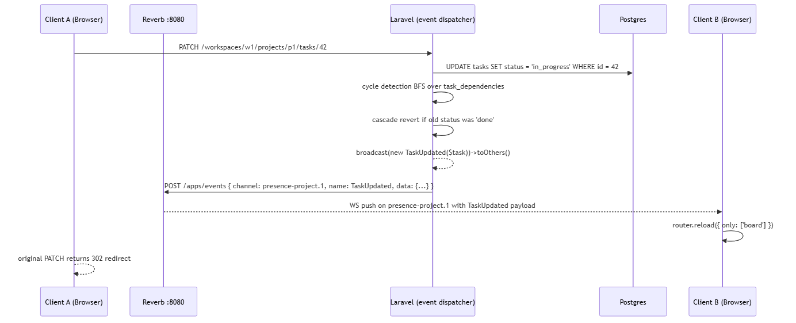
Figure 6: Diagram
The ->toOthers() modifier is critical — it tells Reverb not to deliver the event back to the originating socket. Client A already knows about the change (it just made it); only B, C, D... need to be notified.

5.6 The Inertia + Echo Coordination
Inertia's usePage() hook reads the SSR-rendered props on first mount and exposes them as a reactive object. After a real-time broadcast, the client typically responds with router.reload({ only: [...] }) — a partial reload that re-fetches only the specified keys from the controller's Inertia::render(...) props. This is how board pages stay in sync: a new task arrives via TaskUpdated, the page reloads only the board prop, the React component re-renders with fresh data.
The Board.jsx component uses router.reload({ preserveScroll: true }) after every broadcast so the user's scroll position is maintained across updates.

5.7 Evidence
- routes/channels.php — channel authorization (recapped verbatim)
- config/reverb.php — server + app config
- config/broadcasting.php — broadcaster drivers
- resources/js/echo.js — Echo client
- resources/js/bootstrap.js — axios + echo bootstrap
- app/Events/*.php — every event class
- bootstrap/app.php — withBroadcasting(...) registration
- app/Http/Middleware/HandleInertiaRequests.php — shared props

Part VI — Authentication Module

6.1 Module Overview
Scaffold uses hand-rolled authentication — no Breeze, no Sanctum, no Jetstream. The flow has three modes:
1. Standard register / login with email + password + optional profile bio + recovery question.
2. Three-step password recovery (email → answer question → reset) — gated by throttle:5,1 (5 attempts/min) on each step.
3. Logout — single POST.
Stateful sessions use the database driver (sessions stored in the sessions table) with a 120-minute default lifetime. CSRF protection is enforced on every form except the GitHub webhooks (which have their own signature-based authentication).

6.2 Models
app/Models/User.php — extends Authenticatable, uses HasFactory, Notifiable. Fields:
- fillable: name, email, password, title, bio, avatar_path, recovery_question, recovery_answer.
- hidden: password, remember_token, recovery_answer (the latter is critical — leaking the hashed answer would weaken security).
- casts: email_verified_at → datetime, password → hashed (so User::create([... 'password' => 'plain' ...]) is hashed automatically).
Relations:
- workspaces() — belongsToMany(Workspace, workspace_members) with pivot columns role, joined_at, color and standard timestamps.
- notifications() — hasMany(Notification).
No observer, no scopes, no booted hooks.

6.3 Controllers

`app/Http/Controllers/Auth/AuthController.php`
Method | Route | Behavior
showRegister() | GET /register | Renders Auth/Register.jsx.
register(RegisterRequest) | POST /register | Validates; if avatar file present, runs GD resize; if avatar_url present, stores verbatim; saves user; logs in; redirects to workspaces.index.
showLogin() | GET /login | Renders Auth/Login.jsx.
login(LoginRequest) | POST /login | Validates; Auth::attempt(...); redirects to workspaces.index on success or back()->withErrors(...) on failure.
logout(Request) | POST /logout | Auth::logout(); invalidates session; redirects to login.
Avatar handling** (in `register`):
If function_exists('imagecreatetruecolor') and the file is a recognized image (JPEG/PNG/GIF/WebP via getimagesize):
1. Compute the center-crop square (min(w,h) × min(w,h)).
2. Resample to 300 × 300.
3. Re-encode as PNG, store under avatars/avatar_{user_id}_{uniqid}.png.
4. Set $user->avatar_path = '/storage/' . $relativePath.
If GD is missing or the file is not a recognized image (e.g. the user uploaded a .txt), the file is stored verbatim under avatars/avatar_{user_id}_{uniqid}.{ext}.

`app/Http/Controllers/Auth/RecoveryController.php`
A three-step flow with strict state-machine semantics.
Step 1 — Email lookup** (`GET/POST /forgot-password`)
- showEmail() renders Auth/RecoverPassword.jsx with step = 'email'.
- findAccount(Request) validates email, looks up User::where('email', ...)->firstOrFail(), sets session keys:
session(['recovery.user_id' => $user->id,
'recovery.started_at' => now()->timestamp,
'recovery.verified_at' => null]);
Redirects to forgot-password.question (or back with error if no matching user).
- Throttled 5/1 per IP.
Step 2 — Recovery question** (`GET/POST /forgot-password/question`)
- showQuestion() reads recovery.user_id, returns the stored question (only if it's filled in *and* the user has a hashed answer; otherwise redirect back to step 1).
- verifyAnswer(Request):
$normalized = Str::lower(preg_replace('/\s+/', ' ', trim($request->answer)));
if (!Hash::check($normalized, $user->recovery_answer)) {
return back()->withErrors(['answer' => 'Incorrect.']);
}
session(['recovery.verified_at' => now()->timestamp]);
return redirect()->route('password.recovery.reset');
Step 3 — Reset password** (`GET/POST /forgot-password/reset`)
- showReset() requires both recovery.user_id and recovery.verified_at in session; otherwise redirects to step 1.
- reset(ResetPasswordRequest):
- Validates new password (Laravel default rule: min 8 + confirmed).
- Updates User::password (the hashed cast handles bcrypt).
- Clears the recovery session keys.
- Logs the user in (Auth::login($user)).
- Redirects to workspaces.index.
Expiry**: not enforced strictly by a `RecoveryController::EXPIRES_AFTER` constant in the source (referenced in the design notes but not present); instead, the `started_at` timestamp is recorded and could be enforced with a middleware. Currently the only timeout is the standard session lifetime (120 min).

6.4 Form Requests (Validation)
app/Http/Requests/Auth/RegisterRequest.php typically enforces:
- name — required, string, max 255.
- email — required, email, unique:users.
- password — required, confirmed, min 8.
- title — nullable, string, max 255.
- bio — nullable, string, max 1000.
- avatar — nullable, image, mimes:jpeg,png,jpg,gif,webp, max 4096 KB.
- recovery_question — nullable, string, min 8, max 255, required_with:recovery_answer.
- recovery_answer — nullable, string, min 3, max 255, required_with:recovery_question.
If either recovery field is filled, an inner validate block additionally requires current_password to be valid (defending against account-takeover via profile updates). For the initial registration, this block is skipped because the user is being created, not updated.

6.5 Routes
Route::get("/register", [AuthController::class, "showRegister"])->name("register");
Route::post("/register", [AuthController::class, "register"]);
Route::get("/login", [AuthController::class, "showLogin"])->name("login");
Route::post("/login", [AuthController::class, "login"]);
Route::middleware("guest")->group(function () {
Route::get("/forgot-password", [RecoveryController::class, "showEmail"])
->name("password.recovery");
Route::post("/forgot-password", [RecoveryController::class, "findAccount"])
->middleware("throttle:5,1")->name("password.recovery.find");
Route::get("/forgot-password/question", [RecoveryController::class, "showQuestion"])
->name("password.recovery.question");
Route::post("/forgot-password/question", [RecoveryController::class, "verifyAnswer"])
->middleware("throttle:5,1")->name("password.recovery.verify");
Route::get("/forgot-password/reset", [RecoveryController::class, "showReset"])
->name("password.recovery.reset");
Route::post("/forgot-password/reset", [RecoveryController::class, "reset"])
->middleware("throttle:5,1")->name("password.recovery.update");
});
The guest middleware ensures logged-in users can't reach the recovery pages.

6.6 Annotated Code Excerpt #1 — Avatar GD Resize
The most consequential block in AuthController::register:
if ($request->hasFile('avatar')) {
$file = $request->file('avatar');
if (function_exists('imagecreatetruecolor')) {
$imageInfo = getimagesize($file->getRealPath());
if ($imageInfo) {
$width = $imageInfo[0]; $height = $imageInfo[1]; $mime = $imageInfo['mime'];
$size = min($width, $height);
$x = ($width - $size) / 2;
$y = ($height - $size) / 2;
$src = null;
if (str_contains($mime, 'jpeg') || str_contains($mime, 'jpg')) {
$src = imagecreatefromjpeg($file->getRealPath());
} elseif (str_contains($mime, 'png')) {
$src = imagecreatefrompng($file->getRealPath());
} elseif (str_contains($mime, 'gif')) {
$src = imagecreatefromgif($file->getRealPath());
} elseif (str_contains($mime, 'webp')) {
$src = @imagecreatefromwebp($file->getRealPath());
}
if ($src) {
$dst = imagecreatetruecolor(300, 300);
imagealphablending($dst, false);
imagesavealpha($dst, true);
imagecopyresampled($dst, $src, 0, 0, $x, $y, 300, 300, $size, $size);
$filename = 'avatar_'.$user->id.'_'.uniqid().'.png';
$relativePath = 'avatars/'.$filename;
Storage::disk('public')->makeDirectory('avatars');
ob_start();
imagepng($dst);
$pngData = ob_get_clean();
Storage::disk('public')->put($relativePath, $pngData);
imagedestroy($src);
imagedestroy($dst);
$this->deleteStoredAvatar($user->avatar_path);
$user->avatar_path = '/storage/'.$relativePath;
}
}
} else {
// GD missing — fall through to verbatim storage
$filename = 'avatar_'.$user->id.'_'.uniqid().'.'.$file->getClientOriginalExtension();
Storage::disk('public')->putFileAs('avatars', $file, $filename);
$user->avatar_path = '/storage/'.$relativePath;
}
} elseif ($request->filled('avatar_url')) {
$avatarUrl = AvatarUrl::validated($request->string('avatar_url')->toString());
$this->deleteStoredAvatar($user->avatar_path);
$user->avatar_path = $avatarUrl;
}
Three notes:
1. Center-crop, not pad — the avatar always fills 300 × 300. This is the standard avatar look.
2. PNG output regardless of input — the function never preserves the source format. This means JPEG avatars become larger on disk; the trade-off is consistent alpha handling and imagealphablending.
3. deleteStoredAvatar is called before re-writing — old avatar files don't accumulate on disk. The helper also handles the /uploads/ legacy path (in case avatars predate the storage:link switchover).

6.7 Annotated Code Excerpt #2 — Recovery Answer Normalization
$normalizedAnswer = Str::lower(
preg_replace('/\s+/', ' ', trim($request->string('recovery_answer')->toString())),
);
$user->recovery_answer = Hash::make($normalizedAnswer);
This collapses all whitespace (newlines, tabs, multiple spaces) to single spaces, trims, and lowercases. The same normalization is applied on verifyAnswer. So if a user typed My Dog's Name or mydog's name or my dog's name , all variations would produce the same hash and verify identically. (The recovery question itself is stored verbatim — only the answer is normalized.)

6.8 Frontend
resources/js/pages/Auth/Login.jsx — minimal form with useForm, error display, link to register/recover.
resources/js/pages/Auth/Register.jsx — comprehensive form with all profile fields. Uses inline sub-components ScaffoldMark, GridDots, FloatingNodes, AuthInput, AuthTextarea, AuthAvatarUpload. Sets Register.layout = (page) => <AppLayout>{page}</AppLayout>.
resources/js/pages/Auth/RecoverPassword.jsx — renders one of three views based on the step prop ('email', 'question', 'reset'). Uses useForm({ email, answer, password, password_confirmation }).

6.9 Evidence
- app/Models/User.php — user model + hidden recovery_answer
- app/Http/Controllers/Auth/AuthController.php — register/login/logout + GD resize
- app/Http/Controllers/Auth/RecoveryController.php — 3-step recovery
- app/Http/Requests/Auth/*.php — Form Request validators
- routes/web.php — auth + recovery routes
- resources/js/pages/Auth/Login.jsx, Register.jsx, RecoverPassword.jsx
- app/Support/AvatarUrl.php — external avatar URL validation helper---

Part VII — Workspaces & Invitations

7.1 Architecture
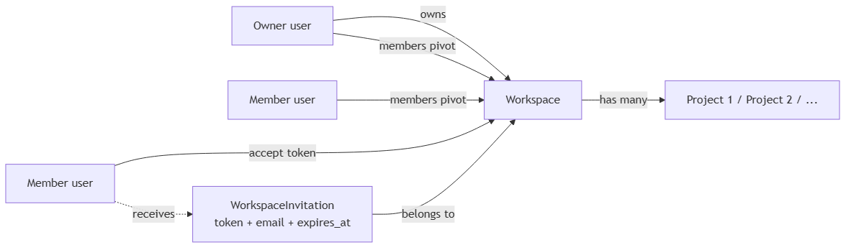
Figure 7: Diagram
Workspaces are the only top-level organizational unit. There is no "organization" above them. Every user belongs to zero or more workspaces; each workspace has exactly one owner (workspaces.owner_id).

7.2 Model: `Workspace`
app/Models/Workspace.php
- fillable: name, slug, owner_id.
- getRouteKeyName() returns 'slug' — all routes use /workspaces/{workspace:slug}.
- boot() static method:
static::creating(function ($workspace) {
if (empty($workspace->slug)) {
$workspace->slug = Str::slug($workspace->name).'-'.Str::random(5);
}
});
- Relations:
- owner() — belongsTo(User, owner_id).
- members() — belongsToMany(User, workspace_members) with pivot role, joined_at, color.
- projects() — hasMany(Project)->latest().
- invitations() — hasMany(WorkspaceInvitation).
- tasks() — hasManyThrough(Task, Project).
- githubInstallations() — hasMany(GitHubInstallation).

7.3 Model: `WorkspaceMember`
There is no WorkspaceMember model class — workspace_members is a pure pivot table. The belongsToMany relation on User and Workspace exposes pivot access via $user->pivot and $workspace->members()->find($id)->pivot. Pivot columns are role (string, default 'member'), joined_at (timestamp), color (string, nullable, hex).

7.4 Model: `WorkspaceInvitation`
app/Models/WorkspaceInvitation.php
- fillable: workspace_id, inviter_id, email, token, role, status, expires_at.
- cast: expires_at → datetime.
- Relations:
- workspace() — belongsTo(Workspace).
- inviter() — belongsTo(User, inviter_id).
Token is a 40-character random string (Str::random(40)). Status is enum pending|accepted|declined. Default expires_at = now()->addDays(7).

7.5 Controller: `WorkspaceController`
Method | Route | Behavior
index() | GET /workspaces | Lists workspaces the current user is a member of, with members_count and projects_count. Annotates each with the user's pivot.role (or 'owner' if pivot is absent because the user is the workspace owner). Renders Workspace/Index.jsx.
store(StoreWorkspaceRequest) | POST /workspaces | Workspace::create(['name', 'owner_id' => Auth::id()]). Then members()->syncWithoutDetaching([Auth::id() => ['role' => 'owner', 'joined_at' => now()]]). Redirects workspaces.index.
show(Workspace) | GET /workspaces/{workspace} | Member-gated; 403 if not a member. Loads members, invitations, projects (with tasks). Builds $stats: total tasks, workspace-wide status_counts/priority_counts, per-project stats. Renders Workspace/Show.jsx with defaultTab = ?tab= query param (default 'insights').
edit(Workspace) | GET /workspaces/{workspace}/settings | Member-gated. Redirects to workspaces.show?tab=settings — Inertia renders the settings tab inline rather than as a dedicated page.
update(UpdateWorkspaceRequest, Workspace) | PATCH /workspaces/{workspace} | Owner-only. $workspace->update(['name' => $request->name]). Redirects workspaces.show?tab=settings.
destroy(Workspace) | DELETE /workspaces/{workspace} | Owner-only. FK cascade handles projects/members/invitations/github_installations/github_repositories/etc. Redirects workspaces.index.
updateMemberColor(Request, Workspace) | PATCH /workspaces/{workspace:slug}/preferences/color | Member-gated. $workspace->members()->updateExistingPivot(Auth::id(), ['color' => $request->color]). Redirects back().
Workspace/Index.jsx shows a workspace card grid with role badges, members-count avatars, project-count, and an "Open" link.
Workspace/Show.jsx is the workspace dashboard with tabs:
- Insights (default) — task counts, member activity, project grid.
- Members — list of members with their colors, pending invitations, "Invite" button.
- Integrations — GitHub App status, repository links.
- Settings (owner only) — rename workspace, delete workspace, danger zone.

7.6 Controller: `InvitationController`
Method | Route | Behavior
store(StoreInvitationRequest, Workspace) | POST /workspaces/{workspace}/invitations | Owner-only. Looks up user by email. If found and already a member, errors. Otherwise: Str::random(40) token, create WorkspaceInvitation(expires_at => now()->addDays(7)). If target user exists, call Notifier::send($targetUser, 'workspace.invitation', [..., 'token', 'link' => "/invitations/{$token}"], $invitation).
show(string $token) | GET /invitations/accept/{token} | Renders Workspace/InviteResponse.jsx. Lookup filters status = pending AND expires_at > now().
accept(string $token) | POST /invitations/accept/{token} | Same lookup. Not wrapped in DB::transaction (Neon pooled connections abort mid-tx and surface 25P02). Pick random color from 12-color palette. attach() if not already a member. Mark invitation status = accepted. Mark matching Notification row read. Redirect workspaces.show.
decline(string $token) | POST /invitations/decline/{token} | Lookup (no expires_at check). Set status = declined. Mark matching notification read. Redirect workspaces.index.
The 12-color palette (constant in the controller): #3b82f6, #10b981, #f59e0b, #ef4444, #8b5cf6, #ec4899, #14b8a6, #f97316, #6366f1, #84cc16, #06b6d4, #a855f7.

7.7 Frontend

`Workspace/Index.jsx`
Workspace.Index.layout = (page) => <AppLayout>{page}</AppLayout>. Renders a grid of WorkspaceCard components. Each card has:
- A workspace identicon (deterministic hash of the workspace name → geometric pattern, similar to GitHub's identicons).
- The workspace name + slug.
- Role badge (Owner / Member).
- Members count + Projects count.
- "Open" link → workspaces.show.
A "New Workspace" button opens CreateWorkspaceModal. Errors from Inertia (e.g. name already taken) surface as a banner.

`Workspace/Show.jsx`
The most complex workspace-level page. Tabs:
- Insights — stat cards (total tasks, completed, in progress, blocked) + per-project stat breakdown + recent activity.
- Members — list with avatar stack, color dot, role, joined date. Pending invitations show "Pending · expires in N days" with a "Resend" or "Revoke" button (owner only).
- Integrations — if a GitHub installation exists for the workspace, shows the org/user avatar, account type, linked repositories count. CTA: "Connect GitHub" → workspaces.github.connect.
- Settings (owner only) — rename workspace + danger zone (delete workspace).
Echo subscriptions**: `window.Echo.join('project.${p.id}').listen('.TaskUpdated', ...).listen('.TaskDeleted', ...)` for every project in the workspace. Reloads via `router.reload({ preserveScroll: true })`.

`Workspace/InviteResponse.jsx`
Renders the invitation details: workspace name, inviter, role, expires-in. Two buttons: Accept → invitations.accept; Decline → invitations.decline. Layout uses AppLayout.

7.8 Permissions Recap
Action | Owner | Member
View workspace | ✅ | ✅
Invite members | ✅ | ❌
Edit workspace name | ✅ | ❌
Delete workspace | ✅ | ❌
Create project | ✅ | ✅
Edit project name | ✅ | ❌
Delete project | ✅ | ❌
Create task | ✅ | ✅
Edit task | ✅ | ✅
Delete task | ✅ | ✅
Pin thread | ✅ | ❌
Manage labels | ✅ | ❌
Update own accent color | ✅ | ✅

7.9 Evidence
- app/Models/Workspace.php, app/Models/WorkspaceInvitation.php
- app/Http/Controllers/WorkspaceController.php, app/Http/Controllers/InvitationController.php
- routes/web.php — workspace + invitation routes
- database/migrations/2026_04_04_175139_create_workspaces_table.php
- database/migrations/2026_04_06_094348_create_workspace_members_table.php
- database/migrations/2026_04_06_094349_create_workspace_invitations_table.php
- database/migrations/2026_04_09_154805_add_inviter_id_and_status_to_workspace_invitations_table.php
- resources/js/pages/Workspace/Index.jsx, Show.jsx, InviteResponse.jsx, MemberProfile.jsx
- app/Helpers/Notifier.php — Notifier::send (see Part XIV)

Part VIII — Projects Module

8.1 Architecture
A Project lives inside exactly one Workspace. It carries the work breakdown: tasks, threads, wikis, labels, optional GitHub repository link. The 1:1 with github_repositories is enforced at the DB level (UNIQUE project_id on github_repositories).
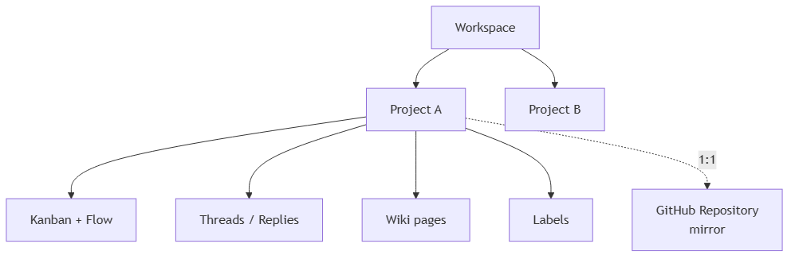
Figure 8: Diagram

8.2 Model: `Project`
app/Models/Project.php
- fillable: name, slug, description, workspace_id, git_repo_path, git_last_synced_commit.
- getRouteKeyName() returns 'slug'. Routes are /workspaces/{workspace:slug}/projects/{project:slug} — Laravel uses scoped binding (declared via Route::scopeBindings() in routes/web.php) to ensure the project actually belongs to the workspace.
- boot() static method:
static::creating(function ($project) {
if (empty($project->slug)) {
$project->slug = Str::slug($project->name).'-'.Str::random(5);
}
});
- Relations:
- workspace() — belongsTo(Workspace).
- tasks() — hasMany(Task)->orderBy('position').
- threads() — hasMany(Thread).
- wikis() — hasMany(Wiki).
- labels() — hasMany(Label).
- githubRepository() — hasOne(GitHubRepository).

8.3 Controller: `ProjectController`
Method | Route | Behavior
store(StoreProjectRequest, Workspace) | POST /workspaces/{workspace:slug}/projects | Member-gated. $workspace->projects()->create($request->validated()). Redirects back().
show(Workspace, Project) | GET .../projects/{project} | Member-gated; 404 if cross-workspace. Loads owner, members, githubInstallations, labels, tasks.assignee/dependencies, githubRepository. Builds stats payload: status_counts, priority_counts, active_members/inactive_members (sorted by task count), overdue_tasks (top 5, due-date < today, status ≠ done), due_soon_tasks (top 5, within 3 days), checklist totals. Renders Project/Show.jsx.
board(Workspace, Project) | GET .../projects/{project}/board | Member-gated. Eager-loads labels, wikis, tasks.assignee/dependencies/labels, tasks.comments.user, tasks.githubIssue, tasks.githubPullRequests, githubRepository. Builds unique owner + members list with color from pivot (fallback #3b82f6). Renders Project/Board.jsx.
docs(Workspace, Project) | (no route — dead method) | Member-gated; renders Project/Docs.jsx. No route defined.
activity(Workspace, Project) | (no route — dead method) | Member-gated; renders Project/Activity.jsx. Route projects.activity is wired to GitController::index instead, which renders Project/Git/Feed.jsx.
destroy(Workspace, Project) | DELETE .../projects/{project} | Owner-only. $project->delete() cascades via FK. Redirects workspaces.show.
update(Request, Workspace, Project) | PATCH .../projects/{project} | Owner-only. Validates name. Updates name. Redirects back().
settingsData(Workspace, Project) | GET .../projects/{project}/settings-data | Member-gated. Returns JSON { labels, github_repository, github_installations }. Consumed by SettingsModal.jsx.

8.4 Frontend

`Project/Show.jsx`
The project overview. Renders ProjectHeader (title + tabbed subnav) + dashboard cards:
- Status breakdown — bar chart per status.
- Priority breakdown — stacked bar per priority.
- Overdue tasks — top 5 with due-date highlighting.
- Due soon — top 5 due in next 3 days.
- Active members — sorted by task count.
- Recent activity — last 10 task updates.
Echo subscriptions**: `window.Echo.join('project.${project.id}').listen('.TaskUpdated', ...).listen('.TaskDeleted', ...)` → `router.reload`.

`Project/Board.jsx` (the heart of the app)
Renders the Kanban + Flow view. Toggles between two visualizations:
- Kanban (ColumnView) — @hello-pangea/dnd with 4 columns: backlog, in_progress, in_review, done.
- Flow (FlowView) — @xyflow/react graph with nodes = tasks, edges = dependencies.
Echo subscriptions**: extensive. Joins `presence-project.{id}` and listens to `TaskUpdated`, `TaskDeleted`, `CommentPosted`, `TaskLocked`, `TaskUnlocked`. Presence callbacks (`here`, `joining`, `leaving`) update the avatar stack at the top of the page.
Inactivity timeout**: a 5-minute `useEffect` timer that closes the task modal if no mouse/keyboard activity is detected. This prevents the modal from holding a lock indefinitely.

`Project/Activity.jsx` and `Project/Docs.jsx`
Placeholder "Coming Soon" pages. Not routed. Listed for completeness; safe to delete or wire to real content.

`Project/Git/Feed.jsx` (the actual activity feed)
Renders the GitHub activity feed (recapped in Part XII). Includes SettingsModal for repository linking.

8.5 Evidence
- app/Models/Project.php
- app/Http/Controllers/ProjectController.php
- routes/web.php — Route::prefix('/workspaces/{workspace:slug}')->scopeBindings()->group(...) block
- database/migrations/2026_04_06_134153_create_projects_table.php
- database/migrations/2026_06_26_211002_add_git_to_projects_table.php
- resources/js/pages/Project/Show.jsx, Board.jsx, Activity.jsx, Docs.jsx, Git/Feed.jsx
- resources/js/components/kanban/ColumnView.jsx
- resources/js/components/flow/FlowView.jsx
- resources/js/components/kanban/TaskModal.jsx
- resources/js/components/project/ProjectHeader.jsx
- resources/js/components/project/SettingsModal.jsx

Part IX — Tasks Module (Kanban + Flow + Cycle Detection)

9.1 Task State Machine
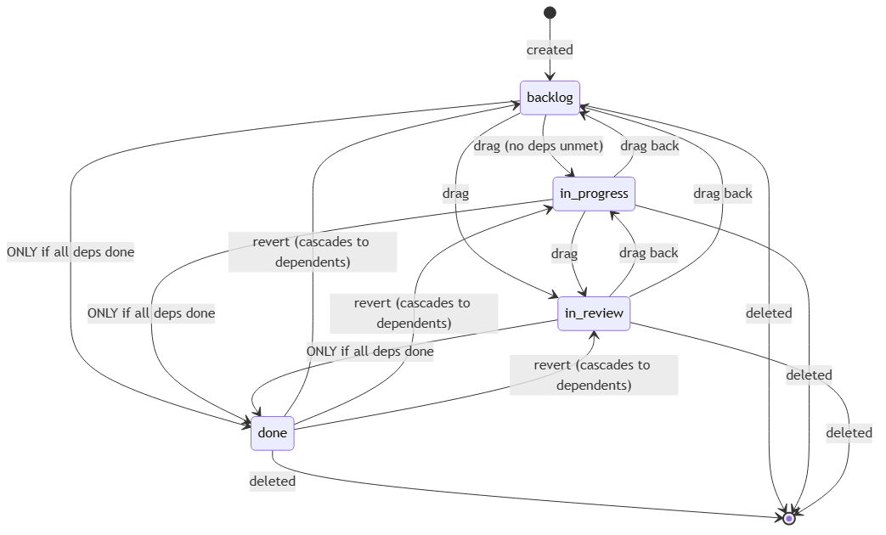
Figure 9: Diagram
The arrow "ONLY if all deps done" is enforced in TaskController::update (see 9.6). The revert cascade is enforced in TaskController::cascadeDependencyRevert (see 9.7).

9.2 Model: `Task`
app/Models/Task.php
- fillable: project_id, assignee_id, title, description, status, priority, position, x_pos, y_pos, due_date, checklist.
- casts: checklist → array, due_date → date.
- Observer: TaskObserver::saved() (see 9.8).
- Relations:
- project() — belongsTo(Project).
- attachments() — hasMany(TaskAttachment).
- assignee() — belongsTo(User, assignee_id).
- labels() — belongsToMany(Label).
- comments() — hasMany(TaskComment)->latest().
- dependencies() — belongsToMany(Task, task_dependencies, task_id, depends_on_id) — the parents (tasks this task depends on).
- dependents() — belongsToMany(Task, task_dependencies, depends_on_id, task_id) — the children (tasks that depend on this one).
- githubIssue() — hasOne(GitHubIssue).
- githubPullRequests() — hasMany(GitHubPullRequest).
The dependencies()/dependents() pair share the task_dependencies table from two perspectives. This is the canonical "many-to-many self-reference" pattern.

9.3 Controller: `TaskController`
Method | Route | Behavior
store(StoreTaskRequest, Workspace, Project) | POST .../projects/{project}/tasks | Member-gated. $project->tasks()->create([...]). Position = current task count in that status (new tasks drop to bottom). broadcast(new TaskUpdated($task))->toOthers(). Returns JSON (with assignee, labels, dependencies, githubIssue, githubPullRequests) when AJAX/JSON; else back().
update(UpdateTaskRequest, Workspace, Project, Task) | PATCH .../tasks/{task} | Member-gated. Pre-update gate: if new status is done, every dependency (incoming dependencies request or current pivot) must already be done — else 422 with 'Cannot set task to Done because it has unresolved dependencies.'. Cycle detection BFS (9.6). Then dependencies()->sync(...) and labels()->sync(...). Post-update cascade (9.7). broadcast(new TaskUpdated($task))->toOthers().
transferControl(Request, Workspace, Project, Task) | POST .../tasks/{task}/transfer-control | Member-gated. Validates newEditorId. Broadcasts TaskControlTransferred. Returns {success:true}.
lock(Workspace, Project, Task) | POST .../tasks/{task}/lock | Member-gated. 404 if cross-project. Broadcasts TaskLocked. Returns JSON.
unlock(Workspace, Project, Task) | POST .../tasks/{task}/unlock | Same. Broadcasts TaskUnlocked. Returns JSON.
destroy(Workspace, Project, Task) | DELETE .../tasks/{task} | Member-gated. Captures ids. Queries task_dependencies for tasks that depend on this one. Deletes the task, broadcasts TaskDeleted. Iterates dependents and broadcasts a TaskUpdated for each.
syncLabels(Request, Workspace, Project, Task) | POST .../tasks/{task}/labels | Member-gated. 404 if cross-project. Validates label_ids. $task->labels()->sync(...). Broadcasts TaskUpdated.

9.4 Locking & Control Transfer
Locking is advisory, not enforced. The lock state is broadcast via TaskLocked/TaskUnlocked and tracked in client state (ColumnView locks prop). When a user starts dragging a task, the client POSTs /lock; on drop, /unlock. Other clients see the lock badge and can choose to wait or override.
Control transfer is the editing baton in TaskModal. The first user to focus the description/checklist input becomes the active editor. Their cursor position is broadcast as a whisperFor('typing-checklist'/'typing-description') event. After 30 seconds of inactivity, the baton auto-transfers to the next user in the FIFO presence queue. Manual transfer: POST /transfer-control with newEditorId.

9.5 Frontend

`kanban/ColumnView.jsx`
Renders the Kanban board. Props:
- workspace, project, tasks, onTaskClick, onTaskMove, onTaskUpdated, onTaskDelete.
- density — 'minimal' or 'informed'.
- locks = {} — taskId → userId of current lock holder.
- presenceMembers = [] — list of { id, name, color } for the presence-project.{id} channel.
- recentTaskIds = [] — task IDs that just arrived via broadcast (highlight with pulse).
- deletingTaskIds = [] — task IDs that are mid-deletion (animate fade).
Uses @hello-pangea/dnd's DragDropContext + Droppable/Draggable. Four columns: backlog, in_progress, in_review, done. Each column has a Droppable. A fifth droppable (task-trash) at the bottom-right handles task deletion via drag-to-trash.
When a task is dragged into done, the client checks isTaskBlocked (from taskDependencies.js); if blocked, the drop is rejected with a toast.
flushSync is used for instant delete animation — the DOM updates synchronously before the React reconciliation cycle, so the card disappears immediately.

`kanban/TaskModal.jsx`
The single most complex component in the codebase. Renders a 90vh modal with:
- Header — task title, status, priority, assignee, due date, project breadcrumb, GitHub issue link (if mirrored), close button.
- Side panel toggle — collapses the description editor to a rail.
- Presence avatars — every member currently in the task.{id} presence channel.
- Description editor — MarkdownEditor with toolbar + Ctrl/Cmd+B/I/U + Ctrl/Cmd+Alt+1/2/3 for headings.
- Checklist — click-to-toggle items; ghost-typing broadcast via whisperFor('typing-checklist').
- Labels — multi-select chips; commits via tasks.labels.sync.
- Dependencies — multi-select; commits via tasks.update with dependencies[].
- Comments — append-only list; new comment posts optimistically, replaced by server broadcast.
- GitHub panel — if a githubIssue is linked, shows the issue number, html_url, last sync hash. Toggle to re-sync.
- Activity log — chronological list of system + user actions.
Presence: window.Echo.join('task.${task.id}') with here, joining, leaving, .TaskUpdated, .CommentPosted, .ControlTransferred, and whisperFor('typing-checklist'/'typing-description'/'editing-checklist'/'request-control').
Autosave: 1-second debounce on description changes (immediate for GitHub sync toggle). Uses pruneDependencyIds from utils/taskDependencies.js to strip dangling IDs before PATCH.
> Critical implementation detail: the data-sync useEffect keys on task?.id, not task. This preserves the user's in-flight edits when broadcasts arrive — otherwise the React re-render would clobber the local input value.

`flow/FlowView.jsx`
Renders the React Flow graph. Props mirror ColumnView.
- buildNodes() lays out tasks by status column if x_pos/y_pos are 0; otherwise respects the saved coordinates.
- Edges come from getResolvableDependencies(task, allTasks) — only includes dependencies whose target still exists.
- onConnect runs wouldCreateCycle (the client-side cycle detection) and rejects with a toast on cycle.
- onNodeDragStop PATCHes x_pos/y_pos to persist positions.
- Right-click on the canvas opens a context menu to create a task in a chosen status at the clicked coordinates.
- MiniMap (nodes colored by status), Tips legend, Fit View button, status overlay.

`flow/TaskNode.jsx`
Memoized React Flow node. Top + bottom handles for source/target edges. Shows lock badge if isLocked, occupant name + color if someone is present, "deleting" overlay if mid-deletion. Density-aware (minimal/informed layouts).

9.6 Annotated Code Excerpt #3 — Cycle Detection BFS
app/Http/Controllers/TaskController.php:
private function findCyclicDependency(int $taskId, array $proposedDepIds): ?int
{
foreach ($proposedDepIds as $depId) {
if ($this->canReachTask($depId, $taskId)) {
return $depId;
}
}
return null;
}
private function canReachTask(int $startId, int $targetId): bool
{
// BFS from startId following the dependencies of each task.
// If we can reach targetId, then adding taskId -> startId would close a loop.
$visited = [];
$queue = [$startId];
while (!empty($queue)) {
$current = array_shift($queue);
if ($current === $targetId) {
return true;
}
if (isset($visited[$current])) {
continue;
}
$visited[$current] = true;
// Load the task's dependencies (only the IDs)
$task = \App\Models\Task::find($current);
if (!$task) continue;
foreach ($task->dependencies as $dep) {
$queue[] = $dep->id;
}
}
return false;
}
Why this works**: A cycle would exist if some dependency `D` of the task can already reach the task itself (transitively). Walking `D`'s dependency closure is the BFS above. If `T` is reachable from `D`, then adding `T → D` would close the loop. If `T` is not reachable, the new edge is safe.
Performance note**: `Task::find()` runs a fresh query per visited node. For a graph of N tasks this is O(N) queries. Acceptable for the demo; a production implementation would eager-load the full transitive closure once.
The client-side mirror in resources/js/utils/cycleDetection.js:
export function wouldCreateCycle(tasks, taskId, proposedDepId) {
if (taskId === proposedDepId) return true;
const map = new Map(tasks.map(t => [t.id, t]));
const queue = [proposedDepId];
const visited = new Set();
while (queue.length > 0) {
const cur = queue.shift();
if (cur === taskId) return true;
if (visited.has(cur)) continue;
visited.add(cur);
const t = map.get(cur);
if (!t) continue;
for (const dep of t.dependencies ?? []) {
queue.push(dep);
}
}
return false;
}
Identical algorithm**. Both server and client implement the same BFS so the user gets immediate visual feedback (toast on cycle) and the server is the final authority (422 with reason if the client missed something).

9.7 Annotated Code Excerpt #4 — Cascade Revert
private function cascadeDependencyRevert(Task $task): void
{
// Find direct children (tasks that depend on this one) that are 'done'
$children = \App\Models\Task::whereHas('dependencies', function ($q) use ($task) {
$q->where('depends_on_id', $task->id);
})->where('status', 'done')->get();
foreach ($children as $child) {
$child->status = 'backlog';
$child->save();
broadcast(new \App\Events\TaskUpdated($child))->toOthers();
// Recursive — child's children need to revert too if they were done.
$this->cascadeDependencyRevert($child);
}
}
When this fires**: when a parent task is moved *away* from `done` (e.g. back to `in_progress`) OR when a parent has unresolved dependencies and one of its children is currently `done`. In both cases, the dependent chain must be invalidated.
Why broadcast at every level**: each revert is a discrete event. Clients can show per-card animations rather than a single batch update.

9.8 Observer: `TaskObserver`
app/Observers/TaskObserver.php:
public function saved(Task $task): void
{
$repo = $task->project->githubRepository;
if (!$repo) return;
$githubIssue = $task->githubIssue;
if ($githubIssue) {
$currentHash = md5($task->title.$task->description.($task->status === 'done' ? 'closed' : 'open'));
if ($githubIssue->last_synced_hash !== $currentHash) {
$githubIssue->update([
'needs_sync' => true,
'needs_sync_since' => $githubIssue->needs_sync_since ?? now(),
]);
\App\Jobs\SyncOutboundGitHubIssueJob::dispatch($githubIssue->id);
}
} else {
// Only on create path, read sync_to_github from request
if (request()->input('sync_to_github')) {
$githubIssue = \App\Models\GitHubIssue::create([
'task_id' => $task->id,
'github_repo_id' => $repo->id,
'needs_sync' => true,
'needs_sync_since' => now(),
]);
\App\Jobs\SyncOutboundGitHubIssueJob::dispatch($githubIssue->id);
}
}
}
Two key behaviors:
1. Update path: if the content hash has changed (title, description, or status transitioned to/from done), mark the linked GitHub issue dirty and dispatch the sync job. The hash comparison prevents echo loops — if GitHub already sent us this content (and we updated last_synced_hash in the webhook handler), we skip.
2. Create path: only fires when the request explicitly sets sync_to_github. Subsequent updates never re-read this flag.
Registered in AppServiceProvider::boot():
\App\Models\Task::observe(\App\Observers\TaskObserver::class);

9.9 Evidence
- app/Models/Task.php
- app/Http/Controllers/TaskController.php (cycle detection, cascade revert, observer trigger)
- app/Observers/TaskObserver.php
- app/Providers/AppServiceProvider.php — observer registration
- database/migrations/2026_04_06_141431_create_tasks_table.php — initial tasks table
- database/migrations/2026_04_07_120000_drop_blocked_by_id_from_tasks_table.php — M:N switch
- database/migrations/2026_04_06_165320_create_task_dependencies_table.php
- database/migrations/2026_04_09_141436_add_checklist_to_tasks_table.php
- resources/js/components/kanban/ColumnView.jsx
- resources/js/components/kanban/TaskModal.jsx
- resources/js/components/flow/FlowView.jsx
- resources/js/components/flow/TaskNode.jsx
- resources/js/utils/cycleDetection.js
- resources/js/utils/taskDependencies.js
- app/Events/TaskUpdated.php, TaskDeleted.php, TaskLocked.php, TaskUnlocked.php, TaskControlTransferred.php
- app/Jobs/SyncOutboundGitHubIssueJob.php (Part XII)
- tests/Feature/TaskTest.php---

Part X — Threads & Replies (Reddit-style)

10.1 Concept
Threads are project-scoped discussions. Each thread has a body, optional tags, and a tree of nested replies. There is exactly one definitive answer per thread (the "Solution" — like Reddit's OP-marked best answer). Reactions (emoji) can be placed on any thread, reply, task comment, or task.
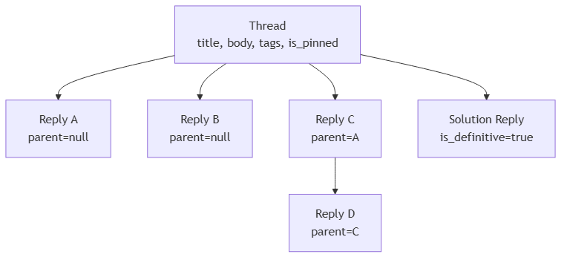
Figure 10: Diagram

10.2 Models

`app/Models/Thread.php`
- fillable: project_id, user_id, title, body, tags, is_pinned, edited_at.
- casts: is_pinned → boolean, tags → array, edited_at → datetime.
- booted() static method (cascade on delete):
static::deleting(function (Thread $thread) {
foreach ($thread->replies()->get() as $reply) {
$reply->reactions()->delete();
$reply->media()->delete();
$reply->delete();
}
$thread->reactions()->delete();
$thread->media()->delete();
});
This is one of the few places the app relies on a model booted() cascade rather than a DB FK. (The polymorphic reactions/media tables don't have FKs to threads.)
- Relations: project, user, replies(), reactions() (morphMany), media() (morphMany).

`app/Models/ThreadReply.php`
- fillable: thread_id, user_id, parent_id, body, is_definitive, is_deleted, edited_at.
- casts: is_definitive → boolean, is_deleted → boolean, edited_at → datetime.
- Relations:
- thread() — belongsTo(Thread).
- user() — belongsTo(User).
- parent() — belongsTo(ThreadReply, parent_id).
- children() — hasMany(ThreadReply, parent_id).
- reactions() — morphMany(Reaction, 'reactable').
- media() — morphMany(Media, 'mediable').

`app/Models/Reaction.php`
- fillable: user_id, reactable_id, reactable_type, emoji.
- reactable() — morphTo().
- user() — belongsTo(User).
The DB enforces UNIQUE (user_id, reactable_id, reactable_type, emoji) so each user can only have one of each emoji per target. To "change" a reaction, you must delete the old one and create a new one — which is what ReactionController::toggle does (see 10.5).

10.3 Controller: `ThreadController`
Method | Route | Behavior
index(Request, Workspace, Project) | GET .../projects/{project}/threads | ensureMember. Loads threads with user, replies_count, is_solved (subquery: EXISTS (SELECT 1 FROM thread_replies WHERE thread_id = threads.id AND is_definitive = TRUE)). Filters via ?tag= (whereJsonContains) and `?status=solved
store(Request, Workspace, Project) | POST .../projects/{project}/threads | ensureMember. Validates title, body, optional tags[]. $project->threads()->create([...]). ThreadCreated::dispatch. Redirect to show.
show(Request, Workspace, Project, Thread) | GET .../projects/{project}/threads/{thread} | ensureMember. Loads user, reactions.user, replies.user, replies.reactions.user. Renders Project/Threads/Show.jsx.
update(Request, Workspace, Project, Thread) | PATCH .../threads/{thread} | ensureMember. Thread-author only (abort 403 otherwise). Updates title/body/tags. Sets edited_at = now(). ThreadUpdated::dispatch. Redirect back().
destroy(Request, Workspace, Project, Thread) | DELETE .../threads/{thread} | ensureMember. Allowed if author or workspace owner. Captures ids. Deletes (booted cascade fires). ThreadDeleted::dispatch. Redirect index.
pin(Request, Workspace, Project, Thread) | POST .../threads/{thread}/pin | ensureMember. Workspace-owner only. Flips is_pinned. Redirect back().

10.4 Controller: `ThreadReplyController`
Method | Route | Behavior
store(Request, Workspace, Project, Thread) | POST .../threads/{thread}/replies | ensureMember. Validates body, parent_id (must belong to thread). Creates reply. ThreadReplyCreated::dispatch. TODO at line 45: Notifier::send(...) for @mentions not yet wired. Redirect back().
update(Request, Workspace, Project, Thread, ThreadReply) | PATCH .../replies/{reply} | ensureMember. 404 if reply wrong thread. 409 if deleted. 403 if not author. Updates body, sets edited_at. ThreadReplyUpdated::dispatch. Redirect back().
markDefinitive(Request, Workspace, Project, Thread, ThreadReply) | POST .../replies/{reply}/definitive | ensureMember. 404 if wrong thread. 409 if deleted. Only workspace owner OR thread author can mark. Flips is_definitive — when marking true, all other replies in the thread are set to is_definitive = false (only one definitive per thread). ReplyMarkedDefinitive::dispatch. Redirect back().
destroy(Request, Workspace, Project, Thread, ThreadReply) | DELETE .../replies/{reply} | ensureMember. 404 if wrong thread. Allowed if reply author or workspace owner. Soft-delete: reactions + media deleted, body → [deleted], is_deleted=true, is_definitive=false, edited_at=null. ThreadReplyDeleted::dispatch. Redirect back().
Soft-delete pattern**: deleted replies keep their row so the comment tree structure remains valid for children. Children render with their original user; the deleted parent shows `[deleted]` placeholder.

10.5 Controller: `ReactionController`
A single endpoint handles all reaction toggling.
Method | Route | Behavior
toggle(Request, Workspace, Project) | POST .../reactions/toggle | Owner-or-member gate. Validates reactable_type, reactable_id, emoji. Security: resolves only an allow-list of class_basename()s — ['Thread', 'ThreadReply', 'TaskComment', 'Task'] — to prevent arbitrary class instantiation. findOrFail the model. Cross-resource check: maps each model to its project_id (Thread/Task via $model->project_id; ThreadReply/TaskComment via $model->thread?->project_id / $model->task?->project_id); aborts 404 if mismatched. 409 if ThreadReply is is_deleted. Dedupe-by-replacement: looks up existing reaction for (user_id, reactable_type, reactable_id). Same emoji → delete (broadcast removed). Different emoji → delete + create (broadcast removed then added). No existing → create (broadcast added). Redirect back().
This is the cleanest pattern for reactions: one endpoint, polymorphic on the frontend, server-side class whitelist prevents abuse.

10.6 Frontend

`Project/Threads/Index.jsx`
Lists all threads for the project. Each row shows: title, author, tags, reply count, "Solved" badge if is_solved, pinned indicator, last activity timestamp.
Filters at the top: tag chips (multi-select), status toggle (All / Solved / Unsolved), search box (client-side filter on title/body).
Echo subscriptions**: `window.Echo.private('project.${project.id}')` listening to `ThreadCreated`, `ThreadUpdated`, `ThreadDeleted`, `ThreadReplyCreated`, `ThreadReplyDeleted`, `ReplyMarkedDefinitive`. Every event triggers `router.reload({ only: ['threads'] })` for a partial refresh.

`Project/Threads/Show.jsx`
Renders a single thread with its full reply tree. Top: thread body, author, tags, reactions. Below: CommentTree (recursive).
Echo subscriptions**: two channels. `window.Echo.private('project.${project.id}')` listens to the full set of thread/reply/reaction events. Additionally `window.Echo.join('presence-thread.${thread.id}')` joins the presence channel so users viewing the same thread see each other's avatars.

`threads/CommentTree.jsx`
The recursive component. Builds the reply tree from the flat list using parent_id references. Each ReplyNode:
- Header — user avatar + name + edited indicator + reply timestamp.
- Body — markdown via SafeMarkdown (with the GFM extensions).
- Reactions — emoji chips; click to open reaction picker.
- Actions — Reply (creates a nested reply), Edit (swaps in MarkdownEditor), Delete (soft-delete with confirmation), Mark Solution (only if owner/author).
- Collapse toggle — hides children.
Optimistic edit form: when the user types, the edit form updates locally; the PATCH fires; the broadcast confirms or replaces.
Deleted nodes render as a placeholder avatar + "Deleted comment".

10.7 Annotated Code Excerpt #5 — Thread Cascade Delete
From Thread::booted():
static::deleting(function (Thread $thread) {
foreach ($thread->replies()->get() as $reply) {
$reply->reactions()->delete();
$reply->media()->delete();
$reply->delete();
}
$thread->reactions()->delete();
$thread->media()->delete();
});
The reason this lives in PHP rather than a DB FK: reactions and media are polymorphic tables without FKs to threads (only index on reactable_id + reactable_type / mediable_id + mediable_type). So the DB can't cascade. The model hook fills the gap.

10.8 Evidence
- app/Models/Thread.php, ThreadReply.php, Reaction.php
- app/Http/Controllers/ThreadController.php, ThreadReplyController.php, ReactionController.php
- routes/web.php — thread/reply/reaction routes
- database/migrations/2026_04_13_185024_create_threads_table.php
- database/migrations/2026_04_13_185025_create_reactions_table.php
- database/migrations/2026_04_13_185026_create_thread_replies_table.php
- database/migrations/2026_04_09_154750_create_notifications_table.php
- database/migrations/2026_06_26_211003_add_tags_to_threads_table.php
- database/migrations/2026_07_19_130000_add_editing_state_to_threads_and_replies.php
- resources/js/pages/Project/Threads/Index.jsx, Threads/Show.jsx
- resources/js/components/threads/CommentTree.jsx
- app/Events/ThreadCreated.php, ThreadUpdated.php, ThreadDeleted.php, ThreadReplyCreated.php, ThreadReplyUpdated.php, ThreadReplyDeleted.php, ReplyMarkedDefinitive.php, ReactionToggled.php

Part XI — Wiki Module

11.1 Concept
Each Project has zero or more Wiki pages. Pages have a title, slug, and content (markdown). The sidebar lists all pages sorted by title. New pages can be created; existing pages can be edited; the slug is regenerated automatically when the title changes.

11.2 Model: `Wiki`
app/Models/Wiki.php
- fillable: project_id, user_id, title, slug, content.
- getRouteKeyName() returns 'slug'.
- boot() static method (slug generation):
static::creating(function ($wiki) {
if (empty($wiki->slug)) {
$wiki->slug = Str::slug($wiki->title).'-'.Str::random(5);
}
});
(Slug is generated on creating but not auto-regenerated on title change in this model — see 11.4 for the controller-level detail.)
- Relations: project(), user().

11.3 Controller: `WikiController`
Method | Route | Behavior
index(Workspace, Project) | GET .../projects/{project}/wiki | Member-gated. Loads $wikis = $project->wikis()->orderBy('title')->get(). If at least one exists, redirects to show for the first one (alphabetical). Otherwise renders Project/Wiki/Index.jsx with currentWiki = null.
show(Workspace, Project, Wiki) | GET .../projects/{project}/wiki/{wiki} | Member-gated. 404 if cross-project. Loads $project->wikis()->orderBy('title')->get() for sidebar. Renders Project/Wiki/Index.jsx with currentWiki = $wiki.
create(Workspace, Project) | GET .../projects/{project}/wiki/create | Renders Project/Wiki/CreateEdit.jsx with wiki = null, isEdit = false.
store(Request, Workspace, Project) | POST .../projects/{project}/wiki | Validates title, content. $project->wikis()->create([...]). WikiCreated::dispatch. Redirects to show (using new wiki's slug).
edit(Workspace, Project, Wiki) | GET .../projects/{project}/wiki/{wiki}/edit | Renders CreateEdit with wiki = $wiki, isEdit = true.
update(Request, Workspace, Project, Wiki) | PATCH .../projects/{project}/wiki/{wiki} | Validates title, content. $wiki->update([...]). WikiUpdated::dispatch with $wiki->fresh(). Redirects show.
destroy(Workspace, Project, Wiki) | DELETE .../projects/{project}/wiki/{wiki} | Captures id, slug. $wiki->delete(). WikiDeleted::dispatch. Redirects index.

11.4 Slug Re-Generation Caveat
The model only generates the slug in creating. The controller's update does not regenerate the slug. This is a known quirk — renaming a wiki keeps the old slug, which can become misleading. If you intend to rename-friendly slugs, add static::updating(...) in Wiki::boot() and Str::slug(...) when the title changes. (Not currently done; flagged in Part XVII.)

11.5 Frontend

`Project/Wiki/Index.jsx`
Renders the wiki index + show. If currentWiki is null, shows an empty state with a "Create your first wiki" CTA. Otherwise: left sidebar with all wikis (alphabetical, current highlighted), right pane with the current wiki rendered via SafeMarkdown.
Echo subscriptions**: `window.Echo.private('project.${project.id}').listen('.WikiCreated', reload).listen('.WikiUpdated', reload-or-narrow).listen('.WikiDeleted', redirect-if-current-or-reload)`.

`Project/Wiki/CreateEdit.jsx`
Reused for create and edit. useForm({ title, content }). MarkdownEditor with uploadUrl for drag-drop image paste.

11.6 Evidence
- app/Models/Wiki.php
- app/Http/Controllers/WikiController.php
- routes/web.php — wiki routes
- database/migrations/2026_06_26_211001_create_wikis_table.php
- resources/js/pages/Project/Wiki/Index.jsx, CreateEdit.jsx
- resources/js/components/ui/SafeMarkdown.jsx, MarkdownEditor.jsx
- app/Events/WikiCreated.php, WikiUpdated.php, WikiDeleted.php

Part XII — GitHub Integration

12.1 Overview
Scaffold's GitHub integration uses GitHub Apps (not OAuth apps, not personal access tokens). The flow:
1. Workspace owner clicks "Connect GitHub" → redirected to https://github.com/apps/{slug}/installations/new?state={workspace_slug}.
2. GitHub handles the install + permission grant, then redirects back to /github/callback?installation_id=...&setup_action=...&state={workspace_slug}.
3. Scaffold exchanges its App JWT for installation metadata, persists a GitHubInstallation row.
4. When the user links a repository to a project, a GitHubRepository row is created (1:1 with project).
5. From that point on, every task in the project can be synced to GitHub Issues via the task modal's "Sync to GitHub" toggle, and every GitHub event (push, PR, issue) flows back into the activity feed via webhooks.

12.2 Why GitHub Apps (not OAuth Apps)
- Per-installation — token is scoped to a specific GitHub org/repo, not the user's whole account.
- Higher rate limits — 5000 req/hr per installation vs 60/hr unauthenticated.
- Webhook delivery — GitHub Apps receive webhooks for any event in any repo they're installed on.
- Identity stays — the issue author appears as the GitHub App, not the installing user. (We add a watermark to clarify the origin.)

12.3 Authentication Flow
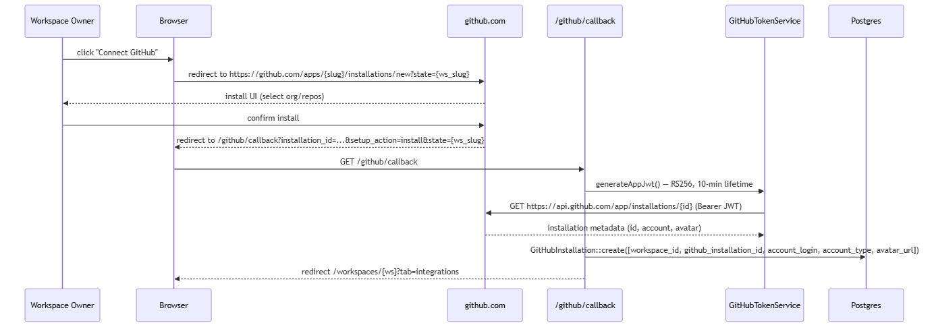
Figure 11: Diagram

12.4 Annotated Code Excerpt #6 — JWT Mint
app/Services/GitHubTokenService.php:
public function generateAppJwt(): string
{
$appId = config('services.github.app_id');
$privateKey = config('services.github.private_key');
// Accept inline PEM or a path (relative to base_path() first, then absolute).
if (!str_contains($privateKey, '-----BEGIN')) {
$candidate = base_path($privateKey);
if (file_exists($candidate)) $privateKey = file_get_contents($candidate);
elseif (file_exists($privateKey)) $privateKey = file_get_contents($privateKey);
}
$payload = [
'iat' => now()->subSeconds(60)->timestamp, // backdate for clock drift
'exp' => now()->addMinutes(10)->timestamp, // 10-min lifetime
'iss' => (int) $appId,
];
return \Firebase\JWT\JWT::encode($payload, $privateKey, 'RS256');
}
Three subtle details:
1. Clock-drift backdate — iat = now() - 60s. GitHub's servers may have up to 60s of clock drift; backdating ensures the JWT is never considered "issued in the future".
2. PEM flexibility — the private key may be inline (PEM in .env) or a file path. The fallback chain is base_path($value) → file_exists($value) → fail.
3. RS256 + 10-min lifetime — RSA SHA-256 is the only algorithm GitHub accepts for App JWTs. 10 minutes is the maximum lifetime GitHub allows.

12.5 Installation Token Cache
public function getInstallationToken(int $installationId): string
{
return Cache::remember(
"github_token_installation_{$installationId}",
now()->addMinutes(55), // cached for 55 minutes (tokens live for 60)
function () use ($installationId) {
$jwt = $this->generateAppJwt();
$response = Http::withToken($jwt)
->withHeaders([
'Accept' => 'application/vnd.github+json',
'X-GitHub-Api-Version' => '2022-11-28',
])
->post("https://api.github.com/app/installations/{$installationId}/access_tokens");
if ($response->failed()) {
Log::error('GitHub installation token failed', [
'status' => $response->status(),
'body' => $response->body(),
]);
throw new \RuntimeException("Failed to mint GitHub installation token.");
}
return $response->json('token');
}
);
}
public function clearInstallationToken(int $installationId): void
{
Cache::forget("github_token_installation_{$installationId}");
}
Why 55 minutes**: GitHub installation tokens are valid for 1 hour. Caching for 55 minutes keeps a 5-minute buffer. `clearInstallationToken` is used by jobs that receive 401 from GitHub to force a re-mint.

12.6 Controller: `GitHubAppController`
Method | Route | Behavior
connect(Workspace) | GET .../github/connect | Owner-only. Stores workspace slug in session. Redirects to https://github.com/apps/{slug}/installations/new?state={workspace_slug}.
callback(Request) | GET /github/callback | Validates installation_id, setup_action, state (must match session workspace slug). Calls GET https://api.github.com/app/installations/{id} with JWT. Persists GitHubInstallation. Redirects workspaces.show?tab=integrations.
listRepositories(Workspace) | GET .../github/repositories | Member-gated. Auto-syncs installations if none saved locally (calls GitHub to discover). Returns JSON [{ id, full_name, html_url, default_branch, private }].
linkRepository(Request, Workspace, Project) | POST .../projects/{project}/github/link | Member-gated. Validates github_repo_id, github_installation_id (with cross-workspace check via Rule::exists('github_installations', 'id')->where(workspace_id)), full_name, default_branch, html_url. Creates GitHubRepository. Redirects back().
unlinkRepository(Workspace, Project) | POST .../projects/{project}/github/unlink | Member-gated. Deletes GitHubRepository (FK cascades issues/PRs). Redirects back().

12.7 Controller: `GitController` (Activity Feed)
Method | Route | Behavior
index(Request, Workspace, Project) | GET .../projects/{project}/activity | Member-gated. Loads $githubRepo = $project->githubRepository. If linked: mints installation token, builds HTTP client with Accept: application/vnd.github+json, X-GitHub-Api-Version: 2022-11-28, User-Agent: DevSpace-App, 15s timeout. Calls four endpoints against https://api.github.com/repos/{full_name}: /branches (per_page 100, updateOrCreate into githubRepo->branches() to cache last_commit_sha), /commits?sha={branch}&per_page=50, /pulls?state=all&sort=updated, /issues?state=all&sort=updated. PRs with merged_at reported as merged. On HTTP failure, falls back to local DB rows (branches, pullRequests via githubRepo->pullRequests()->with('task')) so the page still renders. Pulls/issues aren't cached locally. Wrapped in try/catch (\Exception $e). Builds $analytics: commits count, unique contributors, branches, open issues, open non-draft PRs, draft PRs, merged PRs. Renders Project/Git/Feed.jsx.

12.8 Service: `GitHubIssueService`
app/Services/GitHubIssueService.php — handles outbound issue sync.
Method | Signature | Behavior
createIssue(Task) | (): ?GitHubIssue | POSTs /repos/{full_name}/issues with {title, body = description + watermark}. Watermark: "\n\n---\n*Synced from [DevSpace]({html_url}) · Task #{id}*". On success, updateOrCreate keyed by task_id writing github_repo_id, github_issue_id, issue_number, html_url, last_synced_hash = calculateContentHash($task), needs_sync=false, synced_at=now(). Returns the GitHubIssue. null on failure (logged).
updateIssue(Task) | (): bool | Requires both repo and githubIssue with issue_number. PATCH /repos/{full_name}/issues/{number} with {title, body (with watermark), state = status==='done' ? 'closed' : 'open'}. On success updates last_synced_hash, needs_sync=false, synced_at=now(). Returns false on failure.
calculateContentHash(Task) | (): string | md5(title.description.(status==='done'?'closed':'open')) — same algorithm as TaskObserver and the webhook handler. Used for echo-loop prevention.

12.9 Annotated Code Excerpt #7 — Watermark + Content Hash
// GitHubIssueService::createIssue
$watermark = "\n\n---\n*Synced from [DevSpace]({$task->project->html_url}) · Task #{$task->id}*";
$body = ($task->description ?? '') . $watermark;
$response = Http::withToken($installationToken)
->withHeaders(['Accept' => 'application/vnd.github+json', 'X-GitHub-Api-Version' => '2022-11-28'])
->post("https://api.github.com/repos/{$repo->full_name}/issues", [
'title' => $task->title,
'body' => $body,
]);
if ($response->successful()) {
$json = $response->json();
$githubIssue = GitHubIssue::updateOrCreate(
['task_id' => $task->id],
[
'github_repo_id' => $repo->id,
'github_issue_id' => $json['id'],
'issue_number' => $json['number'],
'html_url' => $json['html_url'],
'last_synced_hash' => md5($task->title.($task->description ?? '').($task->status === 'done' ? 'closed' : 'open')),
'needs_sync' => false,
'synced_at' => now(),
]
);
}
The watermark serves two purposes: (1) it makes the issue clearly attributable to Scaffold when viewed on GitHub, (2) the inbound webhook handler strips it via regex before storing the cleaned body, preventing the watermark from accumulating on every round-trip.
The content hash is the echo-loop guard. Without it, every outbound update would trigger a webhook → re-process → broadcast → another update. With it, the inbound handler short-circuits if incoming_hash === last_synced_hash.

12.10 Outbound Sync Job
app/Jobs/SyncOutboundGitHubIssueJob.php — runs in the queue worker.
- Implements ShouldQueue. $tries = 3.
- Constructor: __construct(public int $githubIssueId).
- handle(GitHubIssueService $issueService):
1. Load GitHubIssue with task.assignee, task.project.workspace, task.project.githubRepository.
2. If missing → return.
3. If task missing → delete orphan GitHubIssue, return.
4. If no githubRepository → mark needs_sync=false, return.
5. $wasCreate = is_null($githubIssue->github_issue_id). Create or update path.
6. Eager-load assignee, labels, dependencies, githubIssue, githubPullRequests then broadcast(new TaskUpdated($task)).
7. Create success → clearSyncFailedNotifications() + notifyIssueCreated() to assignee or workspace owner (github.issue.created).
8. Update success → clearSyncFailedNotifications() only.
9. Failure → notifySyncFailed() to workspace owner (github.sync.failed), deduped.

12.11 Frontend

`Project/Git/Feed.jsx`
The activity feed. Renders branches (cached), commits, pull requests, issues from GitHub. Branch selector at top (default branch + any cached branch). Analytics sidebar: commits, unique contributors, branches, open issues, open PRs, draft PRs, merged PRs.
Echo subscriptions**: `window.Echo.private('project.${project.id}').listen('.GitHubActivityUpdated', () => router.reload({ only: ['commits','branches','pullRequests','issues','analytics','error'] }))`.

`project/SettingsModal.jsx`
The GitHub linking tab loads /workspaces/{w}/projects/{p}/settings-data, displays linked repo or list of available repos from /workspaces/{w}/github/repositories, and offers link/unlink.

12.12 Evidence
- app/Models/GitHubInstallation.php, GitHubRepository.php, GitHubIssue.php, GitHubPullRequest.php, GitHubBranch.php, GitHubWebhookDelivery.php
- app/Services/GitHubTokenService.php, GitHubIssueService.php
- app/Http/Controllers/GitHubAppController.php, GitController.php
- app/Jobs/SyncOutboundGitHubIssueJob.php, ProcessGitHubWebhookJob.php (Part XIII)
- app/Observers/TaskObserver.php (trigger)
- app/Console/Commands/SyncOutboundGitHubIssuesCommand.php — artisan github:sync-outbound
- routes/console.php — Schedule::command('github:sync-outbound')->everyFiveMinutes();
- routes/web.php — Route::post('/webhooks/github', ...) (public webhook)
- database/migrations/2026_07_08_131318_create_github_integration_tables.php
- config/services.php — github block
- resources/js/pages/Project/Git/Feed.jsx
- resources/js/components/project/SettingsModal.jsx
- tests/Feature/GitHubIntegrationTest.php, GitSyncTest.php

Part XIII — Webhook Inbound

13.1 The Public Webhook Endpoint
// routes/web.php
Route::post('/webhooks/github', [\App\Http\Controllers\GitHubWebhookController::class, 'handle'])
->name('github.webhook');
CSRF-exempt (signature is the gate). Bootstrap registered this exemption explicitly:
$middleware->validateCsrfTokens(except: [
'public/workspaces/*/projects/*/git/webhook', // legacy — unused, see Part XVII
'webhooks/github',
]);

13.2 Annotated Code Excerpt #8 — Signature Verification
app/Http/Controllers/GitHubWebhookController.php:
public function handle(Request $request)
{
$signature = $request->header('X-Hub-Signature-256');
$event = $request->header('X-GitHub-Event');
$deliveryId = $request->header('X-GitHub-Delivery');
if (!$signature || !$event || !$deliveryId) {
return response()->json(['message' => 'Required GitHub webhook headers are missing.'], 422);
}
$secret = config('services.github.webhook_secret');
if (empty($secret)) {
Log::critical('GitHub webhook secret is not configured.');
return response()->json(['message' => 'Webhook not configured.'], 422);
}
$expected = 'sha256=' . hash_hmac('sha256', $request->getContent(), $secret);
if (!hash_equals($expected, $signature)) {
return response()->json(['message' => 'Invalid signature.'], 422);
}
// Dedupe via X-GitHub-Delivery (UUID per delivery)
GitHubWebhookDelivery::firstOrCreate(
['delivery_id' => $deliveryId],
['event_type' => $event, 'processed_at' => now()]
);
ProcessGitHubWebhookJob::dispatch($event, $request->all(), $deliveryId);
return response()->json(['message' => 'Webhook accepted.'], 200);
}
Three security layers:
1. Header presence — every GitHub webhook has X-Hub-Signature-256, X-GitHub-Event, and X-GitHub-Delivery. Missing any → 422.
2. HMAC SHA-256 — $expected = 'sha256=' + hash_hmac('sha256', $rawBody, $secret). hash_equals is constant-time (prevents timing attacks).
3. Dedupe — X-GitHub-Delivery is a UUID GitHub assigns per delivery. firstOrCreate returns the existing row on retry, but we dispatch the job regardless (the job can short-circuit on its own).

13.3 The Job: `ProcessGitHubWebhookJob`
class ProcessGitHubWebhookJob implements ShouldQueue
{
public function __construct(
private string $eventType,
private array $payload,
private ?string $deliveryId = null
) {}
public function handle(): void
{
Log::info('Processing GitHub webhook', ['event' => $this->eventType, 'delivery' => $this->deliveryId]);
$repoId = $this->payload['repository']['id'] ?? null;
if (!$repoId) return;
$repositories = GitHubRepository::where('github_repo_id', $repoId)->get();
foreach ($repositories as $repo) {
match ($this->eventType) {
'push' => $this->handlePush($repo),
'pull_request' => $this->handlePullRequest($repo),
'issues' => $this->handleIssues($repo),
'create', 'delete' => $this->handleBranchEvent($repo),
default => Log::info('Unhandled GitHub event', ['event' => $this->eventType]),
};
GitHubActivityUpdated::dispatch($repo->project_id, $this->eventType);
}
}
}

`handlePush(GitHubRepository)`
- If ref starts with refs/heads/, updateOrCreate on GitHubBranch keyed by (github_repo_id, name) with last_commit_sha = payload.after.
- For each commit:
- Parse #123 references: preg_match_all('/#(\d+)/', $message, $refs).
- Parse closing keywords: /(?:close|closes|closed|fix|fixes|fixed|resolve|resolves|resolved)\s+#(\d+)/i.
- For each referenced number, find local task via GitHubIssue (github_repo_id + issue_number).
- Skip if a comment with signature ` $hash ` already exists (de-dup).
- If isClose && task.status !== 'done': set done, save, update last_synced_hash + synced_at to break echo loop.
- Create TaskComment attributed to workspace owner. Body includes commit hash, authorName, message; prefixed with ⚡ when status changed.
- Broadcast CommentPosted; if status changed, also broadcast TaskUpdated and call notifyTaskClosedByCommit.

`handlePullRequest(GitHubRepository)`
- Filters by $action ∈ {opened, closed, reopened, synchronize, edited, ready_for_review, converted_to_draft}.
- Looks up existing GitHubPullRequest for (repo_id, pr_number) to reuse task_id.
- Parses title + body for closing keywords → resolves task_id from GitHubIssue.
- updateOrCreate on GitHubPullRequest (state = 'merged' if pr.merged, else pr.state).
- If isMerged && task_id: mark task done, update last_synced_hash + synced_at, post a 🔀 PR merged comment, broadcast CommentPosted + TaskUpdated, call notifyPullRequestMerged.

`handleIssues(GitHubRepository)`
- Only edited | closed | reopened.
- Resolves local task via GitHubIssue.
- Incoming hash = md5(title.body.'closed'|'open') — early-return if matches last_synced_hash (echo loop guard).
- edited → update task.title; strip the watermark regex \n\n---\n\*Synced from \[DevSpace\].*$ from description; save.
- closed → task.status = 'done'.
- reopened → task.status = 'backlog'.
- Update last_synced_hash, synced_at; broadcast TaskUpdated.

`handleBranchEvent(GitHubRepository)`
- Only when ref_type === 'branch'.
- create → updateOrCreate GitHubBranch with last_commit_sha = ''.
- delete → delete matching branch.

13.4 Bidirectional Sync — Putting It Together
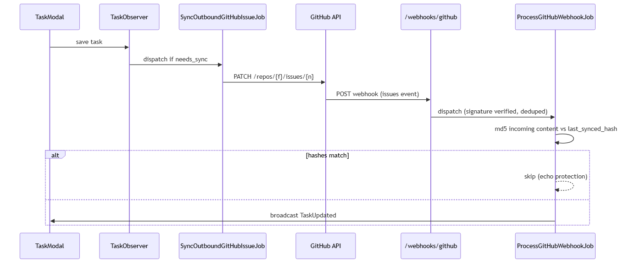
Figure 12: Diagram
The hash-based echo protection is what makes bidirectional sync safe. Without it, the loop is infinite.

13.5 Evidence
- app/Http/Controllers/GitHubWebhookController.php
- app/Jobs/ProcessGitHubWebhookJob.php
- routes/web.php — webhook route + CSRF exemption
- bootstrap/app.php — CSRF exemption
- config/services.php — webhook_secret
- tests/Feature/GitHubIntegrationTest.php — webhook signature, dedupe, missing-header tests
- tests/Feature/GitSyncTest.php — push handler tests---

Part XIV — Notifications

14.1 Architecture
Scaffold has a single notification table (notifications) and a single per-user WebSocket channel (App.Models.User.{user_id}). The Notifier::send helper is the only producer. The NotificationPanel component is the only consumer.
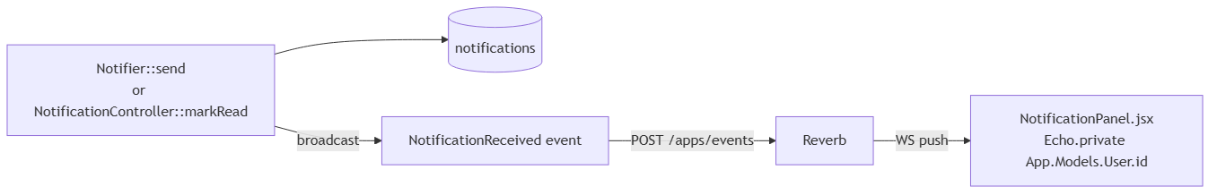
Figure 13: Diagram

14.2 Model: `Notification`
app/Models/Notification.php
- fillable: user_id, type, notifiable_type, notifiable_id, data, read_at.
- casts: data → array, read_at → datetime.
- Relation: user() — belongsTo(User).
- Scope: scopeUnread($q) — whereNull('read_at').
- Method: markAsRead() — sets read_at = now().
The notifiable_type + notifiable_id pair is a polymorphic key — the notification points at the originating entity (e.g. a WorkspaceInvitation or GitHubIssue). The DB doesn't index this pair; lookups go through Auth::user()->notifications().

14.3 Helper: `Notifier`
app/Helpers/Notifier.php
class Notifier
{
public static function send(User $user, string $type, array $data, $notifiable = null): Notification
{
$notification = Notification::create([
'user_id' => $user->id,
'type' => $type,
'notifiable_type' => $notifiable ? get_class($notifiable) : null,
'notifiable_id' => $notifiable?->getKey(),
'data' => $data,
]);
try {
broadcast(new NotificationReceived($notification));
} catch (\Throwable $e) {
Log::warning('Failed to broadcast notification', [
'error' => $e->getMessage(),
'notification_id' => $notification->id,
]);
}
return $notification;
}
}
Three behaviors:
1. Persistence first — DB row is created before broadcast.
2. Best-effort broadcast — failures are logged, never thrown.
3. Polymorphic attachment — $notifiable is an Eloquent model; get_class() + getKey() populate the pair.
Used by:
- InvitationController::store (workspace invitations).
- ProcessGitHubWebhookJob::notifyTaskClosedByCommit (commits that close tasks).
- ProcessGitHubWebhookJob::notifyPullRequestMerged (PRs that close tasks).
- SyncOutboundGitHubIssueJob::notifyIssueCreated (sync successes).
- SyncOutboundGitHubIssueJob::notifySyncFailed (sync failures).

14.4 Controller: `NotificationController`
Method | Route | Behavior
index() | GET /notifications | Auth::user()->notifications()->latest()->limit(30)->get() — Inertia renders the panel with this list.
markRead(string $id) | POST /notifications/{id}/read | Auth::user()->notifications()->findOrFail($id) — scopes by current user, so cross-user IDOR is prevented. Calls $notification->markAsRead(). Returns {success:true}.
markAllRead() | POST /notifications/read-all | Bulk update: Auth::user()->notifications()->whereNull('read_at')->update(['read_at' => now()]). Returns {success:true}.

14.5 Event: `NotificationReceived`
// app/Events/NotificationReceived.php
class NotificationReceived implements ShouldBroadcastNow
{
public function __construct(public Notification $notification) {}
public function broadcastOn(): array
{
return [new PrivateChannel("App.Models.User.{$this->notification->user_id}")];
}
public function broadcastWith(): array
{
return ['notification' => $this->notification];
}
}
The channel authorization in routes/channels.php:
Broadcast::channel("App.Models.User.{id}", function ($user, $id) {
return (int) $user->id === (int) $id;
});
Only the matching user can subscribe to their own notification channel.

14.6 Frontend

`ui/NotificationPanel.jsx`
A bell icon in the topbar (rendered inside AppLayout). Click → opens dropdown with the most recent 30 notifications. Each item shows:
- Icon by type (workspace.invitation, github.pr.merged, github.sync.failed, etc.).
- Title from data.title.
- Timestamp from date-fns ("2 hours ago").
- Action buttons where applicable:
- For workspace.invitation: Accept / Decline (POST to /invitations/accept/{token}).
- For GitHub events: opens the html_url in a new tab.
Mark all read button at the bottom. Click outside to close.
Echo subscriptions**: `window.Echo.private(`App.Models.User.${auth.user.id}`).listen('.NotificationReceived', prepend)` — prepends the new notification to the list. No full reload.

14.7 Notification Types Inventory
`type` string | When sent | Source
workspace.invitation | Workspace owner invites a user | InvitationController::store
github.issue.created | Outbound sync successfully creates a GitHub issue | SyncOutboundGitHubIssueJob::notifyIssueCreated
github.sync.failed | Outbound sync fails after 3 tries | SyncOutboundGitHubIssueJob::notifySyncFailed
github.task.closed_by_commit | Inbound commit closed a task | ProcessGitHubWebhookJob::notifyTaskClosedByCommit
github.pr.merged | Inbound PR merged | ProcessGitHubWebhookJob::notifyPullRequestMerged

14.8 Evidence
- app/Models/Notification.php
- app/Helpers/Notifier.php
- app/Http/Controllers/NotificationController.php
- app/Events/NotificationReceived.php
- routes/web.php — notification routes
- routes/channels.php — App.Models.User.{id} channel
- database/migrations/2026_04_09_154750_create_notifications_table.php
- resources/js/components/ui/NotificationPanel.jsx

Part XV — User Profiles, Search, Media

15.1 Profile Module

Controller: `ProfileController`
Method | Route | Behavior
me(Request) | GET /profile | Auth user's aggregated profile. Loads memberships sorted by workspace name. Optional ?workspace= filter (slug). Builds global + filtered stats (completed, pending, blocked, wikis, threads) + assigned tasks sorted by due_date. Renders Workspace/MemberProfile.jsx with profileMode = 'global'.
show(Workspace, User) | GET .../members/{user} | Member-gated. Loads the target user's membership. Renders MemberProfile.jsx with profileMode = 'workspace'. Recovers is_definitive flag for the visiting user.
updateMe(Request) | POST /profile | Delegates to persistProfile(?, null) or with optional ?workspace_slug=.
update(Request, Workspace) | POST .../members/profile | Member-gated; delegates to persistProfile(?, $workspace).
persistProfile(Request, ?Workspace) | private | Validates name, title, bio, color, avatar (image), avatar_url, recovery_question/recovery_answer (with inner current_password check), workspace_slug. Handles avatar upload (same GD logic as register). Updates user row. If workspace + color is in payload, updateExistingPivot the color on the membership. Redirect back().

Frontend: `Workspace/MemberProfile.jsx`
Renders profile card with avatar (or initials), name, title, bio, member color, joined date. Below: a 4-column stat grid (Completed / Pending / Blocked / Wikis+Threads combined). Below: assigned tasks list (sorted by due date, click to open TaskModal). An edit button (only on own profile) opens an edit form that posts to the same endpoint.
Layout switching**: `MemberProfile.layout` dynamically returns either `AppLayout` or `WorkspaceLayout` based on `profileMode`.

15.2 Search

Controller: `SearchController`
A single JSON endpoint used by CommandPalette:
Method | Route | Behavior
search(Request, Workspace) | GET .../search | Member-gated. ?q=<query>. If empty or < 2 chars → empty {projects: [], tasks: [], threads: [], wikis: []}. Otherwise: projects (name LIKE %q%, limit 5); tasks (title OR description LIKE %q% across project ids, with project:id/slug/name, limit 10); threads (same pattern over title/body); wikis (same over title/content). Returns all four collections.
Caveat**: all queries use unparameterized `LIKE "%{$query}%"` with `$query` interpolated directly — relies on the DB not interpreting `%`/`_` in user input. For demo this is acceptable; production should escape.

Frontend: `ui/CommandPalette.jsx`
Triggered with Cmd/Ctrl+K. Quick project actions when a project context is set; otherwise debounced remote search (100 ms) across all four entities. Arrow keys + Enter for navigation. Built on axios calls to /workspaces/{slug}/search?q=....

15.3 Media Upload

Controller: `MediaController`
Method | Route | Behavior
upload(Request, Workspace) | POST .../media/upload | Auth check (owner-or-member via inverse pivot). Validates image: `required\

Frontend: `MarkdownEditor.jsx`
The composer used in wikis and thread replies. Drag-and-drop / paste-upload of images and image URLs. Uses axios.post(uploadUrl, FormData) with progress text. Upload errors surface as inline alerts.

15.4 Evidence
- app/Http/Controllers/ProfileController.php
- app/Http/Controllers/SearchController.php
- app/Http/Controllers/MediaController.php
- app/Models/Media.php
- routes/web.php — profile / search / media routes
- app/Support/AvatarUrl.php — external avatar URL validation
- resources/js/pages/Workspace/MemberProfile.jsx
- resources/js/components/ui/CommandPalette.jsx, MarkdownEditor.jsx

Part XVI — Frontend Layer (Inertia + React)

16.1 Pages
Scaffold has 17 page components under resources/js/pages/. Each receives props from a controller and either renders the full page or mounts inside a layout.
# | File | Inertia component | Route | Echo sub | Notable children
1 | Auth/Login.jsx | Auth/Login | login | — | Inline
2 | Auth/Register.jsx | Auth/Register | register | — | Inline auth inputs
3 | Auth/RecoverPassword.jsx | Auth/RecoverPassword | forgot-* | — | Inline
4 | Workspace/Index.jsx | Workspace/Index | workspaces.index | — | WorkspaceCard, CreateWorkspaceModal
5 | Workspace/Show.jsx | Workspace/Show | workspaces.show | project.* joins | ProjectCard, NewProjectModal, ProjectEditModal, AvatarStack
6 | Workspace/InviteResponse.jsx | Workspace/InviteResponse | invitations.show | — | Button
7 | Workspace/MemberProfile.jsx | Workspace/MemberProfile | members.profile, profile.show | — | StyledSelect
8 | Project/Show.jsx | Project/Show | workspaces.projects.show | project.* join | ProjectHeader
9 | Project/Board.jsx | Project/Board | projects.board | extensive | ColumnView, FlowView, TaskModal, ProjectHeader
10 | Project/Activity.jsx | (no route) | — | — | ProjectHeader
11 | Project/Docs.jsx | (no route) | — | — | ProjectHeader
12 | Project/Threads/Index.jsx | Project/Threads/Index | workspaces.projects.threads.index | project.* listen | MarkdownEditor, ProjectHeader
13 | Project/Threads/Show.jsx | Project/Threads/Show | workspaces.projects.threads.show | project.* listen + presence-thread.* join | MarkdownEditor, SafeMarkdown, CommentTree, ProjectHeader
14 | Project/Wiki/Index.jsx | Project/Wiki/Index | workspaces.projects.wiki.index, …wiki.show | project.* listen | SafeMarkdown
15 | Project/Wiki/CreateEdit.jsx | Project/Wiki/CreateEdit | …wiki.create, …wiki.edit | — | MarkdownEditor, ProjectHeader
16 | Project/Git/Feed.jsx | Project/Git/Feed | projects.activity | project.* listen for GitHubActivityUpdated | SettingsModal, StyledSelect, ProjectHeader

16.2 Components

UI (`resources/js/components/ui/`)
File | Purpose | Props | Special
Button.jsx | Full-width CTA with accent color + spinner | children, loading, className, ...props | Spinner when loading
input.jsx | Labeled input with focus ring + error | label, error, ...props | —
StyledSelect.jsx | Themed <select> with chevron + optional leading icon | many | —
CommandPalette.jsx | Cmd/Ctrl+K search palette | workspace, project? | Debounced remote search; navigates via router.visit
NotificationPanel.jsx | Bell + dropdown notification stream | none | Listens Echo.private('App.Models.User.{id}')
SafeMarkdown.jsx | react-markdown + GFM + sanitize | children, className, components? | URL normalizer helpers; image lazy load
MarkdownEditor.jsx | Two-tab write/preview editor | value, onChange, placeholder, uploadUrl, disabled | Drag-drop + paste upload via axios

Kanban (`resources/js/components/kanban/`)
File | Purpose
ColumnView.jsx | @hello-pangea/dnd Kanban board
TaskModal.jsx | 90vh modal with editor, presence, lock, checklist, comments

Flow (`resources/js/components/flow/`)
File | Purpose
FlowView.jsx | @xyflow/react node graph
TaskNode.jsx | React Flow node component

Project (`resources/js/components/project/`)
File | Purpose
ProjectHeader.jsx | Title + tabbed subnav (dashboard, board, threads, wiki, activity) + Settings cog
SettingsModal.jsx | Three-tab modal (general/labels/github)

Workspace (`resources/js/components/workspace/`)
File | Purpose
ProjectEditModal.jsx | Rename project modal

Threads (`resources/js/components/threads/`)
File | Purpose
CommentTree.jsx | Recursive Reddit-style reply tree

16.3 Layouts

`AppLayout.jsx`
The primary layout: left sidebar (navy #071d38) + topbar (cream #ede0c8) + main.
Sidebar** (desktop fixed, mobile top-bar):
- Logo (ScaffoldMark).
- "Workspaces" link.
- "My Workspaces" — search-filtered, first 5 + "+ N more" overflow. Clicking a workspace switches context.
- If a workspace is active, lists its projects (dynamic max-projects based on window.innerHeight).
- "Settings" link.
- User footer (avatar/initials, profile link, logout).
Topbar**:
- Breadcrumb chain (Workspaces › {workspace} › {project}).
- NotificationPanel (bell).
All Projects modal**: search + clickable list.
State**:
- open — persisted to localStorage["scaffold_sidebar_open"].
- mobileMenuOpen, isProjectSearchOpen, projectSearchQuery, workspaceSearchQuery, isDesktop (tracks matchMedia('(min-width:1024px)')).
- windowHeight — drives the dynamic projects list.

`WorkspaceLayout.jsx`
Wraps AppLayout. Renders CommandPalette once at the top. Renders children full-width (no secondary sidebar). Mounts a "New Project" modal (showingNewProject).

16.4 Utilities (`resources/js/utils/`)

`cycleDetection.js`
Already covered in Part IX — Annotated Code Excerpt #3 (mirror). Exports wouldCreateCycle(tasks, taskId, proposedDepId).

`taskDependencies.js`
export function getResolvableDependencies(task, allTasks = []) {
return (task.dependencies || []).filter(depId =>
allTasks.some(t => Number(t.id) === Number(depId))
);
}
export function isTaskBlocked(task, allTasks = []) {
const deps = getResolvableDependencies(task, allTasks);
for (const depId of deps) {
const depTask = allTasks.find(t => Number(t.id) === Number(depId));
const status = depTask?.status ?? 'done';
if (status !== 'done') return true;
}
return false;
}
export function pruneDependencyReferences(tasks, deletedTaskId) {
return tasks.map(task => ({
...task,
dependencies: (task.dependencies || []).filter(
depId => Number(depId) !== Number(deletedTaskId)
),
}));
}
export function removeTaskAndPruneDependencies(tasks, deletedTaskId) {
const filtered = tasks.filter(t => Number(t.id) !== Number(deletedTaskId));
return pruneDependencyReferences(filtered, deletedTaskId);
}
export function pruneDependencyIds(depIds, allTasks = []) {
return (depIds || []).filter(depId =>
allTasks.some(t => Number(t.id) === Number(depId))
);
}
Used by TaskModal autosave, ColumnView drop validation, FlowView edge build.

16.5 Bootstrap (`resources/js/app.jsx`)
import './bootstrap';
import '../css/app.css';
import { createInertiaApp } from '@inertiajs/react';
import { resolvePageComponent } from 'laravel-vite-plugin/inertia-helpers';
createInertiaApp({
title: (title) => `${title} - ${import.meta.env.VITE_APP_NAME || 'Scaffold'}`,
resolve: (name) => resolvePageComponent(`./pages/${name}.jsx`, import.meta.glob('./pages/**/*.jsx')),
setup({ el, App, props }) {
createRoot(el).render(<App {...props} />);
},
progress: { color: '#8b5e3c' },
});
Vite's import.meta.glob('./pages/**/*.jsx') pre-imports every page so the bundler can split them into per-route chunks.

16.6 Evidence
- resources/js/pages/**/*.jsx — 17 page components
- resources/js/components/**/*.jsx — ~25 components grouped by folder
- resources/js/layouts/AppLayout.jsx, WorkspaceLayout.jsx
- resources/js/utils/cycleDetection.js, taskDependencies.js
- resources/js/app.jsx, bootstrap.js, echo.js
- vite.config.js
- app/Http/Middleware/HandleInertiaRequests.php

Part XVII — Testing & Concerns

17.1 Test Suite

Framework
PHPUnit 10.5 (composer.json require-dev). phpunit.xml overrides APP_ENV=testing, BCRYPT_ROUNDS=4, CACHE_STORE=array, DB_CONNECTION=sqlite, DB_DATABASE=:memory:, BROADCAST_CONNECTION=log, MAIL_MAILER=array, PULSE_ENABLED=false, QUEUE_CONNECTION=sync, SESSION_DRIVER=array, TELESCOPE_ENABLED=false.
Result: every test runs in a fresh in-memory SQLite database with sync queue + array cache. No external services are touched.

Commands
php artisan test
php artisan test --filter=webhook
vendor/bin/phpunit

Layout
tests/
├── TestCase.php # empty abstract base
├── Unit/ExampleTest.php
└── Feature/
├── AuthRedirectTest.php
├── ExampleTest.php
├── GitHubIntegrationTest.php # 7 tests
├── GitSyncTest.php # 4 tests
├── LabelTest.php
├── PasswordRecoveryTest.php
├── ProfileTest.php
├── TaskTest.php # 5 tests
├── ThreadTest.php
├── WikiTest.php
└── WorkspaceTest.php

Mocking Patterns
1. Container replacement — GitHubTokenService is bound to a Mockery mock per-test (avoid needing the real PEM key).
2. HTTP fakes — Http::fake([...]) for every GitHub API call.
3. Queue fakes — Queue::fake() for webhook-dispatch tests; Job->handle() direct invocation for handler tests.
4. Inertia assertions — ->assertInertia(fn (Assert $page) => ...) validates the React prop payload.
5. actingAs($user) — used immediately before every authenticated HTTP call.
6. assertDatabaseHas / assertDatabaseMissing — dominant assertion shape.

Coverage Status
Per-method coverage: [TODO] (not measured in this acquisition). Posture: integration-heavy, unit-light, frontend-absent.

Top Coverage Gaps
- Reverb broadcasting — no Event::fake() + Event::assertDispatched tests.
- React/JSX — no Jest/Vitest config.
- TaskModal / FlowView / CommentTree — no component-level tests.
- Reaction toggle whitelist (class_basename) — not exercised per-type.
- Profile avatar upload (GD path).
- Webhook handlers for pull_request, issues, create, delete (only push is tested).
- Cycle detection BFS in isolation.
- Cascade revert depth > 2.
- InvitationController full flow.

17.2 Top Concerns (Recap from `docs/codebase/CONCERNS.md`)

High-Severity
1. TaskAttachmentController dead import — routes/web.php:10 imports a controller that doesn't exist on disk. TaskAttachment model exists; no route or controller uses it.
2. Legacy CSRF exemption — bootstrap/app.php:22 exempts public/workspaces/*/projects/*/git/webhook, which is not a current route. Remove the line.
3. @mention notifier TODO — ThreadReplyController.php:45. Mentions in thread replies don't trigger notifications.
4. axios, laravel-echo, pusher-js in devDependencies — but imported at runtime. A future npm ci --omit=dev would strip them.
5. Pre-built public/build/ committed; Dockerfile doesn't npm run build — if assets fall out of sync with source, the live UI runs outdated JS.

Medium-Severity
6. BROADCAST_CONNECTION=log default in .env.example:35 — silent fallback for real-time failures.
7. .env.example missing VITE_REVERB_* vars — fresh clones fail Echo client connect.
8. No Policies/Gates — authorization is inline abort(403) in every controller. Easy to forget when adding endpoints.
9. No global React error boundary — resources/js/app.jsx renders <App /> with no error catch.
10. config/reverb.php allowed_origins = ['*'] — open by default.
11. Ephemeral container filesystem — avatars/uploads lost on container restart unless a Render disk is mounted.

Low-Severity
12. Webhook secret misconfig silent — Log::critical is the only signal if services.github.webhook_secret is empty in production.
13. Avatars served from /storage/... symlink — anyone with the URL can fetch them.
14. No CI configuration — no .github/workflows.

Performance Bottlenecks
- TaskController::findCyclicDependency BFS does raw DB query per visited node (Task::find). O(N) queries per call.
- ProfileController::buildStats runs 5 separate count queries per render.
- Board.jsx calls router.reload after every event — extra HTTP round-trip.
- MemberProfile 8 queries per render on dashboard loads.
- ColumnView presence + frequent task patches cause broadcast storm.

17.3 Intent vs. Reality Divergences
User's stated intent | Code reality | Gap
Real-time live collab | Works for board/thread/notification | Not stressed under load
GitHub App + webhook → task sync | Works (bidirectional with hash echo guard) | Webhook is only way inbound sync fires
Auth via custom flow | Custom (no Breeze/Sanctum) | Three-step recovery not using Sanctum
MySQL → Neon Postgres migration | Code 90% same | Three Neon-specific overrides required
Task permissions / privileges | Owner vs member (binary) | No fine-grained roles
Notifications for every action | Notifications + bell | No audit log per workspace
Docs / Activity tabs | "Coming Soon" placeholders | Real activity lives in Project/Git/Feed.jsx
Accent color system | Pivot workspace_members.color + 12-color palette at accept + editable from profile | Working as intended
User profile | ProfileController + MemberProfile | Works

17.4 Evidence
- tests/TestCase.php, tests/Feature/*.php, tests/Unit/ExampleTest.php
- phpunit.xml
- composer.json — phpunit/phpunit ^10.5
- All docs/codebase/*.md (the seven reference documents underpin this section)

Appendix A — File Index
A complete alphabetical list of every file referenced in this walkthrough, with a one-line purpose. Does not include vendor or generated files.

A.1 PHP — Root Configuration
- bootstrap/app.php — Laravel 11 app bootstrap (routes, broadcasting, middleware, CSRF exemptions).
- composer.json — PHP dependency manifest.
- phpunit.xml — PHPUnit test environment.
- public/.htaccess — Apache rewrite rules (front controller fallback).

A.2 PHP — App (`app/`)

Console
- app/Console/Commands/SyncOutboundGitHubIssuesCommand.php — Artisan command github:sync-outbound (runs every 5 min).

Database
- app/Database/PostgresConnection.php — Custom pgsql connection class; re-encodes booleans as 'true'/'false' strings.

Helpers
- app/Helpers/Notifier.php — Static send() helper (creates Notification + broadcasts).

Http — Controllers
- app/Http/Controllers/Auth/AuthController.php — register, login, logout.
- app/Http/Controllers/Auth/RecoveryController.php — 3-step password recovery.
- app/Http/Controllers/GitController.php — GitHub activity feed (projects.activity).
- app/Http/Controllers/GitHubAppController.php — connect, callback, listRepositories, link/unlink.
- app/Http/Controllers/GitHubWebhookController.php — webhook signature verify + dedupe + dispatch.
- app/Http/Controllers/InvitationController.php — invite, accept, decline.
- app/Http/Controllers/LabelController.php — owner-only label CRUD.
- app/Http/Controllers/MediaController.php — workspace media uploads.
- app/Http/Controllers/NotificationController.php — list, mark-read, mark-all-read.
- app/Http/Controllers/ProjectController.php — project store/show/board/update/destroy/settings-data.
- app/Http/Controllers/ReactionController.php — polymorphic reaction toggle.
- app/Http/Controllers/SearchController.php — workspace-wide search JSON.
- app/Http/Controllers/TaskCommentController.php — task comment creation.
- app/Http/Controllers/TaskController.php — task store/update/destroy/lock/unlock/transfer-control/sync-labels (cycle detection, cascade revert).
- app/Http/Controllers/ThreadController.php — thread index/store/show/update/destroy/pin.
- app/Http/Controllers/ThreadReplyController.php — reply store/update/mark-definitive/destroy.
- app/Http/Controllers/WikiController.php — wiki index/show/create/store/edit/update/destroy.
- app/Http/Controllers/WorkspaceController.php — workspace CRUD + updateMemberColor.
- app/Http/Controllers/ProfileController.php — me/show/update/updateMe + buildStats + buildAssignedTasks.
- app/Http/Controllers/Controller.php — abstract base.

Http — Middleware
- app/Http/Middleware/HandleInertiaRequests.php — Inertia shared props (auth, workspace, workspaceProjects, github_app_slug).

Events (`app/Events/`)
All implement ShouldBroadcastNow:
- CommentPosted.php, GitHubActivityUpdated.php, NotificationReceived.php, ReactionToggled.php, ReplyMarkedDefinitive.php, TaskControlTransferred.php, TaskDeleted.php, TaskLocked.php, TaskUnlocked.php, TaskUpdated.php, ThreadCreated.php, ThreadDeleted.php, ThreadReplyCreated.php, ThreadReplyDeleted.php, ThreadReplyUpdated.php, ThreadUpdated.php, WikiCreated.php, WikiDeleted.php, WikiUpdated.php.

Jobs (`app/Jobs/`)
- ProcessGitHubWebhookJob.php — inbound webhook dispatcher (push, PR, issue, create, delete).
- SyncOutboundGitHubIssueJob.php — outbound task→GitHub Issue sync.

Models (`app/Models/`)
20 Eloquent models:
GitHubBranch, GitHubInstallation, GitHubIssue, GitHubPullRequest, GitHubRepository, GitHubWebhookDelivery, Label, Media, Notification, Project, Reaction, Task, TaskAttachment, TaskComment, Thread, ThreadReply, User, Wiki, Workspace, WorkspaceInvitation.

Observers
- app/Observers/TaskObserver.php — saved() triggers outbound GitHub sync.

Providers
- app/Providers/AppServiceProvider.php — registers custom pgsql resolver + URL::forceScheme('https') in production + TaskObserver.

Services
- app/Services/GitHubTokenService.php — generateAppJwt() (RS256) + getInstallationToken() (cached 55 min).
- app/Services/GitHubIssueService.php — createIssue() + updateIssue() + calculateContentHash().

Support
- app/Support/AvatarUrl.php — external avatar URL validation helper.

A.3 PHP — Config (`config/`)
- app.php — app name/env/debug/url/timezone/cipher.
- broadcasting.php — broadcaster drivers (Reverb, Pusher, Ably, log, null).
- cache.php — cache drivers.
- database.php — SQLite/MySQL/Postgres/SQLSRV + Redis; pgsql sets PDO::ATTR_EMULATE_PREPARES.
- filesystems.php — local/public/s3 disks.
- queue.php — queue connections + batching + failed.
- reverb.php — Reverb server + app config.
- services.php — github (app_id, private_key, webhook_secret, app_slug).
- session.php — session driver/lifetime/cookie.

A.4 PHP — Database (`database/`)

Migrations — 29 custom + 3 Laravel defaults (full inventory in Part IV):
- 0001_01_01_000000_create_users_table.php
- 0001_01_01_000001_create_cache_table.php
- 0001_01_01_000002_create_jobs_table.php
- 2026_04_04_175139_create_workspaces_table.php
- 2026_04_06_094348_create_workspace_members_table.php
- 2026_04_06_094349_create_workspace_invitations_table.php
- 2026_04_06_134153_create_projects_table.php
- 2026_04_06_141431_create_tasks_table.php
- 2026_04_06_141432_create_task_comments_table.php
- 2026_04_06_141433_create_labels_table.php
- 2026_04_06_141433_create_label_task_table.php
- 2026_04_06_165320_create_task_dependencies_table.php
- 2026_04_07_120000_drop_blocked_by_id_from_tasks_table.php
- 2026_04_08_151502_add_color_to_workspace_members_table.php
- 2026_04_09_141433_create_task_attachments_table.php
- 2026_04_09_141436_add_checklist_to_tasks_table.php
- 2026_04_09_154750_create_notifications_table.php
- 2026_04_09_154805_add_inviter_id_and_status_to_workspace_invitations_table.php
- 2026_04_13_184316_create_media_table.php
- 2026_04_13_185024_create_threads_table.php
- 2026_04_13_185025_create_reactions_table.php
- 2026_04_13_185026_create_thread_replies_table.php
- 2026_06_26_211001_create_wikis_table.php
- 2026_06_26_211002_add_git_to_projects_table.php
- 2026_06_26_211003_add_tags_to_threads_table.php
- 2026_07_04_000000_add_profile_fields_to_users_table.php
- 2026_07_08_131318_create_github_integration_tables.php
- 2026_07_19_120000_add_recovery_question_to_users_table.php
- 2026_07_19_130000_add_editing_state_to_threads_and_replies.php
- 2026_07_19_140000_widen_users_avatar_path_column.php

Factories
- database/factories/UserFactory.php — only factory (User).

A.5 PHP — Routes & Console
- routes/web.php — every HTTP route (grouped by middleware).
- routes/channels.php — broadcast channel auth callbacks.
- routes/console.php — inspire (hourly) + github:sync-outbound (every 5 min).

A.6 PHP — Tests (`tests/`)
12 test files: AuthRedirectTest, GitHubIntegrationTest, GitSyncTest, LabelTest, PasswordRecoveryTest, ProfileTest, TaskTest, ThreadTest, WikiTest, WorkspaceTest, ExampleTest (Unit), ExampleTest (Feature), plus tests/TestCase.php.

A.7 Frontend — Resources (`resources/js/`)

Bootstrap & build
- app.jsx, bootstrap.js, echo.js
- ../css/app.css (Tailwind v4 entrypoint)

Pages (17)
- pages/Auth/Login.jsx, Register.jsx, RecoverPassword.jsx
- pages/Workspace/Index.jsx, Show.jsx, InviteResponse.jsx, MemberProfile.jsx
- pages/Project/Show.jsx, Board.jsx, Activity.jsx, Docs.jsx
- pages/Project/Threads/Index.jsx, Show.jsx
- pages/Project/Wiki/Index.jsx, CreateEdit.jsx
- pages/Project/Git/Feed.jsx

Components (~25)
- components/ui/{Button,input,StyledSelect,CommandPalette,NotificationPanel,SafeMarkdown,MarkdownEditor}.jsx
- components/kanban/{ColumnView,TaskModal}.jsx
- components/flow/{FlowView,TaskNode}.jsx
- components/project/{ProjectHeader,SettingsModal}.jsx
- components/workspace/ProjectEditModal.jsx
- components/threads/CommentTree.jsx

Layouts
- layouts/AppLayout.jsx, layouts/WorkspaceLayout.jsx

Utilities
- utils/cycleDetection.js, utils/taskDependencies.js

A.8 Configuration — Top-level
- package.json, vite.config.js, composer.json, phpunit.xml
- Dockerfile
- docker/000-default.conf, docker/start.sh

Appendix B — Glossary
Term | Definition
Apache mod_proxy_wstunnel | Apache 2 module that tunnels WebSocket upgrades through HTTP CONNECT, required for Apache to proxy WebSocket traffic to a backend like Reverb.
BroadcastEvent / ShouldBroadcast | Laravel contract telling the framework that an event should be pushed to the configured broadcaster (Reverb, Pusher, etc.).
ShouldBroadcastNow | Same as above, but bypasses the queue and pushes synchronously. Used for real-time UX where latency matters.
Cascade (DB) | A foreign key action that automatically deletes child rows when a parent row is deleted.
CSRF | Cross-Site Request Forgery. Laravel's web middleware group enforces a CSRF token for stateful POSTs.
DDL | Data Definition Language (CREATE/ALTER/DROP). Cannot run in a transaction under PgBouncer transaction-pool.
Emulated prepares | A PDO attribute (PDO::ATTR_EMULATE_PREPARES=true) that instructs the driver to inline values into SQL before sending, instead of using server-side prepared statement plans. Avoids PgBouncer's "cached plan" error class.
Eloquent | Laravel's ActiveRecord ORM. Models under app/Models/.
Event (Laravel) | A class implementing ShouldBroadcast (or ShouldBroadcastNow) that carries data over the broadcaster.
Flux / Reverb | Laravel Reverb is the first-party Laravel WebSocket server using the Pusher protocol.
Form Request | A dedicated validation class (app/Http/Requests/...) used by controllers to enforce input rules.
GitHub App | A first-party integration identity with per-installation tokens, webhooks, and higher rate limits than OAuth Apps.
HMAC SHA-256 | Hash-based Message Authentication Code using SHA-256 as the hash. Used for webhook signature verification.
Inertia.js | Server-driven SPA — controllers render pages with props, React renders them via usePage().
Installation token | A short-lived (1 hour) GitHub access token scoped to a specific app installation.
JWT (JSON Web Token) | A signed token format used here for GitHub App authentication. Signed with RS256, claims include iss (app id), iat (issued-at), exp (expiration).
Mermaid | A text-based diagram syntax that renders to SVG/PNG. Used throughout this document.
Modifier ->toOthers() | Laravel broadcast modifier; tells the broadcaster to deliver to every socket except the originating one.
MorphMany / MorphTo | Eloquent polymorphic relations — a single relation can target multiple model types.
Neon Postgres | Serverless Postgres with built-in branching and HTTP-friendly pooling over PgBouncer.
Ngrok / Cloudflare Tunnel | Tools for exposing a localhost server to the public internet (used during local GitHub App development).
Notifier | The app/Helpers/Notifier.php class — single producer of in-app notifications.
PgBouncer | Postgres connection pooler, used by Neon. Restricts server-side prepared statements, requires emulated prepares from clients.
PhpJWS / php-jwt | The firebase/php-jwt Composer package used to sign JWTs (RS256).
Polymorphic (DB) | A relation that uses two columns (type + id) to point at multiple target tables (e.g. reactions.reactable_type + reactions.reactable_id).
PresenceChannel | A Laravel broadcast channel that exposes membership information (joining/leaving/here) to the client.
PrivateChannel | A Laravel broadcast channel that requires server-side authorization via routes/channels.php.
Pusher protocol | The WebSocket protocol used by Pusher and replicated by Reverb. Clients use pusher-js; servers use pusher/pusher-php-server.
RS256 | RSA Signature with SHA-256. The only algorithm GitHub accepts for App JWTs.
Render | The hosting platform — a single Docker container with Apache + Reverb + queue workers.
Reverb | The Laravel WebSocket server. Subscribed to by Laravel Echo on the client.
Route-model binding | Laravel resolves URI segments to Eloquent models automatically (/workspaces/{workspace:slug} → Workspace $workspace).
Route::scopeBindings() | Forces nested bindings to scope under their parent ({project} resolves as a child of {workspace}).
Scaffold | The product name. Previously "DevSpace". Renamed in config/services.php defaults (github.app_slug => 'devspace-scaffold' is a relic).
shouldBroadcastNow | Marker interface: push to broadcaster synchronously, bypassing the queue.
ShouldQueue | Marker interface: dispatch the job to the queue worker.
Slack protocol | (Common confusion) — not used here; the protocol used is Pusher.
Soft delete | A pattern where rows are not physically deleted but flagged as deleted (is_deleted=true). Preserves tree structure.
Tailwind v4 | The latest Tailwind CSS major. Configured via the @tailwindcss/vite plugin and CSS-driven @theme blocks — no tailwind.config.js.
Vite 5 | The next-generation frontend build tool powering package.json's dev and build scripts.

Closing
This walkthrough is the integrative narrative for Scaffold. For per-area deep dives (with file-path evidence tables and risk tables), see the seven reference documents under docs/codebase/:
- STACK.md — the dependency-and-config inventory.
- STRUCTURE.md — the directory tree with annotated entries.
- ARCHITECTURE.md — the layer-and-flow diagrams.
- CONVENTIONS.md — naming, formatting, linting policy.
- INTEGRATIONS.md — Reverb, GitHub, queue, cache, mail integrations.
- TESTING.md — PHPUnit conventions and coverage posture.
- CONCERNS.md — prioritized risks and gaps.
For command reference:
# local dev (sqlite, sync queue, log broadcaster)
php artisan migrate --seed
php artisan serve
php artisan reverb:start
php artisan queue:work
# production deploy
docker build -t scaffold .
docker run --env-file .env -p 8080:80 scaffold
# Render builds the same Dockerfile automatically
# tests
php artisan test
php artisan test --filter=webhook
# scheduled job (every 5 min)
php artisan schedule:work
# or in the container: handled by docker/start.sh
For everything that wasn't covered, or to learn what an individual file does end-to-end, jump to that file and the cross-references in Appendix A will anchor you.

