CSE 3100
Scaffold
Web Programming Laboratory
Project Report

Submitted By:
Rafsan Riasat
Roll: 2207006

Introduction
Modern software projects require more than a task list. Teams need a shared place for planning, discussion, documentation, progress visibility, and integration with their source-code workflow. Scaffold addresses these requirements through a workspace-oriented application in which users can create projects, organize tasks, define dependencies, collaborate through structured threads, maintain project wikis, and connect projects to GitHub repositories.
The application follows a Laravel–Inertia–React architecture. Laravel owns routing, validation, authorization, persistence, background jobs, and broadcasting. Inertia.js connects server-side controllers to React pages without requiring a separate REST API for every screen. React provides interactive interfaces such as Kanban and dependency-flow views, while Laravel Reverb and Echo deliver real-time updates.

Project objectives
- Provide secure user authentication and account recovery.
- Isolate data within workspaces and projects.
- Support task management, assignment, labeling, dependencies, and status flow.
- Enable threaded technical discussion and reactions.
- Maintain lightweight project documentation through a wiki.
- synchronize suitable task and repository activity with GitHub.
- Update collaborating users in real time.
- Deploy the application publicly using cloud-hosted infrastructure.

System Data Model

Entity–Relationship Diagram
The data model is centered on users, workspaces, projects, and tasks. Users join workspaces through a membership pivot; each workspace contains projects; and each project contains tasks, threads, and wiki pages. Supporting tables provide labels, dependencies, replies, reactions, media, invitations, notifications, GitHub installations, repository links, webhook deliveries, and synchronization metadata.

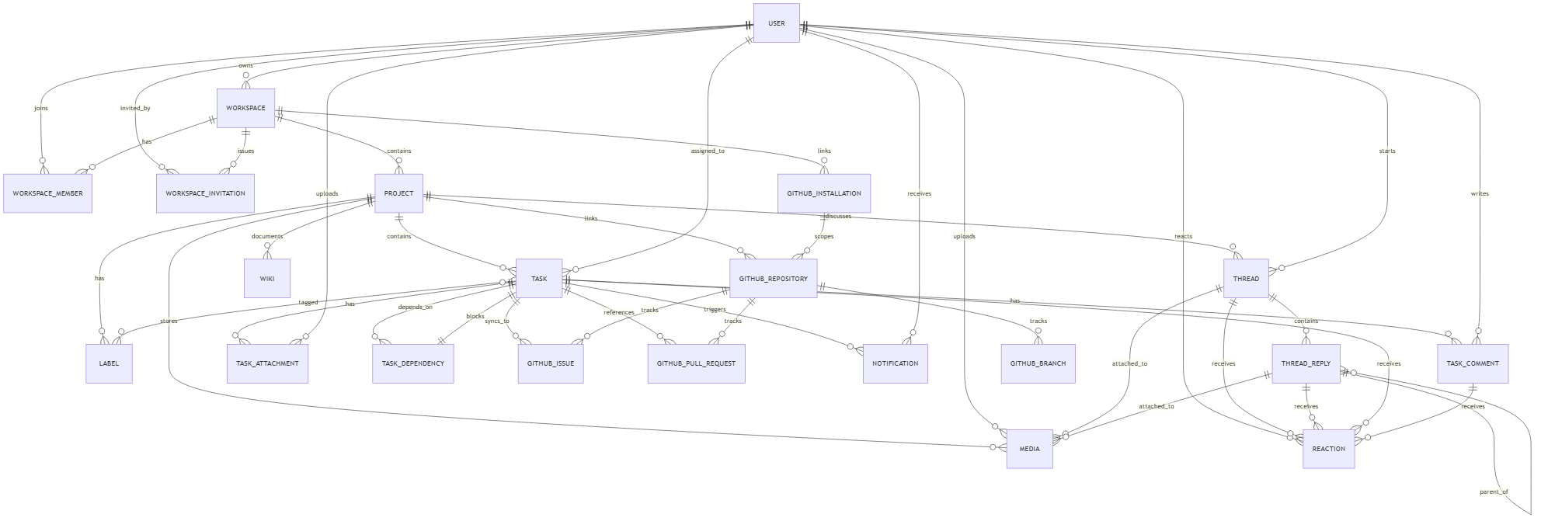

Database Schema Diagram

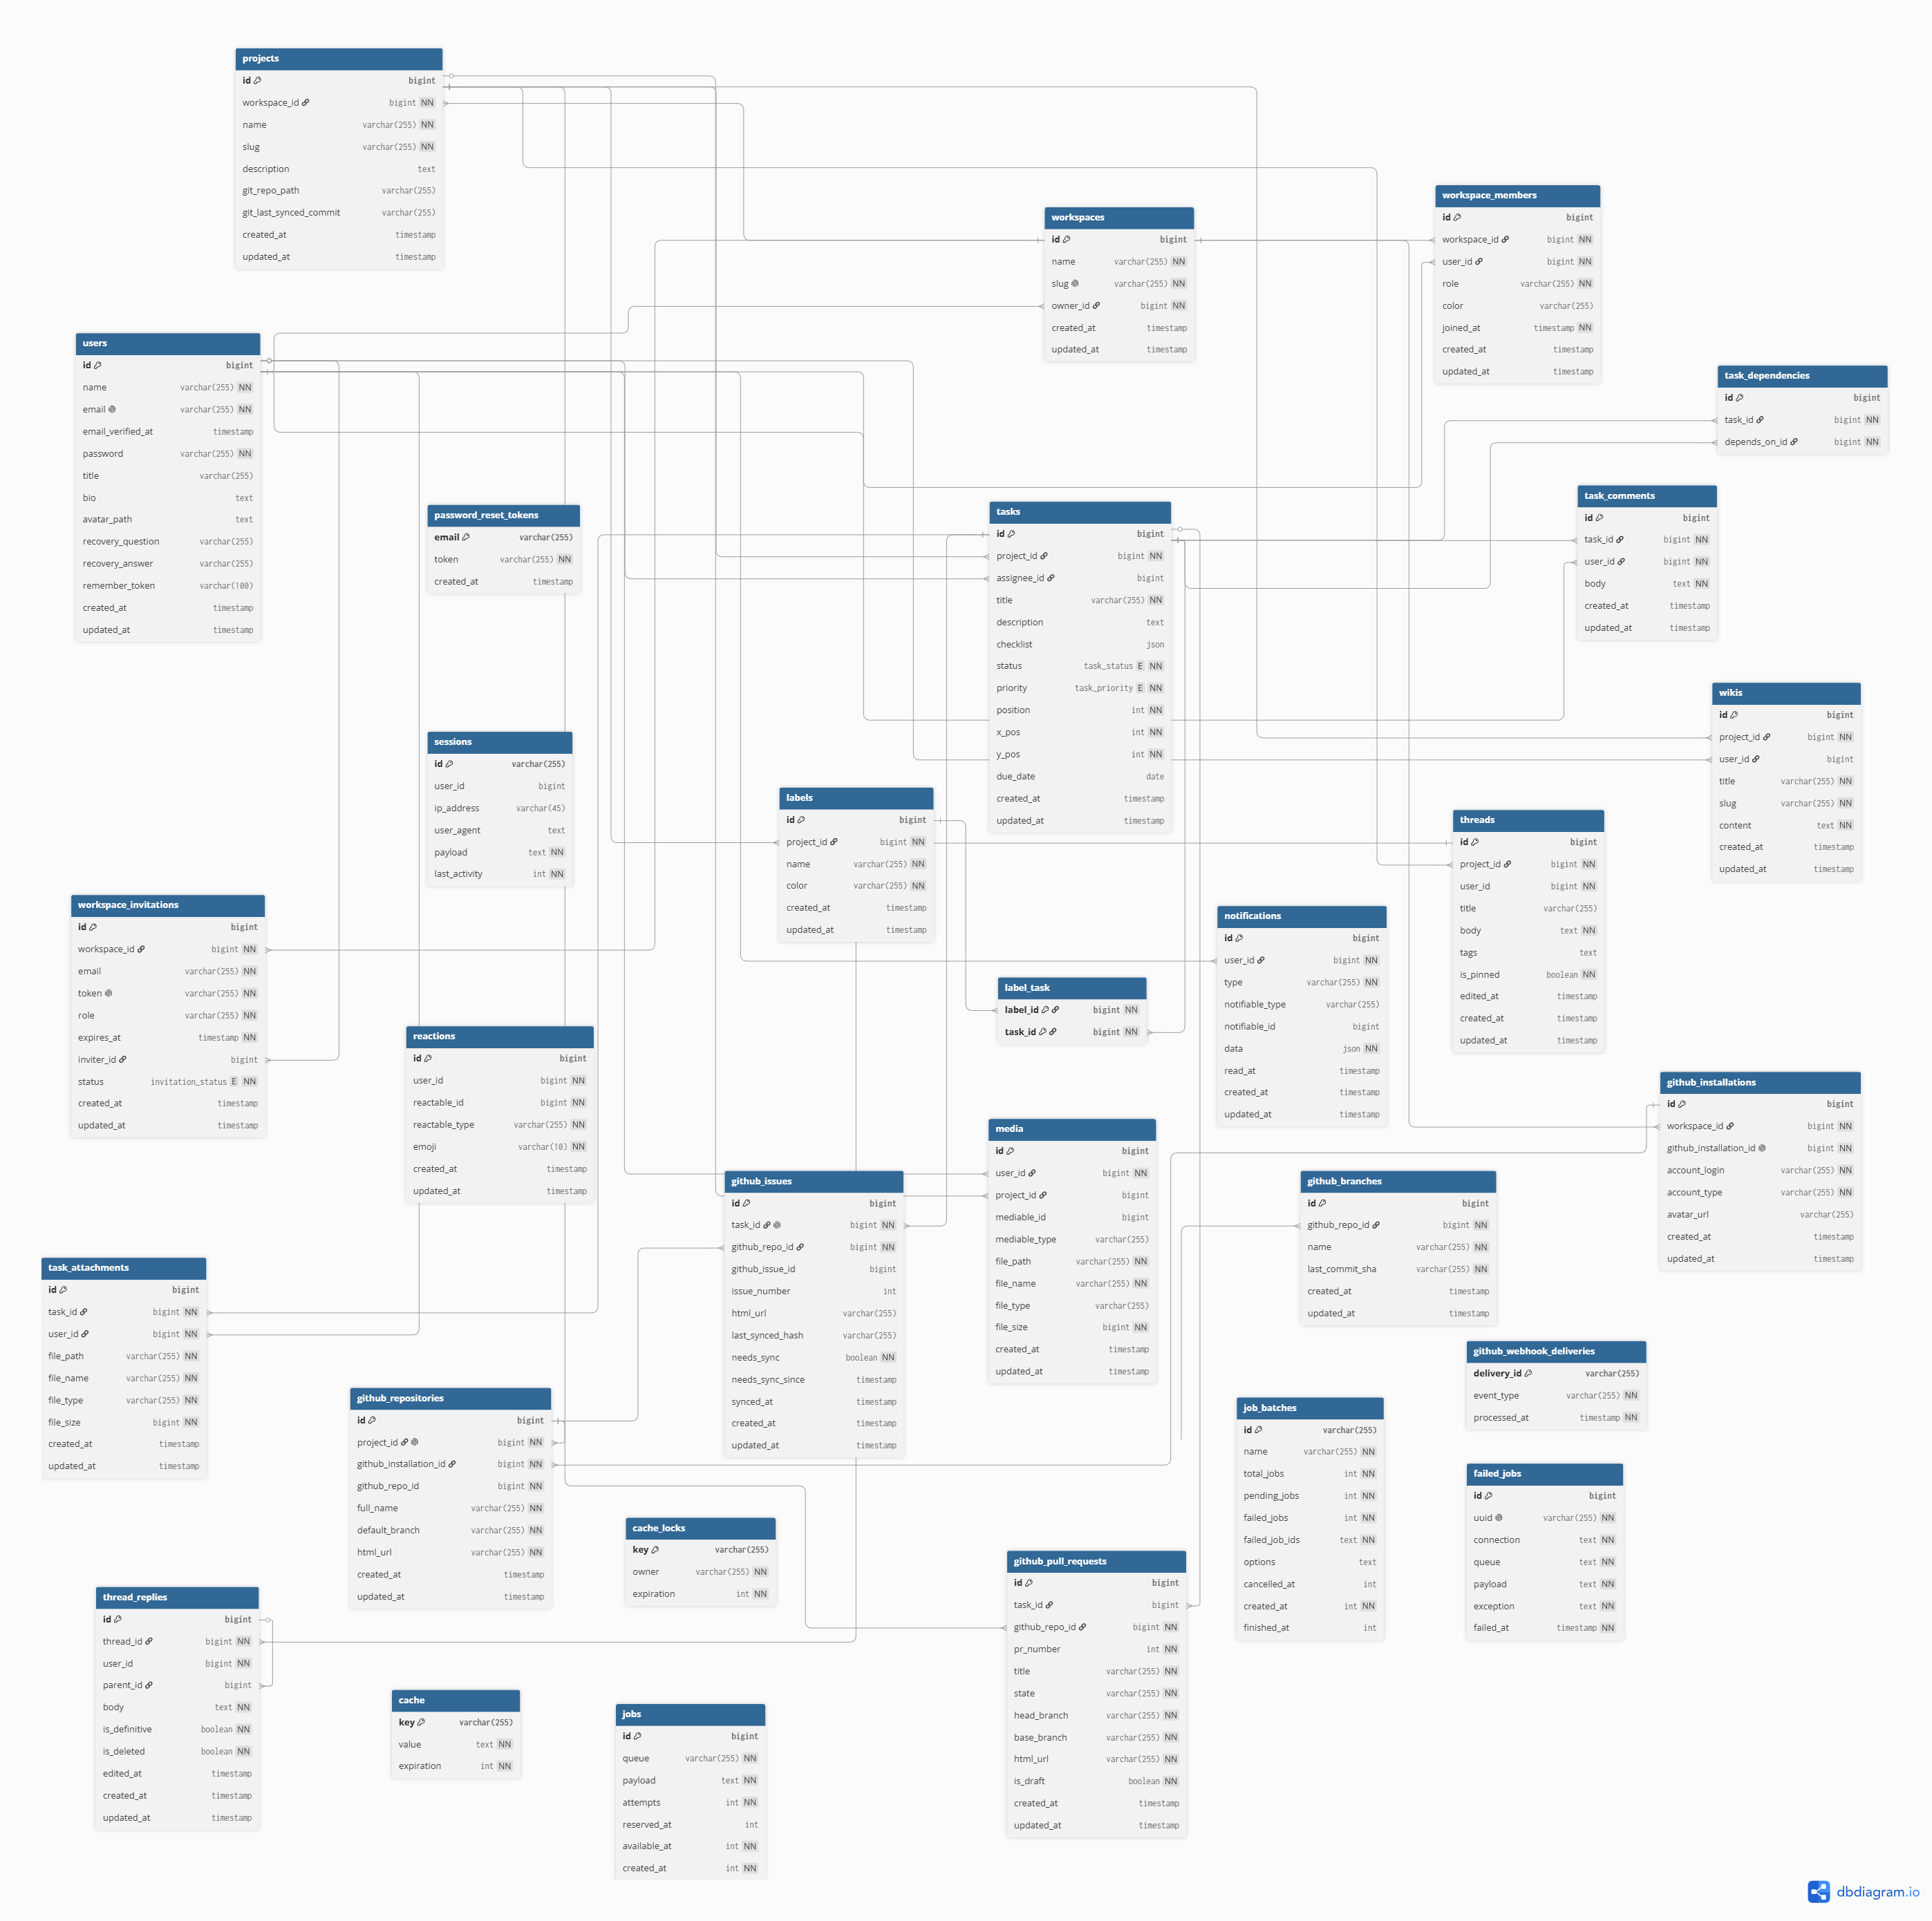
Important database behavior includes foreign-key constraints, cascading deletion where child data should not survive its owner, pivot tables for many-to-many relations, self-references for reply trees and task dependencies, polymorphic associations for reactions and media, and unique constraints for webhook deduplication. Migrations are located in database/migrations/, and model relationships are defined in app/Models/.

Technology Stack and Architecture

Feature overview
The application uses an integrated full-stack architecture rather than operating the frontend and backend as unrelated systems.

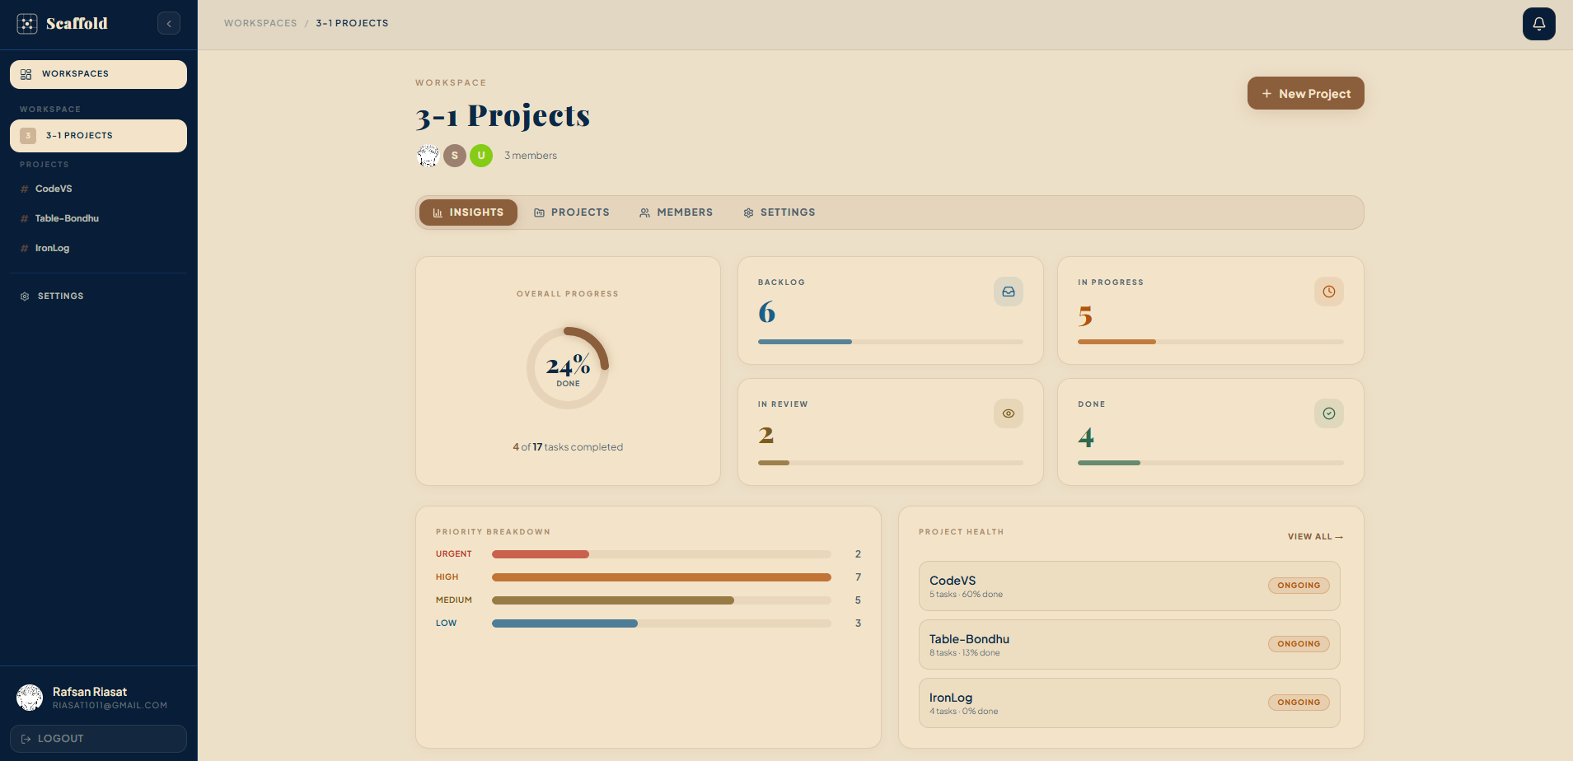

Layer | Technology | Responsibility
Backend | PHP 8.2 and Laravel 11 | Routes, controllers, validation, ORM, jobs, events, security
Frontend | React 19 | Interactive pages, dialogs, boards, forms, trees, filtering
Bridge | Inertia.js | Transfers controller responses and props directly to React pages
Styling | Tailwind CSS 4 | Responsive utility-based design and component styling
Build tooling | Vite 5 | JSX transformation, development server, optimized production assets
Database | Neon PostgreSQL | Persistent relational application data
Real time | Laravel Reverb, Echo, Pusher-JS | WebSocket broadcasting and subscriptions
External integration | GitHub Apps API | Repository linking, webhooks, installation authentication, issue sync
Hosting | Render and Docker | Hosted Apache application, workers, scheduler, and Reverb process

Authentication and Account Recovery

User capabilities
Users can register an account, log in, log out, remain authenticated through a session, and recover access through a security-question workflow. Protected routes redirect unauthenticated visitors to login, while authenticated users are redirected away from guest-only pages.

Implementation
Authentication is implemented with Laravel's session-based authentication facilities. Credentials are validated on the server, passwords are hashed, and the authenticated user's identifier is retained in the session. The account-recovery process is divided into stages: identify the account by email, answer the stored recovery question, and set a new password after verification. Recovery answers are normalized before hashing to avoid mismatches caused only by capitalization or repeated spaces. Rate limiting protects recovery endpoints from repeated attempts.
The application does not depend on a separate frontend authentication token flow. Inertia requests use the same server session and CSRF protections as ordinary Laravel forms.

Relevant files: authentication and recovery controllers under app/Http/Controllers/; authentication routes in routes/web.php; app/Models/User.php; pages under resources/js/pages/Auth/;
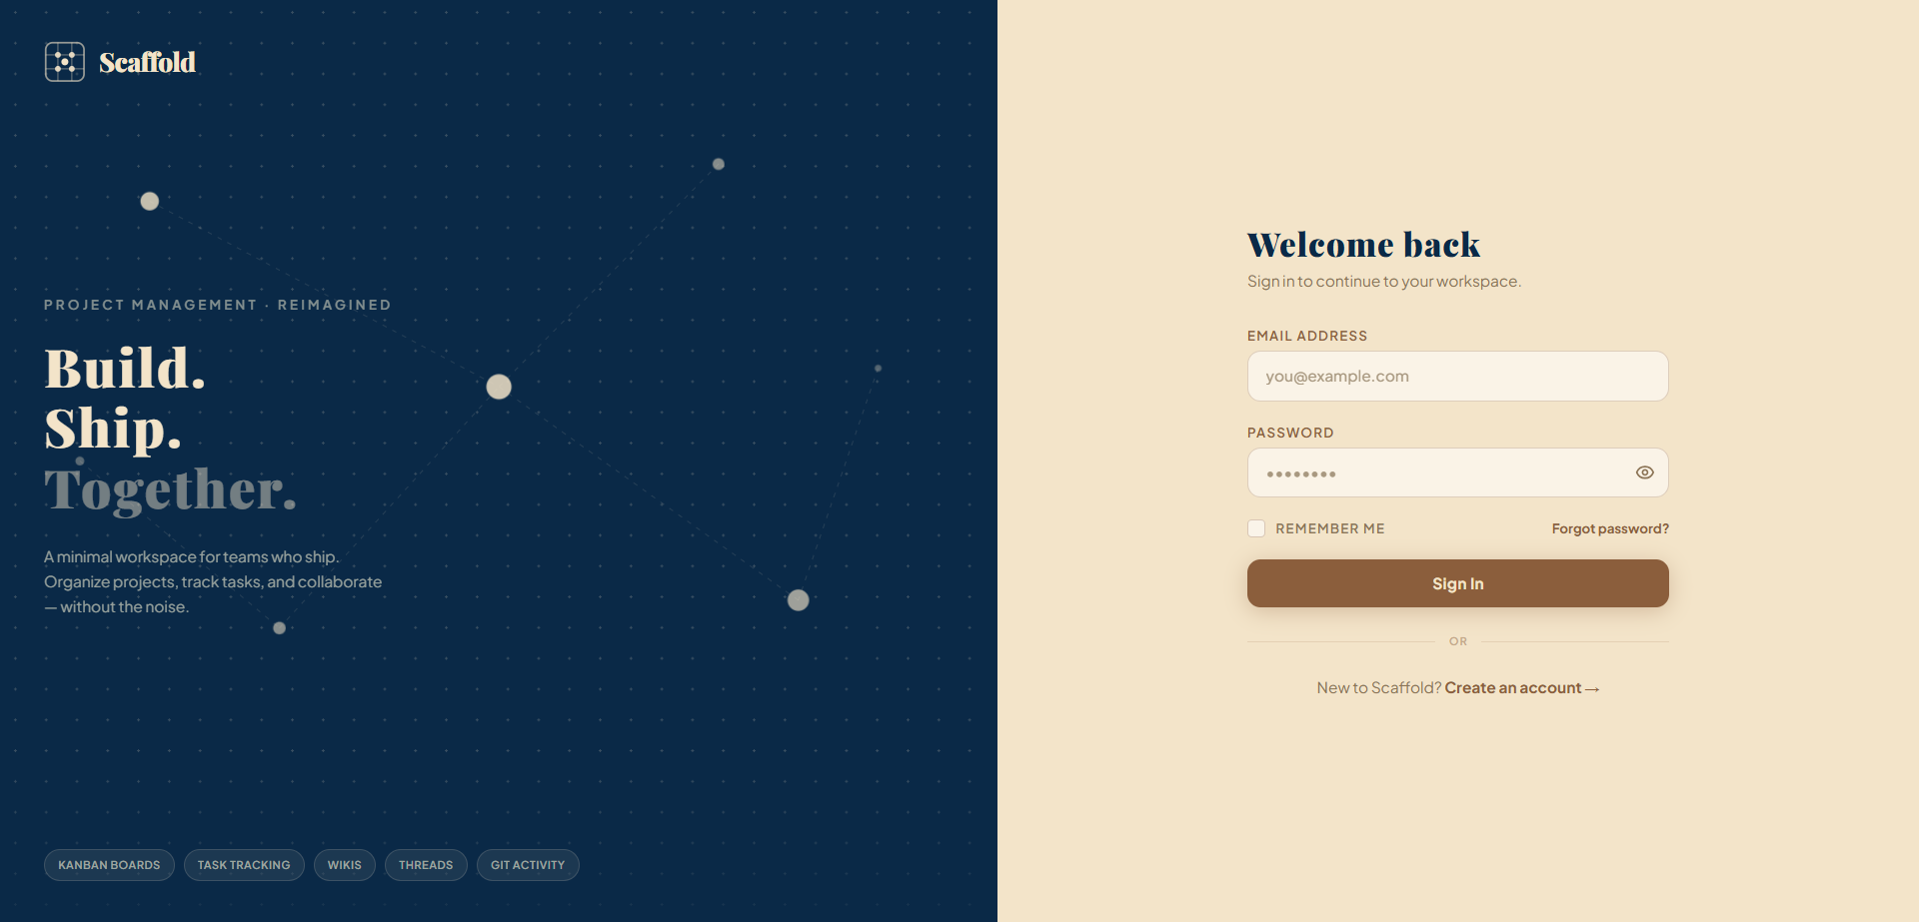
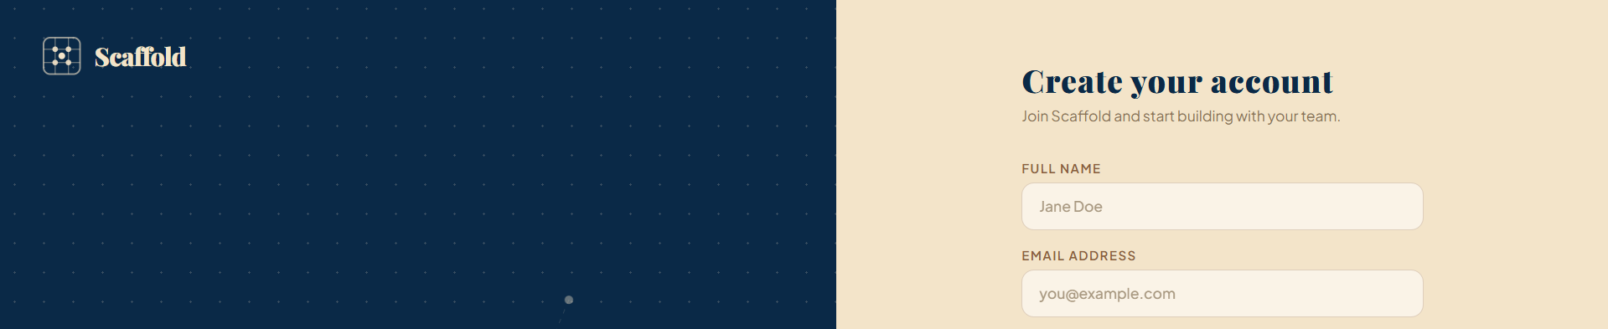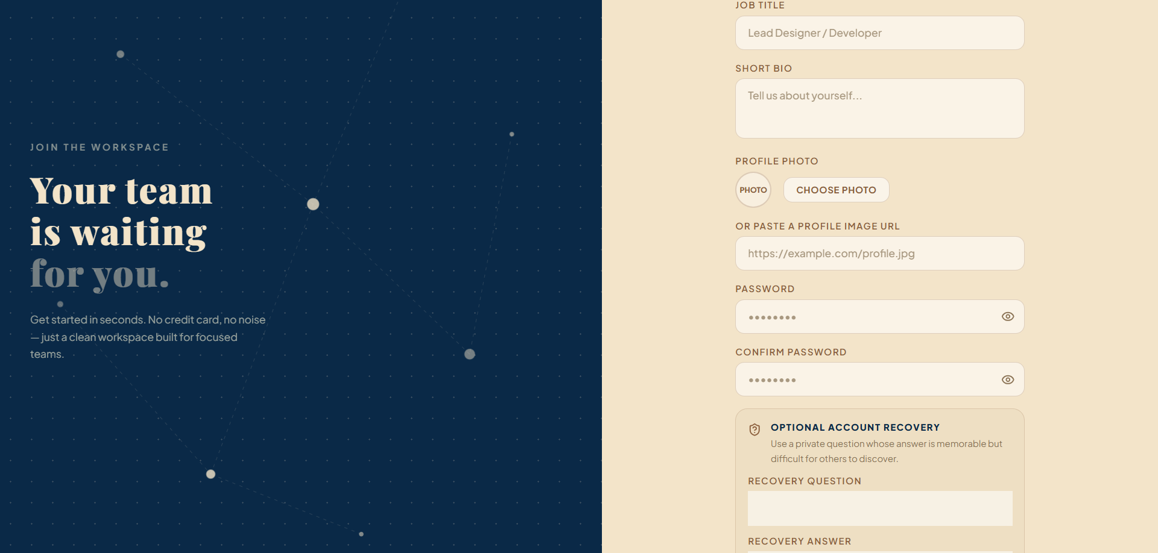

Middleware, Authorization, and Request Security

Feature overview
Middleware provides cross-cutting request protection. The system uses Laravel's web middleware stack for sessions, cookies, CSRF validation, route-model binding, authentication, guest restrictions, and throttling. Inertia middleware shares common properties—such as the current user—with React pages.

Implementation
- Authentication middleware restricts workspace, project, profile, and collaboration routes to logged-in users.
- Guest middleware protects login and registration screens from authenticated users.
- CSRF middleware rejects forged state-changing browser requests.
- Throttle middleware limits sensitive flows, particularly password recovery.
- Route-model binding converts URL identifiers into model instances and returns appropriate errors for missing records.
- Inertia middleware defines shared frontend props and versioning behavior.
- Controller-level authorization verifies workspace membership, ownership, or project association before data is read or modified.
- Broadcast-channel authorization confirms that a user belongs to the workspace associated with a real-time channel.
This layered approach means URL access, form submission, and WebSocket subscription are each authorized rather than relying only on hidden frontend controls.

Relevant files: bootstrap/app.php, app/Http/Middleware/HandleInertiaRequests.php, routes/web.php, routes/channels.php, and authorization checks within controllers.

Workspace Management

User capabilities
A user can create a workspace, view workspaces to which they belong, invite collaborators, manage membership, and delete a workspace when authorized. Each membership can store workspace-specific metadata such as a display color.

Implementation
Workspace is the primary data-isolation boundary. A many-to-many relationship connects users and workspaces through a membership pivot. Controllers scope workspace operations to authenticated members and perform owner checks for destructive actions. Workspace slugs provide readable URLs. Invitations are represented separately so a user can accept or decline access through a controlled token flow.
Deleting a workspace removes related projects and their dependent records according to database foreign-key rules. This prevents orphaned tasks, discussions, and repository links.

Relevant files: app/Models/Workspace.php, workspace and invitation controllers, workspace-related migrations, resources/js/pages/Workspace/, resources/js/layouts/WorkspaceLayout.jsx, tests/Feature/WorkspaceTest.php.
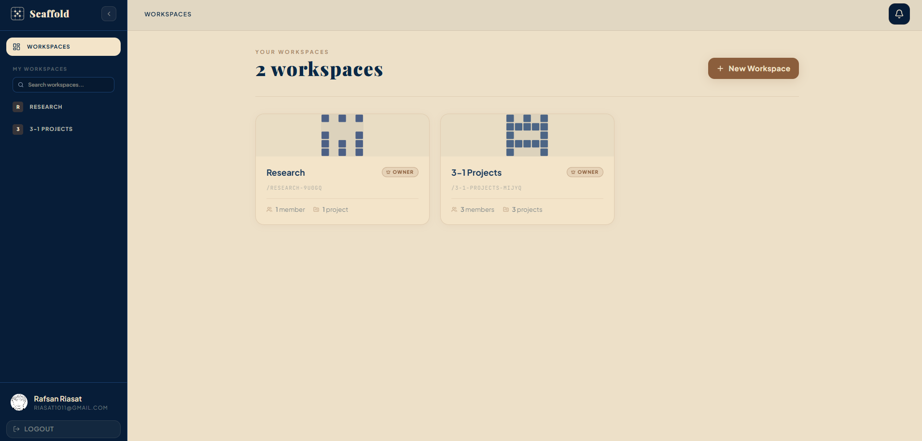

Project Management

User capabilities
Workspace members can create projects, open a project dashboard, update project information, and delete projects subject to authorization. Projects group tasks, labels, threads, wiki pages, activity, and GitHub settings under a single workspace.

Implementation
A project belongs to one workspace, so access is inherited from workspace membership. Project controllers load related records and return Inertia pages with the data needed by project dashboards and boards. Relationships are defined through Eloquent models and reinforced by foreign keys. Project-level route structures make it difficult to mix records from unrelated workspaces accidentally.
The project module acts as the functional hub of the platform: most feature routes are nested around a project, and broadcast authorization resolves project ownership before allowing subscriptions.

Relevant files: app/Models/Project.php, app/Http/Controllers/ProjectController.php, project migrations, pages under resources/js/pages/Project/, and routes/web.php.
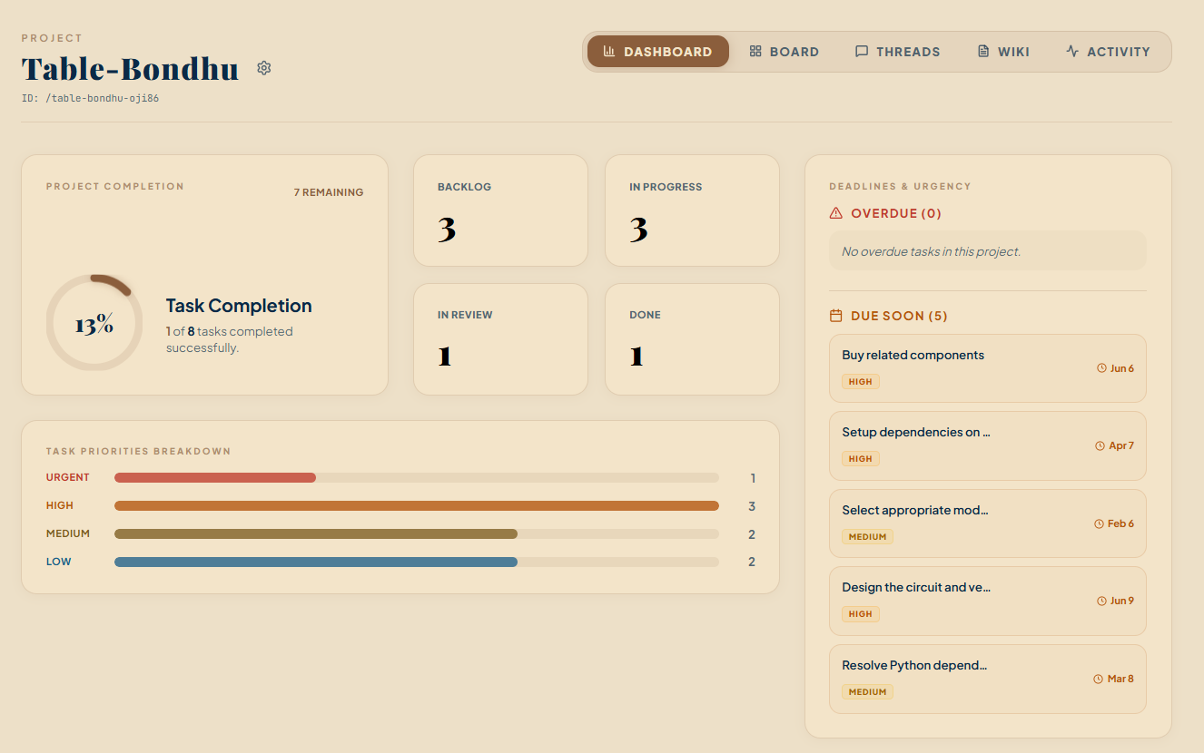

Task Management and Kanban Board

User capabilities
Users can create, edit, assign, label, prioritize, schedule, and delete tasks. Tasks move among statuses such as backlog, in progress, in review, and done. The Kanban board groups tasks visually by status and enables rapid progress tracking.

Implementation
Task input is validated by Laravel before persistence. Eloquent relationships connect tasks to projects, assignees, labels, comments, dependencies, and GitHub synchronization metadata. Status updates trigger safeguards and can be broadcast to other connected clients. The React task interface maintains modal, filtering, selection, and board-interaction state, while Inertia refreshes canonical data from the server.
Labels use a many-to-many pivot and can be attached or detached without duplicating task records. Due dates and selected attributes are cast into appropriate PHP types by the model.

Relevant files: app/Models/Task.php, app/Http/Controllers/TaskController.php, app/Observers/TaskObserver.php, task-related migrations, task pages/components under resources/js/, tests/Feature/TaskTest.php, tests/Feature/LabelTest.php.
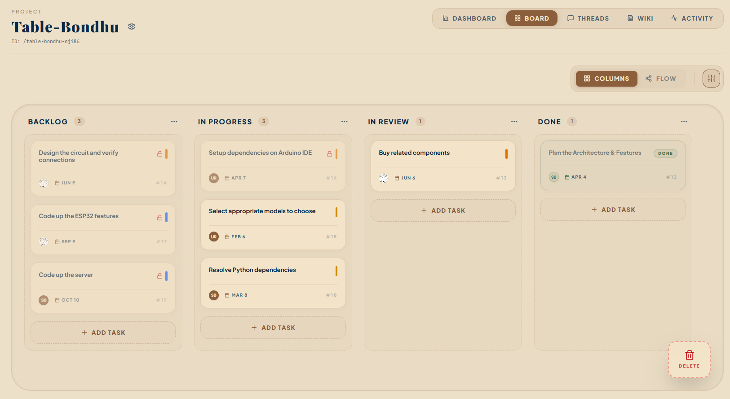
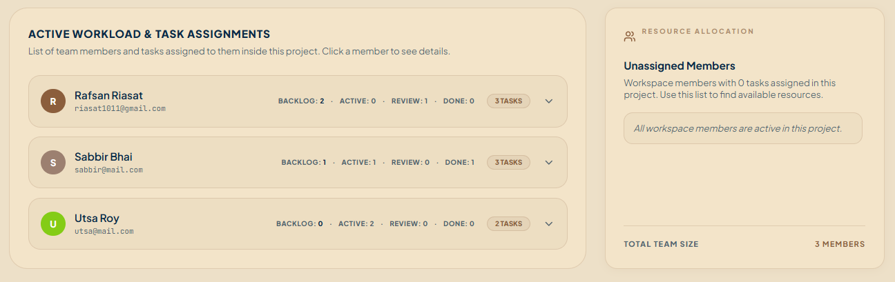
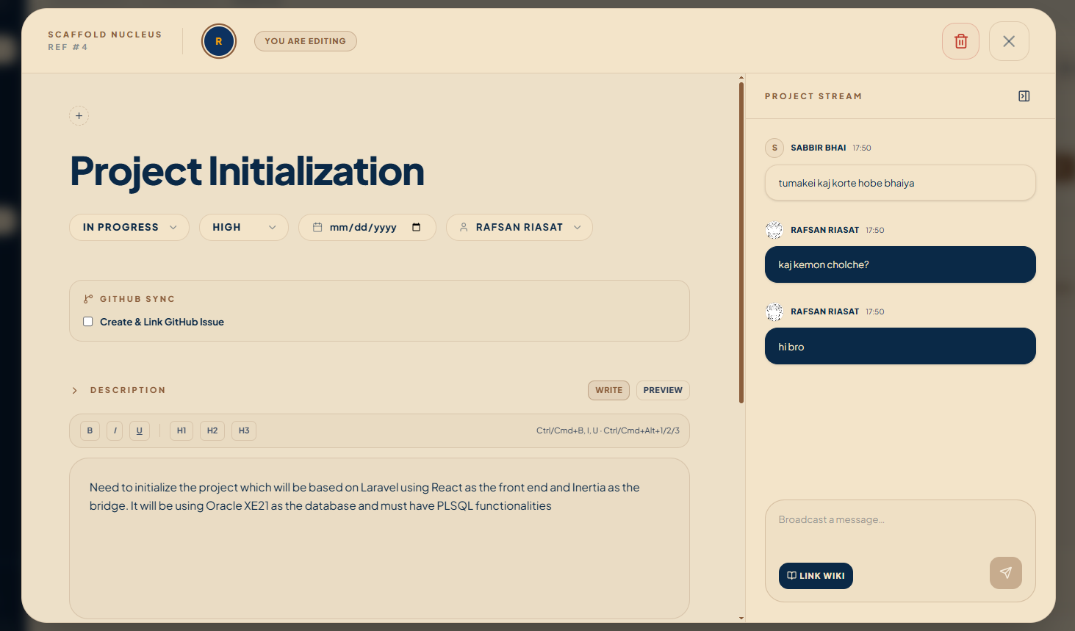
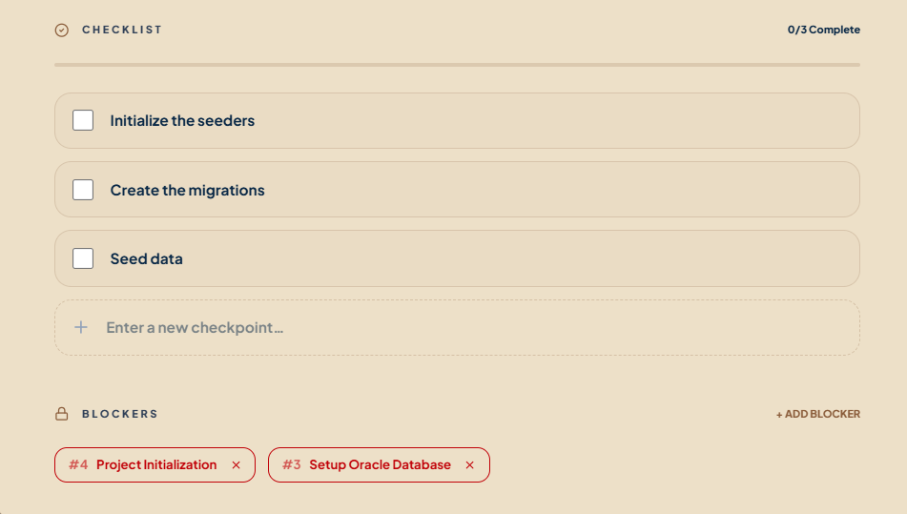

Task Dependencies and Flow View

User capabilities
Tasks can depend on other tasks. Users can inspect these relationships in a flow-oriented view and understand which unfinished prerequisite blocks a task. Invalid circular relationships are rejected.

Implementation
Dependencies are stored in a self-referencing many-to-many table. Both the frontend and backend implement cycle checks. The server performs a breadth-first traversal of dependency links before accepting a new edge, ensuring that adding the relationship cannot create a path back to the original task. The frontend mirrors this behavior for immediate feedback, but the server remains authoritative.
When a previously completed prerequisite is moved away from done, dependent tasks that are no longer validly complete can be reverted recursively. This preserves workflow consistency rather than displaying completed work whose prerequisites are unfinished.

Relevant files: app/Http/Controllers/TaskController.php, resources/js/utils/cycleDetection.js, resources/js/utils/taskDependencies.js, task dependency migrations, flow-view components, tests/Feature/TaskTest.php.
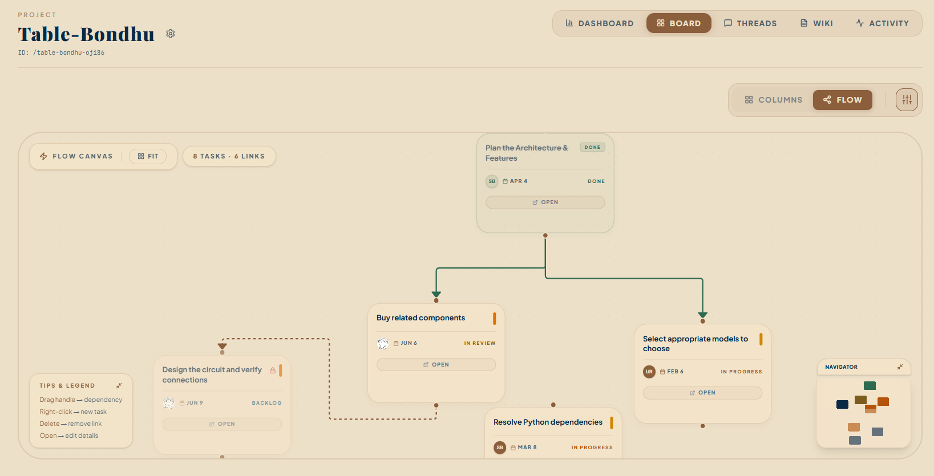

Threads, Replies, and Reactions

User capabilities
Project members can create discussion threads, reply to threads, reply to other replies, react to supported content, and mark a suitable reply as the definitive answer. This supports question-and-answer and design-discussion workflows inside a project.

Implementation
Thread replies use a self-referencing parent_id, allowing a reply tree of arbitrary depth. React recursively renders this hierarchy through a comment-tree component. A definitive-answer reference identifies the accepted response. Reactions use a polymorphic relationship so one reaction implementation can support threads, replies, task comments, and tasks.
Presence-aware subscriptions provide information about users participating in the discussion, while broadcasts propagate changes without requiring a full refresh.

Relevant files: app/Models/Thread.php, ThreadReply.php, and Reaction.php; thread, reply, and reaction controllers; thread-related migrations; pages and recursive components under resources/js/; tests/Feature/ThreadTest.php.
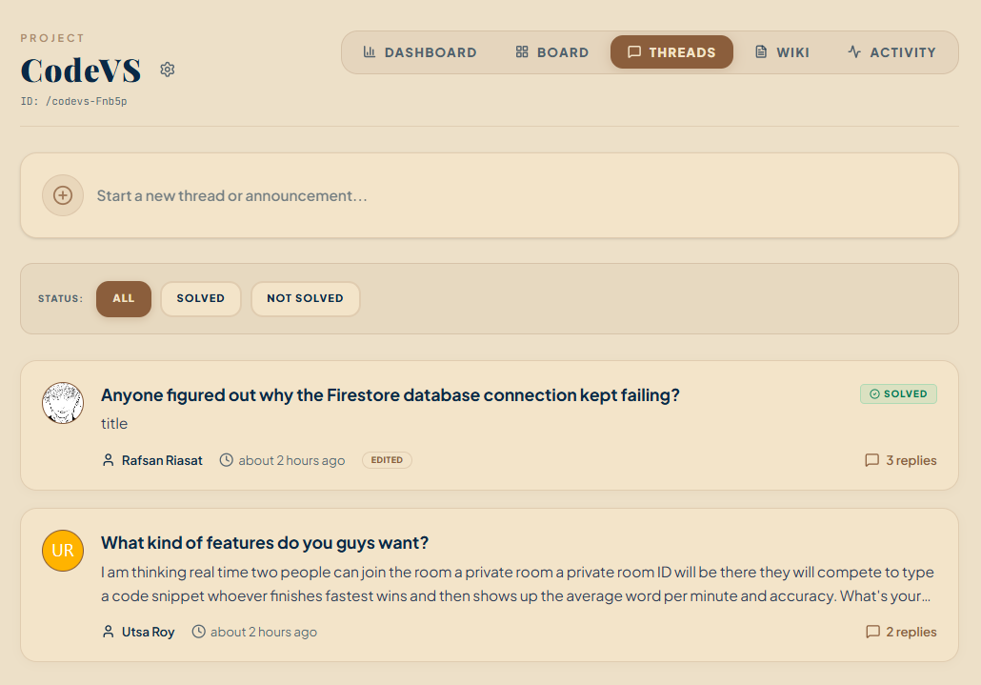
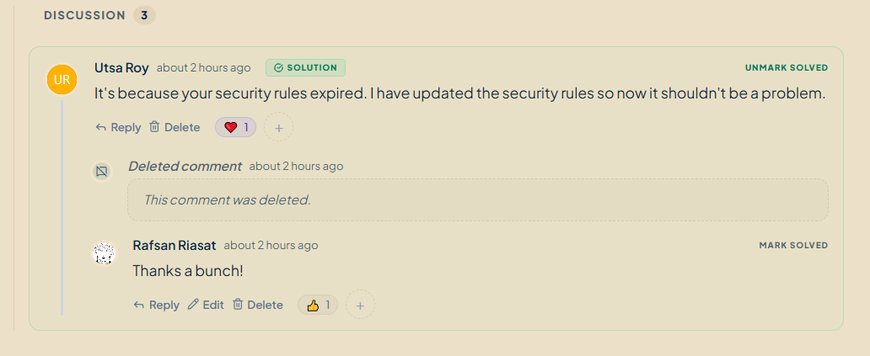

Wiki and Project Documentation

User capabilities
Users can create, edit, view, and remove wiki pages associated with a project. Wiki pages provide a lightweight place for requirements, setup notes, decisions, or other persistent documentation.

Implementation summary
Wiki content is stored relationally and linked to both its project and author. Titles generate readable slugs; updates can regenerate the slug when the title changes. Laravel controllers validate and persist content, while React pages provide editing and display interfaces. Markdown-oriented content can be presented as formatted documentation rather than plain input text.

Relevant files: app/Models/Wiki.php, wiki controller, wiki migrations, wiki pages/components under resources/js/, tests/Feature/WikiTest.php.
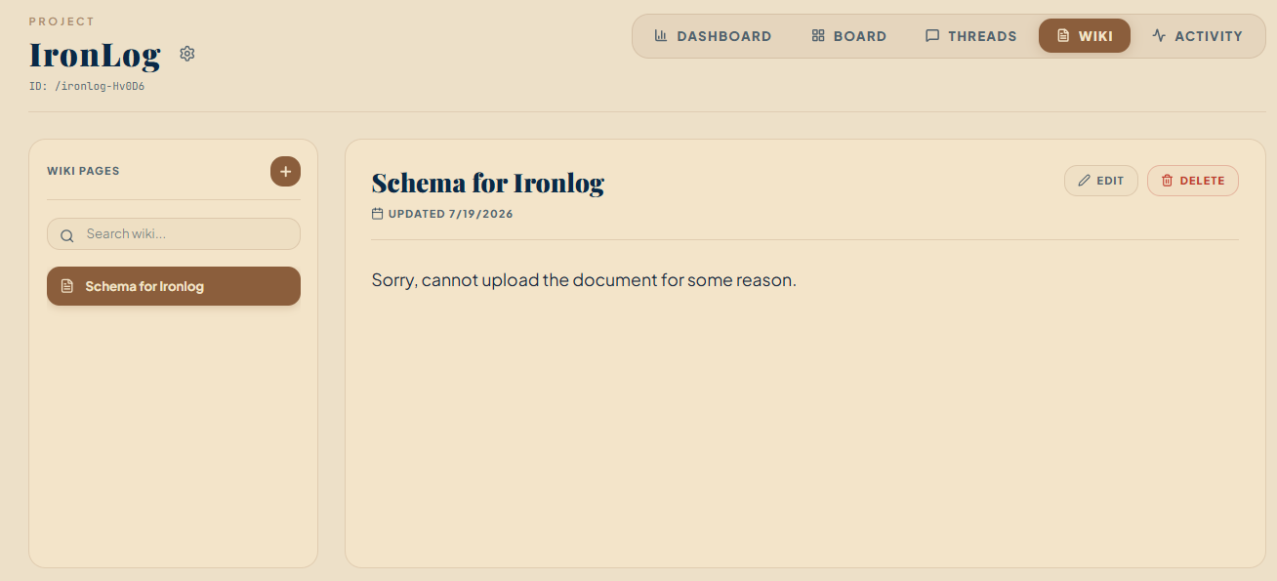

GitHub App and API Integration

User capabilities
A workspace can connect a GitHub App installation, inspect repositories available to that installation, link a project to a repository, and synchronize suitable project-task activity with GitHub issues. Repository activity can also appear inside Scaffold.

Implementation
This integration uses the GitHub Apps API rather than a personal access token. The server creates a short-lived RS256 JWT from the App private key and exchanges it for an installation access token. Installation tokens are cached for approximately 55 minutes to reduce repeated authentication requests. API calls are made from the Laravel backend so private credentials are never exposed to the browser.
Projects store repository-link information, while a dedicated service creates or updates GitHub issues. A content hash records the last synchronized title, description, and state; this acts as an echo-loop guard when the same change returns through a webhook. Marker content can associate an issue with its Scaffold task.

Relevant files: GitHub integration controller, app/Services/GitHubTokenService.php, GitHub synchronization service, GitHub models and migrations, config/services.php, GitHub pages/components, tests/Feature/GitHubIntegrationTest.php.
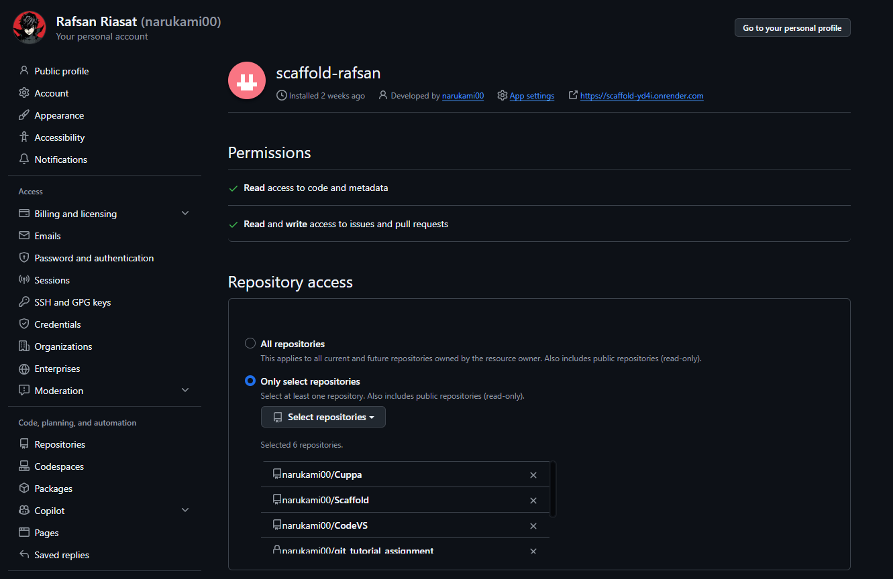
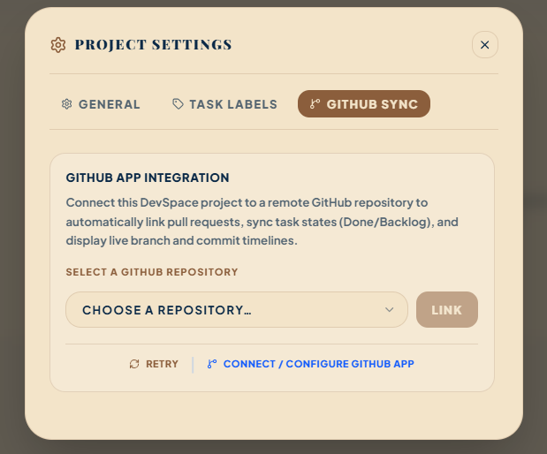
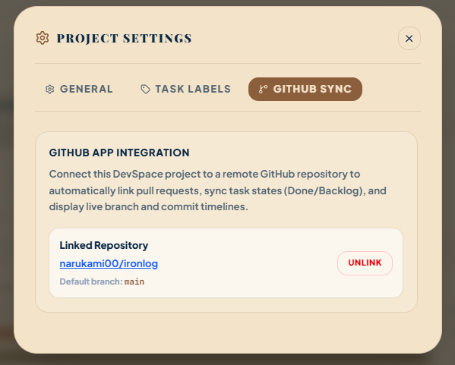

Webhook API and Bidirectional Synchronization

Feature overview
GitHub sends webhook HTTP requests when repository activity changes. Scaffold receives these requests, verifies their authenticity, prevents duplicate processing, and dispatches background work that updates local state.

Implementation
The webhook endpoint verifies the X-Hub-Signature-256 header using an HMAC SHA-256 digest of the raw request body and the configured webhook secret. Requests with missing or invalid GitHub headers are rejected. The X-GitHub-Delivery identifier is stored with a uniqueness guarantee so a redelivered webhook is not processed twice.
Valid payloads dispatch ProcessGitHubWebhookJob. The job interprets supported event types—such as issues, pushes, commits, branches, and pull requests—and updates tasks or activity data. Outbound synchronization is handled by a separate queued job. Queue workers keep API work outside the interactive browser request where appropriate.
The application therefore exposes a focused webhook API while ordinary page navigation continues to use Inertia rather than a large public REST API.

Relevant files: webhook routes in routes/web.php, GitHub integration controller, app/Jobs/ProcessGitHubWebhookJob.php, outbound synchronization job, webhook-delivery migration, tests/Feature/GitHubIntegrationTest.php, tests/Feature/GitSyncTest.php.
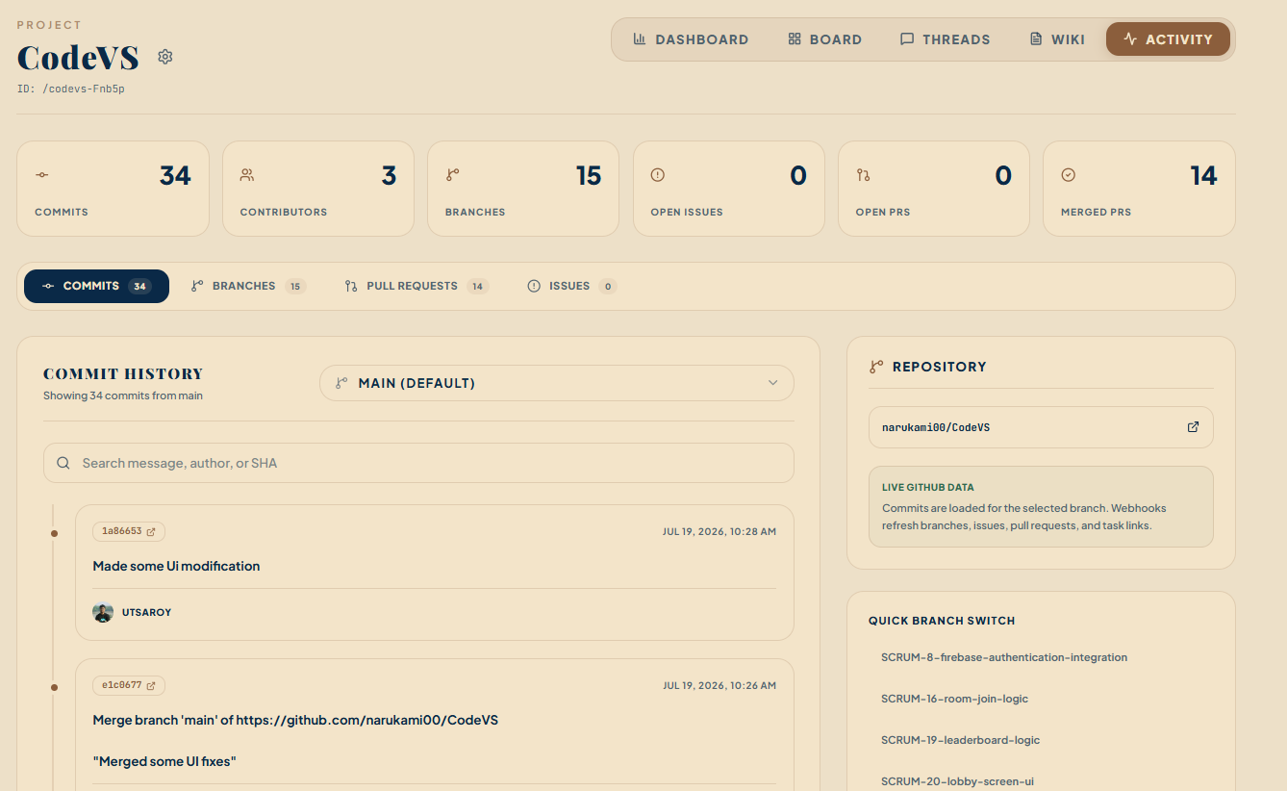
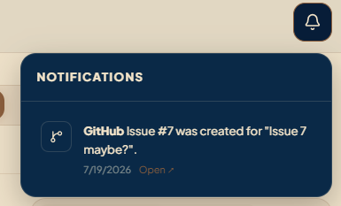
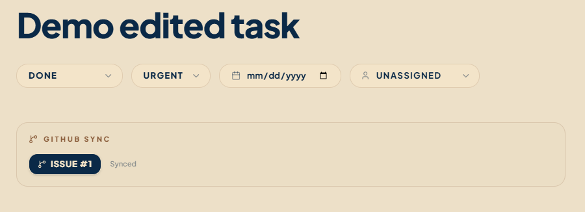

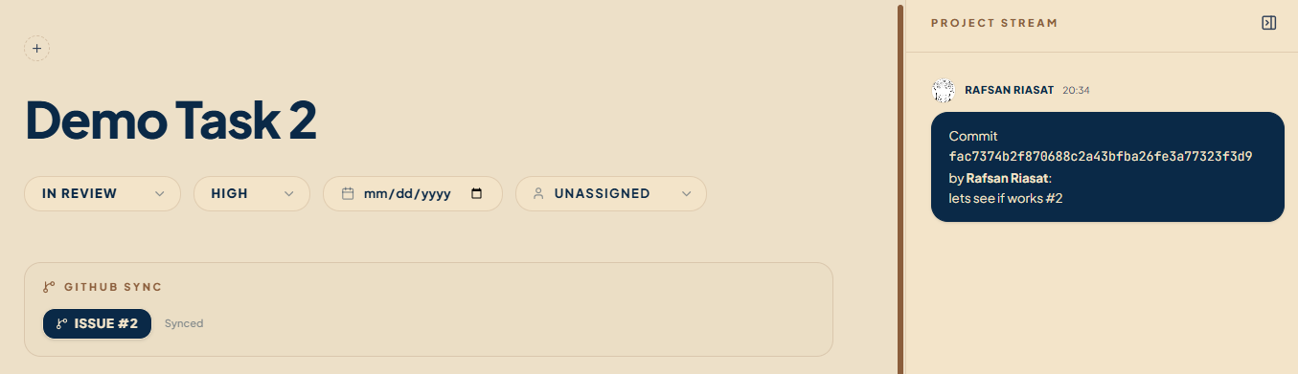
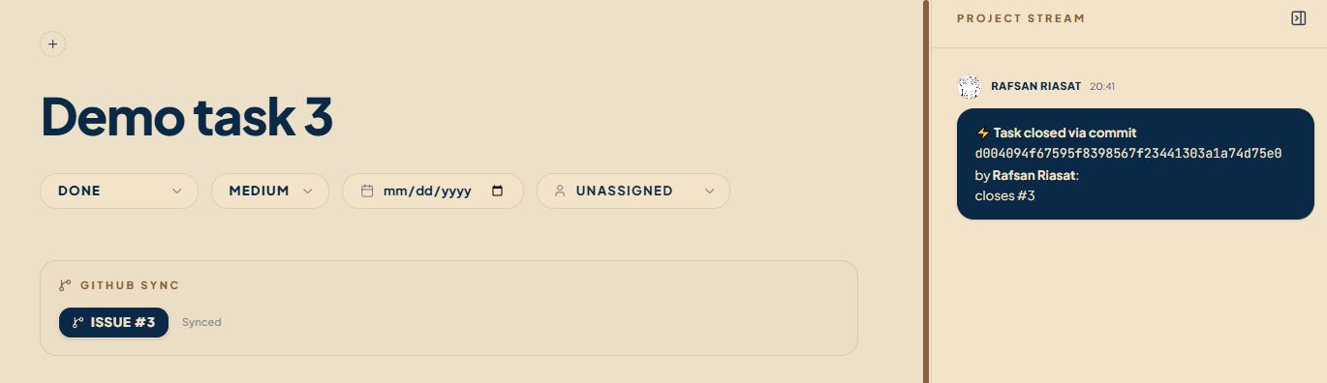
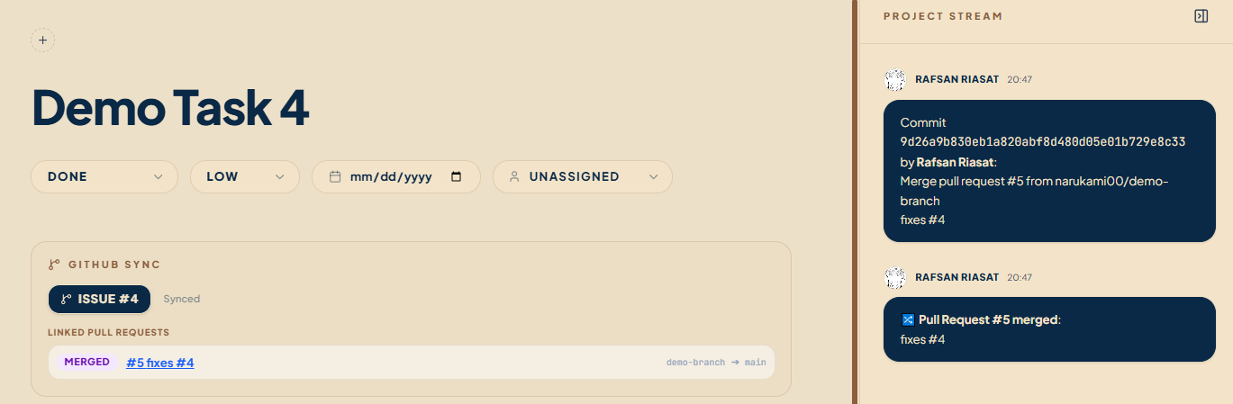
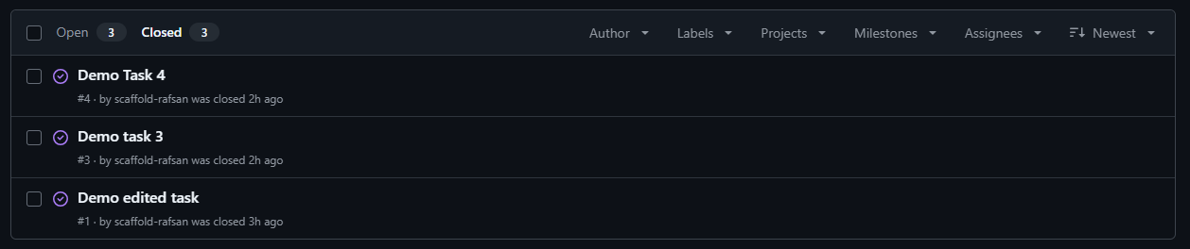

Real-Time Collaboration

User capabilities
Users can see task, thread, notification, and collaboration updates with minimal manual refresh. Presence channels can indicate who is currently viewing or interacting with shared resources.

Implementation
Laravel events implement synchronous broadcasting and publish structured payloads to private or presence channels. Reverb hosts the WebSocket server using the Pusher protocol. Laravel Echo and Pusher-JS subscribe from React pages. Channel authorization verifies that the authenticated user belongs to the workspace that owns the requested entity.
Typical flow:
1. A controller or observer changes a record.
2. A Laravel broadcast event is dispatched.
3. Reverb publishes the event to an authorized channel.
4. Echo receives it in the browser.
5. React updates local state or requests fresh Inertia data.
This mechanism is used for task updates, locking/control messages, thread activity, presence, and user notifications.

Relevant files: app/Events/, routes/channels.php, config/reverb.php, config/broadcasting.php, resources/js/echo.js, React subscription code, docker/start.sh.
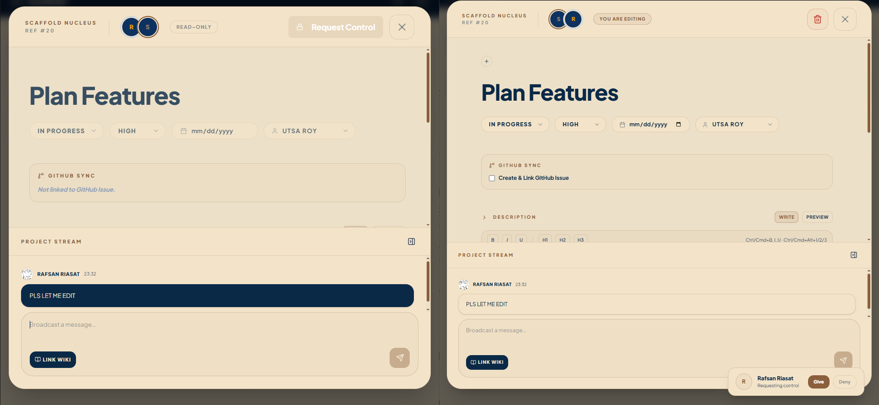

Notifications and Activity

User capabilities
Users receive notifications about relevant application actions and can view or mark them as read. Project activity provides a summarized view of important events, including selected GitHub-originated activity.

Implementation summary
A notification helper centralizes record creation and event dispatch. Notifications are persisted so they survive reconnection, while a private user channel delivers immediate updates to the notification panel. Read actions update stored state and keep the user interface synchronized. Activity views aggregate records associated with the current project or authorized user.

Relevant files: app/Helpers/Notifier.php, notification controller/model/event, notification migrations, resources/js/components/NotificationPanel.jsx, dashboard/activity pages.

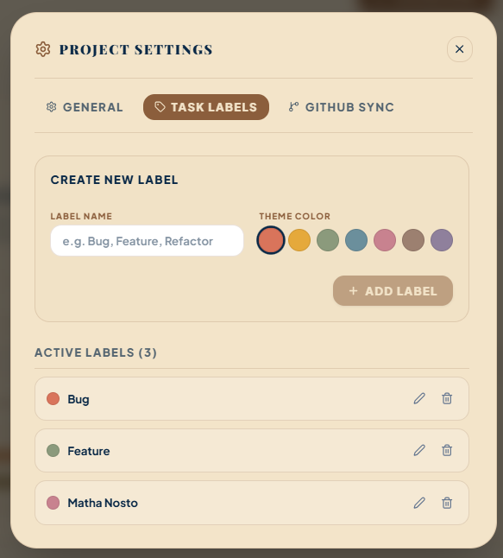
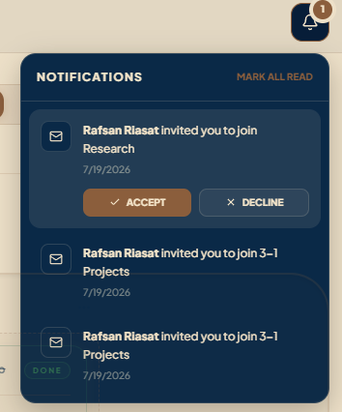

User Profiles, Avatars, and Search

User capabilities
Users can view global or workspace-specific profiles, edit their name, title, biography, color, recovery settings, and avatar, and inspect assigned-task statistics. Search allows authorized users to locate relevant application content.

Implementation summary
Profile statistics are computed from tasks, wikis, and threads scoped to the relevant workspace memberships. Avatar input supports validated remote URLs and uploaded image formats. Where the PHP GD extension is available, uploaded images are center-cropped and resampled to a 300×300 PNG. Previous locally stored avatars are deleted safely when replaced.
Search queries return application entities visible to the current user rather than exposing records across unrelated workspaces. Media support uses a polymorphic design where one attachment mechanism can be associated with multiple supported content types.

Relevant files: app/Http/Controllers/ProfileController.php, search and media controllers, app/Support/AvatarUrl.php, app/Models/Media.php, profile/search pages, tests/Feature/ProfileTest.php.
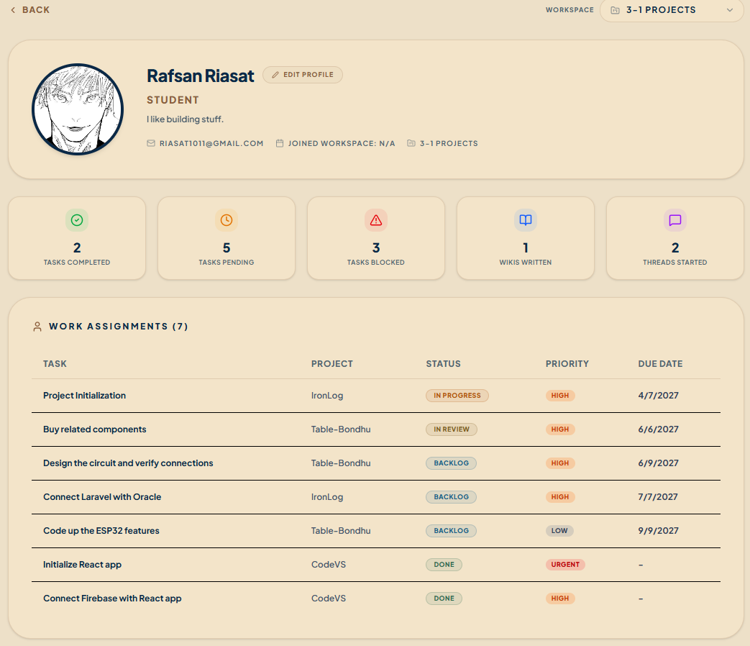
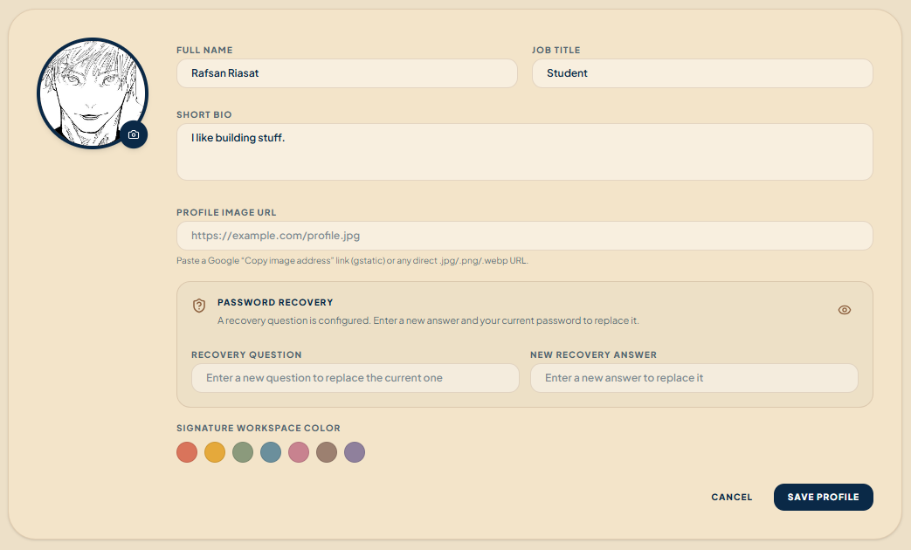
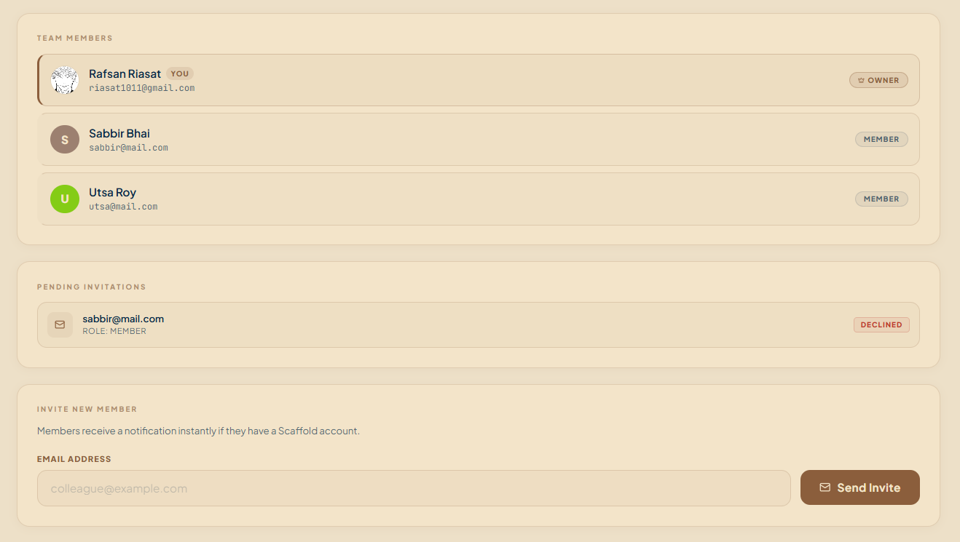

JavaScript, React, and Inertia Functionality

Feature overview
The frontend is a React single-page experience delivered through Laravel and Inertia. It provides modals, navigation, filters, boards, trees, forms, live updates, and reusable interface elements without duplicating backend authorization logic.

Implementation
- React state and effects manage dialogs, form values, selected tasks, board filters, tree expansion, and Echo subscriptions.
- Inertia links and router actions navigate pages and submit mutations while preserving the server-driven routing model.
- Inertia forms display Laravel validation errors close to the relevant fields.
- Reusable components implement task cards, notification panels, comments, profile controls, project navigation, and confirmation dialogs.
- Utility modules provide client-side dependency traversal and task-relationship helpers.
- Vite transforms JSX, performs hot-module replacement during development, and creates optimized production bundles.
- Tailwind CSS supplies responsive layouts, states, typography, spacing, colors, and component visuals.
- Echo subscriptions connect selected pages and components to real-time channels and clean up listeners during unmount.
The frontend assists usability but does not replace server validation or authorization. Any operation initiated from JavaScript is rechecked by Laravel.

Relevant files: resources/js/app.jsx, bootstrap.js, echo.js, pages/, components/, layouts/, utils/, vite.config.js, resources/css/app.css.

Database Functionality and Data Integrity

Feature overview
The relational database is responsible not only for storage but also for preserving valid relationships and supporting efficient scoped queries.

Implementation
- Primary and foreign keys identify records and enforce ownership links.
- Pivot tables implement many-to-many workspace membership, labels, and dependencies.
- Cascading foreign keys clean up subordinate data when a parent is deleted.
- Unique indexes prevent duplicate values and webhook deliveries where required.
- Nullable foreign keys allow optional assignees or selected answers while preserving references when present.
- Model casts convert date, Boolean, and structured values into appropriate PHP representations.
- Eloquent eager loading reduces repeated queries when pages need related workspace, project, label, and user information.
- PostgreSQL-specific connection handling supports Neon/PgBouncer behavior, including emulated prepares and Boolean-binding compatibility.
Local development began with MySQL through XAMPP. Hosted deployment moved to Neon PostgreSQL because GitHub webhooks and external integration required a publicly reachable, persistent application environment. The migration layer allows the same domain model to be recreated consistently across environments.

Relevant files: database/migrations/, app/Models/, config/database.php, app/Database/PostgresConnection.php, app/Providers/AppServiceProvider.php.

Deployment
The hosted demonstration runs in a Docker container on Render. Apache serves Laravel and static assets, while the startup script also runs the queue worker, scheduler, and Reverb server. Apache WebSocket proxy modules forward WebSocket traffic to Reverb. Persistent application data is stored in Neon PostgreSQL rather than inside the disposable container filesystem.
Required secrets—database URL, application key, GitHub App identifiers, private key, webhook secret, and Reverb credentials—are supplied through environment variables and are not embedded in frontend code.

Relevant files: Dockerfile, docker/start.sh, docker/000-default.conf, .env.example, Laravel configuration files.
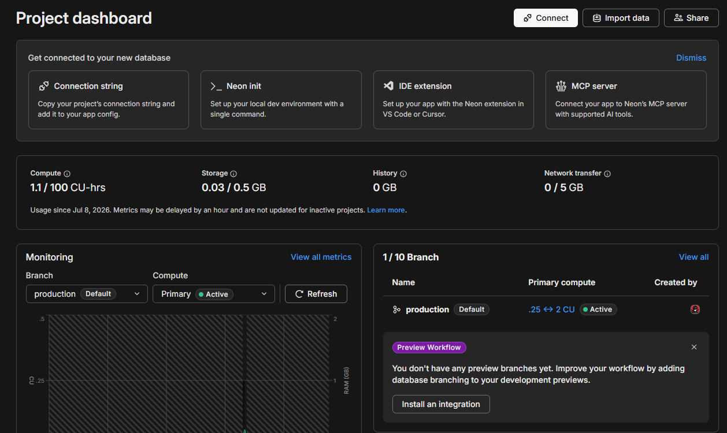
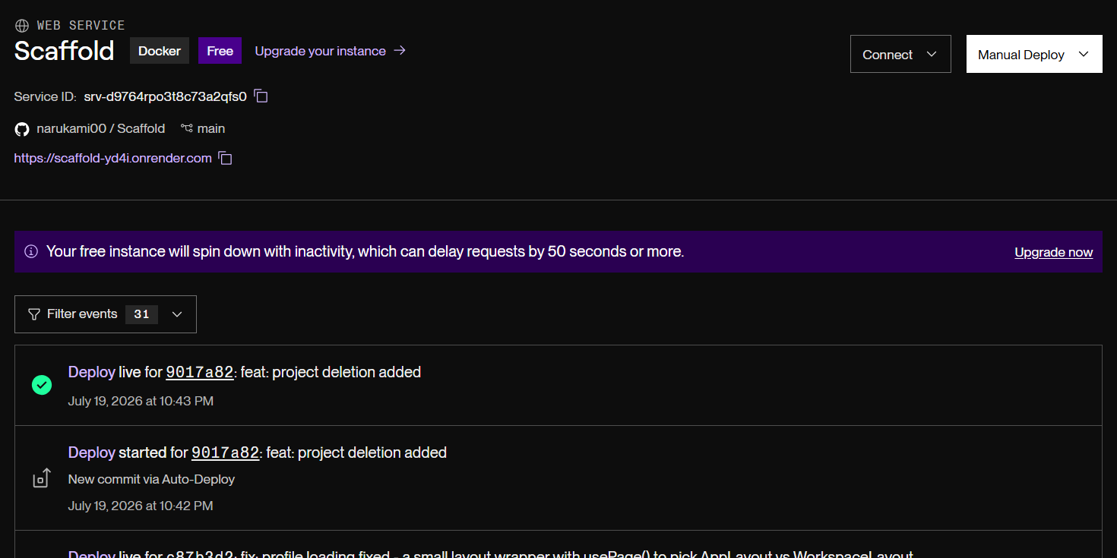
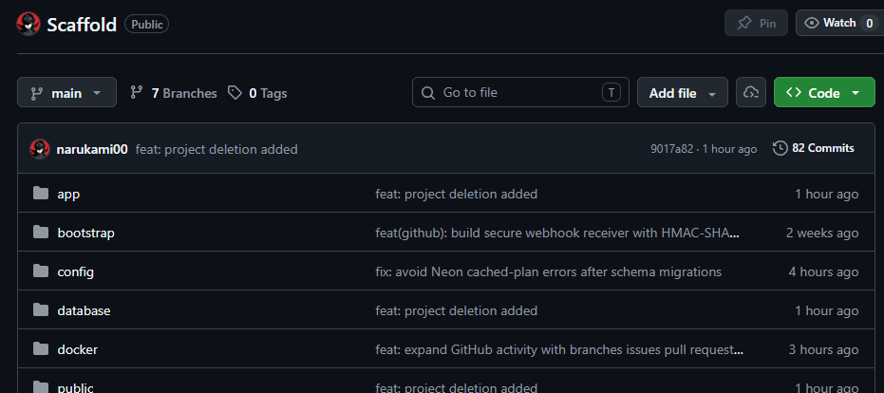

Conclusion
Scaffold demonstrates a complete transition from a local laboratory project to a hosted, multi-user collaboration platform. Its main achievement is the integration of conventional project-management features—workspaces, projects, tasks, discussions, wikis, profiles, and notifications—with technically significant capabilities such as dependency cycle prevention, recursive workflow correction, real-time broadcasting, authenticated GitHub App access, signed webhooks, event deduplication, background synchronization, and cloud deployment.
The architecture assigns clear responsibilities to each technology. Laravel controls security, validation, persistence, integrations, and events; Inertia connects server routes to client pages; React supplies a responsive interactive experience; PostgreSQL enforces durable relational integrity; and Reverb provides real-time communication. Docker and Render package these capabilities into a publicly accessible demonstration environment, while Neon provides managed database persistence.
From a laboratory perspective, the project illustrates full-stack application development across database design, backend programming, middleware, frontend component design, JavaScript interaction, external API consumption, webhook processing, WebSockets, testing, and deployment. The system is functional and extensible, although frontend automation, broader broadcast testing, and additional security and performance hardening would be valuable future improvements.

Github repository: https://github.com/narukami00/Scaffold
Website: https://scaffold-yd4i.onrender.com/

