LMS(issue book)
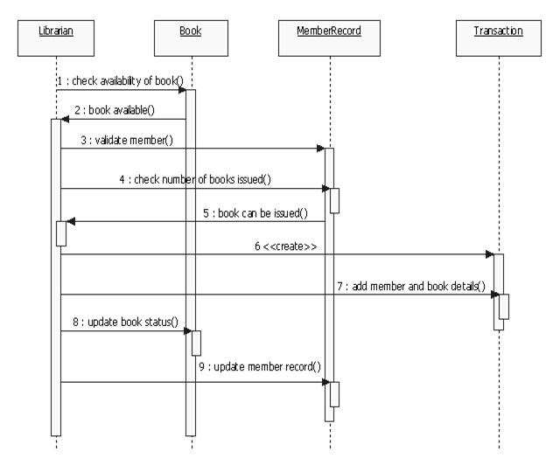

LMS(return book)

Hospital Management System

RRS

