# Use case “Place order”

## Use case code: UC001

## Brief description

This use case describes the interaction between the customer and the software when the customer wants to place an order.

## Actors

* Customer
* Admin

## Precondition

The customer has already created a cart with items.

## Basic flows

| No | Executor | Action |
| --- | --- | --- |
| 1 | Customer | View the cart and request to place an order |
| 2 | Program | Check if the cart condition is satisfied |
| 3 | Program | Ask the customer to update delivery information and delivery instruction |
| 4 | Customer | Update information, choose to place a rush order or not, submit order |
| 5 | Program | Validate input.  Check if the customer has placed a rush order |
| 6 | Program | Calculate shipping fees and display |
| 7 | Customer | Confirm the invoice |
| 8 | Program | Save the invoice and proceed to payment |
| 9 | Customer | Provide payment method |
| 10 | Program | Check successful payment, display transaction information and record it |
| 11 | Admin | Approve the order |

## Alternative flows

| No | Location | Condition | Action | Resume location |
| --- | --- | --- | --- | --- |
| 2.A | Step 2 | The cart condition is not valid (ordered quantity > stored quantity) | Ask the customer to update their cart | Step 1 |
| 4.A | Step 4 | The customer chooses to place rush order | To use case “Place rush order” |  |
| 5.A | Step 5 | The input is invalid or there is no support for rush order from any media or shipping address if rush order is chosen | Ask the customer to update delivery information | Step 4 |
| 10.A | Step 10 | The customer cancel order | Refund full payment to the user | Exit use case |
| 11.A | Step 11 | The admin reject the order or the software deny the order | Refund full payment to the user | Exit use case |

## Activity diagram

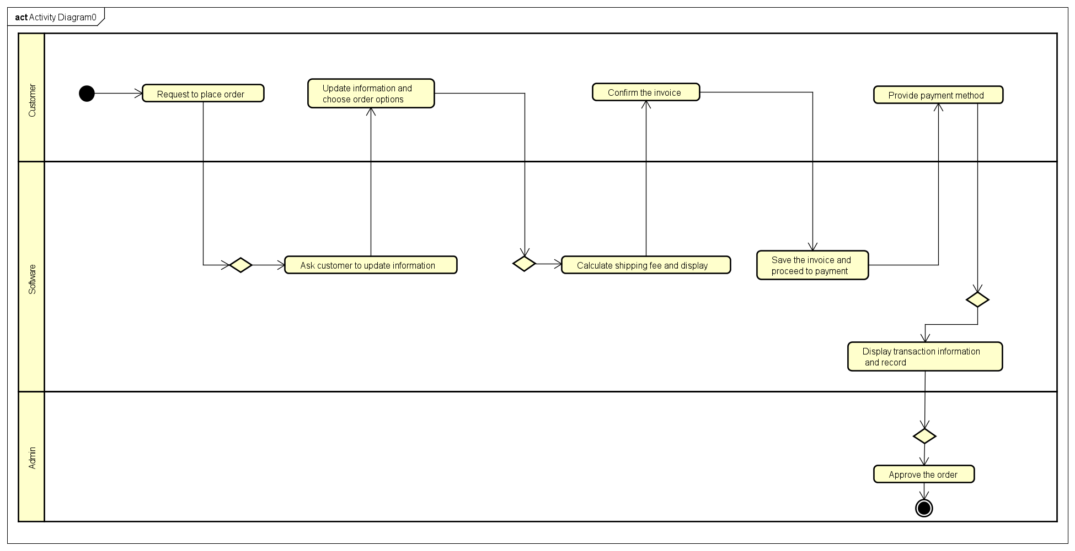

## Input data

| No | Field name | Description | Mandatory | Condition | Example |
| --- | --- | --- | --- | --- | --- |
| 1 | Name |  | yes |  | Bui Thanh Tung |
| 2 | Phone number |  | yes |  | 012345678 |
| 3 | Province | Choose from a list | yes |  | Ha Noi |
| 4 | Address |  | yes |  | 1 Dai Co Viet, Hai Ba Trung |
| 5 | Shipping instruction |  | no |  | From 9-12 AM only |
| 6 | Cart |  | yes |  |  |

## Output data

| No | Field name | Description | Format | Example |
| --- | --- | --- | --- | --- |
| 1 | Title |  |  | DVD Outlast |
| 2 | Price |  | • Comma for thousands  separator  • Positive integer  • Right alignment | 321,999 |
| 3 | Quantity |  | • Positive integer  • Right alignment | 3 |
| 4 | Amount |  | • Comma for thousands  separator  • Positive integer  • Right alignment | 965,997 |
| 5 | Subtotal before VAT |  | 1,000,000 |
| 6 | Subtotal |  | 1,100,000 |
| 7 | Shipping fees |  | 50,000 |
| 8 | Total |  | 1,150,000 |
| 9 | Currency |  |  | VND |
| 10 | Receiver name |  |  | Bui Thanh Tung |
| 11 | Phone number |  |  | 0123456789 |
| 12 | Province |  |  | Ha Noi |
| 13 | Address |  |  | 1 Dai Co Viet, Hai Ba Trung |
| 14 | Shipping instructions |  |  | From 9-12 AM only |

## Use case “Place rush order”

## Use case code: UC002

## Brief description

This use case describes the interaction between the customer and the software when the customer wants to place a rush order.

## Actors

* Customer
* Admin

## Precondition

The customer has already created a cart with items.

## Basic flows

| No | Executor | Action |
| --- | --- | --- |
| 1 | Customer | Choose to place a rush order |
| 2 | Program | Validate input. |
| 3 | Program | Calculate shipping fees and display |
| 4 | Customer | Confirm the invoice |
| 5 | Program | Save the invoice and proceed to payment |
| 6 | Customer | Provide payment method |
| 7 | Program | Check successful payment, display transaction information and record it |
| 8 | Admin | Approve the order |

## Alternative flows

| No | Location | Condition | Action | Resume location |
| --- | --- | --- | --- | --- |
| 2.A | Step 2 | The input is invalid or there is no support for rush order from any media or shipping address if rush order is chosen | Ask the customer to update delivery information | Exit use case |
| 7.A | Step 7 | The customer cancel order | Refund full payment to the user | Exit use case |
| 8.A | Step 8 | The admin reject the order or the software deny the order | Refund full payment to the user | Exit use case |

## Activity diagram

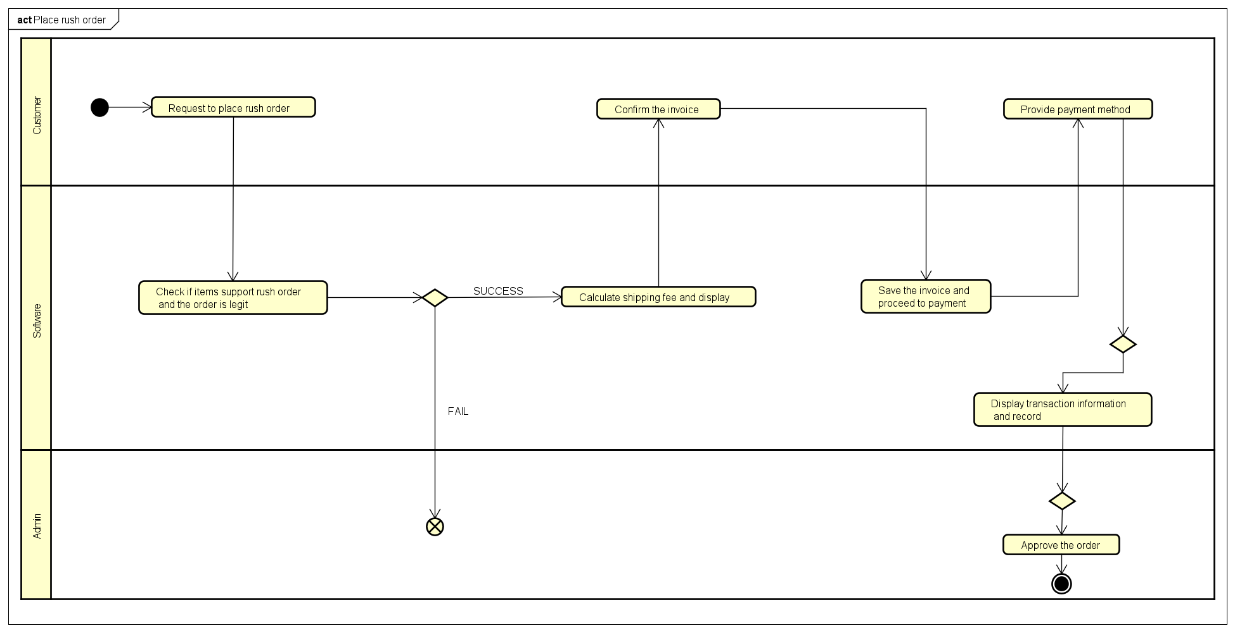

## Input data

| No | Field name | Description | Mandatory | Condition | Example |
| --- | --- | --- | --- | --- | --- |
| 1 | Name |  | yes |  | Bui Thanh Tung |
| 2 | Phone number |  | yes |  | 012345678 |
| 3 | Province | Choose from a list | yes |  | Ha Noi |
| 4 | Address |  | yes |  | 1 Dai Co Viet, Hai Ba Trung |
| 5 | Shipping instruction |  | no |  | From 9-12 AM only |
| 6 | Cart |  | yes |  |  |
| 7 | Expected delivery time | Choose from calendar | yes |  | 12/10/2021  10AM |

## Output data

| No | Field name | Description | Format | Example |
| --- | --- | --- | --- | --- |
| 1 | Title |  |  | DVD Outlast |
| 2 | Price |  | • Comma for thousands  separator  • Positive integer  • Right alignment | 321,999 |
| 3 | Quantity |  | • Positive integer  • Right alignment | 3 |
| 4 | Amount |  | • Comma for thousands  separator  • Positive integer  • Right alignment | 965,997 |
| 5 | Subtotal before VAT |  | 1,000,000 |
| 6 | Subtotal |  | 1,100,000 |
| 7 | Shipping fees |  | 50,000 |
| 8 | Total |  | 1,150,000 |
| 9 | Currency |  |  | VND |
| 10 | Receiver name |  |  | Bui Thanh Tung |
| 11 | Phone number |  |  | 0123456789 |
| 12 | Province |  |  | Ha Noi |
| 13 | Address |  |  | 1 Dai Co Viet, Hai Ba Trung |
| 14 | Shipping instructions |  |  | From 9-12 AM only |

# Use case “Pay order”

## Use case code: UC003

## Brief description

This use case describes the interaction between the customer and the software when the customer wants to pay for an order

## Actors

* Customer
* Admin
* Interbank

## Precondition

The customer has placed an order and the software has calculated the cost.

## Basic flows

| No | Executor | Action |
| --- | --- | --- |
| 1 | Program | Display payment screen |
| 2 | Customer | Enter card information and confirm |
| 3 | Program | Check if the card format is valid or not |
| 4 | Program | Ask the interbank to process the transaction |
| 5 | Interbank | Process the transaction |
| 6 | Program | Save the payment information |
| 7 | Program | Display the transaction information |

## Alternative flows

| No | Location | Condition | Action | Resume location |
| --- | --- | --- | --- | --- |
| 3.A | Step 3 | The customer entered invalid card format | Notifies that the card has wrong format | Step 1 |
| 4.A | Step 4 | The card is invalid | Notifies that the card is invalid | Step 1 |
| 4.B | Step 4 | The card doesn’t have enough balance | Notifies that the balance is not enough | Step 1 |

## Activity diagram

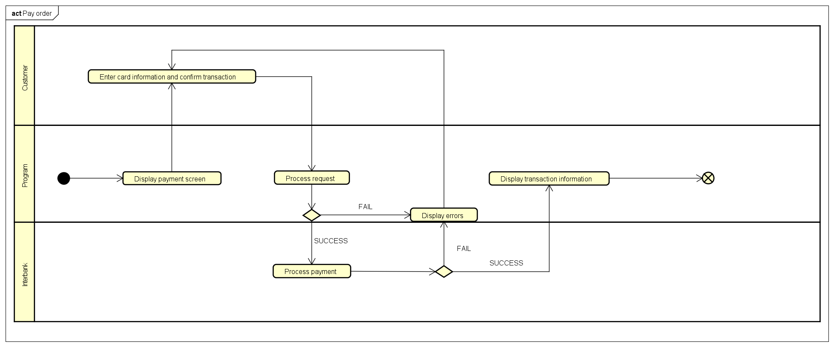

## Input data

| No | Field name | Description | Mandatory | Condition | Example |
| --- | --- | --- | --- | --- | --- |
| 1 | Name |  | yes |  | Bui Thanh Tung |
| 2 | Card number |  | yes |  | 123 456 789 123 |
| 3 | Expiration date |  | yes | Consist of  month and last  2 digits of year | 13/10 |
| 4 | Security Code |  | yes |  | 496 |

## Output data

| No | Field name | Description | Format | Example |
| --- | --- | --- | --- | --- |
| 1 | Transaction ID |  |  | J40431 |
| 2 | Name |  | • Comma for thousands  separator  • Positive integer  • Right alignment | Bui Thanh Tung |
| 3 | Changed amount |  | • Positive integer  • Right alignment | 100,000 |
| 4 | Transaction description |  |  |  |
| 5 | Balance |  | • Comma for thousands  separator  • Positive integer  • Right alignment | 10,000,000 |
| 6 | Transaction date |  | DD/MM/YYYY | 12/10/2021 |
| 7 | Time |  | HH:SS AM/PM | 10:12 AM |