Bomoo2

Phase 1

Download the bomb files from the given source. Open the directory where you have placed the bomb file. Give the permission, chmod 7777 bomb. In order to view the executable assembly from the bomb file, enter.. “objdump -d bomb > bomb.s” enter “strings bomb” , where it displays all the string values stored in the bomb files. The bomb.s files holds assembly codes or instructions in assembly form. Then I have used gdb as debugger for c.

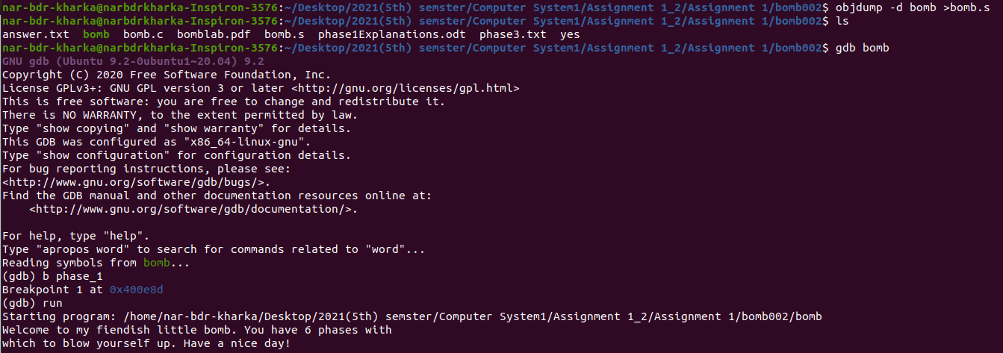

Now we know that we need to know to the input values. Before that you need to set break point so that the boom will not exploit. You can give a random string and test with the conditions. To disassemble the code we use “disas”.

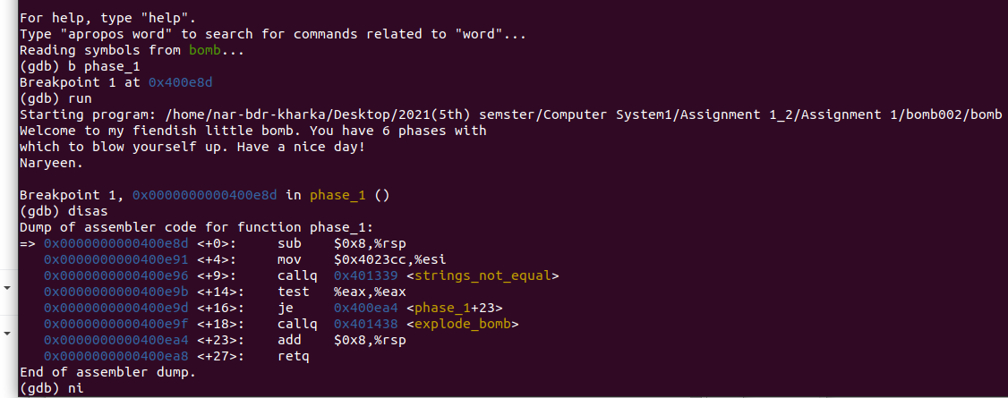

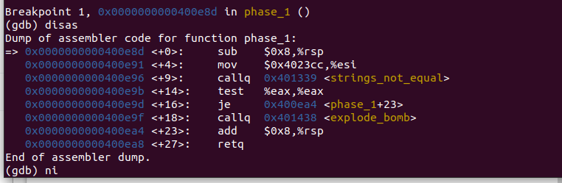

From the above assemble codes line <+9>. There is call function which calls <string not equal>, means from this line we know that input is a string. Line number <+14>, it says that source eax register hold input values and destination eax hold the string values that was already set. Jump function is used to compare the the string and jump (if equal to ) ,else exploded. But in my case the bomb will not explode because I have set the break point .

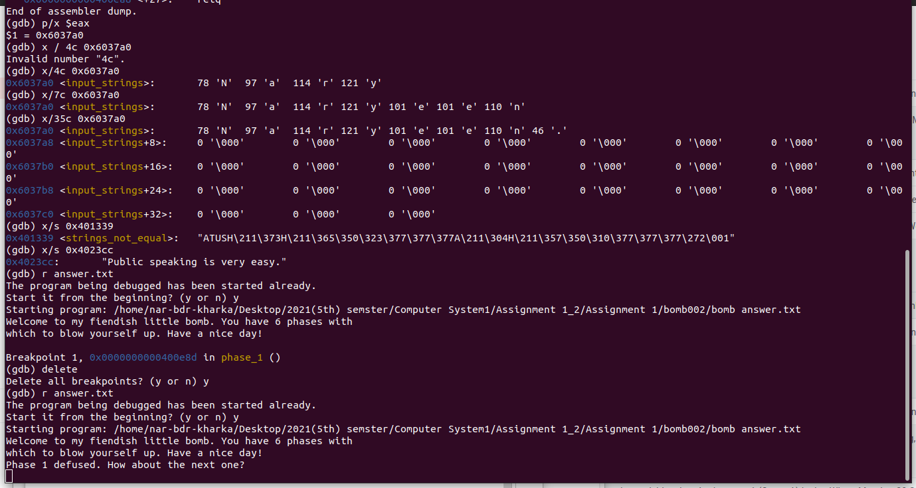

Now we can check the input we have entered or given. For that it is recommended to use “p/x $eax”, simply to get the address of eax register. Once the address is found. Then enter “x/35c 0X6037a0” . It means you have given address for 34 character. If there is space after you have given input , the null value is given by “0”. we can conclude that our input is stored in eax register. To find the input values there are numerous ways. I have find out the two ways. One ways is ,finding what values or string the address hold. Using the command “x/s 0x401339”. It gives the values it stores. Another ways in logically is. When command “strings bomb” is entered , The only answer string is different than other statement. Means all other statement talks about bomb but only one statement talk nothing thus that was the answer. This is through the hint and other is looking at the method call.

