Bomb002

Phase 2

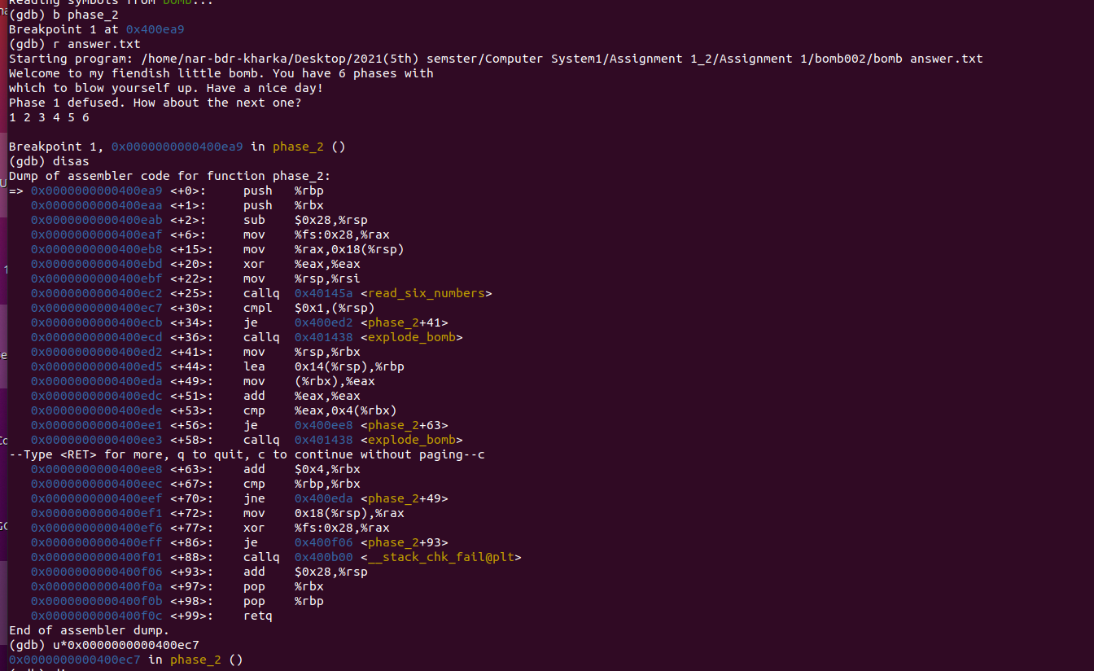

For phase 2 to be diffused. Though there are so many lines but just focused form line <+25> on wards. From that line user know the that program accept only 6 user input as a integer. Since I have given the input as 1 2 3 4 5 6. “u*0x0000000000400ec7” means till this given address. U means “until”.since program always start from call function. Lets keep other lines as it and move to <+25>. It has 6 input values.The input 1 was right. Thus it moves to line<+41>. Continue with “ni”. Means moving to next instruction or next lines.

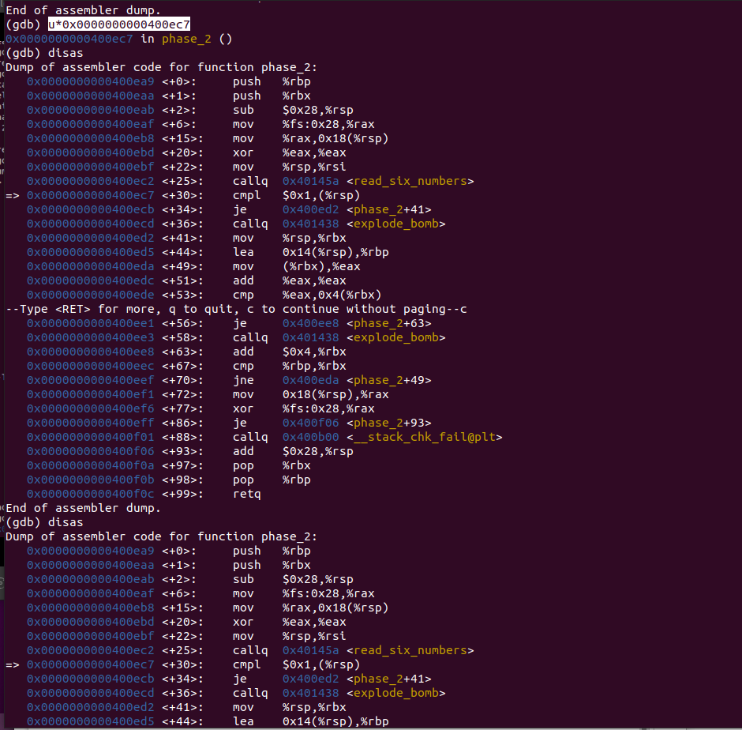

From the given disas, we know that the first values stored in the eax was 1 .cmp function will compare user input with the input already set. If it is equal it will jump to line <+49>. Where the value given will be stored in eax will be moved to ebx. And then it add eax with eax. If the values is not equal it will exploded. Example, the value I have entered was 1 2 3. when iteration reached to third the bomb will exploded because it is wrong means. But since I have used break point. The bomb will not explode And to see what is there is at ebx. Follow the command “x/d 140737488346384”. you will see 1. which means that our input given as “1”matches. First values matches . Now we need to check for others.

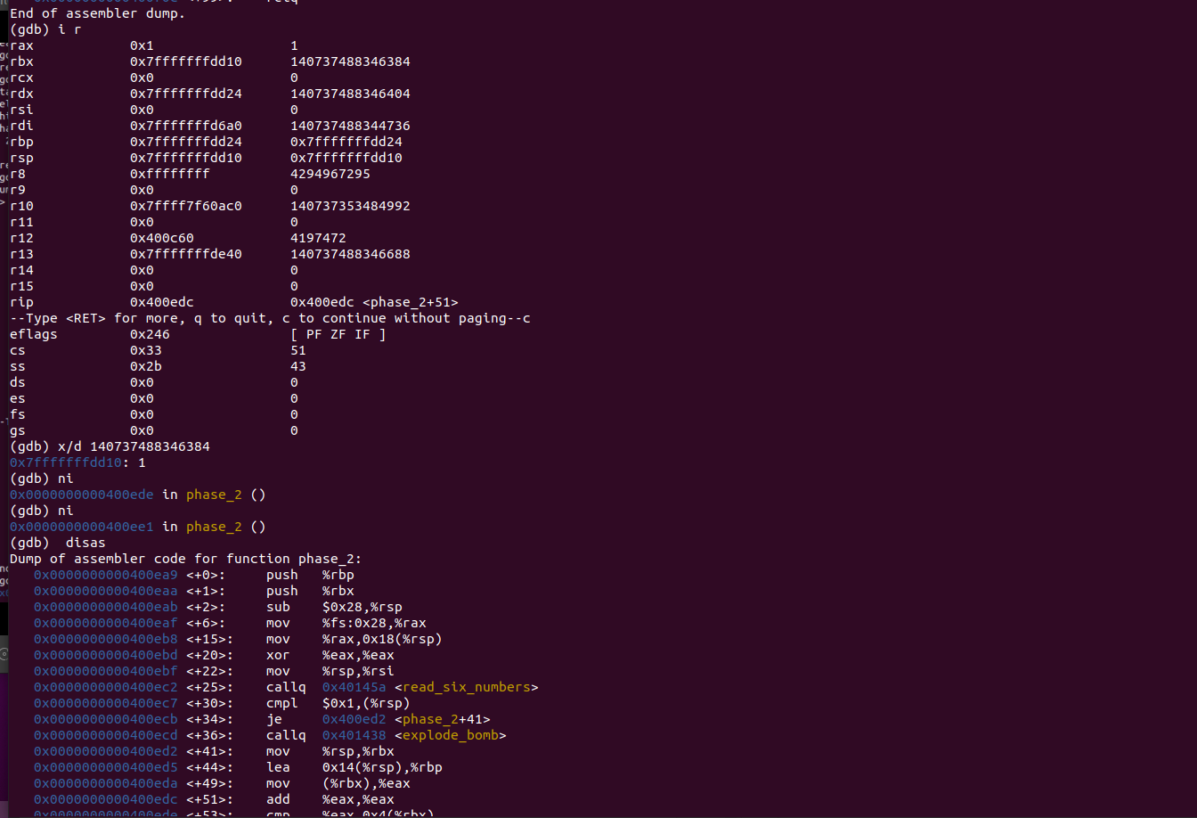
Now we can see there is add function thus it add eax with eax values for every iteration. For first is 1 and for second values 1+ 1 = 2 and for third values it is 2+2 = 4 and for the fourth value 4+ 4 = 8...sixth value 16 + 16 = 32.

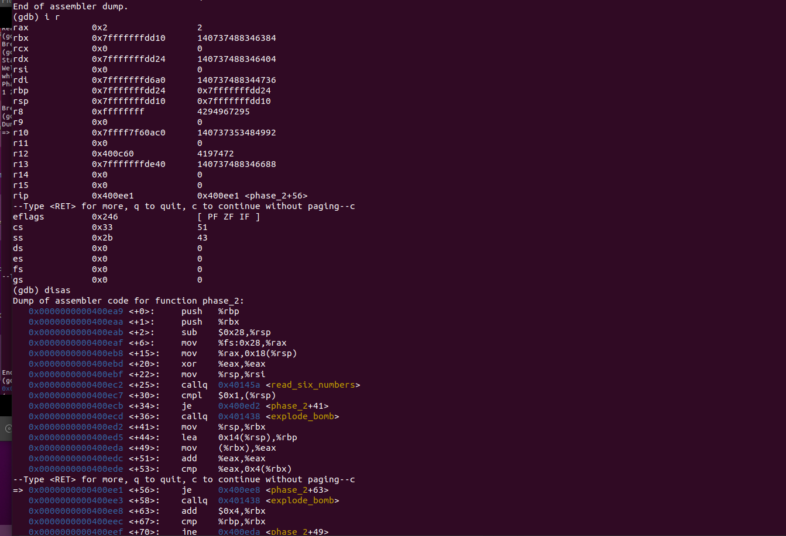

finally phase2 diffused.

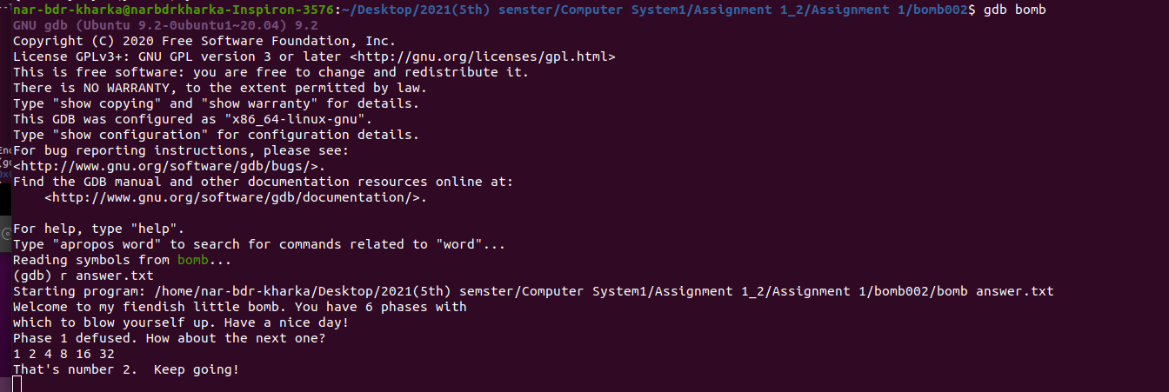

Worried about phase 3!!!!!!

