bomb002

phase 3

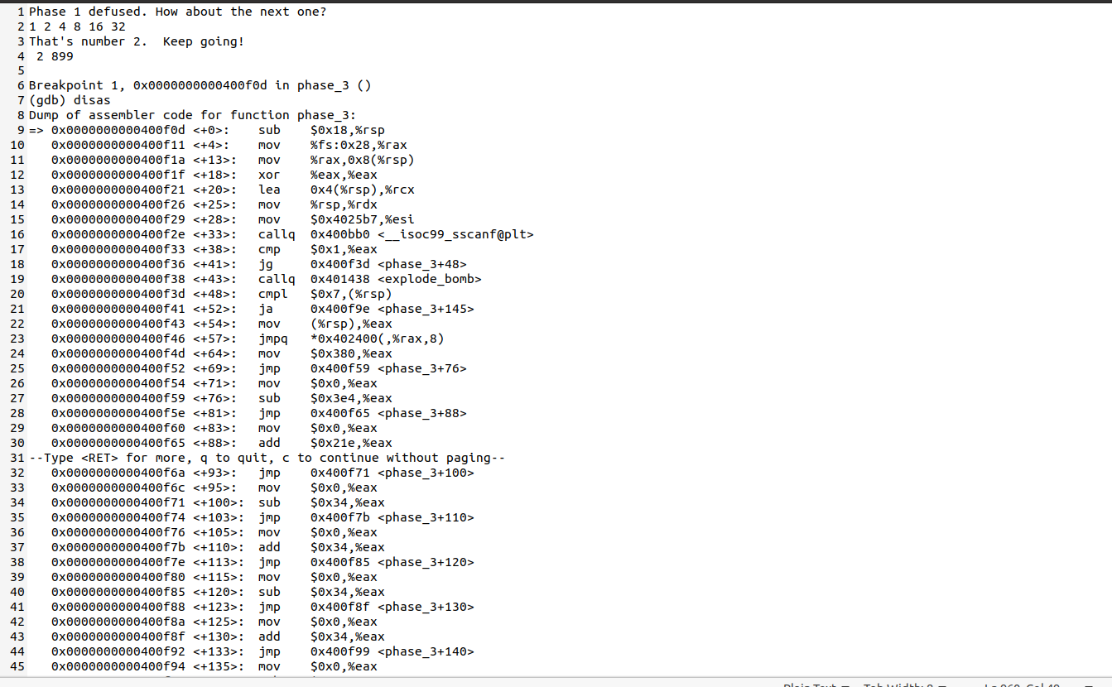

Third phase is giving integer values. First always set the break point so that even if the input given was wrong it wont explode .Taking two integer values and comparing with Dr.Evil given integer. I have started with number 2 and 899. these two integer are entered randomly. And it compares with the stored integer values. If it matches it move to line <+48>. If the integer does not matches then it explode. From the given codes we can figure out that first input lies between 1 till 7 and less than 7.

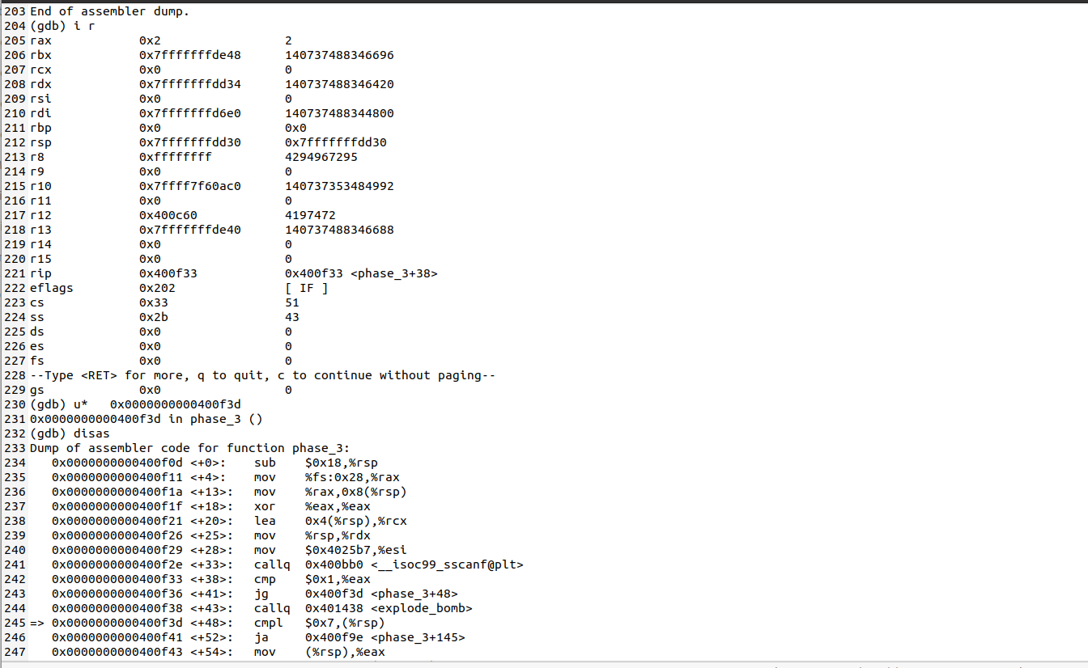

It is always good habit to see what values is at the register. With the command “i r”. this gives what values is stored at particular address and in other ways with the given address we can find the values.

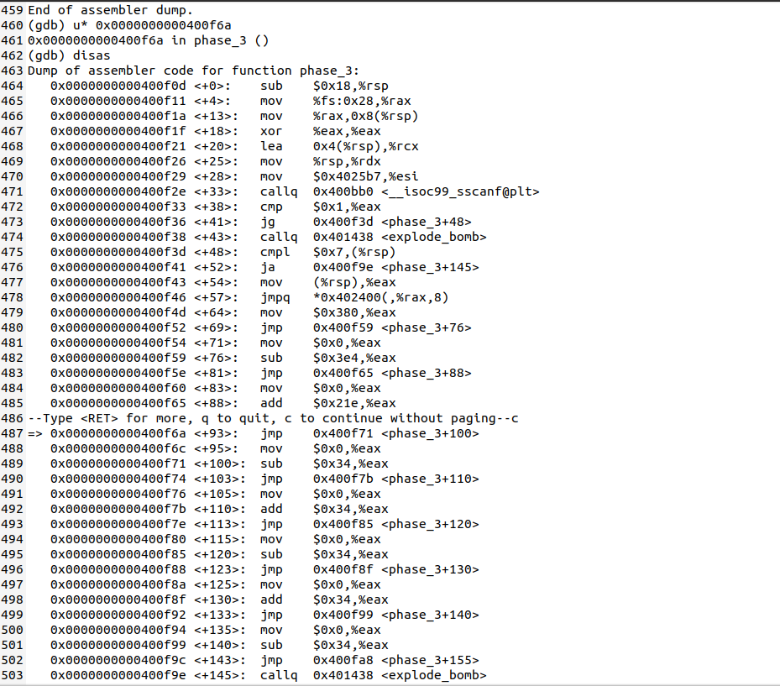

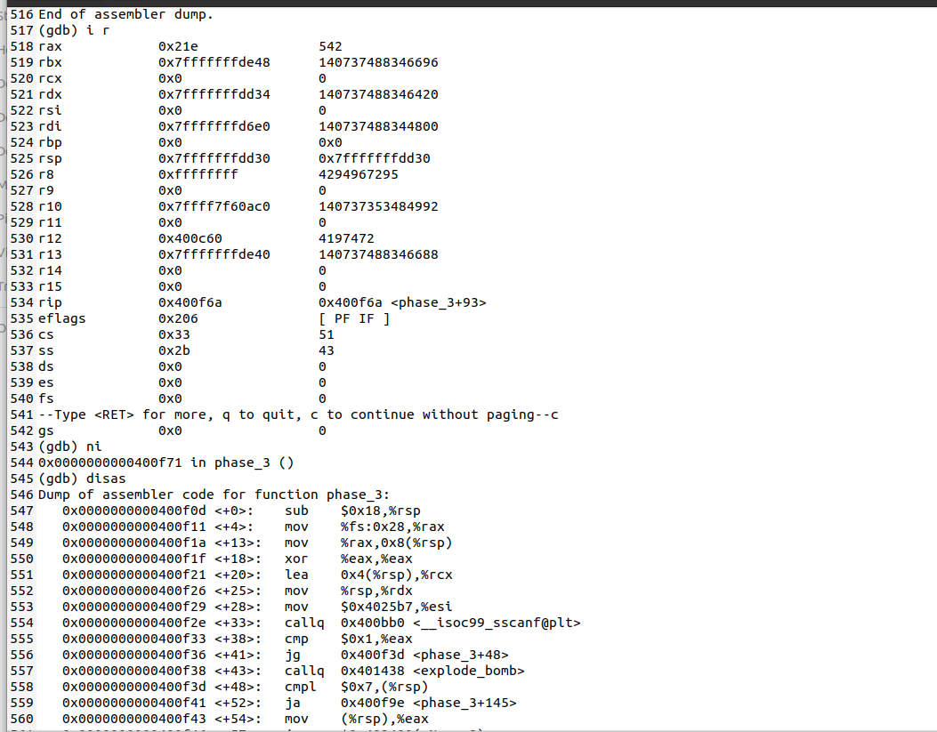

What we can figure out is that is rax hold value 542 . every time it hold the same values in nth iterations., and in the below figures rax hold the value 490 and it is subtracted .

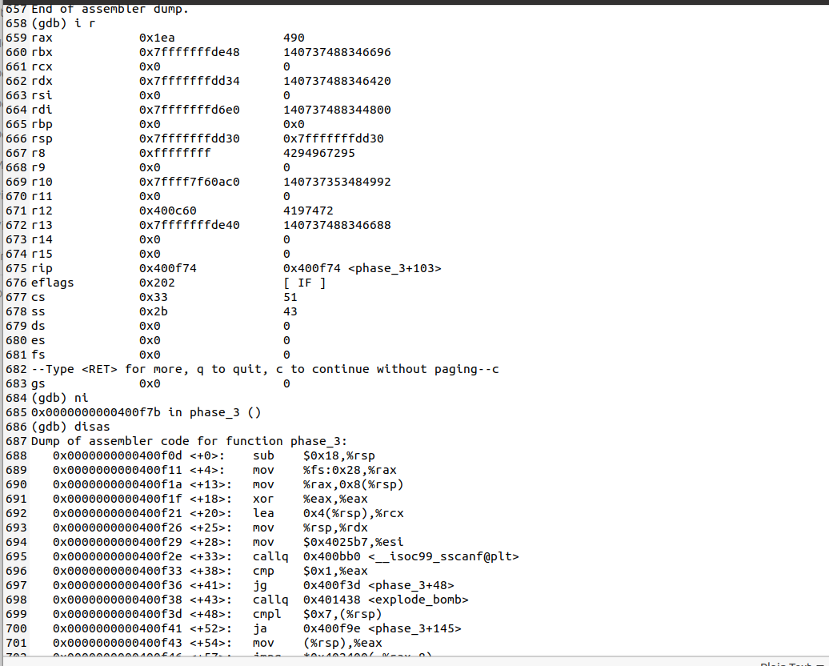

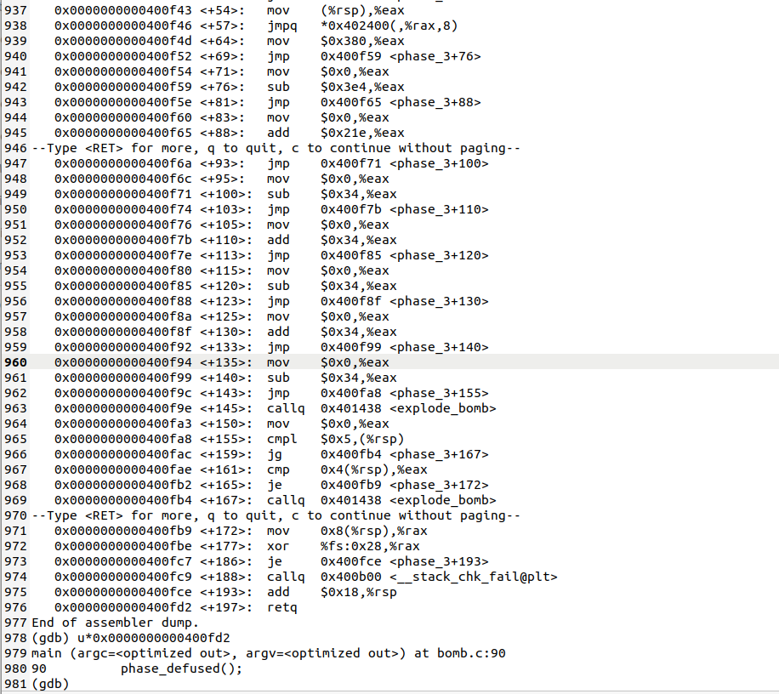

The above codes iterates several times and gives the same difference where I find that value of the second input is 90.

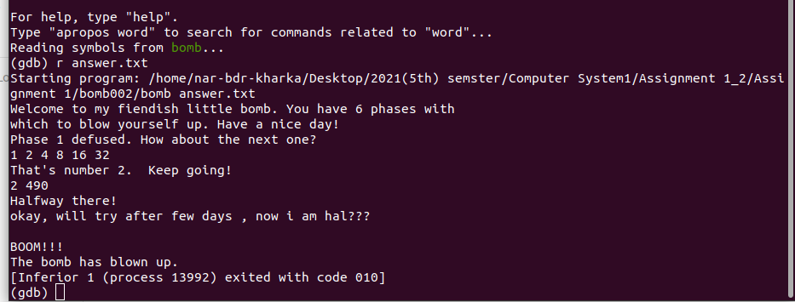

Finally phase 3 is diffuse and eagerly to diffuse rest.

