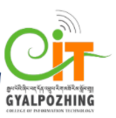

Proposal
For
Second Year Project
Bachelor of Science in Information Technology

Quiz APP

Submitted by

Nar Brd Kharka (12190065)

Gyalpozhing College of Information Technology

Read carefully before filling the form.

- Please do not alter the layout of the application form. Information must be filled in the spaces provided, under set format.
- Guidance notes in various fields should not be deleted.
- Required information should be duly filled in the specified fields.
- Required heads/fields which are not relevant to the project should be marked N/A (Not Applicable) or left blank and should not be deleted.
Guidelines and Forms

Submission Procedure
Duly filled proposal forms completed in all respects should be submitted in form of soft copy and a hard copy to project guide and project coordinator. On receipt of the applications the proposals will be evaluated by reviewer panel and proposal would then be defended by student groups. The project group may need to revise the proposal in light of the evaluator’s recommendations.

For further information, please contact:

Project Coordinator

Sonam Wangmo
sonamwangmo.gcit@rub.edu.bt

Table of Contents
Description Page #

1. Project Identification 1
2. Scope, Introduction and Background of the Project 3
3. Aim and Objectives of the Project 5
4. Methodology 6
5. Benefits of the Project (Expected output/outcomes): 10
6. Risk Analysis/Feasibility 10
7. Project Approval Certificate 11
8. Reviewers Panel Comments 13
10. Project Schedule / Milestone Chart /Work plan 14
13. Report Writing Guidelines 15
Bibliography 16

Note: To update the table of contents, right click in the table and select ‘update field’ and then select ‘Update Entire Table’.
Application for Second Year Project

1. Project Identification
- Reference Number:
(for office use only)
- Project Title: Quiz
- Project Internal Guide:
Name: | Sonam Wangmo
Designation:
Organization: | Gyalpozhing College of Information
Mobile # : | 17391134 | Tel. # :
Email:
C1. Project External Guide:
Name: | NA
Designation:
Organization:
Mobile # : |  | Tel. # :
Email:
C2. Student Group Lead:
Name: | Nar Bdr Kharka
Roll No: | 12190065
Department: | Bachelors of Science in Information Technology
Mobile # : | 17370231 | Tel. # :
Email: | 12190065.gcit@rub.edu.bt
- Organizations Involved in the Project:
(Please identify all affiliated organizations collaborating in the project, and describe their role/contribution to the project.)
D1. Industrial Organizations:
# | Organization Name |  | Role / Contribution
 | NA
D2. Academic Organizations:
# | Organization Name | Role / Contribution
D3. Funding Organizations:
# | Organization Name |  | Role / Contribution
 | NA
- Key Words:
(Please provide a maximum of 5 key words that describe the project. The key words will be incorporated in our database.)
1. Python Quiz
2. Python Learning
3. Python Tutorial
4. Quiz APP
5.python crazy
- Research and Development Theme:
To develop an application where the users will be able to Learn Python with fun and faster and become advance in coding and carrier may be updated.
- Project Status:
(Please mark ☑)
☑ New ☑ Modification to previous Project
☑ Extension of existing project

- Project Duration:
Expected Starting Date: | 01 March 2021
Planned Duration in months: | 5 months

2. Scope, Introduction and Background of the Project
- Scope of the Project:

System Scope

Even today we use paper or diary to keep track of the expense that are made. Most people Even today we use paper or diary to keep track of the learning. We browse so many application to learn coding and about the Language.

I am going to develop an android based application with the following features:

1. Registration: The user has to first register in order to access all the features.

2. Login: The user has to login in order to view all the other details.

3. User Profile: The user can view all the details of what he or she have finished learning

4. Notification: The user will be notified with the progress of the learning as well as the with the new events.

Future scope works

5. Categories: The user can Learn language based on categorized that are made by categorizing them.

User Scope

The scope of the project is global. Any user can learn as well attempt the quiz and level up the Learning activities.

- Introduction (Project Background and Literature Review, Current State of the Art):

(Detailed summary of what all has been done internationally in the proposed area quoting references and bibliography. Please note that this section demonstrates the depth of knowledge of the project team and builds the confidence of the evaluators about capability of the team in achieving the stated objectives.)
(Please describe the current state of the art specific to this research topic.)

“Tell me and I forget, teach me and I remember. It involves me and I learn”. Android is the other dominant player in this space, it was a bit later participant to the game, first being released in Sept 2008, virtually a year later than iOS but it has managed to achieve a reasonably massive share of the mobile market. Quiz App is a language learning platform and it is designing for new learner to develop the basic concept about the language form the beginner to the intermediate levels.

The main focus of the application will be based on the the python learning. The concept will be delivered and moreover the maximum concept will based on the real life problem. The user can actively participate and engage in learning. With the problem the solutions are provided thus user can actively learn.

Although researchers predict that mobile learning has outstandingly influence on education (Alden, 2013) but design and development of mobile learning application consider as
complicated progress for many institutions. One main challenge is to identify how to
design application development environments able to support integration of such
technologies through intuitive mobile interactive environments. Moreover, regarding to
limitations of learning tools such as mobile application, fast and endlessly changes, there
are priorities in design and development phase between content and context, instruction,
interface, learning approach and... . “How do I create an environment to teach what I am trying to teach? The conundrum lies in the struggle between the ideal learning environment and the pragmatic solution based on available resources. Should an educator first consider technological decisions or traditional

This quiz application will help to learn in different stages with interactive questions and with the solutions thus it will be easy for the learner to get the ideas. And moreover it will add user with the new skills and knowledge.

Consequently, this Quiz application is developed in hope to help the students to improve the learning in language. It is a powerful application to know more about the language updates and Events. It is developed with an aim to help people keep learning language with easy and simply and hoping to provide the GUI in the later part too. Where new learner can get good chance to explore from very beginning to the intermediate as well as simple advanced level in small part like hacking and all.

Literature Review:

For higher education, more than 50% of teenagers aged twelve to seventeen use their smart phones as their primary internet access device with traditional desktops trailing behind (Pew, 2013). College-age students expect mobile compatibility not only on websites, but web applications as well. McGhee & Kozma( 2001) argued that “The movement of mobile wireless technologies in education is a recent trend, and it is now becoming the hottest technology in higher education”.
Co-founders Davit Kocharyan and Yeva Hyusyan created SoloLearn after running an offline coding bootcamp in Armenia. After incorporating in Pleasanton, CA and Armenia, they launched the first version of SoloLearn in 2014. This applications is good for learning but things need to be improved like they provide more adds besides the coding explanations and the lessons. And more over they do not provide the events like on user want to learn python and the he or she want some events to be joined thus the application that I am developing will notified with the event thus user will be benefited more.
On the other hand there is another app called Python 3, which was developed in Russia. but all are based on the coding and there are many problem like unable to run ide and programs getting deleted where what I was developing was different like the solutions are given and more will be given quiz and it is like a games on python. Simple and user interactive.

Current State of Art

There are few learning Quiz App but there is not much content as well as it is only basic level and it is not much user interactive. Even today we browse websites for Learning but more interactive is Mobile Application. Some uses book or refers friends notes to learn Language thus an proper Application is required for learning language.

- Challenges:
(Please describe the challenges, specific to this research topic, currently being faced internationally.)
1. I might face problems due to hardware failures.
2. As an amateur developer, i might not be able to complete our project on time.
3. The application may not have all the categories the user need to do quiz
- Motivation and Need:
(Please describe the motivation and need for this work.)
As a student we depend on the learning application and learning platform to developed skilled. Although there are some platform to learn python but I have not found the proper platform with the user requirement. Therefore , I decided to developed a platform where beginner and intermediate learner can learn.

3. Aim and Objectives of the Project
(Please write the actual aim of your project. Also, describe the measurable objectives of the project and define the expected results. Use results-oriented wording with verbs such as ‘to develop.’, ‘to implement.’, ‘to research.’, ‘to determine. ‘, ‘to identify.’ The objectives should not be statements and should not include explanations and benefits. The objective should actually specify in simple words what the project team intends to achieve (something concrete and measurable/ deliverable). Fill only those objectives that are applicable to the proposed project.)
AIM: The aim of our project is to develop an application which will help the students to learn language with quiz.

OBJECTIVES:
1. To develop a platform for learning Language.
2. To improve in coding.
3. To help users to be more advanced in learning.

4. Methodology

- Development / Research / Test Methodology:
(Please describe the technical details and justification of your development and research plan and test plan and testing strategies. Identify specialized equipment, facilities and infrastructure which are required for the project and their utilization plan. The block diagrams, system flow charts, high level algorithm details etc. have to be provided in this section. Also, describe the overall methodology to be used for the particular research topic)

Problem Statement
As a student we have to learn so many things and we refer so many websites and application and sometimes we feel that our hunger for the learning dies. Not finding the right and good required lessons. Although there are some applications but those application does not provide enough features for learning and some are there but to learn fully we do not find effective by the end and again interest in learning is not upgraded. On contradictory different people need different lessons to learn meaning familiarity with the learning platform.
Planning
In this phase, I will discuss about the general information of the project and make an overview of the project.

Requirement gathering and Analysis
I will start collecting relevant information from the research papers and existing system. After collecting, I will work on understanding the problems in detail and do some brainstorming and conduct a survey related to the project.

Design
In this phase, a design (or a prototype) will be prepared from the requirements that was collected in the previous phase. Accordingly, an ER diagram will be prepared.

Coding/Implementation
After design phase, according to the ER diagram and prototype implementation of the project will start.

Testing
After coding, each function will be tested separately with the process of unit testing.

Documentation
Simultaneously i will prepare a document of my project.

Methodology

I have decided to work on using Agile model as it is used for developing small projects. It helps in detecting errors easily and furthermore, it reduces risk.

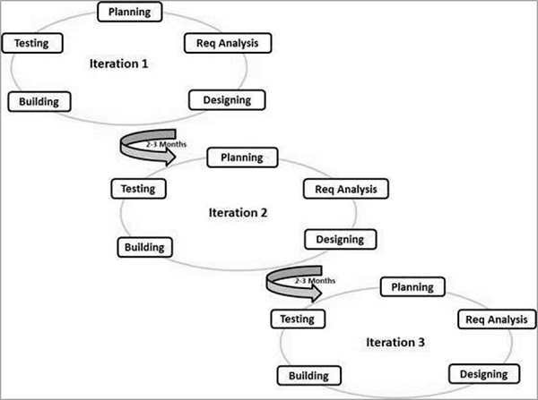

Agile Model
An agile model is a combination of iterative and incremental process model. It breaks the product into small incremental builds. These builds are provided in iterations.
Firstly,i will plan and prepare an overview of the project. Then, I will study in detail about the problems and design a prototype for the project. After designing, we will start with the implementation. At the end of each iteration, a working product is produced.

- Project Team:
Title / Position | Number
Project Internal Guide
Project External Guide
Student Team Members
Others (please specify)
Add more rows if required

- Project Activities:
(Please list and describe the main project activities, including those associated with the transfer of the research results to customers/beneficiaries. The timing and duration of research activities are to be shown in the Gantt chart in Section 8.)
1. Installation of software and tools: Installation of android studio, Java Development Kit, and database server.
2. Resource Gathering: Video tutorials, online references and books related to android app development and XML.
3. Design Phase: It includes designing user interface, database design and understanding the functionalities of the features.
4. Development Phase: In this phase, development of features in the app starts.
5. Testing: The product will be tested for its functionalities and will also be carried out for integration testing to ensure that it produces a desired function.
6. Final Documentation: After all the phases are done i will document about the project and will prepare a final report for my project.

- Key Milestones and Deliverables:
(Please list and describe the principal milestones and associated deliverables of the project. A key milestone is reached when a significant phase in the project is concluded, e.g. selection and simulation of algorithms, completion of architectural design and design documents, commissioning of equipment, completion of test, etc.) The timing of milestones is also to be shown in the Gantt chart in Section 8.
No. | Elapsed time from start (in months) of the project | Milestone | Deliverables
1 | 21/02/2021 – 13/03/2021 | Literature Review | Literature Review .
2 | 15/03/2021 – 25/03/2021 | Requirement Gathering | Analyzing the gathered information.
3 | 26/03/2021 – 07/04/2021 | Design | Starting phase of coding.
4 | 09/04/2021 – 02/05/2021 | Coding | Trying to complete the project
5 | 04/05/2021 – 15/05/2021 | All the test case will be done | Completion of the all the test cases.
6 | 17/05/2021 – 24/05/2021 | Final Documentation. | Presentation.
(Please add more rows if required.)

5. Benefits of the Project (Expected output/outcomes):
- .Learn better.
By using my app, the users will be able to learn better with the quiz and lessons together.
- . Be more competitive in programming
From my app, the user will be more aware of learning programming and user will be competitive in doing programming.
- . Since user will get the notification of the events, where user can perform well in coding and carrier.
By using my app, the users will be able to know events. The events will boots their carriers
- . Quiz will help in preparing for the exams.
It will be revision for the intermediate learner and easy to prepare for the basis exams as well as intermediate exams.

6. Risk Analysis/Feasibility
- Risks of the Project:
(Please describe the factors that may cause delays in, or prevent implementation of, the project as proposed above; estimate the degree of risk.)
(Please mark ☑ where applicable) Low Medium High
Technical risk ☑
Timing risk ☑
Budget risk -

A1. Comments (Describe the risk):

1. Technical Risk:

As an amateur developer, i might face some technical risk such as
- Handling sophisticated software.
- I might not get all the resources that are required to develop an application.
- I might face some hardware problems (4GB RAM).

2. Timing Risk:

I might face some risk regarding time such as
- I might not be able to complete my project within the given time period.
- Pre-planned schedule may get delayed.
Feasibility Study

There is more demand in learning, Learning is going to take place more and more in more years to come.

7. Project Approval Certificate
(Approval of Project Proposal by the Competent Authority (Department Chairman) and Project Review Team is mandatory before the start of project execution.)
Project Review Team:

Sl # Name Signature

(Please add more rows if required.)

Project Coordinator
Name:
Designation:
Email:
Date: Signature:

Competent Authority – Head of Department
Name:
Designation:
Email:
Date: Signature
& stamp:

8. Reviewers Panel Comments

10. Project Schedule / Milestone Chart /Work plan

(Project schedule using MS-Project (or similar tools) with all tasks, deliverables, milestones, clearly indicated are preferred. Task should be measured in terms of hours)

0.00 Prototype
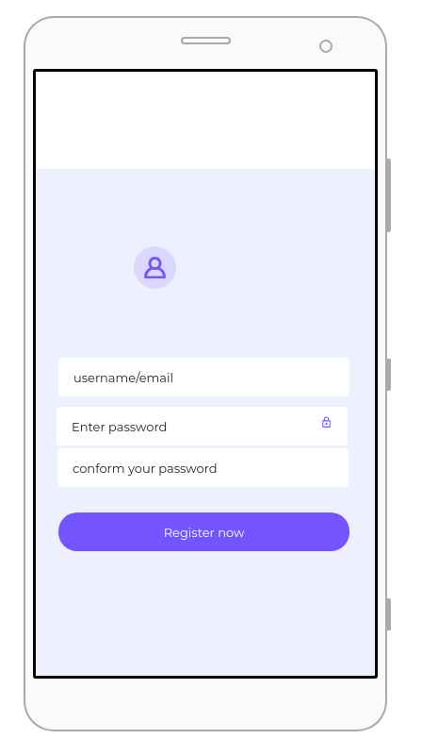
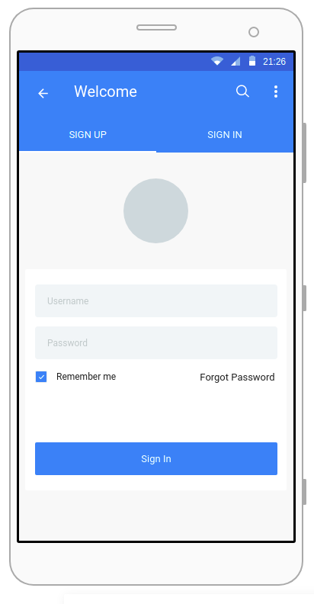

Here user can sign for the first time. If the user is new user can actively do sign up in sign up user can provide his or her details and do register. Once user is done with registration. User can do login and then view the home screen. Before all user will be viewing the splash screen for few second with the application logo and GUI design.

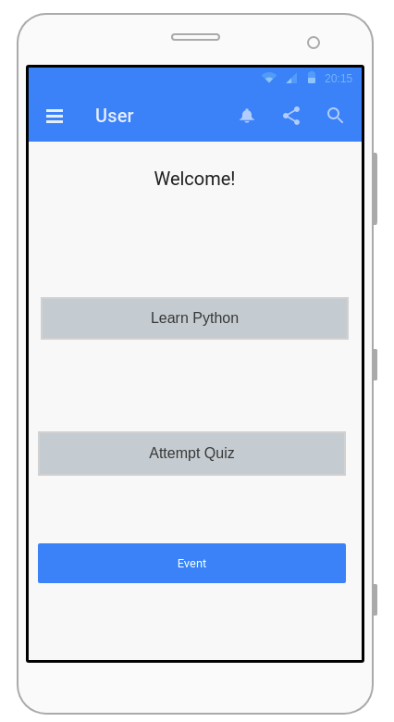
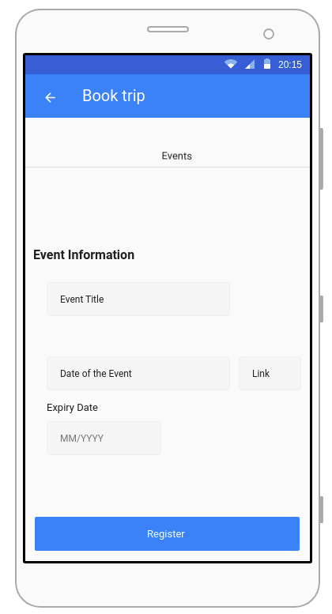

This screen will be there when user do login. As in home there are many options for the user. User can select any options as he or she likes. Like user can go for learn python, Attempt quiz, event or dashboard. Suppose user click to the event. There user can see or view the event and the certain information like event title with date like starting date as well ending the date will be given thereby user will be aware about the events and take active participating. With it there will be link given. But user need to do registration for this.

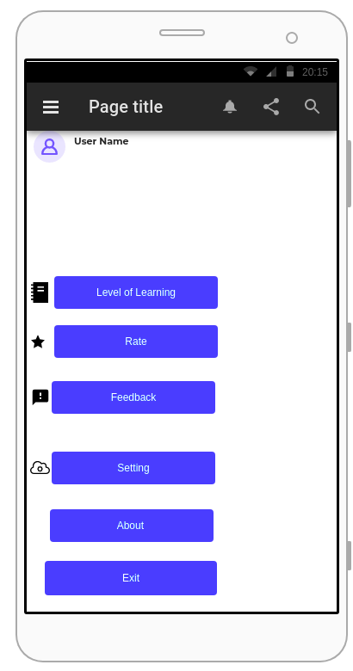
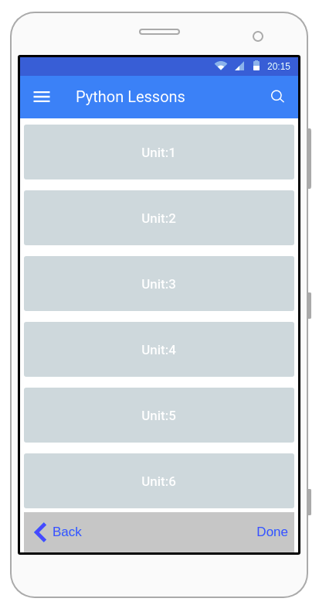

Here user can go to click the navigation bar and user can view the details like your level of learning as well as the level of the quiz. User can provide the feedback after learning and attempting the quiz. And other part is the python lesson and this is connected to the quiz. Like in quiz all the questions will prepare base on the lesson. And all the button are user interactive like user can jump form one point to other.

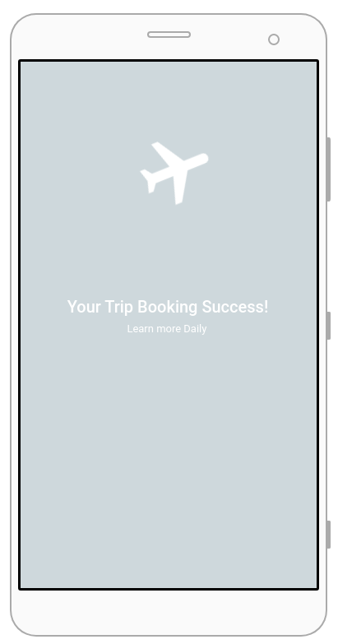
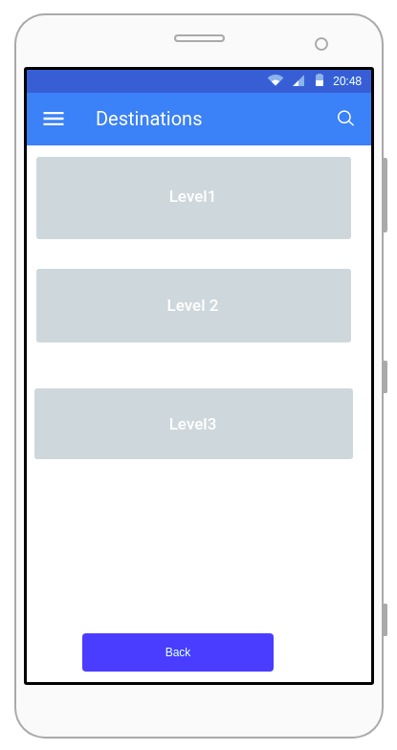

This screen is like if the user select the option quiz and there user can click to level one and do the quiz. It is very interesting that the quiz will be all from the lessons. User can level up the levels and get more benefits and with this event will be done in smooth ways thus there might be trip to roam the whole world in free.

Bibliography

Facebook for Developer from
https://developers.facebook.com/success-stories/sololearn
Independence University from
https://www.independence.edu
http://developer.android.com/guide/index.html.
http://developer.android.com/guide/topics/ui/declaring-layout.html
Srinivas, Davanum (December 9, 2007)."Android — Invoke JNI based methods (Bridging C/C++ and Java)".Archivedfrom the original on December 16, 2008. Retrieved

